Sally Miller p146020
Dissertation Research Proposal

Table of Contents

1.0 Introduction: Loyalty Cards and How They Can Benefit Smaller or Locally Owned Pubs | 2
1.1 Rationale | 2
1.2 History and Background | 2
1.3 Aim and Objectives | 2
2.0 Research | 2
2.1 Methodology | 2
2.2 Philosophy | 3
2.3 Research Approach | 3
2.4 Research Method and Strategy | 3
2.5 Sample | 4
2.6 Data Collection | 4
2.7 Data Analysis | 4
2.8 Limitations and Ethical Considerations | 4
2.9 Reliability and Validity | 4
3.0 Resources and Planning | 4
3.1 Resources | 4
3.2 Gantt Chart | 5
4.0 Bibliography | 6

- Introduction
Loyalty Cards and How They Can Benefit Smaller or Locally Owned Pubs
1.1 Rationale
It has been written about over the past few years that the British Pub is failing. In 2015, 26 pubs were closing each week likely due to higher prices because of taxes increasing (Smithers, 2016). Camra has argued that the sector should receive tax relief to help as it could be a ‘fragile recovery’. Pubs could use a type of loyalty system to help customer want to go to their local pub more often. Additionally, the researcher works in a locally owned pub so can therefore research and suggest help for that specific pub.
1.2 Background
The term “public house” was first used in the 17th century, during this century is when these establishments truly boomed where they appeared all over the country. In 1830, The Beer Act was brought in, this allowed home owners to brew and sell their own beer, which in effect meant opening their own pubs. This resulted in up to 30,000 new “beerhouses”, which appeared a lot like the modern-day pub. In 1869, the Wine and Beerhouse Act was brought in which helped restrict the number of pubs across the country, as landlords complained they could no longer make a profit. More attempts were made to help reduce the number of pubs in 1904 where a new law was brought in where authorise could forcibly close down drinking establishments in exchange for compensation. 10% of pubs were closed down within a decade. Since the 1950s, the number of pubs has steadily decreased with people using different types of places, such as wine bars. Up to 5 pubs are closing each day in England and one in six people are claiming they no longer drink alcohol (Collins, 2011).
Total number of pubs in 1982 in the UK were 67,800. In 2015 it decreased to 50,800. The price of a pint has gone from £2.02 in 2002, to £3.23 in 2014. With tax increasing from £1.43 to £2.24 (BBPA, 2017).
1.3 Aims and Objectives
The aim of this dissertation is to understand if customers will be more likely to visit a local pub if they receive benefits in the form of a loyalty card.
The following objectives will be achieved through carrying out extensive research:
- Identify why people attend their local pub
- Investigate what more can be done to increase business
- Make appropriate recommendations based on the findings
2.0 Research
2.1 Methodology
In this section which research methods are going to be used will be discussed to help achieve the aims and objectives that have previously been stated.
(Kothari, 2004) stated that research is an academic activity and as such the term should be used in a technical sense. Research comprises defining and redefining problems, formulating hypothesis or suggesting solutions; collecting, organising and evaluating data; making deductions and reaching conclusions; and at last carefully testing the conclusions to determine if they fit the formulating hypothesis.
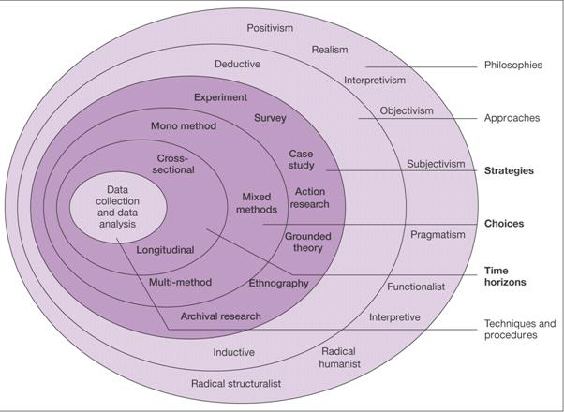
Figure 1 shows the research onion provided by Saunders et al, it highlights various research structures that can be used (Saunders, et al., 2009). The research onion theorises that selecting a methodology was a process that consisted of many layers. It includes the philosophy, research approaches, research activities, time management and data collections methods. A philosophy of interpretivism has been chosen as well as a deductive approach using quantitative and possible qualitative techniques for data collection and analysis. Quantitative research is based on facts and figures, while qualitative research is used to explore and identify ideas and interests (Srivastava & Rego, 1958).
Figure 1 - The Research Onion (Saunders, et al., 2009)
2.2 Philosophy
The research philosophy forms the outer layer of the research onion. The research philosophy relates to the development of knowledge and the nature of that knowledge (Saunders, et al., 2009). Interpretivism is going to be used to do human emotions being involved and it is not an exact science with clear and factual answers. In the case of business and marketing (Saunders, et al., 2009) states that it is appropriate as many business situations are complex and can be exclusive depending on an individual’s contribution.
2.3 Research Approaches
The philosophical assumptions guiding positivist research include an objective view of reality, which the research seeks to measure and explain (Belk, 2006).
A deductive approach aims to test theory, it involves developing a theory and hypothesis. The outcome will either be confirmation or modification of a theory (Collis & Hussey, 2009).
2.4 Research Method and Strategy
Survey research is the most widely used method for primary data collection, this helps gain an understanding of people’s knowledge, attitudes, preferences and buying behaviour (Kotler & Armstrong, 2010). Primary data is collected directly by the researcher for some specific purpose or study. This approach is the most suitable as it allows data collection to be analysed and findings can be made from the results (Srivastava & Rego, 1958).

2.5 Sample
The convenience sample is the method chosen for this study. A convenience sample is where the researcher selects the easiest to reach and most convenient individual’s (Kotler & Armstrong, 2010). This will be the most efficient as it will be able to be achieved within the time limit allocated and a wide variety of results can be collected. The sample used will consist of customers of local pubs, non-customers from the same area and committee members, all participants will be aged 18 or over.
2.6 Data Collection
Questionnaires are a very effective method to collect data, they can be flexible and open or closed questions can be answered, which help provide qualitative responses (Kotler & Armstrong, 2010). Participants will be limited in some of their responses and able to express their opinion in more detail in others.
2.7 Data Analysis
The findings from the data collection will be shown using spreadsheets, graphs, tables and figures. These tools will help display the results in an effective and easy to understand manner. The most important aspects will be displayed.
2.8 Limitations and Ethical Considerations
2.8.1 Time Management and Sample
Due to the having a time limit it is important all research is done within the limit given. This may limit the amount of research that can be undertaken and therefore could limit this study.
The sample that will be pursued will be a convenience sample, as previously mentioned. This method will be used due to it being the most effective, however, using this sample may not be representative of a variety of opinions of perspectives. Nevertheless, this method will be used as it will be the most effective technique to implement given the time limit.
2.8.2 Ethical Considerations
This topic is intended to consider better marketing techniques for smaller pubs and is not to examine any ethical implications. Therefore, the only people that will be used in the sample will be over the age of 18 and have full disclosure that no personal information will be used or asked. This research is highly unlikely to cause any psychological harm.
2.9 Reliability and Validity
Validity is measuring what is thought is meant to be measured and not another concept or problem. Reliability refers to the accuracy of the measurement (Thyer, 2010). “Perfect” reliability and validity will remain an illusion for any kind of research (Baumgarten, 2010).
It will be very important to ensure the data collected is of high reliability and validity, therefore the researcher must carry out fairly and consistently to all participants.
3.0 Resources and Planning
3.1 Resources
In order to carry out this study successfully and achieve the objectives stated previously, there are various resources that will be required. The resources needed will be:
- A P.C or laptop with suitable software, for example, excel for spreadsheets to effectively show data collected.
- Internet access to carry out research
- Library resources, for example, books for research
- A printer to print off questionnaires and to print of completed work to submit
3.2 Gantt Chart
Figure 2 - Gantt Chart
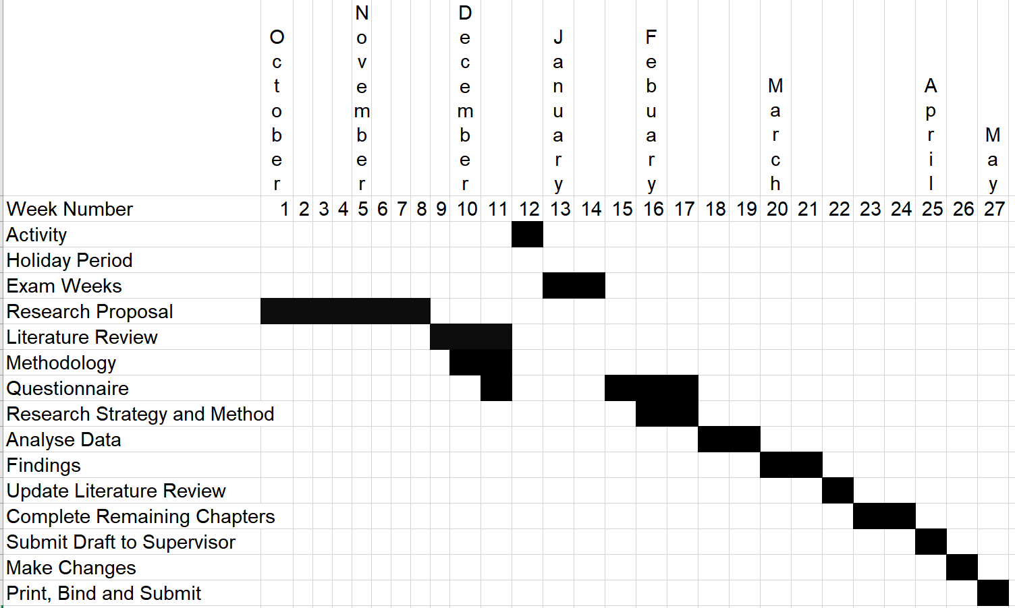

Bibliography
Baumgarten, M., 2010. Paradigm Wars - Validity and Reliability in Qualitative Research, s.l.: GRIN.
BBPA, 2017. [Online]
Available at: www.beerandpub.com/statistics
Belk, R. W., 2006. Handbook of Qualitative Research Methods in Marketing. Cheltenham: Edward Elgar Publishing Limited.
Collins, N., 2011. The rise and fall of the British pub. [Online]
Available at: www.telegraph.co.uk/foodanddrink/foodanddrinknews/8287145/The-rise-and-fall-of-the-British-pub.html
Collis, J. & Hussey, R., 2009. Business Research: A Practical Guide for Undergraduate and Postgraduate Students. Basingstoke: Palgrave Macmillan.
Kothari, C. R., 2004. Research Methodology: Methods and Techniques. Delhi: New Age International Ltd..
Kotler, P. & Armstrong, G., 2010. Principles of Marketing. 13th ed. New Jersey: Pearson Education.
Saunders, M., Lewis, P. & Thornhill, A., 2009. Research Methods for Business Students. 5th ed. Essex: Pearson Education Limited.
Smithers, R., 2016. Number of pubs in UK falls to lowest level for a decade. [Online]
Available at: https://www.theguardian.com/lifeandstyle/2016/feb/04/uk-pubs-lowest-number-for-decade-2015-camra-beer-tax-campaign
Srivastava, T. N. & Rego, S., 1958. Business Research Methodology. New Delhi: Tata Mcgraw Hill Education Private Limited.
Thyer, B., 2010. The Handbook of Social Work Research Methods. 2nd ed. California: SAGE Publications.

