I acknowledge the use of Copilot on 19th November 2025 to gain further understanding on the topic.
    - I used the prompt(s): (e.g. Please check the following text for readability, grammar and syntax).
    - I confirm that I have not presented any AI generated text as my own work. I confirm I have copies of my drafts, notes, and other resources I used before, and after the use of AI tools which I may be asked to provide in evidence.

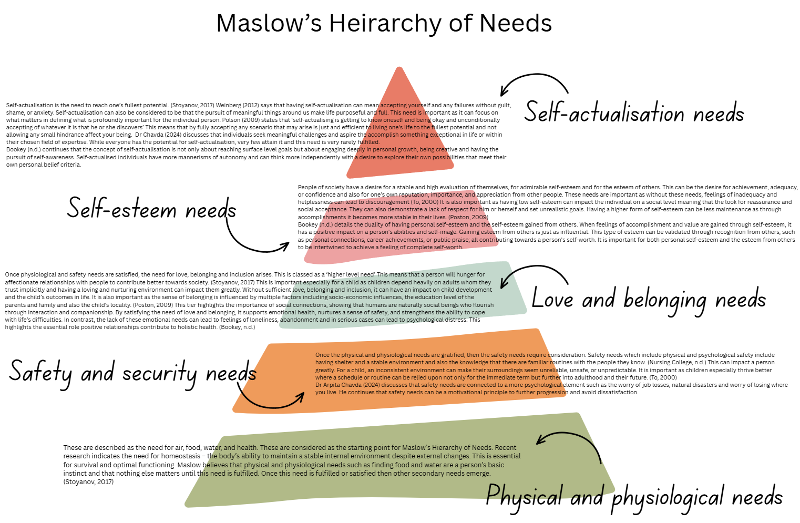
Component 1 - Infographic
Component 2 - The concept of holistic child development.

Holistic child development is an approach which nurtures all aspects of a child’s growth. This includes physical, social, emotional, cognitive, and spiritual aspects. It is recognised that each of these aspects are deeply interconnected and develop together.
A concept is a vague idea or notion that helps understand, categorise, and communicate more efficiently. It allows the grouping of related experiences to have a shared understanding. For example, in education, looking at a topic or theme through a conceptual lens can provide learners with connections and a purpose to their learning. (Lattanzio and Muller, 2017).
Wagner (n.d.) suggests that Maslow’s Hierarchy of Needs (1943), affords a good starting point when considering child development in a holistic way. She discusses that Maslow suggests the five hierarchical needs; physiological, safety, social, esteem and self-actualisation, can allow greater understanding and recognition of progressing through each need can allow practitioners to develop the needs already achieved by the child and which needs are identified to build upon to be fulfilled.
Bertrand Russell (1994) states ‘We must have some concept of the kind of person we wish to produce before we can have any definite opinion as to the education which we consider best’ In more recent years, strategies and frameworks have been built upon this principle to allow for a more holistic approach with the review of the type of person that will grow and flourish in society.
To understand the concept of holistic child development, it is important to consider positive relationships. Positive relationships are often depicted by interactive behaviour such as ‘Child A waited for their turn whilst playing in the school yard.’ This has an impact on the child’s brain development and forms new neural pathways. Evidence from neurological research demonstrates how these acts of interactive behaviour can lead to different interpretations of physical, social, emotional, and cognitive development. (Johnson, 2010).
It is typically adults that provide a loving, secure and nurturing relationship base. According to Lopez Turley, Desmond and Bruch (2010), a family consisting of a single parent or of two parents can significantly impact a child and can help them succeed in the world. Sociologists have seen a positive link between an enriching familial life and a child’s well-being which then transcends into adult life. When a parent has a more engaging input into their children’s lives such a tracking development, being observant and having a more open dialogue, the child often has higher educational outcomes. Studies have shown that a child’s intellectual development often links to the parent and child’s communication levels.
The area that a child is brought up in can also have an effect on the development of relationships. For example, Macdonald, Gealy and Tinney (2019), discuss that the emotional, social, and behavioural development in children from a Flying Start background and the quality of adult – child interactions have an impact on the child’s development. Their research along with research from Save the Children (2013) noted that children living in a more deprived area were at more of a risk of having poorer key skills, being less likely to catch up with peers and that by the age of seven, their results would be determined.
There are many differences of holistic child development on a global scale. In New Zealand, the concept of Te Whakiri embodies child development as an integration of cognitive, social, cultural, physical, emotional, and spiritual human development as interwoven together to form an approach which ensures a person becoming a valued member of society. (Hargreaves, 2020). The Te Wharkiri principle focuses that any immediate needs that can arise through experiences at any given moment will affect and modify a child’s development. This approach is not dissimilar to what Maslow discusses in his hierarchy of needs.
Additionally, the Reggio Emilia approach in Italy focuses on learning environments that can share common spaces are interconnected to the point of becoming one thing. There is no curriculum to follow and is completely focused on child led learning. This concept promotes supporting children’s relationships with their peers, family, and society in general. (Wagener, n.d.)
Practitioners must also consider safety when exploring the concept of holistic child development. It is important for a child to feel safe to develop holistically because having a developed feeling of safety can depend on the response to their needs. (Brodie, 2018). De Mello et al. (2014) discuss the importance of the safety and protection of children and that the importance of a safe home environment and the quality of the environment the child lives in has an impact on their development. This then transferred to having a more stable upbringing.
The United Nations Convention on the rights of the Child (UNCRC) details a broad variety of principles regarding the safeguarding of children. Article 19 of the UNCRC states ‘Governments should ensure that children are properly cared for and protect them from violence, abuse and neglect from their parents and anyone else who looks after them’. (UNCRC, 1989). This makes it clear that a child’s right to safety and security are part of their basic human rights.
Another concept of holistic child development is transitions and how this can affect a child. According to Birth to 5 matters (2021), effective transitions acknowledge the vital role of children feeling genuinely understood. A high-quality early years' experience can depend on maintaining continuity between home, school and other settings that can be involved with a child and often display transitioning between each setting as easy. However, despite these horizontal transitions happening frequently, not all children experience them with confidence or comfort.
Historically, one of the more infamous transitions for children occurred during World War Two, where 1.5 million children, mothers, teachers, and vulnerable adults were evacuated from densely populated areas such to more rural areas of the countryside which carried a lower risk of being attacked (Johnson, 2021). ‘Operation Pied Piper’ was deemed successful with many evacuees reporting to have enjoyed their time with their foster families and thriving by learning new skills and experiences they would not have had from living in the city. However, this period of transition was not without its challenges. John Bowlby, Emmanuel Miller and D.W. Winnicott published an open letter to the British Medical Journal in 1939 detailing the major psychological problems that arose especially for children between the ages of two and five years old. They linked that the separation from the infant's mother would cause biological and physiological factors that would impair the child’s development. (Bowlby, Miller & Winnicott, 1939) This literature corresponds with Maslow’s Hierarchy of Needs relating to the basic needs of a person.

Component 3 – Maslow's significance in understanding child development.
To understand child development in regard to Maslow’s Hierarchy of Needs involves recognising the different needs and how they relate to a child's ability to thrive and grow in society. Maslow’s Hierarchy of Needs demonstrates a framework of interpreting child development through a holistic lens. His theory identifies the requirement for children to have their basic physical and emotion needs met before being able to fully engage in learning, building confidence and reaching their fullest potential. The following will discuss the impact of Maslow’s Hierarchy of Needs in my own practice and the influence this has had on the child’s development.
Firstly, a pupil in my school setting was getting extremely upset when arriving to the breakfast club provision. This was becoming a daily occurrence. He would want to stay with his mother and would become increasingly upset when she left him. After witnessing the distress this was causing him and some of the other children, I decided to greet the child every morning to offer my assurances to him and his mother as I felt that she was becoming quite upset too. It was initially quite challenging to address the behaviours he was displaying but I offered for him to have a separate space to the other children, and this space also allowed him to self-regulate with fewer distractions. Based on Bowlby’s attachment theory that ‘children are pre-programmed from birth’ (Wilson-Ali et al, 2019) to develop core relationships and attachments and the need to stay close to their primary care giver, I could understand why the child displayed these negative feelings of attachment and loss. To help the child further, I discussed with the school Additional Learning Needs Coordinator (ALNCo) about his need to have further support along the Individual Development Plan (IDP) pathway. This has given the child resources to use both at home and at school to help with his fears of attachment and loss. In regard to Maslow’s Hierarchy of Needs, this child's need for safety and security are displayed here along with the sense of love and belonging. Until these needs are met, self-esteem needs cannot be addressed.
Secondly, a pupil I work with on a one-to-one basis had a large variety of adults working with him throughout the school year. These adults would sometimes change on a weekly basis. This provided no sense of stability, inclusion or belonging for him as due to his autism spectrum disorder (ASD) diagnosis, he already struggled to form attachments with those around him. Due to his lack of security, he would often get angry and upset. This coupled with a speech delay proved extremely hard for him to communicate his needs or wants. I became his full-time support and although it was initially challenging, especially due to the fact he assumed I was also going to leave him, he rarely co-operated with things I would ask him to do. Details from Nursing College (2023) supply that for safety needs to be met for a person, a familiar environment can give feelings of security, coupled with familiar routines with people they trust and things that they know. I decided to read the child's Individual Development Plan (IDP) which detailed his specific needs and how this would help him in his day-to-day activities. By utilising the information detailed in the plan, I was able to create bespoke resources such as a ‘now and next’ visual display whereby he could visually see what was happening now and what he would be required to participate in next. This experience helped me to understand how I can modify my approach to help different learners and tailor their environment to meet their needs. With respect to Maslow’s Hierarchy of Needs, achieving this child's sense of security, emotional safety and belonging needs was paramount before attempting to look at his self-esteem needs.
Finally, when lesson planning, I gave the pupils the option of what they wanted to learn. As a school, the afternoon break had been taken away from the children. After discussions with the class, we decided that they were going to write a letter to the headteacher, persuading her to allow for the afternoon break to be reinstated. This enabled me to create lesson plans around grammar, punctuation, and various aspects of persuasive writing. It also gave the children the opportunity for their voices to be heard. There were times when the more confusing aspects of the lesson needed to be explained further but by reviewing the work and modifying the approach to the children, I was able to ensure they fully understood. By giving the children, a voice through their letters, I was able to give them the opportunity to increase their confidence, self-esteem, and independence. According to the article by Howard, Burton and Levermore (2020), positive self-esteem can influence a child's feeling of competence or self-efficacy. Children with a higher self-esteem can be more motivated and seek to do well in life. By presenting their letters to the headteacher they valued the sense of importance and that their voice was being listened to. Through creating this activity, it showed me that looking at what is important to younger people also matter and has merit. In reference to Maslow’s Hierarchy of Needs, the children’s self-esteem needs were recognised and how they developed the desire for achievement.
To summarise, Maslow is significant to Early Years practice as each need level does need to be addressed and achieved before moving on to any further hierarchical needs. According to Naaz and Khalid (2023), Maslow’s Hierarchy of Needs in education has an impact on student motivation, engagement, and overall wellbeing, and by applying Maslow’s theory in practice can enhance a child's educational experience and holistic development.

Reference List
Birth to 5 Matters, (n.d.) Transitions. Available at: https://birthto5matters.org.uk/transitions/
British Medical Journal (1939). Correspondence. Available at:https://pmc.ncbi.nlm.nih.gov/articles/PMC2178618/pdf/brmedj04176-0033c.pdf
Brodie, K. (2018) The holistic care and development of children from birth to three : an essential guide for students and practitioners. Abingdon, Oxon ; Routledge, Taylor & Francis Group.
Chavda, D. (2024) Maslow’s Hierarchy of Needs: A Critical Evaluation Available at: https://ijsi.in/wp-content/uploads/2025/01/18.02.012.20240903.pdf
Collins, J. and Foley, P. (eds) (2008) Promoting children’s wellbeing : Policy and practice. Bristol: Bristol University Press. Available at: https://doi.org/10.56687/9781447342618.
De Mello, D., Pereira N., Pancieri, H., De La Ó Ramallo Veríssimo,M., Pamplona Tonete, V., Malone, M. (2014) ‘Child safety from the perspective of essential needs’. Available at:https://www.researchgate.net/profile/Debora-Mello-2/publication/267756436_Child_safety_from_the_perspective_of_essential_needs/links/55e97b8108aeb6516264809c/Child-safety-from-the-perspective-of-essential-needs.pdf. (Accessed: 8 November 2025).
Hargraves, V, (2020) Principle of Holistic Development Kotahitanga. Available at: https://theeducationhub.org.nz/principle-of-holistic-development-kotahitanga/
Hierarchy of Needs, A Theory of Human Motivation. Available at: https://cdn.bookey.app/files/pdf/book/en/hierarchy-of-needs.pdf
Holzknecht, J. (2007) Maslow’s hierarchy of needs. Austin, TX: Castalia Media.
Howard, C., Burton, M., & Levermore, D. (2020). Children’s Mental Health and Wellbeing in Primary Schools. The Whole School Approach. Available at: https://uk.sagepub.com/sites/default/files/the_impact_of_self_esteem_on_children_0.pdf
Johnson, J. (2010) Positive and trusting relationships with children in early years settings. New ed. Exeter, England: Learning Matters.
Johnson, M. (2021) Operation Pied Piper: Britain’s Forgotten War Children. Available at:https://booksandideas.net/IMG/pdf/20211223_children.pdf
Lattanzio, T. and Muller, A. (2017) ‘What Is a Concept?: A Fresh Look at Teaching Factual Information’, Childhood education, 93(5), pp. 410–419. Available at: https://doi.org/10.1080/00094056.2017.1367238.
López Turley, R.N., Desmond, M. and Bruch, S.K. (2010) ‘Unanticipated Educational Consequences of a Positive Parent-Child Relationship’, Journal of marriage and family, 72(5), pp. 1377–1390. Available at: https://doi.org/10.1111/j.1741-3737.2010.00771.x.
Macdonald, N., Gealy, A.-M. and Tinney, G. (2019) ‘Exploring the effect of an attachment intervention in areas of multiple deprivation on adult–child interaction and the implications for children’s social, emotional and behavioural development’, Early Child Development and Care, 191(5), pp. 670–684 doi: 10.1080/03004430.2019.1641704.
Naaz, H. & Khalid S. (2023). Relevance of Maslow's Hierarchy of Needs in the Education. Available at:https://www.ijmra.us/project%20doc/2023/IJPSS_JUNE2023/IJPSS3July23_22806.pdf
Nursing College, (2023). Maslow’s Hierarchy of Needs. Available at: https://nursingcollege.mespune.in/wp-content/uploads/2023/06/Maslows-Hierarchy-of-Needs.pdf (Accessed: 19 November 2025).
Poston, B. (2009) An exercise in personal exploration: Maslow’s Hierarchy of Needs. Available at: https://www.ast.org/pdf/308.pdf. Accessed: 8 November 2025)
Russell, B. (1994) On Education, Especially in Early Childhood. London: Routledge.
Save the Children. (2013). Too young to fail. Giving all children a fair start in life. Available at: Too Young to Fail: Giving all children a fair start in life - Save the Children’s Resource Centre
Stoyanov, S (2017), An Analysis of Abraham H. Maslow's a Theory of Human Motivation, Macat International Limited, Milton. Available from: ProQuest Ebook Central. Accessed: 8 November 2025).
To, K (2000), A Theory of Human Motivation. Available at: https://moodle.uwtsd.ac.uk/course/format/tiles/mod_view.php?cmid=629416 (Accessed: 8 November 2025).
UNCRC (n.d.) ‘a summary of the un convention on the rights of the child’ Available at: https://www.unicef.org.uk/wp-content/uploads/2019/10/UNCRC_summary-1_1.pdf (Accessed: 19 November 2025)
Wagner, K. (n.d.) The Holistic Development of Babies and Young Children. Available at: https://uk.sagepub.com/sites/default/files/upm-binaries/24496_02_Fabian_Ch_01.pdf
Weinberg, D.R., (2012), Montessori, Maslow, and Self-Actualization. Montessori Life, 23(4), pp. 16-21.
Wilson-Ali, N., Barratt-Pugh, C., & Knaus, M. (2019). Multiple perspectives on attachment theory: Investigating educators’ knowledge and understanding. Australasian Journal of Early Childhood, 44(3), 215-229. https://doi.org/10.1177/1836939119855214 (Original work published 2019)

