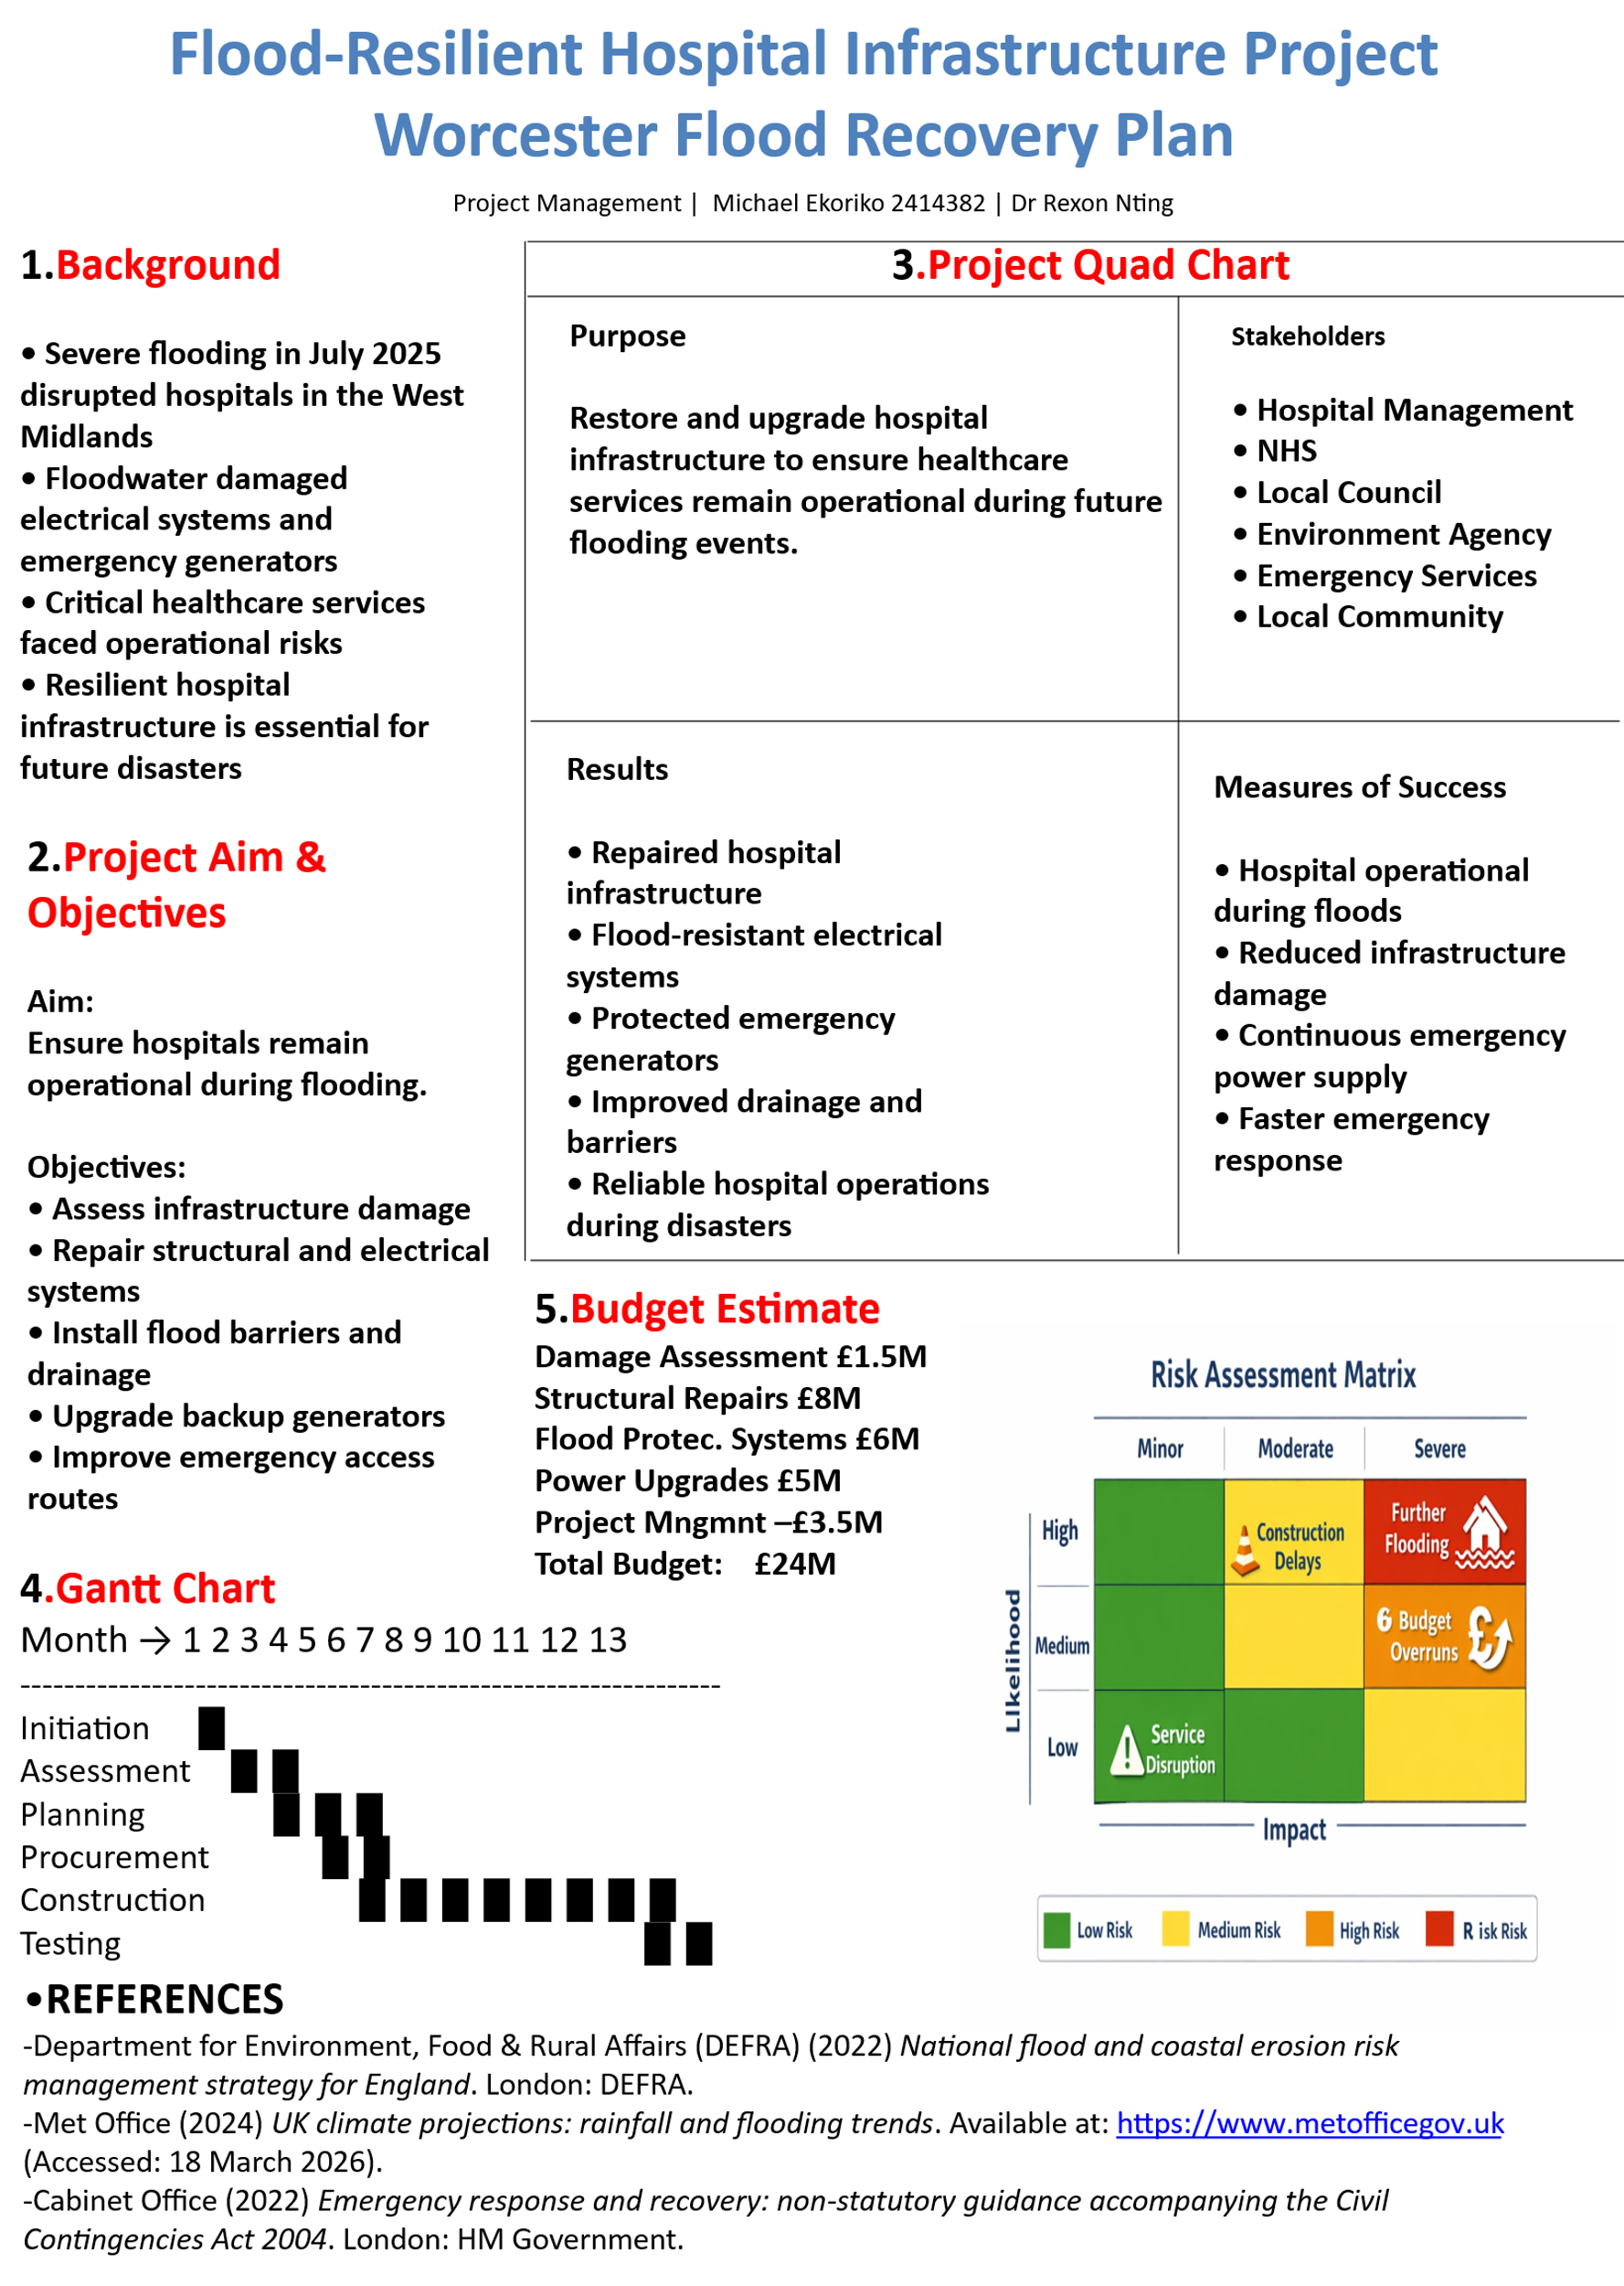

PART B - Reflections from the feedback received from tutor
Reflecting on the feedback I received from my tutor, I gained a clearer understanding of the strengths of my poster as well as the areas that require improvement. The poster, which focused on a flood-resilient hospital infrastructure plan for Worcester, was generally seen as relevant and well-organised, but there were several suggestions that will help me improve future work.
One of the main positive points highlighted was the structure of the poster. The way I divided the content into sections such as background, objectives, project details, timeline, and budget made it easier for the reader to follow the overall message. My tutor noted that the flow of information was logical, moving from the problem (flood damage to hospitals) to proposed solutions and expected outcomes. This helped communicate the purpose of the project clearly. In addition, including elements like the risk assessment matrix and budget breakdown showed that I understood key project management concepts, which strengthened the academic quality of the poster.
Despite these strengths, a common piece of feedback was that the poster appeared too text-heavy. Many of the sections contained long bullet points, which made it less visually engaging. Some peers mentioned that when viewing a poster, people tend to scan rather than read everything in detail, so using shorter phrases, visuals, or diagrams would have been more effective. For example, the Gantt chart and risk matrix were useful, but they could have been designed in a more visually appealing way, possibly with clearer colours or simplified layouts to improve readability.
Another area that was pointed out was the overall presentation and consistency. While the headings were clear, there were small issues with alignment, spacing, and font sizes that affected the professional look of the poster. These details may seem minor, but they can influence how the work is perceived. A more consistent layout would have made the poster look more polished and easier to navigate.
An important reflection from this feedback is that I should have used more advanced digital tools to create the poster. I relied on a basic format, which limited my ability to design something visually strong. In future, I would use platforms like Canva, PowerPoint, or other design software to improve the overall appearance. Developing my digital design skills would allow me to present information in a more creative and engaging way, using icons, graphics, and better layout techniques.
The feedback also made me realise that I could have highlighted the key messages more clearly. Although all the necessary information was included, the most important points did not stand out as much as they could have. Using visual emphasis, such as colour, bold text, or summary boxes, would help draw attention to the main ideas quickly.
Overall, this feedback has been valuable in helping me understand that effective communication is not just about including the right content, but also about how it is presented. In the future, I will focus on improving both my visual design and digital skills to create more engaging and professional posters.

PART C- Project Management Plan

Flood-Resilient Hospital Infrastructure Project: Worcester Flood Recovery Plan

1. Introduction
Flooding poses one of the most serious risks to essential infrastructure in the UK, with hospitals being particularly vulnerable. Hospitals must maintain continuous operations during emergencies, yet they are highly susceptible to damage due to their reliance on electrical systems, critical equipment, and access routes. In recent years, climate change has led to more extreme weather events, including increased rainfall and flash floods, which have exposed weaknesses in healthcare infrastructure (Met Office, 2024). In July 2025, severe flooding in the West Midlands caused substantial disruptions to hospital services in Worcester, highlighting the urgent need for resilient infrastructure capable of withstanding such events.
The Worcester Flood Recovery Plan has been designed to address these challenges. The project seeks to repair damaged infrastructure, implement preventative measures to reduce future flood risks, and ensure that hospitals continue operating under adverse conditions. This plan adopts recognized project management frameworks, incorporating planning, monitoring, risk management, and stakeholder coordination (PMI, 2021). It also aims to provide a clear and structured roadmap for all stakeholders, ensuring accountability, efficiency, and measurable outcomes.
Flood resilience in hospitals is not only about infrastructure; it also includes ensuring that critical systems—such as power supply, communication networks, and emergency access routes—remain functional during flood events. The project therefore combines structural, electrical, and operational enhancements to provide a comprehensive solution. This plan will detail the scope, methodology, work breakdown, schedule, resource allocation, stakeholder engagement, and risk management strategies, providing a complete blueprint for project delivery.

2. Project Description
The Worcester Flood Recovery Plan focuses on repairing and enhancing hospital infrastructure affected by flooding and implementing measures to mitigate future risks. The project includes structural repairs, upgrading electrical systems, improving drainage, installing flood barriers, and enhancing emergency access routes. It spans a 13-month timeline and involves a range of stakeholders, including hospital management, NHS authorities, local councils, environmental agencies, contractors, and emergency services.
The overarching objective is to create a hospital infrastructure that can withstand future flood events without disrupting critical healthcare services. This includes ensuring that patient care, emergency operations, and life-support systems remain uninterrupted during floods. The project integrates technical solutions with practical planning, using modern project management techniques to coordinate complex activities while adhering to budgetary and time constraints.
By enhancing the resilience of hospitals, the project aims to reduce both direct and indirect impacts of flooding. Direct impacts include damage to equipment, structural degradation, and financial loss. Indirect impacts involve service disruptions, delayed emergency response, and compromised patient care. Effective implementation will protect not only hospital infrastructure but also public health and safety.

3. Scope

In Scope
- Comprehensive assessment of flood-related damage to hospital buildings and infrastructure.
- Structural repairs to ensure building safety and integrity.
- Electrical system upgrades to maintain uninterrupted power supply during flooding.
- Installation of flood defenses such as barriers and pumps.
- Enhancement of drainage systems to prevent water accumulation.
- Protection and relocation of emergency power generators.
- Improvement of access routes for emergency vehicles during flood conditions.
- Testing and commissioning of upgraded systems.

Out of Scope
- Construction of new hospital buildings.
- Upgrades unrelated to flood resilience.
- Regional flood prevention initiatives beyond hospital sites.

Deliverables
- Fully repaired and reinforced hospital infrastructure.
- Operational flood-resistant electrical systems and emergency generators.
- Improved drainage and flood mitigation systems.
- Documented testing results confirming system functionality.
- Final project report summarizing all activities, outcomes, and lessons learned.
Clearly defining what is included and excluded ensures that project objectives remain focused and manageable, avoiding scope creep and unnecessary costs (PMI, 2021).

4. Work Breakdown Structure (WBS)
A Work Breakdown Structure (WBS) divides the project into smaller, more manageable tasks, allowing better planning, monitoring, and control. It also helps assign responsibilities clearly and ensures that all aspects of the project are accounted for (APM, 2019).

Level 1: Project Phases
- Initiation
- Damage Assessment
- Planning and Design
- Procurement
- Construction and Implementation
- Testing and Commissioning
- Project Closure

Level 2: Key Tasks
1. Initiation
- Define objectives, goals, and success criteria.
- Identify key stakeholders and define roles.
- Obtain approvals and funding agreements.
2. Damage Assessment
- Conduct detailed site inspections.
- Evaluate structural, electrical, and mechanical damage.
- Document findings in a formal report.
- Identify risks related to ongoing flooding.
3. Planning and Design
- Develop project schedules and timelines.
- Allocate resources including personnel, materials, and technology.
- Finalize technical design for repairs and flood defenses.
- Conduct health and safety assessments.
4. Procurement
- Identify contractors and suppliers.
- Prepare tenders and conduct bidding processes.
- Execute procurement contracts and agreements.
5. Construction and Implementation
- Carry out structural repairs to buildings.
- Upgrade electrical systems and protect generators.
- Install flood barriers and pumps.
- Improve drainage and emergency access routes.
6. Testing and Commissioning
- Perform system tests for electrical, drainage, and structural upgrades.
- Conduct safety and operational inspections.
- Validate that all systems meet project requirements.
7. Project Closure
- Prepare final reports summarizing outcomes, challenges, and lessons learned.
- Conduct stakeholder review meetings.
- Release resources and formally close the project.
The WBS ensures that each phase is systematically addressed, minimizing the likelihood of errors or omissions.

5. Quad Chart
The Quad Chart is a tool to summarize key project information for stakeholders in a concise format (PMI, 2021).
- Purpose: Restore and upgrade hospital infrastructure to maintain operational continuity during flood events.
- Stakeholders: Hospital management, NHS authorities, local council, Environment Agency, emergency services, local community.
- Results: Repaired infrastructure, flood-resistant electrical systems, protected generators, improved drainage, reliable hospital operations.
- Measures of Success: Hospitals remain operational during flooding, reduced damage to infrastructure, uninterrupted power supply, efficient emergency response.
The Quad Chart provides a quick visual summary for decision-makers and ensures that the project’s objectives, outcomes, and metrics are clearly communicated.

6. Gantt Chart
A Gantt chart outlines the project timeline and illustrates task dependencies, durations, and milestones. For this project, the timeline is 13 months:
Phase | Duration (Months) | Key Activities
Initiation | 1 | Define objectives, identify stakeholders
Damage Assessment | 2–3 | Site inspections, risk identification
Planning & Design | 3–5 | Schedule, budget, resource allocation
Procurement | 5–6 | Tendering, contracting, material sourcing
Construction & Implementation | 6–11 | Repairs, electrical upgrades, flood defences
Testing & Commissioning | 11–12 | System validation, safety checks
Closure | 13 | Final reporting, stakeholder review
The Gantt chart allows monitoring progress, adjusting schedules, and ensuring that critical tasks are completed in sequence (APM, 2019).

7. Stakeholders’ Involvement
Successful project delivery depends on collaboration among multiple stakeholders. Stakeholders provide funding, approvals, technical guidance, and operational support.

Key Stakeholders
- Hospital Management: Provides oversight and ensures operational continuity.
- NHS Authorities: Approves budgets, ensures compliance with healthcare standards.
- Local Council: Regulatory approvals and coordination with local infrastructure.
- Environment Agency: Guidance on flood risk mitigation (Environment Agency, 2023).
- Emergency Services: Ensure emergency access routes and safety planning.
- Local Community: Provides feedback and supports project acceptance.

Engagement Strategy
- Regular stakeholder meetings and progress reports.
- Workshops to identify risks and mitigation strategies.
- Public communications to inform the community of timelines and disruptions.
- Feedback mechanisms to capture concerns and suggestions.
Active engagement ensures that stakeholders remain informed, aligned, and supportive throughout the project (APM, 2019).

8. Allocation of Resources
Resource allocation ensures that human, financial, material, and technological resources are available when needed.

Human Resources
- Project Manager
- Civil Engineers
- Electrical Engineers
- Construction Workforce
- Health and Safety Officers
- Risk Management Specialists

Financial Resources
- Damage Assessment: £1.5M
- Structural Repairs: £8M
- Flood Defenses & Drainage: £6M
- Electrical Systems & Generators: £5M
- Project Management Costs: £3.5M
- Total Budget: £24M

Material & Technological Resources
- Flood barriers and pumps
- Drainage systems
- Electrical components and backup generators
- Project management software and monitoring tools
Efficient resource allocation ensures cost control, timely task completion, and high-quality outcomes (PMI, 2021).

9. Risk Analysis
Risk management identifies, evaluates, and mitigates potential threats to the project (DEFRA, 2022).

Key Risks
Risk | Likelihood | Impact | Mitigation
Further flooding | High | Severe | Temporary flood defenses, contingency planning
Construction delays | Medium | Moderate | Flexible scheduling, additional contractor support
Budget overruns | Medium | High | Cost monitoring, contingency funds
Service disruption | Low | High | Phased construction, emergency protocols

Risk Management Strategy
- Continuous monitoring and updating of risk register
- Proactive planning to address high-impact risks
- Regular communication with stakeholders regarding risk status
- Scenario planning for extreme weather events
The risk management plan ensures resilience and preparedness throughout the project lifecycle.

10. Conclusion
The Worcester Flood Recovery Plan provides a structured approach to restoring and upgrading hospital infrastructure to withstand flooding events. Applying recognized project management techniques ensures efficiency, stakeholder engagement, and risk mitigation. The project addresses immediate repair needs and strengthens long-term resilience, ensuring that hospitals continue to provide critical services during adverse conditions.
Successful completion will result in operational continuity, reduced infrastructure damage, and enhanced emergency preparedness. Integrating flood resilience into healthcare infrastructure planning is essential to protect public health, reduce financial losses, and maintain trust in healthcare services (Environment Agency, 2023; DEFRA, 2022).

11. References
- Association for Project Management (APM) (2019). APM Body of Knowledge (7th ed.). Princes Risborough: APM.
- Cabinet Office (2022). Emergency response and recovery: non-statutory guidance accompanying the Civil Contingencies Act 2004. London: HM Government.
- Department for Environment, Food & Rural Affairs (DEFRA) (2022). National flood and coastal erosion risk management strategy for England. London: DEFRA.
- Environment Agency (2023). Flood risk management plans: protecting communities and infrastructure. Available at: https://www.gov.uk
- Met Office (2024). UK climate projections: rainfall and flooding trends. Available at: https://www.metoffice.gov.uk
- Project Management Institute (PMI) (2021). A Guide to the Project Management Body of Knowledge (PMBOK® Guide) (7th ed.). Pennsylvania: PMI.
- World Health Organization (2020) Flooding and health: fact sheet. Geneva: World Health Organization.
- National Health Service (2023) Estates and Facilities Alert: Severe Weather Guidance. London: NHS England.
- Intergovernmental Panel on Climate Change (2021) Climate Change 2021: The Physical Science Basis. Cambridge: Cambridge University Press.

