Chapter One
Introduction

- Research Question
The Silent Divide: Gendered Stigma and Help-Seeking Amongst Emergency Service Personnel.

1.1 Rationale
This dissertation will investigate how gender influences stigma and the views on seeking help among police emergency services personnel. Emergency service staff at first point of contact face significant levels of occupational stress, due to high demand levels, excessive exposure to traumatic incidents and mental health challenges. Research indicates that the risk of PTSD among emergency personnel is ‘heterogeneous, with different trajectories of symptom development observed over time’ (Pietrzak, et al., 2014). Despite increasing awareness and efforts to improve mental health outcomes, those seeking help remain low, particularly amongst males. Bridging mental health disciplines with public health approaches, may enhance help-seeking trauma mitigation, (Tan, et al., 2023). The research aims to identify barriers that exist in seeking mental health support, specifically focused on gender, and to inform more inclusive and effective support.

1.2 Background
Police emergency service personnel are routinely exposed to traumatic incidents, placing them at heightened risk for developing mental health challenges. The construction of masculinity within police culture significantly impacts help-seeking ‘views on masculinity, shaped by hegemonic masculinity ideals, contribute to reluctance in utilizing available mental health services’ (Khumalo, 2021). Help-seeking behaviours remain relatively low, particularly among men. This disparity may be attributed to a range of factors, including entrenched cultural stigma and gender norms. Research suggests that occupational culture significantly shapes both the experience of mental health difficulties and the likelihood of seeking support, with notable gender differences in uptake.
Mental health-related sickness within policing is alarmingly high, with the Police Federation, reporting that policing has become the profession with the highest rates of mental health-related sickness, with ‘four in five officers’ having experienced feelings of stress, low mood, anxiety, or other difficulties with their mental health or wellbeing in 2024” (Police Federation, 2025). It is suggested that this issue is not exclusive to front-line officers. A survey conducted by Mind (2019) revealed that poor mental health also significantly affects front-line staff too. Parkes et al. (2024) found that sickness amongst police officers and staff varies according to several sociodemographic, occupational, and health-related factors, with women, non-uniformed staff, and those experiencing poorer mental health more likely to take sick leave.
Gendered stigma plays a critical role in shaping help-seeking behaviours. Kaitz et al. (2022) identified that societal patterns of masculinity may inhibit men from discussing mental health openly. Bradbury (2020, p.933) similarly noted that “females tend to respond more positively toward mental health issues,” suggesting that women may be more open and less stigmatising in their attitudes, which could facilitate more frequent and open discussions.
The complex interplay between occupational roles, gender norms, and stigma is central to understanding help-seeking behaviours. Canfield (2019) argued that “self-stigma and masculine ideals may discourage help-seeking behaviours, as seeking support can conflict with the role expectations of strength and assertiveness commonly associated with male emergency personnel.” However, Smith et al. (2025, p295) emphasised that “mental health concerns are ubiquitous and deserving of the same compassion and support as that offered for other health problems.”
Evidence suggests that men face greater internal and external barriers to discussing mental health issues compared to women. This is reinforced by gendered communication patterns. Stattin & Eriksson (2024) found that “communication patterns about mental health struggles differ between men and women, with implications for how these struggles are experienced and expressed.” Danielsson et al. (2009) further suggested that “men and women differ in how they experience, interpret, and communicate mental health struggles, influenced by social, familial, and clinical factors.” Men tend to face significant stigma in various social environments, not just contained to the work environment, which deters them from accessing support, (Soomro & Yanos, 2019).
Within policing, stigma surrounding mental health is deeply embedded in organisational culture. Velazquez & Hernandez (2019) noted that “the stigma within law enforcement culture around seeking mental health treatment is linked to organizational and social ideologies,” which may deter officers and staff from seeking support care due to fears of being perceived as unfit for duty. Bell & Eski (2016) highlighted that “discussing psychological injury is often perceived as potentially damaging to one’s career,” a perception reinforced by a macho culture, cynicism, and lack of empathy. Confidentiality concerns also play a significant role, with Newell et al. (2022) stating that “officers worry that disclosure may not remain private,” exacerbating fears of career repercussions and social exclusion.
While both men and women face barriers to help-seeking, the nature and impact of these barriers may differ. Addressing gendered stigma requires a multifaceted approach, including cultural transformation, organizational reform, and the development of gender-responsive mental health services. By understanding and addressing these nuanced dynamics, emergency service organisations can foster a more supportive and inclusive environment for mental health disclosure and care.
1.3 Research Aims and Objectives
The overall aim of this research is to explore how gender influences attitudes towards seeking help with mental health support amongst emergency workers and to explore how stigma manifests differently across genders. To identify the cultural and organisational factors that reinforce or mitigate gendered stigma and to provide recommendations for gender-specific mental health interventions and strategies. This will be achieved through the setting of specific objectives.
- Evaluate mental health stigma, gender influences, and help-seeking behaviours among police employees.
- Investigate experiences and perceptions of mental health support.
- Analyse how leadership affects help-seeking attitudes and behaviours.
- Develop evidenced-based recommendations to enhance mental-health support and reduce stigma, with a focus on gender-sensitive approaches for police personnel.

1.4 Anticipated Outcomes
An improved understanding of gendered stigma and the barriers to seeking help, leading to recommendations as to how improvements could be made to break down the barriers.

1.5 Research Methods and Timeline
Research according to Cohen and Manion (1980) is defined as that which ‘employs empirical methods and empirical statements. Cohen further states that an empirical statement is defined as a descriptive statement about what “is” the case in the “real world” rather than what “ought” to be the case. (Cohen, 1980). This proposal aims to explore and understand the real gender challenges around seeking help within the emergency services.
This proposal will adopt the research onion framework, which outlines the relevant and appropriate research phases. As Tengli (2020) states, ‘to develop sound research methodology scholarly research starts with the research question(s), the objectives followed by the series of decisions on choice of research philosophy, approach to research, then the research design.’
The research will be underlined by both interpretivism and pragmatism. Interpretivism allows for the understanding of subjective experiences and gendered stigma among emergency personnel. Pragmatism supports the integration of qualitative and quantitative methods to thoroughly explore the research question.
An abductive approach will be employed, commencing with the observation of stigma and help-seeking behaviours. This will hopefully evolve into the identification of any emerging patterns or trends. The iterative process will provide opportunity to explore the complex issues and then refine through ongoing data collection.
The concurrent mixed methods design, outlined by (Creswell, 2003), explores quantitative and qualitative phases simultaneously. There are three types of concurrent mixed methods design: concurrent triangulation, concurrent nested and concurrent transformative’ (Hanson, et al., 2005). A concurrent triangulation mixed methods design will be adopted for this research. Concurrent triangulation, as described by Adu (2023) and Hanson et al (2005), involves collecting both types of data, with equal priority, and then determining whether both methods have yielded similar findings.
“Quantitative method is a research tool used to help measure variables or quantify observations” (Adu 2023). Quantitative research explains phenomena by collecting numerical data that are analysed using mathematically based methods” (Aliaga & Gunderson 2002). This will form part of the research.
Additionally, correlation analysis will examine relationships between variables such as gender, stigma perception, help-seeking behaviour, and length of service. In respect of quantitative data, a survey strategy will be developed, distributing Likert-scale questionnaires online to a broad range of emergency service staff. The questionnaires will seek to measure stigma, help-seeking behaviours and attitudes and the perceived gender norms. Descriptive statistics will then be utilised to analyse the data. Descriptive research involves collecting data to ‘answer questions or test hypothesis concerning the current status of the situation’ (Long et all 1985).
Qualitative data is ‘descriptive information that focuses on concepts and characteristics, rather than numbers and statistics. Qualitative data analysis tries to answer questions about why people behave as they do and what motivates that behaviour’ (Sheldon, 2024). The qualitative data for this study will be collected through the questionnaire, defined by gender. This will explore experiences, stigma, barriers to seeking help and any ingrained cultural influences. Data will be analysed using thematic analysis with manual coding.
Secondary data from existing statistics, including HR data, will be reviewed to contextualise the findings and to identify any trends or patterns. A cross-sectional time horizon will be adopted, with data collected at a single point in time to capture current attitudes and behaviours.
Informed consent will be obtained from all participants, with confidentiality and anonymity of participants maintained. Given the sensitivity of the topic, access to support resources will be ensured.
1.6 Value of Research
The research holds significant value for both academia discourse and practical applications within policing. Investigating and examining the factors that influence the confidence and willingness of employees to seek help when suffering with mental ill health, can significantly impact the individual and the organisation, in terms of their ability to deliver the service expected of them. The anticipated findings are expected to have practical implications for SWP, highlighting the barriers to seeking help and proposing actionable solutions to enhance take-up rates. The research has the potential to improve sickness levels and health support of key workers.

By thoroughly investigating the factors that impact help-seeking, the study will allow for valuable insights into how service uptake can be increased. Importantly, it aspires to engage senior leaders within SWP, providing them with the insights that can inform policy changes and support initiatives prioritising mental health support.

Having outlined the rationale for this research, the dissertation is structured into five chapters. Chapter two reviews academic literature aligned to mental health support within policing. Chapter three details the mixed methodology, including the questionnaire approach. Chapter four analyses the findings from SWP employees, and chapter five concludes by highlighting the key insights and proposed recommendations to strengthening the support available regardless of gender.

Chapter Two
Literature Review

2.0 Chapter Introduction

Singh et al (2024) asserts that a literature review is a systematic approach to analysing and synthesizing existing research on a particular topic. Similarly, Aveyard (2010) identifies a literature review as a ‘critical academic resource’ which combines research and organisational insights on a defined topic.

In the context of this dissertation, this review aims to conduct a critical analysis of the factors that influence help-seeking among police personnel, with a particular focus on gender.

To ensure a comprehensive understanding of this subject area, a thematic approach will be undertaken, reviewing existing research around key themes which influence help-seeking. This methodology enables the identification and exploration of themes which impact decision making within the literature for consideration, thereby providing a structured framework to explore the complexities of the subject area. This critical thinking approach demonstrated in figure 1, will support the development of the best available evidence informing the analysis of the research topic (Machi & McEvoy, 2022).

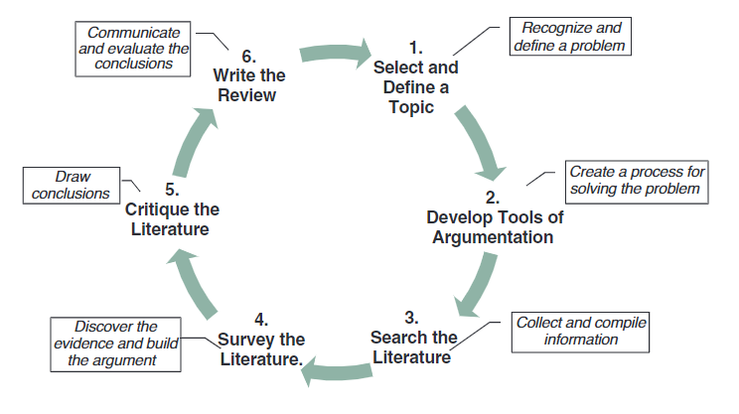
Figure 1 – The Literature Review Applied Critical Thinking Process (Machi & McEvoy, 2022)

The wellbeing of police staff and officers is fundamental to ensuring that we have the resilience to protect the public at first point of contact and to continue to provide a high-quality service. Within South Wales Police, there are numerous wellbeing resources and services available, see appendix 2. However, staff must feel confident in accessing these services and have confidence that they will be supported and protected throughout the experience.

Despite the availability of services, engagement remains relatively low. This is influenced by several factors, including the perceptions and views of mental health and the environmental culture. Influenced by traditional norms, that reinforce toughness, self-reliance and restrictive emotionality, such norms can contribute to challenges in expressing mental health difficulties particularly amongst males, (Sharp, et al., 2022). Existing literature highlights the importance of addressing these perceptions to improve uptake rates.

Leadership plays a key role in engagement, through promoting awareness and creating the opportunities to access wellbeing services. Actual supportive behaviours of managers both contribute to reducing symptoms of common mental disorders and improving wellbeing among staff, it is suggested that organisational and team-led interventions, including leadership behaviours, are important for promoting mental health, (Petrie, et al., 2018). Supportive behaviours have been identified as key mechanisms through which leadership can protect and promote employee mental health, (Hammer, et al., 2024) Understanding the multi-faceted barriers that prevent engagement and creating an environment that encourages engagement is key. Denial of mental health challenges and insufficient psychological safety can contribute further to non-disclosure, (King, et al., 2021).

This literature review will focus on the first objective within the research framework: identifying the factors that hinder help-seeking and the barriers employees face. By examining these issues, the review aims to contextualise the dynamics influencing engagement. This awareness is essential to shape future strategies, to improve staff wellbeing, maximise capacity and improve police resilience to deliver the service our communities expect.

2.1 Mental Health Within Policing

Mental health within policing is complex, shaped by the role, culture and evolving societal expectations. Officers and staff are frequently exposed to traumatic events, which can heighten the risk of mental health disorders such as depression, anxiety and post-traumatic stress disorder (PTSD). Prolonged and continuous exposure, combined with a culture that historically stigmatises seeking help, can often result in staff feeling isolated (Porter & Lee, 2024).

Historically, policing culture has emphasised maladaptive coping mechanisms, such as alcohol and drug misuse and isolation, rather than engagement with mental health services available (Padilla, 2023). Whilst, attitudes are slowly shifting, barriers remain.

As first responders’ individuals, experience challenges in recognising and supporting those in crisis, exacerbated by limited training specific to recognising mental health issues. Managers are often at the forefront when supporting staff and creating a healthy work environment, however leaders often find addressing mental health challenging, highlighting a need for targeted training to build confidence, (Gayed, et al., 2018). ‘Officers report strong peer support but highlight the need for enhanced multi-agency collaboration and improved training to better manage these situations and reduce the impact on their own wellbeing’ (Lamb & Tarpert, 2019).

In respect of mental health promotion, leveraging men’s social practices and embedding mental health discussions within acceptable masculine frameworks may facilitate more effective engagement. ‘Approaches that incorporate humour or align with men’s identities and social roles have shown potential in reframing help-seeking as less threatening and more acceptable’ (Erentzen, et al., 2018).

A large-scale UK study conducted in 2020 involving 40,299 police staff, found depression to be the most common mental disorder (9.8%), followed by anxiety (8.5%) and PTSD (3.9%). ‘Exposure to trauma within the past six months doubled rates of anxiety and depression and increased PTSD risk six-fold’ (Stevelink, et al., 2020). In 2024 this was reinforced by a Study conducted by the University of Cambridge, who declared that ‘UK police forces are facing a mental health crisis with a record’ 17,752 officers in England and Wales signed off for stress, depression, anxiety, or PTSD, which they state was a 22% increase on the previous year. That nearly 1 in 5 officers and staff exhibit symptoms of PTSD, and 4 in 5 report experiencing low mood or anxiety, with high workloads and poor work-life balance’ (University of Cambridge, 2024)

Research highlights several occupational stressors and personal factors associated with suicidal risk in policing, which include work related stress, exposure to traumatic incidents, shift work, relationship problems and alcohol use. ‘These factors may contribute cumulatively to increased risk, although protective factors and preventative measures can mitigate these effects’ (Chae & Boyle, 2013).

Culture remains a significant barrier to help-seeking. There is a fear that admitting mental health struggles could harm career progression. Gender norms also influence help-seeking. Men are less likely to utilise services often due to stigma and role conflict. ‘Men tend to engage less in mental health service use partly because seeking help is often associated with femininity, which may create a gendered role conflict for men’ (Pattyn, et al., 2015). Research suggests that men opt to take medication over psychotherapy and actually hold more stigmatising attitudes, including shame and blame: ‘Males with affective, anxiety, or substance use disorders have lower odds than females of consulting health professionals or using self-management strategies’ (Harris, et al., 2016).

Women in general seek support more than men, but patterns can vary by social role and employment status. It is argued that employment status influences service use differently by gender, with working women, more likely to use psychological services, while working men may be less likely to use general or psychiatric services. ‘These patterns suggest that societal norms linked to professional roles affect decisions to seek care’ (Drapeau, et al., 2009).

Gender differences in help-seeking are shaped by social norms, stigma, service preferences and cultural expectations. Men tend to be less likely to seek support and face increased attitudinal barriers than women (McKenzie, et al., 2018).

2.2. Culture

Understanding cultural dynamics is crucial to understanding attitudes towards help seeking. Factors which can influence decision making such as guilt, perceptions of letting others down and strong camaraderie within policing can all influence help-seeking behaviours. Gender may play a key role in this decision making, as women and men may perceive mental health differently due to societal expectations (Hurless, et al., 2025). Organisational practices, such as being overlooked for promotion, can often reinforce a culture of silence and stigma. Additionally, generational changes and developing societal norms can further determine attitudes.

Cultural identity influences mental health perceptions through acculturation (adopting mainstream norms) or enculturation (retaining original cultural values). Literature indicates that racial or generational identity may not strongly predict help-seeking behaviours, cultural values and gender continue to exert significant influence (Hurless, et al., 2025).

Culture and gender interact in complex ways to shape mental health attitudes and behaviour. Effective interventions must seek to address both dimensions to reduce disparities and foster support.

2.3 Organisational / Colleague Perception

Police culture significantly shapes attitudes towards seeking mental health support. A dominant masculine culture within policing promotes resilience and self-reliance, creating stigma around help-seeking and limiting perceived organisational acceptance (Meek, 2024). This environment fosters fear of being seen as “weak or incompetent”, deterring employees from accessing psychological services (Demirkol & Nalla, 2019). Concerns about confidentiality and the impact speaking out may have on career progression are worrying. Staff fear that seeking help could result in being labelled “unfit for duty” reinforcing avoidance behaviours (Demirkol & Nalla, 2019). Research indicates that male officers and staff experience higher self-stigma than female colleagues even though general attitudes toward help-seeking remain similar (Loynd, 2022).

Police officers and staff are often the first to respond to some of society’s most traumatic events, yet cultural norms often discourage seeking support. Masculinity contest culture explains these behaviours and their influence on turnover intentions (Goodijohn, 2023).

Existing studies reveal inconsistencies in help-seeking across forces, highlighting the requirement for a comprehensive review of cultural and institutional dynamics driving these barriers.

2.4 Leadership and Perceived Support

Effective leadership can set the tone and culture of the organisation. Supportive leadership, where staff feel safe and empowered, fosters trust and encourages help-seeking. It can be linked to positive outcomes such as enhanced psychological health and reduced stress, (Shabalala & Chitamba, 2026) Conversely, a lack of accountability and unrealistic expectations can create cynicism and discourage staff from speaking out. Research suggests that perceived gaps between the support offered, and the actual individual experience can impact employee confidence to engage. Supportive leadership has also been found to be a ‘facilitator of resource accumulation that enhances employee resilience and wellbeing’ (Shabalala & Chitamba, 2026).

Leadership within organisations significantly influences mental health support-seeking behaviours, with gender-specific nuances evident in research. For example, "women who had male supervisors reported less organisational support, which may indirectly affect their likelihood to seek mental health support" (Konrad, et al., 2010).
Additionally, women in male-dominated units or organisations led by men reported more experiences of gender harassment and discrimination, factors that can discourage accessing support services. In contrast, for men, "gender composition and leadership gender were unrelated to outcomes such as perceived fairness or discrimination", suggesting leadership impact differs by gender (Konrad, et al., 2010).
One study found that male subordinates with female supervisors tended to have more trust in leadership compared to males with male supervisors and females with female supervisors, (Garcia-Cabrera, et al., 2023). There is extensive academic research around how supervisor gender can influence staff development however there is limited research around whether supervisor gender influences the reporting of mental health concerns.
Visible and caring leadership at all levels, has been associated with better access and use of support services (Clarkson et al., 2023). This highlights that leadership style and communication strongly influence employees’ willingness to seek help. Similarly, Poddar and Chhajer, 2024 highlighted that leadership advocacy and strengthening the role of leaders as an important aspect of fostering psychological safety and encouraging disclosure of mental health challenges. This highlights that effective and strong leadership can create an environment conducive to help-seeking, though gender specific effects remain unclear.
Overall, while leadership quality and gender composition appear to impact women’s perceptions of organisational support and experiences related to mental health, evidence for a direct effect on men’s help-seeking behaviour is limited. Leadership that is visible, supportive, and actively promotes mental health may facilitate support-seeking across genders, but women may be more sensitive to leadership gender and organisational dynamics.

2.5 Reporting Procedures and Support

Assessing the effectiveness of reporting mechanisms is critical in shaping the reporting landscape. Systems perceived as inadequate or lacking confidentiality can make reporting feel futile. Establishing organisational values and transparent reporting measures can alleviate concerns. However, "even the most transparent systems may fail if they are not supported by a genuine commitment from leadership to support" South Wales Police, HIVE Survey, 2025. If employees perceive a disconnect between policy and practice, their willingness to seek help may not improve, indicating that structural changes alone are insufficient without a cultural shift.
Continuous learning and awareness are essential. Employees are more likely to report when they are familiar with the process. Training alone may not address the issue; bespoke methods of outreach and addressing underlying cultural issues are necessary. While progress within SWP is commendable, it raises questions about sustainability and long-term impact. "The distinction between participation in training sessions and awareness in comparison to taking the step to seek support remains a challenge" (South Wales Police, HIVE Survey, 2025). This supports the argument for continuous evaluation and adaptation of training programs to ensure effective implementation and high uptake.
The availability and adequacy of social support influence mental health differently across genders. "Female officers reported higher availability of social interaction and attachment but also experienced poorer mental health when the adequacy of attachment was low". Conversely, "single male officers with low work-related social support showed poorer mental health" (Hanson & Padyab, 2023). This suggests that communication about mental health resources should consider these gender-specific nuances to be effective.
In conclusion, ensuring police staff know what mental health support is available is vital and may require gender-sensitive approaches. The relationship between social support and mental health varies between male and female employees, so tailored communication and support strategies are essential to foster a work environment that encourages officers to seek assistance when needed.

2.6 Emotional and Psychological Consequences

Unaddressed mental health issues among police employees have serious implications for individuals and organisations, such as reduced productivity, low staff morale, absenteeism, and increased turnover. As Shah (2024) notes, ‘organisations often misattribute burnout to individual failings rather than systemic factors,’ hindering effective intervention.
Sickness absence is notably high among UK police staff. A study of 40,343 employees found that 54% reported sickness absence in the previous year, with 8% experiencing long-term absence (20+ days). Higher absence rates were linked to factors such as female gender, non-uniformed roles, poor mental health, and high job strain (Parkes, et al., 2024).
Absences due to psychological illness and stress have nearly doubled over a decade, reaching 8.82%, with 39% of affected staff taking repeated absences (Cartwright & Roach, 2021). Between 2019 and 2023, some forces reported over 200% increases in occupational health referrals for psychological illness (Quin, 2024).
Psychological health-related absences among police employees are rising and exceed general workforce norms. Risk factors are well-documented, and the consequences of inaction are severe. A "culture of silence" fosters stigma and internal conflict, reducing job satisfaction and increasing attrition. This underscores the need for systemic reform that prioritises engagement and support to create a healthier organisational culture.

2.7 South Wales Police Wellbeing Strategy

The South Wales Strategy, created within South Wales Police supports the literature and recognises the impact and importance of supporting staff and maintaining a healthy workforce. South Wales policy highlights the ambition of keeping communities safe through maintaining a healthy, engaged, and resilient workforce, see Appendix 1.
The objectives of the Strategy, refer to the impact and need to maintain resilience, recognising as per the literature that absenteeism is rising and impacting upon the resilience of South Wales Police to deliver the service. Similarly, the strategy recognises that individuals will continue to present for work whilst ‘suffering in silence’ with a recognition that there is a need to change and impact the culture through strong leadership to ensure employees feel safe to report and embedding a healthy culture, see Figure 2.
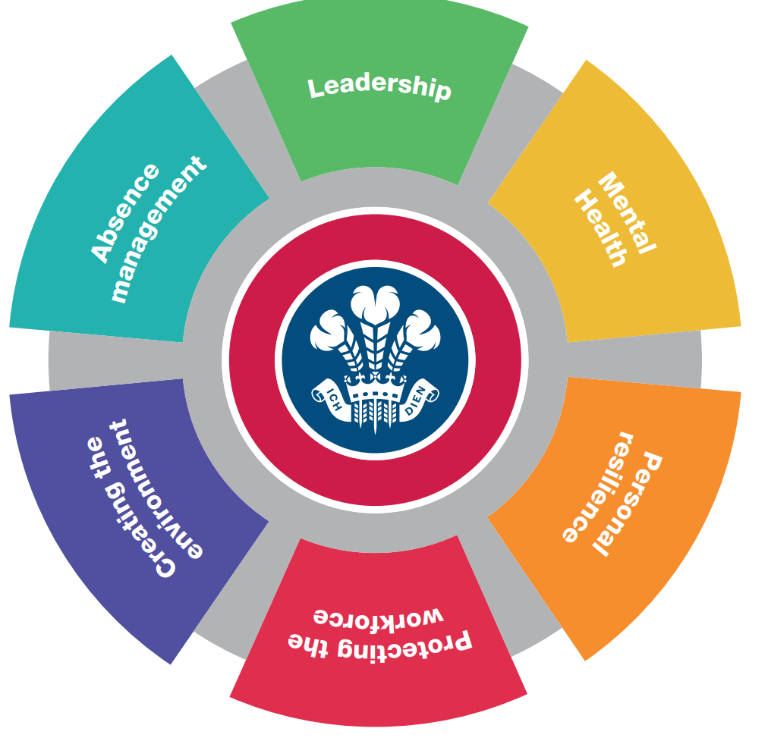

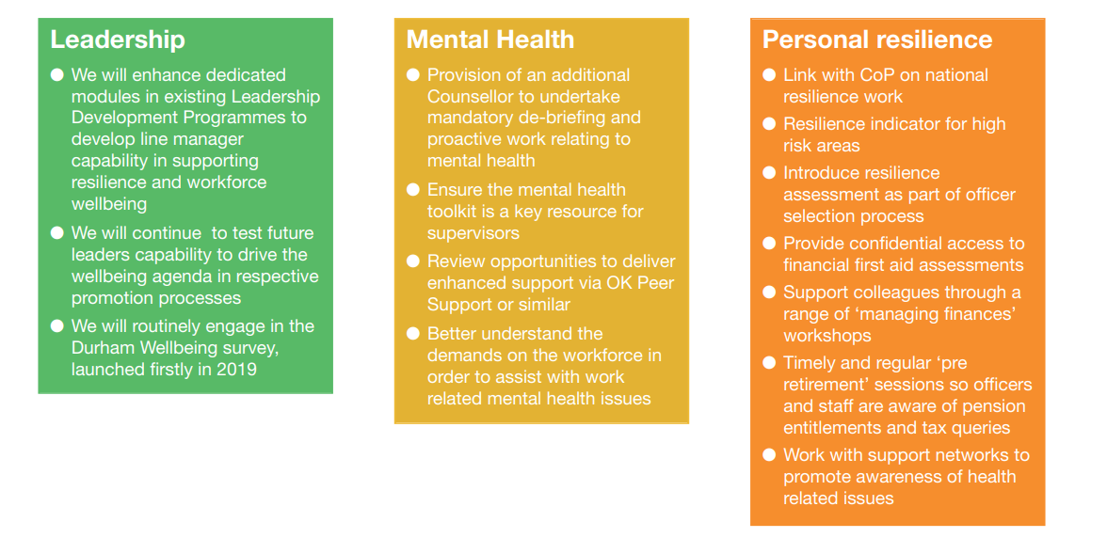
Figure 2- Wellbeing Strategy SWP (2025)
Whilst the policy reflects findings identified within the literature review, it does not adequately recognise the importance of understanding the needs of individuals directly affected. There is no evidence that their views were actively sought to inform what support or provisions they would require as emphasised by Murphy (2023). Although South Wales Police engaged in internal consultation with key stakeholder, this did not extend to those impacted by the policy itself. The omission risks creating a perception that the policy was implemented to individuals rather than with them, demonstrating a gap in its application.

2.8 Summary
Gender remains a significant barrier to help-seeking within policing, shaped by organisational culture, psychological factors, and operational pressures. Despite well-intentioned policies, current wellbeing initiatives often fail to achieve their objectives. Understanding these complexities requires a reassessment of existing strategies and the development of targeted approaches to foster a more supportive police culture.
Further research is needed to examine the confidence and willingness of SWP personnel to report concerns. This gap raises critical questions about how organisational values and policies influence help-seeking and how victims’ experiences are acknowledged. Exploring local perceptions will provide valuable insights into the interplay between employees, victim experiences, and reporting behaviours.
The next phase of this study will detail the research methodology, including strategy, data collection techniques, and researcher involvement. The aim is to generate evidence-based recommendations to inform policy and training, improving accessibility and effectiveness of support and creating a resilient workforce.

Chapter Three
Research Methodology

3.0 Introduction

Within policing, mental health challenges present a significant concern, influencing recruitment, public perception, and the force’s ability to deliver daily business effectively. To explore this issue, this chapter adopts an action research approach, which is defined as "an approach to research that emphasizes the active participation and leadership of people who are directly experiencing the issues under investigation" (Cornish, et al., 2023). This method is appropriate as it is recognised for its participatory nature and its focus on seeking change, (Baum, et al., 2006), ensuring that those impacted can participate in seeking change. The methodological framework for data collection is therefore designed to address objectives two, three, and four as outlined in the introduction.

3.1 Research Strategy
Research can be understood through various perspectives. (Gomez-Diaz & Recio, 2022) identify research as a process which gathers information to answer specific and defined questions. Another perspective focuses on research quality and methodological rigor, noting that research is often assessed within relevant paradigms (Hostler, 2024). For example, a narrow definition of research quality may privilege ‘quantitative, confirmatory research grounded in scientific realism’ but potentially, disadvantaging other approaches such as ‘constructivist or qualitative research’ (Hostler, 2024).

The diversity of definitions highlights the complexities involved in research. Research according to Cohen and Manion (1980) is defined as that which ‘employs empirical methods and empirical statements. Cohen further states that an empirical statement is defined as a descriptive statement about what “is” the case in the “real world” rather than what “ought” to be the case (Cohen, 1980).

The concept of strategy is often viewed as ambiguous and subject to interpretation across academic and practical contexts. Cory (2024) notes that the term ‘strategy’ is often used interchangeably with several distinct concepts which ‘complicates its clear definition and application’. The lack of clarity can result in inconsistent approaches, making it vitally important to establish a precise understanding of the process.

A well-defined research strategy must align with the wider organisational framework and not operate in isolation. This means integrating business, product, and technology strategies through roadmaps that convert plans into actionable, adaptable operations. Effective strategies should remain flexible to ‘accommodate change or setbacks, rather than being rigidly fixed’ (Talonen & Hakkarainen, 2008). Clear alignment between the research strategy and the research aims and objectives ensures a focused direction and supports systematic exploration of the research question (Biggam, 2017).
This study applies both a research strategy and research methods, with distinct yet interconnected concepts (Scribbr, 2021). It adopts the ‘Research Onion’ framework to structure the methodology, as shown in Figure 3.

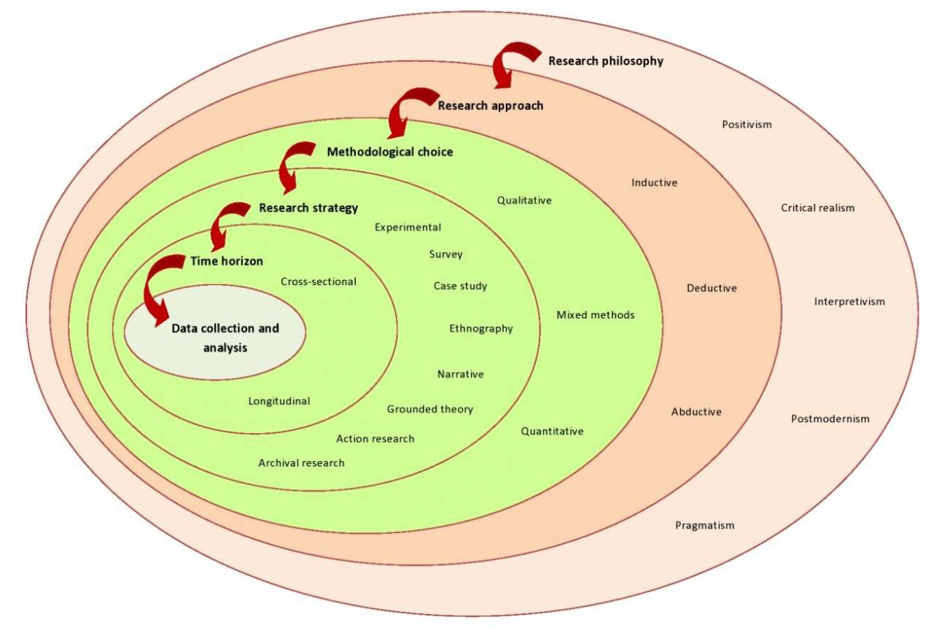

Figure 3 – Research Onion Framework
(Tengli, 2020)

The Research Onion Framework provides a ‘building block’ from which to work from, ensuring that there is clear line of sight, between the research title and the proposed data gathering methods to address it. Providing a consistent approach ensures there is systematic advancement in managing the complexities inherent in understanding mental health amongst first responders, and the impending factors that can influence help-seeking such as gender.

As outlined earlier, the research will be underlined by both interpretivism and pragmatism. Interpretivism allows for the understanding of subjective experiences and gendered stigma among emergency personnel, it is a theoretical approach that ‘emphasizes understanding human action through interpretation rather than solely through natural science methods’ (Matta, 2015). Pragmatism is a philosophical perspective, that emphasises ‘the practical consequences and effects of concepts and beliefs as central to their meaning and truth’ (Schoneberger, 2016). Both methods advocate for the inclusion of qualitative and quantitative methods to investigate extensively the research question.
An abductive approach will be utilised, commencing with the observation of stigma and help-seeking behaviours. An abductive approach refers to a form of ‘reasoning that involves formulating the most plausible explanations for observed phenomena’ (Dellsen, 2024). It is often seen as a systematic approach that aims to identify the nature and purpose of explanations, (Pietarinen & Stanley, 2025). This approach will allow for the identification of any emerging patterns or trends.
The concurrent mixed methods approach, outlined by (Creswell, 2003), explores quantitative and qualitative phases concurrently. There are three types of concurrent mixed methods design: concurrent triangulation, concurrent nested and concurrent transformative’ (Hanson, et al., 2005). A concurrent triangulation mixed methods design will be adopted for this research. Concurrent triangulation, as described by Adu (2023) and Hanson et al (2005), involves collecting both types of data, with equal priority, and then determining whether both methods have yielded similar findings.
“Quantitative method is a research tool used to help measure variables or quantify observations” (Adu 2023). Quantitative research explains phenomena by collecting numerical data that are analysed using mathematically based methods” (Aliaga & Gunderson 2002). This will form part of the research.
Additionally, correlation analysis will examine relationships between variables such as gender, stigma perception, help-seeking behaviour, and length of service. In respect of quantitative data, a survey strategy will be developed, distributing Likert-scale questionnaires online to a broad range of emergency service staff. The questionnaires will seek to measure stigma, help-seeking behaviours and attitudes and the perceived gender norms. Descriptive statistics will then be utilised to analyse the data. Descriptive research is a qualitative approach that provides straightforward summaries of phenomena in everyday language, (Doyle, et al., 2020).
Qualitative data refers to information that is collated to explore variables and phenomena that are not predetermined, (Khoa, et al., 2023). It requires careful analysis and reflection to generate understanding and theory (Maher, et al., 2018).The qualitative data for this research will be collected via qualitative questions within the questionnaire. This will explore experiences, stigma, barriers to seeking help and any ingrained cultural influences.
Data will be analysed using thematic analysis, which is a qualitative data analysis method focused on identifying, analysing, and reporting patterns or themes within data, (Kiger & Varpio, 2020).
Secondary data from existing statistics, including HR data and gender-specific mental health support uptake will be reviewed to contextualise the findings and to identify any trends or patterns. A cross-sectional approach will be utilised, with information being assessed at a single point in time, to capture current attitudes and behaviours. Informed consent will be obtained from all participants, with confidentiality and anonymity of participants maintained.
Questionnaires were distributed to all control room and front desk staff, which included both Staff and Officers. This totalled 452 employees. Determining an acceptable sample size for preliminary analysis in questionnaire is dependent on the specific study, however it is accepted that for a pilot a minimum of around 30 respondents is often recommended, (Bujang, et al., 2024). Fugard and Potts indicate a broad range of between 2 to 400. ‘However, whilst Fugard and Potts offer a quantitative starting, researchers should consider the nature of their thematic analysis and conceptualisation of themes when deciding on sample size’ (Braun & Clarke, 2016).

3.2 Research Philosophy
There are four main research paradigms explored within research philosophy, with this research being set within pragmatism and interpretivism. ‘Pragmatism as a primary philosophical framework is characterized by its focus on the practical consequences of concepts and the use of meaning in context, rather than abstract’ (Santoro & Penco, 2012). Further work by Peirce distinguishes pragmatism from psychologism by grounding its phenomenological categories, providing a structured yet flexible philosophical foundation, (Hookway, 2012). Pragmatism as a primary philosophical framework reinforces the ‘contingent, practical, and evolving nature of knowledge and truth’ (Christensen, 2022).

Within this research pragmatism serves as the primary philosophical framework, emphasising diverse methodologies to effectively investigate sensitive and complex issues such as mental health. This aligns with the research aim to explore and understand the dynamics affecting the willingness of SWP employees to seek help.

It is vital to recognise that each respondent’s experience of mental health and help-seeking is individual and unique to that person. That their perspective is built upon their experience and therefore their reality of the situation is individual. Reality can be understood as a ‘pattern of relations that perpetuate over time’ (DeWiel, 2013).

‘Constructivist epistemology views knowledge as actively constructed by learners rather than passively received, (Kumar, 2018). Adopting a constructivist epistemology will allow participants to share their lived experiences. Ensuring anonymity in the responses provides reassurance and creates a supportive environment where respondents can actively express their views through qualitative questioning.

The quantitative research approach is often grounded in the positive paradigm. This assumes that ‘social phenomena can be measured and analysed similarly to natural phenomena’ (Maksimovic & Evtimov, 2023). The positivist paradigm aims to find ‘universal truths through empirical observation and measurement’ (Carminati, 2018). The focus on objectivity and replicability can also improve clarity of research findings. The paradigms focus on ‘measurable variables and statistical analysis support the identification of patterns and relationships that might not be apparent through qualitative methods alone, (Maksimovic & Evtimov, 2023). However, criticism of positivism, recognises the inflexibility regarding absolute objectivity. That it tends to ‘disregard the influence of the researcher’s perspective and the contextual factors that shape social phenomena’ (Ayat & Nusratullah, 2025). Whilst it offers enlightening perspectives its recognised constraints require a more concentrated approach. This research prioritises interpretivist.

This study prioritises interpretivist qualitative elements to provide a comprehensive understanding of the subjective factors influencing help seeking. The research philosophy shapes the chosen methodology to gather a robust understanding of the research topic.

3.3 Research Approach
Inductive methodology refers to an approach where conclusions or theories are developed based on the analysis of empirical data, moving from specific observations to broader generalisations’ (Bendassolli, 2013). Inductive research generally includes formulating concepts based on the data, rather than starting from an established theory, (Barroga, et al., 2023). It generally provides a systematic approach to reviewing raw qualitative data into summary, and establishing clear links between research objectives and findings, and develop frameworks that represent underlying experiences, (Thomas, 2006). However, it is recognised that this approach may not be as strong as some analytic strategies for theory or model development.

In contrast deductive methodologies refer to an approach that starts with an existing theory or hypothesis, which is then tested or applied to data to confirm, refine or expand the theory, (Fife & Gossner, 2024).

Both approaches present an opportunity to gather and present detailed information. Inductive reasoning is a cognitive approach involving existing data, that allows for inferences or predictions to be made from the available information. This form of reasoning projects from what is known to what is not known, allowing generalization, (Heit, 2000).

In contrast, deductive reasoning is a cognitive approach through which conclusions are logically derived from given premises or rules, which is considered a foundational skill that supports everyday problem solving and is believed essential for acquiring more advanced logical expertise, (Johnson-Laird, 1999).

To address the research question, both research approaches were utilised, forming the foundation from which the conclusions and recommendations were derived. The deductive approach was depicted in addressing objective 1, following an extensive literature review. Objective 2 and 3 was addressed using the inductive approach, generating theories and concepts from data gathered.

Quantitative and qualitative primary data was obtained via staff questionnaires, to gain a thorough understanding of the respondent’s views of the mental health support available and their thought and feelings regarding help-seeking. Utilising this approach allows for evidence to be gathered and recommendations to be made. By utilising inductive and deductive reasoning, insights and theories from the collected data can be drawn.

This multidimensional approach allows for extensive data to be gathered while supporting the overarching goal of fostering a greater understanding of mental health reporting and help-seeking.

3.4 Methodical Choices

The preference of research methodologies is enlightened by the six layers of the research onion strategies Saunders et al, 2019. The primary research is survey research.

Survey research is a methodological approach, which is utilised to gather data that reflects societal changes by gathering information from individuals. It involves creating surveys to obtain responses that can be analysed to understand patterns, attitudes, or behaviours within a population, (Tourangeau, 2004).

The design phase of the survey is crucial to ensure that it effectively addresses the research objectives. Technological advancements have introduced new methods of data collection. Whilst these offer advantages, such as cost-effectiveness and timeliness, (Evans & Mathur, 2005), it is also recognised that it presents challenges such as non-response errors, confidentiality concerns and technical difficulties, (Sills & Song, 2002).,

Action research is a methodological approach, that combines both the creation of knowledge and practical action. It is characterized by its cyclical process of planning, acting, observing and reflecting to address problems whilst also gaining actionable insights, (Guy, et al., 2020). In respect of the research topic this will allow the respondents to outline the problem as to why take-up rates are low in help-seeking and the challenges that are faced. It will also allow them an opportunity to discuss possible solutions designed to enhance individual help-seeking. By combining methodologies, the research addresses the complexities of help-seeking. This framework encourages respondents to share their lived experiences and to actively be involved in proposed solutions.

Quantitative data collection methods, via the use of questionnaires, were employed to gather information regarding the confidence and willingness of SWP employees to seek help and report poor mental health. This quantitative approach enables the analysis of statistical data and reporting behaviours across SWP.

However, by engaging respondents through a comprehensive, exhaustive and well-designed questionnaire, the research provided an opportunity to explore their experiences, thoughts and views regarding reporting and seeking help for poor mental health and to identify the challenges and barriers faced.

3.5 Time Horizon
‘A cross-sectional time horizon involves collecting data at one or over a limited period to provide a snapshot of the research subject, (Vasconcelos, 2020). A cross-sectional time horizon will be adopted, allowing for a dedicated examination of the factors influencing help seeking at a specific point in time. This approach allows for data collection at a given point in time, in respect of the individuals, views and experiences. It serves as a tool for evaluating practices and data availability, (Prager, et al., 2020).

Cross-sectional data can often effectively be paired with longitudinal data to enhance understanding of dynamic processes. Longitudinal studies are observational or interventional research design in which individuals are tracked over a set time to observe associations between exposures and outcomes, (Prager, et al., 2020).Whilst longitudinal studies offer greater insights into changes and developments over a sustained period of time, they also present numerous drawbacks and challenges. One limitation being the sheer complexity and difficulty in conducting such research. They often need significant time for data collection, which can lead to issues such as participant attrition or changes in technology that lead to issues that affect data retrieval, (Kuula & Putkiranta, 2012).

The cross-sectional data collection within this research allows for data to be collected within a narrow time frame, making it possible to analyse the results from a large data pool of 97 respondents. This allows for meaningful data to be collected within set parameters. Longitudinal research was not possible within this research given the time constraints.

3.6 Data Collection – Techniques and Procedures
Structured questionnaires offer several benefits, such as standardised data collection which can improve the accuracy and completeness of the information gathered, (Payne, et al., 2017). Additionally, structured questionnaires, especially when digitised, can enhance data quality and participation, (Heiervang & Goodman, 2011). Structured questionnaires were designed to gather measurable insights into help-seeking behaviours using Microsoft Forms.

Anonymising questionnaires offer numerous advantages, primarily protecting the confidentiality and identity of research participants. Anonymisation helps safeguard respondents against discrimination or harm that could arise from disclosure of sensitive or personal information, (Jamal, et al., 2014).It also facilitates data sharing and fosters trust and participation in research. The questionnaire allows for statistical data to be obtained from the
targeted participants.

The questionnaires allowed employees with varying lengths of service and gender with diverse experiences of mental health seeking, to provide views ensuring a representation from a cross-section of staff.

Questionnaires traditionally, include two types of questions, open-ended and closed-ended.
Open-ended questions allow respondents to provide free text which can create an opportunity for respondents to reveal new issues that perhaps had not been considered or captured by the researcher. However, they can also present challenges in analysis and reporting due to their ambiguous status between qualitative and quantitative data, (O'Cathain & Thomas, 2004). Closed-ended questions in comparison can provide pre-defined response options, facilitating easier quantification and analysis, (Stefkovics, et al., 2025). Each however serve distinct purposes and present different challenges, both open and closed questions have been chosen for the questionnaire having considered the goals and the respondents.

Likert questions are structured questions designed to capture ‘the intensity of respondent’s attitudes or opinions through ordered response categories, (Ferrando, et al., 2025). Such questions can vary in the number of response categories. Likert questions were utilised throughout the questionnaire to obtain quantifiable data, from which trends and patterns could be drawn out, thus gathering a clear picture of staff thoughts and feelings regarding help-seeking and the barriers presenting.

Throughout the research a conscious decision was made to utilise both primary and secondary data as each has a clear purpose and role. Collecting primary data through questionnaires offers several operational and methodological advantages, providing time efficiency and cost-effectiveness, (Bolaji, et al., 2025), it also provides essential awareness of respondents views and experiences regarding help-seeking, ensuring that the findings are contextually relevant and current.

Conversely, secondary data from existing sources offers several benefits. The growing accessibility of data, supported by efforts to develop open and well-maintained datasets along with advances in statistical software, has made secondary data analysis more feasible and attractive for researchers, (Rodriguez, 2021). Utilising existing secondary data affords the ability to address new questions or critiques as per this research top. It allows an opportunity to assess current views and feelings against tangible historic data. This two-pronged approach allows for a greater situational awareness within the broader discourse on police help seeking specific to gender.

3.7 Data Analysis
Data analysis involves ‘examining, processing, and interpreting data to uncover hidden patterns, relationships, and insights that support decision-making and predictions’, (Kotu & Deshpande, 2015). Data analysis is a multi-faceted process, that involves ‘data preparation, application of statistical and machine learning methods, and interpretations of results to inform decisions across different domains’ (Grady, et al., 2023).

Data analysis can be categorised into several types. The main categories include ‘descriptive, explanatory, inferential, qualitative analysis, and specialised methods’ (Taherdoost, 2020).

Descriptive analysis involves summarising and organising data. It plays a vital role in study analysis by ensuring data is easier to understand and interpret, (Harbison & Simmons, 2024). In contrast, qualitative data analysis is a ‘systematic, iterative process focused on identifying patterns and themes with qualitative data to provide meaningful descriptions and potentially develop theory, while addressing methodological rigor and practical challenges’, (Flick, 2013).

The data gathered through the questionnaire process must be evaluated, to ensure that it is completed correctly. The data is then analysed via Microsoft Forms software, allowing for a variety of statistical methods, including descriptive statistics to summarise the data to identify correlations and patterns.
Qualitative and quantitative data analysis differ in their nature, purpose and methodological approach. Qualitative data analysis focuses in uncovering new aspects hidden within the data, interpreting meanings and patterns (Schoonenboom, 2023). In contrast, quantitative data analysis deals with numerical data.
The two approaches differ in their aims, qualitative research seeks ‘depth of meaning’ whereas quantitative research emphasises ‘objectivity and generalizability’ (Sandelowski, 2000).
Statistical data refers to the process of ‘examining data to discern patterns, relationships, and insights that can inform decision making and understanding, (Nisbet, et al., 2009). Information obtained from the respondents via the questionnaires, were dissected into core areas, to ensure that the responses could be effectively analysed.
Thematic analysis is a qualitative data analysis approach concerned with identifying trends. A popular framework involves six steps, which guide researchers through ‘data familiarisation, coding, theme development, and refinement’ as illustrated below:

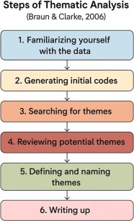
Figure 4 – Steps of Thematic Analysis - Braun and Clarke, 2006

Braun and Clarkes six step framework is widely recognised. The first stage involves familiarisation with the data to have a detailed understanding of the content, recognising any patterns. This sets the groundwork for subsequent coding.
The second stage of analysis is coding, systematically identifying features of the data relevant to the research topic. This coding ‘is not merely mechanical but involves interpretive engagement with the data’, (Campbell, et al., 2021).
The third stage constructing themes, ensures that the codes are determined into broader patterns that capture the data. This process is ‘iterative and reflexive, allowing themes to evolve as understanding deepens’, (Campbell, et al., 2021). The fourth stage involves checking the consistency of themes, to ensure that the accurately reflect the data. The fifth stage, defining and naming themes, focuses on articulating accurately each theme and how it aligns to the research question. The sixth and final stage, involves combining the ‘analytic narrative and data extracts to present a coherent and persuasive account of the findings’ (Campbell, et al., 2021).

3.8 Ethics
Ethical behaviour is essential as it reflects norms, standards and values that ensure respectful and responsible interactions amongst individuals, (Al Halbusi, et al., 2021). Leadership has been shown to influence ethical behaviour. Ethical leadership positively impacts employees ethical conduct by establishing an ethical climate within organisations, (Mehra & Narwal, 2025). Ethics are key to this research.

Throughout, compliance with the University of Wales Trinity Saint David, Research Ethics & Integrity Code of Practice (2022) is scrutinised. The submission of an ethics form and subsequent approval is a key component prior to commencing research.

Given the sensitive nature of the research, ensuring confidentiality was vitally important. Respondents were made aware of their purpose and role and that their involvement would be anonymous. Mental health is recognised as a sensitive topic, talking about it can have an impact on individuals which is recognised. To reduce the risk of triggering staff, support networks were made available, when the request for completion was sent. Similarly, staff were advised that completing the questionnaire was optional and at any point they could withdraw from the process.

Complying with the General Data Protection Regulation (GDPR) is vitally important for reasons that extend beyond the legal obligation. The development of GDPR platforms aims to support organisations in managing the complex legal and technical requirements, (Issaoui, et al., 2023). All data collected within this research project is securely stored, with access limited to the researcher. All data that is no longer required is disposed of according to data protection regulations.

Having focus on key aspects highlights the commitment to ensuring that ethical research is conducted.

3.9 Limitations
Limitations in research encompass methodological weaknesses in study design and conduct, biases inherent in observational data and practical challenges in data collection, (Munthe-Kaas, et al., 2018). In observational research, limitations often are time related.

Given the sensitive topic, respondents may be reluctant to disclose their true feelings or experiences, thus, they may not respond honestly. Similarly, they may agree with or endorse comments regardless of their true opinion. This is often referred to as ‘acquiescence bias’. Acquiescence bias can have a significant impact as it can distort outcome findings. Additionally, careless responding can impact on findings. Within this research, the fact that the ‘researcher’ is a senior officer could also impact the willingness and openness of respondents to engage truthfully. Respondents may be weary and sceptical around pushing back against current policies and procedures. To attempt to alleviate this risk, it is essential that respondents are aware of the confidentiality and anonymity to encourage openness.

Conducting research within a 24/7 emergency control room, who are operating under high demand can have constraints in respect of respondent’s ability, appetite and time to complete questionnaires, creating an impact on return rates.

The research captures a moment in time, limiting the ability to draw conclusions around sustained patterns and trends. This research could be enhanced through longitudinal research, which offers several benefits that enhance the understanding of changes and outcomes over time, (Evans, et al., 2010).

The next chapter will analyse the empirical findings of the 97 questionnaires and the information gathered.

Chapter Four – Findings and Analysis

4.0 Survey Findings: Description, Analysis and Synthesis

This chapter evaluates the results identified from Chapter three. The investigation centres on research objectives two and three, which sought to:
- Investigate experiences and perceptions of mental health support.
- Analyse how leadership affects help-seeking attitudes and behaviours.
Guided by the framework of Description, Analysis, Synthesis and Evaluation, illustrated in Figure 5, this allows for the systematic evaluation of patterns and trends, (Lewandsowki & Dilworth, 2010).

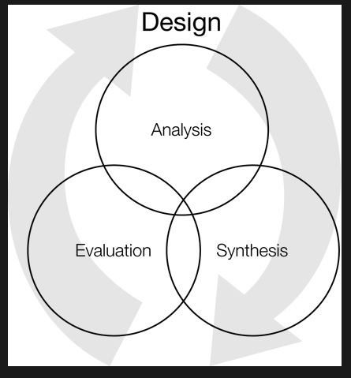

Figure 5 – Description, Analysis, Synthesis and Evaluation

  - Mental Health Within Policing - Problem Profile –South Wales Police

In August 2025, a detailed analysis of Mental Health Sickness absence in South Wales Police was undertaken force-wide with a particular focus on current absence rates and an analysis of mental health absence trends over the previous 12 months. The analysis considered absence trends by gender, see appendix 3.

The analysis also focused on the management of mental health related absences and utilisation of supportive interventions including Occupational Health and Counselling Services.

The report highlighted that the total time lost due to Mental Health Absence:

- Had increased month on month since Feb 2025.

- That the total time lost due to mental health absence had now exceeded time lost to all other absence reasons combined.

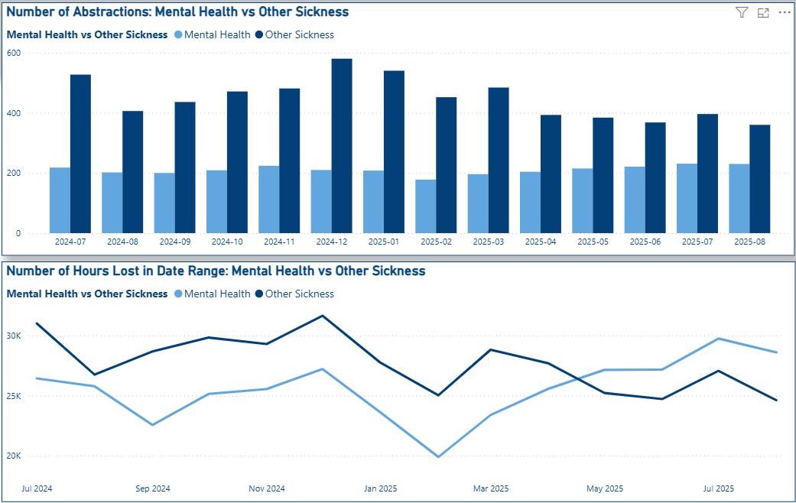

Figure 6 – Number of Abstractions: Mental Health vs Other Sickness

Further to the above findings, it was established that:
- Mental Health absence counted for over 50% of all sickness absences for police officers and 51% for police staff members across the workforce.
- Mental Health absence rates are higher among female officers (61.5% of total time lost due to sickness) vs. males (54.7%)

Within South Wales Police counselling referrals have fluctuated see Figure 8:

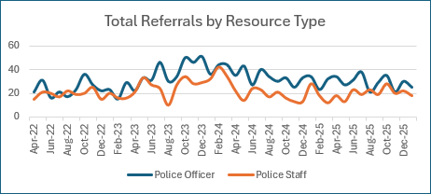
Figure 8 – Total Referrals by Resource Type

The data shows that demand for counselling has remained consistent. This supports the literature review which highlights that whilst consistent, engagement remains relatively low. Whilst referrals remain static mental health sickness continues to increase year on year, in line with the national picture.

The foundation for this report was to explore further the impact gender has on help seeking specifically at the first point of contact within the Public Service Centre (PSC). To review the local findings against the national picture around mental health absence and support.

4.2 Description
The study employed a mixed-methods online questionnaire, distributed via Microsoft Teams, to examine the experiences and perceptions on the influence of gendered stigma on help-seeking behaviours among police emergency service personnel.
A voluntary sampling strategy was adopted, which is a type of ‘non-probability sampling strategy where participants self-select to be part of a study’ responding to an open invitation (Ene-Margit, 2021). This survey targeted all police control room employees, 452 in total. This involved purposive sampling, whereby the selection of the participants’ were guided by the specific aims and objectives of the study rather than random selection’ (Campbell, et al., 2020) The questionnaires were designed to include both closed and open-ended questions (Appendix 4). This allowed for the gathering of qualitative and quantitative data and for the participants to freely express their thoughts and personal experiences.

A deductive approach, utilising research design, hypotheses, and analysis and the findings from evidence and data gathered from sources including HR data and the literature review allowed for a detailed and reliable understanding.

A feedback rate of 97 respondents was attained reflecting healthy engagement with the research topic, see Appendix D. Questionnaire data analysis followed Braun & Clarke, (2006) inductive thematic analysis method, this allowed for ‘themes related to experiences’ to be extracted from the data. Responses were examined comprehensively across key groups including age, gender, rank or police staff grade and service, enabling intricate distinctions and comparisons to be made.

Significantly, the questionnaire compilation was intended to test both conceptual understanding of health seeking as well as capture the views of those that had sought help. This provided an opportunity to establish how lived experiences impacted the confidence and willingness of individuals to report and seek help for mental health worries.

This approach matches the study’s aims of bridging gaps between assumptions and realities.

4.3 Public Service Centre Establishment
The PSC has a current establishment of 452 employees, see appendix 5, of which females account for approximately 75.6% of the workforce and males approximately 24.34%, see Figure 9:

 | Headcount
Female | 342
Male | 110
Grand Total | 452

Figure 9 – HR Employment Data 12.03.25

Nintey-seven questionnaires were returned, a return rate of 21.5% of the workforce. Of the 97 questionnaire responses received from SWP employees, 61 identified as female (13.5%) and 36 as male (8.0%), see Figure 10:

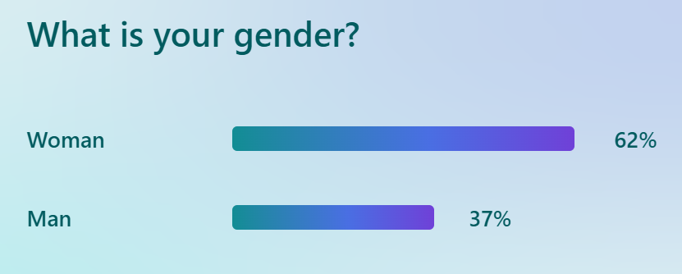
Figure 10 – What is your gender?

Interestingly the gender split among participants closely mirrored the staff compilation in the control room. This somewhat contradicts the literature review that males are less likely to engage. However, it can be argued that the anonymity of the questionnaire encouraged greater participation.

The age demographic of the workforce, as of 12 March 2026, is shown in Figure 11:

 | Headcount
Under 26 | 60
26 - 40 | 170
41 - 55 | 133
Over 55 | 89
Grand Total | 452

Figure 11 HR Data – Age Profile PSC

The age distribution of respondents reflects the demographic profile of the department. Of the respondents, 6% were aged 18-24, 36% were aged 25-39, 30% were aged 40-49, 11% were aged 50-55, and 16% were aged 56 or over.

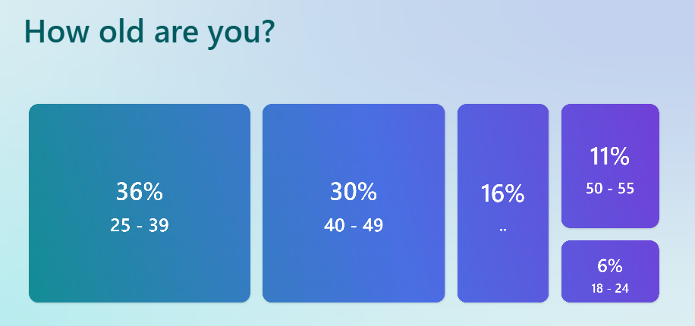
Figure 12 - Age Distribution of Respondents

In terms of roles, most respondents (62%) were police staff members grade 2-5. A further 22% were police staff members grades 6, while 4% were police staff members grades PO1-PO3. Police Officers, ranging from Police Constable to Chief Inspector, accounted for the remaining 4% of respondents, as illustrated in Figure 13:
What is your Rank of Police Staff Grade?
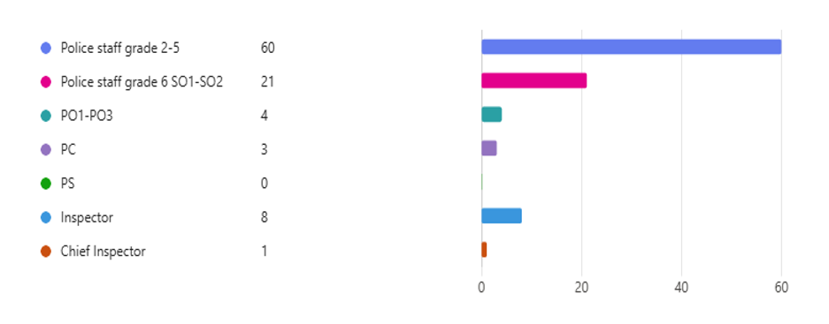
Figure 13 -Grade / Rank of Participants

An analysis of the department identified that the length of service of the department, ranged from under 2 years to 20yrs plus, see Figure 14:

 | Headcount
Under 2 yrs | 108
2 - 5 yrs | 109
6 -10 yrs | 75
11 - 15 yrs | 24
16 - 20 yrs | 40
Over 20 yrs | 96
Grand Total | 452

Figure 14 – HR Data Length of Service

Questionnaire respondents exhibited a broad range of professional experience as illustrated in Figure 15:

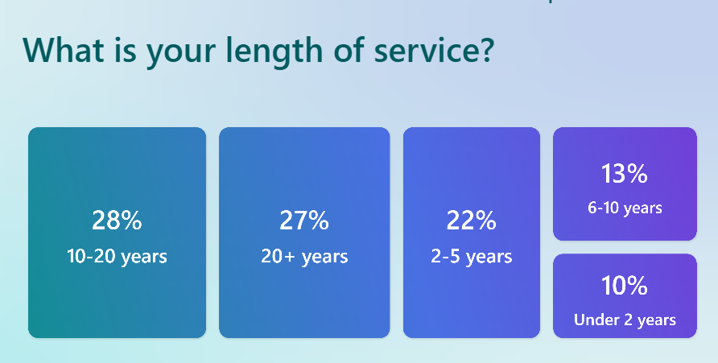
Figure 15 - Service Length of Respondents
Interestingly, this distribution indicates that there is a higher respondent rate amongst those with greater service. This contradicts existing literature which suggests that our younger workforce is more open to discussing mental health. Alternatively, it may indicate that more experienced employees feel greater confidence and security in providing feedback. This insight is important for SWP, as it highlights the potential to foster a more transparent organisation culture, ultimately enhancing trust and confidence.

4.4 Thematic Analysis of Objective 2 – Experiences & Perceptions of Mental Health Support
Having identified the demographics and methodological framework, this section thematically evaluates gender stigma and help seeking amongst emergency service personnel, directly addressing research objective two.

Whilst questionnaires offer a meaningful insight, it cannot be forgotten that the responses may be subject to bias, there is a suggestion that ‘respondents tend to answer based on the positive or negative polarity of questions rather than their specific content’, (Camara-Costa, et al., 2026). Similarly, perceptual questionnaires can be vulnerable to ‘emotional valence, item wording, respondent interpretation and personality traits’ (Hill, et al., 2019) which can also impact the reliability.

The analysis identified numerous organisational challenges that deter individuals from reporting poor mental health within SWP. These obstacles align with the literature confirming that mental health within policing is complex. The data highlights systemic challenges that create organisational barriers and result in under-reporting.

The findings identified an awareness of policy and available support but a need for targeted communication and greater leadership accountability to address perceived awareness gaps. The review highlights the importance of tailoring messages to specific audiences. Concerns related to seeking help, encompass a range of barriers, one prominent concern, is stigma. This stigma ‘is influenced by social support dynamics and coping strategies, as well as how mental health is framed, whether psychologically or biologically, which can either mitigate or exacerbate perceived stigma’ (Talebi, et al., 2016).

4.4.1 Impact of Role on Mental Health
Most respondents across the workforce (59.8%) reported that their role had an impact on their wellbeing and mental health, see Figure 18.
The results indicate that males are more than twice as likely as females to respond ‘No’, this suggests that there are gendered differences in perception and confidence in reporting. In comparison females, are considerably more likely to respond 'Maybe', indicating uncertainty or mixed experiences that may require deeper qualitative exploration. These patterns show organisational-level themes and highlight opportunities for targeted support.
Overall, the data suggests, that there is a widespread perception that the role impacts mental health across genders and that gender does in fact shape how respondents interpret the impact, this is in line with the literature review. Research indicates that males tend to exhibit higher levels of stigma compared to females which may contribute to a reluctance to acknowledge the impact of their role on their mental health, (Bailey, 2021).

Impact of Role on Mental Health
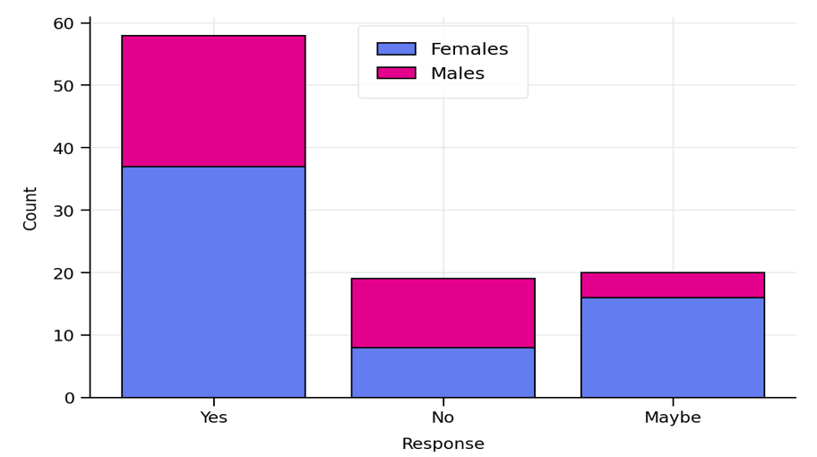
Figure 18 – Impact of Role on Mental Health

4.4.2 Stress Level Analysis
Respondents were asked to rate their stress level, on a scale of 1-10. The results reveal that peak stress levels differ by gender. Female respondents display a bell-shaped distribution centred on moderate stress levels, see Figure 19.

Female Stress Distribution
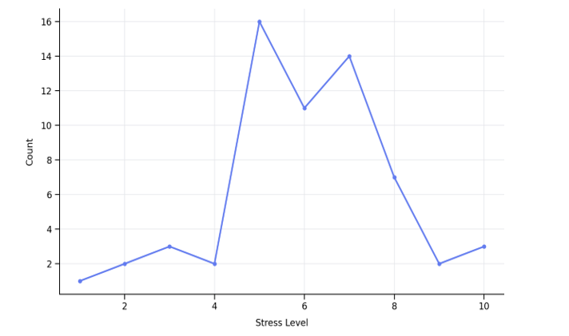

Figure 19 – Female Stress Distribution

Female respondents display their peak stress level at level 5 (16 respondents), with a clustering across moderate to high levels (5-7). Levels 6 and 7 also remain elevated, forming a bell-shaped trend. This implies sustained mid-range pressure across the female group.
In contrast male respondents display a right-skewed distribution with higher stress levels dominating. The peak occurs at level 8 (9 respondents) and shows high-stress clustering, at levels 7-8. This indicates that higher-intensity stress episodes are more common among male respondents, see Figure 20:

Males Stress Distribution
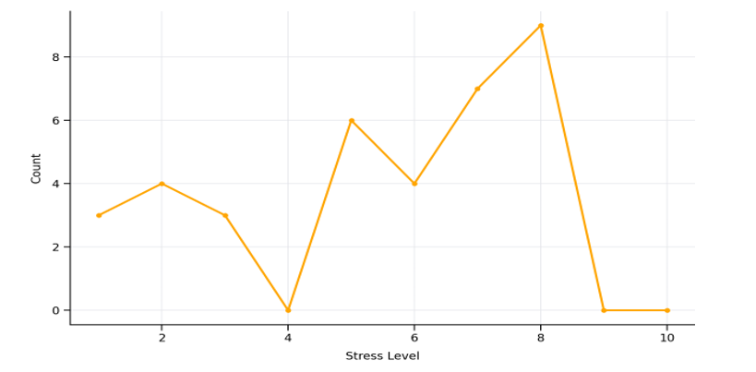
Figure 20 – Male Stress Distribution
When comparing stress levels, females more often report low-to-moderate stress whereby males more often report higher stress levels, see Figure 21:

Stress Distribution Comparison
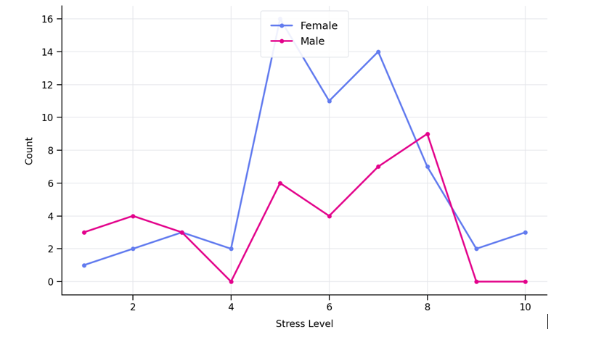
Figure 21 - Stress Distribution Comparison

This indicates differing stress profiles: females tend to experience moderate levels of stress, while males experience sharper, higher-intensity peaks. When supporting females’ wellbeing, consideration should be given to workload balance and sustained support for moderate stress, in comparison if focusing on male wellbeing, it is important that there is focus on burnout prevention and support for managing episodes of high-level stress. This supports the view of Lamb and Tarpert, as highlighted in the literature review which outlines the need for multi-agency collaboration and improved training.

4.4.3 Stress Level Contributors by Gender
The chart below presents a summary of responses across the different stress categories, broken down by gender, Figure 22:
Stress Level Contributors by Gender
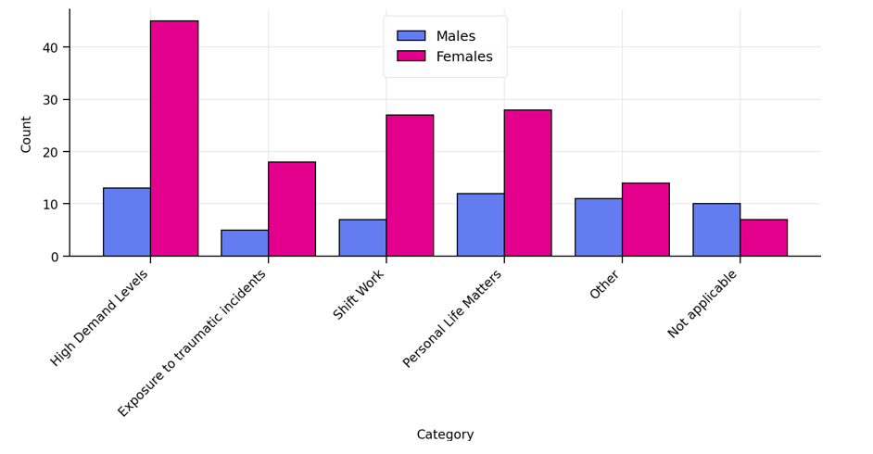
Figure 22 – Stress Level Contributors by Gender

The data illustrates gender-based differences in reported stress levels. Females consistently report higher levels of stress across all key categories. This is particularly evident within High Demand Levels, Shift Work, and Exposure to Traumatic Incidents. In contrast males were more likely to state that certain stressors were Not Applicable, suggesting reduced perceived impact or lower reporting levels.
Possible recommendations to overcome such differences, could involve conducting focused listening groups with female members of staff to improve understanding of the underlying issues affecting them, alongside a review of workloads. Shift patterns should be reviewed to ensure sufficient rest periods between duties, and trauma-informed support and resilience training should be made more freely available.
In addition, the lower reporting trends among male staff should be examined further to identify cultural or organisational blockers that are perhaps influencing engagement.

4.4.4 Role Influence on Support Seeking
Analysis of the questionnaire responses indicates that both the role and the gender of the person undertaking the role, influence the probability of seeking support, see Figure 23. Female respondents were more likely to answer “Yes”, recording 23 responses compared to 12 from males. This suggests that role-related support barriers or motivators may be more pronounced among female staff.
Despite this, the most frequent response across both genders was “No”. Males recorded 19 'No' responses and females 24, indicating that a large portion of staff do not feel their role limits their willingness to seek support, this contradicts the literature review.
Female respondents reported a higher number of “Maybe” responses (14 compared with 5 for males), suggesting greater uncertainty about role-based constraints or differences in experiences within the organisation.
Overall females accounted for a larger proportion of responses, (61 compared to 36 from males), despite this, proportional patterns remain, showing more complexity in the perception of female respondents. Female responses were more evenly spread across all three category areas. This perhaps suggests that female staff may experience role influence as more nuanced or context dependent.
These findings, indicate potential role-related barriers affecting female employees. The higher level of ambivalence among female respondents highlights a need to potentially review role expectations, culture, leadership and the awareness and accessibility of support pathways.

Responses by Gender
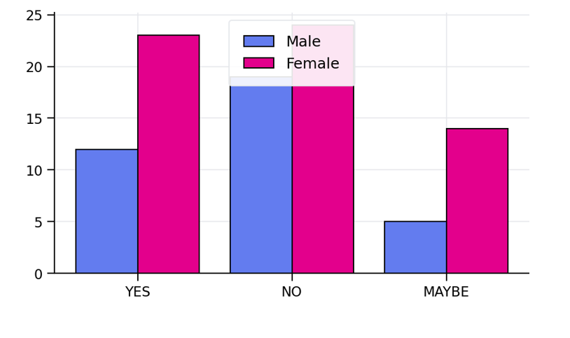
Figure 23 – Impact of Role on Seeking Help – Gender Comparison

4.4.5 Occupational Health Support Awareness
Questionnaire responses demonstrated a high level of awareness amongst staff regarding the occupational health support available to them. Only 14 respondents indicated that they were either unsure or did not understand the support on offer, see Figure 24:

Are you aware of Occupational Health and the Support they can Offer you?
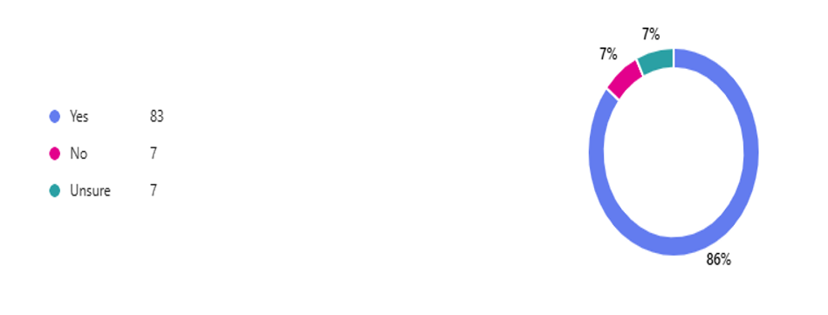
Figure 24 – Occupational Health Support
Interestingly, whilst a significant number of employees understood the support available, the perceptions of the adequacy of the support differed notably. When asked if the support was sufficient only 27 respondents reported ‘yes’ while 58 individuals reported either being unsure or believed the support to be insufficient, see Figure 25:

If you answered yes, is the Support Sufficient?
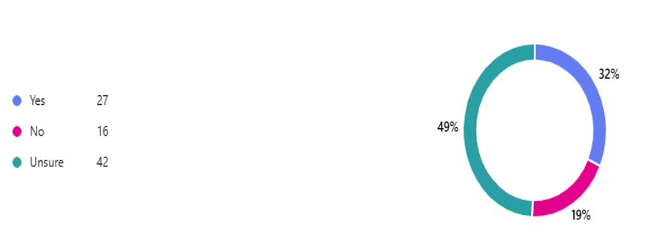
Figure 25 –Occupational Health Support – Is It Sufficient?

The disparity highlights an organisational gap between the general awareness of available resources and the confidence in their effectiveness. These quantitative findings are strengthened by the qualitative analysis, which identified organisational failings relating to the consistency of training, and equity of access to occupational support.
Respondents frequently drew on their own personal experiences, offering an insight into the reality and practicality of seeking support. Furthermore, several respondents raised concerns regarding barriers that were presented when reporting, suggesting that these challenges may undermine the reliability and effectiveness of the reporting framework, these views were supported in the literature review, by Shabalala and Chitamba.
Preferences around the reporting process were also evident, indicating a need to review and adapt existing processes to better meet employee needs.

4.4.6 Occupational Health Support Recommendations
Respondents were asked if they had any recommendations as to how their service could be improved, the below word cloud was created from the responses, see Figure 26:

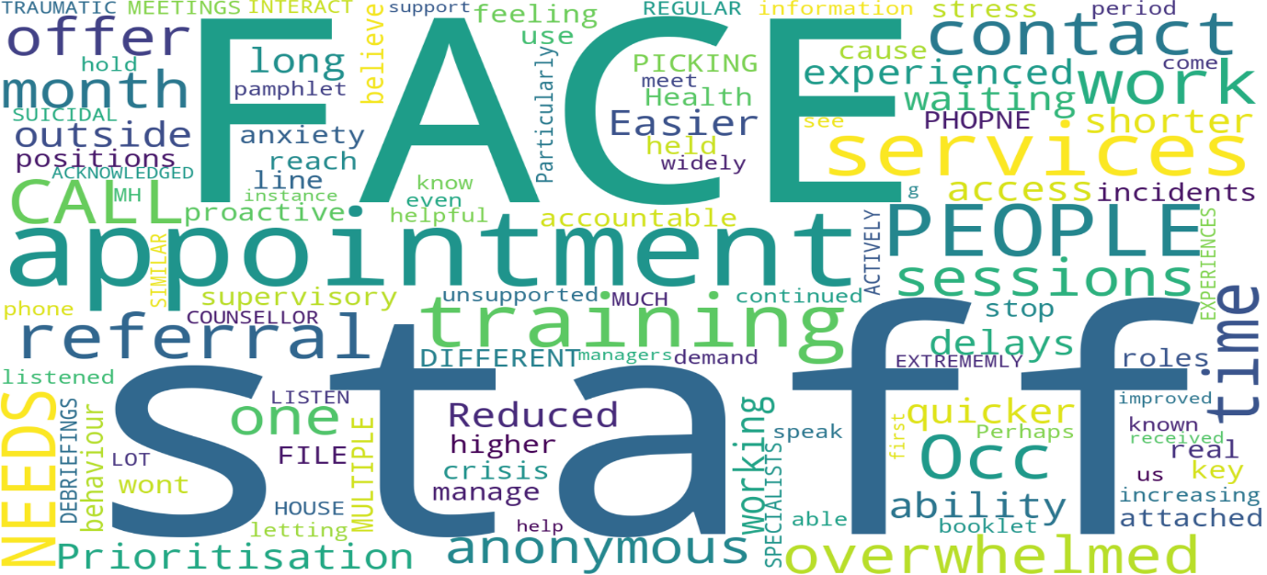

Figure 26 – Word Cloud – Recommendations for Occupational Health Improvement
The recommendations for occupational health improvement highlight several recurring themes through the word cloud analysis, including the benefit of face-to-face support, access to staff wellbeing and mental health specialists, reduced waiting times with quicker access to services, and more pro-active outreach from Occupational Health. Additional priorities include improved accountability and training for managers, increased resourcing greater consistency in provision and ongoing contact with staff, all of which will be documented in the proposed recommendations.

4.4.7 SWP Wellbeing Strategy
Overall awareness of the Wellbeing Strategy was mixed amongst respondents. Out of the participants who took part, 41 people confirmed that they were aware of the strategy, while 38 stated they were not aware. An additional 13 respondents indicated they were unsure, suggesting a level of uncertainty around the visibility and communication of the strategy, see Figure 27.
When analysed by gender, notable differences were evident. 30% of male respondents stated that they were aware of the strategy, compared with 54% of the females who responded.
Conversely 54% of males stated that they were not aware, compared with 35% of females. The degree of uncertainty was also greater amongst males, with 16% unsure compared to 10% of the female respondents.
Overall, females demonstrated a greater understanding and awareness of the strategy. While levels of non-awareness were broadly similar, the disparity in awareness highlights possible communication gaps, particularly in reaching male staff.
To address these findings, it is recommended that communication is enhanced towards male staff. In addition, a review of current communication channels should be undertaken to ensure that the Wellbeing Strategy is effectively promoted and accessible within the organisation.
SWP Wellbeing Strategy Awareness by Gender
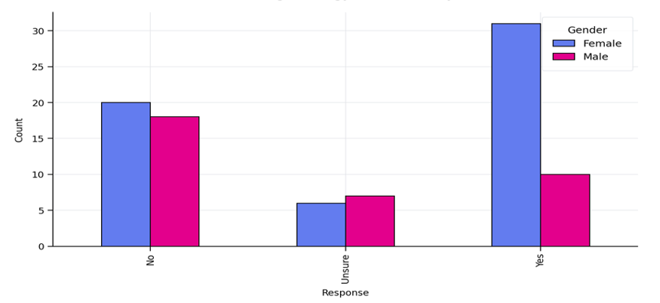
Figure 27 – SWP Wellbeing Strategy Awareness by Gender

4.4.8 Occupational Access of Support by Gender
The responses indicate that twice as many respondents did not access support compared with those that did and that females are more likely to access support than males. With 38% of females reporting engagement compared to 25% of males. Non-engagement amongst males was notably high at 75%, this supports the literature review, observations of Drapeau et al and McKenzie et al, see Figure 28:

Occupational Health Support Access by Gender
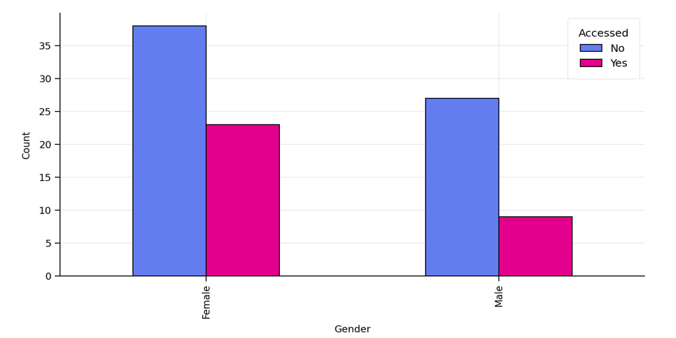

Figure 28 – Occupational Health Support Access by Gender
Among those that did access the support available, satisfaction with the service provided was predominantly positive, see Figure 29:
How did you Rate the Service Provided?
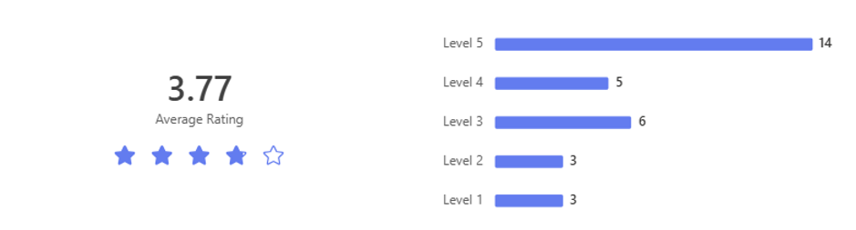
Figure 29 – Occupational Health Service Rating

4.5 Thematic Analysis of Objective 3 – Leadership Influence on Help-seeking
4.5.1 Supervisor Impact on Help-seeking
The impact of leadership responsiveness and supervisory engagement on organisational reporting cultures and employees trust has been widely examined. Respondents rated their confidence in receiving constructive professional guidance and support from their line manager. This highlighted the extent to which supervisory behaviour influences help-seeking, openness and trust within the organisation.
Transparent leadership offers numerous benefits to organisations, by fostering open communication, trust and positive relational dynamics, (Salvatico, 2006). Similarly transparent communication contributes to quality employee-organisation relationships, this plays a vital role in shaping the organisations internal reputation, as employees’ positive evaluations are linked to authentic leadership and transparent communication, (Men, 2014).
Respondents consistently emphasised the critical role of transparent communication and consistent support from leaders.

In examining the correlation between supervisory support and reporting intentions, it was recognised that, of the 97 respondents, 67 reported having female supervisors while 30 reported having male supervisors.
Respondents were asked whether they felt that the gender of their supervisor would influence their decision to seek help. The responses from both male and female respondents have been separated, to show the differing views, see Figure 30:

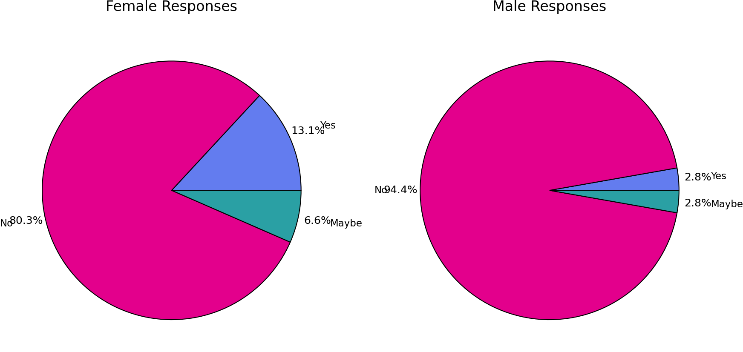
Figure 30 – Supervisor Impact on Disclosure

Overall, most respondents (both male and female) indicated that supervisor gender does not influence their decision to seek help, this contradicts the literature review, whereby Konrad etc all indicated that supervisor gender can influence seeking support.
However, female respondents were more likely than male respondents to indicate that gender may influence their decision. Females also expressed greater uncertainty, with a higher proportion selecting ‘Maybe’. In contrast, male respondents gave more definitive answers, with 95% choosing ‘No’.
Despite the slight differences, overall confidence in support appears high, with approximately 75% of respondents selecting "Yes", indicating strong overall trust.
Interestingly, gender differences are evident in levels of certainty. Females showed higher uncertainty (21%) compared to males (7%), while males were more decisive in their responses, both positive and negative. Importantly, the ‘unsure’ responses appear to be due to a lack of clarity rather than negative perceptions. This again highlights a potential for targeted communication, to reduce gender-based uncertainty, see Figure 31:
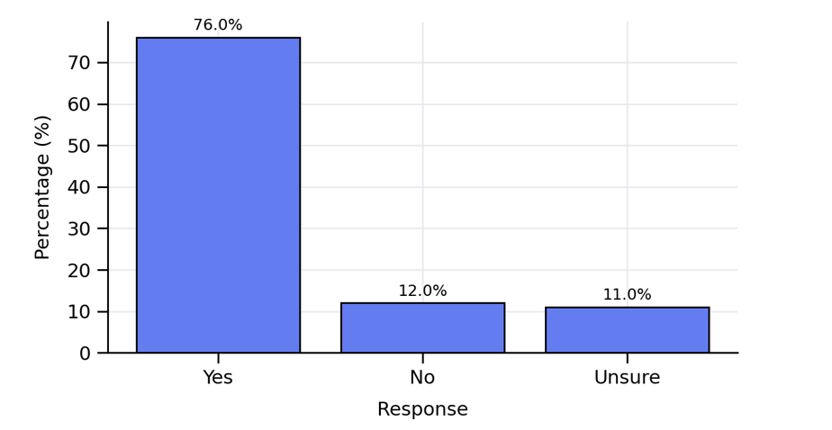
Figure 31 – Perceived Supervisor Support if Disclosing Mental Health

Potentially there is an opportunity to share practical examples of supportive supervision amongst the supervisor cohort and to raise awareness of available resources. A priority is closing the ‘uncertainty gap’ by publishing a simple explanation as to what happens when someone is referred to manage expectations. Alongside this, organisations must ensure that there is ongoing support for supervisors, through refresher training on dealing with trauma, supporting staff, active listening, confidentiality and appropriate signposting.
Evaluating the effectiveness of support systems is key within the organisation to ensure there are improvements in the experiences of individuals reporting mental health concerns.
Evidence suggests that when leaders actively promote supportive behaviours and display a genuine commitment to supporting poor mental health staff feel more empowered to raise concerns (Siami, et al., 2023). However, Interestingly, despite staff having confidence in their supervisors, very few would approach their supervisor and disclose they were suffering, as can be seen later in the research findings.

4.5.2 Supervisor Impact on Help-seeking
Interestingly when asked if gender influences stigma or help-seeking behaviours, most respondents reported that it didn’t, 54.1% of females and 63.9% of males. Reponses indicating that gender does influence stigma or help-seeking where similar, with 27.87% of females and 30.56% of males responding ‘yes’, see Figure 32:
Clustered Bar Chart: Responses by Gender
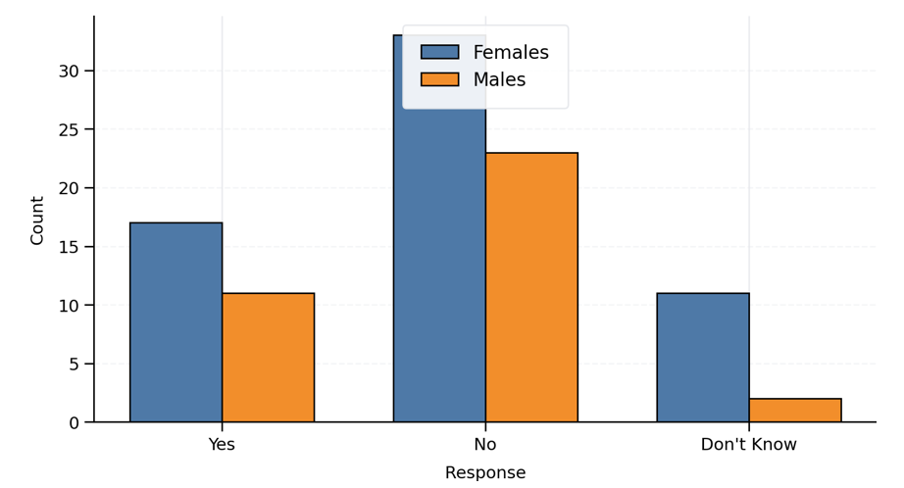
Figure 32 – Gender Influence on Stigma / Help-Seeking

Males show slighter higher agreement that stigma influences help-seeking (30.6% vs 27.9%). Although the difference is slight, it does suggest that males may perceive stigma marginally more often as a barrier than females.
Male responses appear to be more decisive, whereas female respondents demonstrate greater uncertainty, which may reflect greater nuanced complexities. Overall, however, both genders do not believe that stigma influences help-seeking.

4.5.3 Action taken when Seeking Help
Respondents were asked to outline what action they would take if experiencing poor mental health. The most common action for both genders was ‘seek help’, see Figure 33:

Mental Health Actions by Gender
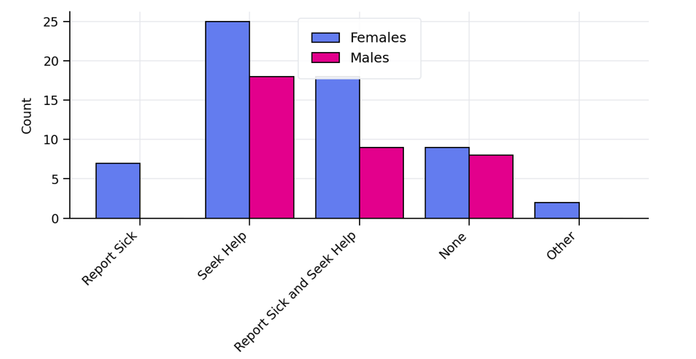
Figure 33 – Action Taken when Seeking Help

Overall females were more likely than their male counterparts to take supportive or proactive action to address poor mental health. Female respondents recorded higher counts across all categories. Notably, only females reported solely taking sickness absence, (females 7 / males 0).
Taking combined action (reporting sick and seeking help) was common amongst both genders, although females did so more frequently. Responses indicating ‘no action’ were slightly greater among male respondents though the difference was minimal.
In summary, females consistently and frequently demonstrated greater engagement with support-seeking behaviours, including higher levels of seeking help, combined actions and all responses recorded under ‘other’.
These findings again reinforce the need for greater targeted communication towards males as they are less likely to report sickness or undertake combined actions. However, their relatively high tendency to seek help along indicates a preference for less formal routes of support.
4.5.4 Reporting Physical Health v. Reporting Mental Health
The questionnaire explored the discord between perceived organisational norms and actual reporting behaviours. It is widely recognised that organisational trust is crucial. Trust is conceptualised as a ‘relational, risk-informed construct that is both an individual and collective phenomenon’ (Mayer, et al., 1995) and is critical to aligning stakeholder expectations and ensuring safety in complex environments’, (Dietz & Den Hartog, 2006).
Respondents were asked if they would be more likely to report a physical condition than a mental health condition. The results indicated that there was a strong overall tendency to report physical conditions. This pattern was evident across both genders. A total of 61 Females and 36 Males selected either ‘yes’ or ‘maybe’. Overall, 72% of females and 86% of males indicated a preference for reporting physical conditions over mental health conditions.
Twenty-seven respondents (16 females and 11 males) expressed a willingness to engage in further research through interviews or focus groups, indicating a workforce that is eager for engagement.
Gender-based differences were evident in response patterns. Males indicated a higher reluctance to respond ‘no’, with only 12% selecting this option compared to 23% of females. This suggests that males are less likely to explicitly state that they would not favour reporting physical conditions. In contrast, females, displayed higher levels of uncertainty, reflected in a greater proportion of ‘maybe’ responses.
The most distinguished gender difference appeared in the ‘no’ category, where females selected ‘no’ nearly three times more often than their male counterparts. This may suggest females are more open to the possibility of reporting mental health conditions.
Overall, female responses were more evenly distributed across categories, whereas male responses centred pre-dominantly around ‘yes’. However, both genders overwhelmingly favoured reporting physical health conditions over mental health conditions, this potentially indicates that there is a stigma associated with mental health reporting, particularly among male respondents. see Figure 34:
Reporting Preference by Gender
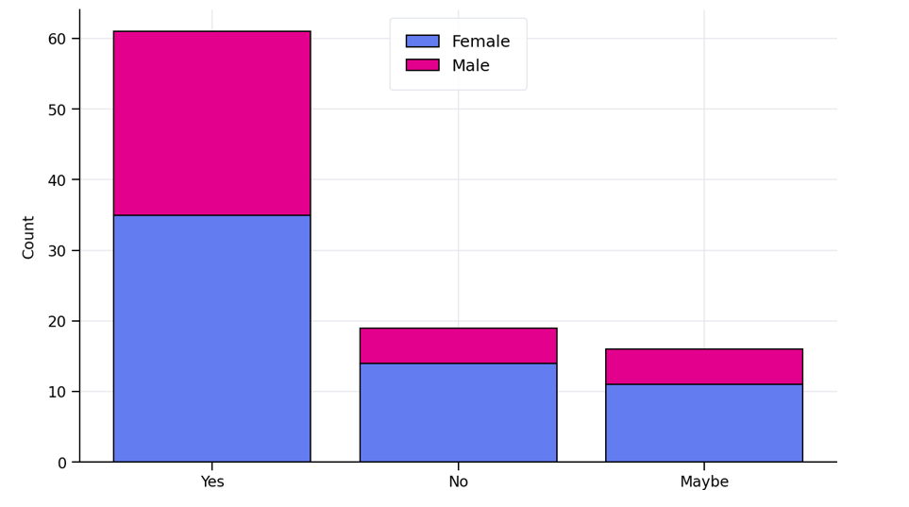
Figure 34 – Reporting Preference by Gender
We supplemented this question, with a follow-up question asking respondents to explain why they would be more likely to report physical illness rather than a mental illness.
Sixty-five free-text responses were analysed and grouped into common themes using a keyword-based approach, See Figure 35 & Figure 36:
Theme | Count
Visibility / easier to explain physical | 23
Stigma | 14
Supervisor/management & culture | 14
Support networks & therapy | 12
Self-management / coping / carry on | 8
Career / opportunity concerns | 7
Fear of being judged | 7
Workload / busyness / stress levels | 7
Believability / validity concerns | 6
Impact on role / safety / performance | 6
Diagnosis / recognition / threshold | 5
Gendered factors (men/menopause) | 3

Figure 35 –Reporting Preference Analysis (1)
Themed Analysis of Reasons: Mental vs. Physical Reporting
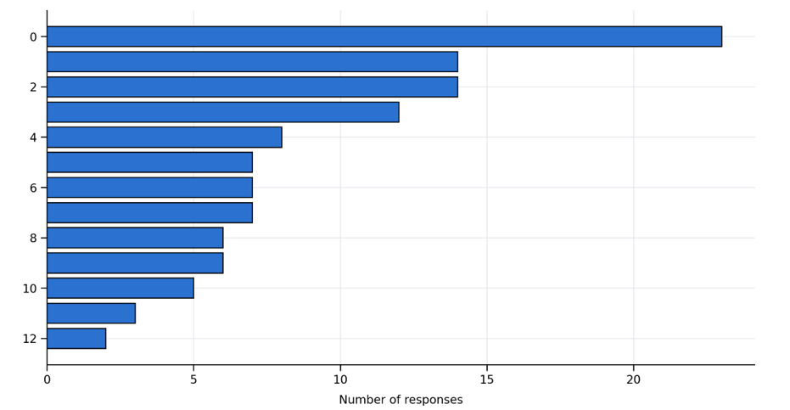
Figure 36 –Reporting Preference Analysis (2)
The most frequently reported themes were visibility and the relative ease of explaining physical illness (23 responses), stigma (14, support networks and therapy (12) and self-management or ‘carrying on’ (8). It should be noted that each response could map to multiple themes, see Figure 37:
Some respondents highlighted that there was very little support and a lack of confidentiality, this was supported in the literature review by Demirkol and Nalla who raised concerns regarding confidentiality.
Respondents highlighted a stigma around disclosure alongside fears that in doing so might negatively affect perceptions of their ability to perform their role. Interestingly, male respondents appeared to take longer to request help.
There's still a strong stigma around mental health, and I felt that keenly. Mine deteriorated significantly, but because I was on the promotion pathway and in a position of influence, I convinced myself it was better to bury it'
I thought showing any vulnerability might undermine trust or credibility'
Physical conditions are clear and obvious with proven medical solutions. Mental Health is a problem which one feels that you can sort out yourself'
It is easier to show people a physical condition'
More likely to be taken seriously'
Fear of being judged'

Figure 37 – Freetext Reporting Preference

4.5.5 Suffering in Silence
Respondents were asked whether they had ever remained silent, when suffering with poor mental health, see Figure 38 and 39:
Have you ever remained silent, when suffering with poor mental health?
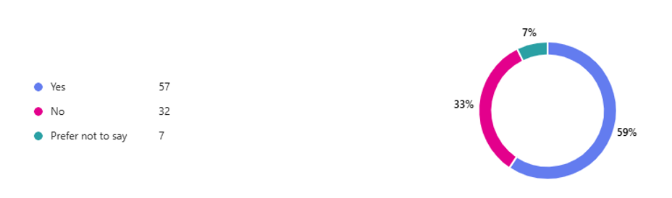
Figure 38 – Suffering in Silence

Responses by Gender
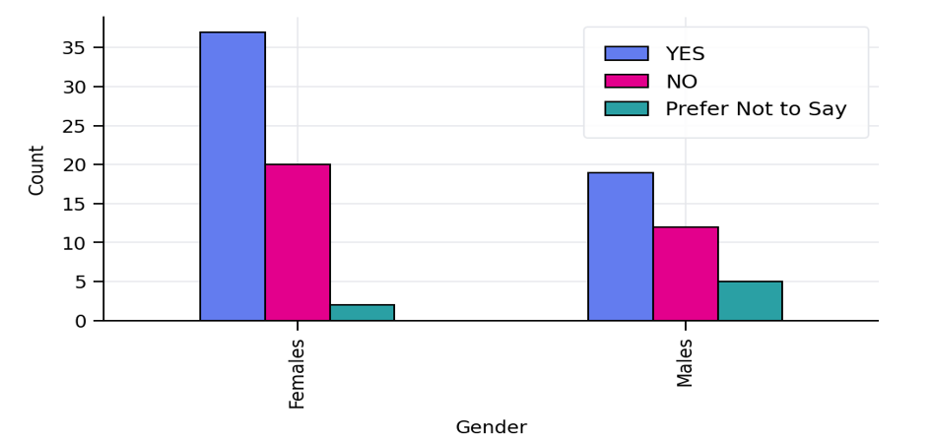
Figure 39 – Suffering in Silence – Responses by Gender

The findings show that women report remaining silent almost twice as often as men. Female respondents chose ‘yes’ to remaining silent on 37 occasions, compared to 19 occasions for men. This may suggest gender differences in the willingness or ability to disclose mental-health struggles.
The findings also show that men are more likely to choose ‘prefer not to say’. Men are 2.5 times more likely to avoid answering the question. This may indicate a higher discomfort discussing mental health, stronger stigma or a reluctance to disclose even anonymously.
Silence emerged as the most common response for both genders, with nearly 60% of participants reporting that they stayed silent at some point. This suggests that silence around mental health issues is a major cultural or organizational challenge.
Females displayed a wider spread of responses and appeared more comfortable choosing clear “Yes” or “No” answers. This pattern commonly appears when a group experiences greater stigma or fear of judgement. Males have a higher “silence-to-speaking” ratio. Although, women report silence more frequently.

4.5.6 Suffering in Silence – Why?
Respondents were asked to share their reasons for remaining silence. There were several key themes identified, see Figure 40:

Key Themes from Responses
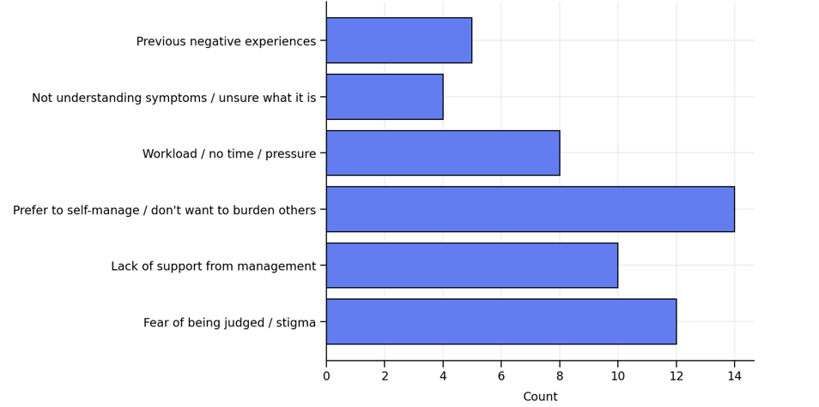
Figure 40 – Suffering in Silence – Key Themes

The dominant barrier to disclosure is fear of judgement. Respondents reported concerns about being perceived as weak, not being believed or having their professional credibility questioned if they admit they are struggling.
Similarly, there appears to be a lack of confidence in management support. Many respondents described feeling unsupported by their supervisors, citing poor listening, limited care, or lack of availability. Some cited being previously refused support creating mistrust.
Many respondents choose to self-manage to avoid burdening other. A significant theme throughout the responses was the belief that they should cope alone. Many tended to mask symptoms or tried to resolve issues independently.
Workload and operational pressures were also significant. High demand and low staffing levels discouraged staff from reporting concerns, as they feared ‘letting the team down’. Several members documented that reporting high workloads felt pointless due to the perceived lack of viable solutions to address.
More personally, staff felt that there was just a general lack of understanding of mental health symptoms. That some employees did not initially recognise their symptoms as mental health related or struggled to articulate what they were experiencing.
Previous negative experiences or dismissive responses further reduced willingness to seek help. Some simply had privacy concerns, stating a preference to keep their personal lives separate from work.
Overall, the data indicates a culture in which staff continue to struggle in silence. Stigma, lack of managerial consistency and workload pressure contribute to delayed disclosure, increasing the risk of burnout, presenteeism and late crisis-point disclosures.
Organisations would benefit from strengthened and consistent manager training to improve confidence, understanding and support around mental health.

4.5.7 Mental Health Disclosures
Respondents were asked, that if they were to report concerns regarding their mental health then who would they look to approach first, see Figure 41:

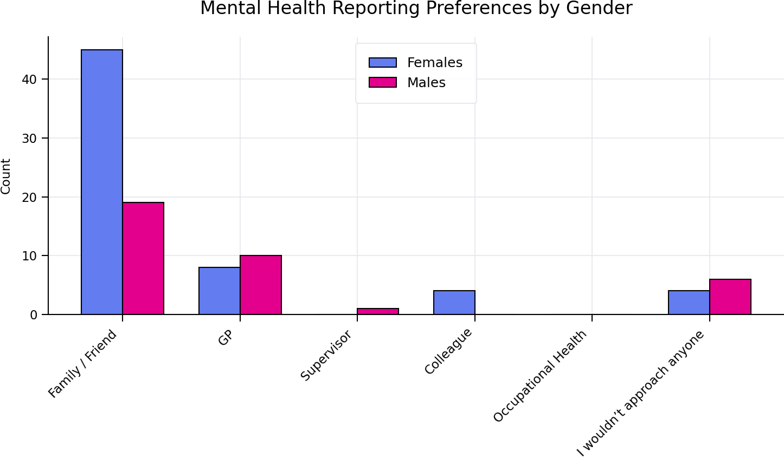
Figure 41 – Mental Health Reporting Preferences by Gender

The results captured how respondents would choose to report concerns about their mental health, with set categories outlined. The most preferred option was speaking with family or friends. This option was overwhelmingly the choice of both genders. Females are more than twice as likely as males to choose this route. This shows that help-seeking is heavily informal.
The results show that the option of consulting with the GP is higher among males. While females report visiting the GP more overall, males are proportionally more likely to visit their GP than females. This may suggest that males take greater comfort speaking with medical professionals and have less reliance on personal networks.
Approaching supervisors as first contact is rare amongst both genders. This may indicate a lack of trust, concerns around stigma or fear of career impact. Leadership visibility in mental-health culture may need improvement. Interestingly, females are more likely to approach a colleague, which may reflect a greater peer support network or more open communication patterns amongst colleagues.
Surprisingly, no one selected occupational health, despite occupational health being a formal support route. This suggests lack of awareness, perception of limited confidentiality or lack of trust or visibility. This is a major occupational opportunity.
Worryingly, males are 50% more likely to not approach anyone at all. This aligns with commonly observed patterns of lower help-seeking among males. Male staff appear more hesitant to seek help, shown by the higher GP preference and the “I wouldn’t approach anyone” responses.

4.5.8 Barriers to Seeking Support?
Respondents were asked to identify the barriers to seeking support, see Figure 42:

What are the Barriers to Seeking Support?
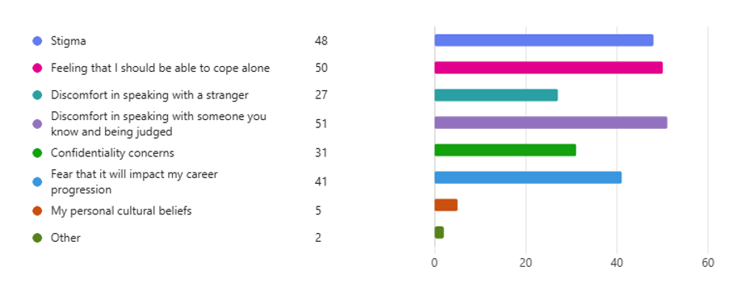
Figure 42 – Barriers to Seeking Support
The chart below visualises the barriers to seeking support by gender, Figure 43:

Barriers to Seeking Support by Gender
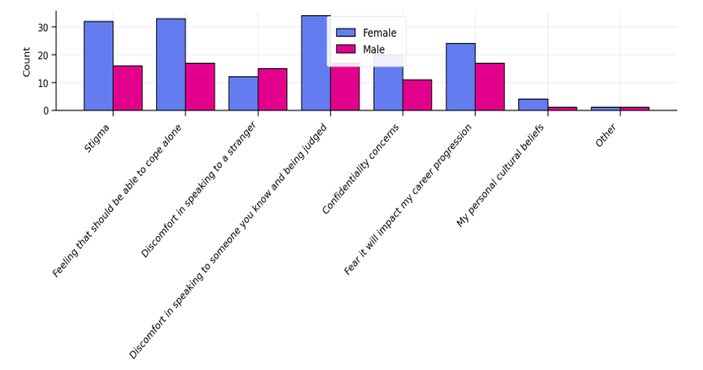
Figure 43 – Barriers to Seeking Support by Gender

Eight key barriers are listed and compares how often female and male respondents selected each option. Overall, women report higher barriers across almost all categories. For every barrier except one (“Discomfort speaking to a stranger”), female respondents selected the barrier more frequently than male respondents.
This suggests, that women perceive greater obstacles in seeking support. Men’s barrier profile is flatter, with fewer high peaks. Fear of judgement and self-expectation to cope alone are major factors for women. Men’s barriers cluster more evenly, but expectation to cope alone is the most significant.
Women consistently report higher fear of judgement, stigma, and internal expectations to cope. Interestingly, emotional and social factors dominate for both groups, fear of judgment, expectation to cope alone and stigma. These outrank practical or structural concerns.
Men report more comfort speaking to strangers than women. This is the only barrier where males score higher.
Staff were asked a series of questions to ascertain feelings around several key areas, see Figure 44:

How would you rate the following Statements?
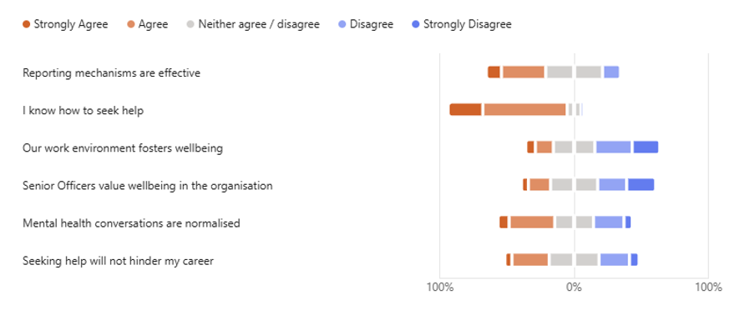

Figure 44 Statement Ratings
This was further broken down by gender, figure 45:

% Positive (Strongly Agree + Agree) by Gender and Question
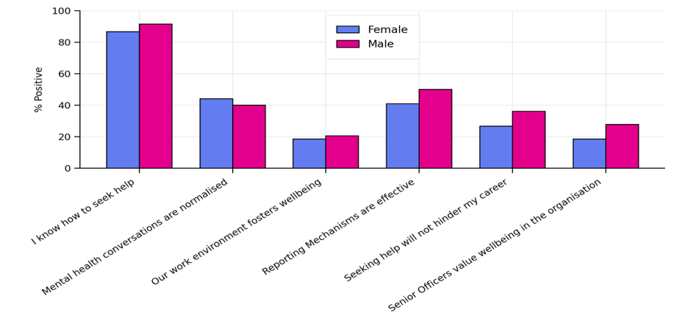
Figure 45 – Statement Ratings by Gender

Male respondents show higher sentiment index than females. Help-seeking awareness shows a high positivity score for both genders. Of note wellbeing, environment and senior officer support are key concern areas. Neutral responses are consistently higher for females on the lowest-scoring items (reporting mechanisms, career safety), hinting at uncertainty or low psychological safety rather than outright rejection. Leadership is the largest drag on sentiment, especially for females.

Respondents were asked to identify the main barriers to reporting poor mental health:

- Stigma, Judgment & Perception of Weakness
Seeking support is often viewed negatively. Staff fear being judged, labelled, or seen as weak. Many believe that the position they carry, holds an expectation that they should be resilient, which discourages openness.
2. Lack of Time & High Workload
High demand, performance pressure, and limited breaks mean staff struggle to find time to seek help. Busy environments normalise stress and reduce opportunities for support.
3. Confidentiality & Trust Concerns
Some respondents raised concerns about who could see their personal information and whether disclosures might lead to redeployment, monitoring, or negative career impact. This erodes trust in help‑seeking.
4. Inconsistent Management Support
Respondents indicated that managerial support varies widely. Some leaders are empathetic and informed, while others lack time, training, or awareness. Some respondents feel this actively discourages them from seeking help.
5. Long Waiting Times & Limited Capacity
Respondents indicated that delays in Occupational Health, TRIM referrals, and counselling availability are common. Limited counsellor capacity means support isn't always available when needed most.
6. Awareness & Clarity of Processes
Some respondents indicated that they are unsure what help is available, how to access it, or what happens after they seek support. Lack of clear pathways creates confusion and hesitation.
7. Organisational Culture
Some respondents feel undervalued. Gossip culture, lack of meaningful wellbeing action, and inconsistent leadership messaging appear to contribute to scepticism.
8. Personal Barriers
Some individuals struggle with simply starting the conversation around their mental health concerns, with underlying thoughts that they should be able to cope independently.
The most significant barriers are stigma, workload pressure, and delays in support access. While support exists, cultural and structural barriers reduce confidence in using it.

4.5.9 Wellbeing Feedback
Respondents were asked if they had any suggestions as to how wellbeing service could be improved, see Figure 46:

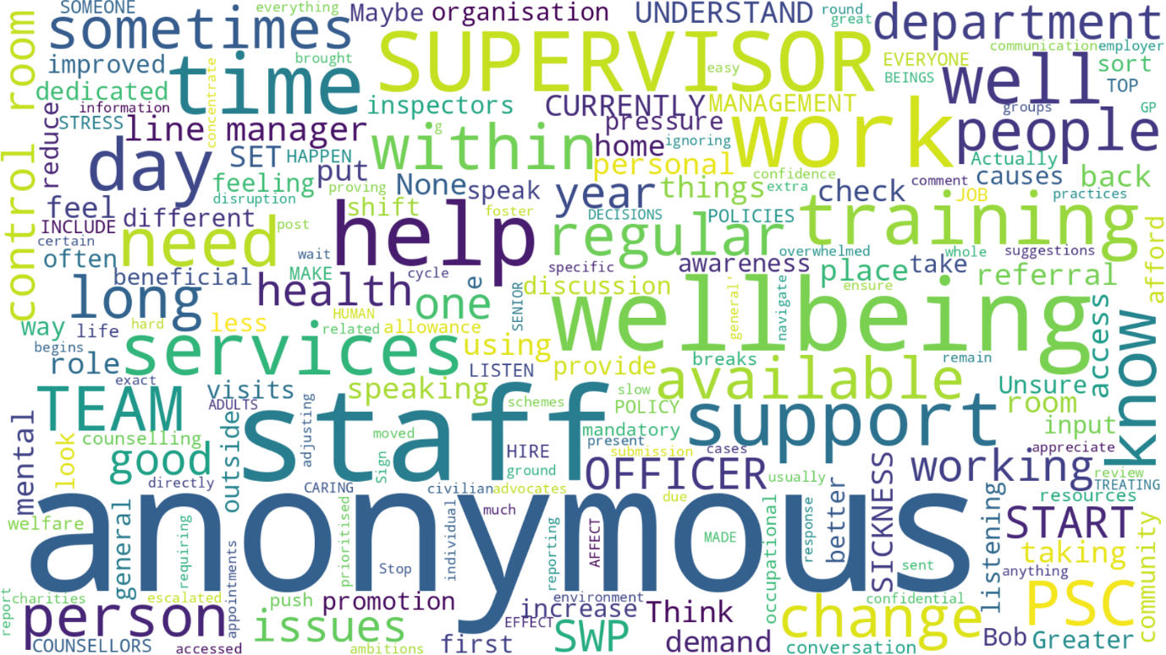

Figure 46 – Wellbeing Feedback
The responses highlight consistent themes around wellbeing, support, and workplace culture, with several key points identified:
- Access to Wellbeing Services
Respondents feel that wellbeing services are hard to access with long waiting times for referrals and counselling. This impacts decision making around reporting. Staff report a desire for more counsellors and more diverse wellbeing options, such as regular check-ins, annual wellbeing conversations, and trauma support sessions.
- Need for Better Visibility and Communication
Respondents frequently mentioned that information around wellbeing services is difficult to obtain and poorly advertised. Staff that they would benefit from greater promotion of options available. Suggestions included, clear accessible list of available services, more regular communication and reminders, more wellbeing visits in the department, drop-in sessions, training day inputs and being more physically present.
- Management Culture and Support
A significant number of respondents reported concerns regarding management behaviours and organisational issues. Respondents indicated a desire for listening, empathy and consistency from supervisors, with a request that staff rotating too often disrupts stability. Staff raised a concern that supervisors were often ‘too busy’ to support staff with competing demands and that often wellbeing isn’t genuinely prioritised. Many respondents indicated a desire to receive ‘proper’ training for difficult conversations and wellbeing related responsibilities.
- PSC Working Conditions and Environment
Several respondents cited that organisational pressures impacted their ability to take wellbeing breaks, and that they held feelings of guilt if they did due to high workloads.
- Desire for Human Connection
Interestingly, several respondents indicated a desire, to have leaders sit with staff, talk with them and just generally be approachable, emphasising the importance of being seen, heard and valued.

- Training, Education and Prevention
Respondents indicated a desire for regular training around mental health and wellbeing. Normalising conversations would make help-seeking more attractive and ensuring that professional help was available when needed would reinforce the organisations commitment.
4.6 Conclusion – Integrative Analysis and Empirical Findings
In examining the culture and structural frameworks shaping mental health reporting within SWP and reviewing primary and secondary data with theoretical frameworks, several patterns emerge.

The research indicates that while respondents are generally aware of mental health policies and services available, many lack confidence in how effective or accessible that support is.
Gaps in communication, inconsistent training and limited leadership, contribute to uncertainty, stigma and overall reluctance to report across both genders.

Gender differences are evident, female respondents show higher engagement with support services but greater uncertainty and a fear of being judged, while males are more likely to stay silent avoid formal reporting and rely on medical professionals or no one at all.

Overwhelmingly, both genders prefer informal help-seeking, notably from family or friends and very few would approach supervisors or the Occupational Health Department, highlighting trust and cultural barriers.

Silence is a major theme, with nearly 60% of staff having stayed silent having experienced poor mental health. Many struggle to understand and recognise symptoms reinforcing the need for greater education, clearer pathways and more proactive support.

Respondents consistently requested improved communication, stronger and consistent training, and increased and accessible support services. Targeted approaches for male and female respondents, clearer reporting methods and enhanced leadership support are key areas for improving mental health outcomes.

The next chapter will present findings and recommendations in detail based on the analysis provided in this paper.

Chapter Five

Conclusion and Recommendations

5.1 Conclusions Against Research Objectives

5.1.1 Objective One: Mental Health Stigma, Gender Influences, and Help-Seeking Behaviours
The results indicate that organisational culture significantly outlines employee’s confidence and readiness to report mental health concerns. A significant proportion of staff, believed that underreporting occurs, indicating weariness to report and therefore selective reporting practices. These findings align with literature which indicated that peer loyalty and operational norms strongly influence reporting behaviours.
Gender arose as a key determinant. Male respondents were more likely to deny the impact of their role on their mental health, and therefore more likely to avoid reporting, aligning with literature suggesting higher stigma among men (Bailey 2021). Female respondents in comparison exhibited greater uncertainty and higher engagement with support-seeking behaviours.
Overwhelmingly, both genders favoured informal help-seeking, particularly speaking with family or friends. Silence remained prevalent, with nearly 60% of respondents reporting that they had remained silent at some point throughout their service. This highlights a deep-rooted organisational and cultural challenge within policing.
These findings reinforce Aveyard’s (2010) assertion that understanding the complexities of reporting behaviour is essential for fostering accountability.

5.1.2 Objective Two: Experiences and Perceptions of Mental Health Support
The study identified institutional barriers that impact reporting, including fear of stigma, inconsistent training, lack of awareness of support pathways, and perceived ineffectiveness of reporting systems. Staff highlighted insufficient training and a lack of understanding of mental health symptoms, with some employees struggling to recognise or articulate their experiences.
A clear gap exists between awareness of support and confidence in its effectiveness. Notably, no respondents selected Occupational Health as a first point of contact, suggesting significant trust and visibility issues. These findings support the need for improved communication, leadership accountability, and more accessible support mechanisms.

5.1.3 Objective Three: Leadership Influence on Help-Seeking Attitudes
Leadership surfaced as a crucial factor in shaping reporting behaviours. While 73% of respondents expressed confidence in reporting channels, many reported fear and uncertainty regarding outcomes. This indicates a disconnect between procedural confidence and emotional safety.
Institutional trust was identified as critical for improving reporting confidence. The findings support Walsh & Vito’s (2018) argument that strong leadership fosters environments where employees feel empowered to report concerns.
However, despite confidence in supervisors, very few employees indicated they would approach their supervisor directly, suggesting a lack of psychological safety and concerns about career impact.

5.1.4 Objective Four: Evidence-Based Improvements to Mental Health Support
Staff with lived experiences, who experienced negative outcomes, reported reluctance to engage in future reporting.
Three key areas for consideration were identified:
- Cross-sectional limitations - attitudes may change over a period, longitudinal research is needed.
- Cultural barriers - silence, stigma, and mistrust remain embedded.
- Training inconsistencies - significant differences in delivery and access reduces confidence.
These findings accentuate the need for systematic interventions that address both structural and cultural barriers.

5.2 Gender-Based Observations
The analysis identified significant gendered differences in perceptions, behaviours, and experiences relating to mental health reporting. Highlighting the requirement for customised organisational strategies that identify how gender shapes help-seeking patterns, stigma and confidence in reporting.

    - Gender Differences in Reporting Confidence and Perceived Impact
Male respondents were more than twice as likely as females to respond “No” when asked whether they would report mental health concerns, implying a greater reluctance to recognise or disclose difficulties. Females were considerably more likely to respond “Maybe”, indicating greater uncertainty and more nuanced experiences.
Both genders recognised that policing does impact mental health, however the impact was interpreted differently. Females displayed greater openness to recognising mental health challenges, whereas males showed a stronger tendency toward self-reliance and emotional suppression.

    - Gendered Patterns in Help-Seeking Behaviour
Help-seeking behaviours differed between genders. Female respondents were more than twice as likely as males to seek support from family or friends. In contrast, males were proportionally more likely to consult a professional, GP. Indicating a preference for confidential and professionalised support. Worryingly, males were also 50% more likely not to approach anyone, reinforcing patterns of silence and self-support.
These findings highlight that while females engage more frequently in help-seeking, males may require targeted interventions to reduce barriers associated with stigma and expectations to cope alone.

    - Gendered Barriers to Reporting
Both genders recognised emotional and social barriers, fear of judgement, stigma, and expectations to cope alone, as the most significant barriers. Female respondents continually and persistently reported higher levels of fear of judgement and internalised expectations to cope. Males reported greater solace in speaking to strangers, indicating a preference for anonymity and emotional distance.

    - Gender Differences in Engagement with Support Services
Analysis showed that 38% of female respondents accessed support, compared with 25% of males. No respondents selected Occupational Health, suggesting systematic issues with trust or visibility. Females exhibited greater levels of engagement with combined actions, whereas males showed lower overall engagement.

    - Gendered Organisational Challenges
Female respondents’ higher levels of uncertainty indicate that organisational culture, leadership visibility, and recognised support pathways may not be meeting their needs. Male underreporting appears linked to cultural norms around masculinity, emotional restraint, and fear of stigma. These patterns spotlight the need for gender-specific interventions to address distinct psychological and cultural pressures.

  - Recommendations
The following recommendations are designated to address the structural, cultural, and psychological barriers recognised in this study. They aim to strengthen reporting mechanisms, enhance psychological safety, and foster a more supportive and accountable organisational culture.

    - Implement Comprehensive Training Programmes (Short Term)
Training should be remodelled to ensure uniformity, relevance and accessibility. Key areas of focus should include:
- Strengthened Mental Health Awareness: improving understanding of symptoms, early warning signs, and the impact of policing on wellbeing.
- Ensure clear guidance on reporting processes: simplifying procedures and expectations to reduce uncertainty.

Gender Specific Considerations:
Males:
- Within training include stigma content: addressing cultural norms that discourage help-seeking and attempt to normalise help-seeking and challenge self-reliance.

Females:
- Ensure staff are aware of the importance of confidentiality and address the worry of ‘being judged’.
- Improve trauma informed work
- Provide additional resilience training, with practical tools to manage stress.
This recommendation directly addresses the widespread concerns about inconsistent training and limited understanding of mental health highlighted in the findings.

    - Foster a Supportive Organisational Culture (Long Term)
Cultural change requires visible, sustained leadership commitment. It is important that there is accountability at all levels. At a leadership level it is important to re-invigorate conversations around mental health, ensuring the conversations remain meaningful. It is also important that there is peer-led engagement, aiming to reduce stigma. Strengthening communication around confidentiality and career safety is important. Visibility will seek to achieve this, building trust and confidence.
This recommendation responds to the finding that employees trust supervisors in principle but do not feel safe approaching them in practice.

    - Strengthening Reporting Mechanisms and Communication
To increase confidence in reporting consideration should be given to the following:
- Map the reporting journey end-to-end.
- Improve transparency and encourage feedback, ensuring employees understand the stages of reporting.
- Communicate confidentiality safeguards clearly and repeatedly.
- Publish simple explanations of referral processes to close the “uncertainty gap”.
- Highlight positive reporting outcomes to counteract fear-based narratives.
These actions address the widespread perception that reporting systems are ineffective or unclear.

    - Enhance Supervisor Capability and Accountability
Supervisors play a pivotal role in creating psychological safety. Consideration should be given to:
- Providing refresher training on trauma, active listening, confidentiality, and signposting.
- Offer practical tools for daily wellbeing support.
- Share examples of supportive supervision to model best practice.
- Ensure supervisors receive ongoing development in mental health and wellbeing.
This recommendation responds to the finding that supervisors are rarely approached despite high confidence ratings.

    - Address Gender-Specific Barriers and Needs
Given the clear gender differences identified, consideration must be given to tailored support:
For Women:
- Emphasise emotional safety, confidentiality, and non-judgement.
- Provide trauma-informed support and resilience training.
- Offer female-only listening groups to explore experiences.
For Men:
- Normalise help-seeking and challenge self-reliance norms.
- Promote confidential 1:1 support option.
- Increase targeted communication to address underreporting.
- Highlight male role models who model help-seeking behaviour.
These actions address the gendered patterns of silence, stigma, and help-seeking identified in the findings.

    - Improve Occupational Health Visibility and Accessibility
Given that neither gender selected Occupational Health as a first point of contact, consideration should be given to:
- Increase visibility of Occupational Health Services available.
- Improve access routes to mental health professionals.
- Provide pro-active outreach rather than reactive support.
- Address concerns about confidentiality and independence.
This recommendation responds to the perception that Occupational Health is ineffective or untrustworthy.

    - Strengthen Communication and Awareness Campaigns
It is recommended that communication should be strategic, targeted, and ongoing, through:
- Specific and tailored messaging to specific audiences.
- Normalise help-seeking through positive narratives and live studies.
- Promote wellbeing strategies and available resources more effectively.
- Review communication channels to ensure the Wellbeing Strategy is accessible and understood.
- Increase peer-normalisation messaging to reduce stigma.
This recommendation addresses the gap between awareness of support and confidence in its effectiveness.

5.4 Conclusion
The findings of this study identify a steadfast and rooted “silent divide” within emergency services, where gendered stigma and organisational culture cross to define help-seeking behaviours.
The analysis identified that ‘silence’ is a defining feature of employee experience, with almost 60% of respondents reporting that at some point throughout their service they had withheld their concerns. It is arguable that this silence was not solely individual hesitation but a result of structural and cultural norms in existence, such as loyalty to colleagues, fear of judgement and mistrust in the process. The impact of which suppresses conversations around mental health. The analysis reinforces the wider literature on policing culture and highlights the need for systemic change to dismantle barriers that inhibit transparency and psychological safety.
The analysis identified that gender plays a key role in defining how employees navigate mental health challenges. Male respondents displayed a greater degree of denial, self-reliance, and reluctance to report, reflecting embedded masculine norms that corelate vulnerability with weakness. Female respondents, while more open to recognising mental health impacts, reported greater fear of judgement and uncertainty, suggesting that organisational structures still fail to meet their needs for emotional safety and confidentiality.
These gendered differences emphasise the intricacy of stigma within emergency services and demonstrate how cultural expectations define not only whether individuals seek help, but how they seek it, from whom, and at what personal cost.
The study demonstrates that improving mental health reporting within the police service does require procedural refinement but in addition and more importantly requires cultural transformation.
The study demonstrated the importance of having confidence in supervisory support, recognised and consistent training, clear leadership and gender-responsive interventions to bridge the silent divide.
While the recommendations developed for SWP reflect its operational context, the methodological rigour of this research positions its conclusions for wider relevance across UK policing and emergency services. Tackling gendered stigma is not solely a matter of wellbeing; it is a matter of organisational integrity, ethical responsibility, and employee trust.
By addressing the cultural and structural barriers that maintain silence, emergency services can migrate toward a more accountable, supportive, and psychological safe environment for all employees.

