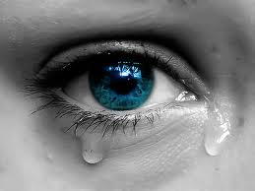
Sexual Exploitation.
- Introduction.  - The effect of the Internet.  - Seeing the Signs.  - Risk factors.  - Ethical Issues  - Child exploitation Transgressors.  - Evidence based practice.  - Diversity issues.  - Child exploitation reporting.  - Prevention of Child Exploitation.  - Organisations.  - The National Crime Agency.  - Legislation.  - Conclusion. | Sexual abuse is defined as any sexual activity when consent is not given. This can be sexual contact that can be gained by force or even threatening action, the age of the participant is regardless as it is between adult and child (Zastrow & Kirst-Ashman, 2013). Child sexual exploitation is inclusive of, child pornography, child prostitution and sex trafficking. Children who have been exploited carry the scars for life and may suffer from attempting suicide, insomnia, depression and self-harming.  Children who are mostly affected by child exploitation go from infancy to young adults. They are often children who live in poverty or low-income families with a lack of parental support and guidance. Children from these environments are often targeted. These children may have less life experience to judge from which makes them easy targets to be tricked or misled (Zastrow & Kirst-Ashman, 2013). There is also a fear that many children who have been exploited are blackmailed into their adult life by their exploiters. Many of these children grow up feeling guilt, confused and angry as a result of their experiences (Hermann, 1987).  Childs sexual abuse is a problem with many layers, characteristically complex and has consequences that there is no definition for (Barber, 2012).  Introduction.

When the Internet was introduced into our society what came with it was a new form of child abuse. With all the new technologies accessibility is at the touch of a button. The ability to send obscene e-mails or text messages, the showing of child pornography photos and grooming online (Davidson & Gottschalk, 2011). It has been implied by Choo (2009) in a study that 85% to 95% of child abuse cases that the abuser is known to the child, but the abuser has used technology to groom the individual. According to this information it is implied that the use of the internet has given the perpetrator greater opportunity to sexually abuse a child. The universal use of the Internet has revolutionized the way we live our lives it has made geographical distance a thing of the past as can be said for the sharing of information (Stanley, 2001). The Internet used in the right hands is a fantastic tool to educate the children of today, but there is also sadly a dark side to it (Won, OK-Ran, Chulyun, & Jungmin, 2011).  As suggested, there is good and bad with everything and the same can be said for the internet. On average a child can spend up to at least 40hours a week online (Irvine, 2009). With all this time online it brings with it the addition of abusers to exploit younger users and with the internet it gives them a greater opportunity to groom children, exploit children, the production of harmful images (Quayle, Vaughan & Taylor, 2006). The internet has produced a way for theses perpetrators to enter a child’s family home without having physically to gain access.  Grooming typically starts through a manipulative, non-sexual approach to aid in enticing a child through engaging with them, by getting the child too slowly trust them before luring them into their trap (Davidson & Gottschalk, 2011). The internet helps abusers to gain trust quicker as the conversations are instant, and the abuser can have several victims across the world (Davidson & Gottschalk, 2011). Sexual abusers use the internet for child grooming for immediate gratification or to lay the groundwork for the physical abuse (Davidson & Gottschalk, 2011).  The Internet has changed the way that people communicate. Chat rooms have become such an easy way to access information and to target children (Davidson & Gottschalk, 2011). It is implied by Choo (2009) in a study that 65% of abusers use social networking sites as this enables them an effective, quick and confidential way to exploit children. Abusers use their skills and knowledge to gain public access to the children’s information. According to Davidson & Gottschalk (2011) a study carried out in America found that 74% of children had made up their own profiles on these sites and the worrying fact is that 57% had left their profiles open to the public, which meant that they could be viewed by anyone. This gives the abuser all the information that they require to begin the abuse. Before the internet information like this would not be possible to gain.  Internet Threat. | 
The internet gives an abuser a large degree of anonimity, which lets them hide behind a mask to gain the trust of a child and enticing them to become virtual friends (Choo, 2009). A child makes friends online and doesn’t genuinely know who they are talking to, as far as they are concerned it could be someone of the same ag with the same interests. It becomes for some a trusted ally. It’s a virtual world (Aiken et al., 2011). The advances made to technology has introduced abusers to programs that allow them to hide their identyties whch makes them extremely difficult to locate and trace them (Choo, 2009).

Largely uncensored as the internet is it has led to children being exposed to content negative in nature material wich is sexually explicit. A study has implied that between 1998 and 2012, 1.3million reportsconsisting of inappropriate behaviour sexually were sent to children (National Center for missing & exploited children, 2012).

It is also suggested that older children are a greater target as they are curious, able to get out and about and also more sexually curious (David & Gottschalk, 2011). The older the children the more they want to expnd on their social media platforms, they also like to take risks. Information sharing doesn’t seem to be an issue to them and they will talk to strangers without fera of recrimination.

Wolak et al., (2008) have suggested that the internet has only given abusers a new way for an old crime and imply that the data of sexual abuse is largey inaccurate. It is implied by Richards (2011) that environmetnal and situational factors are the main roles in sexual offences as it has been suggested before abusers personally know their victims and not targeted by people that they don’t know.

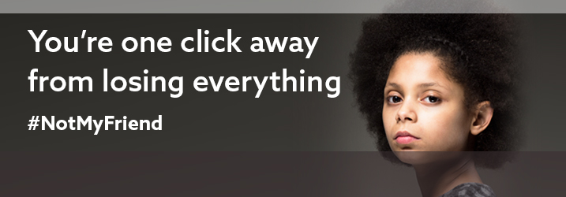

Sexual Exploitation.
Seeing the Signs.

The sexual exploitation of children to identify can be extremely difficult. The signs shown can be similar to adolescents behaviour which can mask the signs.

Certain behaviours may be displayed by children who are being sexually exploited:

- Showing an unsuitable sexual behaviour for their age.
- Being scared of situations and certain people.
- Showing signs of change in their emotional wellbeing.
- Isolating themselves from others.
- Becoming more and more secretive.
- Being able to buy new things without explanation as they have money.
- A child spending an increasing amount of time with older friends.
- Falling behind with their education.
- Becoming part of a gang culture.
- Taking alcohol and drugs.
- Shoplifting.

Some physical signs that may include:

- Injury that can’t be explained.
- Loosing weight.
- Self-harming.
- Sexually transmitted diseases.
- Pregnancy and abortions can also occur (Coffey, 2014).

The risk factors that sexual abuse and exploitation are associated with can happen to any young person or child. It can happen at any age and no, matter what their background is. Research does imply that there are certain factors that make a young person or child more vulnerable to exploitation. These include:  - that girls are more likely to fall victim than boys.  - Even so they are just as vulnerable as girls.  - The average age for an abused boy is between the ages of 11 and 14.  - girls between 4 and 6 years of age.  - According to Zastrow & Kirst-Ashman, (2013) children with some sort of disability are the most vulnerable.  - Lack of self-esteem and confidence.  - Different age group of friends.  - A child who is a young carer may be more vulnerable.  - A child in the care system.  - An individual who has suffered sexual abuse previously.  - Loosing someone close to them through bereavement.  - Being homeless.  - Living in poverty or from a low-economical background.  - Having no role models to aspire to.  Risk Factors. | 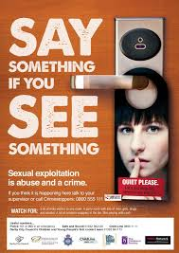  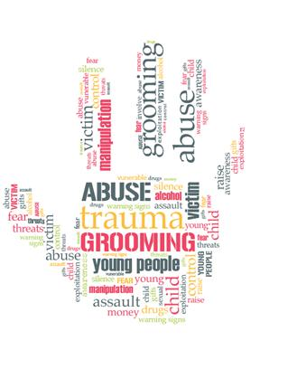
Ethical Issues.
There are many ethical issues with such a sensitive topic. Sexual exploitation or abuse must always be reported.
- A practitioner in the field needs to enquire and gather all the information before being able to proceed and help the child.
- Due to criminal proceedings questions need to be carefully asked as not to change in the child’s mind what has happened (Branaman & Gottileb, 2013).
- Practitioners must never take their previous experiences into account, or their feelings as it can alter the child’s recollection of events.

Child exploitation Transgressors.

The transgressors can be group led or individuals of either gender and age ranges vary. The explotation can present itself as a one off crime or a series over time. Explotation can be planned and organised or an opportunistic crime (Department of Education, 2017).

The identification of these perpetrators can be extremely difficult as young people and children may only know them online at first so their real identies are anonimous. There isn’t always recorded data as they can hide their identity.

The abusers may share their victims around amongst their friends so therefore there are a number of different perpetrators. Location will also change which makes it difficult for the young person to know where they are. Also they may be drugged and due to this details become sketchy and inconclusive
young people may be given alcohol or drugs, so may not remember details clearly (Berelowitz et al, 2012).
A perpetrator is a very manipulative individual who likes to have control and power over a young person or child.
They may groom children and use them to help them groom others, blackmailing them to bring thir friends, breaking free can be difficult as they can be paid handsomly for their services and are drawn back when finances run out.
Sexual Exploitation.

.
Sexual Exploitation.
Evidence based and Assessment Practices.
There are several objectives when it comes to assessing and treatment of victims of child sexual exploitation. The objectives according to Zastrow & Kisrt-Ashman (2013) are:
- The provision of a safe environment.
- The acknowledgement that the victim understands that what has happened to them is not their fault.
- Educating the child on how to express their emotions.
- Seeing what the child needs. Could be medical help and emotional support.
- To share if possible, with the child’s family so that they gain all the help and support needed at home.

- Micro level of intervention – The psychodynamic theory is used a great deal as a treatment. These theories stress how important the stages of the unconscious and psychosocial development are on the mind. It is implied by Walsh (2010) that the victims challenges and problems may come from inside the victim fighting their own demons as well as external conflicts. They may also use an intervention which is known as crisis which can be built upon the victims’ strengths.  - Mezzo-level – Practitioners may use the structural family theory. This is used to bring the family element back together to help the victim. Their support and understanding are crucial to aiding the victim. Role play is used in this intervention. All members of the family need to understand how the victim has felt and is feeling. There is also a family emotional theory that some practitioners use to gain knowledge of the emotional ties within the family (Walsh, 2010).  - Macro-level – This is based on prevention. Preventing child abuse from happening. Education and information are key to this. To educate children to the dangers of the internet. Courses should be held for children, families and communities to educate them to all manner of child exploitation.  Diversity.  Diversity issues are also important. Many young people from low- income and low-educational background are of greater risk. The difference in culture should also be looked at as some countries done see the sexual exploitation of a child in the same way. |  | 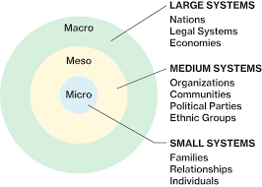
Child exploitation reporting.

It is imperitive that if anyone thinks a child is in danger to get in touch with the police immediately, or even share concerns with someone that can help.

All organisations have safeguarding procedures in place which must be adheared to. There is an NSPCC helpline that can be contacted 08088005000, there are always professionals who are at the other end of the phone to give of their advice.
Follow your organisational child protection procedures. Organisations that work with children and families must have safeguarding policies and procedures in place.
There are local organisations also in the safeguarding of children which are placed in the childs local authority.Contact your local child protection services.

It is imperitive for professionals to assess Child sexual exploiation risks to take into consideration the following actions:

Support the victim. Always remember that the victim is blameless. They need to be able to express their thoughts and feelings giving as much information as they can without feeling judged. The young persons social media accounts need to be looked at as well as their drug and alcohol use.

It is important to gather all the information to help the young person in this process, but it is also just as important to look at the bigger picture and see how these victims could be protected not only what has happened. Investigate the family environments and the strengths and weaknesses of them and also the individuals strengths and weaknesses (Brown et al., 2013).

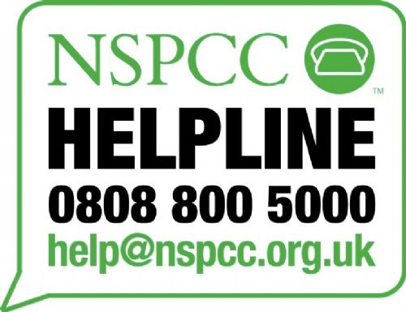
Prevention Of Child Exploitation.

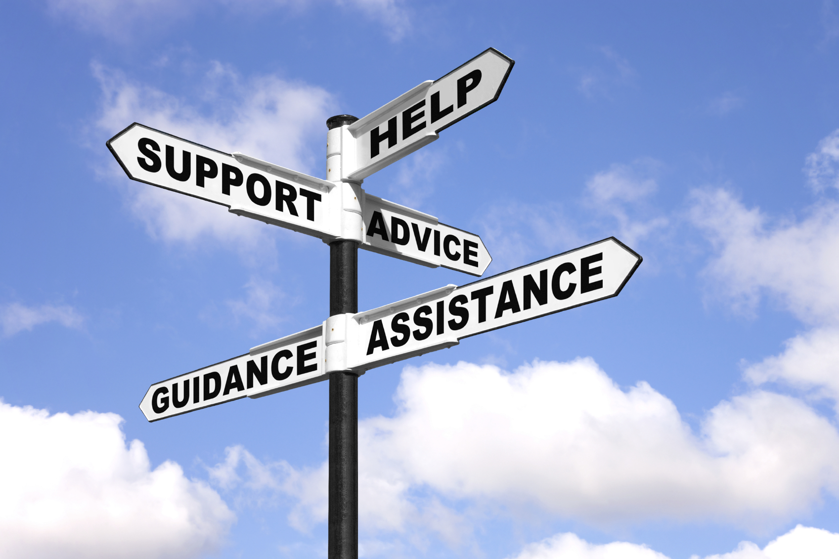

It is of vital importance to prevent Child sexual exploiation. Raiseing awareness of the signs is key. Children need to be taught what meaningful healthy relationships are, and if a child has any worries regarding a relationship that they know how to report it to someone (Coffey, 2014).

One of the best placed organisation to educate our childrenare Schools, and they are able to participate in this process from a very young age. All the education that can be given should enable a child to see risks and act accordingly.

Being able to discuss what a meaningful healthy relationship with a child means being able to create positivity and to challenge negativity. Being able to give workshops in schools by the police on they can keep themselves safe, this would also give them a positive relationship with the police with good interaction.

Exploring topics such as the following with young children:

- Safeguarding.
- Where and when help is needed.
- Friendships.
- To speak out without fear.
- What is inappropriate behaviour.
- What is inappropriate touch.

Schools have in recent years put in place mentoring schemes between its pupils, where an older pupil becomes a mentor for a younger child who is in need of support. This has been beneficial as youngsters feel less intimidated by someone similar to themselves. They find it easier to open up and trust someone who isn’t an authority figure such as the police.

Raising awareness in the communities of what child sexual exploitation is would also be beneficial. Communities know the children and are in a perfect position to safeguard the children (Coffey, 2014).

According to D'Arcy and Thomas, (2016) night time is also a very informative time to spot child sexual exploitation with night clubs, pubs, cab firms, fast food shops and emergency services playing a key role. Therefore it is also important that they become educated in child sexual explotation, who it envolves and what it entails. To recognise the signs, also how to report such behaviours.
It's important that workers in the night-time economy:

When organisations work together in giving an abused child all the help it needs there can be many barriers as there are several partnerships working together. Therefore, it needs a great deal of discipline and communication to overcome such barriers.
There needs to be clarity in each organization member role in the case. There is no place for negativity or not sharing information needed to proceed.
Training is also key for the smooth running of the organisations. Roles should be given so that each individual is accountable for themselves.
The lack of communication is the largest barrier as information sharing is an issue, individuals hide information as some think that they are far superior to others or that they think that they can do the job better. Professional rivalry.
Organisations have differing priorities and cultures.
Partnership improvement with these organisations is key to liftin the barriers. Being able to deliver an effective workplace takes a great deal of hard work

Organisations.

The National Crime Agency.

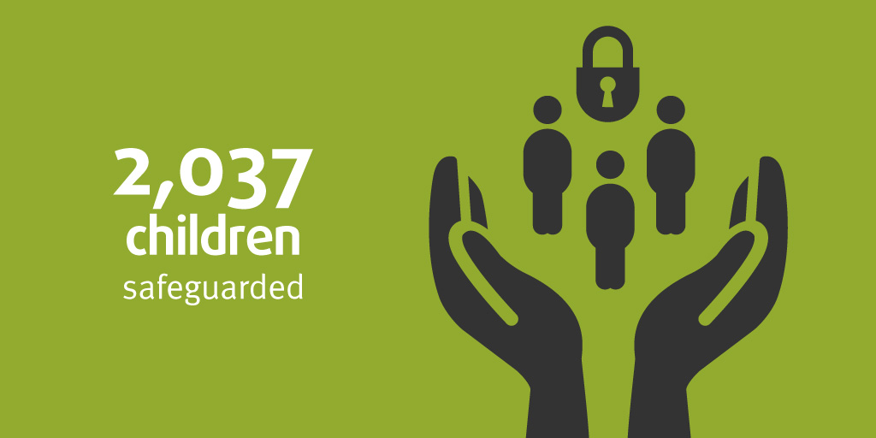

Children safeguarded from sexual abuse and exploitation as a result of NCA activity in 2017/18

The National Crime Agency protect children from abuse and sexual exploitation. They do so by areesting the abusers and sageguarding the victims. Education is also key in protecting young people and children on hoaw they are able to protect themselves online.

Working closely with the police and other voluntary sectors abroad as well as in the United Kingdom, it has been vital to the success by protecting the victims and bringing perpitrators to justice.

By investigating these offences the targets are covering all forms of child abuse and exploitation. Abusers who take part in contact child abuse and the abusers online who are grooming children, looking at indecent images or even recording the abuse.

The National Crime Agency are not limited in their juristiction they work on cases in the United Kingdom and those abusers that go from the United Kingdom abroad to comit their crimes.

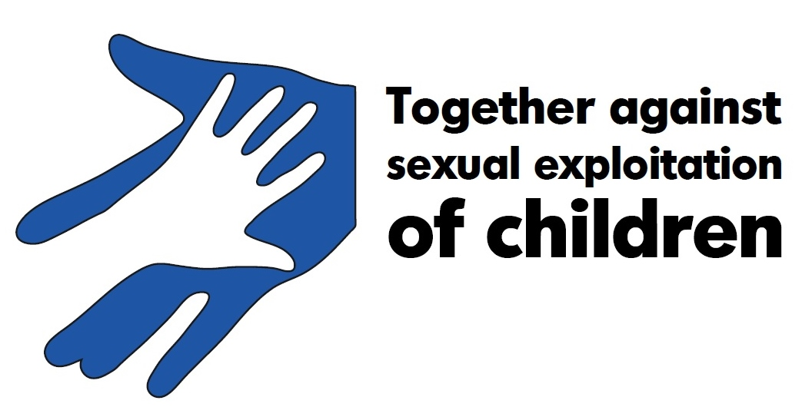

Legislation in the United Kingdom states that it is illegal to:
- To communicate sexuall with a child or young person.
- Child grooming and meeting the child.
- Engaging a youngperson in sexual activity.
- Having indecent photographs.
- Making indecent images.
- Paying for a childs services.

The Investigation of child sexual exploitation.

Under Section 116 of the Anti-Social Behaviour, Crime and Policing Act 2014, in England and Wales the police can request establishments such as hotels and B & B’s if they think that child sexual eploitation is taking place a full list of guests and all their information.

In Wales, Safeguarding of children and young people from sexual exploitation (PDF) is statutory guidance on preventing child sexual exploitation and outlines the roles and responsibilities of professional organisations such as Local Safeguarding Children Boards (LSCBs), the police, health and education services and voluntary groups (Welsh Government, 2010).

The promotion and safeguarding of the welfare of at risk children and young people of abuse there is an all Wales protocol which outlines what organisations responsibilities are (All Wales Child Protection Procedures Review Group, 2013).

Key policy
Tackling and preventing child sexual exploitation
In England and Wales, Tackling child sexual exploitation (PDF) sets out how the government is dealing with child sexual exploitation. It includes actions for healthcare, social care, education, law enforcement and criminal justice agencies (Home Office, 2015). A progress report has since been published to give an update on the actions taken to date and sets out next steps to achieve objectives around:



To conclude, child sexual exploitation is a massive problem, and due to the internet it has added an extra dimension to it. The child abusers have taken advantage of the situation. The internet has facilitated child grooming to a new level. Continuously the internet is evolveingand has become a large part of all our lives, but especially the children and young people.
Whilst investigating this topic abusers who commit such crimes firstly in large use internet communication, by gaining the child’s trust. The dramatic impact that the internet has had on child exploitation by providing an abuser with an avenue to find their prey. It is an setting that is ideal due to the anonymity aspect and the masks they hide behind.
The findings imply that child exploitation is connected to their worlds. To be able to understand the problems for themselves then they need to be educated as suggested in whaht meaningful relationships really are (WAG, 2011).
There is no quick fix to this massive problem, but from research and further reflection solutions could be aided by preventetive engagement, which would be open to all ages.
The direction of resources should be aimed at the sole needs of these children and young people to give them continuity of support which is vital for them to open up.
In addition, The definition of child sexual eploitation is problematic as it seems that people just see it as child grooming which is not the case this needs to be adressed as for professional to be able to help they need to have a far greater understanding.
Research also suggests that parctice and policies also need to to reflect this as it is not only grooming, awareness is key for this. There are so many avenues that theses perpetrators take.
Findings suggest that there is a need to widen current policy definition to be able to better recognise young peoples abuse beyond grooming, this could then contribute to an improved working definition of child sexual exploitation.
It is also implied that a re-articulation of the grooming model is needed so that children and young people recognise and are aware of the coercive nature of bad relationships, this would also lend itself to show them the reasoning behind their notion of staying in such exploitative relationships.

Further information also suggests that as a policy concept child sexual exploitation should have included other kinds of transactional sex, raising the questions regarding the choices that theses children and young people face. What makes them exchange sex for financial gain? Would it be for their emotional wellbeing or material wellbeing?
Questions like these may give professionals a fountain of knowledge in how to deal with these situations which could lead on to further preventative measures being put in place.

Reference List.

Aiken, M., Moran, M. and Berry, M.J., 2011, September. Child abuse material and the Internet: Cyberpsychology of online child related sex offending. In 29th meeting of the INTERPOL Specialist Group on Crimes against Children, Lyons, France, September (pp. 5-7).

All Wales Child Protection Procedures Review Group (2011) All Wales protocol: missing children (PDF). Cardiff: All Wales Child Protection Procedures Review Group.

Barber, G.A. and Whitefield, J.S., 2012. Cultivated child abuse: a 2-year-old with hyponatremic seizures. Pediatric emergency care, 28(11), pp.1234-1235.

Benson M, Fox G, DeMaris A and Van Wyk J (2003) ‘Neighbourhood disadvantage, individual economic distress and violence against women in intimate relationships’.AJournal of Quantitative Criminology 19 (3), 207-235.

Brown R and Ward H (2013) Decision-making within a child’s timeframe: An overview of current research evidence for family justice professionals concerning child development and the impact of maltreatment. London: Childhood Wellbeing Research Centre, Institute of Education.

Choo, K.K.R. and Australian Institute of Criminology, 2009. Online child grooming: A literature review on the misuse of social networking sites for grooming children for sexual offences (Vol. 103). Canberra: Australian Institute of Criminology.

Coffey A (2014) Real voices: Child sexual exploitation in Greater Manchester. Available online: http://anncoffeymp.
com/wp-content/uploads/2014/10/Real-Voices-Final.pdf

Davidson, J. and Gottschalk, P., 2011. Characteristics of the Internet for criminal child sexual abuse by online groomers. Criminal Justice Studies, 24(1), pp.23-36.

D’Arcy K, Dhaliwal S, Thomas R, with Brodie I and Pearce J (2015) Families and Communities Against Child Sexual Exploitation (FCASE) Final Evaluation Report. Luton: University of Bedfordshire.

Home Office (2015) Tackling child sexual exploitation (PDF). London: HM Government.

Home Office (2017) Tackling child sexual exploitation: progress report (PDF). London: HM Government.

Kim, W., Jeong, O.R., Kim, C. and So, J., 2011. The dark side of the Internet: Attacks, costs and responses. Information systems, 36(3), pp.675-705.

Liljeros, F., Edling, C.R., Amaral, L.A.N., Stanley, H.E. and Åberg, Y., 2001. The web of human sexual contacts. Nature, 411(6840), p.907.

Martin, J., 2015. Conceptualizing the harms done to children made the subjects of sexual abuse images online. Child & Youth Services, 36(4), pp.267-287.

Quayle, E., Vaughan, M. and Taylor, M., 2006. Sex offenders, Internet child abuse images and emotional avoidance: The importance of values. Aggression and violent Behavior, 11(1), pp.1-11.

Sabina, C., Wolak, J. and Finkelhor, D., 2008. The nature and dynamics of Internet pornography exposure for youth. CyberPsychology & Behavior, 11(6), pp.691-693.

WAG. (2011) Safeguarding Children and Young People from Sexual Exploitation
Supplementary guidance to Safeguarding Children: Working Together Under The
Children Act 2004
Welsh Government (2010) Safeguarding of children and young people from sexual exploitation (PDF). Cardiff: Welsh Assembly Government.

Zastrow, C.H. and Kirst-Ashman, K.K., 2013. Understanding Human Behavior and the Social Environment.. CA: Brooks. Coles, United States.

