University of Wales

Program Name: Certificate of Higher Education in Skills for the Workplace
Assignment Title: PROFESSIONAL CAREER DEVELOPMENT
Module Code: BMSW4005

Submitted By:
Student Name: Joseph Bangura
Student ID: 1818368
Lecturer Name: Dr Sylvia Hoffman

Date of Submission: 10/01/20

Professional Career Development

Table of Contents
Introduction 1 2
Career development plan 3
Career development plan in health and social care: 4
Career development process: 5
Knowledge and skills to work effectively 6
Personal strength and capacity 7
Areas of development 8
Establishing policies for personal and employment development 9
Conclusion: 10
References 11
Appendix……………………………………………………………………………………………………………………………………………….12

Introduction
Developing individual to fit for a job or perform the tasks in a specified sector is defined as a professional development plan. The professional development plan is formed and designed with including some element like education, mentoring with observation as well as training and motivation to explore the individual intrinsic quality to develop as a suitable employee for a particular sector like health and social care. Career or professional development plan could be formed by organizational or personal interest where key objectives can include developing the individual to perform effectively to achieve the personal career or organizational goals and success. In this report, it will describe the requirement and process of the professional development plan as well as personal qualification and measurement to develop a career development plan to achieve professional success.

Career development plan
The professional development plan is the individual plan and strategy with a written document of gathering the knowledge and skills as well as quality to perform a job and achieve the success particular sector (Roman, 2014). Personal and organizational goals and objectives can achieve by formulating a career development plan which can include relevant knowledge and skills to play a role in the specified sector like health and social care. Plan can be formulated short time and long term basis to achieve the goals where training and development, education and motivation, performance and expectation as well as the future outcome of the operation will be included in the career development plan (Donner, 2001).
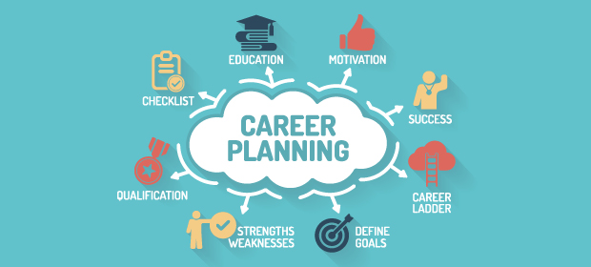
Figure: Career development plan for health and social care (Sources: Gorter, 2011)

A career development plan in health and social care:
To develop a plan in health and social career some skills and knowledge can assist to perform the job to achieve the career goals. These skills perception of the society regarding health and social care which can measure the potentiality to develop a career in this sector, then understanding the participant's psychology is also required to identify the career and its position as well as the potential outcome of service regarding health and social care (Aveyard, 2014). Moreover, critical thinking and problem-solving capacity, coordination and communication as well as understanding and realizing capability are essential to communicate, convince and manage others which are highly significant to develop a career in the health and social career.

Career development process:
Identifying the interest sector and measuring its potentiality is the first step to develop a career plan and then finding the quality and skills to perform the job or make me an employee for this sector like health and social care. Assessing the career expectation and existing qualification with knowledge and skill and then relate both to identify the expectation and gap to recover it. Getting education and training, communicating with experience and expert person regarding this sector like health and social care organization for building myself to get career success (Adams, et al., 2006). At a time it is essential to measure the gap between performance and expectation towards achieving the career goals and taking corrective action more training, knowledge and advice from the skilled and supervisors to recover the gap.
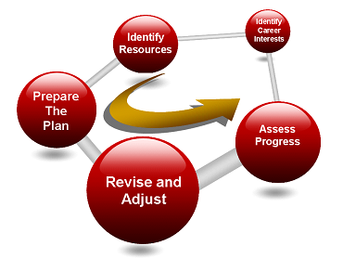
Figure: Career development process for health and social care (Sources: Gorter, 2011)

Knowledge and skills to work effectively
For making myself as a perfect employee for the health and social care programs and activities some skills are needed to develop and improve at this moment. With identifying these skills and by improving and developing those skills, I think I'll be able to achieve professional success. Communication skills, writing, reading, speaking active listening and leadership skills are now most importantly need to develop to present as a good employee in the social care and health sector (Sørensen, et al., 2012). Communicating with colleagues, subordinates and boss can assist me to solve any problem in the job field like in social care and health sector. Direct and indirect communication including social media, email and internet as well as other communication media can assist me to make a good cooperative and integrative relation with those people to get the assistance in my profession (Smith, 2017). Active listening can help anyone to visualize the actual thing and role to communicate and solve the thing. I think I need to develop the listening skill where it has to make sure the listening first for understanding and determining the role. Good speaking the next part of good listening and a good listener can ensure good delivery with good speaking. In the social care and health sector, a service holder or employee needs to understand the event first with listening and visualizing the theme of the event and then speaking with proper information to communicate properly. Expressing one is highly dependent on the effective speaking capacity of this person and I think, I'll able to express myself during communication in this field to get professional success. However, reading is also a vital skill of an individual which must be developed to present as a good employee. To understand written something it is required to reading it and understanding the theme of it properly to identify the personal role (Reeves, et al., 2013). Similarly, writing helps one to communicate with written document and I think, writing skill of mine need to develop for reporting the last information to the senior and to suggest anything regarding the performance and supporting things. Moreover, leadership skills play a vital role in the profession and career where good leadership skilled person can achieve the success promptly comparing with the less leadership skilled person. I have leadership skill but need to develop for making me a perfect employee in the social and health care programs and activities.

Therefore, to present me as a good employee in the health and social care sector, those skills and experience need to develop to provide good service to achieve the professional and career success.

Personal strength and capacity
With analyzing the personal condition, I have identified some strength like perseverance strength, interest to learn something new, social behaviour with the relevant people within this field, idea and strategy to solve a problem and innovating capacity with assessing feedback from the relevant people. This skills and capacity provide me with good strength and I think those skills are conducive to achieve other relevant skills to get a professional good outcome. Due to some weakness considering my skills, I need to pay more attention towards overcoming the weakness because I have much opportunity to build a career in the social and health care sector considering its potentiality and acceptability to the people in the UK (Hudson, 2002). Though the presence of more expert and capable persons and employee can create potential threat to build a career in this sector compared with them, I'm highly enthusiastic to pay my best performance to recover my weakness and to make me a good employee in this sector with developing relevant skills and experience. For that reason, communication and cooperation with the skilled and expert persons will conduct consistently.

Moreover, maintaining good behavior in the workplace is required to build a cooperative and integrative relationship with the subordinates, colleagues and skilled persons (Makhashvili, 2013). And for this purpose, abusive and unacceptable behavior with those people, shouting in the workplace, individual insults have to avoid in professional activities. Social and health care sector is the combination of different people and it is essential to manage those people with a cool and calm mind maintaining the people’s feedback and opinion regarding the performance.

Areas of development
Some quality and skills need to improve for making me perfect for conducting the health and social care service because this sector includes different people and their feedback, service outcome and required modification as well as rules and regulation to conduct the operation (Parker, 2003). For maintaining the people and service with gathering their opinion and feedback, it is required to develop my skill like communication and leadership skill. Understanding the assigned things with active listening and reading and then measure the role to perform the thing is the precondition to perform the task more effectively. This leadership and communication skill development not only assist me to provide the service effectively but also assist me to achieve a good professional position with success.

Establishing policies for personal and employment development
To enhance the professional development plan, some recruitment process and strategies have to maintain which will include the employee selection, recruitment and management to get a better outcome. The employee selection process should be cost-effective with managing job description and qualification. Proper recruitment method and sources can identify the best-suited person to perform the specific task effectively to get organizational and professional success (Ryan, 2008).

The job description will include the job duties and responsibilities of the individual to the organization as well as different rules and regulation must be informed to the employee to maintain the organizational code of conduct. The different condition needs to maintain by employee imposed by an organization to perform the social and health care service properly. Specified knowledge, quality and skill are required to perform the job that can describe by job qualification that must be existed to an individual. As an employee development plan, I need to enhance my strength area as well as essential to achieve relevant knowledge, skills and quality to make me suitable capable for social and health care service.

An organization can impose the employee development plan with focusing on some factors like employees interest side, their strength and weakness as well as their flexibility (Reeves, et al., 2013). Moreover, employee development plan also needs to include the equality management where no discrimination is acceptable considering the age, ethnic minority, disability, race, religion and others to ensure a good workplace to get a better outcome.

Some rules and legislation should be maintained by an organization like health and social care to develop professional development plan and I think, that legislation and policies need to provide a good learning and cooperative working environment to the employee to achieve skills to provide a better outcome to achieve the goals. This legislation can be related to equality and no discrimination, wages and payment, respect and treatment, organizational behaviour as well as motivational and enhancement ways and strategies that can ensure the organizational and personal benefit.
Therefore, I think career development plan needs to consider the interest sector and developing required skills for this sector and then recovering the gap with identifying the gap to provide a better outcome to the sector that can assist to achieve the career success. In health and social care sector, personal skills are highly encouraged to develop to maintain and manage the people involved with this sector because participants in this sector are from different nature and culture and their feedback and opinion also different. Integration, communication, expression, understanding and realizing the critical condition and solving with proper way also a vital part of the individual's skill to develop a career to achieve the success (Stefl, 2008).

Conclusion:
The professional career development plan is the key step to develop an individual to provide better service with maintaining the required skills and knowledge. In the social and health care sector, personal skills are highly required to ensure the expected service to the people with utilizing the relevant knowledge, skills and qualities of an individual. Communicating and convincing the participants involved with the service and understanding their problem before providing service with maintaining their opinion and feedback also included the employee's skill. Different process and strategies are existed to develop personal development which can ensure the professional and career development too. Moreover, those knowledge, skills, qualities, development process and strategies are highly conducive to personal and professional career development as well as professional success.

References
Adams, K., Hean, S., Sturgis, P. and Clark, J.M., 2006. Investigating the factors influencing the professional identity of first‐year health and social care students. Learning in Health and Social Care, 5(2), pp.55-68.
Aveyard, H., 2014. Doing a literature review in health and social care: A practical guide. McGraw-Hill Education (UK).
Donner, G.J. and Wheeler, M.M., 2001. Career planning and development for nurses: the time has come. International Nursing Review, 48(2), pp.79-85.
Gorter, J.W., Stewart, D. and Woodbury‐Smith, M., 2011. Youth in transition: care, health and development. Child: care, health and development, 37(6), pp.757-763.
Hudson, B., 2002. Interprofessional in health and social care: the Achilles' heel of partnership?. Journal of interprofessional care, 16(1), pp.7-17.
Saakashvili, N. and van Voren, R., 2013. Balancing community and hospital care: a case study of reforming mental health services in Georgia. PLoS medicine, 10(1), p.e1001366.
Parker, R.M., Ratzan, S.C. and Lurie, N., 2003. Health literacy: a policy challenge for advancing high-quality health care. Health Affairs, 22(4), pp.147-153.
Reeves, S., Perrier, L., Goldman, J., Freeth, D. and Zwarenstein, M., 2013. Interprofessional education: effects on professional practice and healthcare outcomes. Cochrane Database of systematic reviews, (3).
Reeves, S., Perrier, L., Goldman, J., Freeth, D. and Zwarenstein, M., 2013. Interprofessional education: effects on professional practice and healthcare outcomes. Cochrane Database of systematic reviews, (3).
Roman, L.A., 2014. Using social media to enhance career development opportunities for health promotion professionals. Health promotion practice, 15(4), pp.471-475.
Ryan, R.M., Patrick, H., Deci, E.L. and Williams, G.C., 2008. Facilitating health behaviour change and its maintenance: Interventions based on self-determination theory. The European Health Psychologist, 10(1), pp.2-5.
Smith, R.D., 2017. Strategic planning for public relations. Routledge.
Sørensen, K., Van den Broucke, S., Fullam, J., Doyle, G., Pelikan, J., Slonska, Z. and Brand, H., 2012. Health literacy and public health: a systematic review and integration of definitions and models. BMC public health, 12(1), p.80.
Stefl, M.E., 2008. Common competencies for all healthcare managers: the Healthcare Leadership Alliance model. Journal of healthcare management, 53(6).

Appendix
In class activities
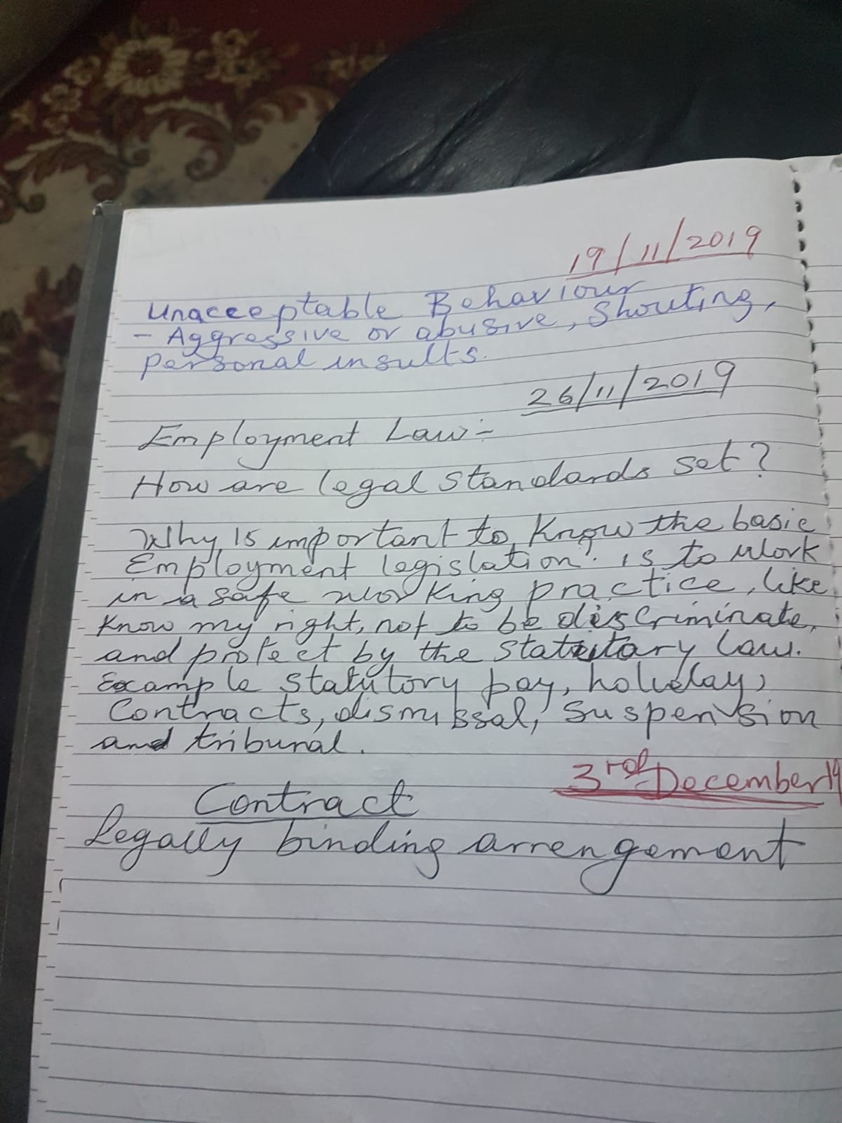
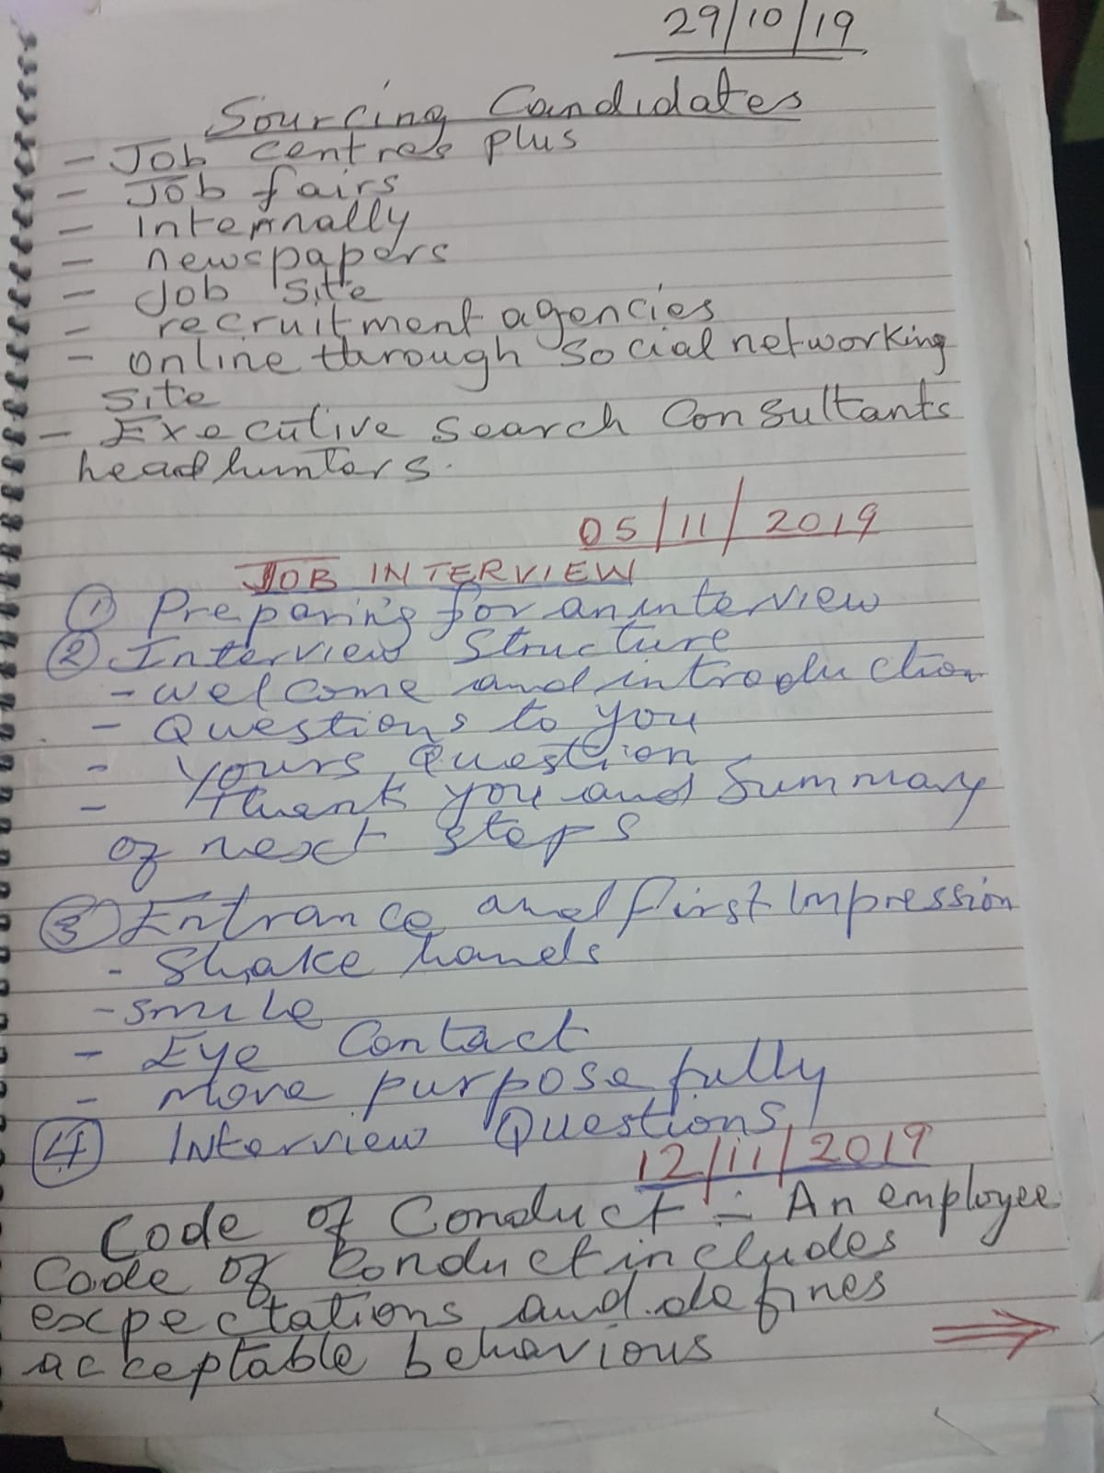
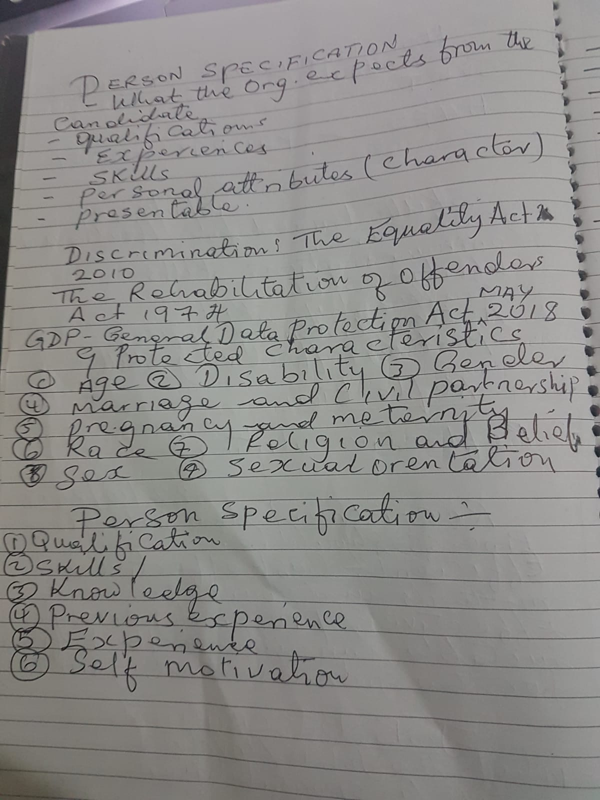

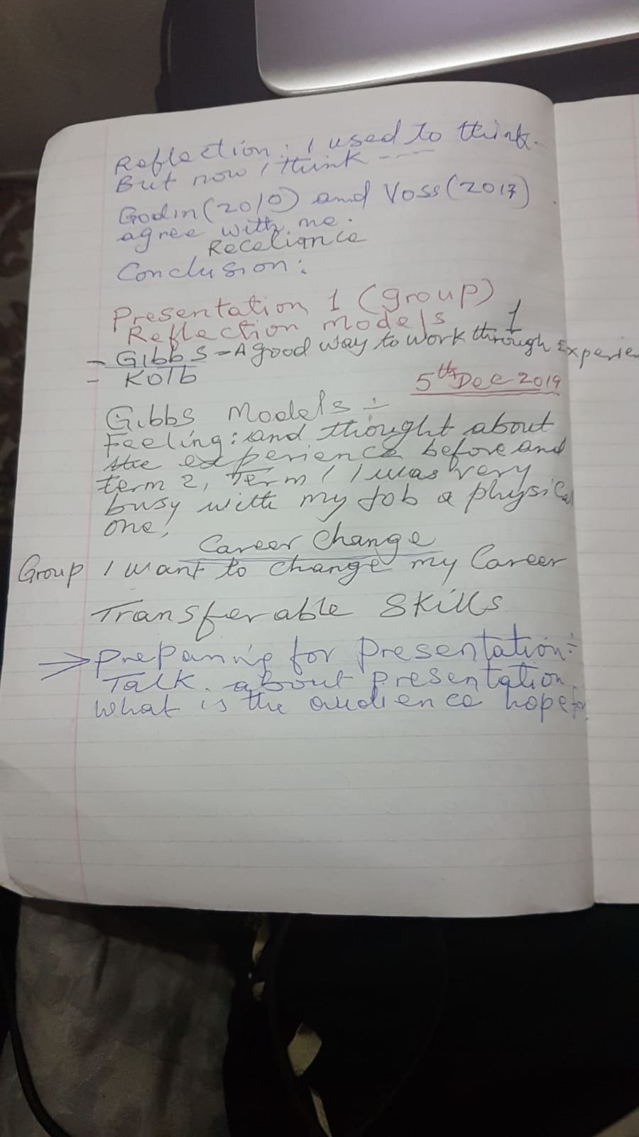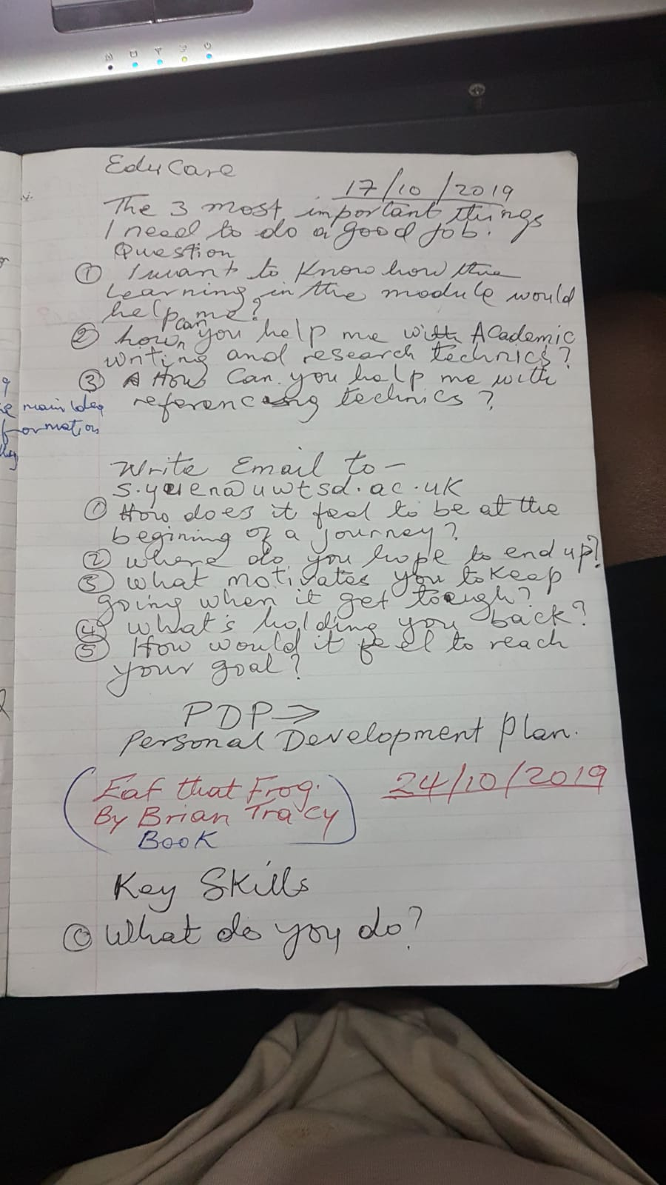

Role Play Slides



