DS 1 Template

My Screenshots/Photos

Screenshot/Photo 1
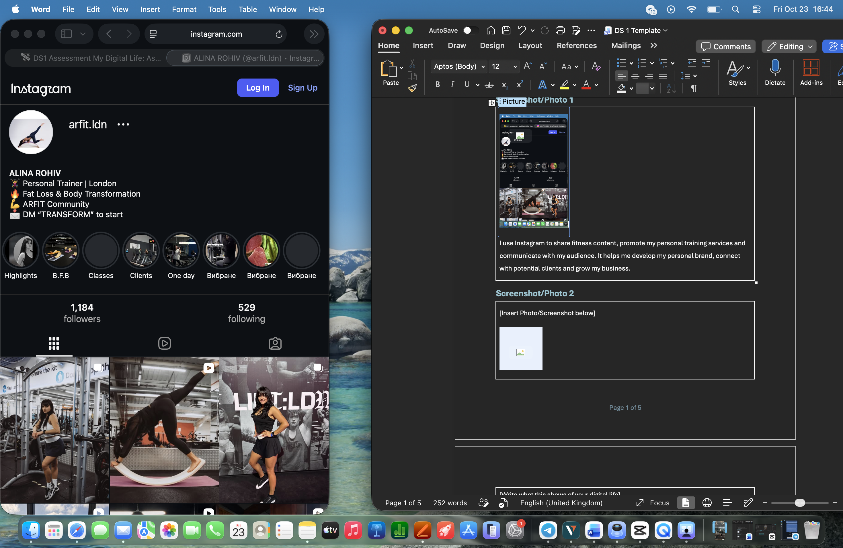
I use Instagram to share fitness content, promote my personal training services and communicate with my audience. It helps me develop my personal brand, connect with potential clients and grow my business.

Screenshot/Photo 2
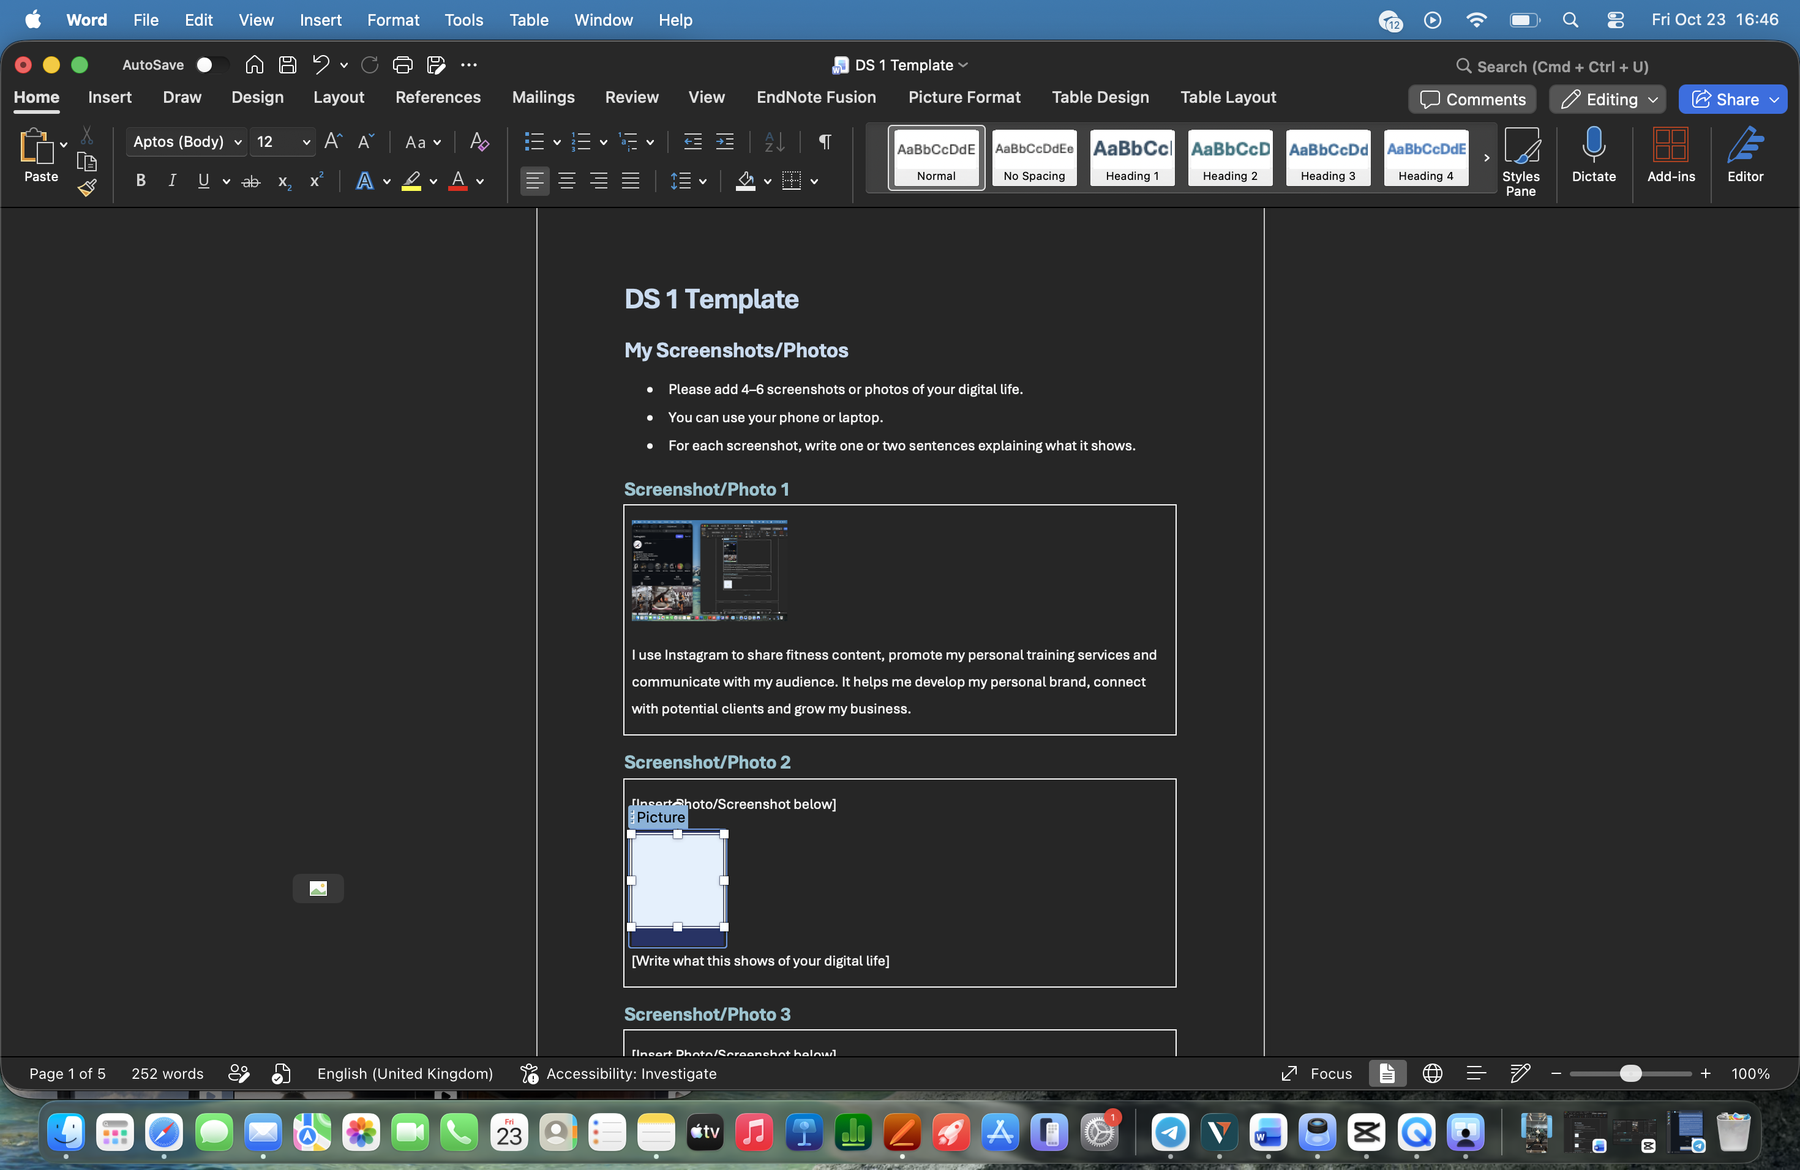
I use Microsoft Word to complete my university assignments and create professional documents for my personal training business, including client contracts and training plans. It helps me organise information, develop my writing skills and present my work professionally.

Screenshot/Photo 3
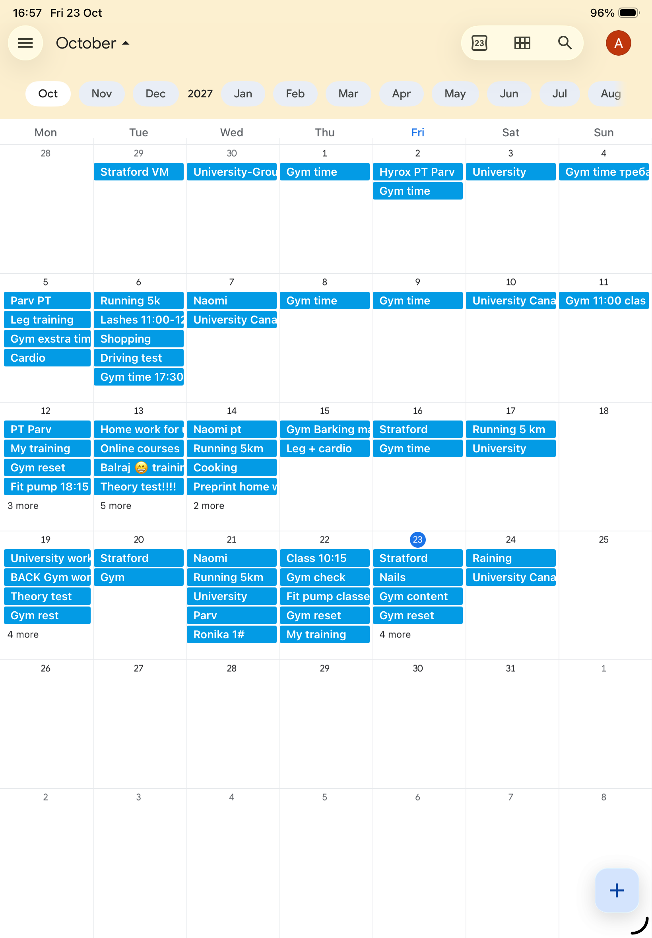
I use Calendar every day to organise my busy schedule, including university classes, personal training sessions, group fitness classes and personal activities. It helps me manage my time effectively, avoid overlapping appointments and maintain a good balance between work, education and personal life.

Screenshot/Photo 4
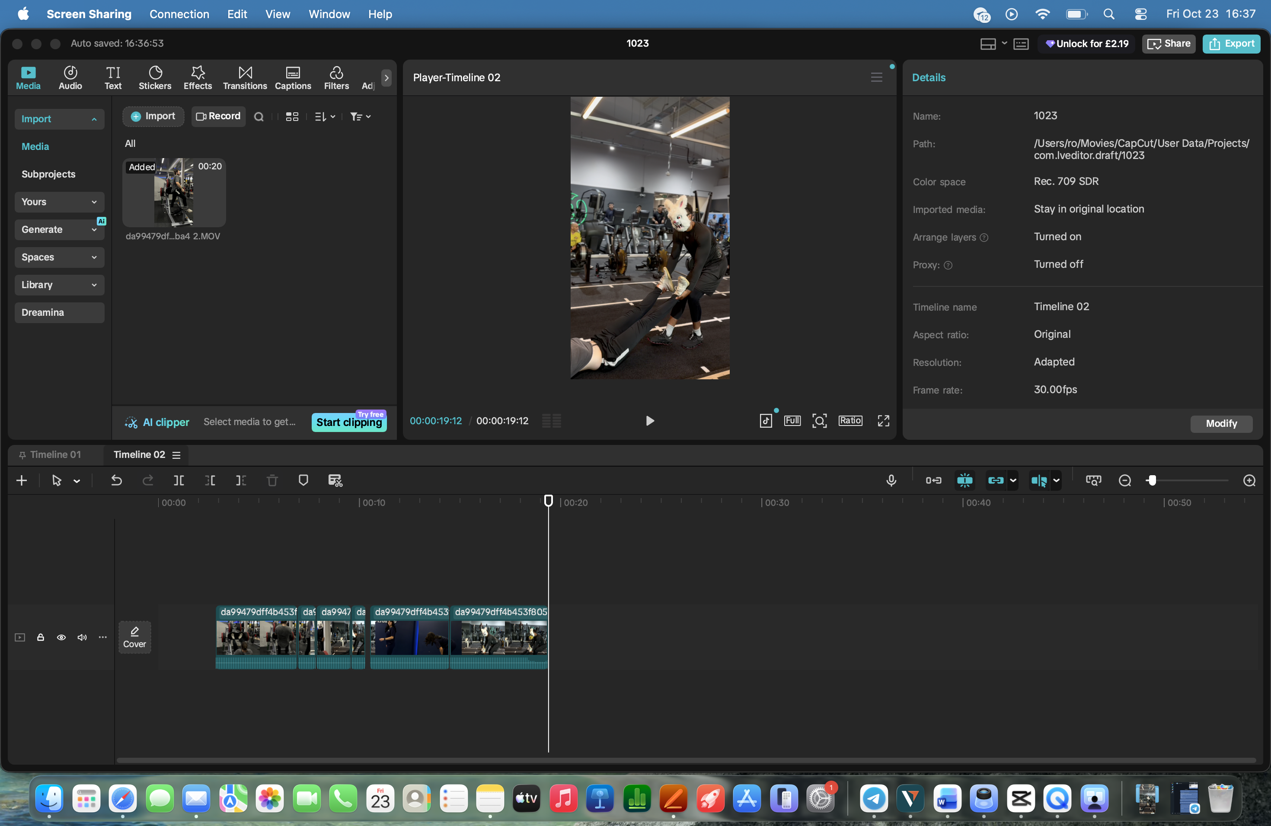
I use CapCut to edit fitness videos and create engaging content for social media. I add music, text, transitions and visual effects to make my videos more professional. This helps me promote my personal training services, attract new clients and develop my digital marketing skills.

Screenshot/Photo 5
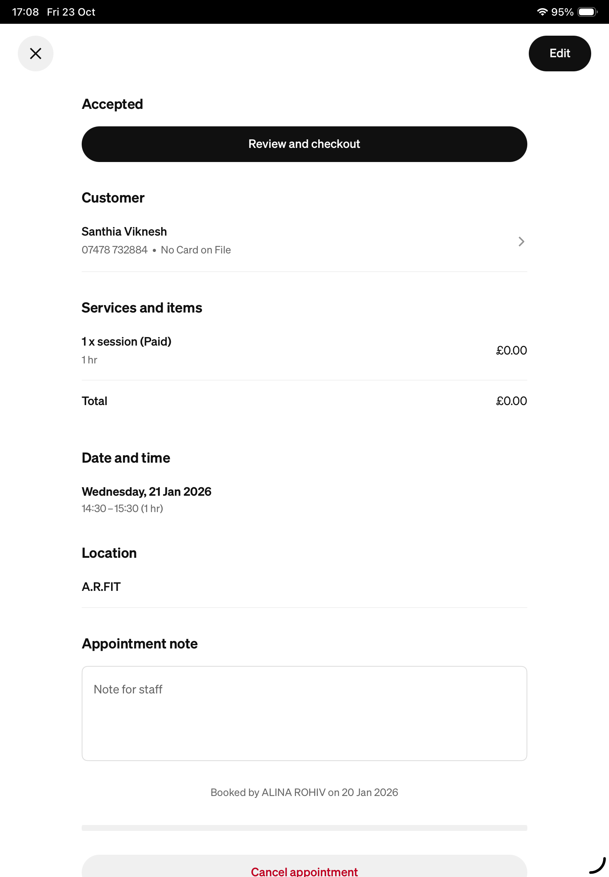
I use Appointment to manage my personal training bookings and communicate with my clients. I send appointment confirmations with the date, time and location of each session. This helps me stay organised, avoid scheduling mistakes and provide a professional service. It also makes managing my fitness business easier and more efficient.

My Short Reflection
Digital technology plays an important role in my everyday life, studies and career as a personal trainer.
I use Instagram to promote my fitness services, CapCut to create videos, Calendar to organise my schedule, and Appointment to manage client bookings. I also use Microsoft Word for my university assignments and professional documents.
I feel confident using social media, communicating with clients and creating digital content. These skills help me develop my personal brand and manage my work more effectively.
However, I would like to improve my Microsoft Office skills, especially Excel, and learn more about digital marketing and business management.
In the future, I would like to open my own fitness studio. I believe improving my digital skills will help me manage my business, attract clients and achieve my professional goals.

