
Name: Chandanpreet kaur

Student id: 2227261

Module Title: | Dissertation
Module Code: | LCMB7020
Course: | MASTER OF BUSINESS ADMINISTRATION IN GENERAL MANAGEMENT
Dissertation Topic: | The impact of influencer marketing on consumer purchase decision in the Sportswear industry.
Lecturer: | Dr. Jaya Gopalkrishnan

Master’s Degrees by Examination and Dissertation
Declaration Form.
1. This work has not previously been accepted in substance for any degree and is not being concurrently submitted in candidature for any degree.
Signed: Chandanpreet kaur
Date : 09-02-2024

2. This dissertation is being submitted in partial fulfilment of the requirements for the degree of Master in Business Administration.
Signed : Chandanpreet kaur
Date : 09-02-2024
3. This dissertation is the result of my own independent work/investigation, except where otherwise stated.
Other sources are acknowledged by footnotes giving explicit references.
A bibliography is appended.
Signed: Chandanpreet kaur
Date: 09-02-2024

4. I hereby give consent for my dissertation, if accepted, to be available for photocopying, inter- library loan, and for deposit in the University’s digital repository
Signed :Chandanpreet kaur
Date : 09-02-2024

Supervisor’s Declaration.
I am satisfied that this work is the result of the student’s own efforts.
Signed : Dr. Jaya Gopalkrishnan
Date: 09-02-2024

University of Wales: Trinity Saint David
E-Thesis Deposit Agreement

Details of the Work
I would like to deposit the following item in the digital repository maintained by the University, and/or in any other repository authorized for use by the University:

Title: the impact of influencer marketing on consumer purchase decision in the sportswear industry
This item is a product of my own research endeavours and is covered by the agreement below in which the item is referred to as “the Work”. It is identical in content to that deposited in the Learning Resources Centre, subject to point 4 below.
I agree that the University of Wales: Trinity Saint David may electronically store, copy or translate the Work to any approved medium or format for the purpose of future preservation and accessibility. The University is not under any obligation to reproduce or display the Work in the same formats or resolutions in which it was originally deposited.
UW: TSD Digital Repository
I understand that work deposited in the digital repository will be accessible to a wide variety of people and institutions, including automated agents and search engines via the World Wide Web.
I understand that once the Work is deposited, the item and its metadata may be incorporated into public access catalogues or services, such as national databases of electronic theses.

I agree as follows:
- That I am the author or have the authority of the author/s to make this agreement and do hereby give the University of Wales: Trinity Saint David the right to make available the Work in the way described above.
- That the electronic copy of the Work deposited in the digital repository and covered by this agreement, is identical in content to the paper copy of the Work.
- That I have exercised reasonable care to ensure that the Work is original, and to the best of my knowledge, does not breach any laws including those relating to defamation, libel and copyright.
- That I have, in instances where the intellectual property of other authors or copyright holders is included in the Work, gained explicit permission for the inclusion of that material in the Work, and in the electronic form of the Work as accessed through the open access digital repository, or that I have identified and removed that material for which adequate permission has not been obtained and which will be inaccessible via the digital repository
- That University of Wales: Trinity Saint David does not hold any obligation to take legal action on behalf of the Depositor, or other rights holders, in the event of a breach of intellectual property rights, or any other right, in the material deposited.
- That I undertake to indemnify the University of Wales: Trinity Saint David against all actions, suits, proceedings, claims, demands and costs occasioned by the University in consequence of any breach of this agreement

Signature: Chandanpreet kaur
Date: 09-02-2024

Abstract
In this age of social media dominance, the stage between influencer marketing and consumer behaviour has become a critical field of research especially in sportswear industry. This research investigates the refined power of influencer marketing in consumer purchase decision-making by adopting a mixed methods approach that provides an all-round view on how social media influencers influence brand insights and buying behaviours. By applying quantitative analysis, such as ANOVA and regression analysis of data collected from 53 participants, and qualitative thematic analyses this research shows the importance for engagement frequency with influencers on social media in establishing consumer trust while also detailing how the authenticity affects the consumer trust.
The research shows that Instagram is the main social media platform for sportswear influencer engagement. Quantitative findings show a strong relationship between the frequency of influencer engagement and an increase in trust towards sportswear brands, which consequently affects consumer behaviour. Quantitatively, the critical nature of authenticity, sincere engagement and relevance emerges qualitatively with consumers preferring influencers whose endorsements appear to be genuine as well as based on their values.
Based on these findings, the dissertation provides practical recommendations for sportswear brands focusing on authenticity in influencer collaboration, building long-term collaborations between a brand and an influencer to ensure effective campaigns. The study also emphasizes the need for storytelling, user-generated content and multi-platform strategies to increase consumer engagement as well as trust. This research gives helpful information to marketers who are trying to understand the dynamics of consumer engagement in a digital environment, emphasizing how authenticity and strategic partnerships with influencers can help shape purchase decisions.

Acknowledgement
I like to convey my deepest appreciation to my supervisor Dr Jaya Gopalkrishnan for guiding and providing feedback throughout this study.
I am indebted to my colleagues and friends who supported me and assist me in gathering prerequisites for my study. Finally, I am grateful to my family for helping me complete my education and supporting me throughout the journey.
Your Signature: Chandanpreet kaur
Date:09-02-2024

Table of Contents
Abstract 6
Acknowledgement 7
List of Tables 11
Chapter 1: Introduction 12
1.1 Introduction 12
1.2 Research Background 12
1.3 Research Rationale 14
1.4 Research Aim and Objectives 15
1.4.1 Research Aim 15
1.4.2 Research objectives 15
1.5 Research Questions 15
1.6 Research Significance 16
1.7 Research scope 16
1.8 Research gap 17
1.9 Chapter overview 17
1.10 Summary 17
Chapter 2: Literature Review 19
2.0 Chapter Introduction 19
2.1 Conceptual Framework 19
2.2 Concept of influencer marketing in the context of the sportswear industry 19
2.3 Impact of influencer marketing in increasing customer purchasing decision 22
2.4 Challenges facing by sportswear industry in opting for influencer marketing 24
2.5 Recommendation strategies for effective utilisation of influencer marketing in attracting purchasing decision of customers 26
2.6 Theoretical Perspectives 28
2.6.1 Parasocial interaction theory 28
2.6.2 Social influence theory 30
2.7 Gap in Literature 32
2.8 Chapter Summary 32
Chapter 3: Research Design and Methodology 33
3.1 Introduction 33
3.2 Research Philosophy 33
3.3 Research Approaches 34
3.4 Research Design 34
3.5 Research Strategy 35
3.5.1 Type of Investigation 35
3.5.2 Choices 36
3.6 Sampling Method 36
3.6.1 Sample Type 36
3.6.2 Sample Size 37
3.6.3 Sampling Method 37
3.7 Data Collection Method 37
3.8 Data Analysis Plan 38
3.9 Ethical Considerations 39
3.10 Research Limitations and Accessibility Issues 40
3.11 Conclusion 40
Chapter 4: Data Analysis and Discussion 42
4.1 Introduction 42
4.2 Data Analysis Plan 42
4.3 Survey Analysis 43
4.3.1 Quantitative analysis 43
4.3.2 Inferential Statistics 44
4.3.3 Qualitative Analysis 50
4.4 Discussion 54
4.5 Summary 56
Chapter 5: Conclusions and Recommendations 57
5.1 Introduction 57
5.2 Conclusion 57
5.3 Recommendations 59
5.4 Research Limitations 60
References 62
Appendix 71
Quantitative Survey 71
Qualitative Survey 73
Google form Questions……………………………………………………………………..89

List of Tables
Table 4.1: Descriptive Statistics of Trust by Influencer Engagement Frequency 38
Table 4.2: ANOVA on Influencer Endorsement Impact on Brand Trust 39
Table 4.3: Trust and Influencer Followers Correlation 41
Table 4: Summary of Trust Impact on Purchases Regression 42
Table 4.5: ANOVA of Trust's Predictive Power on Purchasing 42
Table 4.6: Coefficients of Trust Influence on Purchasing 43

Chapter 1: Introduction

1.1 Introduction
Influencer marketing is the effective collaboration with famous social media users for promoting the products and services of an organisation in reaching maximum customers. The research focuses on estimation of the impact of influencer marketing on purchasing decisions of customers in organisations from the sportswear industry. The overall research process is developed by following the both “primary quantitative and” “secondary qualitative data” in analysing customers purchasing behaviour corresponding to influencer marketing. The research estimates effective recommendations for improving marketing performance through collaboration with influencers in the sportswear industry.

1.2 Research Background
Influencer marketing refers to the process of driving brand messages to the target customers through collaboration with influencers in the society. Influencer marketing provides an effective way of promoting a brand by encountering psychological factors of customers during making purchasing decisions. Influencers refer to a person having the ability to sway the purchasing decision of people through the audience's reach. Influencer marketing is effective in increasing purchasing decisions of customers by 88% by increasing authenticity with the influencers (forbes.com, 2024). An influencer can be an athlete, public figure, well-known celebrity and social media influencers. The influencer marketing is led by the multiplicative effect by attracting a smaller group of people to influence others in the market segment of an organisation. Influencer marketing allows reaching a targeted customer base with the audience reach of the selected influenced person by organisations.
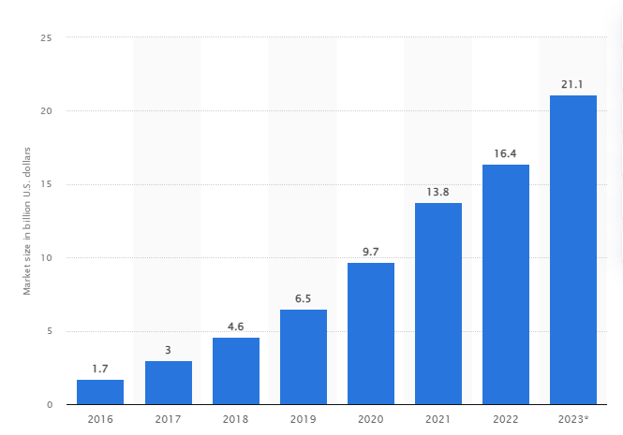
Figure 1.1: Increasing of influencer marketing globally
(Source: statista.com, 2022)
The graph addresses increasing value of the influencer marketing globally with time for improving sales performance of organisations. The application of influencer marketing is increasing rapidly in the global market with the acceptance rate of 76.9% globally (economictimes.indiatimes.com, 2023). Inflector marketing is increasing in the sportswear industry through using the influences of renowned sports persons for attracting customers to enhance the sales rate. Moreover, on social media platforms people like to share corresponding perspectives and beliefs about products and brands that influence others to make purchasing decisions. The global sportswear industry is growing rapidly and was valued as $182.01 billion in 2022 that is expected to grow by 6.72% till 2030 (fortunebusinessinsights.com, 2022). The application of influencer marketing develops the growth rate of the sportswear industry with the increasing purchasing decision of its targeted customers. Therefore, adoption of influence marketing is beneficial for attracting psychological behaviour of customers with the message provided by the influencer.

1.3 Research Rationale
The development of social media branding strategy influences buying behaviour of customers with creating emotional connection. The main issue is identifying the factors influencing purchasing decisions of customers corresponding to a product and service. The quality and price is insufficient to give the answer of influencing factors in customers’ purchasing decisions. The adoption of influencer marketing is effective to motivate the customers irrespective of quality and price of products in the sportswear companies. Development of influencer marketing strategy impacts the business value of sportswear companies with the increasing customers’ motivation to purchase products from it. Moreover, with the application of influencer marketing, sportswear companies can attract 71.20% of the effective internet users with social media profiles (forbes.com, 2024). The customers’ behaviour shifted towards social media platforms with the following rate and viewere’s base of brands. Hence, the research focuses on estimation of impact of the influencers marketing approach in attracting customers’ purchasing decisions.
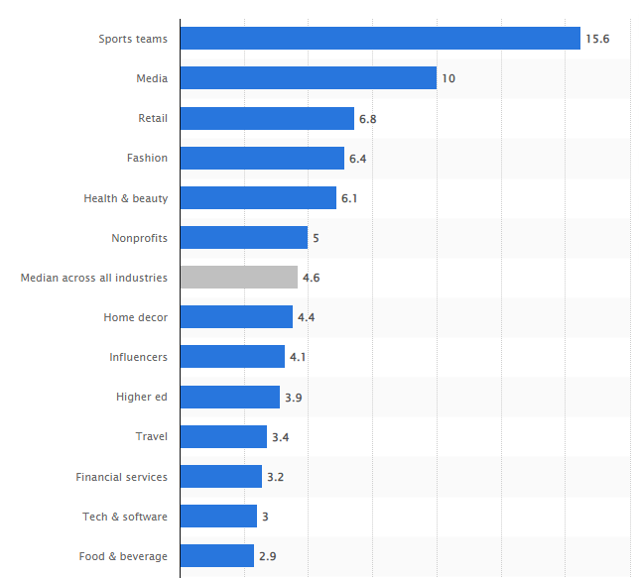
Figure 1.2: Application of influencer marketing by sportswear brands
(Source: statista.com, 2023)
Influencer marketing increases in sportswear companies by increasing the social media impact value of organisations. Multiple sports organisations such as Nike, Puma, Rebook, Fila and Lululemon increased application of influencer marketing by developing brand values in the global market. The research introduced strategies for developing influencer marketing in sportswear companies to increase purchasing decisions of customers. Moreover, people like to buy products by getting confirmation from corresponding sportspersons. Sportswear organisations can develop inflector marketing to attract a broader customer base with the audience group of selected influencers. The influencer marketing strategy eliminates the issue of selecting a target audience in social media marketing by organisations. The research developed strategies for influencer marketing in sportswear companies with the application of influenced sportspersons. Hence, the research solves the issue of identification of potential customers through the influencer marketing in increasing sales performance by developing purchasing decisions of customers.

1.4 Research Aim and Objectives

1.4.1 Research Aim
The research aims to find out the effective impact of “influencer marketing approach” in the purchasing decisions made by customers in the sportswear industry for developing business value.

1.4.2 Research objectives
The key objectives of this research are
- To find key approaches of “influencer marketing” concerning to the sportswear industry
- To investigate the impact of influencer marketing on the decision-making process of customers of the sportswear industry during purchasing
- To examine challenges faced by sportswear industry for developing influencer marketing
- To recommend strategic process of effective application of the influencer marketing in attracting purchasing decision of customers in the sportswear industry

1.5 Research Questions
- What are the key approaches of influencer marketing concerning the sportswear industry?
- What is the impact of influencer marketing on the decision-making process of customers of the sportswear industry during purchasing?
- What are the challenges faced by the sportswear industry for developing influencer marketing?
- What is the strategic process of effective application of influencer marketing in attracting purchasing decisions of customers in the sportswear industry?

1.6 Research Significance
The research is significant as it conveys information about customer attraction within sportswear companies with the adoption of influencer marketing. The analysis of impact on influencer marketing in psychological behaviour of customers can describe corresponding impact on organisations. Sportswear industry faces stiff competition with the increasing market value globally that requires differentiation between barn recognition. Adoption of influencer marketing is effective in increasing brand visibility over social media platforms for attracting customers (Janson, 2023). For example, Nike has applied influencer marketing in 2020 with the Instagram posts of “Cristiano Ronaldo” and increased the social media impact by $4.12 million (forbes.com, 2021). On the other hand, application of influencer marketing improves brand value with development of its social media impact value.
The research is significant as it conveys information about the marketing strategy efficiency with the influencer marketing in increasing brand value with customer acquisition. Moreover, with the adoption of influencer marketing the social media content enriched with brand message to the target customers with brand positioning (Ooi et al., 2023). The research is beneficial as it conveys information about strategic positioning of sport brands by empowering the marketing campaigns in social media platforms. The sportswear industry has increased the application of social media advertising by 86% to improve marketing campaign’s efficiency (forbes.com, 2021). Therefore, the research is significant in developing effective marketing strategy with influencing the purchasing decision of customers through selected influencers.

1.7 Research scope
The research is carried out with the secondary method by collecting qualitative data for achieving the objectives of finding impact of influencer marketing on customers’ purchasing decisions. The research has a future scope of developing the marketing performance of sportswear companies in attracting maximum customers globally with the application of recommended strategies. The findings of this research can be applied for further study about the implementation strategy of influencer marketing in attracting more customers. Thus, this research work has scope of application in further study and in sportswear organisation for developing effective marketing decisions based on customers’ purchasing decisions on social media platforms (Mandarić, Hunjet and Vuković, 2022).

1.8 Research gap
The research has a knowledge gap in developing the theoretical connection between the customers’ psychological behaviour and influencer marketing in increasing business value. This research has limited resources for describing the relationship between the purchasing decision of customers and business operation in a particular sector (Zak and Hasprova, 2020). The research gap lies in defining the factors influencing customers purchasing decisions in sportswear companies globally. The research fails to define the negative impact of influencers marketing on sportswear organisations that lowers brand value. Hence, the research gap consists in the analysis process with the consideration of one type of data for evaluating link between influencer marketing and purchasing decision of customers (Chu, 2023).

1.9 Chapter overview
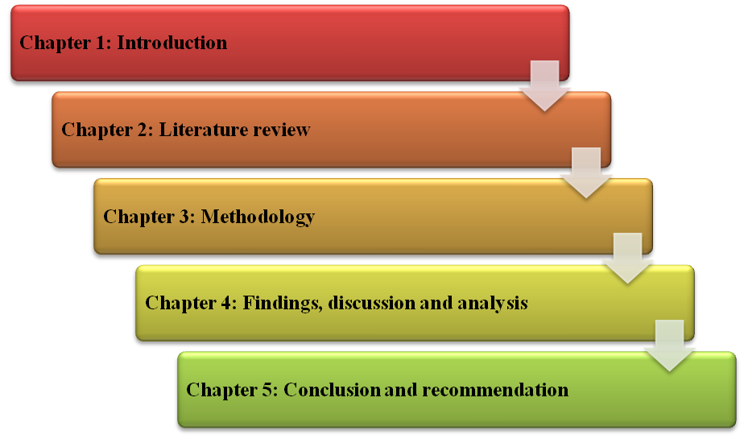
Figure 1.3: Chapter overview of the dissertation
(Source: Self-created)

1.10 Summary
The research focuses on developing connections between influencer marketing and purchasing decisions of customers in the sportswear industry. This chapter provides background analysis of the inflector marketing connecting to the sportswear industry for defining the scope of the research. It is summarised that application of influencer marketing is effective in connecting the customers with the brand message over social media platforms. The application of influencer marketing is increasing globally with development of customer acquisition. The research is developed with qualitative analysis for finding historical data about the application of influencer marketing on the sportswear industry.

Chapter 2: Literature Review

2.0 Chapter Introduction
The literature review has provided information about the customer awareness due to influencer marketing on analysis of pre-determines data based on existing sources. The review of literature sources in this chapter developed knowledge about the impact of influencer marketing on the customer purchasing decision in the sportswear industry. The contemporary literary sources have addressed the impact of influencer marketing on the customer purchasing intention in the sportswear industry. The implication of using influencer marketing in the customer engagement and purchasing intention in the sportswear industry is mentioned in this chapter by analysing predetermined data. This chapter provided the theoretical perspective of the implication of influencer marketing in the sportswear industry to influence the customer's intention to purchase the product. This chapter provides information about the recommendation strategies for influencer marketing of a sportswear brand based on analysis of pre-existing data.

2.1 Conceptual Framework
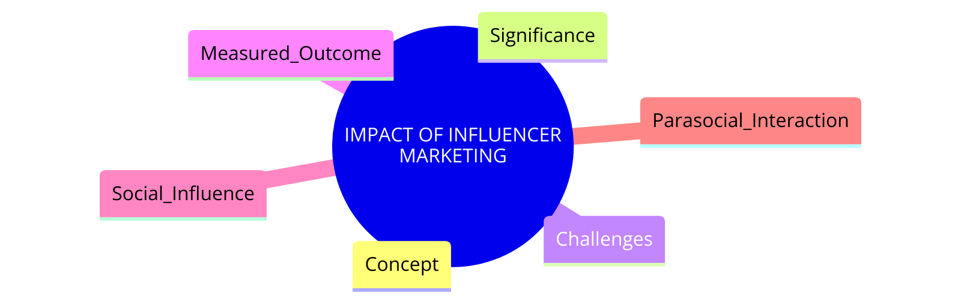
Figure 2.1: Conceptual Framework
(Source: Self-created)

2.2 Concept of influencer marketing in the context of the sportswear industry
The concept of influencer marketing can be defined as a type of social media marketing involving product placements from influencers. The influencers in the target market help the brand to promote its product in the social media platform in a larger population and enhance the product reach. As per the view of Campbell and Farrell (2020), influencer marketing can be defined as the practice of compensating individuals for the purpose of social media posts related to the product and service. The small businesses in the sportswear industry are struggling to enhance the customers in the global market through social media due to lack of reliability on the product. However, the use of engaging social media content and consumers interacting through the influencer marketing creates an impact on sportswear business. Moreover, the use of influencer marketing in the sportswear industry helps to create products and offers awareness among the online customer base. As mentioned in the report of Haenlein et al. (2020), Influencer marketing is used by sportswear brands such as Nike to inspire the community with the recommendation of influencers. Thus, recommendation of products of a particular brand by famous has influencers with huge followers in social media influence the customer purchasing intention.
The influencer marketing in the sportswear industry is the way to enhance the brand exposure in the global market through the use of social media posts by influential individuals. The individuals with a significant online presence are partnered with sportswear businesses to promote the products to its larger follower’s base. As per the view of Masuda et al. (2022), businesses are investing in influencer marketing by collaborating with social media influencers to influence the consumers’ purchasing behaviour over traditional marketing. The use of influence marketing is in high demand in the sportswear industry due to perceiving trustworthiness and expertise provided by the social media influence. Social media influencer marketing is similar to the use of celebrities for advertising the product and service in the traditional mass media. However, the degree of engagement with the audience in the influencer marketing is higher than traditional celebrity endorsement developed by a sportswear business. As per the report of Lee and Kim (2020), successful influencer marketing on Instagram endorsed by sports brands use athletes and social media influencer to enhance product endorsement. The sports brand paid social media influencers to upload promotional posts on the media channels to influence the purchasing decision of the target customer in the online market. Thus, it is important for the sportswear business to increase the use of influencer marketing to enhance the customer trust on the product and service provided to the target population.
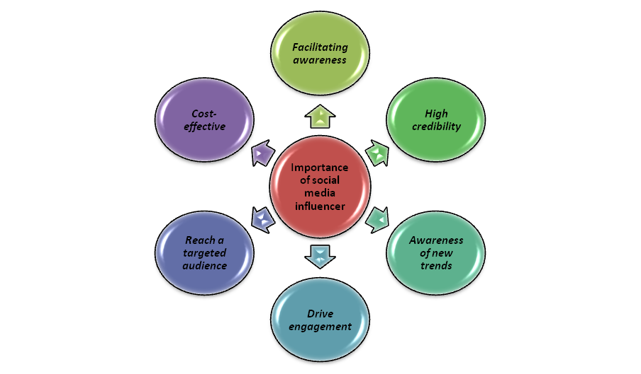
Figure 2.2: Importance of social media influencer on development of a sportswear business
(Source: Self-created)
The integration of influencer marketing in the business operation of sportswear brands helps to increase brand exposure to a larger population in the global market. The posting of social media content by famous influencers for promoting a particular product and services helps to create awareness about the special feature to influence the purchasing behaviour. As mentioned in the report of Chopra et al. (2023), successful influencer marketing implicated by business involves the identification of the right influencer to curate advice and suggestions. The particular brand of sports shoes recommended by an influencer and professional dancer on social media enhance the trust level of the potential customers. The influencers followed by the sports athletes across the globe have the better potential to promote the product of a sportswear brand to influence the customer's purchasing motive. On the other hand, influencer marketing limited the customer engagement to the specific product offered by a sportswear brand in the global market. As per the report of Martínez-López et al. (2020), the better understanding of consumers’ responses to influencer marketing is an important part to determine the impact of brand recommendation. Thus, the increase of the brand recommendation by the influencers such as sport athletes in social media influences the customer behaviour and engagement through effective content post.

2.3 Impact of influencer marketing in increasing customer purchasing decision
Increased Brand Awareness among sportswear industry
Influencer Marketing in Sportswear Industry
• Influencers are paid to create and share content for recommending products and services of sportswear brands.
• As mentioned in the report of Andreani et al. (2021), Social media influencers enhance consumer recognition of brands in competitive markets.
• Influencers collaborate with sportswear brands to increase buying interest and product awareness.
• Influencers post about unique product features on social media platforms like Instagram and Facebook.
• As per the view of Tanwar et al. (2022), The main objective of influencer marketing is to increase brand awareness and reach new audiences.
• Frequent posts by influencers increase customer awareness, thereby increasing product sales in the global market.

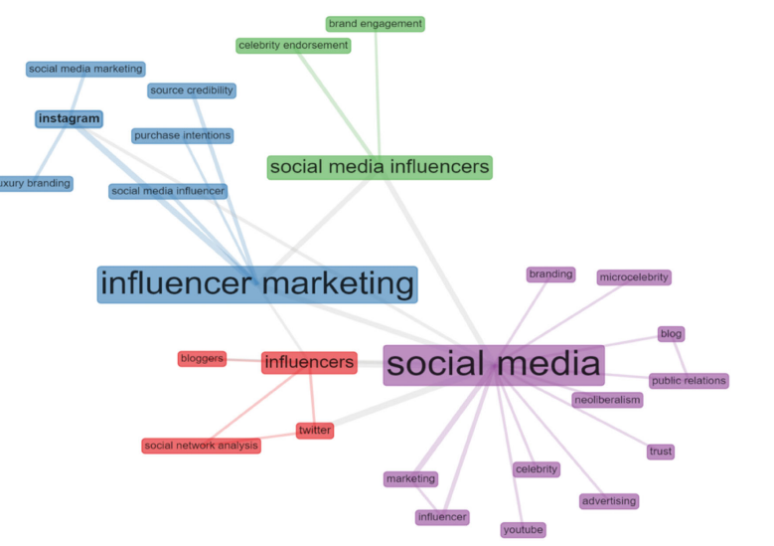
Figure 2.3: Impact of using influencer marketing through social media by a business
(Source: Tanwar et al. 2022)
Building a relationship of trust with the customer in sportswear industry
Influencer Marketing in Sportswear Industry
• Incorporates special media posts showcasing real-life product usage.
• Influencers create positive customer relationships through social media posts.
• As mentioned in the report by Leung et al. (2022) report highlights influencers' large followings enhancing customer relationships.
• Influencer marketing has increased in the sportswear industry, promoting positive customer relationships.
• Negative influencer reviews can impact product purchase rates.
• As per the view of Belanche et al. (2021), ), message conveyed by an influence in the social media platform creates a negative impact on the customer attitudes toward the brands.
• Social media platforms allow influencers to share product opinions, influencing relationship building.
• Development of a positive relationship with customers by a sportswear brand through influencer marketing is an important part in the business development in the global market.

Cost-effective advertising strategy in influencing customer purchasing decision
The use of social media influencer in marketing by a sportswear brand over traditional media marketing has reduced the scope of additional cost in marketing. The cost associated with influencer marketing is much lesser than the traditional marketing helping a sportswear brand to reach larger customers in a cost effective way. As per the report of Mallipeddi et al. (2022), the budget of influencer marketing is associated with the cost of hiring an influence based on followers and social media presence. The large number of followers in the social media accounts of an Influencer determines the cost of collaboration with sportswear brands. Makeover, influencer marketing can be a cost-effective marketing strategy by a sportswear business having budget constraints rather than traditional advertising channels to influence customer purchasing decisions. As per the view of Taylor (2020), influencer marketing is associated with cost per thousand exposures (CPM) in case of micro-influencer to enhance the customer engagement. The businesses in the sportswear industry are using influencer marketing to create an impact on the purchasing decision of the customer as it saves time and cost. Thus, the reduction of marketing cost by incorporating influencer marketing helps to influence customer base and enhance business profitability.

2.4 Challenges facing by sportswear industry in opting for influencer marketing
Poor campaign implementation by influencers to promote sportswear brand
The selection of right and effective content for the promotion of products offered by sportswear brands through influence marketing creates an impact on the custom purchase intention. The poor campaigning idea about the product crate and negative impact on customer base using social media creating an impact on the product sales. As per the view of Moustakas et al. (2020), poor strategy and idea to promote products offered by brand in virtual influencer marketing create an impact on customer engagement. The risk associated with the influencer marketing implicated by a sports brand is the effectiveness of the right digital content to justify the benefits of a product. On the other hand, the poor representation of the product on the virtual media by influencers creates an impact on the customer purchasing decision affecting business growth. As per the view of Femenia-Serra and Gretzel (2020), the lack of analysis of content of endorsers’ campaign of product state an impact on the creating customer engagement through social media posts. The lack of control over quality of the content development by an influence on the sportswear brand creates an impact on customer awareness. Therefore, the increase of customer engagement can be affected due to poor campaigning ideas implicated by influence collaborating with sportswear brands in the global market.
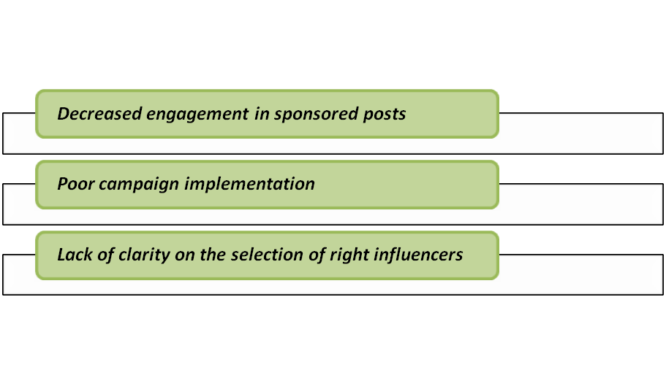
Figure 2.4: Challenges facing by a sportswear brand in the implication of influencer marketing
(Source: Self-created)
Lack of clarity on the selection of right influencers by businesses in sportswear industry
• The choice of the right influencer significantly influences customer awareness in the global market.
• As per the view of Weismueller et al. (2020), Lack of selecting right influencer selection can negatively affect product promotion and global exposure.
• Collaboration with influencers not related to sports industry can hinder customer purchasing decisions.
• The absence of suitable influencers can negatively affect marketing strategies and customer purchasing behavior.
• As mentioned in the report of Makrides et al. (2020), it suggests that selecting the right influencers directly addresses the target audience, leading to high conversion rates.
• Lack of selection of rights influenced by sportswear brands creates an impact on customer convection rate in the global market through effective marketing activities through social media campaigns.
Decreased engagement in sponsored posts related to product offers by sportswear brand
The decrease in social media influencer’s popularity in the global market has a direct impact on the engagement of the customer in sponsored posts based on sportswear brands. The popularity of influencer among the users of social media is unstable leading to creating impact on sponsored content to generate desired market reach. As per the report of Morton (2020), the level of success of the sponsored posts on social media for influencing customer purchase decisions is based on the influencers’ popularity. The reduction of engagement of influencer in the social media reduces the effectiveness of the sponsored posts related to the product and service offered by sportswear industry. The decrees in the engagement of the customer due to unreliable content created by influencers create a negative impact on the brand image of a sportswear brand in the online market. As per the view of Belanche et al. (2021), diffusion and popularity of accounts managed by influencers create an impact on engagement of the customer in social media promotion. The lack of conveying the brand message properly through sponsored posts by influence fails to meet desired market reach aims by a sportswear brand. Thus, the lack of content clarity in the sponsored posts leads to reduction of influence of purchasing behaviour of customers through influencer marketing.

2.5 Recommendation strategies for effective utilisation of influencer marketing in attracting purchasing decision of customers
Creation of authentic influencer content to enhance brand value among the target customers
The use of authentic content promoted by collaborated influencers in the online market enhances the brand value among the customer. The delivery of right and authentic information about the products offered by a sports brand through influencer marketing may create a positive impact on customer buying intention. As per the report of Wellman et al. (2020), the authenticity of sponsored content by a business helps to meet the ethical aspect in social media to enhance brand reputation. The providence of right information about the consist and feature of product by influencer in sponsor post create a positive impact on the customer engagement and brand reputation. Additionally, increase of customer engagement in campaigns started by influencers collaborating with sportswear brands influence the buying and conversion rate. As mentioned in the article by Van Driel and Dumitrica (2021), the increase of authenticity of the influencer’s presentation hence the effectiveness of marketing campaigns to enhance brand reputation. Authenticity of the social media content thorough recommendations delivered by the influencer based on the service and product offered by sportswear company influence the customer engagement. Thus, the increase of content authenticity by influencers as well as brands in the sportswear industry may create a positive impact on brand value influencing customer buying intention.
Needs to focus on development of engaging content rather than simply advertisements
The marketing approach of a sportswear brand is focusing on advertisement of the product through the collaboration of influencers by posting about the product experience. However, lack of initiative of market and influencer to engage the customer in the online market reduces the customer's intention to purchase sports goods from a specific brand. As per the view of Lou (2022), the advertisement in the social media helps a business to create awareness about its market presence within the global market. On the other hand, increase of social media events with the collaboration of influencers creates an impact on the customer engagement. As per the report of Van der Vegt et al. (2021), influencer organises online events with the collaboration of brands to increase customer interaction and engagement on the product offered. The increase of the marketing campaign rather than regular banner ads enhances the market reach of sportswear brands among the target global audience. Thus, interactive campaigns by influencers in the online market enhance the brand value of a business in the sportswear industry to create a positive impact on customer purchasing behaviour.
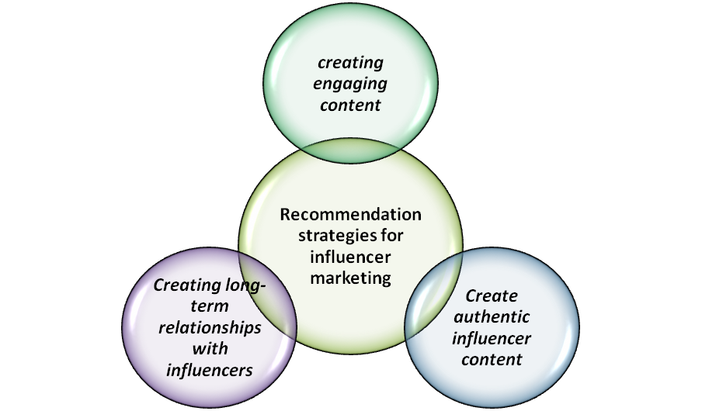
Figure 2.5: Recommendation strategies for influencer marketing implicated by Sportswear brand
(Source: self-developed)
Creating long-term relationships with influencers for exposure in Sportswear industry
- Long-term relationships between sportswear brands and influencers positively impact brand value.
- As per the view of Ibáñez-Sánchez et al. (2022), Positive reviews of products by influencers creates an impact on product sales of a business.
- Social media campaigns enhance brand's online presence.
- The creation of strong relationships helps the brand to have market exposure and build trust within the target population in sportswear brands.
- As per the view of Acikgoz and Burnaz (2021), Influencers provide market exposure by delivering business objections to promotions.
- Positive relationships with social media influencers increase global brand market exposure.
- the increase of the market exposure of a Sportswear brand among the global customer depends on the creation of a positive relationship with social media influencers.

2.6 Theoretical Perspectives

2.6.1 Parasocial interaction theory
Influencers marketing become a dominant force for increasing purchasing decisions of customers with the development of brand loyalty. As per the view of Zhang and Hung (2020), parasocial interaction defines one-way communication with the customers through the “non-reciprocal relationship” with the inclusion of publicly known persons. The “parasocial interaction theory (PSI)” estimates emotional intimacy of customers with respect to the selected influencers. On the other hand, “word-of-mouth” branding strategy focuses on increasing brand recognition among customers with individual recommendations. According to Lu et al. (2023), the application of PSI increases endorsement effects from the selected celebrity figure in influencer marketing. PSI theory describes the social relationship of an influenced person with the audiences for applying the person in influencer marketing. Moreover, the customers' attitude towards products promoted by the influencers is influenced by the corresponding attitude to the influencer.
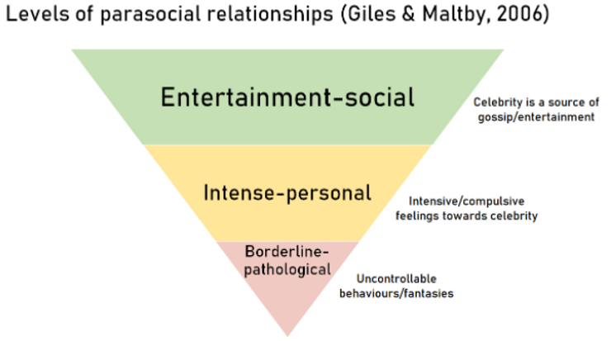
Figure 2.6: Levels of Parasocial Relationships
(Source: Giles & Maltby, 2006)
The PSI theory is defined by two factors and these are customers and the character considered for influencer marketing. The strength analysis of selected characters is necessary for defining the interest of corresponding customers to the promoted products and services. As per the report of Lu et al. (2023), PSI theory explains the imagined relationship between the customers and selected media characters for determining psychological impacts on the audiences. Moreover, with the analysis of consumer behaviour from the online media users organisations can develop influencer marketing with the PSI theory. The report of Penttinen et al. (2022) argued that PSI theory is an imaginary and one-sided concept in the context of influencer marketing that expects to increase customer’s acquisition. Moreover, parasocial relationships develop satisfaction, commitment and comfort to the audiences from the selected influencers. Measurement of the brand responses based on the PSI factors is necessary for increasing purchasing decisions of customers with influencer marketing. Hence, adoption of influencer marketing and the influenced body requires considering customers engagement and interaction for lowering risk of failure.
Parasocial interaction defines the relationship of influencers with corresponding customers in the mass media. The interlink between influencers and corresponding audiences can be defined with the analysis of perceived behaviour of audiences. As per the view of Kim (2022), parasocial interaction has positive influences in the purchasing decision of customers by creating physical attractiveness of products and services. Creation of social attractiveness is necessary for formation of parasocial interaction positively by connecting the audiences of influencers. As per the argument of Shen et al. (2022), parasocial interaction develops communication strategies between the audiences and selected virtual individuals. The character of the selected virtual individual is important in determining the purchasing decision of the customers through the branding message. Attitude of influencers impacts on the parasocial interaction with audiences positively for increasing corresponding attraction. Social media users like to follow compatible influencers to buy any products and services for getting a similar approach to the influencer. Hence, physical approaches of selected influencers have positive influences over the customer’s attractiveness in making affirmative purchasing decisions.

2.6.2 Social influence theory
Social influence is defined as the changes in emotional thinking and behaviour caused to an individual person over social media platforms that influence the decision-making process of audiences. The theory describes social influences for attracting purchasing decisions of customers through identification, internalisation and compliance. As per the view of Ciranka and van den Bos (2021), development of social influence provides long-term benefits to organisations with customer attraction. Moreover, social influences develop social learning to an organisation for increasing confidence of customers' attraction in the uncertain external environment. As per the argument of Ozuem et al. (2021), the level of customers’ engagement and involvement to a brand can be determined with influences of those customers over social media platforms. Hence, development of influencer marketing is beneficial in increasing long-term benefits to organisations with customer engagement.
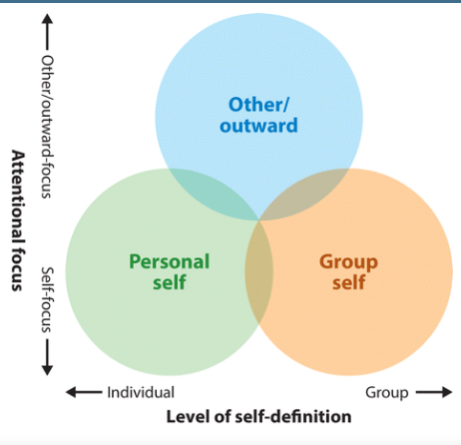
Figure 2.7: Integration of social influences
(Source: Spears, 2021)
The social influence describes group-self, other in the outward and personal self for determining the impact of influential consent to the audiences. This categorisation defines multiple audiences for attracting through self-focus and individual influences. As per the report of Spears (2021), social influence is beneficial for developing cognitive emotional connection with the customers through social media influencers. The concept of social influence is applied for defining psychological influences of customers corresponding to the social media contents. Organisations can apply self-definition and self-focus strategy of the social influence theory for increasing customers purchasing decisions. The improvement of self-focus within marketing strategy of organisation increases customer’s interest to view about its products and services. As per the view of Ozuem et al. (2021), “social influence theory” is effective for resolution of social conflicts among customers and any prejudice in developing customers' attractions. Moreover, application of social influences increases psychological factors such as emotions, attraction, attitude and motivation of customers. Henceforth, adoption of “social influence theory” is beneficial in attracting maximum customers to organisations with the increasing attraction with psychological encounter.
Social influences attract people towards particular brand messages with the increasing visibility of the organisation over social media platforms. According to Ajzen (2020), customers’ beliefs corresponding to a product and service can be influenced with social influences. On the other hand, understanding the behavioural form of customers is necessary for development of social influence models based on the products and services of organisations. The “social influence theory” is effective to understand the behavioural aspect of customers over social media platforms through the exposure rate based on influencers. Adoption of social influences approach is beneficial for organisations in increasing customer’s attraction to make corresponding purchasing decisions. Organisations can improve the brand value with the increasing of purchasing decisions of customer’s regarding the products and services offered with the social media message from influencers. As per the view of Argo and Dahl (2020), social influences create one-way communication with the customers by increasing purchasing decisions towards products and services of organisations. Hence, application of social influences increases customers' acquisition for making the purchasing decisions corresponding to the brand endorsement of organisations.

2.7 Gap in Literature
The review of literature is based on the determination of the impact of influencer marketing in fencing customer purchasing decisions by businesses in the sportswear industry. However, the gap in this chapter is that limited information about the negative impact of similar influencer marketing strategies by businesses in the compo motive sportswear industry (Fastenau, 2018).

2.8 Chapter Summary
It can be summarised that the implication of the innovative marketing strategies by business helps to enhance the customer awareness and influence the purchasing intention. The influencer marketing is an innovative strategy implicated by business in sportswear brands to enhance the customer reach and enhance product sales in the global market. The decrees in the consent quality create an impact on the engagement of the audience on online campaigns implemented in the global market. The increase of market awareness among the customer through influencer market helps sportswear brand to enhance the market share across the globe. Thus, it is important for a business to enhance const quality in influencer marketing to have high influence on the product purchase and business profitability.

Chapter 3: Research Design and Methodology

3.1 Introduction
The design and methodology of research used in the analysis on influencer marketing and consumer purchase decisions in sportswear are discussed in this chapter. Due to the nature of consumer behaviour and other components that comprise digital marketing strategies, an integrated approach was used in order for outcomes to be valid. The research was undertaken to determine the range and depth of influence that influencers have on target buyers, using a mixed-methods approach combining qualitative as well as quantitative analyses in order to provide an integrated perspective regarding the phenomenon under study.
The mixed method approach was critical in the addressing of research objectives by revealing some influencer approaches, this mixed method uses quantitative and qualitative analysis both. How they worked and what were challenges as well strategic processes within sportswear industry. Therefore, a questionnaire was employed and the data gathered in both quantitative forms to be analysed through SPSS as well as qualitatively by NVivo. This methodology permitted a fine-grained understanding of consumer perceptions and behaviours, thus providing information on the process driven by sportswear influencers. This section provides the philosophical underpinnings, research methodology used in designing and strategy as well sampling methods data collection procedures and analytic plan to ensure that all these are analysed adequately relative to questions posited (Ding et al., 2019).

3.2 Research Philosophy
According to pragmatic philosophy of research combining positivism and interpretivist, this study is based on the factors that affect purchase decisions from consumers in a sports apparel industry through influencer marketing. The positivism is realized through the use of quantitative analysis based on survey data, with statistic tools functioning as cold technic applications applied to objective scientific research and measurement – determination of customer behavioural aspects. By following this approach, it is taking the assumption of reality being extra linear and measurable thus giving rise to patterns which are quantitative and observable type for utilization of empirical evidence in their analysis.
On the contrary, interpretivism directs qualitative part of this study as it acknowledges that social phenomena are subjectively interpreted. By means of NVivo, the software for analysis was used to reveal complex perceptions and underlying factors that motivate consumers influenced by sportswear influencers according to their responses in the survey. This recognizes the constructed nature of social realities, whereby individual experiences and meanings develop a deeper understanding of influencer marketing’s efficacy (Rode and Ringel, 2019).
By adopting these philosophical paradigms, this study uses a mixed-methods approach to answer its research questions. This dual nature of support a more balanced analysis in relation to both statistical importance for influencer marketing that impacts people as well subjective experience and perceptions which underline consumer engagement with digital area.

3.3 Research Approaches
The research method used for the study is a mixed – methods; deductive and inductive philosophies are applied to have diverse panorama on how influencer marketing affects consumer’s decisions of buy products from sportswear brands. The deductive approach is materialized through the application of quantitative research data by surveying hypotheses based on previous theories and literature influencer marketing & consumer behaviour stats to study with the SPSS program. In this perspective, the theoretical constructs can be empirically substantiated and quantitative marketing effect on consumer decision making to customer decisions through controlled hypothesis. The approach also has a systematic process in which each variable (endogenous) that is linked with another one must have all revealed so as when last exposure takes place then accounting for selecting an endogeneity condition it terminates value chains at ex
While, the inductive approach for qualitative study of research that identifies patterns themes, and insights from free-moment survey questions. NVivo for this part enables flexible and open investigation of consumer attitudes, experiences, motivations with no preconceiving hypotheses. Such approach serves to uncover the delicate as well objective patterns of Influencing in respect with influencer marketing allowing developing novel theories from data (Wang, 2021).

3.4 Research Design
The structure of this research design is a cross-sectional mixed methods approach chosen to reflect consumer attitudes and behaviours towards influencer marketing in the sportswear industry at one particular point in time. By using this design, quantitative and qualitative data are collected simultaneously to allow a comprehensive analysis of phenomena under study. The quantitative part of the study has a structured survey where data is collected on consumer interaction with sportswear influencers, purchase decisions influenced by this and perceived credibility of endorsements. This allows statistical analysis of relationships and patterns between variables in SPSS, providing objective quantitative information about the impact of influencer marketing.
Simultaneously, the qualitative aspect is aimed at understanding consumer perceptions and experiences with influencer marketing in detail. Open-ended survey questions are used to capture rich responses that are analysed using NVivo, providing a more profound understanding of the qualitative aspect consumer decision making processes. The combination of quantitative and qualitative data gathering strategies allows the study to capture its research objectives from all angles including both measurable results brought about by influencer marketing as well as individual consumer experiences (Ollie, 2023).
Research design of a cross-sectional nature implies that data is collected once from sample population which represents the target population as at such instance. Although this layout is effective in assessing how the current stage of influencer marketing’s impact on consumer behaviour looks, it does not follow changes over time. However, it sheds light on the performance of influencer marketing approaches and issues that could hinder sportswear companies to utilize these strategies in changing consumers’ buying behaviour.

3.5 Research Strategy

3.5.1 Type of Investigation
The approach of investigation in this study is explanatory and explorative aimed at explaining and clarifying the process by which influencer marketing influences consumer purchase decision making processes within sportswear industry. The explanatory part of the research attempts to elucidate connections and causations between influencer marketing strategies and consumers’ behaviours. This is achieved through quantitative analysis which involves use of statistical methods to analyse survey data and test hypotheses on the impact that sportswear influencers have in purchase decisions, brands trust levels and new product trial (smith, 2023).
At the same time, this study is exploratory in nature especially at the qualitative analysis level where a number of new insights and understanding on consumer perceptions and experiences with influencer marketing are derived. This section of the investigation examines subjective answers gathered with open-ended survey questions to understand underlying motivations, attitudes and drivers that shape consumer interaction with influencers. The exploratory nature of this research is essential for revealing emerging trends, challenges and opportunities within influencer marketing strategies which have not been widely noted in current literature.
This combined investigative methodology allows for a comprehensive analysis of the subject matter, whereby explanatory analysis serves as a reliable basis to be presented through empirical evidence and exploratory analysis provides depths and context toward quantitative findings. With this twofold approach, the study not only adds to a theoretical understanding of influencer marketing’s effects but also provides valuable practice-oriented insights for stakeholders in industry who want to fine-tune their strategies within an everchanging market environment (Samyak, 2023).

3.5.2 Choices
In meeting the research aim and objectives, this study uses methodological pluralism approach whereby quantitative and qualitative approaches are used to form a holistic mixed-methods strategy. This selection is based on the premise that methodological singularity cannot completely capture the multifaceted nature of influencer marketing’s influence over consumer purchase decisions. The quantitative data is collected through structured surveys and allows for the empirical measurement of consumer behaviour as well perceptions on a large scale, which makes them generalizable by nature with statistically significant outcomes. At the same time, qualitative data collected via open-ended survey questions can help analyse more complex and subtle aspects of consumer experiences as well as their perceptions towards influencer marketing in sportswear. This methodological decision provides a more comprehensive and multidimensional understanding of the phenomena under study, making use of the strengths that quantitative methods have while at the same time reaping benefits from qualitative approaches to generate rich, actionable insights into influencer marketing’s effectiveness and challenges.

3.6 Sampling Method

3.6.1 Sample Type
We used non-probability purposive sampling approach to identify sample type in this study. This strategy was adopted to allow consumers who engage actively with sportswear brands and influencers in social media platforms participate, since these participants can offer sufficient insights into the mentioned research questions. The target participants included those interested in sportswear and whose influencers they followed, with the aim of obtaining information from consumer groups that implement such opinions based on their persuasion through writing by some individuals called Influencer Marketers to whom buying ideas are seen. This sample structure contributes significantly to getting depth and specificity in the analysis of how influencer marketing affects consumer choice behaviour (Dhiman, 2019).

3.6.2 Sample Size
The sample size of the research consisted of 53 respondents based on distribution created by online-based survey. This decided magnitude was developed on the project base and considering reach, response rate which is possible for such kind of research per time limitations resources. Although a larger sample should capture the broader field of consumer viewpoint, the sampling provides adequate data for quantitative and qualitative analyses. With a total sample size of 53, there is the possibility to use statistical tests in order to detect trends and patterns that apply during consumer behaviour so as to ensure manageability for qualitative analysis regarding depth level within boundaries laid out by this study (Zhu, 2023).

3.6.3 Sampling Method
The sampling procedure used in the present study include use of convenience method, one type of non-probability technique. The choice of using this particular method can be modelled upon the very basics of its survival value; practicality and efficiency because data was to be gathered from a subset that is easier available towards the target population. Participants largely recruited through social media channels by tapping into sportswear and the fitness community networks. Adoption of this method allowed accessing scholars with sympathies towards sportswear influencers, which might have taken into consideration biases introduced by programmatic sample selection. In regards to this constrain, the use of convenience sampling was considered a valid approach for fulfilling research objectives under study’s logistics confinements.

3.7 Data Collection Method
Data collection is done by using sampling of the possible groups that can produce knowledge ranging from respondents, experts or a combination like in this experimental propositional research design where researches are combined with practitioners on how they perceive child survival and their experiences help gain the required outcomes.
For this study the method used in data collection was well crafted and formulated to aim at collecting significant information pertaining to interact with consumer purchase decisions potentially brought by influencer marketing within sportswear industry. Through the employment of a mixed-methods approach, data was collected using an online survey which incorporated both closed and open-ended questions. The survey was conducted among users across social media networks where it reached people interested in sports clothing subscribing to influencers working on this area. This approach allowed the effective harvest of a broad spectrum of information, from quantitative metrics with regards to consumer behaviours and qualifications based on perceptions and experiences (Atef, 2022).
The closed-ended questions were framed in order to determine the number of times, that clients interact with influencers, they intended buying products endorsed by them and the extent of trust attached to these endorsements. Such quantitative data was needed to carry out the statistical analysis that would detect patterns, trends and correlations. In contrast, the qualitative questions were developed with a view to measure on how deep consumer perceptions thought experiences and perceived influence placed on influencer endorsement. Participants were prompted to expound on their beliefs regarding the validity of influencer marketing and its impact in creating feelings over consumers’ trust as well as their decisions when purchasing goods or services (Ali, 2023).
For confidence in the reliability and validity of deployments, a pre-test was done on some individuals before full commission is made. This test phase gave chances for the correction of question formulators and their structures ensuring verifiability they were intended to avoid bias. Thereafter, anonymized and aggregated for analysis; the qualitative comments were analysed using SPSS to test statistical significance of while NVivo a computer programme successfully in identification themes from them.
Referring quantitative and qualitative approach employed in collecting data was essential for gaining a complete picture of what characterized global influencer marketing spread mechanics because though combination helped identify numerical dimension width measurements concerning themes breadth comprehension while perceptions depth values regarding corresponding is introduced.

3.8 Data Analysis Plan
This research applied a data analytical plan that was specifically designed for this study so as to systematically investigate how influencer marketing impacted consumer purchases in the sportswear industry, with quantitative and qualitative methods. As for quantitative data collected with the help of closed-ended survey questions, SPSS (Statistical Package for the Social Sciences) software was used. We would also utilize descriptive statistics to summarize the data, inferential statistical tests including ANOVA (Analysis of Variance) in order to compare differences between groups and correlation analyses that would allow us exploring relationships between variables such as frequency with influencers engagement and purchase decision.
In addition to these tests, simple regression analysis was performed predicting the impact of certain variables like credibility perceived by consumers on influencers over consumer trust and purchase behaviour. This quantitative analysis has thus created a solid empirical basis to enable the detection of meaningful patterns and trends in data.
A thematic analysis was conducted on the qualitative data from open-ended survey responses using NVivo software. This involved coding the data to identify common themes and trends that came out from participants’ narration of their experiences with influencer marketing. The qualitative analysis was to assist in the comprehension of the quantitative results more, showing why people act as they do and what subjective values consumers attach influencer endorsements.
The merger of SPSS and NVivo analyses made it possible to conduct a comprehensive analysis of the research questions in this study, combining quantitative methodology with qualitatively rich findings. Using a mixed-methods approach ensured multiple ways of understanding the phenomena investigated, reflecting the research objectives to reveal all aspects related to influencer marketing’s impact on consumer decision within sportswear industry.

3.9 Ethical Considerations
Ethical issues were throughout the research designs and procedures that should be considered from ethics point of view as well as maintaining academic investigational integrity. Before data collection, the research proposal submitted to the institutional ethics committee was done in order to meet ethical standards. Informed consent was also an important part of this study where participants were clearly informed about the reasons for studying, voluntariness as well as confidentiality that their responses would be maintained through anonymous. All information was 100% anonymous, and no personal identifiers such as modus operandi or street name were collected in the survey questionnaire ensuring respondent privacy.
All data was kept confidential, accessible to the research team only and used strictly within this study. Moreover, proper care was taken to make sure that the questionnaire asked did not involve bias since neither discomfort nor distress is induced which would affect responding. With these ethical principles it was intended to observe the dignity, rights and welfare of all participants through conducting research with highest standards possible integrity and ethical responsibility.

3.10 Research Limitations and Accessibility Issues
This study recognizes the several limitations and accessibility problems that might be linked with its finding including their interpretation, outreach to the results. First of all, the convenience sampling and administration of social media channels may result in selection bias because respondents are present online more than the average population thereby they might also be interested to a greater extent so far as influencers’ marketing promotion is concerned. This sampling strategy restricts the generalizability of findings across all demographics in sportswear market.
Furthermore, the cross-sectional nature of this study provides information at a static time point meaning that opportunity to analyse trends in consumer behaviour and influence marketing effect over term is absent. Another potential threat to the validity of self-reported data is response bias which finds that participants may provide answers particularly meant for social acceptance or deny having bought certain products whilst forgetting transpired at all among other reasons. These limitations point out the necessity of careful reading between lines in terms of interpreting results and suggests where further works can be carried to bridge these gaps, providing better understanding on influencer marketing (Frei, 2019).

3.11 Conclusion
The methodology chapter has given a detailed research design and strategy to be used in the investigation of how influencer marketing affects consumer decisions concerning their purchases of sportswear. Utilizing a multimethod approach that incorporates both quantitative statistical analysis done using SPSS and the qualitatively generated insights from NVivo; this study will easily integrate diverse impacts associated with influencer marketing. In spite of the limitations and ethical concerns seen in this research framework, it has been carefully designed to omit rigour; relevance as well is properly maintained throughout its entirety.
Selected approaches highlight a dedication to the comprehensive captured of consumer attitudes and habits which provide an indispensable assistance in handling with influencer marketing tactics. Understanding the labour market segmentations to companies that manufacture sportswear, an analysis of pertinent macroeconomic factors and shaping those implications on domestic labour distribution. Such findings would be built upon a strong structure sufficient enough for providing insightful conclusions not only relevant from academic perspective but also connected with practicality in reference which can impact both theoretical knowledge interpretation novel approach the continuation includes data This chapter lays the ground for a thorough discussion of research questions, foreshadowing what would be new to know about and pointing impacts for marketers and industry people as well.

Chapter 4: Data Analysis and Discussion

4.1 Introduction
The results of data analysis, both quantitative and qualitative to understand the impact influencer marketing has on consumers’ purchasing decisions in sportswear are presented in this chapter. A robust mixed-methods design was used to analyse data from 53 participants which were statistically tested using the SPSS and
NVivo software package for coding open ended survey questions. The quantitative analysis was showed to identify the trend, suggestion and difference in data with focus on variables like interaction frequency of influencers; attitude towards brands that employ endorsements for sportswear purchase intention. At the same time, qualitative analysis was conducted to consumer perceptions and experiences in order to reveal hidden motives and attitudes towards influencer marketing.
This integrated analysis provides a holistic understanding of the outcomes obtained from influencer marketing strategies, and hence meets research objectives that reveal consumer behaviour intricacy in digital environment. Through the synergy of quantitative outcomes and qualitative interpretations, this chapter seeks to show the in-depth conclusion and discussion of the influence of social media and various main stream aspect that leads to the consumer buying the product. The findings from the analysis both quantitative and qualitative will be showed in the later coming headings in this chapter.

4.2 Data Analysis Plan
In the part of Data analysis careful analysis is carried out considering the research question and finding valuable insight form the survey. Every step done very carefully to reveal influencer marketing connection with sportswear consumer purchase decision was laid down clearly the structure had been involved on two concurrent resourcefulness of SPSS for numeric particulars and NVivo with respect to qualitative insight which was aimed at handling intricate issues perceptively. The research plan, in quantitative numbers encompasses various descriptive statistics to reflect overall picturization of the data and some inferential tests like Anova based on level interaction with influencers coupled correlation analysis between trust feelings towards sportswear brands versus endorsement effects from them. Except for this, regression analysis was employed to forecast consumer behavior by some influencer attributes suggested by Ngulube (2023).
With regard to the qualitative aspect, a thematic analysis using NVivo was performed at identifying common themes in open-ended answers about consumer attitudes toward influencer marketing and value of endorsements as well authenticity in content. This methodology allowed the recovery of nuanced consumer stories and experiences, which embellished quantitative outcomes. The holistic plan for data analysis was not only about to quantify the magnitude of influence that influencer marketing had but also why such patterns emerged, giving an overview perspective on its efficacy in sportswear industry.

4.3 Survey Analysis

4.3.1 Quantitative analysis
Frequency analysis
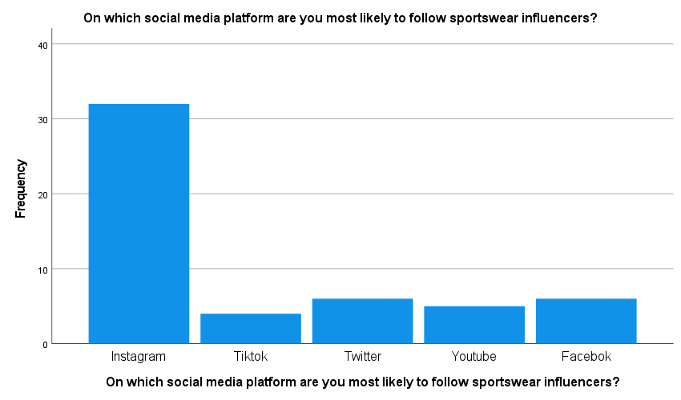
Figure 4.6: Bar graph for Preferred social media for Sportswear Influencer Engagement
The frequency analysis of the survey data on preferred social media platforms to follow sportswear influencers reveals that participants prefer one. Instagram is the leader in terms of choice with 60.4% of respondents naming it their main destination for monitoring sportswear influencers activity. This is in line with Instagram’s visual orientation, which fits well the depiction of sportswear and fitness-related content. Other such platforms like Twitter and Facebook have a rather small following at 11.3% each, as compared to YouTube which was preferred by 9.4%. To this end, Tik-Tok being the youngest of these platforms has already managed to attract 7.5% in response with a clear indication that it is gaining popularity by the day. The distribution of preferences also supports the dominant position that Instagram holds in influencer marketing within sportswear and points out to a heterogeneous landscape of social media platforms where influencer marketing can be most efficiently conducted.

4.3.2 Inferential Statistics
Analysis of Variance (ANOVA)
The ANOVA was used to test whether the levels of trust towards sportswear brands differed statistically depending on how often people engaged with influencers. The independent variable, "How often do you engage with sportswear influencers on social media?" was categorized into five levels: ‘Never’, ‘Rarely’, Monthly, Weekly and Daily. The dependent variable was the self-reported trust in a sportswear brand measured on an ordinal scale from 1 (minimum trust) to 5 (maximum trust) (Masuadi et al., 2021).
Descriptives
How much do influencer endorsements affect your trust in a sportswear brand?
 | N | Mean | Std. Deviation | Std. Error | 95% Confidence Interval for Mean |  | Minimum | Maximum
 |  |  |  |  | Lower Bound | Upper Bound | Minimum | Maximum
Never | 2 | 1.50 | .707 | .500 | -4.85 | 7.85 | 1 | 2
Monthly | 11 | 3.18 | 1.328 | .400 | 2.29 | 4.07 | 1 | 5
Weekly | 17 | 3.18 | 1.185 | .287 | 2.57 | 3.79 | 1 | 5
Daily | 10 | 4.20 | 1.317 | .416 | 3.26 | 5.14 | 2 | 5
Rarely | 13 | 2.31 | 1.109 | .308 | 1.64 | 2.98 | 1 | 5
Total | 53 | 3.09 | 1.362 | .187 | 2.72 | 3.47 | 1 | 5
Table 4.1: Descriptive Statistics of Trust by Influencer Engagement Frequency
Descriptive statistics showed diversity in trust levels depending on the engagement frequency. The lowest mean trust score was reported among the respondents who never interacted with influencers (1.50), and daily engagers had the highest mean score of 4.20, which may indicate a trend that more frequent engagement could lead to higher levels of trust in brands promoted by influencer- endorsed sportswear brands
ANOVA
How much do influencer endorsements affect your trust in a sportswear brand?
 | Sum of Squares | df | Mean Square | F | Sig.
Between Groups | 25.552 | 4 | 6.388 | 4.320 | .005
Within Groups | 70.976 | 48 | 1.479
Total | 96.528 | 52
Table 4.2: ANOVA on Influencer Endorsement Impact on Brand Trust
The ANOVA test resulted in a significant F-statistic (F(4, 48) =.032; p < .05), suggesting that the mean trust scores were not equal between groups. Specific post-hoc comparisons using the Tukey HSD test showed significant differences. Of particular note, there was a large mean trust difference between those who never interact with influencers and daily interactionists (mean diff = – 2.700, p= .046) suggesting clearly an interplay of engagement frequency on the basis of which one can have greater or lesser amount of trust in what they say.
In addition, the daily engagement group was significantly different from rarely engaged (mean difference = 1.892; p = .005), which went with the pattern that higher frequency of engagement leads to a high-level trustworthiness. The findings indicate that influencer marketing produces a quantifiable impact on consumer trust, which is dependent upon the level of involvement.
The homogeneity of trust perception was also studied. The Tukey HSD revealed that daily group was not part of the homogeneous subset which coexisted with rarely, weekly and monthly groups characterized by similar level of trust. It emphasizes that daily involvement can be seen to constitute a separate determining force of trust toward sporting garments brands.
In sum, the ANOVA findings highlight consumer engagement frequency with influencers and underline that in such a way it affects consumer trust towards sportswear brands. Statistical data indicates that high levels of the engagement frequency are connected to an increase rate in trust for brands endorsed by influencers, showing a positive correlation. This discovery is particularly helpful to marketers looking to capitalize on the referral power acting through influencers’ relationships and warranted brand trust within this vertical industry (Kim, 2017).
Correlation Analysis
Pearson’s correlation coefficient was used to investigate the relationship between trust in sportswear brands and how important an influencer with what number of followers is perceived. This analysis aimed to establish whether the credibility associated with influencer endorsements – and consequently, a sportswear brand’s trustworthiness – is dependent on an influencers popularity as signified by their follower count.
The correlation analysis found a Pearson’s Correlation coefficient (r) of -0.120 with two-tailed significance p value .391. This outcome implies a weak negative relationship between the two factors though not statistically significant. The negative direction of the correlation means that with an increase in importance attributed to followers’ number, trust for sportswear brand slightly diminishes. Nevertheless, the high p-value suggests that this correlation is not significant statistically and we cannot conclude with confidence that there exists a relationship between these variables in the population from which our sample was drawn (George and Mallery, 2019).
The sample size N=53 might not be large enough to detect a small effect magnitude, which could explain the lack of statistical significance. Alternatively, it is possible that the number of followers an influencer has does not significantly influence consumers’ trust in a brand implying that other factors may be more vital in generating this concept.
Correlations
 |  | How much do influencer endorsements affect your trust in a sportswear brand? | How important is the number of followers an influencer has when you consider their sportswear recommendations?
How much do influencer endorsements affect your trust in a sportswear brand? | Pearson Correlation | 1 | -.120
 | Sig. (2-tailed) |  | .391
 | N | 53 | 53
How important is the number of followers an influencer has when you consider their sportswear recommendations? | Pearson Correlation | -.120 | 1
 | Sig. (2-tailed) | .391
 | N | 53 | 53
Table 4.3: Trust and Influencer Followers Correlation
These results emphasize the cleaver of ties that exists in influencer marketing and multi facets subjects associated with trust on brand endorsement. Although the number of followers may be seen to provide associations with authority, it does not automatically mean that trust will follow towards a brand endorsed by an influencer. The outcome of this could mean that consumers are discriminating and may use other cues, like the essence or nature of content in it, genuineness here consciousness by which consumer is highly associated with influencer among others so as to influencing decision process. This insight presents an important point for the sportswear brands to keep in mind while working with any influencers as they need not only rely upon follower counts of said individuals but should also consider their quality and relevancy towards the targeted audience.
Regression Analysis
Furthermore, in the study by using simple linear regression analysis to investigate whether influencer endorsements indeed work as a determinant predictor of consumer’s actual purchase behavior. Respondents’ response to the independent variable of ‘How much do influencer endorsements affect your trust in a sportswear brand? was used as predictor for likelihood of having ever purchased any sportswear product recommended by an influencer.
The model summarize implies that the r-square of .139 or about 13.9% variance in purchasing behavior can be explained by the level trust at a brand name sportswear because it has an endorsed by influencer endorsements. The adjusted R square value of .122 incorporates the effects sample size and number predictors, reducing slightly explained variance which results in moderate effect sizes (Enrico Bertini, 2017).
Model Summary
Model | R | R Square | Adjusted R Square | Std. Error of the Estimate
1 | .373ª | .139 | .122 | .471
a. Predictors: (Constant), How much do influencer endorsements affect your trust in a sportswear brand?
Table 4: Summary of Trust Impact on Purchases Regression
The ANOVA table alongside the regression proved that trust in a brand due to a celebrity endorsement is statistically significant because of where variables, 1 and52 cut-off: (F(1, 51) = 8.219, p = .006), Db This importance provides proof to the suggestion that influencer endorsements undoubtedly influence whether a consumer is going to buy an item or product.
ANOVAª
Model |  | Sum of Squares | df | Mean Square | F | Sig.
1 | Regression | 1.823 | 1 | 1.823 | 8.219 | .006^{b}
1 | Residual | 11.309 | 51 | .222
1 | Total | 13.132 | 52
a. Dependent Variable: Have you ever purchased a sportswear product recommended by an influencer?
b. Predictors: (Constant), How much do influencer endorsements affect your trust in a sportswear brand?
Table 4.5: ANOVA of Trust's Predictive Power on Purchasing
Considering the coefficients, constant B = 1.122 p< .001 is for expected purchase likelihood having trust influenced by endorsements at zero level. The coefficient for trust in a brand (B = .137, p =.006) is positive; this means that when the level of trust increases purchase likelihood also increase
Coefficientsª
Model |  | Unstandardized Coefficients |  | Standardized Coefficients | t | Sig.
 |  | B | Std. Error | Beta | t | Sig.
1 | (Constant) | 1.122 | .162 |  | 6.934 | .000
1 | How much do influencer endorsements affect your trust in a sportswear brand? | .137 | .048 | .373 | 2.867 | .006
a. Dependent Variable: Have you ever purchased a sportswear product recommended by an influencer?
Table 4.6: Coefficients of Trust Influence on Purchasing
This regression analysis also highlights the impact of influencer endorsements on consumer purchase decision in sportswear industry. The positive relationship between trust in the sportswear brand and influencer endorsements implies that consumers are likely to be influenced by authentic influencers who can garner their trust, thus driving sales. This result has important implications for sportswear companies planning to include influencer partnerships as part of their marketing strategy, highlighting the importance of building trust through credible endorsement by an influential person.
Multi linear regression
The multi linear analysis observes the relationship between various factors and the consideration of influencers' opinions in sportswear purchases. The mean values propose moderate consideration for influencers' opinions (Mean = 2.58) and engagement with sportswear influencers on social media (Mean = 3.40), while there is a slight preference for influencer-endorsed sportswear is indicated (Mean = 1.53). However, there is a neutral nature in the influencer’s follower count (Mean = 1.85).

Coefficientsª
Model |  | Unstandardized Coefficients |  | Standardized Coefficients | t | Sig.
 |  | B | Std. Error | Beta | t | Sig.
1 | (Constant) | 2.631 | .651 |  | 4.040 | .000
1 | How often do you engage with sportswear influencers on social media? | .049 | .115 | .060 | .428 | .670
1 | Do you prefer influencer-endorsed sportswear over non-endorsed products? | -.244 | .271 | -.127 | -.898 | .373
1 | How important is the number of followers an influencer has when you consider their sportswear recommendations? | .086 | .141 | .086 | .608 | .546
a. Dependent Variable: Do you consider influencers' opinions when making sportswear purchases?

The regression analysis indicates that the combined effect of these factors accounts for a small proportion of the variance in considering influencers' opinions (R² = 0.029). Precisely, engagement with sportswear influencers and preference for influencer-endorsed products have a weak and not a significant effects on the individuals.

4.3.3 Qualitative Analysis
Thematic analysis
By means of NVivo, we have created hierarchical charts that are visual representations for the themes derived from open-ended responses in your questionnaire. Each chart relates to a unique feature of influencer marketing in the sportswear industry. For each of these themes, we can elaborate on the findings as follows:
Key Approaches of Influencer Marketing in Sportswear Industry
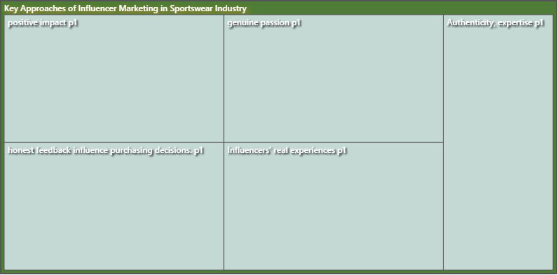
Figure 4.7: Hierarchal chart for theme 1.
Most probably, your NVivo chart shows the way in which diverse influencer marketing strategies are seen by consumers. The theme ‘Emphasis on Brand Quality’ indicates that consumers value the fact when influencers pay attention to brand quality and performance characteristics of sportswear. Another sub-segment, “Effective Influencer Focus,” could point to a need for influencers who are able to reach and resonate with their audience highlighting the right match between an influencer’s image and brand (Zamawe, 2015).
Impact of Influencer Marketing on Consumer Decision Making
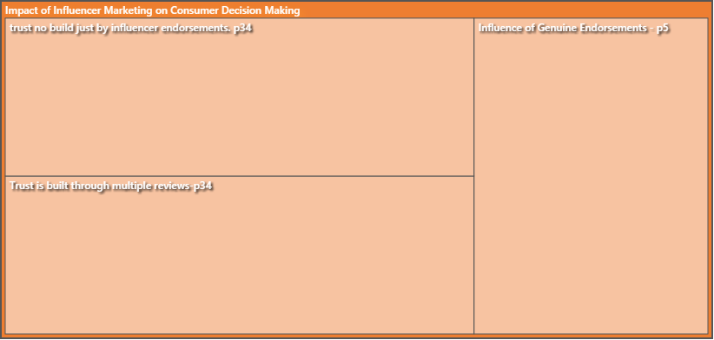
Figure 4.8: Hierarchal chart for theme 2
The chart of this theme could point out some factors, for instance “Trust is Built Through Multiple Reviews” and the ‘Influence of Genuine Endorsements’ which imply that consumers value several repetitions to verify the product quality as well as honest recommendations. This implies a subtle consumer behavior where the decision-making process is driven by an impression of honesty and consistency in actions.
Challenges Faced by Sportswear Industry in Implementing Influencer Marketing
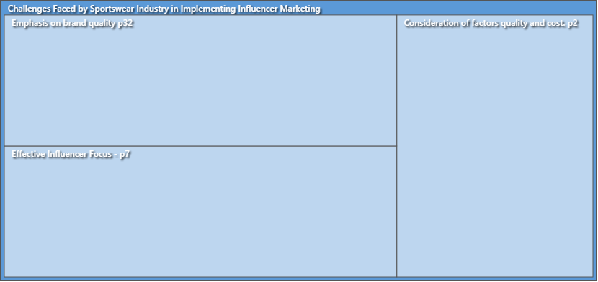
Figure 4.9: Hierarchal chart for theme 3
The NVivo chart here could depict in-text themes, such as “Balance between Factors during Endorsement”, which might concern the issues that brands encounter to guarantee authenticity, while also focusing on aligning influencer’s endorsements with brand values and messages; or “possible Influencers over exposition of Authenticity” meaning a potential threat for generating.
Strategic Application of Influencer Marketing in Sportswear Industry
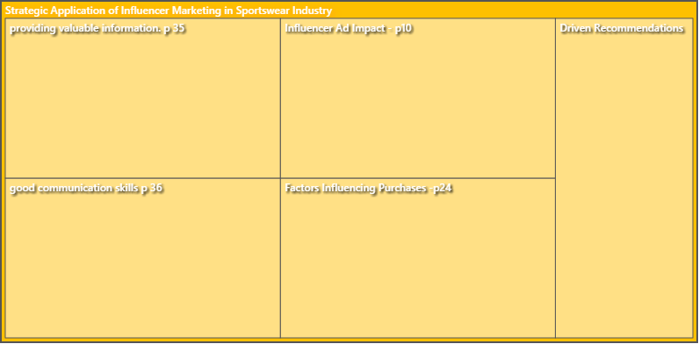
Figure 4.10: Hierarchal chart for theme 4
Within this theme, the hierarchical chart would depict elements like “Good Communication Skills” implying that influencers should have exceptional communication skills in conveying benefits of sportswear products persuasively and be able to influence purchases.” Factors Influencing Purchases,” might encompass components used when planning an influencer marketing campaign such as timing; platform
All these schemas taken from NVivo units are visual illustrations of the data structure and thematic inferences. In our dissertation, the arguments would be discussed in greater detail using charts that are to be interpreted and rationalized on how they contribute towards understanding the role influencers play within consumer behaviour among sportswear industry (Roberts, Dowell and Nie, 2019).
Influence on Purchase Decisions
One of the on-going themes in this industry is that influencers’ impact on consumers buying behaviour. The narratives extracted from free- responses in a survey, analyzed in NVivo software present multifaceted interpretation of what happens with an influencer marketing approach inside the heads if consumers and how it influences purchase decision.
Influencers, seen as reliable friends or specialists, become an intermediary between sportswear labels and potential consumers. They determine consumer behavior through their product experiences whereby they talk about the products in testimonials, demonstrate and explain how to use them showing features specifically related to users. Looking at the NVivo data analysis, it was unveiled that tales mostly contained implied truthfulness from both sides of engagement between influencer and brand. Attitudes were found to be more likely when the influencer s credibility was seen as non-transactional and paper promise.
In addition, influencers who have generated a sort of community with their followers tend to influence decision making in terms on purchasing. In this article, influencers when responding to the comments of their followers and produce contents that touch on what interest them they help build trust. Influencers are hence perceived in such communities as validated and trustworthy which is equal to advice from a friend leading them to motivate purchase intentions greatly (Dhakal, 2022).
Further, the study suggested issue relevance and specificity as relevant. Influencers representing as knowledgeable in terms of sportswear or offering stories, goals and path similar to audience can exert more influence on purchases. The endorsements by these figures are more than advertisements but as knowledge credible recommendations. This is more pronounced in stories where consumers have stated they switched brand allegiances or tried new products due to influencer advocacy that was aligned with both their personal fitness goals and other lifestyle choices.
In addition, ‘social proof’ is clearly evident in consumer narratives. Psychologically, seeing someone else especially an appreciated influencer using a product successfully can lead to people loving it.

4.4 Discussion
Integration of Quantitative and Qualitative Findings
The interdisciplinary applied research approach adopted by the study presents a complex dais, where influencer marketing powers itself to be an important tool in consumer behavior trends. As to the nature of these relationships, they all can be considered quantitative as their findings expressed a strong relationship between frequency of involvement with influencers and trust in sportswear brands; moreover, trust revealed moderate percentage linkage with actual purchase behavior. The results are confirmed by qualitative details that point out authenticity, perceived sincerity as well as relevance to be the main factors behind influence brought on through endorsements (Bhushan, 2022).
The Role of Authenticity and Trust
The theme of authenticity comes through as one of the core elements in Influencer Marketing efficacy story. The findings indicate that consumers tend to follow the recommendations of those influencers whom they see as genuine and sincere in their endorsements. There is bibliographic support for this, specifically in the section on consumer behavior which highlights trust as a determiner of purchase intention (Thompson et al., 1996). The analysis of themes highlights the importance consumers attach to authentic reviews and organic engagement which is consistent with the quantitative data where trust leads purchasing behaviour.
Influencer Engagement and Consumer Behaviour
The large ANOVA results indicate that the trigger how much consumers approach influencer is important. High levels of engagement elicited by brand type helped to attain higher trust scores among consumers—this might be due the repeated exposure effect. But the qualitative data layer increases depth by making a statement that not all of engagement is created equal—consumers can distinguish between sheer frequency and genuine interaction in which they have personal stories, quality content, or some sort of interactive communication.
Critical Evaluation of Influencer Marketing
Although influencer marketing appears to be promising, the research also highlighted potential limitations including consumer suspicion when faced with blatant commercialization or unnatural behavior. Influencer marketing is a strategic approach that must incorporate the right amount of persuasiveness to create consumer trust without losing authenticity. The sportswear brands therefore need to tread the challenges carefully in order to utilize influencer partnerships completely.
Limitations and Implications for Future Research
Limitations of the study such as its cross-sectional design and convenience sampling may affect generalizability. The longitudinal approach could be used by future researchers to monitor change over time and stratified random sampling method would help in diversifying the sample. Also, focusing on influencer characteristics like perceived credibility and similarity to the consumer might provide additional information about how nuances of effectiveness are achieved (Noyes et al., 2019).
Practical Implications for the Sportswear Industry
The impact of the study on sportswear industry is immense. Marketers need to build sustainable, genuine relationships with influencers whose beliefs reflect those of the brand. The results imply that the targeted selection of influencers, based on authenticity and ability to interact with followers in a meaningful way is likely to be more effective than simply focusing on those with the greatest number of followers.
Concluding Thoughts
In summary, the effect of influencer marketing on purchase decisions by consumers is complex and as a result, there are several factors that play significant roles in this web such as trust relationship between the consumer and an influencer or not buying from someone they do not know; frequency with which engagement occurs among other things for instance authenticity being under question due to lack of credibility surrounding some popular social media personal In this respect, the present study helps to determine a specific role of influencer marketing in sportswear industry and shows basic directions for brands’ strategy refinement in digital age (Statswork, 2019).
In creating the content for this discussion, you would elaborate on each of these points in detail supported by citations from your literature review and return to specifics of what was found. You would also critically analyse the differences and similarities between your findings and literature, providing explanations while reflecting on further implications of research.

4.5 Summary
The study undertaken gave a multi-dimension view of the effects that influencer marketing had on consumer purchase decisions in the sportswear industry. Through quantitative analysis, a statistically significant relationship between consumer engagement with influencers and their trust in sportswear brands was found as well as moderate predictive association between the level of trust towards these brands and purchasing behavior. However, the results were moderated by qualitative findings which pointed to authenticity and genuine relationships as a core of influencer marketing. (Grepsr, 2021)
Thematic analysis showed that all influencer engagements are not equally convincing. The success of influencer endorsements depends on the genuineness in which an individual is perceived as an influencer, relevance that must be present between content being promoted and a consumer’s lifestyle; finally, credibility because it stems from expertise and consistency. The qualitative findings serve as a background for the quantified data, demonstrating that consumer trust is multidimensional and essential to decision-making.
This study reveals the strategic value of authenticity in influencer marketing and emphasizes on sportswear brands need to invest long-term, value-oriented partnerships with influencers. The findings are useful to the sportswear industry, suggesting a more sophisticated consumer base that rewards substance over popularity in the digital world.

Chapter 5: Conclusions and Recommendations

5.1 Introduction
This concluding chapter summarizes the diverse results of this study, uniting threads of quantitative evidence and qualitative insights regarding influencer marketing in sportswear. It critically analyzes the interface between empirical data generated through statistical analyses and narrative insights derived from participant responses. These two-dimensional views provide a complete pictorial representation of the current influencer marketing scene and its powerful grip on consumer buying behavior.
As such, the discourse goes beyond just presenting results and enters into theoretical and practical implications for sportswear industry. The results are broken down to expose the driving forces behind influencer marketing and how such mechanisms influence brand strategy as well as consumer involvement. This conversation is crucial to practitioners who find themselves at the convergence of changing marketing ideals, determined to wield digital sway (Statswork, 2019a).
The chapter moves on to outline recommendations, summarizing the research into feasible solutions for industry stakeholders. It also stops to consider the intrinsic limitations of the research, recognizing that such constraints bound this study while offering possible avenues for future academic inquiry. The goal is to provide the academic and professional communities with insights that can guide decision-making and strategic planning.
This chapter seeks to contribute a voice to the current discourse on influencer marketing and its role in shaping consumer preferences/behaviors. In that regard, this endeavor aims at inspiring future research and guiding strategic implementations. It sets the study as a stepping stone to influencer marketing place in this dynamic shifting landscape of consumer engagement and brand communication.

5.2 Conclusion
The aim of this dissertation was to investigate the changing nature of influencer marketing and its influential effects on consumer purchase decision-making process in case with sportswear’s
Based on the quantitative and qualitative research paradigms, this study has shed light upon influencer marketing as a complex phenomenon of contemporary consumer culture.
Qualitatively, the study established a strong relationship between consumers’ interactivity with sportswear influencers and their trust of brand which was confirmed by statistical analysis in form of ANOVA and regression Analysis. These approaches showed that the level of engagement frequency was positively linked to trust, and this trust further affected purchase decisions. In particular, the regression model accounted for a large part of variance in purchase behavior supporting predictive power of trust on consumer purchases (Bharani, 2023).
Quantitatively, the study revealed the subtle processes behind influencer marketing. Thematic analysis revealed the perceive authenticity of influencers which turned out to be a foundation for successful marketing. Consumers demonstrated a preference for influencers that represent real product consumption, clear endorsements and compatibility with their personal values ​​and lifestyle. The stories implied that the relationship between consumer and influencer depended on a trust base of efficient, reliable content.
The study also revealed the critical strategic considerations required to be observed by sportswear industry for effective influencer marketing. The results reveal the significance of a careful selection process for influencer collaborations, emphasizing authentic congruence rather than just sheer number of followers. The influencer marketing strategies that work well are those which have been incorporated in the brand’s overall marketing mix and also customized to meet specific interests of a target audience.
The study went further to highlight challenges of the influencer marketing in sportswear sector which include risk of consumer skepticism and complication involved with ROI measurement. These challenges require a calculated and restrained approach, whereby brands need to find the middle ground between persuasive influence and consumer trust.
The findings of this study have deeper implications to marketing practitioners. They emphasize how sportswear brands should forge real connections with influencers, centered on authentic and captivating content that can influence customer choices. Additionally, they highlight the worth of influencers not only as marketing instruments but also as crucial stakeholders in brand storytelling and consumer involvement (Thenmozhi, 2023).
The limitations of the study, especially on sample size and data gathering method pose a warning against generalization. They also highlight the scope for further research such as longitudinal studies to trace how influencer marketing impacts evolve over time and experimental designs that can firmly establish causality.
Essentially, the results from this study add to a better understanding of how influencer marketing can be strategically used and its consumer appeal in sportswear. It also becomes a starting point for future academic research and provides actionable advice to brands willing to enter the world of influencer marketing. Consumer engagement has constantly evolved and influencer marketing is a living proof of how brands need to be innovative in order to survive the digital world.

5.3 Recommendations
The following recommendations can be made to sportswear brands seeking ways of maximizing their influencer marketing strategies given the insights derived from the research findings. These suggestions are directed to improving the effectiveness of influencer campaigns, strengthening consumer trust and finally; impact purchase decisions.
Prioritize Authenticity in Influencer Partnerships: Brands should look for associations with influencers who have true passion and drive towards the sportswear industry, as well as whose personal brand fits to that of their company. If influencers are genuine ambassadors of the sportswear they endorse, then this can help them gain trust and credibility among their followers which is necessary to influence buying decisions (Statswork, 2019b).
Foster Long-term Collaborations: Brands should not settle for short-term campaigns or one-off collaborations with influencers but focus on the long term. This enables the creation of a cohesive storyline and contributes to establishing an audience that trusts what their influencer recommends over time (Dhiman, 2019).
Diversify Influencer Selection: Although big-name influencers with huge followings are appealing, brands should also look at small influencers. Such individuals tend to have high engagement rates and are able to reach niche segments easily. The dedicated follower bases of theirs can see them as more relatable and trustworthy with such endorsements (Anders, 2021).
Incorporate Storytelling: Promote influencers to share personal stories and experiences that include the sportswear products, not only product placements. Through storytelling, emotional bonding is established and the brand becomes more memorable in consumers’ minds.
Leverage User-Generated Content: Promote and disseminate consumer generated content where consumers demonstrate their own experiences with the brand. This not only creates social proof but also magnifies the impact of influencer endorsements, creating layers of truth (Grepsr, 2021).
Utilize Multi-Platform Strategies: Influencers should not be limited to one social media platform but rather encouraged to interact with audiences across different online platforms. This multi-platform approach helps in reaching out to a larger audience and also provides for the difference content consumption habits.
Engage in Active Listening and Feedback: Brands have to be proactive in watching the consumer response patterns toward influencer campaigns and respond accordingly. This reciprocated communication may shed light on the betterment of future campaigns as well as help to strengthen the consumer-brand bond (Ngulube, 2023).
Invest in Analytics: Brands should use analytics tools to measure the success of influencer marketing campaigns by tracking engagement rates, conversion rate and ROI. Data-derived insights may be used as a basis for making well informed decisions on future marketing strategies.
Ethical Transparency: Make sure to be ethically transparent in all influencer collaborations and clearly disclose partnerships and sponsored content. This not only follows the standards of advertising but also keeps up with consumer confidence (Davis, 2022).
Educate Influencers on Brand Messaging: Give influencers the right training and materials to ensure they comprehend key messages of your brand. A consistent and unified message from influencers fortifies brand awareness, as well as the marketing messages (Malcom, 2023).

5.4 Research Limitations
The research carried out sheds light on the role of influencer marketing in swaying consumer purchase decisions within a sportswear industry. Nevertheless, some shortcomings should be noted since they have implications for the interpretation and generalizability of the results.
Second, while the convenience sampling technique is very practical and applicable in many situations it may not represent a certain population. The respondents attracted through social media may be more inclined to being digitally active and possibly even influenced by online marketing than the average consumer. As a result, the findings may not generalize to populations with lower digital engagement or other media usage patterns.
Secondly, the cross-sectional design of study captures a single point in time and does not include changes in consumer behavior or shifts influencer marketing trends overtime. The longitudinal approach would be helpful in terms of tracking trends and establishing stronger correlations between cause and effect (Barroga and Matanguihan, 2022).
Moreover, the sample size of 53 respondents is sufficient for preliminary investigation but rather small in a quantitative study. A bigger sample size would enable more accurate estimates of the population parameters and possibly uncover subtle effects which are undetectable in a smaller dataset.
The second constraint of the study comes from the dependence on self-reported data, which may be inclined to prejudices like social appeal or recall bias. Respondents may report higher levels of engagement or fail to indication the degree of their vulnerability, thereby biasing outcomes (Lakshman et al., 2000).
Such limitations highlight the need for careful interpretation of study results and offer a clear pathway to future studies, which should seek to fill these gaps and use this research as its foundation.
Future Research Suggestions
The result of this study lays more path for future research on the influencer marketing, that can help in untying even further depths into this field, as well as its result towards customer behavior within sportswear.
Longitudinal Studies: To follow the alteration of consumer attitudes towards influencer marketing in longer period of time, a longitudinal design would be beneficial. Such research could put light on the permanency of influence endorsements and trust growth through influencer relationships (Jamil et al., 2022).
Experimental Designs: To further isolate the effects of influencer marketing, experimental studies should be carried out. These would enable researchers to control variables such as type of influencer content, frequency of exposure and nature of the product endorsements in order for them to observe direct effects on consumer behavior (Li, Larimo and Leonidou, 2020).
Larger and More Diverse Samples: Increasing the sample size and providing a wide range of demographic spread would improve generalizability. Stratified random sampling can also be employed to incorporate a broader spectrum of ages, geographical locations and patterns of social media usage (Appel et al., 2020).
Multi-Platform Analysis: Since influencer marketing is a cross-platform phenomenon, future research can compare the effect of endorsements on different social media platforms to determine any platform specific dynamics and efficacy (Dwivedi et al., 2021).

References
Acikgoz, F. and Burnaz, S., (2021). The influence of'influencer marketing'on YouTube influencers. International Journal of Internet Marketing and Advertising, 15(2), pp.201-219.
Ajzen, I., 2020. The theory of planned behavior: Frequently asked questions. Human Behavior and Emerging Technologies, 2(4), pp.314-324.
Ali, K. (2023). Data collection: How do I collect data for writing an article? [online] ILLUMINATION. Available at: https://medium.com/illumination/data-collection-how-do-i-collect-data-for-writing-an-article-18ae88ec0aa6 [Accessed 6 Feb. 2024].
Anders, S. (2021). Social Media in Sport. [online] Medium. Available at: https://shaneanders.medium.com/social-media-in-sport-ac31a89f1a48.
Andreani, F., Gunawan, L. and Haryono, S., (2021). Social media influencer, brand awareness, and purchase decision among generation z in Surabaya. Jurnal Manajemen Dan Kewirausahaan, 23(1), pp.18-26.
Appel, G., Grewal, L., Hadi, R. and Stephen, A.T. (2020). The Future of Social Media in Marketing. Journal of the Academy of Marketing Science, [online] 48(1), pp.79–95. doi:https://doi.org/10.1007/s11747-019-00695-1.
Argo, J.J. and Dahl, D.W., 2020. Social influence in the retail context: a contemporary review of the literature. Journal of Retailing, 96(1), pp.25-39.
Atef, T. (2022). Data Collection. [online] MLearning.ai. Available at: https://medium.com/mlearning-ai/data-collection-2dc5d69d9e0f [Accessed 6 Feb. 2024].
Barroga, E. and Matanguihan, G.J. (2022). A practical guide to writing quantitative and qualitative research questions and hypotheses in scholarly articles. Journal of Korean Medical Science, [online] 37(16). doi:https://doi.org/10.3346/jkms.2022.37.e121.
Belanche, D., Casalo, L.V., Flavian, M. and Ibanez-Sanchez, S., (2021). Building influencers' credibility on Instagram: Effects on followers’ attitudes and behavioral responses toward the influencer. Journal of Retailing and Consumer Services, 61, p.102585.
Belanche, D., Casaló, L.V., Flavián, M. and Ibáñez-Sánchez, S., (2021). Understanding influencer marketing: The role of congruence between influencers, products and consumers. Journal of Business Research, 132, pp.186-195.
Bharani (2023). What Is Quantitative Data? [Overview, Examples, and Applications]. [online] Medium. Available at: https://medium.com/@bharani.blogs/what-is-quantitative-data-overview-examples-and-applications-eb52d7bce5c8 [Accessed 6 Feb. 2024].
Bhushan, M. (2022). NVivo 2022 Basics For Qualitative Data Analysis. [online] Medium. Available at: https://medium.com/@mehulbhushan2690/nvivo-2022-basics-for-qualitative-data-analysis-1bd3875775d9 [Accessed 6 Feb. 2024].
Brulé, E. (2020). Thematic analysis in HCI. [online] Medium. Available at: https://medium.com/usabilitygeek/thematic-analysis-in-hci-57edae583ca9.
Campbell, C. and Farrell, J.R., (2020). More than meets the eye: The functional components underlying influencer marketing. Business horizons, 63(4), pp.469-479.
Chopra, A., Avhad, V. and Jaju, A.S., (2021). Influencer marketing: An exploratory study to identify antecedents of consumer behavior of millennial. Business Perspectives and Research, 9(1), pp.77-91.
Chu, X. (2023). Impact of Influencer Marketing on Consumer Purchase Intention: Effect of Word of Mouth, Opinion Leadership. Advances in Economics Management and Political Sciences, 20(1), pp.282–288. doi:https://doi.org/10.54254/2754-1169/20/20230207.
Ciranka, S. and van den Bos, W., 2021. Adolescent risk-taking in the context of exploration and social influence. Developmental Review, 61, p.100979.
City, B. (2023). 100 Days of Data Analytics: A Complete Guide. [online] Medium. Available at: https://medium.com/@brittanycity/100-days-of-data-analytics-a-complete-guide-d278ac34655b [Accessed 6 Feb. 2024].
Davis, J. (2022). The Dangers Of Social Media For Athletes. [online] Medium. Available at: https://medium.com/@josephsdavis6/social-media-and-its-negative-affect-on-athletes-ebfe2db69229 [Accessed 14 Oct. 2022].
Dhakal, K. (2022). NVivo. Journal of the Medical Library Association, 110(2), pp.270–272. doi:https://doi.org/10.5195/jmla.2022.1271.
Dhiman, A. (2019). Sampling Methods. [online] Analytics Vidhya. Available at: https://medium.com/analytics-vidhya/sampling-methods-6c6e21773a1c.
Ding, Y., Zhang, S., Zhang, R., Zhou, W., Ye, R. and Zhang, J. (2022). SPSS-Based Analysis of Factors Affecting High School Students’ Core Literacy in The Context of The New College Entrance Examination. [online] www.atlantis-press.com. doi:https://doi.org/10.2991/978-94-6463-040-4_185.
Dwivedi, Y.K., Ismagilova, E., Hughes, D.L. and Carlson, J. (2021). Setting the Future of Digital and Social Media Marketing research: Perspectives and Research Propositions. International Journal of Information Management, [online] 59(1), pp.1–37. doi:https://doi.org/10.1016/j.ijinfomgt.2020.102168.
economictimes.indiatimes.com (2023), Dubai’s shift in consumer behaviour fuels influencer marketing surge. Available at: https://economictimes.indiatimes.com/news/international/uae/dubais-shift-in-consumer-behaviour-fuels-influencer-marketing-surge/articleshow/106014312.cms?from=mdr [Accessed on: 15 January, 2024]
Enrico Bertini (2017). From Data Visualization to Interactive Data Analysis. [online] Medium. Available at: https://medium.com/@FILWD/from-data-visualization-to-interactive-data-analysis-e24ae3751bf3.
Femenia-Serra, F. and Gretzel, U., (2020). Influencer marketing for tourism destinations: Lessons from a mature destination. In Information and Communication Technologies in Tourism 2020: Proceedings of the International Conference in Surrey, United Kingdom, January 08–10, 2020 (pp. 65-78). Springer International Publishing
forbes.com (2021), The Rise Of Athleisure In The Fashion Industry And What It Means For Brands. Available at: https://www.forbes.com/sites/forbescommunicationscouncil/2021/05/03/the-rise-of-athleisure-in-the-fashion-industry-and-what-it-means-for-brands/?sh=549fa34e3ae0 [Accessed on: 15 January, 2024]
forbes.com (2024), Top Social Media Statistics And Trends Of 2024. Available at: https://www.forbes.com/advisor/in/business/social-media-statistics/ [Accessed on: 15 January, 2024]
fortunebusinessinsights.com (2022), Key market insight. Available at: https://www.fortunebusinessinsights.com/sportswear-market-102571 [Accessed on: 15 January, 2024]
Frei, L. (2019). How to Write a Successful Data Science Article on Medium. [online] Medium. Available at: https://towardsdatascience.com/how-to-write-a-successful-data-science-article-on-medium-e984c3eb1b39 [Accessed 6 Feb. 2024].
George, D. and Mallery, P. (2019). Ibm Spss Statistics 26 Step By Stepa Simple Guide And Reference. Abingdon: Routledge.
Giles, D.C. and Maltby, J. (2006) Praying at the altar of the stars - researchgate, ResearchGate. Available at: https://www.researchgate.net/profile/John-Maltby/publication/242475256_Praying_at_the_altar_of_the_stars/links/0deec528f846f84acd000000/Praying-at-the-altar-of-the-stars.pdf (Accessed: 10 February 2024).
Grepsr (2021). Qualitative and Quantitative Data Analysis Methods. [online] Grepsr Blog. Available at: https://medium.com/grepsr-blog/qualitative-and-quantitative-data-analysis-methods-62b8c05341c4 [Accessed 6 Feb. 2024].
Haenlein, M., Anadol, E., Farnsworth, T., Hugo, H., Hunichen, J. and Welte, D., (2020). Navigating the New Era of Influencer Marketing: How to be Successful on Instagram, TikTok, & Co. California management review, 63(1), pp.5-25.
Ibáñez-Sánchez, S., Flavián, M., Casaló, L.V. and Belanche, D., (2022). Influencers and brands successful collaborations: A mutual reinforcement to promote products and services on social media. Journal of Marketing Communications, 28(5), pp.469-486.
imagesbof.in (2023), BoF Promo Codes: Puma’s #ForeverFaster campaign helped acquire 18,000 new consumers. Available at: https://www.imagesbof.in/bof-promo-codes-pumas-foreverfaster-campaign-helped-acquire-18000-new-consumers/ [Accessed on: 15 January, 2024]
Jamil, K., Dunnan, L., Gul, R.F., Shehzad, M.U., Gillani, S.H.M. and Awan, F.H. (2022). Role of Social Media Marketing Activities in Influencing Customer Intentions: a Perspective of a New Emerging Era. Frontiers in Psychology, 12(1), pp.1–12. doi:https://doi.org/10.3389/fpsyg.2021.808525.
K, A. (2016). Software for Data Analysis in SPSS On over view. SSRN Electronic Journal. doi:https://doi.org/10.2139/ssrn.4183343.
Kim, H., 2022. Keeping up with influencers: exploring the impact of social presence and parasocial interactions on Instagram. International Journal of Advertising, 41(3), pp.414-434.
Kim, T.K. (2017). Understanding one-way ANOVA using conceptual figures. Korean Journal of Anesthesiology, [online] 70(1), p.22. doi:https://doi.org/10.4097/kjae.2017.70.1.22.
Lakshman, M., Sinha, L., Biswas, M., Charles, M. and Arora, N.K. (2000). Quantitative Vs Qualitative Research Methods. The Indian Journal of Pediatrics, 67(5), pp.369–377. doi:https://doi.org/10.1007/BF02820690.
Lee, S. and Kim, E., (2020). Influencer marketing on Instagram: How sponsorship disclosure, influencer credibility, and brand credibility impact the effectiveness of Instagram promotional post. Journal of Global Fashion Marketing, 11(3), pp.232-249.
Leung, F.F., Gu, F.F., Li, Y., Zhang, J.Z. and Palmatier, R.W., (2022). Influencer marketing effectiveness. Journal of Marketing, 86(6), pp.93-115.
Li, F., Larimo, J. and Leonidou, L.C. (2020). Social Media Marketing strategy: definition, conceptualization, taxonomy, validation, and Future Agenda. Journal of the Academy of Marketing Science, [online] 49(1), pp.51–70. doi:https://doi.org/10.1007/s11747-020-00733-3.
Lou, C., (2022). Social media influencers and followers: Theorization of a trans-parasocial relation and explication of its implications for influencer advertising. Journal of Advertising, 51(1), pp.4-21.
Lu, Y., Liu, X., Hu, Y. and Zhu, C., 2023. Influence of livestreamers' intimate self-disclosure on tourist responses: The lens of parasocial interaction theory. Journal of Hospitality and Tourism Management, 57, pp.170-178.
Makrides, A., Vrontis, D. and Christofi, M., (2020). The gold rush of digital marketing: assessing prospects of building brand awareness overseas. Business Perspectives and Research, 8(1), pp.4-20
Malcom, O.C. (2023). Writing an Article for your Data Analysis Project. [online] Medium. Available at: https://medium.com/@okonkwoebuka456/writing-an-article-for-your-data-analysis-project-d9c9d14a78a6 [Accessed 6 Feb. 2024].
Mallipeddi, R.R., Kumar, S., Sriskandarajah, C. and Zhu, Y., (2022). A framework for analyzing influencer marketing in social networks: selection and scheduling of influencers. Management Science, 68(1), pp.75-104.
Mandarić, D., Hunjet, A. and Vuković, D. (2022). The Impact of Fashion Brand Sustainability on Consumer Purchasing Decisions. Journal of Risk and Financial Management, [online] 15(4), pp.1–17. doi:https://doi.org/10.3390/jrfm15040176.
Martínez-López, F.J., Anaya-Sánchez, R., Fernández Giordano, M. and Lopez-Lopez, D., (2020). Behind influencer marketing: key marketing decisions and their effects on followers’ responses. Journal of Marketing Management, 36(7-8), pp.579-607
Masuadi, E., Mohamud, M., Almutairi, M., Alsunaidi, A., Alswayed, A.K. and Aldhafeeri, O.F. (2021). Trends in the usage of statistical software and their associated study designs in health sciences research: A bibliometric analysis. Cureus, [online] 13(1). doi:https://doi.org/10.7759/cureus.12639.
Masuda, H., Han, S.H. and Lee, J., (2022). Impacts of influencer attributes on purchase intentions in social media influencer marketing: Mediating roles of characterizations. Technological Forecasting and Social Change, 174, p.121246.
Morton, F., (2020). Influencer marketing: An exploratory study on the motivations of young adults to follow social media influencers. Journal of Digital & Social Media Marketing, 8(2), pp.156-165.
Moustakas, E., Lamba, N., Mahmoud, D. and Ranganathan, C., (2020), June. Blurring lines between fiction and reality: Perspectives of experts on marketing effectiveness of virtual influencers. In 2020 International Conference on Cyber Security and Protection of Digital Services (Cyber Security) (pp. 1-6). IEEE.
Ngulube, P. (2023). Improving the quality of reporting findings using computer data analysis applications in educational research in context. Heliyon, [online] 9(9), p.e19683. doi:https://doi.org/10.1016/j.heliyon.2023.e19683.
Noyes, J., Booth, A., Moore, G., Flemming, K., Tunçalp, Ö. and Shakibazadeh, E. (2019). Synthesising quantitative and qualitative evidence to inform guidelines on complex interventions: clarifying the purposes, designs and outlining some methods. BMJ Global Health, [online] 4(1), p.e000893. doi:https://doi.org/10.1136/bmjgh-2018-000893.
Ollie (2023). The Influencer Effect: Harnessing the Power of Social Media for Your Brand. [online] Medium. Available at: https://medium.com/@ohermans1/the-influencer-effect-harnessing-the-power-of-social-media-for-your-brand-cd5435f370fe#:~:text=Social%20media%20influencer%20marketing%20is [Accessed 6 Feb. 2024].
Ozuem, W., Willis, M., Howell, K., Lancaster, G. and Ng, R., 2021. Determinants of online brand communities’ and millennials’ characteristics: A social influence perspective. Psychology & Marketing, 38(5), pp.794-818.
Penttinen, V., Ciuchita, R. and Čaić, M., 2022. YouTube it before you buy it: The role of parasocial interaction in consumer-to-consumer video reviews. Journal of Interactive Marketing, 57(4), pp.561-582.
Roberts, K., Dowell, A. and Nie, J.-B. (2019). Attempting Rigour and Replicability in Thematic Analysis of Qualitative Research data; a Case Study of Codebook Development. BMC Medical Research Methodology, [online] 19(1), pp.1–8. doi:https://doi.org/10.1186/s12874-019-0707-y.
Rode, J.B. and Ringel, M.M. (2019). Statistical Software Output in the Classroom: A Comparison of R and SPSS. Teaching of Psychology, 46(4), pp.319–327. doi:https://doi.org/10.1177/0098628319872605.
Samyak, S. (2023). The Power of Social Media Influencers: Impact and Ethics. [online] ILLUMINATION. Available at: https://medium.com/illumination/the-power-of-social-media-influencers-impact-and-ethics-b39165afab74.
Shen, H., Zhao, C., Fan, D.X. and Buhalis, D., 2022. The effect of hotel livestreaming on viewers’ purchase intention: Exploring the role of parasocial interaction and emotional engagement. International Journal of Hospitality Management, 107, p.103348.
smith, sara (2023). The Impact of Social Media Influencers on marketing and consumer behavior. [online] Medium. Available at: https://medium.com/@smithsara200018101257/the-impact-of-social-media-influencers-on-marketing-and-consumer-behavior-8eb7035a3afb.
Spears, R., 2021. Social influence and group identity. Annual review of psychology, 72, pp.367-390.
statista.com (2022), Influencer marketing market size worldwide from 2016 to 2023. Available at: https://www.statista.com/statistics/1092819/global-influencer-market-size / [Accessed on: 15 January, 2024]
statista.com (2023), Average number of weekly brand posts on Instagram in 2023, by vertical. Available at: https://www.statista.com/statistics/873935/daily-instagram-brand-posts-by-vertical/ [Accessed on: 15 January, 2024]
Statswork (2019a). Data Analysis Plan for Quantitative Research Analysis. [online] Medium. Available at: https://statswork.medium.com/data-analysis-plan-for-quantitative-research-analysis-6b7f2ddc2aa5 [Accessed 6 Feb. 2024].
Statswork (2019b). Quantitative Data Collection Methods. [online] Medium. Available at: https://statswork.medium.com/quantitative-data-collection-methods-959341f244a8 [Accessed 6 Feb. 2024].
Statswork (2019c). Steps in Quantitative Data Analysis. [online] Medium. Available at: https://statswork.medium.com/steps-in-quantitative-data-analysis-c6b154491dde.
Tanwar, A.S., Chaudhry, H. and Srivastava, M.K., (2022). Trends in influencer marketing: a review and bibliometric analysis. Journal of Interactive Advertising, 22(1), pp.1-27.
Taylor, C.R., (2020). The urgent need for more research on influencer marketing. International Journal of Advertising, 39(7), pp.889-891.
Thenmozhi (2023). Research methods of Quantitative Analytical Software and its pros and cons. [online] Medium. Available at: https://medium.com/@thenmozhi_14588/research-methods-of-quantitative-analytical-software-and-its-pros-and-cons-a9e553254abe [Accessed 6 Feb. 2024].
Thompson, C.B., Schwartz, R., Davis, E. and Panacek, E.A. (1996). Basics of research (part 6): Quantitative data analysis. Air Medical Journal, 15(2), pp.73–84. doi:https://doi.org/10.1016/s1067-991x(96)90005-x.
Van der Vegt, I., Mozes, M., Gill, P. and Kleinberg, B., (2021). Online influence, offline violence: language use on YouTube surrounding the ‘Unite the Right’rally. Journal of Computational Social Science, 4, pp.333-354.
Van Driel, L. and Dumitrica, D., (2021). Selling brands while staying “Authentic”: The professionalization of Instagram influencers. Convergence, 27(1), pp.66-84.
Wang, G. (2021). Application of SPSS Data Analysis in Moral Teaching of College English Course. doi:https://doi.org/10.1145/3482632.3482670.
Weismueller, J., Harrigan, P., Wang, S. and Soutar, G.N., (2020). Influencer endorsements: How advertising disclosure and source credibility affect consumer purchase intention on social media. Australasian marketing journal, 28(4), pp.160-170.
Wellman, M.L., Stoldt, R., Tully, M. and Ekdale, B., (2020). Ethics of authenticity: Social media influencers and the production of sponsored content. Journal of Media Ethics, 35(2), pp.68-82.
Zak, S. and Hasprova, M. (2020). The role of influencers in the consumer decision-making process. SHS Web of Conferences, [online] 74(03014), p.03014. doi:https://doi.org/10.1051/shsconf/20207403014.
Zamawe, F. (2015). The Implication of Using NVivo Software in Qualitative Data Analysis: Evidence-Based Reflections. Malawi Medical Journal, [online] 27(1), p.13. doi:https://doi.org/10.4314/mmj.v27i1.4.
Zhang, K. and Hung, K., 2020. The effect of natural celebrity–brand association and para-social interaction in advertising endorsement for sustainable marketing. Sustainability, 12(15), p.6215.
Zhu, A. (2023). What are Sampling Methods? [online] Geek Culture. Available at: https://medium.com/geekculture/what-are-sampling-methods-104cab017b24 [Accessed 6 Feb. 2024].

Appendix

Quantitative Survey
1. How often do you engage with sportswear influencers on social media?
- Daily
- Weekly
- Monthly
- Rarely
- Never
2. On which social media platform are you most likely to follow sportswear influencers?
- Instagram
- YouTube
- Facebook
- Twitter
- TikTok
3. Have you ever purchased a sportswear product recommended by an influencer?
- Yes
- No
4. How much do influencer endorsements affect your trust in a sportswear brand?
- Greatly
- Moderately
- Slightly
- Not at all
5. Do you consider influencers' opinions when making sportswear purchases?
- Always
- Sometimes
- Rarely
- Never
6. Do you believe sportswear influencers provide valuable information about the products they endorse?
- Strongly agree
- Agree
- Neutral
- Disagree
- Strongly disagree
7. How likely are you to try a new sportswear brand if it is endorsed by an influencer you follow?
- 1
- 2
- 3
- 4
- 5
8. Do you think influencer endorsements reflect the true quality of sportswear products?
- Always
- Often
- Sometimes
- Rarely
- Never
9. Have you ever been disappointed with a sportswear product endorsed by an influencer?
- Yes
- No
10. Do you prefer influencer-endorsed sportswear over non-endorsed products?
- Yes
- No
11. How important is the number of followers an influencer has when you consider their sportswear recommendations?
- Very important
- Somewhat important
- Not very important
- Not important at all

Qualitative Survey
1. What qualities do you look for in a sportswear influencer when considering their recommendations?
2. Can you describe a specific instance where an influencer significantly influenced your decision to purchase a sportswear product?

