

STUDENT NAME: SIMRET WELDEKDIAN MANNA
Student ID: 2318869
PROGRAMME: BSc Applied Computing
Module: Data warehousing and data mining
Module code: ACCA6026
Lecturer: MD Abrar Jahin Almazi Bipon
Table of Contents
Abstract 2
Introduction 2
Strategic Data Warehouse for NHS England 3
Task 1, Foundational Understanding and Initial Design 3
1.2 Data Warehouse Architecture and ETL 4
1.3 Data Marts for Executive Decision-Making 5
1.4 Normalisation vs. Dimensional Modelling 6
Task 2 Design and Implementation Plan 8
2.1 Source System Identification 8
2.2 Star Schema Design 8
2.3 Data Marts and Schemas 9
2.4 ETL Plan 11
2.5 Data Quality and Governance 12
Conclusion 12
References (IEEE) 13

Abstract
Today, the NHS has information stored in systems that are primarily intended for day-to-day processes and not analysis. That creates a situation where data is spread thin across a wide array of tools, resulting in misaligned numbers, delayed reporting and inability to get a broader view of data from across services. This report outlines a plan to implement a centrally located, secure data warehouse. It discusses the difference between the systems used for everyday working and this new "central store" system and how one type works for everyday use and is simple and quick, while the other type works in the other way with information easily searched, compared and analyzed over months or years. The design is built in clear steps: Information is copied from existing systems in a safe way, checked and cleaned, and stored in a standard manner, with a consistent meaning for all. Patient information is secure in compliance with privacy regulations and access is limited. There are special views for each team: one for performance, one for money and one for patient safety. The result is a trusted source of information. It can help the NHS to be more efficient, identify issues earlier, plan more effectively for the future and ensure that decisions are made on accurate facts.

Introduction

NHS England is one of the world's largest healthcare systems, with vast amounts of data stored on patients, staff, finance and services. Now, however, all that information is stored on hundreds of individual computer systems that book appointments, store patient records, pay employees and deal with budgets.
When it comes to big questions – such as admission or ordering medicines for the day these systems work well. The information is not consolidated, different teams have different numbers for the same information, reports take a long time to put together, and it is difficult to see long-term trends or act on them appropriately.
This document describes the Strategic Data Warehouse – a secure repository in which all this information is consolidated and synchronized in a consistent format. It will not jam the medical treatment systems used by doctors and nurses. Rather, it will transform discrete pieces of information into clear, reliable information that can be used by leaders, finance, and clinical staff to make better decisions, run services more smoothly, enhance the care that patients receive without incurring unnecessary costs.

Strategic Data Warehouse for NHS England
One analytics platform to enhance operational efficiency, patient care and sustainability [1].
Executive Summary
Today, NHS England runs one of the world's largest and most data rich healthcare systems, but the operational data is spread across hundreds of Electronic Patient Record (EPR), Patient Administration (PAS), workforce and finance systems. This report proposes an approach to the strategic data warehouse solution that brings these sources together to form a single, controlled analytical platform. The proposed architecture includes a normalized staging layer, a dimensionally designed enterprise warehouse and data marts designed for roles, allowing the Chief Executive, Finance Director and Medical Director to make decisions based on real-time, trust-wide information without having to impact the transactional systems that physicians use daily [2].

Task 1, Foundational Understanding and Initial Design
  - OLTP Systems vs. Data Warehouses
The Electronic Patient Record (EPR), PAS, and the Electronic Staff Record (ESR) are all Online Transaction Processing (OLTP) systems designed to deal with many very short, atomic transactions such as admitting a patient, prescribed medicine, schedule a clinic appointment etc. They are extremely normalized, contain no data redundancy, referential integrity and protect concurrency with ACID transactions . These systems are designed for writing optimization and generally contain a short time only [3].
In contrast, a Data Warehouse is a subject-oriented, integrated, time-variant and non-volatile repository that is built for decision support . The schema is denormalized around facts and conformed dimensions optimized for reading intensive analytics and scans billions of records across many years. The OLTP question can be the equivalent of ‘is bed 12 occupied?’ the Warehouse question could be ‘how have A&E wait times changed over the past 36 months in the 42 ICSs (adjusted for case-mix)’.
NHS England has identified three step change benefits for a warehouse: firstly it moves the analytical burden away from OLTP systems and protect front-line responsiveness; secondly, it gives a “one version of the truth” for all the Trusts which will resolve a number of current discrepancies between the different conflicting KPIs that exist within national reporting ; and thirdly it enables a long history to be stored, harmonized, which can be used to train machine learning models for the purposes of modelling for future demand forecasting, Modelling the size of future workforce, modelling for capability for health stratifications, etc. None of which would be possible in a transactional database.

1.2 Data Warehouse Architecture and ETL

Figure 1 The overall design of the DDP follows a classic Inmon-based hub-and-spoke model scaled to NHS-size and information-governance requirements [4]. The system uses five logical layers working together for stratification-force and capabilities for stratified health purposes where transactional databases can’t help.
SOURCE SYSTEMS  EPR. PSA. Work force  Finance. External  feeds | STAGING  AREA  Validation.Cleaning.  De-duplication | ENTERPRISE DATA WAREHOUSE  Fact +Dimension  Tables  (Star Schema) | DATA  MARTS  Finance.Operations.  Clinical quality | BI &  ANALYTICS  Power BI · Tableau ·  Qlik dashboards
Figure 1, High level Data warehouse architecture for NHS England (ETL flows left → right)

Source systems can be thought of as trust EPRs (e.g. Epic, Cerner, System C), the nationalPAS, the Electronic Staff Record, finance ledgers and authorized external feeds, such as ONS demographics or weather data for demand modelling. Extracts from source systems are achieved using a mixture of change-data-capture(for high volume tables) and scheduled batch extracts (for slow moving reference data), minimizing the load on production systems.
Landing zone After the raw data is extracted it landed into a landing zone which is separate from the enterprise warehouse.
The raw extracts are then validated, cleansed, de-duplicated, de-pseudonymized prior to business logic being applied to them. Enterprise warehouse the integrated, historically rich data is then held in the enterprise warehouse using dimensional model. Data marts on top of the warehouse sit role-specific data marts and a Presentation Layer consisting of Power BI and Tableau dashboards.ETL The ETL process represents the connective tissue between the source systems and the warehouse. It performs extraction from each of the sources on a defined cadence commonly every 15 minutes for clinical activity and daily for finances.
Transformation uses business rules normalizing units, mapping local codes to national standard (ICD-10, HRG, ODS site codes), de-identifying NHS number using salted SHA-256 and calculating various measures such as length of stay and 30-day readmission indicators.
Loading is done using bulk, set based insert into fact tables which is further partitioned to provide flexibility, and slowly changing dimension(SCD Type 2) methods are employed to store historical data changes for staff and locations. ET L always extracts data from read-only sources (e.g. Replica databases or log-shipped copies of production servers) and runs this activity outside core clinical hours to ensure minimal impact on OLTP system performance, as this is the primary concern expressed by trust IT Directors to us during digital transformation programmes.

1.3 Data Marts for Executive Decision-Making

A data mart is a subject-oriented slice of the warehouse that has been pre-aggregated and structured for a specific user group [5].
The three executive data marts required for NHS England are:
Executive (CEO) Mart:

For the Chief Executive who require a cross-system, top-down view of the system, this marts contains the highest level of KPIs (emergency care 4-hour performance, elective waiting times, total bed occupancy, ambulance handover, mortality indices, net financial position) rolled up to ICS and region and is updated every 30 minutes and monthly in order for the CEO to identify system wide pressures and confidently brief ministers [6].

Finance Director Mart:

For the Finance Director, who needs to track and understand income, expenditure and value.
This involves bringing together activity facts with cost HRGs and contracted tariffs, performing variance analysis against plan, benchmarking of cost per case within a cohort of trusts, monitoring agency spending and capital programme activity [7].
It also highlights leading indicators (such as high-cost drug usage, theater utilization) which will predict the next month’s run-rate. The slowly changing dimensions maintain organizational change and so the ability to compare trends over time is preserved.

Medical Director Mart:
For the Medical Director who must understand clinical quality and patient safety, the mart shows 30-day readmissions, hospital-acquired infections, surgical site infections, events, mortality reviews, sepsis compliance and PROMs. The data in the marts can be drilled down from a national level down through trust, specialty, to team and then to individual case to support the Medical Director’s statutory responsibility for clinical governance in the context of the CQC. The three marts share conformed dimensions within the data warehouse, ensuring that ‘a patient’, ‘a trust’ and ‘a financial month ‘are understood to mean the exact same thing across all board reports, the greatest cultural shift to be achieved by the data warehouse [8].

1.4 Normalisation vs. Dimensional Modelling

Typical OLTP database tables are normalized to remove duplicate information. Patient information will be stored in one table, addresses in another, episode details in a third and so on. Foreign keys join these tables together.
While this requires less storage space and avoids the update anomaly, to answer one question about an analytics domain, it might mean querying a dozen tables, requiring effort from the user, both cognitive and in terms of performance.
Dimensional modelling (Kimball) presents a trade off the other way; the facts or measurable events of the business (the equivalent of a finance transaction, or a patient episode in this case for NHS) is placed in one table (fact table), surrounded by deformalized descriptive or dimension tables who, what, when, where information. Space required may be higher, but the user benefit and performance benefits are considerable [9].
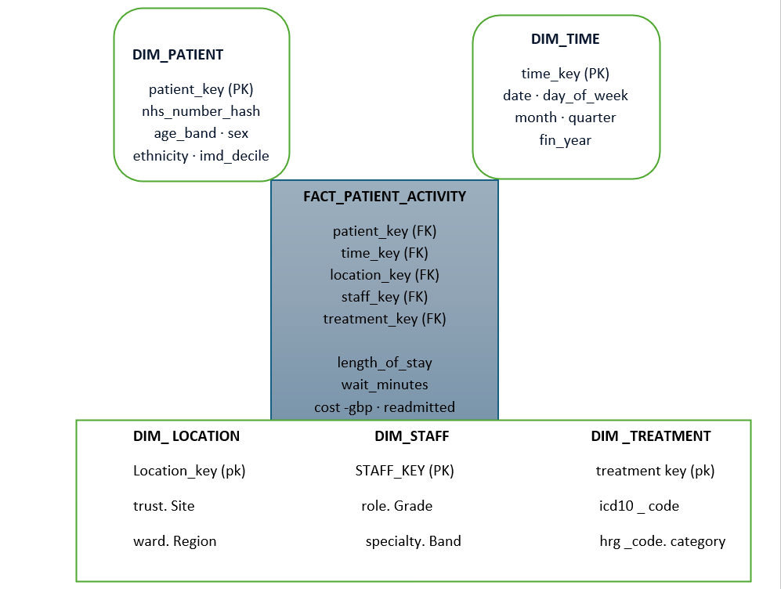
Figure 2. Star schema for NHS patient-activity analytics, with one central fact and five conformed dimensions.
Figure 2 shows a star schema for NHS patient activity, with the fact table consisting of a record for every completed episode, and metrics (stay length, wait minutes, cost and readmission) and keys into 5 conformed dimensions (patient pseudonymized time, location, staff and treatment) stored in that fact. Such a query ( “average stay length by specialty and region last quarter “ ) involves a join per dimension, which is efficiently mapped by BI tools to partition-pruned scans in seconds, not minutes.

Task 2 Design and Implementation Plan

2.1 Source System Identification

The sources of internal data include trust Electronic Patient Record systems (Epic, Cerner, System C Medway), the Patient Administration System for patient demographics and admissions, departmental clinical systems (radiology RIS/PACS, pathology LIMS, theatres, maternity etc.), Electronic Staff Record for workforce, finance ledgers (Oracle/SAP) and Estates & Facilities CAFM system. The external sources of data include ONS for population denominators, OS for geography, met office for weather related demand, CQC inspection feed and approved research datasets including HES. All internal and external sources are catalogued with source owner, frequency of refresh, governance category and justification under the Caldicott principles prior to data integration into the service [10].

2.2 Star Schema Design

The center of the warehouse is a constellation of star schemas with conformed dimensions.
The premier example is FACTPATIENTACTIVITY (figure 2). Grain is explicitly stated. One row for each completed inpatient, outpatient or emergency episode. Defining the grain so precisely is a conscious Kimballian decision and it is a key feature for preventing double counting in NHS reporting returns [11].
Measures on the fact table are fully additive such as days of stay, minutes of wait, cost gbp, number of episodes, readmitted30d (0 or 1), and died in episode (0 or 1). 0/1 integers used for Booleans allow rates to be summed and pound cost data, rather than a mixture of currencies, ensures clarity.
DIM_PATIENT is anonymized; all patient ID fields were pseudonymized by substituting them for salted SHA-256 hashes so longitudinal data can be analyzed without compromising patient identity . Descriptive elements (age group, sex, race category, IMD rank) enable inequality analysis whilst respecting Data Protection Act 2018 and Caldicott guidelines .
DIMTIME has data up to 2050 and includes day of week, financial year (April to March), a flag indicating bank holidays, and a flag for winter pressure periods - small but very useful bits of information to aid operational reporting. DIMLOCATION describes all NHS trusts using ODS site codes, with ward and bed levels. DIMSTAFF describes role, grade, specialty and contract types without patient identifier from the ESR (Electronic Staff Record) database.
DIMTREATMENT captures all ICD-10 and OPCS-4 procedure codes as well as all Healthcare Resource Group (HRG) codes to enable analyses based on disease or intervention and the same facts.
Two further fact tables share the same dimensions as the previous. FACTFINANCELEDGER has monthly total trust expenditure data keyed on time, location and chart of accounts. FACTWORKFORCEROSTER holds daily shifts with data on hours worked, agency spend, vacancy hours etc. Keyed on time, staff and location. Since each star is joined to DIMTIME and DIM_LOCATION, Finance and Medical Director mart data can be correlated readily, i.e., by examining links between spikes in agency staffing and readmission trends.
Each dimension has surrogate integer keys (patient key, staff key, etc.) in preference to natural keys. This ensures the warehouse design is independent of underlying systems changes, for instance, site name changes after a trust merger, and supports Slowly Changing Dimensions Type 2, ensuring that if a doctor moves trusts, their entire historical career remains in place within the Warehouse . Fact tables are partitioned by month by date key and sorted by selectively chosen foreign keys, to deliver millisecond response times on tables containing multiple billion records.
There is an explicit avoidance of the use of Snowflakes. To have decomposed DIM_PATIENT in ethnicity tables, or deprivation tables etc., might save some megabytes of storage but increase complexity and introduce confusion for the analysts more significantly than these small savings, as experienced repeatedly in past NHS BI initiatives .

2.3 Data Marts and Schemas
The marts Three departmental marts have materialized directly above the warehouse to enable millisecond response time dashboards. The Operations Mart - Materializes FACTPATIENTACTIVITY, rolled up by trust, day, and specialty, pre-computing things like A&E 4-hour breaches, RTT-incomplete waiting list count, bed occupancy, and ambulance handover time. A small star: AGGOPSDAILY (fact) joined with DIMTIME, DIMLOCATION and a minimal DIM_SPECIALTY.
The Finance Mart - Joins FACTFINANCELEDGER with costed activity from FACTPATIENTACTIVITY to give a cost-per-spell, income vs plan and agency vs substantive spend ratios.
Schema: AGGFINANCEMONTHLY joined with DIMTIME, DIMLOCATION, DIMACCOUNT. The Clinical Quality Mart - Based on the core clinical and safety measures: SHMI, HSMR, readmission rates, HAIs, never-events. Aggregates FACTPATIENTACTIVITY weekly and uses case-mix adjustment factors stored in a DIMCASEMIX table. Schema: AGGQUALITYWEEKLY joined with DIMTIME, DIMLOCATION, DIMTREATMENT and DIMCASEMIX.
Each mart utilizes shared conformed dimensions, so a term like "acute trust" will never have a different meaning between the Finance Mart and the Operations Mart.
The use of materialized views combined with intelligent incremental refresh means they only rebuild themselves on changes rather than querying gigabytes of detailed data every time.

The marts Three departmental marts have materialized directly above the warehouse to enable millisecond response time dashboards. The Operations Mart - Materializes FACTPATIENTACTIVITY, rolled up by trust, day, and specialty, pre-computing things like A&E 4-hour breaches, RTT-incomplete waiting list count, bed occupancy, and ambulance handover time. A small star: AGGOPSDAILY (fact) joined with DIMTIME, DIMLOCATION and a minimal DIM_SPECIALTY.
The Finance Mart - Joins FACTFINANCELEDGER with costed activity from FACTPATIENTACTIVITY to give a cost-per-spell, income vs plan and agency vs substantive spend ratios.
Schema: AGGFINANCEMONTHLY joined with DIMTIME, DIMLOCATION, DIMACCOUNT. The Clinical Quality Mart - Based on the core clinical and safety measures: SHMI, HSMR, readmission rates, HAIs, never-events. Aggregates FACTPATIENTACTIVITY weekly and uses case-mix adjustment factors stored in a DIMCASEMIX table. Schema: AGGQUALITYWEEKLY joined with DIMTIME, DIMLOCATION, DIMTREATMENT and DIMCASEMIX.
Each mart utilizes shared conformed dimensions, so a term like "acute trust" will never have a different meaning between the Finance Mart and the Operations Mart [12].

2.4 ETL Plan

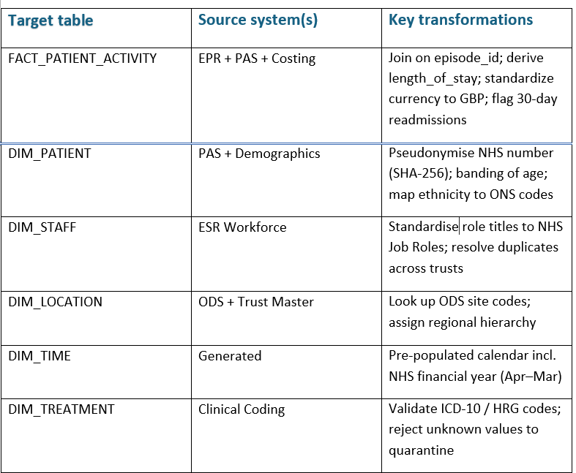
Table 1 briefly describes the simpliﬁed ETL plan, including what goes where, and what the important transformations are. It shows the intention to take non-intrusive extracts from production replicas, the intention to reject faulty rows to a quarantine area, rather than aborting the whole load, and the ability to re-run it in an idempotent way [13].

Table 1. Simplified ETL plan source mapping and key transformations.

2.5 Data Quality and Governance

Quality is assured by automated rule sets at the boundary with the staging area - completeness, range and referential checks and by reporting on pass-rates for data stewards using dashboards. Governance is Caldicott principles and UK GDPR: data pseudonymisation by default, access is by role via AD groups, full audit trails and a shared data-sharing register published online. Sign off for any new datasets by Information Asset Owners before data enters production [14].

Conclusion
Building this strategic data warehouse will bring huge benefits to NHS England. At present information is spread across numerous disparate systems that struggle to give a single version of truth that is unambiguous and consistent. By centralizing data within this system, we can resolve the fragmented information and present it in an accessible, secure, organized environment.
The system can co-exist with current day-to-day systems that are already impacting patient care, rather than adding additional burden or reducing capacity. Messy information is being converted to valuable insight enabling consistent, accurate comparisons between services, accurate reports at far greater speeds and leadership with the evidence to support decision making and improve the service offering and value.
From day one the solution supports the core needs around operational efficiency, finance management and patient safety, and provides the mechanisms to proactively identify risk, plan capacity needs more effectively and manage the service with a robust, yet secure and privacy enhancing, dataset. In summary this is more than just a technical delivery, it is enabling NHS England to have coherent data to operate effectively, safely and sustainably for the long term.

References (IEEE)

[1] | D. a. D. J. {Wyllie, "{Role of data warehousing in healthcare epidemiology},," {Journal of Hospital Infection},, Vols. (89),, no. {Elsevier}, pp. {267--270},, {2015),.
[2] | T. {White, {A Guide to the NHS},, {Radcliffe Publishing}, (2010),.
[3] | A. {Nordeen, {Learn Data Warehousing in 24 Hours},, {Guru99}, {2020},.
[4] | K. a. K. T. A. {Kakish, "{ETL evolution for real-time data warehousing},," in {Proceedings of the Conference on Information Systems Applied Research ISSN},, (New Orleans, Louisiana, USA),, (Education Special Interest Group of the Association of Information Technology Professionals, AITP), {2012},, pp. {1508},.
[5] | C. {Vercellis, {Business intelligence: data mining and optimization for decision making},, (Chichester, West Sussex, United Kingdom),: {John Wiley \& Sons}, ,{2011},.
[6] | O. a. S. M. {Ratzesberger, {The sentient enterprise: The evolution of business decision making},, (Hoboken, New Jersey, USA.),: {John Wiley \& Sons}, (2017),.
[7] | H. a. R. S. a. L. X. a. B. H. a. A. A. a. A. O. {Zhang, "{Developing scalable management information system with big financial data using data mart and mining architecture},," {Information Processing \& Management},, Vols. (60),, no. {Elsevier}, pp. {103326},, (2023),.
[8] | P. a. M.-H. S. a. V.-P. M. a. M.-N. G. L. E. a. V.-H. H. a. A.-O. I. {De-La-Cruz-Vdv, "{Data Mart and key performance indicators to optimize decisions in a medical service clinic},," in {2023 18th Iberian Conference on Information Systems and Technologies (CISTI)},, {Aveiro, Portugal},, {IEEE}, (2023),, pp. (1--6),.
[9] | S. a. H. M. a. G. M. N. {Kanagaraj, "{NORMALISATION AND DIMENSIONALITY REDUCTION TECHNIQUES TO PREDICT PARKINSON DISEASE USING PPMI DATASETS.},," {Oxidation Communications},, Vols. {43},, no. (1), pp. {117--126},, {2020},.
[10] | C. a. K. W. {Hofmann, "{Source-specific system identification},," in {2016 IEEE International Conference on Acoustics, Speech and Signal Processing (ICASSP)},, {Shanghai, China},, {IEEE}, {2016},, pp. {161-165},.
[11] | C. {Adamson, {Mastering data warehouse aggregates: solutions for star schema performance},, {Indianapolis, IN, USA},: {John Wiley \& Sons}, {2012},.
[12] | C. {Ghezzi, "{Designing data marts for data warehouses},," {ACM Transactions on Software Engineering and Methodology (TOSEM)},, Vols. {10},, no. {ACM New York, NY, USA}, pp. {452--483},, {2001}.
[13] | A. {Simitsis, "{Modeling and managing ETL processes.},," in {VLDB PhD Workshop},, {Berlin, Germany},, {CEUR-WS.org}, {2003},, pp. {41--50},.
[14] | R. {Mahanti, {Data quality: dimensions, measurement, strategy, management, and governance},, {Milwaukee, WI},: {Quality Press}, {2019},.

