Section 1
Professional journal contents list
2003506

1.1 Professional journal contents list Section 2
  - Fieldwork placement contract
  - Supervision contract
  - Supervision recording Section 3
  - professional development plan
  - placement risk assessment
  - Reward chart created by student on placement
  - Four retlective recordings
  - Learning mentors final report Section 4
  - Safeguarding policy
  - Equal opportunities policy
  - Health and safety policy Section 5
  - NOS checklist
  - Community profile
  - Summary of own learning
  - Observation of the workplace

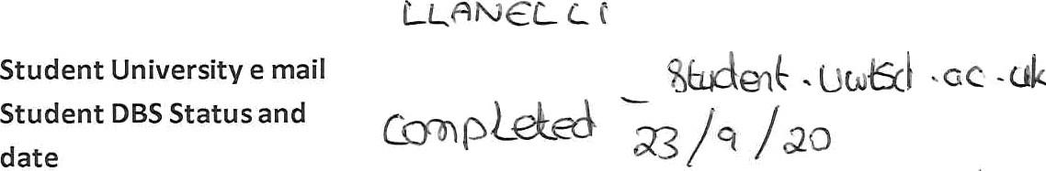
FIELDWORK PLACEMENT CONTRACT
{
/
Please confirm that your organisation has in
student can have access to them:
”(
Facilities/equipment available
to student
Please outline the activities expected of the student
(Use more space if necessary)
Level 4 Placement: 200 hours (100 or more face to face Youth Work).
Duration of placement

Aims/Purpose of the Organisation
Email
Tel.
Name of Organisation

HOST ORGANISATION INFORMATION


Where possible please complete this information ele ctronically, the text boxes will eNpand to contain the necessary information.

STUDENT INFORMATION
Student Name
Student Address
Additional requirements
Name of fieldwork  supervisor | 
Fieldwork supervisor Tel.
Fieldwork supervisor e mail | /)q g¿ g <,/ g gp y .y

Thank you for using www.freepdfconvert.com service!

Only two pages are converted. Please Sign Up to convert all pages. https://www.freepdfconvert.com/membership

