University of Wales Trinity Saint David
School of Engineering
David Carpanini
1702360
Motorsport engineering
13/03/22
Contemporary Powertrain Design
ACHA6004



Contents
Abstract 3
Base vehicle data 3
Torque Vectoring (TV) & Power Transfer Unit 4
Lumped Mass Model 5
Resultant graphs 7
Clutch Pack Calculations 8
Axial Load Application 9
Power loss calculation/characteristics 10
Longitudinal Acceleration 10
Yaw Rate of the FF 11
Hand wheel position 12
Controls and improvements 12
Conclusion 12
References 13
Bibliography 14

Abstract
This report is an in-depth analysis of the engineering principles and systems that are applied to the Ferrari FF. This report will look in depth at the All-wheel drive train system along with how the vehicle dynamics is affected with the AWD system. Data will be gathered from reliable sources such as Ferrari and press releases. Throughout the report a lumped mass model will be produced to help understand the dynamics and mass distribution of the FF. Calculations of the vehicles centre of gravity, moment if inertia, inertial conjugate, and the dynamic index to further understand the impacts on the overall dynamics of Ferraris first AWD platform. This report will also consider the mechanical torque path or toque vectoring system along with calculations for the clutch packs to work out the torque capacity, clutch sizes, and axial force seen. The longitudinal acceleration will also be analysed with a focus on different surfaces with various coefficients of friction with the yaw rate and hand wheel position being considered. The report will also look at the possible control systems that are in place to help stabilise the car.

Base vehicle data
The FF model is the model in Ferrari’s history to be produced with an AWD system with the first model being manufactured in 2011.the AWD system in the FF is called the 4RM system which stands for 4 Ruote Motrici, which in Italian translates to 4WD. The FF is fitted with Ferraris 6262cc, 650 hp naturally aspirated engine in a v configuration with the pistons set at a 65-degree angle. The Vehicles engine Is mounted in the front mid location (just behind the front axle) allowing room for the front of the vehicle to be fitted with a power transfer unit. This power transfer unit contains two wet clutches, one for each front wheel long with two forward gears and one reverse gear, this unit is purely for the front wheels and is driven by the front of the crankshaft. The rear of the car comprises of drive shaft that goes from the rear of the engine’s crankshaft via the propeller shaft, to a transaxle rear e-differential/7 speed dual clutch gearbox combination that sits midpoint between the two rear wheels where then the power will transfer from this unit to the rear wheels via a set of half shafts. The Ferraris construction ensures that weight distribution is a key factor with 53% of the weight being over the rear axel and 47 %over the front.
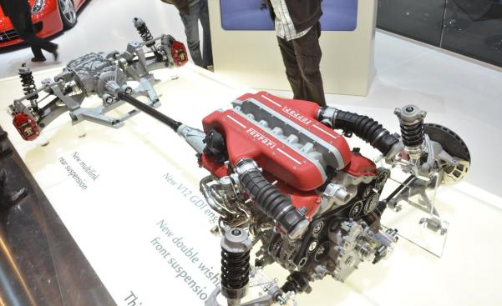
Figure 1 Ferrari FF drivetrain Configuration

Torque Vectoring (TV) & Power Transfer Unit
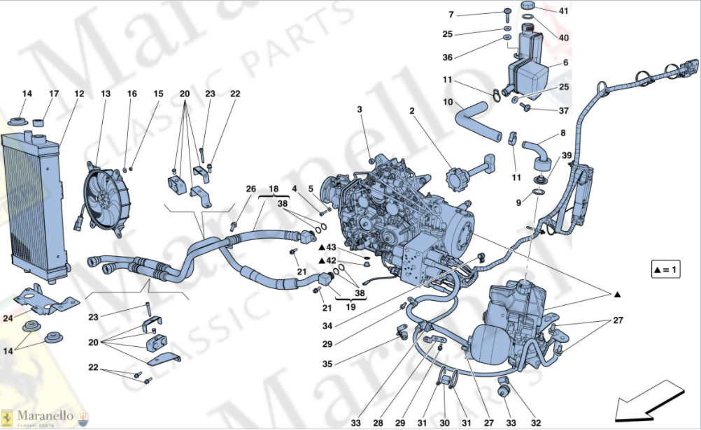
Figure 2 Power Transfer unit (Marenello Classic Parts, 2020)
Torque Vectoring is a concept that has been seen before in several production cars with it becoming widely known with the system being introduced into the Mitsubishi Evolution IV, along with various other electric and AWD vehicles. The Ferrari FF is Equipped with a the 4Rm system. This system allows for torque vectoring, meaning the vehicle can transfer torque to any given axel or wheel which in order will help improve the grip, stability and handling characterises of the vehicle. “By slowing down or sending power to specific wheels, you can shift the weight of a car and improve grip” (Haj-Assad, 2017), this process is done by the vehicles ecu and monitor each wheel for slip or yaw detection as its also called. In most cases torque vectoring is done by Appling the breaks of a certain wheel to allow for more torque to go to the opposite side, the biggest downside to this style of system is the increase in break wear compared to a system that uses a wet clutches like the Ferrari FF. A TV system is quite comparable to an open differential in numerous ways. TV systems work with the principle of the torque transferred from the propeller shaft to the crown wheel in the differential, this toque is then applying to the spider gears which are located at the sides internally in the differential, torque then is transferred to the half shafts and then eventually to the wheels, this whole process is done in milliseconds. With open differential which are common on most vehicles torque will always be equal in each drive shaft. This implies that the average angular velocity in each wheel when the vehicle is cornering is equal to the input angular velocity.
Torque vectoring is also seen in practice on more road going vehicles than expected below is a list of some road vehicles that are equipped with a torque vectoring system is seen in figure 3.
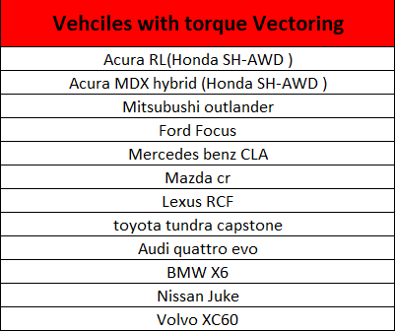
Figure 3 Vehicles with torque Vectoring
In the case of the Ferrari FF the “It's not the most common form of torque vectoring but it still works well.” (GTE engineering, n.d.). This is due to the front and rear axel not having a mechanical connection unlike 99% of other AWD vehicles. This is down to Ferrari’s use of the power transfer unit that runs off the front of the crank shaft via a conical gear, instead the vehicle uses electronic controls to send torque where its required. The way the FF is constructed allows for no use of a second prop shaft thus making the rotational inertia lower in addition as being able to have a lower centre of gravity (COG) thus helping the vehicle dynamics in cornering allowing for more stability and improved handling, along with reducing the mass compared to a regular AWD system. The AWD system in the FF is only fully active when the vehicle is in one of three modes these being either snow, wet or comfort if the vehicle is in sport or esc mode (which are located on the steering wheel) (demuro, 2021), then the vehicle is RWD but has the ability to send up to 20% of engine torque to the front wheels via the PTU if the vehicle needs it. The PTU can be seen in figure 2.
If the vehicle is in AWD, then the PTU plays a vital role in controlling the torque distribution. The PTU is an independent 3 speed gearbox, 2 forward gears and 1 reverse located in the front of the chassis. The lower gear is dedicated to gears 1 and 2 in the main gear box. Where gear 2 in the PTU is dedicated for gears 3-4 in the main gears. The gear ratios are designed to be mismatched as that, “The clutches that drive the front wheels were designed to be constantly slipping thereby allowing the two forward front gear ratios to run smoothly with the four gears they correspond with at the rear.” (GTE engineering, n.d.). when the car exceeds gear 4 there is a loss of torque due to the multiplication of torque through the gearbox which in turn allows for the rear wheels to have all the available power if the road surface and tyres has enough friction.

Lumped Mass Model
For this investigation into the Ferrari FF, a lumped mass model has been calculated allowing for analytical calculations of the vehicle’s individual masses. The lumped mass model consists of 3 masses that are present, the first mass is denoted by the abbreviation m1, where this represents the frontal mass of the vehicle. The second mass Is denoted m2, this represents the total passenger weight, each passenger weigh has been set to 80kg (rettner, 2013) as this is the average 1st world country weight and would also allow for baggage as the FF is designed to be practical Ferrari that seats 4 with a boot. The rear mass of the vehicle is denoted by m3. Other denotation to consider are g which is the distance between m1 and m2 as well as I which represents the wheelbase of the vehicle. The centre of gravity position (COG) is represented in the model by the letter F. The assumption has been made that the vehicle has a 50/50 weight distribution from side to side as the main driveline components are central in the vehicle.
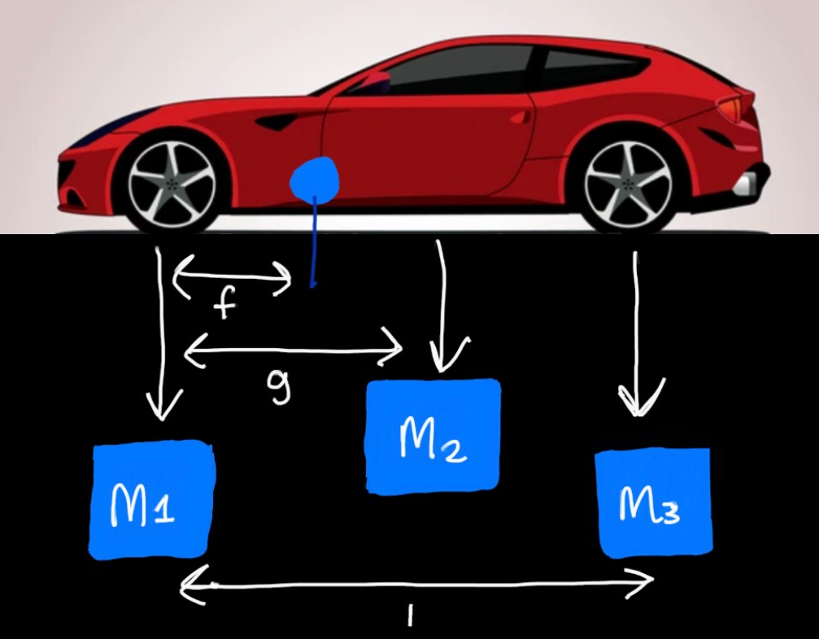
Figure 4 Lumped Mass Model
The lumped mass model has been produced using the excel software package. There has been several assumptions made throughout the investigation. The first assumption is the distance that’s denoted by the letter g, this has been assumed at 60% of the vehicle’s wheelbase. The excel calculator allows for multiple choice of passengers in the vehicle between 1-4 so the assumption for g was decided when the vehicle will have two passengers in it, if the vehicle has more than two passengers then the g value would be 70% of the I (wheelbase)
The vehicles inertia has been calculated using the COG position that was previously calculated this has been done about the z-z axis. The vehicles yaw has also been calculated (Izz) along with the initial conjugate (C). The C value represents the moment at which the there is no rotational displacement about the CoG only the rotational transfer will be witnessed. The inertial conjugate is the association between the yaw moment and direction of the vehicle. In a steady sate cornering moment, the yaw acceleration will be zero as the vehicle has grip. The yaw moment for the vehicle will occur around the z axis of the vehicle. The lateral force that is denoted by the letter f is witnessed on the front axle of the FF unlike the rear of the vehicle where there are lateral reactive forces.
The Dynamic index (DI) of the vehicle has been calculated and represents the relationship between the initial conjugate and the distance from cog to the rear axle line (I-f). “The dynamic index or DI gives us a unique insight into the way the chassis will behave when maneuverer on a ground plane at speed” (borgman, 2007). The dynamic index also is responsible for the way the rear tyres react to the road surface during a transient movement. If the overall value of the dynamic index is less that 1, this means that c is less than the I-f value.
$DI=\frac{Izz}{mab}$
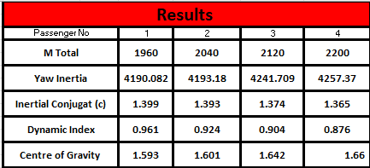
Figure 5 Results data inc yaw, inertial conjugate, dynamic index and COG

Resultant graphs
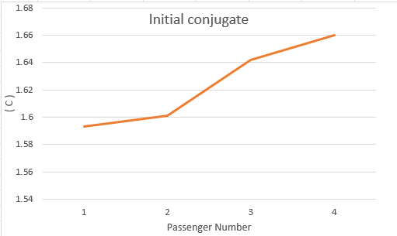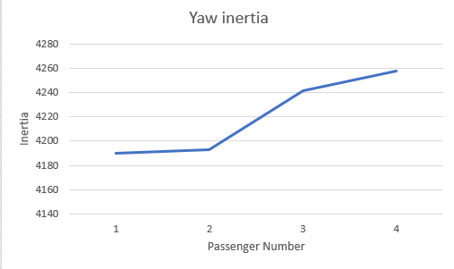
Figure 6 initial conjugate Figure 7 yaw inertia

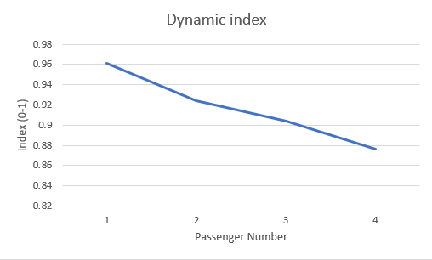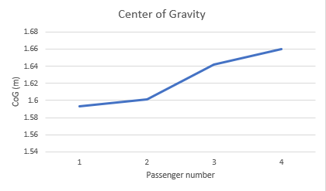
Figure 8 Dynamic index Figure 9 Centre of Gravity

Clutch Pack Calculations
To complete the calculations from clutch pack firstly the size of the clutch must be assumed. Using images of the FF when its driveline was on display an estimation can be made as the size of the brake disk is known, that being 398mm as seen in figure 10 below which is data from Ferrari’s website.
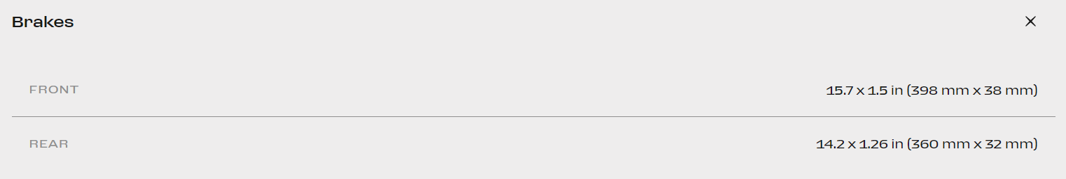
Figure 10 Ferrari FF brake disc sizing
From this beak sizing it will allow for an approximate sizing of the power transfer unit, the imagine was imported into solid works where the correct size could be placed on the disc and the PTU calculated. using the first image figure 11 the size of the PTU is shown at 131.09 mm and to validate the sizing a second image was taken and measured figure 12 and the resultant size was 132.68mm.
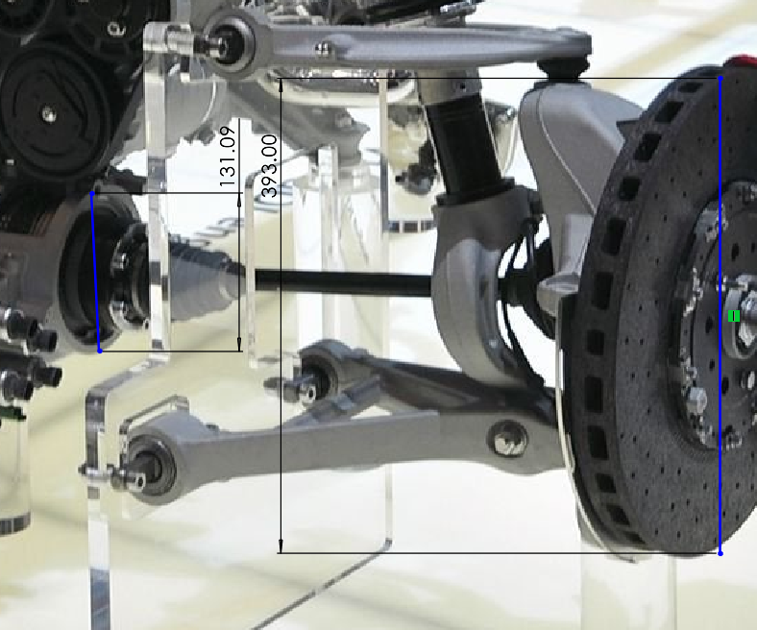
Figure 11 PTU measurement 1
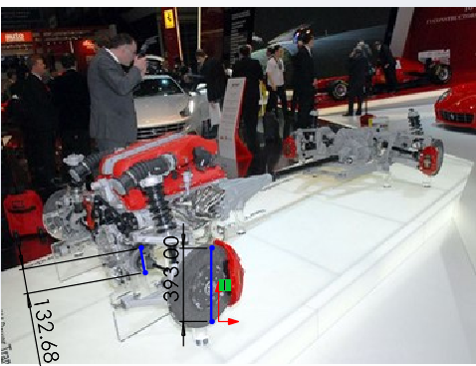
Figure 12 PTU sizing
From these results it can be assumed that the clutch in the FF could have a PTU of anything between 100-150mm as leaving room for error due to the camera angle so an assumption of the inner clutch being 100mm and the outer clutch at 130mm. Throughout the excel calculator these values have been left as variable choices so if any new information is discovered about the clutch sizes the calculations can be changed instantaneously.
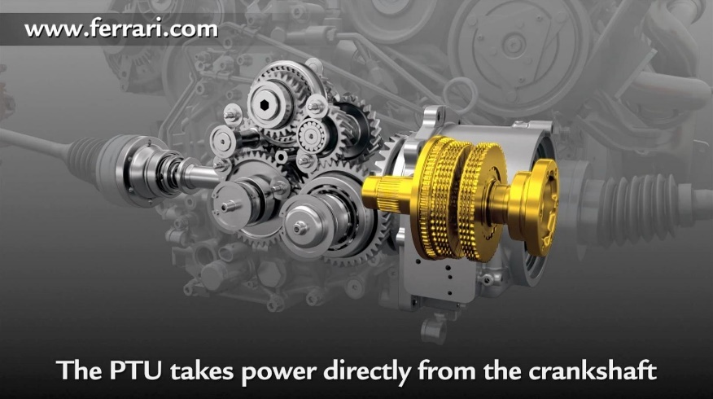
Figure 13 PTU system and clutch packs
The PTU in the FF will only see 20% of the torque that is produced from the engine. The maximum torque value (T) that will be experienced by the PTU is 136.6nm as the total torque value is 683nm. The number of clutch plates can be assumed to be 4 as seen circled in figure 13. These four clutch plates will have a total of 8 clutch faces, the clutched are stacked on the input shaft of the PTU as the stacking process allows for a lower fractional material in the clutch face to allow for the torque vectoring. The flywheel coefficient of friction value (µ) has to be assumed from it is found that a carbon clutch can range anywhere from 0.04 µ research (G Pica, 2016) up to 0.1 µ (Sandford, 2022)The coefficient of friction between the clutch faces will be inconsistent throughout the operation as numerous factors will effect the clutch these could be influences such as the overall force exerted on the clutch plates along with oil pressure and temperature as these may fluctuate through the use of the vehicle.

Axial Load Application
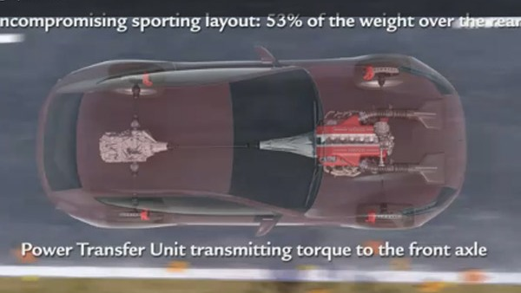
Figure 14 Ferrari FF drivetrain and axles
To understand the loads seen by the FF’s axels, constant wear theory must be applied to calculate the force that applied by the clutch pack. To calculate this value the assumed valued for the clutch that were previously completed will be used. The volume of force that is applied to the clutch has a direct relationship with the amount of torque that will be present in the PTU at any moment. The forces that are expected to be seen are compressive forces which are applied via an electro-hydraulic actuator, but these forces will be observed when the vehicle is in one of three AWD settings, or the vehicle is experiencing slip in the other settings and the ECUs will then try to correct it. The equations that will be used to calculate this force are.
$$T=\frac{µW\left(r1+r2\right)}{2}$$
$$W=\frac{2T}{µ(r1+r2)}$$
The resultant forces are as follows in figure 15. Where the force per face is 2.846KN and overall having a force of 22.767 KN.
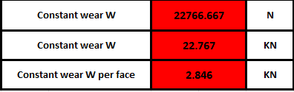
Figure 15 constant wear W
If the torque split was increased by Ferrari to 40% there would be a huge increase in overall forces going through the FF’s PTU, thus increasing the risk of damage as there would be an increase in axial loads and would minimise the lifespan of the component.

Power loss calculation/characteristics
Looking at the power loss that occurs throughout the clutch packs an assumption of vehicle speed has been made whilst changing from first to second gear, the speed chosen is 22 mph or 10m/s. the power loss will come from one side of the vehicle being on a different road surface to the other side in this calculation with the left wheels being on an icy surface with the µ value of 0.05 (Engineering toolbox, 2004) and the right side of the vehicle being on a normal dry asphalt road with the µ value of 1. It is seen that as the difference in the coefficient values are increased there will be a bigger loss in the power compared to when all the vehicle’s wheels are on a stable surface with a steady coefficient value there is minimal to no power loss at this moment. This calculation is done by using the gear ratios for 1st gear and the final drive ratio also including the rolling radius of the wheel and tyre to calculate the angular velocity of the clutch packs and determine the power loss.

Longitudinal Acceleration
To be able to calculate the longitudinal acceleration a calculator model has been created in excel this calculator allows for the tractive forces to be found.
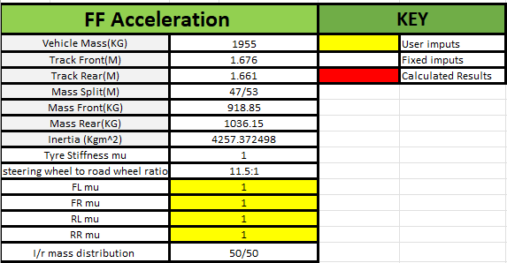
Figure 16 initial acceleration calculator
To calculate the longitudinal acceleration an input has been placed into the calculator to replicate the vehicle launching on dry tarmac with good traction. For this test each tyre coefficient of friction has been set to a µ value of 1.
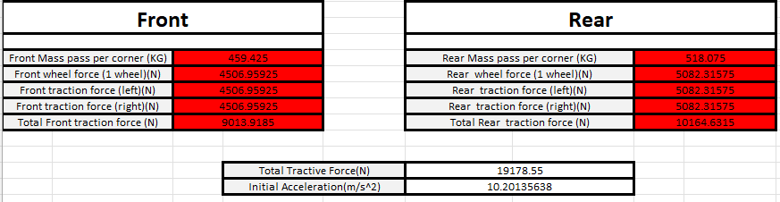
Figure 17 results from initial acceleration calculation
The tractive forces were calculated (figure 17) with the difference in the front and rear being the 47/53 weight distribution with the front result being 9013.92N and the rear being 10164.63N thus totalling the tractive forces seen by the FF to 19178.55N. The Initial acceleration was then able to be calculated this resulted in an initial acceleration of 10.2 m/s². The initial acceleration calculation was conducted by using the equation $a=\frac{f}{m}$.

Yaw Rate of the FF
The yaw has been calculated using the previous set up of the vehicle with the left side on a lower coefficient surface than that of the right, seen below in figure 12.
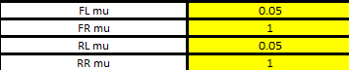
Figure 18 Coefficient of friction for ice and dry asphalt
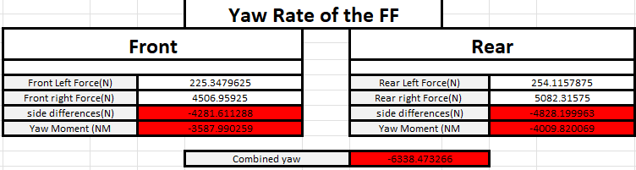
Figure 19 yaw rate results
Due to the severity of the differences in surfaces a large yaw rate is seen by the FF the total Yaw for the front of the vehicle is -3587.99 NM and the rear of the vehicle the yaw moment is -4009.82NM to give a combined yaw moment of -6338.47NM. The yaw value can then be used to calculate the yaw rate of the vehicle by using this results in a yaw rate of -85.3deg/s².
$$Yaw Rate=\frac{Yaw Moment(r)}{Inertia (Izz)}$$
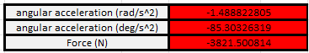
Figure 20 angular acceleration and lateral force on front
The total lateral force seen -3821.5 N. The values are seen as negative as they are opposing in the opposite direction.

Hand wheel position
The hand wheel position uses a corner stiffness value which has been gathered from research the first source has shown as 880 N/degree (mchenrysoftware, n.d.) and another source has shown at 867 N/degree (stamenkovic, 2013) so an average of 873.5 N/degree will be used.
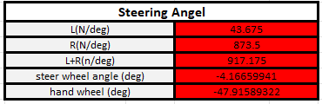
Figure 21 steering angles
The final hand wheel calculation has resulted in an angle of 47.92 degrees as the surface change between the two surfaces is extremely different resulting in the vehicle to want to go left as there is less resistance and lower coefficient of friction.

Controls and improvements
the Ferrari ff uses a “F1 dual-clutch gearbox that combines the unadulterated driving pleasure of a sequential gearbox with the comfort of an automatic” (ferrari, 2011) as this gearbox will help the drop in acceleration when shifting gear causing unwanted weight transfer when having to come off the power like in a manual geared car. Systems such as the differential have also been incorporated into the lower half of gearbox helping to keep the mass balance throughout the vehicle and help to keep the centre of gravity low and in the middle to give a better cornering response. On the control screen in the gauge cluster of the ff there is a vehicle dynamics setting which allows for five different adjustments of the e-diff and the AWD, it also allows 4 different settings for the F1-trac and ESC as well as 3 different settings for the f1-dc and the SCM.

Conclusion
The Ferrari ff is one of Ferraris most practical vehicles they have ever produced. The balance of the v12 engine mounted just behind the rear axle along with the PTU and the f1-trac gearbox and e-diff in the rear allow for the Ferrari to be a well dynamically balanced vehicle whilst being able to fit 4 passengers plus baggage. The 4Rm system that is present in the FF is one of the most advanced AWD on a production vehicle as there is no prop shaft connecting the front and rear drive line as they are both driven off separate ends of the crankshaft. The AWD system also allows for the FF to have superb handling qualities on several varying friction surfaces such as snow and ice. The way the vehicle is set up to allow for an only 2WD experience still allows for the driver to have maximum feel and have the classic Ferrari handling characteristic of a big engine RWD GT car.

References
borgman, s. (2007, january 2). dynamic index. Retrieved from wheels in motion: https://www.wheels-inmotion.co.uk/forum/index.php?/topic/794-dynamic-index/
demuro, d. (2021, may 20). the ferrari ff. doug demuro. california.
Engineering toolbox. (2004). Friction coefficients and calculator.
ferrari. (2011). ferrari ff. Retrieved from ferrari: https://www.ferrari.com/en-EN/auto/ff
G Pica, C. C. (2016). Dry Dual Clutch Torque Model with Temperature and Slip Speed Effects. springer link. Retrieved from springer link.
GTE engineering. (n.d.). Ferrar FF . Retrieved from GTE enigneering: http://www.gte-engineering.com/ferrari-4rm-ptu-rebuild.html
Haj-Assad, s. (2017, may 09). what is torque vectoring. Retrieved from Auto guide: https://www.autoguide.com/auto-news/2017/05/what-is-torque-vectoring-.html
Marenello Classic Parts. (2020). Ferrari FF Ptu system. Retrieved from ferrari parts: https://www.ferrariparts.co.uk/Diagram/Ferrari/FF/026-PTU-System
mchenrysoftware. (n.d.). discussion cornering stffness. Retrieved from msmac3d vd3.30: https://www.mchenrysoftware.com/help/msmac/index.html#!discussioncorneringstiffness.htm
mustafa E. Amiryar, K. R. (2016). Review of Flywheel Energy Storage System. MDPI.
rettner, r. (2013, may 39). the weight of the world. Retrieved from live science : https://www.livescience.com/36470-human-population-weight.html
S.Kitade, K. (2018). Polymer Matrix Composites: Applications. science direct .
Sandford, M. (2022). swansea.
stamenkovic, m. (2013). Determination of Cornering Stiffness. belgrade.
Why high end. (2010). Ferrari 4RM (4 Ruote Motrici). Retrieved from why high end : http://www.whyhighend.com/ferrari-4rm.html

Bibliography
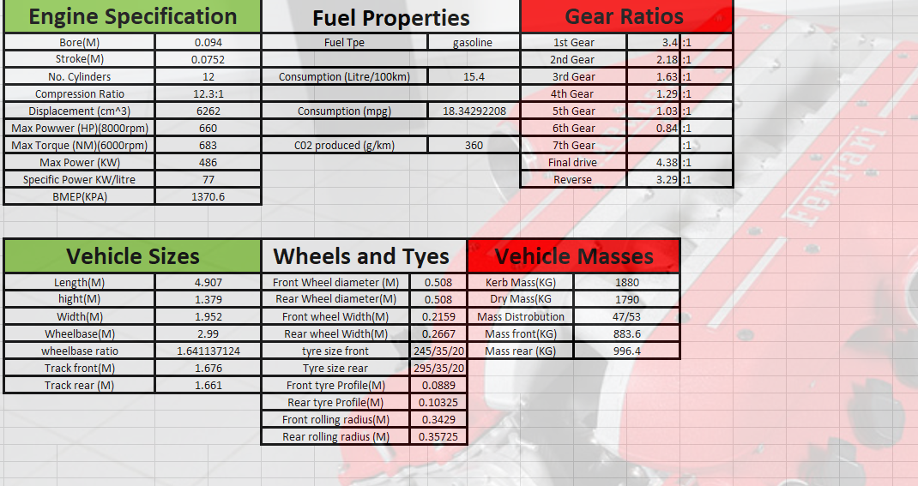Figure 22 base vehicle data for the Ferrari FF
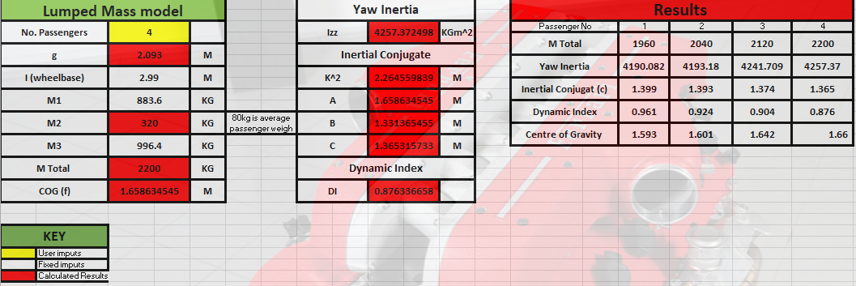
Figure 23 Lumped Mass model, inertia , inertial conjugate and dynamic index
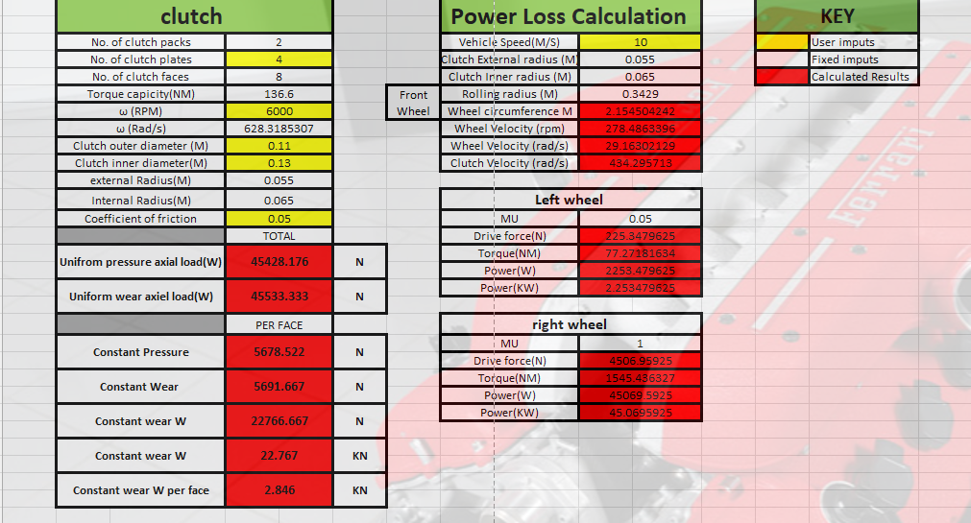
Figure 24 Clutch pack calculations
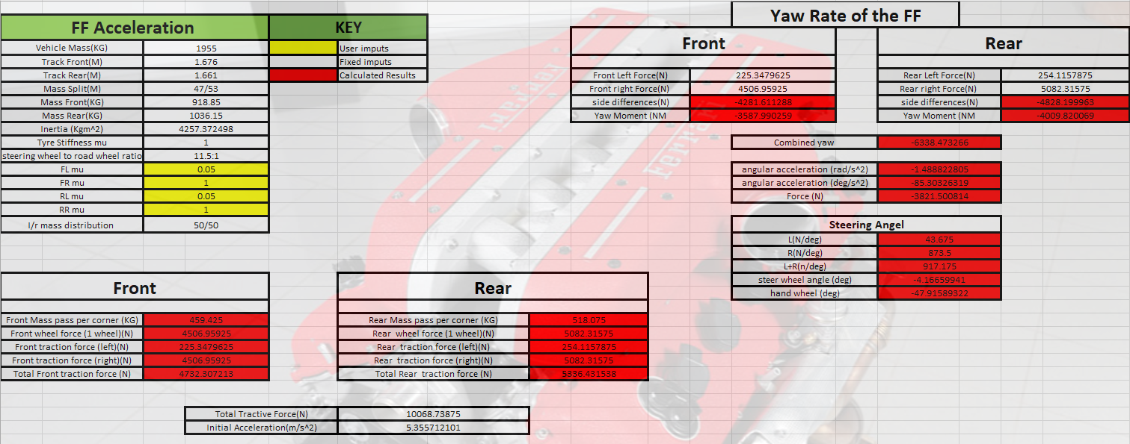
Figure 25 Acceleration Calculation and Yaw Rate

