Curtis Cana
1500738

Children and young people in focus: Practice Log
ECCH7002

Introduction – What is Childhood?
What is Childhood? This is a question we must ask ourselves as professionals in order to truly understand the life stages of young people. In this practice log I will critically explore what is meant by the term ‘childhood’ and find out if there is really a true definition. I will also explore when childhood starts and ends by using texts from theorists and using points from related legislation and policy. The notion of Childhood linked to the Health and Wellbeing of children will be reflected upon throughout this piece of work whilst pinpointing some complicating factors which may influence certain individual young people’s experiences of childhood
Let us first start off by looking at the term childhood and what it means. Childhood in a modern global context means a time period in an individual’s life where they learn, develop and grow as people through activities of play. This can be supported by UNICEF (1989) who state “Childhood is the time for children to be in school and at play, to grow strong and confident with the love and encouragement of their family and an extended community of caring adults. It is a precious time in which children should live free from fear, safe from violence and protected from abuse and exploitation, this is further supported by the United Nations Convention on The Rights of The Child (1989)
However, Higonnet (1998) cited in Prout (2005) discusses childhood representation by saying how “children have been painted and photographed from the eighteenth century to the present. She shows romantic representations of childhood, such as those found in the paintings of Reynolds and Gainsborough (as pictured below), were constructed through a semiotic opposition with adulthood”.

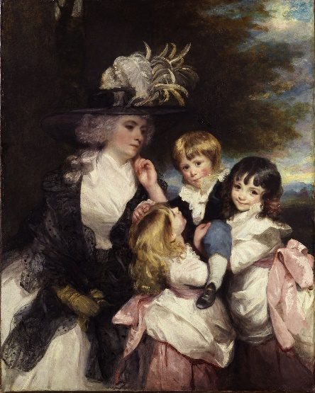


This shows us historical interpretations of childhood and how childhood has been looked at for many years, whereas now there is a similar but different viewpoint on childhood. I will now move on to identify when childhood starts and ends. Childhood is often described as starting at the age of three and ending at the age of twelve. It is seen that when the child starts to become playful which is usually around the age of three, then they have entered childhood. This can be supported by Erik Erikson (1958) development theory where he states, “During this period we experience a desire to copy the adults around us and take initiative in creating play situations”. And further supported by Green (2010, pg. 72) who says, “The child is conceptualised in both traditional developmental and socialization theories as a human becoming, a work in progress, a deficient inert creature programmed by either society or biology to become the future completed adult model”.
Childhood is said to end at the age of twelve when the child progresses to a teenager at the age of thirteen. This is seen as the time when children start puberty and take on risky behaviours and when the natural things that they used to do as a ‘child’ cease to exist. However, some people may argue that with the growing challenges that young people face with new tools such as social media, childhood ends much sooner than the age of twelve, I will be exploring this in the next part of the log.

Part 1 – Barriers to Childhood – Growing Concerns.
In a modern 21st century day and age the idea of a ‘childhood’ may be slightly different to the childhood that appeared for many of our parents or grandparents. With the introduction of so much technology that children can get their hands on, its no wonder that there is a change in how children act and behave. From the latest game’s consoles, smartphone, tablets, wireless technology and social media platforms, surely this must have an affect on the upbringing of today’s modern children.
I am now going to explore the impact that todays modern technology has on children. Social media is forever growing. Since the introduction of Bebo and myspace back in 2005 there have been countless attempts of creating digital platforms ever since. According to Instagrams Terms of Use (2018) “We want our Service to be as open and inclusive as possible, but we also want it to be safe, secure, and in accordance with the law. So, we need you to commit to a few restrictions in order to be part of the Instagram community”. One of these restrictions is that users must be 13 years or older and this is the rule that current popular social media sites follow including Facebook and Snapchat. However, from a practice perspective we have found children as young as 11 and 12 accessing social media accounts with cases that have led to bullying and children becoming the victims of online paedophiles. As supported by an article published in Kent Online (2019) which says “Teachers are urging parents to ban their children accessing social media as they issue a warning about staying safe online. Ramsgate Arts Primary School says the risks of children being exposed to strangers, bullying and inappropriate content is behind an e-safety campaign it is running”.
The problem is that there is no way of monitoring an individual’s age, so they are able to provide a ‘fake’ date of birth, allowing them full access to a social media platform. As Twenge (2017, pg. 2) discusses by saying “iGen has arrived, born in 1995 and later, they grew up with cell phones, had an Instagram page before they started high school, and do not remember a time before the internet”. And its not only the usage of social media on the increase by children, social media ‘addiction has also been identified as an issue among children. This can sometimes be described as an obsession, as Alter (2017, pg. 21) clarifies by stating “obsessive passions, however, are unhealthy and sometimes dangerous. Driven by a need that goes beyond simple enjoyment, they’re likely to produce behavioural addictions”
Another form of technology that is invading children’s lives is gaming. Gaming is a concept that has been around for many of years, starting off as the necessity of an arcade, to being able to play on games consoles. Now, however, gaming has become much more widely accessed by children via smartphones, tablets, consoles and other sources. I will start by discussing Fortnite, the game that god children ‘addicted’. I myself, have played Fortnite and have to be honest, don’t find what is so ‘addictive’ about the game, however as recent news articles report “Health professionals have spoken out about the impact playing Fortnite has on children - likening its addictive nature to that of hard drugs. Played by more than 200 million users, the cartoon multiplayer shooter game is costing children sleep, their school work and causing them to become violent”.
There are many other popular games that have become under fire for many years, for the affect that they have on children. However, for most children video gaming is a way of escaping reality and shutting off from the outside world. Of course, there are health disadvantages to children playing video games such as lack of exercise and the toll video games have on a child (this will be explored in part 3).
I will briefly explore the topic of Additional Learning Needs as a barrier to childhood. Additional Learning Needs can range from a variety of disorders or conditions such as attention deficit hyperactivity disorder (ADHD) or attention deficit disorder (ADD) and can include disabilities in which prevent children from learning. As supported by Dauncey (2016, pg. 1) who defines special learning needs as “ a child has a learning difficulty1 if they have a significantly greater difficulty in learning than the majority of children of the same age, have a disability which either prevents or hinders them from making use of educational facilities of a kind generally provided for children of their age in schools within the area of the local authority”.
By a child having an additional learning need it can affect how they engage with their peers and education. Speech and Language difficulties can be one of these additional learning needs. As Peer (2012, pg. 65) states “one in ten children has SLCN, this is equivalent to three children in every primary school classroom. SLCN is the most common type of special educational need in children below seven years”. There is support and relevant legislation in place for children and young people with Additional Learning Needs. The Additional Learning Needs and Education Tribunal (Wales) Act 2018 provides advice and guidance to schools around how to manage children with additional learning needs, however the fact remains that children with ALN have a different and sometimes difficult childhood than those who grow up without any additional learning needs.
Finally, to conclude this part of the log I will bring the above pieces of text together to explore the notion of play and the importance and impact It has on the growth and development of a child. As highlighted in the above text I have explored some of the ideas that could prevent childhood from being ‘fulfilled’. With the burdens of social media, video gaming and barriers such as individuals with additional learning needs the child needs the opportunity to play and explore. As supported by The United Nations Convention of the Rights of the Child (Article 31, 1989) which states “that children and young people have the right to have fun in the way they want to, whether by playing sports, watching films, or something else entirely. However, what we are seeing is children being stuck inside and not going outside to play or taking part in physical activity which is a concern. Waite (2011, pg. 23) discusses this by saying “ being in an outdoor environment gives very young children the opportunity to experience more aspects of the natural world and stimulates all their senses, for example being able to listen to a wide range of sounds, from the gentle rustle of the leaves to engine of a jet plane overhead”. Children aren’t encouraged enough by parents to go outside and explore, from a personal experience as an individual who grew up around technology such as video games and social media, I was still fortunate enough to have the experiences of coming home stinking dirty covered in mud and going down the woods and building a den and spending hours there. Louv (2005, pg. 31) says “over the past decade, a small group of researchers has begun to document the de naturing of childhood, its multiple causes, extent, and impact. Much of this is new territory, the criminalization of natural play

The downplay of children not participating in any or enough physical activity has detrimental affects on their health too. When discussing how Physical Education within primary schools affects children. Lavin (2008, pg. 79) acknowledges “ the promotion of healthy, active lifestyles among children and young people is a long standing, frequently stated aim of PE programmes in schools” and further states “ in order to help combat the trend towards sedentary living and increased in childhood and adult obesity, the governments review of PE is focusing much attention on pupils learning about the value of healthy, active lifestyles”. This falls into line with evidence of growing childhood obesity rates as evidenced by a statement in The Express (2019) which says, “Analysis from the National Child Measurement Programme shows the proportion of children aged 10-11 with severe obesity has reached an all-time high”.

Part 2 – Children’s upbringing: The “ACEs” Debate & Attachment Theory
In this part of the practice log I am going to be looking at the idea of Adverse Childhood Experiences (ACEs) and the upbringing of a child. Adverse Childhood Experiences can include a range of trauma models that a child may have experienced or witnessed. The World Health Organisation (2019) say that “Adverse Childhood Experiences (ACE) refer to some of the most intensive and frequently occurring sources of stress that children may suffer early in life. Such experiences include multiple types of abuse; neglect; violence between parents or caregivers; other kinds of serious household dysfunction such as alcohol and substance abuse; and peer, community and collective violence. There is an ACEs score which can be calculated upon completion of a questionnaire. An example of the questionnaire has been affixed to the appendices of this practice log.
Adverse childhood experience can affect children in different ways at different stages of their life. It all comes down to how resilient a child is. Resilience allows children to become resistant to certain aspects that have negatively affected their lives. Larkin & Felitti (2013) say that “Medical research on “adverse childhood experiences” (ACEs) reveals a compelling relationship between the extent of childhood adversity, adult health risk behaviours, and principal causes of death in the United States. Ultimately children who have experienced ACEs face great implications in later adult life, as supported by Merrick et al (2004) who states, “Exposure to childhood adversity has an impact on adult mental health, increasing the risk for depression and suicide”.
From a practice perspective, I have witnessed children who have experienced trauma in accordance to the ACEs questionnaire. Their behaviours are completely different to those of a child who hasn’t faced past trauma. Depending on the type of trauma that the child has encountered, in some cases they seem withdrawn and wish to remain isolated, but in other cases completely crave attention and almost seek a sense of belonging. In my opinion, I think the concept of adverse childhood experiences can carry some weight in identifying why children behave in certain ways. I would, however, argue the authenticity of the ACEs questionnaire which provides an ACE score to identify if a child has experienced adverse childhood experiences. There needs to be a way of exploring the past trauma with the child, as opposed to sitting there and completing a questionnaire with them which could cause potential trauma that may not be dealt with through discussion with professionals. I do believe that ACEs affect the childhood of an individual especially in cases where they have experienced extreme cases of trauma, such as sexual abuse and neglect where individuals are unsure of how to cope with their emotions stably. In any event of adversity, a child usually receives counselling, although this can have unintended consequences, as Geldard & Geldard (2008, pg. 47) report when discussing the process of child therapy by saying “parents of emotionally disturbed children are likely to be anxious and concerned about their children. They may also be worried about what may happen if their child is to enter into a counselling relationship with someone who is not personally known to them” This can have implications on the counselling process potentially adding to the childhood trauma.
I am now going to explore attachment theory in children. The idea of attachment is when a person wants attention from an individual who over time, they have developed a bond or connection with. As explored by Holmes (1993, pg. 67) “attachment is an overall term which refers to the state and quality of an individual’s attachments. These can be divided into secure and insecure attachment. Like many psychodynamic terms, attachment carries both experiential and theoretical over tones. To feel attached is to feel safe and secure”.
A child who has developed an attachment to an individual or caregiver may experience issues when or if an attachment or dependency on an individual start to breakdown. Discussed by Betts (2002 pg. 129) who says “Historically, behaviours considered delinquent have been different for boys and girls. Boys’ offenses typically included aggressive behaviour, vandalism, and theft, whereas girls’ offenses were usually related to status offenses such as running away or truancy”

Part 3 – The Wellbeing of a Child
Firstly, I will define wellbeing. Wellbeing is the concept of how well an individual is. This could be through a variety of factors such as health, mentally, physically or emotionally. As supported by Musgrave (2017, pg. 3) who discusses the definition of wellbeing by saying “wellbeing can be examined from philosophical, economic, psychological, sociological and health perspectives. The range of contexts that can influence wellbeing means that the concept of wellbeing is also nebulous and, again, there are many definitions”. Children need to be able to develop an identity for themselves in order for us to tackle issues they may be facing in terms of their health and wellbeing. Children may create separate identities for themselves at different time periods through their childhood, this can be linked to creativity. Collins (2008, pg. 12) when discussing identity says, “the emphasis on difference presents further complexity as it places individual within a social arena where comparisons can be made”.
A factor that can influence the health and wellbeing of children is living in poverty. From a personal level as a child who grew up in a deprived area, where there was a lack of opportunities and families in the area did struggle to meet ends meet. We were all treated differently, there was a huge influx of services into the area, mainly projects led by Communities First, a Welsh Government initiative set up to provide support for deprived areas in Wales. Although we appreciated the help and services, we received in some cases it felt like I was a charity, having opportunities thrown at me just because I lived in a certain area while my friends who lived in non-communities first areas were left out. I remember the times where I was in school and we had invites to “educational visits” and other trips outside of school because we lived in communities first areas. Even during the time, I attended university doing my undergraduate degree I received an additional bursary, because I lived in a certain postcode area. But growing up in poverty does have an impact on a child’s health and wellbeing. As Collins (2008, pg. 88) reports that “the explicit linking of certain problems, poor child health, poor educational achievement, anti-social behaviour, limited employment opportunities and a poor neighbourhood, led to an analysis focused on problems as concentrated in geographical areas.
With the introduction of The Wellbeing of Future Generations Act (2014) in wales sets the standards that institutions needed to meet and adhere too. These seven goals that were introduced relate to children, to improve the health and wellbeing of future generations.
The promotion of health and wellbeing in schools is vital to children. Children spend the majority of their day in school and come into contact with teachers, adults and other children on a daily basis. The upkeep of a child’s personal health and wellbeing is closely monitored in a health promotion school. This can be evidenced by Naidoo (2016, pg. 223) who says “The development of health education and promotion in schools has reflected many approaches to health promotion. Health education has tended to reflect the medical view of health, and in many countries is almost exclusively concerned with hygiene, nutrition and fitness”.

Part 4 – Summary & Conclusion
To bring this practice log to a conclusion I will summarise the key findings and items explored during this piece of work. I believe that I have answered the question of what is childhood? By stating that Childhood is a period of an individual’s life between the ages of 3 to 12 where they engage in playful activities and develop themselves as people by following examples of nurture from parental figures and the world around them. I have concluded that childhood ends when the individual starts puberty, although I have highlighted that because of modern societal changes and technological advances, childhood, may for some end earlier than the age of 12. I have supported this by using Erik Eriksons development stages.
I have in depth, explored some of the complicating factors that may lead to a restricted or limited childhood for some individuals. Through the use of social media and other technology some children may be trying to ‘grow up too quickly’ and be part of the adult world. Whilst there are some individuals who have complex additional learning needs in which may prevent them from doing certain things or limiting their childhood experiences.
I have explored two modern ideologies surrounding childhood, these being adverse childhood experiences and the attachment theory. I have linked these to how they affect the wellbeing of a child.
Finally, I have explored the notion of wellbeing in children and what steps professionals should take to ensure the health and wellbeing of children. Throughout the piece of work, I have also provided examples from practices, as well as experiences from a personal level. As Bolton (2010, pg. 43) suggests “A closely observed event, written about, reflected upon, discussed critically and re explored through further writings, stands metonymically for the whole of that professionals practice”.
To summarise my opinion, I agree that childhood must have a starting point. In terms of life stages this starting point being age 3, where most children start attending pre school provisions and are introduced to ideas of play. I do believe that the childhood stage must also end to allow the child to move onto becoming a teenager, however Its important to remember that puberty starts at different time periods for individuals. Therefore, I conclude that there can not be a set end age for childhood.
When exploring the concepts that define childhood, such as the idea of play and being creative, we must take into consideration that we live in the 21st century and there are technological advances that are beyond our control, in which children will participate in. I think that its important we introduce some of these technological advances in the concept of play, for example the popular smartphone video game which released in 2016 called Pokemon Go, which was a child friendly game which used the ideas of virtual reality and augmented reality to create a fun game that allowed children to explore the outdoors.
We now have more of an understanding than we ever have regarding children with additional learning needs. With thanks to recent legislation and polices, the education system has adapted to these children by putting things in place to support them with their learning.
The ideology of adverse childhood experiences is a valid one when exploring the behaviour of children and why certain children act the way they do. However, I don’t believe it to be 100% accurate in identifying trauma in all individuals and believe more effort should be focused on exploring trauma with children as opposed to gaining statistics from questionnaires on how many people have adverse childhood experiences. Bowlby has introduced a valid theory when exploring attachment. The idea of a child becoming dependant on a caregiver is a valid one especially if you can make the link that they have suffered some sort of adversity in their childhood. It also explains why some children may behave in certain ways after the relationship or disappearance of the caregiver starts to breakdown.
The health and wellbeing of children is of the utmost importance and needs to be explored in much more depth than it already is. With rising childhood obesity rates throughout the United Kingdom, more should be done to tackle this by reintroducing emphasis on participation teams across the country to get involved and support children in their respective rights as in accordance with the UNCRC.

Reference List
Alter, A (2017) Irresistible, London, Penguin Random House UK
Bolton, G (2010) Reflective Practice, London, SAGE Publications Ltd.
Collins, J (2008) Promoting Children’s Wellbeing: Policy and Practice, Bristol, Open University Press
Dauncey, M (2016) Additional Learning Needs in Wales, Cardiff, National Assembly for Wales
Erikson, E (1958) Theory of Development, Available at: https://www.learning-theories.com/eriksons-stages-of-development.html Accessed: 05/04/2019
Express (2019) Child Obesity ‘timebomb’ could devastate NHS, Available at : https://www.express.co.uk/news/uk/1102820/child-obesity-crisis-devastate-nhs-diabetes-type-2 Accessed: 05/04/2019
Gainsbourgh, T (1727) Portrait of Wife and Daughter, Available at: https://www.nationalgallery.org.uk/artists/thomas-gainsborough Accessed: 05/04/2019
Green, L (2010) Understanding the life course, Cambridge, Polity Press.
Geldard & Geldard (2008) Counselling Children: A Practical Introduction, London, SAGE Publications Ltd.
Holmes, J (1993) John Bowlby & Attachment Theory, London, Routledge.
Huebner et al (2003) Exploring the utility of social control theory for youth development: issues of attachment, involvement and gender. Available at: https://journals.sagepub.com/doi/abs/10.1177/004411802237860 accessed: 05/04/2019
Instagram (2018) Terms of Use, Available at: https://help.instagram.com/581066165581870#, Accessed: 05/04/2019
Kent Online (2019) Ramsgate Primary School urges parents to ban social media as children start e- safety campaign, Available at: https://www.kentonline.co.uk/thanet/news/teachers-plea-to-ban-social-media-201890/, Accessed: 05/04/2019
Larkin & Felitti (2013) Social Work and Adverse Childhood Experiences Research: Implications for Practice and Health Policy, Available at: https://www.tandfonline.com/doi/abs/10.1080/19371918.2011.619433 Accessed: 05/04/2019
Lavin, J (2008) Creative Approaches to Physical Education, Oxon, Routledge.
Louv, R (2005) Last Child in the Woods, New York, Atlantic Books.
Mail Online (2018) Its like having a child addicted to drugs, Available at: https://www.dailymail.co.uk/sciencetech/article-6877611/Doctors-warn-Fortnite-caused-children-smash-cars-stop-eating.html Accessed: 05/04/2019
Merrick et al (2004) Journal of Effective Disorders, Available at: https://www.sciencedirect.com/science/article/pii/S016503270400028X Accessed: 05/04/2019
Musgrave, J (2017) Supporting Children’s Health and Wellbeing, London, SAGE Publications Ltd.
Naidoo, J (2016) Foundations for Health Promotion, China, Elsevier
Peers, L (2012) Special Educational Needs: A guide for inclusive practice, London, SAGE Publications Ltd.
Prout, A (2005) The Future of Childhood, Oxon, Routledge.
Reynolds, J (1787) Lady Smith and Children, Available at: https://www.pinterest.com/pin/13792342588857946/ Accessed 05/04/2019
Twenge, J (2017) iGen, Atria Books, New York.
UNICEF (1989) Childhood Defined, Available at: https://www.unicef.org/sowc05/english/childhooddefined.html Accessed 05/04/2019
United Nations (1989) Convention on the Rights of the Child
Waite, S (2011) Children Learning Outside the Classroom, London, SAGE Publications Ltd.
Welsh Government (2018) Additional Learning Needs and Education Tribunal Act
Welsh Government (2014) Future Generations Act
World Health Organisation (2019) Adverse Childhood Experiences, Available at: https://www.who.int/violence_injury_prevention/violence/activities/adverse_childhood_experiences/en/ Accessed: 05/04/2019

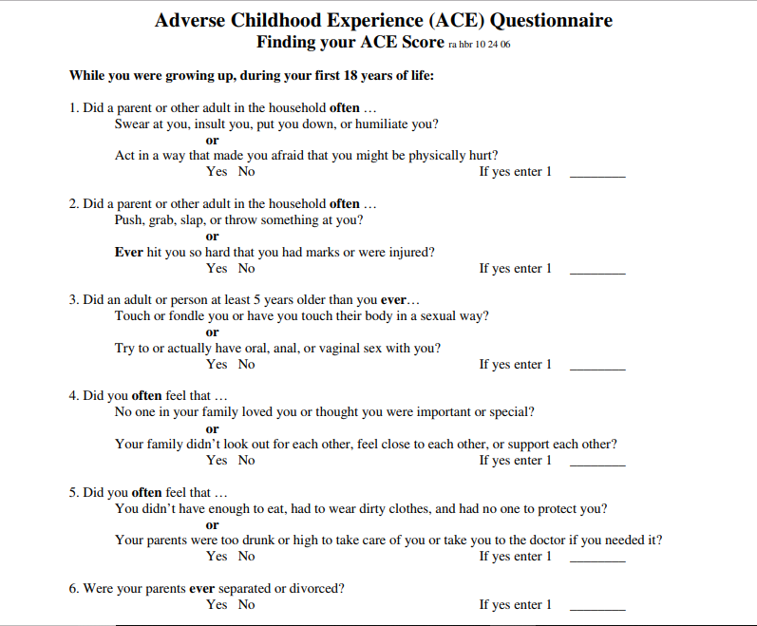
Appendix 1



