MODULE TITLE: Understanding and Engaging in the Customer Experience

MODULE CODE: BMSK 5003

Student ID: 1605672
Student Name: Mohammed Miah
Module tutor: Mr Y Kumar

Table of Contents
Introduction 1
1. Critically analyses the factors that impact your organization's ability to maximize customer value 2
1.1 Value chain analysis 2
1.2 Strengths of the company 4
1.3 Resources and Capabilities of the company: 4
1.4 External environment: 5
1.4.1 PEST analysis: 5
1.4.2 Porter Five Forces: 7
2. Critical understanding of your organizations quality processes and its effectiveness in meeting customer requirements. 9
2.1 Indemnification of the customers need: 9
2.2 Leadership theories 9
2.3 Operational theories: 11
Conclusion 17
Reference 18

Introduction
Customers are the main resources for any company. Every company should have the policies and the strategies for managing the customer’s value and the service (Ida et al., 2011). But certain factors in the market affect the business industry and its customer’s experiences and the customer’s service. These factors can grow from both internal and external sides of the market. Thus, to develop the profitability and the customer relationship, the company must have a flexible business and marketing strategy (Viardot and Dessler, 2011). Marks and Spencer is one of the reputed and growing industries in the UK market. The company has faced lots of ups and downs over the period. The company has developed the profitability in the food section but unfortunately, the clothing sections have faced the losses which ultimately declined most of the profitability. For the better customer’s service, Marks and Spencer had to develop the strategy to use the customer’s experiences for the validity and the profitability. For the better customer’s service, every company has to focus on the quality process. Marks and Spencer have been developing the quality in their management and the process for better customer relationship management. This report will discuss the facts of the customer service and the customer experiences in the context of Marks and Spencer.

1. Critically analyses the factors that impact your organization's ability to maximize customer value
Every factor or the elements in the market or the company have influenced the productivity and the performance of the management (Viardot and Dessler, 2011). The factors can create both positive and negative impacts on the organization's ability to perform their service. At the same time, the factors and elements of the organization affect the ability to maximize the customer’s value as the customer’s service requires the strategy and the operational activities from the company (Hoffman & Woody, 2013). Marks and Spencer have identified certain criteria and stages where the organization may develop the customer’s value. These are given below:

1.1 Value chain analysis
Value chain analysis (VCA) is the internal environment that affects the company’s benefits and the customer’s service in many ways (Howes et al., 2016). VCA implies the approach that the company uses for the verification, identification, management, and execution
Basically, the systematic approaches of Value chain analysis in Marks and Spencer helps the company to handle the products and quality with the process to differentiate and develop the customer’s satisfaction. The VCA in Marks and Spencer is given below:
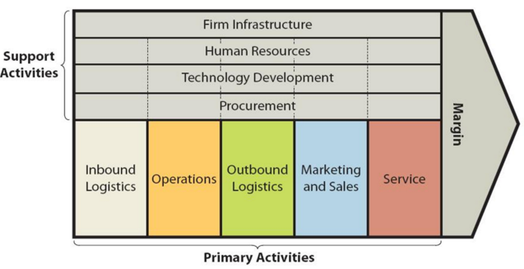
Figure 1 Value Chain Analysis
Source: (Ida et al., 2011)
Human resource management: Every company must start from the beginning to develop the customers’ service based on market preferences and choices (Viardot and Dessler, 2011). Human resource management of the company maintains the employees and their performance which lead to the products quality and the service (Johnson et al., 2011). The engagement of employees in Marks and Spencer and their integration in the company have impacts on the service for the customers. The more employees are engaged in the company and motivated by the employers, the more Marks and Spencer is able to maximize its value for the customers.
Supply chain management: Customer values increase the availability of the product in the company (Ida et al., 2011). Every company should have focused on the effective supply chain management as this significant department is involved in the management and movement of the products and raw materials for the production and operation (Howes et al., 2016). Marks and Spencer have improved the system for developing the supply chain management maximize the worth of the products and the service to develop the customer’s value.
Marketing and sales management: The impacts of the marketing operation of any company directly influence the customer’s expectation and satisfaction (Hoffman & Woody, 2013). Marketing activities of the company focus on the commercialization and the promotional activities for developing the customer’s awareness, the sale, and the brand image. The better the marketing functions of the company, the better the company will be able to handle and maximize the customer’s value for the company (Buttle and Maklan, 2015). Marks and Spencer believe in the frank and effective marketing and promotional activities which drive the management to develop the customer’s value in the market.
Operation management: Operation of any company basically affects the outcome and the productivity of the company. The operation should be managed and maintained by the operational management of the company to manage the customer’s service and the company’s brand image. Marks and Spencer have been operating with the various approaches for the market and their various operational management such as TQM, Kaizen or the capacity management directly influences the customer’s value of the company.
There are certain factors that are related to the company’s internal and the external environment that drives the company to sustain its productivity for the better. Marks and Spencer have been identified some of the factors from both external and the internal environment. These are given below:

1.2 Strengths of the company
Strengths of any company represent the internal value and the core competencies that drive the company to take the opportunities (Viardot and Dessler, 2011). Based on the vision, mission and objectives of the company, Marks, and Spencer has developed its strengths with the new strategy and the new culture. The company has a flexible business culture that accepts the changes and challenges. At the same time, human resource of any company relates to the better value of the products (Johnson et al., 2011). Marks and Spencer have the loyal customers and the professional human resources for the production and the operation.
Marks and Spencer have been developed the techniques for quality products with the help of various techniques. These techniques and the approaches of the operation and the production increase the value of the products by minimizing the wastages. Marks and Spencer have been using the Six Sigma, lean techniques, JIT, Kaizen, and TQM. These techniques in the production would develop the customer’s products and values for the company as well.

1.3 Resources and Capabilities of the company:
Resources and capabilities of any company either drive the company to take the opportunities or develop the strategy for the business (Ida et al., 2011). Marks and Spencer have been facing the loss in the clothing sections but at the same time, the food section of the company has been increasing the profitability for the company. To maximize the customer’s value in the market, Marks and Spencer have its own techniques and resources. These are given below:
Competitive advantages:
Competitive advantages of any company increase the benefits and the value of the company in the market (Hoffman & Woody, 2013). The more competitive advantages the company can develop, the more power and the brand image the company has in the market. At the same time, the competitive advantages have the liabilities and responsibilities of the company (Howes et al., 2016). Marks and Spencer have the market image and the competitive advantages that drive the company to develop its productivity and the customer’s value more than others.

Marketing strategy and promotional activities:
Marketing strategy and the objective of the company work for the commercialization to create the awareness and the customer’s value in the market (Howes et al., 2016). Marks and Spencer have developed the flexible marketing strategy based on the market segmentation and the preferences of the customers. Also, the company develops the promotional activities that relate to the development of the brand image of the company (Byrd and Megginson, 2013). The customer’s value and the service directly connected to the marketing activities of others. Marks and Spencer need to develop its marketing and promotional activities to maximize the customers’ value in the market.

1.4 External environment:
The market of the countries contains the various elements and these elements have dynamic impacts on the different business industry (Ida et al., 2011). The elements of the business environment of the market influence the strategy and the customer value if the company is able to handle the opportunities (Viardot and Dessler, 2011). Marks and Spencer are looking for the betterment of the customer’s value in the market and at the same time, every pressure from the external environments are uncontrollable and unpredictable. These pressure may lead the company to handle the barriers and to develop the customer’s value in the competitive market (Johnson et al., 2011). Marks and Spencer have identified some of the factors in the market that can help the company with the opportunities.

1.4.1 PEST analysis:
PEST analysis is the analytical tool that helps any company to work with the different macro environment. These are given below:
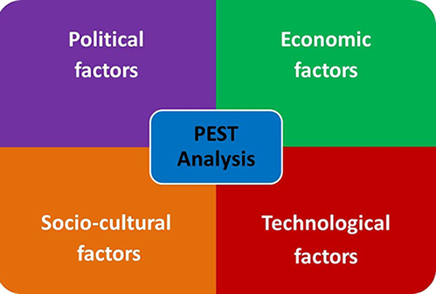
Figure 2 PEST Analysis
Source: (Viardot and Dessler, 2011)
Political factor: Political factors and the influences of the market impose strictly and several rules for the business (Hoffman & Woody, 2013). While thinking about the customer value in the company, Marks and Spencer have been operating in the various markets within the different countries throughout the world.
Based on the differences in the country or home tax, every company must focus on the rules that political situation impose (Byrd and Megginson, 2013). The more Marks and Spencer can adapt the rules and manages the power and authority, the more the company is able to handle the political instability and approachable business and marketing strategies for increasing the customer’s value in the market.
Economic factor: Based on the economy of any country, marketers make the decision for the products and the service (Ida et al., 2011). The different market’s economy of Marks and Spencer will prefer the different rules and system. At the same time, the company can face the stable economic factors of the UK for their customers. The economic factors of any country or in the UK include the GDP, GNP, customer’s disposable income, employment rate, spending pattern, monetary and fiscal policy, and the currency rate (Johnson et al., 2011). To sustain in the competitive market, Marks and Spencer would go for the betterment of the products and service and the marketing activities which will increase the customer’s service and the value in the company.
Social factor: Social factors and the system of the society create certain values, norms, and the traditions of the individual (Byrd and Megginson, 2013). Marks and Spencer have always been responsive to the social culture and the preferences of the customers in the market. Based on every culture and the traditions in the UK, every company has to be more concerned and more flexible to manage the competition and the customer’s demand in the market (Buttle and Maklan, 2015). Thus, the company has been successful to manage and maximize the customer’s value in the market.
Technological factor: Every market is embracing the usages of the technology and the service (Viardot and Dessler, 2011). Technology has changed the operation, activities and the system of the market. Marks and Spencer know the fact of the technology as most of the customers are demanding the communication through the technology. They have plenty of demands and the choices based on the global and local market and the rise of the technology. Every demand should be fulfilled to get their attention and the brand image to develop the customer’s value (Hoffman & Woody, 2013). Marks and Spencer have implemented the technology in the company to manage the communication with the customers and to develop the customer’s relationship management in order to get the value from the market.

1.4.2 Porter Five Forces:
There are others external environment and the factors that affect the business operation of the company (Byrd and Megginson, 2013). These might help the company to look for the better customer’s service in order to sustain in the market. Marks and Spencer have identified some of them and these are given below:
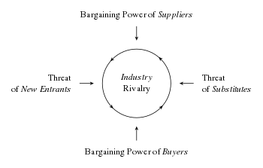
Figure 3 Porter's Five Forces
Source: (Ida et al., 2011)
Power of suppliers: Power of suppliers can create basically hazards the barriers for the company and the power can be drastic if the market is concentrated for the company and the suppliers for the materials are less in number (Viardot and Dessler, 2011). Marks and Spencer ensured the power of suppliers are decreasing through maximizing their customers and professional relationship in the market which helped them to create the value among the customers.
Power of buyers: Every company fears for the power of the buyers (Byrd and Megginson, 2013). The market can increase the power of the buyers when the buyers are declining in the numbers. Marks and Spencer have created its own value in the market which represents their worth and quality for the customers and the customer’s value increases in the company as well.
New entry: Every new entrant in the UK market develops tremendous opportunities for the other as well as the competition (Hoffman & Woody, 2013). During the entrant of the new industry, Marks and Spencer would look for the more quality in the products and service to sustain in the market and to create the brand image for the market. The reverse system is applied here for maximizing the customer’s value in Marks and Spencer.
Rivalry against the competitors: The exiting competitions can grow based on the systematic power and the flexible strategies for the market (Ida et al., 2011). Marks and Spencer have identified some of its competitors like Tesco, ASDA and Next place. To compete and sustain in the markets, Marks and Spencer have to make the move for the better customer’s service and value to compete with the competitions.
Threats of Substitute: The business strategies of companies can be imitated by the others with lower pricing strategy (Buttle and Maklan, 2015). Thus, the substitute industries develop the differentiated product’s quality and the brand value in the market. Marks and Spencer had to take the better steps to maximize the value of the customers to sustain in the market by developing the business strategy.

2. Critical understanding of your organizations quality processes and its effectiveness in meeting customer requirements.

The quality process reminds the company to accept the fact that every customer demands the certain service and the products from the company (Johnson et al., 2011). The basic customers’ demand can be fulfilled through the quality process of the company. Marks and Spencer have identified the basic needs and the demands of the customers which drive the company to develop the effectiveness. These are given below:

2.1 Indemnification of the customers need:
Based on the products and the service, the customers may look for the various options and the variation in the products (Viardot and Dessler, 2011). But certain needs are necessary for every type of customers whether the products are goods or services. Every customer will look for the information, quality, fairness, customer’s service and the empathy from the company (Hoffman & Woody, 2013). Marks and Spencer have identified the basic needs of the customers based on their market and they developed their quality process to increase the effectiveness and to meet the customer’s requirement. These are discussed below:

2.2 Leadership theories
For the quality management and the effectiveness of any company must link with the different theories and the models of the leadership in the company (Buttle and Maklan, 2015). The suitable and correct leadership brings the effectiveness among human resource and increases the profitability of the company. In Marks and Spencer, the leadership theories are used based on the situation.
Situational leadership model
Situational leadership represents the responsible and the flexible person who is the most effective, and the influential leader in the company (Meglich et al., 2016). The situational leader acts and behaves according to the situations in the company. For the quality process and the management in Marks and Spencer, the leadership is the first choices to meet the customer’s requirement.
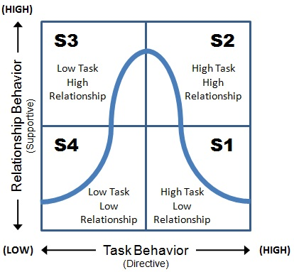
Figure 4 Situational Leadership
Source: (Lientz and Larssen, 2014).
The directive leaders in the company are the one that focuses on the facilities and benefits of the company (Ida et al., 2011). They would believe in the high direction with the less support in Marks and Spencer. On the other hand, the supportive leaders in the company believe in the motivation with less direction. The participative leader in the company both supports and directs the employees as the employees are less educated and motivated (Viardot and Dessler, 2011). In Marks and Spencer, the employees who are not potential enough for the performance, the leaders participate with them to develop their integrity for the customer’s service. The delegate leaders of the company approach the innovative approach for the company (Meglich et al., 2016). In Marks and Spencer, the delegate leaders are leading the HR for the innovation of the new product for meeting the customers demand in the market.
System leader
System leader refers to the responsible leaders focusing on the development of the professional relationship among the employees, team, and management (Johnson et al., 2011). At the same time, this leader tries to minimize the conflict and to develop the skills of employees.

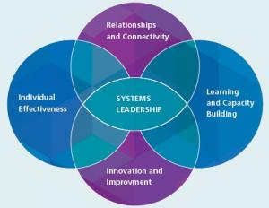
Figure 5 System leader
Source: (Zenger et al., 2011)

When the management of Marks and Spencer focuses on the quality process, the system leaders are appointed to manage the professional relationship with the stakeholders and to minimize any possible barriers and the problems among the team working. The system leaders in the company develop the innovation and the improvement in the quality process (Kadampully et al., 2013). Thus, Marks and Spencer relies in the system leaders in the various situations.

2.3 Operational theories:
Operation of any company links to the quality process of the company (Ida et al., 2011). The effective operational approaches of the company help the management to develop the customer’s service and the value to meet the requirement. After the suitable leadership, Marks and Spencer have focused on the management of the operation to maintain the quality process.
Operation management
Operational management refers to the systematic approach of the company to manage and control the operation accomplishing the business objectives (Viardot and Dessler, 2011). The operational management of the company links to the quality process to maximize the effectiveness of the company. Marks and Spencer use Operation management approaches to meet the customer’s requirement and to develop the quality of the service. Certain techniques for the quality process in Marks and Spencer are given below:
TQM
Total quality management is the most significant operational management approach represents the quality management system of the company (Hoffman & Woody, 2013). TQM believes in developing all the function related to the production and department for the customer’s service (Palmer and Hartley, 2016). Based on TQM, Marks and Spencer have developed the functional unit that focuses on the demands and the choices of the customers in the market and ensures that the news is provided to the new product development.
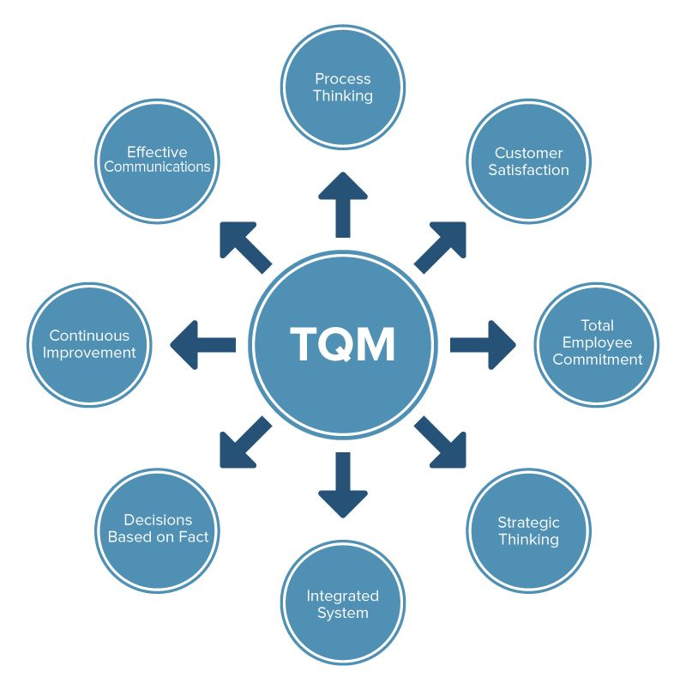
Figure 6 TQM
Source: (Buckley & Ghauri, 2015)
JIT
Just In time or JIT in the company implies to the system of managing the production and the inventory (Viardot and Dessler, 2011). The JIT focuses on the minimization of the cost to minimize the inventory for the company’s production. In Marks and Spencer, the JIT ensures that the production and operation of the company maintain the quality process for the customer’s requirement. The effectiveness of the company relies on JIT as the less inventory of the company minimizes the complexities and the cost as well (Jehn & Mannix, 2011). In the company, quality process ensures the better JIT is managed by the management.

Kaizen
As a Japanese term, Kaizen basically representing the development of the labor productivity for the minimization of the cost (Hoffman & Woody, 2013). Kaizen implies to the elements and the related factor that affect the labor productivity within the company. The more developed Kaizen in the company, the more labor productivity develops the quality in the products and the service based on the requirement of the company (Palmer and Hartley, 2016). In Marks and Spencer, Kaizen has developed the effectiveness of the company to increase the potentiality of the management to meet the customer’s demand for the quality and the information.
Six Sigma
Six Sigma in the company refers to the system of the operating system and the approach focusing on the massive production for developing per unit production and minimizing the cost of the production of the company (Huselid and Becker, 2011). Through Six Sigma, the high number of production will minimize the fixed cost for the company and the high labor productivity will lead to the highest quality of the products
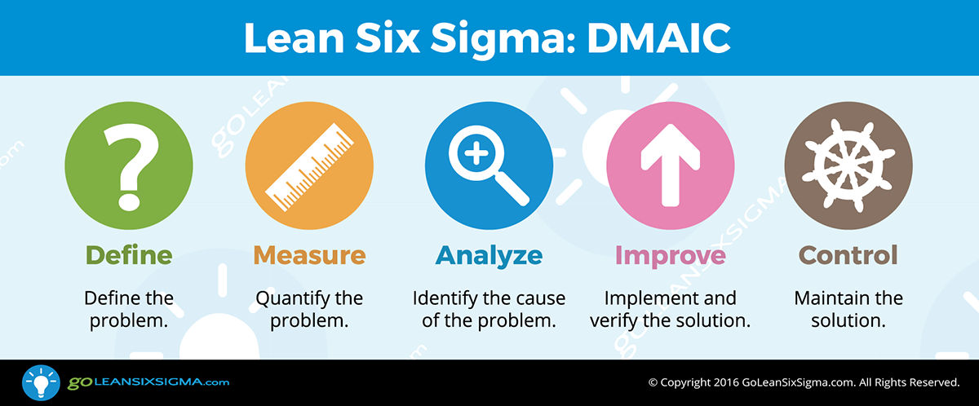
Figure 7 Six Sigma
Source: (Blair and Hitchcock, 2011)
Also, the Six Sigma refers to the better production and the massive production which will balance the supply in the market balancing the market reputation for the company.
Lean Techniques:
Lean techniques in the company refer to the system that focuses on quality management and the process through labor productivity (Ida et al., 2011). The company ensures the labor productivity increases the quality of the products with minimizing the cost of the production. For the customer requirement in the market, Marks and Spencer have developed the lean techniques to develop the quality process.
Queuing:
Queuing implies to process that focuses on the development of the product’s design, process, operational delivery, and better customer’ service (Viardot and Dessler, 2011). The leaders of Marks and Spencer developed the queuing service to accomplish the customer’s service based on their demanded products. Achieving the business objective, the company can relate to the quality process to develop quality management based on the customer requirement in the market (Johnson et al., 2011). Marks and Spencer have used more operational approaches for their importance.
Control and Distribution System
Control and distribution system of the company manage the control and the supply system and the distribution process would focus on the delivery and management of the products and the raw materials (Hoffman & Woody, 2013). Based on the quality of the resources, the products and the services contain the quality that customers require from the company. Control and distribution refer to the part of the management that develop the system of managing and controlling the movement of the products, supply chain management and the raw materials in the distribution (Caplan and Coleman, 2012). The control and distribution system in Marks and Spencer have been used by the management which created their effectiveness for the service. The control system of the company creates the limitation for the production or the usages of the resources where the wastages are minimized through the proper checkup (Beard and Kitson, 2014). At the same time, the distribution system in Marks and Spencer is managed with the right time and the critical path to minimize any sort of barriers or the problems while processing for the quality.
Process Design:
Process design literally indicates the system for developing the procedures steps by steps. Quality process design implies to the system of identifying and managing the process for the quality operation and the quality production.
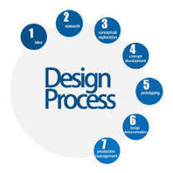
Figure 8 Process Design
Source: (Boselie and Chand, 2011)
Process design of Marks and Spencer focuses on the several paths and the designs to ensure the company has its quality based on the customers’ preferences in the market. At the same time, the process design of the company links to the benefits that develop the quality in the service or the products (Johnson et al., 2011). Thus, Marks and Spencer provide tremendous attention towards the process design for the effectiveness and the quality.
Capacity Management
Capacity management of the company basically refers to the system to manage the capacity and the storage for the production and the operation (Ida et al., 2011). The right capacity management of any company relates to the various parts of the management to enhance the quality management for the better operation and the service.

Figure 9 Capacity Management Tools
Source: (Bharwani and Bhutt, 2012)
The capacity management tools help the management to maintain the quality of the service and the productivity for the customers (Caplan and Coleman, 2012). In Marks and Spencer, the capacity management process ensures that the management is able to know about its storage and the system of managing the capacity.
Stock & Logistics Management
Stock and logistics management refers to the significant part of the operational management of the company which to stock the expected inventory for them (Johnson et al., 2011). The stock and the logistic management focuses on the various actions for managing the quality of the products to meet the criteria of the customers (Beard and Kitson, 2014). In Marks and Spencer, the quality can be managed and maintained if the products are managed effectively and safely in the stock and logistic area.
Through every process and the operational approach of the company, and management can develop the quality of the products. At the same time, the quality process under all of this operational approach can help Marks and Spencer to meet the customers’ requirement and to manage the own effectiveness in the market.

Conclusion
Customer’s decision-making process of the buying decision must be influenced by the company to develop their awareness towards the company and its products (Viardot and Dessler, 2011). At the same time, the company should develop their quality in the service and the products to develop the customer’s value and the service in the market. Based on the customer’s relationship management in this competitive market, no industry can rely on only the products to survive (Caplan and Coleman, 2012). Marks and Spencer have created its value and the brand image to handle the competition in the market. But the customers seek for the value and the service form the company which must be tackled to survive as well. Marks and Spencer had to go through various losses and unfortunate but in the end, they focused on the customer’s value and the quality management in the company to develop the profitability and the sustainability. This report has discussed all the factors associated with the customer’s satisfaction, value and the quality process in the context of Marks and Spencer.

Reference
Beard, L. and Kitson, T. (2014). Regulated river basins. Paris: Unesco.
Bharwani, S. and Bhutt, N., (2012). Challenges for the global hospitality industry: an HR perspective. Worldwide hospitality and tourism themes, 4(2), pp.150-162.
Blair, A. and Hitchcock, D. (2011). Environment and business. London: Routledge.
Boselie, P., and Chand. S. (2011). Strategic human resource management: A balanced approach. Tata McGraw-Hill Education.
Buckley, P. J., & Ghauri, P. N. (2015). International Business Strategy: Theory and Practice. Routledge.
Buttle, F. and Maklan, S. (2015). Customer relationship management. London: Routledge.
Byrd, M. and Megginson, L. (2013). Small business management. New York, NY: McGraw-Hill.
Caplan, F. and Coleman, J. (2012). Operational Mid-Level Management for Police. Springfield: Charles C Thomas.
Dunphy, S.M., Herbig, P.R. and Howes, M.E., (2016). Selection; Meaning and steps involved in the selection procedure.
Hersey, P., Blanchard, K. H., & Johnson, D. E. (2011). Management of organizational behavior.
Hoffman, A. J., & Woody, J. G. (2013). Climate change: What's your business strategy? Harvard Business Press.
Huselid, M.A., and Becker, B.E., (2011). Bridging micro and macro domains: Workforce differentiation and strategic human resource management. Journal of management.
Jehn, K. A., & Mannix, E. A. (2011). The dynamic nature of conflict: A longitudinal study of intragroup conflict and group performance. Academy of management journal, 44(2), 238-251.
Lientz, B. and Larssen, L. (2014). Manage IT as a business. Amsterdam: Elsevier Butterworth Heinemann.
Mathis, R., Jackson, J., Valentien, S. and Meglich, P. (2016). Human Resource Management. Boston: Cengage Learning.
Mok, C., Sparks, B. and Kadampully, J. (2013). Service Quality Management in Hospitality Tourism and Leisure. Hoboken: Taylor and Francis
Palmer, A. and Hartley, B. (2016). The business environment. Maidenhead: McGraw-Hill Education.
Sierk, Y., Dvora Yanow, Y. and Ida, S. (2011). Organizational Culture. Cheltenham: Edward Elgar Pub.
Viardot, E. and Dessler, G. (2011). The timeless principles of successful business strategy. New York: Springer
Zenger, J., Folkman, J., Edinger, S., Zenger, J., and Zenger, J. (2011). The extraordinary leader.

