Human DIGESTIVE SYSTEM POSTER

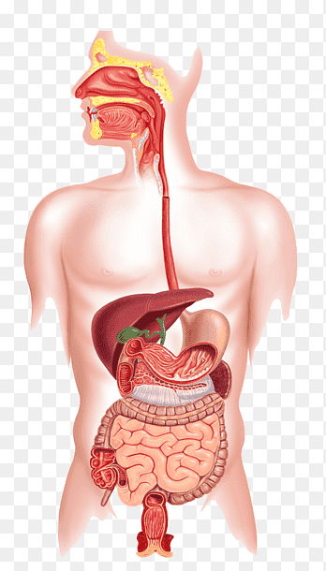

2. Salivary Glands
1. Mouth
3. Oesophagus
9. Gall Bladder
7. Liver

8. Pancreas
5. Stomach
6. Smaller Intestine
10. Larger Intestine
11: Rectum
12: Anus

( Calvetti, 2012 )
1. Mouth- As a person eats food, the mouth is the starting point of the human digestive system. The GI tract pushes the food down within the process of eating. When the food is swallowed the tongue also contributes to pushing the food towards your throat. The food then goes into your oesophagus. (NIDDK, 2017)

2. Salivary Glands- As mentioned previously above, the mouth is the start of the human digestive process. Factually speaking, the process begins before the person consumes a single piece of their food. The salivary glands are triggered at the point of food being sighted as well as the smell. During the process of eating, the food chunks are chewed into small pieces so they can be digested without any difficulty. (Cleveland Clinic, 2018)

3. Oesophagus- The oesophagus is located in a person’s throat and has the function of receiving the food entering rom the mouth after the person chews and swallows the food. Within the oesophagus, there is a small flap that covers the windpipe as the person swallows the food in to prevent blockage- leading to choking. Peristalsis is the process of where the oesophagus delivers the food to the stomach. Before this however, at the bottom of the oesophagus, there is an organ called he sphincter which is required to relax before letting food pass into the stomach. This opens and forbids the contents of the stomach e.g. acid from rebounding into the oesophagus again (Cleveland Clinic, 2018).
Gastro-oesophageal reflux disease (GORD)- this disease, which is a common cause involved in indigestion, comes by constant injection of acids into the oesophagus which then cases infection and inflammation. When blood vessels erode in this process, this is known as haemorrhage. Consistent reflux cases crucial inflammation and if the damage is serious, greater damage occurs to the oesophagus.(Waugh & Grant, 2014 p.p. 322).
Healthy lifestyle includes eating lower amounts but an increased number of meals and cutting food or drinks off that may bring about these symptoms. Furthermore, other things such as keeping to a healthy weight also contributes to a health lifestyle. (NHS, 2020)

4. Stomach- The stomach is made out of many muscles and it is found where the oesophagus is as well as on top of both of the intestines. The stomach has the primary function of absorbing food and is highly important for converting food into smaller chunks, so it is easier for the intestines to digest the food. The burning action of the stomach muscles helps break down the food and contributes to the digestive process. The stomach also releases enzymes to compress the food down chemically. One of the enzymes, known as pepsin, has the responsibility for breaking proteins down. (Belsley, 2020)

5. Small Intestine- Similar to the stomach, the small intestine also possesses the function of compressing food down using enzymes made in the pancreas and other chemicals such as bile from your liver. The small intestine is one of the main elements of the digestion process. While food is in the small intestine, nutrients are absorbed and received through the walls and are injected into your bloodstream. The leftovers of this process all move into your large intestine as waste. (Khatri, 2020)

6. Liver- The liver has a large number of jobs but its primary role in the digestion process is to process and store the nutrients that are absorbed from the small intestine. Bile which is stored in the liver is inserted into the small intestine and this also plays a major part in compressing acids and a few vitamins. The liver gets the products taken by both of the intestines and produces the substances that the body requires to work effectively. This organ also eliminates chemicals that can be potentially harmful to the body as well as intoxicant substances that can be harmful. (Cleveland Clinic, 2018)

7: Pancreas-The pancreas has a very important job in digestion and in controlling the amount of sugar going into the blood. The pancreas has two primary functions which are producing enzymes to digest proteins, fats, etc in the intestines. The pancreas also produces insulin and glucagon. (Szalay, 2018)
d

8 : Gallbladder- The gallbladder has the role of bile storage and concentration in between the daily 3 meals. Functioning of the gallbladder is administered by bile acids via a receptor and by signals connected to the digestive system e.g. hormones in the intestines which empties the gallbladder as well as refills it. This cycle looks and controls the level of bile entering the intestine. (Housset, 2016)

9. Large Intestine- The large intestine makes up 1/5 of the total length of the gastrointestinal tract. This intestine is accountable for producing indigestible food substances after the scenario of where a handful of the nutrients enter the small intestine. The large intestine contains 4 various parts. It consists of the cecum and ascending colon, transverse colon, descending colon, and sigmoid colon. The large intestine carries an important role by taking water, vitamins, etc. from waste substances (Azzouz, 2020)

10 . Rectum- The rectum is an area that starts right at the bottom of the large intestine. The rectum has nothing in it because waste is stored higher in the descending colon which is slightly above the rectum. At some point, the descending colon becomes full of waste and this then passes into the rectum, which then creates the need to move the bowels. (Ruiz Jr, 2019)

11. ANUS: The anus is the access at the distant end of the digestive tract and it is where waste leaves the body, after the bowels move. The anus is connected with a reopening of the skin on the outside. A ring made out of muscles, which is known as the anal sphincter, holds the anus shut until the person has a bowel movement and needs to remove waste. (Ruiz Jr, 2019)

