Enhancing Quality Control and Efficiency in Aerospace Thermal Coating through CMM Integration at Bodycote Newport

Viktoria Berces
BEng (Hons) Mechanical and manufacturing engineering

A dissertation submitted to the University of Wales Trinity Saint David

Declaration/Statements page
DECLARATION
This work has not previously been accepted in substance for any degree and is not being concurrently submitted in candidature for any degree.
Signed Viktoria Berces Date 17/05/2024
STATEMENT 1
This work is the result of my own investigations, except where otherwise stated. Where correction services have been used, the extent and nature of the correction is clearly marked in a footnote(s).
Other sources are acknowledged by footnotes giving explicit references. A bibliography is appended.
Signed ......................................................................... Date ...............................
STATEMENT 2
I hereby give consent for my work, if accepted, to be available for photocopying and for inter-library loan, and for the title and summary to be made available to outside organisations.
Signed ......................................................................... Date ...............................

Abstract

This study aims to uncover the distinctions between the existing manual inspection method and the forthcoming introduction of coordinate measurement machine (CMM) inspection, including their respective benefits and drawbacks.
In order to explore and understand the differences, time and motion studies were carried out.
The findings revealed that CMM inspection required slightly more time than manual inspection. Nonetheless, the major distinction lies in the fact that CMM inspection can proceed autonomously, allowing operators to multitask and thereby enhance overall efficiency.
The Gage R&R study conducted for manual inspection definitively established shortcomings in the measurement system regarding its repeatability and reproducibility. Inconsistencies were observed between measurements conducted by different operators and those repeated by the same operators.
The Gage R&R analysis of the CMM indicated that the machine achieved high levels of accuracy and repeatability in its measurements.
The examination of the CMM loop program and the Gage R&R analysis conducted on ten components demonstrated the effectiveness of the measurement system in this instance. It led to the conclusion that employing CMM instead of manual inspection yields greater accuracy and reliability, particularly crucial for inspecting aerospace components.

Table of Contents
Abstract 3
List of Figures 6
List of Tables 7
1 Introduction 8
1.1 Research motivation 8
1.2 Thesis organisation 9
2 Background research 10
2.1 Thermal Spraying 10
2.2 Bodycote Newport 11
2.3 Coordinate Measuring Machine 11
2.4 Literature review 12
2.5 Conclusion 13
3 Methodology 14
3.1 Inspection planning 14
3.2 Manual and CMM inspection processes 16
3.3 Time and motion study 19
3.4 Conclusion 21
4 Results and analysis 22
4.1 Measurement system analysis 22
4.2 Gage R&R Analysis of Manual Inspection 25
4.2.1 Top diameter Gage R&R analysis 25
4.2.2 Middle diameter Gage R&R analysis 32
4.2.3 Bottom diameter Gage R&R analysis 37
4.2.4 Flange thickness Gage R&R analysis 41
4.3 Type 1 Gage R&R Analysis of CMM Measurements 45
4.3.1 Type 1 Gage Study for top diameter 46
4.3.2 Type 1 Gage Study for middle diameter 47
4.3.3 Type 1 Gage Study for bottom diameter 48
4.3.4 Type 1 Gage Study for flange thickness 49
4.4 Gage R&R Analysis of CMM loop program 50
4.4.1 Top diameter Gage R&R analysis 50
4.4.2 Middle diameter Gage R&R analysis 53
4.4.3 Bottom diameter Gage R&R analysis 55
4.4.4 Flange thickness Gage R&R analysis 57
4.4.5 Conclusion 60
5 Conclusion and Recommendations 62
5.1 Conclusion 62
5.2 Limitations 63
5.3 Recommendations and future work 63
6 References 65
7 Appendix A - Mitutoyo C776 68
8 Appendix B – Brake rod drawing 69
9 Appendix C - Micrometer 70
10 Appendix D – Height gauge 71
11 Appendix E – Manual inspection flow chart 72
12 Appendix F – CMM inspection flow chart 73
13 Appendix G – Time and motion study – Manual inspection 74
14 Appendix H – Time and motion study – CMM inspection 76
15 Appendix I – CMM loop program 78
16 Appendix I – CMM loop program/b 79

List of Figures

Figure 1 - Classification of thermal spray process 10
Figure 2 - The process of making a collaborative inspection plan with a production plan 15
Figure 3 - An overview of the strategy map 16
Figure 4 - Measurement systems variation 22
Figure 5 - Accuracy of measurement system 23
Figure 6 - Bias of measurement system 23
Figure 7 - Brake rod 24
Figure 8 - Marked component 25
Figure 9 - Gage R&R (Anova) report for top diameter (manual Gage R&R) 32
Figure 10 - Gage R&R (Anova) report for middle diameter (manual Gage R&R) 37
Figure 11 - Gage R&R (Anova) report for bottom diameter (manual Gage R&R) 41
Figure 12 - Gage R&R (Anova) report for flange thickness (manual Gage R&R) 44
Figure 13 - CMM gage R&R part locations 45
Figure 14 - Type 1 Gage Study for Top diameter 47
Figure 15 - Type 1 Gage Study for Middle diameter 48
Figure 16 - Type 1 Gage Study for Bottom diameter 49
Figure 17 - Type 1 Gage Study for Flange thickness 50
Figure 18 - Gage R&R (Anova) report for top diameter (CMM Gage R&R) 52
Figure 19 - Gage R&R (Anova) report for middle diameter (CMM Gage R&R) 55
Figure 20 - Gage R&R (Anova) report for bottom diameter (CMM Gage R&R) 57
Figure 21 - Gage R&R (Anova) report for flange thickness (CMM Gage R&R) 59

List of Tables

Table 1 - Top diameter, two-way Anova table with interaction (manual Gage R&R) 27
Table 2 - Top diameter, Variance components (manual Gage R&R) 29
Table 3 - Top diameter, gage evaluation (manual Gage R&R) 30
Table 4 - Middle diameter, Two-way Anova table with interaction (manual Gage R&R) 33
Table 5 - Middle diameter, Variance components (manual Gage R&R) 34
Table 6 - Middle diameter, gage evaluation (manual Gage R&R) 35
Table 7 - Bottom diameter, two-way Anova table with interaction (manual Gage R&R) 38
Table 8 - Bottom diameter, Variance Components (manual Gage R&R) 38
Table 9 - Bottom diameter, Gage Evaluation (manual Gage R&R) 39
Table 10 - Flange thickness, Two-way Anova table with interaction (manual Gage R&R) 42
Table 11 - Flange thickness, Variance Components (manual Gage R&R) 42
Table 12 - Flange thickness, Gage evaluation (manual Gage R&R) 43
Table 13 - Top diameter - One-way Anova table (CMM Gage R&R) 51
Table 14 - Top diameter - Variance components (CMM Gage R&R) 51
Table 15 - Top diameter - Gage evaluation (CMM Gage R&R) 51
Table 16 - Middle diameter - One-way Anova table (CMM Gage R&R) 53
Table 17 - Middle diameter - Variance components (CMM Gage R&R) 53
Table 18 - Middle diameter - Gage evaluation (CMM Gage R&R) 54
Table 19 - Bottom diameter - One-way Anova table (CMM Gage R&R) 55
Table 20 - Bottom diameter - Variance components (CMM Gage R&R) 56
Table 21 - Bottom diameter - Gage evaluation (CMM Gage R&R) 56
Table 22 - Flange thickness - One-way Anova table (CMM Gage R&R) 58
Table 23 - Flange thickness - Variance components (CMM Gage R&R) 58
Table 24 - Flange thickness - Gage evaluation (CMM Gage R&R) 58

Introduction

In the rapidly developing aerospace industry, it is essential to comply with the highest quality standards and strict regulations in order to ensure safe operation. Narrow tolerances, precision, and accuracy typical of the aerospace industry.
Bodycote Newport, which specializes in the thermal coating process of aerospace products, strives to achieve the highest quality. It continuously strives to improve quality and improve the efficiency of processes and quality inspection.

Central to this initiative is the integration of coordinate measuring machine into the thermal coating workflow. By incorporating CMM technology, Bodycote Newport aims to elevate its quality assurance processes, streamline inspection procedures, and ensure the precise measurement of critical dimensions. This integration holds the promise of not only improving product quality but also optimizing production workflows, ultimately driving greater customer satisfaction and market competitiveness.
This study tries to reveal the advantages and disadvantages of CMM integration compared to traditional manual inspection.

Research motivation

The motivation behind conducting this study and implementing CMM inspection is the continual rise in customer orders.
With Bodycote Newport experiencing a surge in orders from current clients and the addition of new customers, there's a pressing need to enhance inspection procedures for increased efficiency. An effective and meticulously operating inspection system holds particular significance, notably in the aerospace sector.

Thesis organisation

Chapter 2 – This chapter provides an overview of thermal spraying and introduces Bodycote Newport. It outlines the key features of the coordinate measuring machine (CMM) and incorporates a literature review on CMM and its various applications.
Chapter 3 – This chapter introduces the methodology, detailing the distinctions between manual and CMM inspection methods via a process map. Furthermore, it includes analysis of time and motion regarding inspection procedures.
Chapter 4 – This chapter describes the main characteristics of the measurement system analysis. Additionally, it provides a comprehensive overview of the Gage R&R study conducted for manual inspection, as well as the type 1 study conducted for CMM inspection. Furthermore, the chapter examines the loop program Gage R&R studies concerning the ten manually inspected components
Chapter 5 - The final chapter encompasses the conclusions and observations drawn from the study. It also discusses the study's limitations and proposes future directions for research.

Background research

Thermal Spraying

Qadir et al. (2024) highlights in their research that the primary objective of thermal coating is to protect materials from external environmental factors like corrosion and heat, rendering them resistant.
During the thermal spraying procedure, the powder is subjected to a heated, high-speed flame, reaching the surface. This can occur as the powder passes through the flame or by introducing the powder into the flame externally. Once the molten powder particles make contact with the surface, they solidify, establishing a firm bond.
Various types of thermal spraying processes exist, as illustrated in the diagram provided in Figure 1 – Classification of thermal spray process (Qadir et al, 2024). Among these, the high velocity oxygen fuel, plasma spray, and wire arc spraying processes are the most prevalent.

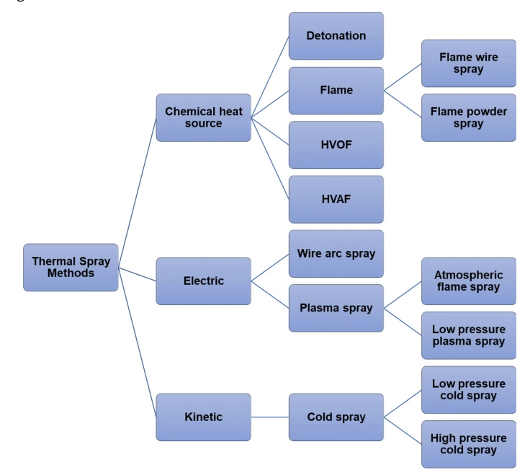
Figure 1 - Classification of thermal spray process

Bodycote Newport

Bodycote operates in 23 countries across 165 global locations, specializing in heat treatment, surface technology, and hot isostatic pressing.
At the Newport facility, the primary focus is on thermal coating processes. With 2 wire arc spraying booths, 4 plasma booths, and a high velocity oxygen fuel booth, the site is well-equipped for various applications.
The company specializes in thermal coating for aerospace components and parts, while also providing services for products utilized in the oil and gas sector.

Coordinate Measuring Machine

As described by Nikam (2018), the coordinate measuring machine (CMM) assesses the geometric attributes of the examined object. This machine can operate manually under operator control or automatically via an inspection program tailored to the specific object being assessed.
CMMs find extensive application in industries such as aerospace, automotive manufacturing, and other sectors demanding high precision.
At the Bodycote Newport site, a Mitutoyo Euro C776 model is employed, as detailed in Appendix A. This model offers a measuring range of 700 mm along the X and Y axes and 600 mm along the Z axis.
Primarily used for dimensional inspections, this machine is well-suited for assessing small to medium-sized products treated with thermal coating by the company.

Literature review

The study conducted by Melichar et al. proves that human factors have an influence on the measurements made by the CMM.

It can be concluded from the experiment that if a more accurate component analysis is required, then the measurement system would probably have been unacceptable.

When the required component accuracy reaches a level (approximately 0.005 mm) where human intervention in the measurement process becomes impractical, and automation becomes necessary.

Repeatability and reproducibility of an automatic CMM is recommended for critical components. Automating the process addresses the challenges associated with human factors, enhances repeatability and reproducibility, and ensures a higher level of accuracy in the measurement of critical components. This aligns with the idea that as the required accuracy increases, the need for automated systems becomes crucial to meet stringent quality standards and maintain consistency in measurements.

In alignment of Lorenzo et al. (2017) findings the implementation of Coordinate Measurement Machine is expected to result in an increase in production. This is due to the improved trust among partners resulting from more reliable measurement control.
The enhanced reliability in quality checks and measurements not only boosts confidence but also contributes to higher standards and operational efficiency. The combination of advanced measurement technologies and increased trust is anticipated to have a positive impact on the production landscape, promoting growth and reliability across various areas.

Lorenzo et al. (2017) also states that integrating continuous control into the measurement process enables anticipation of instrument deviations from specifications and calibration needs. This proactive strategy supports efficient planning and assists in controlling maintenance costs associated with CMM usage.

Additionally, it is apparent that utilizing the CMM led to a minor increase in operational time, accounting for less than 5% of the total usage duration. However, this investment facilitated the implementation of programming and autonomous functionalities.

Furthermore, comprehending the CMM's behaviour and condition simplifies the calibration process by eliminating unnecessary maintenance and calibration tasks prompted solely by the lapse of an annual period.

As Anagnostakis et al. states in his study, inspection planning and tooling are necessary and beneficial especially in case of CMM, thus knowledge can be successfully recorded. The quality of the process is significantly improved by accurate and constant feedback on the inspection processes, the result will be a more responsive and informed production process. This contributes to greater efficiency and accuracy.

Conclusion

In summary of the literature review, it is evident that for critical components with tight tolerances, automated measurement is necessary due to the potential influence of human factors on measurement outcomes.

Particularly concerning aerospace components, as in the context of this study, precision is essential. Therefore, a measurement system that operates with high accuracy, alongside properties like repeatability and reproducibility, is indispensable.
Additionally, it can be concluded that implementing CMM inspection may extend operational duration, although simplifying calibration processes.

Moreover, documenting the CMM inspection process is essential as it helps in the discovery of possible errors and facilitates the continuous improvement of the processes.

Methodology

Inspection planning

As Filz et al (2021) writes in their study, during the production process, the raw material is formed into a final product by adding different values. During this process, quality inspection is important at certain stages of production, which makes it possible to discover all kinds of quality problems.

At Bodycote Newport, quality inspection occurs at multiple points in the production process. Incoming products undergo check during pre-production inspection, aligning with the data card specifications. The first article inspection validates the initial batch, while the final inspection precedes the final dispatch.

As Shiokawa et al (2019) also writes, it is necessary to establish an inspection plan that aligns with the production schedule, as depicted in Figure 2 – The process of making a collaborative inspection plan with a production plan (Shiokawa et al, 2019). In the event that a usable inspection plan cannot be implemented due to the production plan in use, an alternative production plan must be developed and applied until a new inspection plan can be formulated. The inspection plan must also address the evaluation and resolution of non-conforming products.

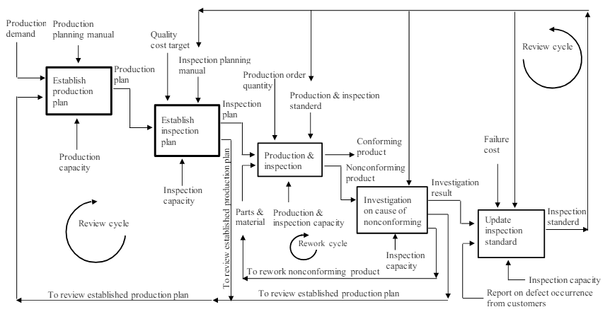
Figure 2 - The process of making a collaborative inspection plan with a production plan

When developing a new inspection plan potential costs arising from the interplay between inspection and production speed must be considered. Figure 3 – An overview of the strategy map (Shiokawa et al, 2019) illustrates the necessity of determining the maximum cost associated with rapid production and inspection rates. Moreover, it highlights the costs of delayed delivery resulting from slow inspection rates coupled with fast production, as well as the potential expenses incurred from slower production and rapid inspection.
Focusing on potential product defects and their costs, which may result from rushed inspection or fast production speed, is the most important.

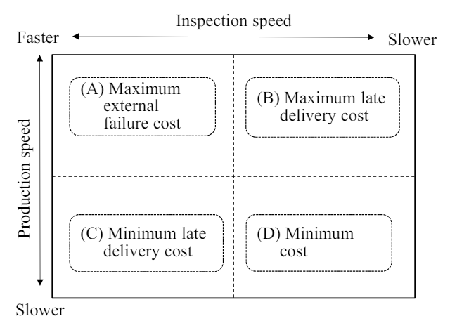
Figure 3 - An overview of the strategy map

Manual and CMM inspection processes

Appendix E features the manual inspection flow chart, illustrating the detailed steps involved in the process. It's evident that manual inspection entails numerous time-consuming stages.

Presently, a significant portion of pre-production inspection occurs outside the designated inspection room due to the absence of a height gauge in that area. Instead, there's a single height gauge positioned on the shop floor, shared among operators and inspectors.

This setup presents challenges as individuals may have to wait for the gauge to become available, leading to potential delays. Moreover, frequent use by multiple individuals may result in its improper maintenance and higher wear and tear.

The concurrent usage of the micrometer during inspections can exacerbate these issues, causing further delays. It's imperative that all measuring instruments undergo calibration before each inspection.

For brake rod inspections, the initial requirement is to cleanse the parts thoroughly with an appropriate solution to eliminate any accumulated dirt.

It's essential for parts to maintain a suitable temperature, ideally between 19 and 21 degrees Celsius. Therefore, it's crucial to verify the temperature before commencing inspection. If the parts aren't within the correct temperature range, they should be transferred to a temperature-controlled inspection room and kept there until the appropriate temperature is achieved.

If the parts need to be relocated to the inspection room due to unsuitable temperature conditions, during manual inspection, the inspector has two options. They may choose to measure the diameter in the inspection room when the required temperature is reached and then move the parts to the shop floor for flange thickness measurements with the height gauge. Alternatively, they can wait until the parts reach the appropriate temperature and then perform both diameter measurements and flange thickness measurements directly on the shop floor. However, this process invariably results in time loss during the inspection.

The first step of the inspection is the visual examination of the components and the recording of any deviations and, if necessary, notifying the quality engineer.

The micrometer is used to measure the diameter. The data card mandates a single measurement for the top, middle, and bottom diameters. Any discrepancies from the specified values must be documented, and the quality engineer alerted accordingly. Following measurement, the manufacturing route card is endorsed. Subsequently, the parts are resealed in their container and forwarded to the subsequent station, namely the degreasing station.

During inspections conducted with a Coordinate Measuring Machine (CMM), detailed procedures are followed to ensure accuracy and precision. The flow chart for CMM inspection can be found in Appendix F.

As mentioned earlier, it's crucial for the components to be at the appropriate temperature. With the CMM situated in a temperature-controlled inspection room, unnecessary movement can be avoided during CMM inspection.
Before any measurements commence, it's imperative to calibrate the CMM to guarantee its accuracy.

Similar to manual inspections, the components are subjected to thorough cleaning and visual inspection to ensure they meet quality standards. Following this, they are carefully positioned on the CMM bed according to specified coordinates.

The inspector initiates the measurement process by executing a loop program tailored to the component being measured. During this time, the inspector has the flexibility to attend to other tasks while the program runs.

Upon completion of the measurement program, an inspection report is generated, detailing the precise measurements obtained. Subsequently, the manufacturing route card is signed, indicating the completion of the inspection process. The inspected parts are then returned to their packaging and routed to the next stage of production, typically the degreasing station, for further processing.

The clear difference between manual and CMM inspection is that the latter consists of fewer steps. It simplifies the process by having all the measurements done by one machine at the same time.
In contrast, manual inspection involves additional steps and handling due to the separation of measurement tools. Initially, components are assessed on the shop floor due to the positioning of the height gauge. Subsequently, they are relocated to the inspection room for diameter evaluations.

Moreover, in CMM inspection, the inspector's continuous presence is not necessary until the inspection concludes. This allows them the opportunity to multitask while the CMM independently conducts measurements, a departure from the constant oversight required in manual inspections.

Another significant distinction is the data recording requirements. As per the data card, manual inspection mandates a singular measurement for the top, middle, and bottom diameters, along with three measurements for flange thickness.

On the other hand, CMM inspections involve capturing 16 points for both diameter and flange thickness, highlighting a higher degree of precision and detail.

Time and motion study

Time and motion study aims to record each stage of the process and record the time required to complete it.
Conducting a time and motion study is a fundamental component of lean manufacturing methodologies. According to Kumar et al. (2022), the primary objective of lean manufacturing, or continuous improvement, is to optimize resource utilization by minimizing waste.
Throughout this assessment, the operator performing the task is observed, and the duration of each step is documented. This analysis helps to determine areas where possible time loss and unnecessary movements occurs, thereby facilitating process improvement.

The time and motion analysis outlined in Appendix G revealed that inspecting the 10 parts manually took 85 minutes.
During manual inspection, the inspector moved the parts from the Goods In area to the Pre-production inspection area on the shop floor using a pallet truck. However, there was a delay during this process due to the unavailability of a pallet truck.
The micrometer needed for the inspection was collected from the inspection room. However, if the micrometer is already in use, it can also lead to delays.
Following the cleaning of the parts, it was necessary to verify the temperature, ideally ranging between 19°C and 21°C. If the temperature falls outside this range, the parts must be relocated to the temperature-controlled inspection room until they reach the desired temperature. These procedures may result in additional time loss and unnecessary movement. During the study, the temperature of the components was measured at 19.5°C, indicating suitability.

Prior to inspection, the measuring instruments underwent calibration, with the operator manually calibrating the height gauge and micrometer. Ensuring precise calibration is crucial as it can impact the results. The calibration outcomes were documented on the data card.

Following the visual inspection of the parts, measurements were taken using a height gauge and micrometer, and the findings were documented on the data card.
If there are potential visual or dimensional defects, they should be documented on the manufacturing route card, and the quality engineer needs to be alerted to initiate the non-conforming process.
Following the inspection, the manufacturing route card was signed and stamped, and the parts were put back in the box and moved to the next degreasing station.

The time and motion study for CMM inspection, detailed in Appendix H, revealed a total required time of 90 minutes.

One major distinction between CMM and manual inspection lies in the environmental conditions: CMM inspection occurs within a temperature-controlled room, eliminating the necessity for unnecessary movement even if the parts are not at the optimal temperature. In the study, the components were measured at 19.3°C. Additionally, CMM inspection does not require a height gauge or micrometer. Furthermore, calibration in CMM inspection is automated, ensuring greater accuracy compared to manual calibration performed by operators.

Following the calibration of the CMM, visual inspection of the parts ensued, following a similar process to manual inspection. Subsequently, the parts were positioned on the CMM bed at designated locations, and the program was initiated. The outcome was attached to the data card, signed, and stamped. After inspection, the parts were restored to the box and transferred to the degreasing area. Likewise with manual inspection, any visual or dimensional defects must be documented, and the quality engineer should be promptly informed.

Conclusion

In summary, the adoption of CMM provides significant advantages over conventional manual inspection techniques, offering enhanced efficiency and precision.
Also, the study highlights avoidable movements and delays that can significantly prolong inspection times. The findings suggest that CMM inspection requires more time, however operators are not required to remain by the machine during the process. Additionally, CMM calibration is more precise compared to manual calibration performed by inspectors.

Results and analysis

Measurement system analysis

Feldman (2018) emphasizes the importance of conducting Measurement System Analysis (MSA) to assess the reliability of a measurement system, which encompasses processes, products, and personnel. One aspect of MSA involves conducting a Gage R&R study, particularly focusing on continuous data, which are quantitative measurements expressed in units.

In the course of an MSA study, several key characteristics are evaluated. Repeatability assesses whether consistent results are obtained when the same individual measures the same unit multiple times using the same measuring device. Reproducibility, on the other hand, examines whether different individuals obtain consistent results when measuring the same unit multiple times with the same device. Stability considerations address the consistency and reliability of changes within the measurement system over time.

Yadav (2016) illustrates the variation of the measurement system concisely in Figure 4 – Measurement systems variation (Yadav, 2016).

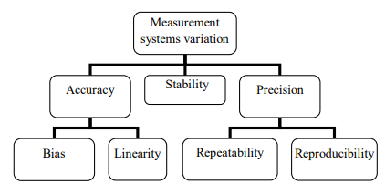
Figure 4 - Measurement systems variation

As Yadav (2016) describes accuracy indicates how much the measured values deviate from the true value which is illustrated in Figure 5 – Accuracy of measurement system (Yadav, 2016)
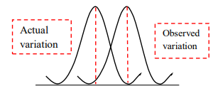
Figure 5 - Accuracy of measurement system

Bias reflects the disparity between the average of measured values and the true values. Bias results in inaccurate estimations, manifesting as either overestimation or underestimation.
The primary causes of bias include improperly functioning or utilized measuring equipment and an inadequate quantity of measured data. Increasing the number of measured units does not eliminate bias. Bias is shown in Figure 6 – Bias of measurement system (Yadav, 2016)
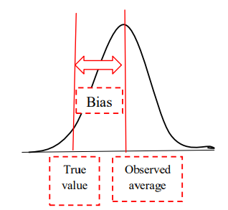
Figure 6 - Bias of measurement system

Precision defines how much data measured under identical conditions deviate from each other, with its magnitude depends on these measured values.

Stability refers to the consistency of the system in providing the same average value over a specific duration when measuring the same component using the identical measurement method. Linearity means the consistency over the measured range.

As Zanobini et al (2016) noted repeatability denotes the ability of an operator to obtain consistent values when measuring the same component multiple times with the same measuring device. Conversely, reproducibility evaluates whether different operators can achieve identical measurement results when using the same measuring device on identical components.
The most effective method for assessing repeatability and reproducibility issues involves conducting a Gage R&R study. This study employed Minitab software and the Anova method to perform the analysis.

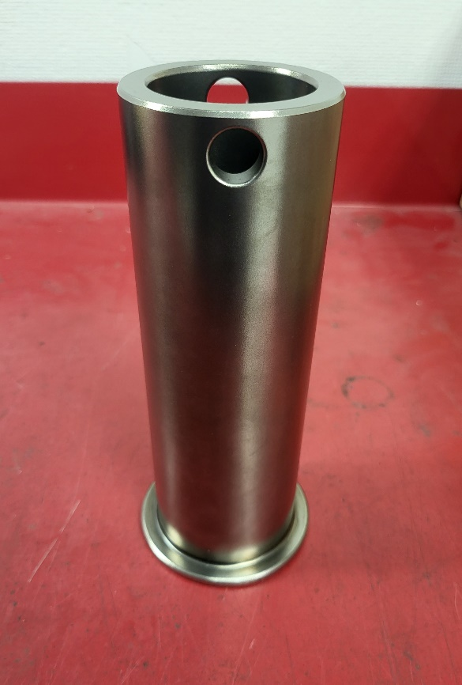
Figure 7 - Brake rod

During the Gage R&R study, 3 operators measured 10 components three times. Figure 7 shows the part used for the study, the so-called brake rod. Appendix B shows the drawing of the brake rod.
A micrometer (Appendix C) and a height gauge (Appendix D) were used to measure the parts.

Prior to conducting measurements, specific points on the components were marked at designated distances to ensure uniformity across all three operators during the measurement process. The marked part is illustrated in Figure 8.
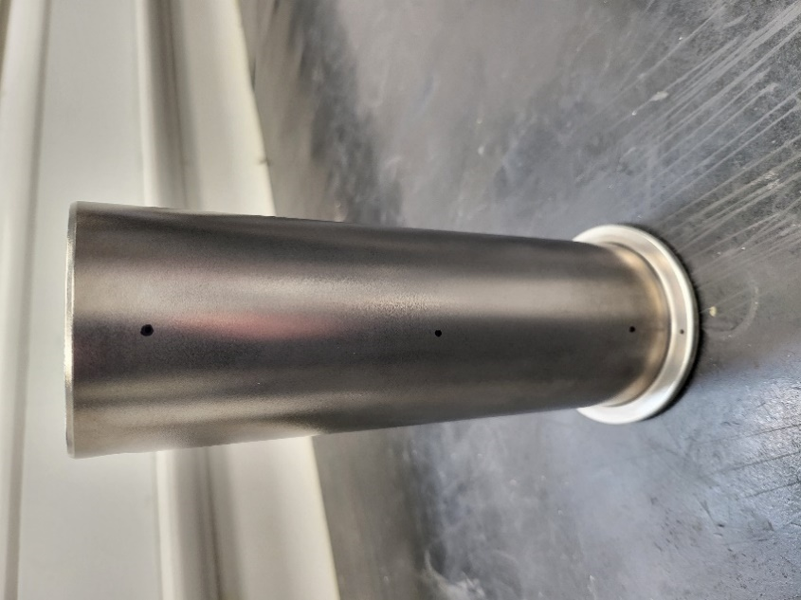
Figure 8 - Marked component

Operators were tasked with measuring the top, middle, and bottom of the diameter using a micrometer. The outer diameter values were obtained in a temperature-controlled room. However, the flange thickness was measured using a height gauge positioned on the shop floor, an environment not temperature controlled.

Gage R&R Analysis of Manual Inspection

Top diameter Gage R&R analysis

Due to the possibility of producing and testing different components, it is important to establish the effect of variations in the number of components on the response variable.
From Table 1 below, it can be concluded that since the P value in the case of part number is 0.501, which indicates that this factor does not have a large effect on the variables.
Since the value of P is greater than 0.05, i.e. alpha, which is the conventional significance level, the null hypothesis cannot be rejected.

This suggests that the component used in the study does not have a significant effect on the response variable, so the differences between the different response variables arose only from random differences and were not the result of methodological differences between the components.
Thus, the behaviour of the response variable appears consistent across the tested components.

The P-value associated with the operator element is found to be 0, an exceptionally low value that prompts the rejection of the null hypothesis. This outcome signifies that operators significantly influence the outcome. The discrepancies observed in measurements performed by different operators are not random occurrences; rather, they expose inherent systematic differences in their approaches. Consequently, the operator factor emerges as a crucial source of variability in the study. It becomes imperative to acknowledge and address this factor during measurements due to the diverse measurement techniques, skills, and experiences of each operator. These distinctions ultimately impact the measurement results, highlighting the importance of considering operator variability in interpreting study findings.

The interaction between part number and operator reveals how the effect of part numbers on the response variable varies depending on the specific operator conducting the task or measurement.

The terms part number and operator refer to the relationship between the component and the operator, to what extent the operator performing the task influences the measurement results.

With a P-value of 0.024, which doesn’t exceed the conventional threshold of 0.05, the null hypothesis can be confidently rejected. This indicates that the association between operators and the measurement outcomes of each component is not random. Instead, the impact of part numbers on the response variable is contingent upon the operator conducting the measurement. The effect of the part number on the response variable depends on which operator performs the measurement. Hence, the P-value holds statistical significance.

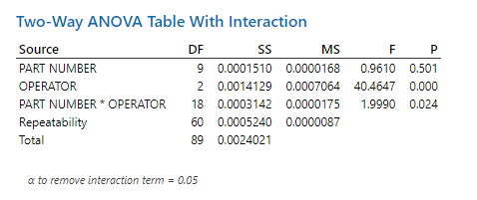
Table 1 - Top diameter, two-way Anova table with interaction (manual Gage R&R)

The Total Gage R&R represents the cumulative effect of repeatability and reproducibility.
Repeatability examines whether consistent results are attained when the same operator, utilizing the same equipment under identical conditions, measures the same component. It ensures that measurement outcomes remain consistent across repetitions.

As Table 2 shows below, when measuring the top diameter, repeatability accounts for 25.24% of the total observed variation. This indicates that inaccuracies and variations in measurement results originate primarily from inconsistencies within the measurement process itself.

Conversely, reproducibility evaluates the extent to which the experiment can be replicated by different operators, using different equipment and under varying conditions. It ensures that measurements give consistent results, regardless of the operator conducting the task.

Reproducibility, comprising 74.76% of the total observed variation in top diameter measurements, may arise from differences among operators during the measurement process. These differences may stem from variations in operators' experience levels, familiarity with measurement devices, utilization of different measurement techniques, or even motivational factors.
The differences among operators significantly contribute to the total variation observed.

The operator factor contributes to 66.36% of the total deviation observed in the study. This high percentage reflects the significant impact of differences in operators' measurement techniques on the variability of measurement results for a given component. In essence, the outcome of measurements depends largely on which operator conducts the measurement.

The interaction between operator and part number accounts for 8.40% of the total deviation. This indicates that, in addition to the variation attributable to each factor independently, the combined effect of operator and part number further amplifies variability. Hence, the variation observed in each component is also influenced by the specific operator conducting the measurement.

Therefore, it is crucial to evaluate the relationship between individual factors collectively, rather than in isolation. This comprehensive approach ensures a thorough understanding of the factors contributing to variability in measurement outcomes.

The term part-to-part, which has a value of zero, measures the variation between different components. It indicates the extent to which differences among the components themselves influence the variations observed in the measurement results, or whether they contribute to any form of variation at all. Given its zero value, it can be concluded that differences between components have no noticeable effect on the variability observed in the measurement results.

Total variation encompasses all the variations observed in the study, including those attributed to repeatability, reproducibility, and part-to-part variations.

From this analysis, it can be deduced that within the total variation, the contribution of part-to-part variation to the overall variability observed in the study is negligible. Thus, other factors such as repeatability, reproducibility, and operator exert a more significant influence on the variations observed.

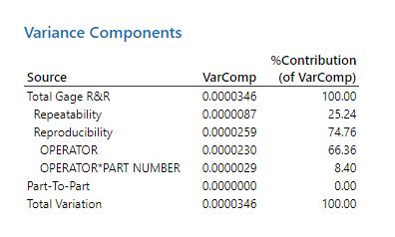
Table 2 - Top diameter, Variance components (manual Gage R&R)

Table 3 presents a more detailed statistical analysis, indicating that the standard deviation of the Total Gage R&R is 0.0058828. The study variation, calculated as 6 times the standard deviation, amounts to 0.0352968, representing 100% of the observed variation across the entire study.

For repeatability, signifying the consistency of measurements obtained by the same operator under identical conditions for a given component, the standard deviation is 0.0029552. The study variation attributed to repeatability totals 0.0177313, contributing to 50.23% of the overall variation observed.

In terms of reproducibility, which reflects differences in measurements between operators, the standard deviation is 0.0050867. This component contributes 86.47% to the total study variation.

Operator variability, representing differences attributed to the operators, is characterized by a standard deviation of 0.0047923. This component also accounts for a substantial portion of the total variation at 81.46%, paralleling the significance of reproducibility.

The standard deviation associated with the correlation between operator and part number is 0.0017054, contributing 28.99% to the total study variation.

Lastly, part-to-part variation shows no deviation, indicating that it does not contribute to the total study variation.

The primary distinction between variance components analysis and gage evaluation lies in their objectives and methodologies. While variance components analysis aims to determine the relative contribution of each component to overall variation, gage evaluation assesses the operation and performance of the measurement system using statistical metrics like standard deviation.
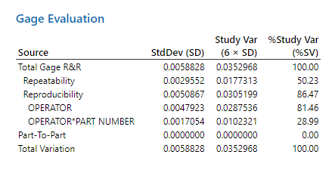
Table 3 - Top diameter, gage evaluation (manual Gage R&R)

Figure 9 presents the Gage R&R report, specifically focusing on measurements of the top diameter.
The bar chart illustrates the components of variation highlights the primary contributor to variability within the study. Furthermore, as indicated in Table 2, the gage R&R accounts for the entire observed variation in the system.
Notably, the part-to-part component shows no discernible impact on the system's variation, suggesting potential shortcomings in the measurement process.
Ideally, in a well-functioning measurement system, the primary source of variation should originate from differences between individual parts, which would indicate that the largest differences are between the individual measured parts.
A well-functioning measurement system would be able to establish and record the differences between the measurements of individual elements.
Therefore, concerning the top diameter, it is evident that the measurement system is not functioning optimally, given that the bulk of all variations comprises the Gage R&R component, encompassing both repeatability and reproducibility.
The R chart by operator illustrates the consistency of measurements across operators, revealing the degree of variability in their respective measurements of the same component. Essentially, it indicates how reliable and uniform the operators are in their measurements.

The centre line of the chart is determined by the average of all measurements, while the boundary values are derived from the variations observed in these measurements. A smaller average value signifies less variability among measurements.

Upon analysis, it becomes apparent that all three operators exhibit inconsistency in their measurements. However, the first and the third operators’ measurements show the greatest disparity, with measurements exceeding the upper and lower control limit values for a component.

In contrast, the Xbar chart portrays the variation among individual components and the relationship with repeatability. It represents the average measurement obtained by each operator for every component. Noticeable discrepancies exist among the measurements provided by the three operators, suggesting higher variability within the measurement system.
In an efficient system, the discrepancy between control limit values would be minimal, with numerous outlier measurements falling beyond these limits. This pattern signifies the measurement system's capability to detect occurring variances.

The top diameter by part number chart displays the measured values of individual components. The proximity of these data points indicates the level of variation among measured values. Examining the chart reveals deviations among measured values of different components, which indicates the variance occurring in the measurement system.
In the subsequent graph, top diameter by operator, all measured values by operators are depicted, with the line within each box denoting the mean value of these measurements.
It can be inferred that the measurement values obtained by the first operator exhibit a higher average compared to those obtained by the second and third operators.
The part and operator Interaction graph illustrates the average values measured by operators for each component. It's evident that the measurements taken by the first operator significantly higher from those obtained by the second and third operators, suggesting that the first operator adds bias to the measurement.

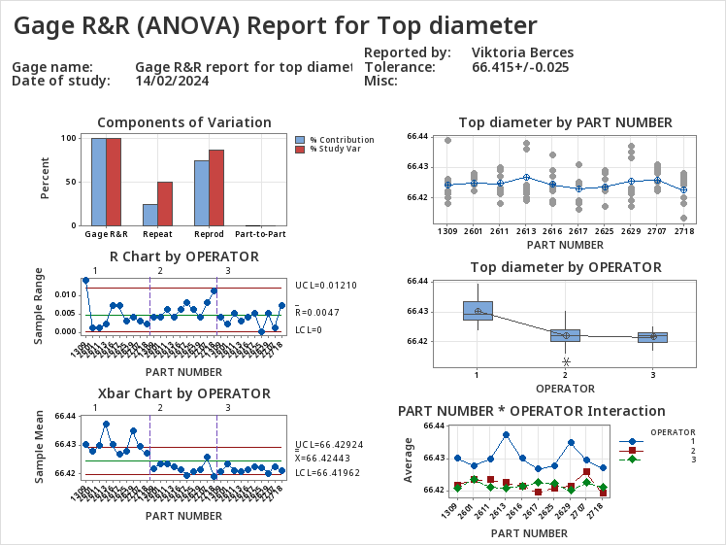
Figure 9 - Gage R&R (Anova) report for top diameter (manual Gage R&R)

Middle diameter Gage R&R analysis

Table 4 presents the two-way ANOVA analysis for the middle diameter measurements.
Regarding the part number factor, the P-value is calculated as 0.220, surpassing the significance threshold of 0.05. Consequently, the null hypothesis cannot be rejected, implying that any observed variation between operators and measurement outcomes is likely due to random factors. Thus, the P-value in this context does not have a significant effect on the variability.

Similarly, for the operator factor, the P-value is 0.187, exceeding the significance level. Consequently, the null hypothesis cannot be dismissed, indicating that operators do not exert a significant impact on the results. Consequently, differences and deviations in measurement outcomes are likely random. This contradicts the findings from the top diameter analysis, where operator influence on measurement outcomes was evident and varied across operators.

Regarding the examination of the part number and operator relationship, the high P-value of 0.851 suggests that the interaction between operators and components does not substantially contribute to the observed variation in the measurement system. This finding also contrasts with the top diameter analysis, where the relationship between the operator and the measurement results of individual components was not random.

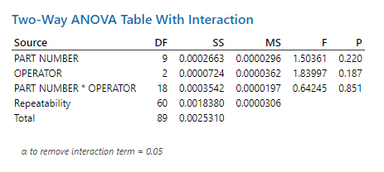
Table 4 - Middle diameter, Two-way Anova table with interaction (manual Gage R&R)

Based on the data presented in Table 5, it's evident that the Total Gage R&R component accounts for a substantial portion of the overall variation in the measurement system, contributing to 99.42% of the observed variance. This component is the sum of repeatability and reproducibility.

Repeatability, representing the consistency of measurements by the same operator under identical conditions, contributes significantly to the total variation, amounting to 98.47%. This indicates notable inconsistencies among operators when measuring the middle diameter, significantly impacting the overall deviation in the measurement system.
Reproducibility, meaning whether the entire study can be repeated by changing conditions, operators, and measuring devices, contributes only 0.95% of the total variation. All of this contradicts the results measured in the case of the top diameter, where the high percentage of reproducibility had a significant impact on the deviations occurring in the measurement system.
The operator component accounts for only 0.95% of the total variance, suggesting minimal differences in measurements attributable to operators. While relatively small, this factor remains noteworthy and should not be overlooked. This value differs from the operator component observed in the top diameter analysis, where it contributed significantly to overall variation.
Part-to-part variation, reflecting differences between individual components, contributes a modest 0.58% to the total variation. Similar to the top diameter analysis, this component appears to have negligible significance in the overall system variation.

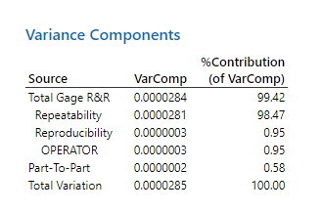
Table 5 - Middle diameter, Variance components (manual Gage R&R)

Table 6 presents the gage evaluation for the middle diameter, offering a comprehensive statistical analysis and computation. It can be deduced from this data that the total Gage R&R accounts for 99.71%, with Repeatability contributing 99.23% to all variations observed. Additionally, reproducibility stands at 9.73%, while the operator component is 7.61%.

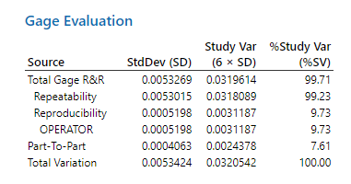
Table 6 - Middle diameter, gage evaluation (manual Gage R&R)

Figure 10 illustrates the Gage R&R report for the middle diameter measurement.
From the components of variation diagram, it is clear that the measurement system does not function properly, as the largest percentage of variation is accounted for by Gage R&R and within that also by repeatability.
Beckert (2017) states that the typical MSA acceptance criteria is 10%, although in certain instances, up to 30% may be deemed acceptable, subject to customer approval.
If the measurement system were functioning optimally, the part-to-part component would constitute the highest percentage of variation. However, if the part-to-part component ranks highest but the Gage R&R components exceed 10%, it suggests potential deficiencies in the measurement system requiring improvement.
The R chart by operator illustrates the range between the highest and lowest measured values for each component by every operator, with the centreline denoting the average deviation of all measurements. Analysis reveals that the measurements by the second operator exhibited the least consistency, as several measurements exceeded the upper control limit. Conversely, measurements by the first and third operators appears more consistent.
The Xbar chart of the operator assesses the deviations among the measurement results of each component alongside the repeatability. Ideally, the measured values would cluster within tight limits, with numerous outliers. However, in the Xbar chart for the middle diameter, the distance between the lower and upper control limits is substantial, with few out-of-control points, indicating a high variation in the measurement system.
The box plot for the middle diameter by operator indicates that the averages of the values measured by the three operators are relatively close to each other. However, noticeable deviations from the average can be observed, particularly for the first and second operators.
Part number and operator interaction graph shows the correlation between part number and operator.
The measurements by the three operators exhibit some inconsistency. Notably, the first and second operators show fluctuations in their measurement results, while those of the third operator are comparatively more consistent. In contrast, for the top diameter, the measurements of the second and third operators aligned more consistently, whereas those of the first operator tend to be higher, suggesting a potential operator error.

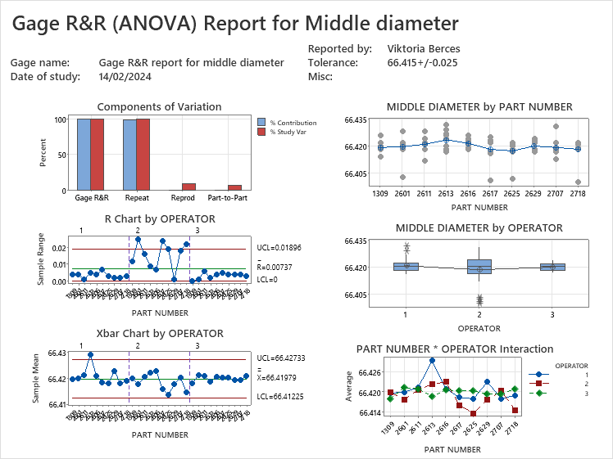
Figure 10 - Gage R&R (Anova) report for middle diameter (manual Gage R&R)

Bottom diameter Gage R&R analysis

Table 7 indicates that the P-value for part number is 0.081, surpassing the significance level of 0.05. Therefore, there is insufficient evidence to reject the null hypothesis, suggesting no significant differences among the measurement results.

Similarly, the P-value for the operator factor also exceeds the significance level, leading to the retention of the null hypothesis.
However, upon analysing the interaction between part number and operator, the P-value falls below the significance level. Thus, rejecting the null hypothesis suggests that the relationship between measurement results and operators is not random; rather, operators exert influence on the outcomes.

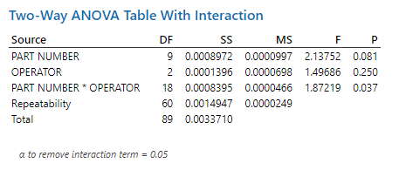
Table 7 - Bottom diameter, two-way Anova table with interaction (manual Gage R&R)

Table 8 shows the contribution of each element to the overall variation within the system. Notably, the Total Gage R&R element, encompassing both repeatability and reproducibility, constitutes 84.82% of the total variation.
Specifically, the variability resulting from the consistent yet differing measurements by the same operator contributes 64.17% to the overall variation. Moreover, reproducibility, accounting for 20.65% of all variations, comprises 1.99% attributed to the operator alone, while the interaction between the operator and individual part numbers account for 18.66%. This suggests discrepancies in how operators measure individual components. Furthermore, part-to-part variation, reflecting differences in measurement results among individual parts, contributes 15.18% to the total variation.
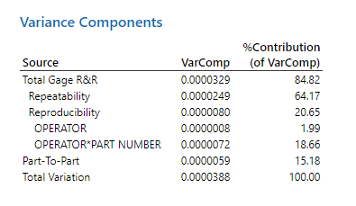
Table 8 - Bottom diameter, Variance Components (manual Gage R&R)

From Table 9, it is evident that the Gage R&R value stands at 92.10%, calculated as the ratio of the total Gage R&R to all variations, multiplied by 100. This percentage indicates an unacceptable level of variability in the measurement system, surpassing the permissible threshold.

Gage R&R encompasses both repeatability and reproducibility. As per the table, repeatability emerges as the primary issue, constituting a significant portion of the total variability at 80.11%. Following closely, reproducibility, which relates to variations among different operators, accounts for 45.44%, while the operator's interaction with the parts contributes 43.19%. Additionally, part-to-part differences, indicating variations between individual components, represent a substantial percentage at 38.97%.

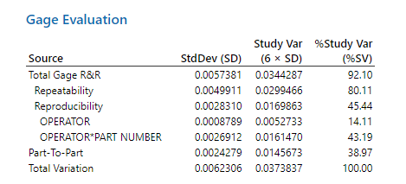
Table 9 - Bottom diameter, Gage Evaluation (manual Gage R&R)

Figure 11 presents the Gage R&R report for the bottom diameter measurements. Upon examination of the components of variation depicted in the first figure, which visually illustrates the variability within the measurement system, it is evident that the system is unsatisfactory due to exceedingly high Gage R&R components.

Analysis of the R chart by operator graph reveals that measurements from the first and third operators exhibit remarkable consistency. However, measurements from the second operator surpass the upper control limit, indicating inconsistency in their measurements.

The Xbar chart on the operator graph reveals that only a limited number of measurements by the first and second operators fall outside the lower and upper control limits, suggesting a wide gap between these limits and thus indicating substantial variation within the measurement system. Moreover, the measurements taken by the third operator fluctuate around the average, implying insufficient detection of differences between components.

The bottom diameter by part number graph displays measurements of individual parts, revealing considerable variation within the measurement system as well, as the data points for each component are relatively dispersed.

Examining the bottom diameter by operator box diagram, which presents all measured values categorized by operators, it becomes apparent that the averages of the measurements by operators are relatively close to each other.

Finally, analysis of the figure depicting the interaction between part number and operator indicates that operators' measurements vary depending on the part being measured. Additionally, it is observed that measurements by the first operator tend to be relatively higher compared to the other operators.

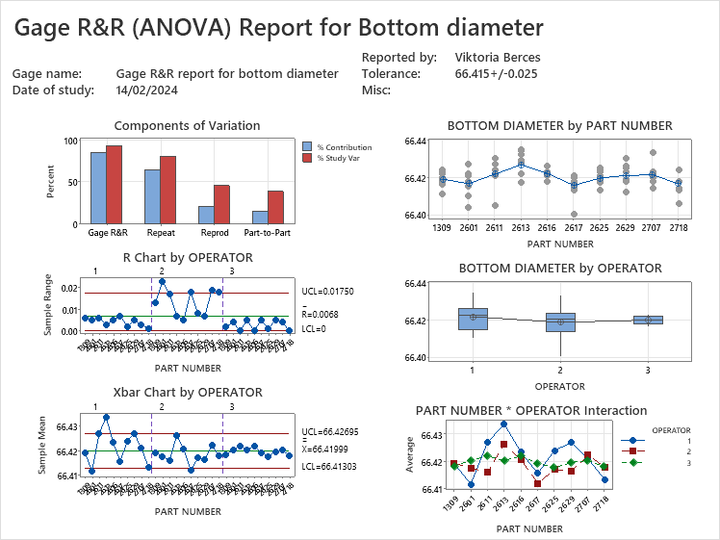
Figure 11 - Gage R&R (Anova) report for bottom diameter (manual Gage R&R)

Flange thickness Gage R&R analysis

Table 10 displays the P-values corresponding to each component in the assessment of flange thickness measurements. For part number, the P-value is 0.108, exceeding the significance level of 0.05. This indicates that the null hypothesis cannot be rejected, suggesting that differences among individual part numbers are not statistically significant.
Similarly, the P-value for operators is 0.250, also surpassing the 0.05 threshold. Consequently, there is insufficient evidence to reject the null hypothesis, implying no significant disparity in measurements between operators.
However, for the interaction between part number and operator, the P-value is 0.037, falling below the significance level. As a result, the null hypothesis is rejected, suggesting that the relationship between the measurement results of the operators and the components is not random, but there is a correlation.
The analysis indicates that while significant differences between part numbers and operators are not apparent, there is a notable interaction effect between part numbers and operators.

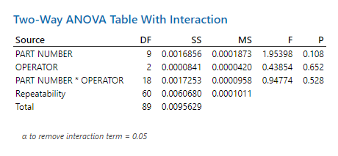
Table 10 - Flange thickness, Two-way Anova table with interaction (manual Gage R&R)

Table 11 illustrates the contribution of each individual component to the overall variation within the system.

It is evident that Total Gage R and R, encompassing repeatability, account for 91.14% of all variations. Consequently, it can be inferred that consistent results cannot be achieved by the same operator using the same measuring device under identical conditions.

On the other hand, the part-to-part component contributes 8.86% to the total variation.

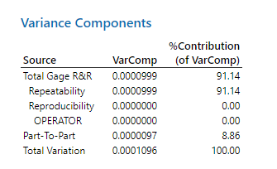
Table 11 - Flange thickness, Variance Components (manual Gage R&R)

In gage evaluation, the effectiveness of the measuring system is scrutinized using statistical parameters. Analysis of Table 12 reveals that the total Gage R&R, particularly the repeatability component, accounts for 95.47% of the measurement system's variation. Additionally, 29.76% of the variation stems from differences between individual parts.
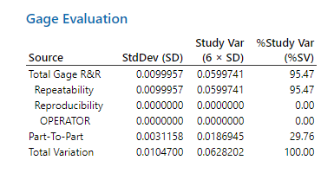
Table 12 - Flange thickness, Gage evaluation (manual Gage R&R)

Figure 12 illustrates the Gage R&R report for flange thickness. The components of variation graph distinctly indicate that the measurement system is not functioning adequately, given the notably high values observed for both Gage R&R and, specifically, the repeatability component.
Examining the R chart by operator, it becomes apparent that the measurements by the second and third operators frequently reach the upper and lower control limits, signifying inconsistent measurement practices.
The Xbar chart by operator depicts the average measurements by operators for each component. The notable spread between the upper and lower control limits suggests substantial variation in the measurement system. Furthermore, in the case of the third operator, the measurements fall very close to the average, which may indicate that the measurement system is not able to effectively recognize the variation of the parts.
The flange thickness by part number figure shows the measurement values for each component. Scattered points for individual measurement values may indicate that the measurement system is not fully able to distinguish whether the variation originates from the measurement system itself or from differences between the components.
The flange thickness by operator box diagram shows the average of all measurements made by operators. From the figure, it can be established that the average of the measurements performed by the individual operators differs from each other and that the individual measurements of the second operator are well outside the average.
The interaction plot between part number and operator reveals instances where measurements by different operators converge, indicating similarities in how operators measure the parts.

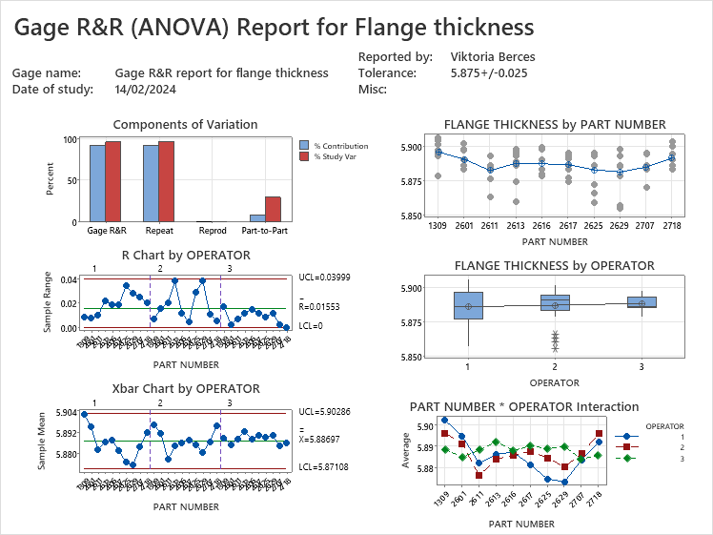
Figure 12 - Gage R&R (Anova) report for flange thickness (manual Gage R&R)

Type 1 Gage R&R Analysis of CMM Measurements

During CMM Gage R&R analysis, the objective is to evaluate the repeatability and reproducibility of the Coordinate Measuring Machine (CMM), as well as its accuracy in producing consistent measurement results. In the study, a single component was measured ten times at three different locations. Dynamic Gage R&R methodology was employed, meaning that the component's position was changed between measurements. Figure 13 illustrates the various positions where measurements were taken. Following the initial ten measurements, the component was repositioned for subsequent measurements at two additional locations, each involving another set of ten measurements.
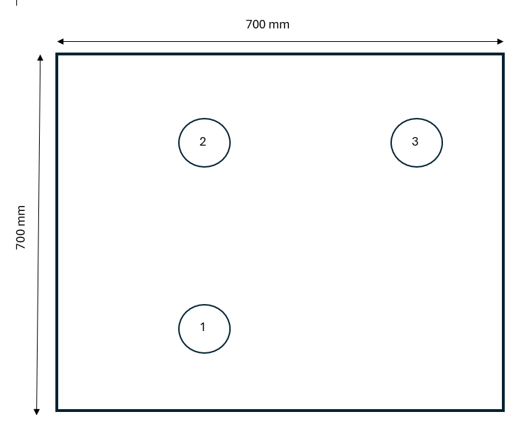
Figure 13 - CMM gage R&R part locations

For this study, a final product was utilized, which had undergone coating, grinding, and superfinishing processes. Measurements were conducted on the components within a temperature-controlled environment, maintaining a temperature of 21 degrees Celsius.

Type 1 Gage Study for top diameter

Displayed in Figure 14 is the run chart for the type 1 gage study focusing on the top diameter. The specification for the diameter was set at 66.655 mm with a tolerance of +/-0.015 mm, resulting in a total tolerance range of 0.03 mm. The run chart indicates that the measurements obtained from the CMM closely align with the diameter specification.
As noted by Anrejiova (2014), the $C_{g}$ index primarily reflects repeatability, evaluating the variability in relation to the specified tolerance.
The $C_{g}$ value is determined by comparing the variation to a percentage of the tolerance. The value of $C_{g}$ can be calculated using the following formula:

$$C_{g}=\frac{\frac{K}{100}*T}{6*s_{g}}$$
where T equals the tolerance, while sg is the standard deviation. The tolerance percentage, denoted as K, is typically set at 20%.
$C_{gk}$, which is the bias and repeatability index, can be obtained with the formula below, where$x_{g}$ is the mean of the measured values, while $x_{r}$ is the reference value.

$$C_{gk}=\frac{\frac{K}{200}*T-\left|{\overline{x}}_{g}-x_{r}\right|}{3*s_{g}}$$

$C_{gk}$The greater the difference between the reference value and the average of the measured values, the lower the value of $C_{gk}$.
The generally accepted standard for $C_{g}$ and $C_{gk}$ is 1.33. If the values for these two indices exceed this threshold, it indicates that the measurement system is operating effectively.
In this instance, the $C_{g}$ value is 6.52, and the $C_{gk}$ value is 5.40, suggesting minimal variation within the measurement system.
For a measurement system to be deemed suitable for production use, the repeatability and bias values must not exceed 15. If the $C_{g}$ and $C_{gk}$ values surpass 1.33, and the aforementioned conditions are met, it can be inferred that the measurement system is viable for production purposes.

The repeatability and bias can be calculated using the equations below.
$$\%Repeatability=\frac{20}{C_{g}}$$
$$\%Repeatability and Bias = \frac{20}{C_{gk}}$$

In the case of the top diameter, the repeatability is 3.07%, while the repeatability and bias combined is 3.70%, indicating exceptionally favourable outcomes.

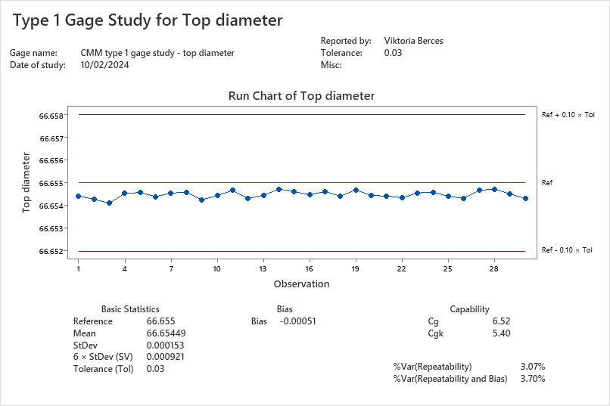
Figure 14 - Type 1 Gage Study for Top diameter

Type 1 Gage Study for middle diameter

Figure 15 depicts the run chart for the middle diameter. It can be inferred that there is minimal variation among the measured values. With a $C_{g}$ value of 4.39 and a $C_{gk}$ value of 3.92, it is evident that the measurement system is functioning effectively. This is further supported by the repeatability, measured at 4.56%, and the combined repeatability and bias, recorded at 5.10%.

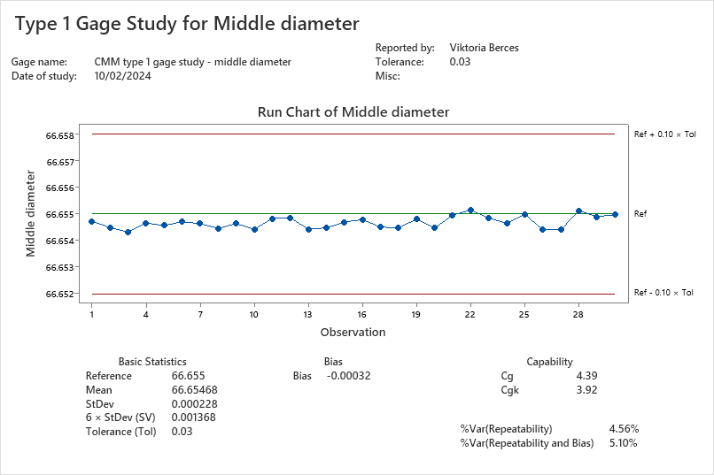
Figure 15 - Type 1 Gage Study for Middle diameter

Type 1 Gage Study for bottom diameter

Figure 16 presents the run chart for the bottom diameter. Similar to the previous CMM measurements, it suggests minimal variation. The $C_{g}$ value of 5.24 and $C_{gk}$ value of 4.60 indicate the effective functioning of the measurement system. This conclusion finds support in the repeatability, calculated at 3.82%, and the combined repeatability and bias, recorded at 4.35%.
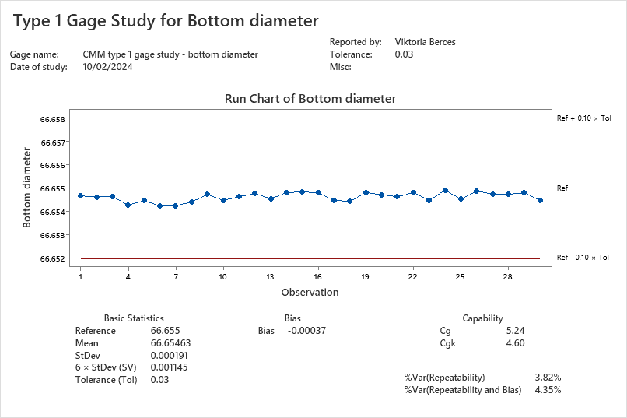
Figure 16 - Type 1 Gage Study for Bottom diameter

Type 1 Gage Study for flange thickness

Illustrated in Figure 17 is the run chart for flange thickness, revealing minimal variation in the measured values. With a $C_{g}$ value of 8.52 and a $C_{gk}$ value of 5.86, it is evident that the measurement system is operational. The repeatability value of 2.35% and the combined repeatability and bias of 3.42% further confirm the proper functioning of the measurement system.
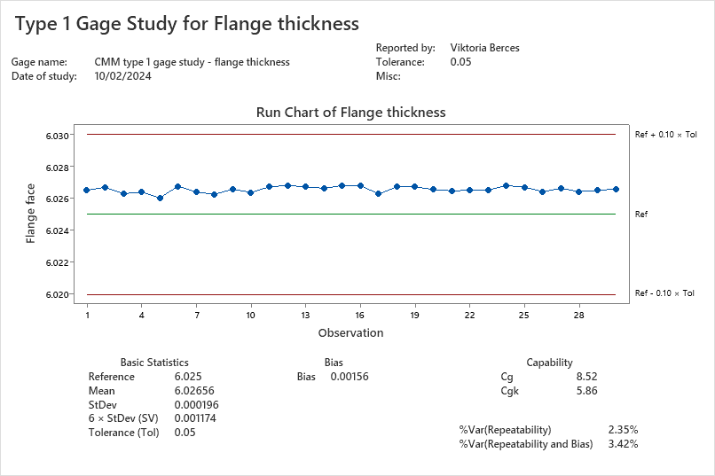
Figure 17 - Type 1 Gage Study for Flange thickness

Gage R&R Analysis of CMM loop program

Top diameter Gage R&R analysis

The CMM Gage R&R study demonstrated the machine's accuracy. Conversely, a manual Gage R&R study involving three operators assessing ten parts revealed issues with the measurement system's functionality. In a subsequent CMM Gage R&R study using the same ten parts, each component was measured three times. Appendix I and Appendix J show the set up of the inspected parts using the loop program.
In Table 13, pertaining to the top diameter, only the parts and repeatability are presented as the CMM, serving as the sole operator, conducted the measurements on all ten parts. Consequently, no interplay between parts and operators could be established, and reproducibility isn't indicated. The P-value for the parts component is found to be 0, indicating a rejection of the null hypothesis with certainty, implying the parts' differences are statistically significant. The repeatability's P-value isn't provided, lacking statistical significance.
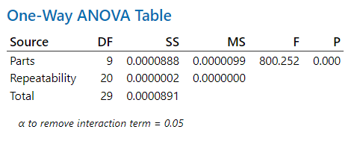
Table 13 - Top diameter - One-way Anova table (CMM Gage R&R)

Table 14 illustrates that repeatability, which assesses the variance between measurements conducted by the same operator on the same part, contributes 0.37% to the total variation.
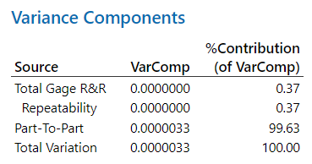
Table 14 - Top diameter - Variance components (CMM Gage R&R)

Table 15 further analyses variations, highlighting that repeatability causes only 6.12% of deviation, whereas 99.81% derives from the components, underscoring the measurement system's effectiveness.
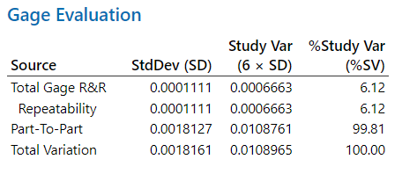
Table 15 - Top diameter - Gage evaluation (CMM Gage R&R)

Figure 18 depicts the Gage R&R report for the top diameter. The components of variation graph illustrates each component's percentage contribution to total variation, confirming the part-to-part component solely drives variations, affirming the system's efficacy.

The top diameter by parts graph suggests minimal variation between measurement results for each component individually. However, observable differences between parts indicate their distinctiveness from each other. All of these findings suggest a minimal variation within the measurement system.
The R chart displays the range between the largest and smallest measurements for each component, averaging 0.00017, a remarkably low figure.

The Xbar chart further confirms low system variation, as evidenced by the narrow gap between upper and lower control limits, with numerous points lying outside these limits.
Overall, based on top diameter measurements, the CMM inspection system is deemed highly effective.
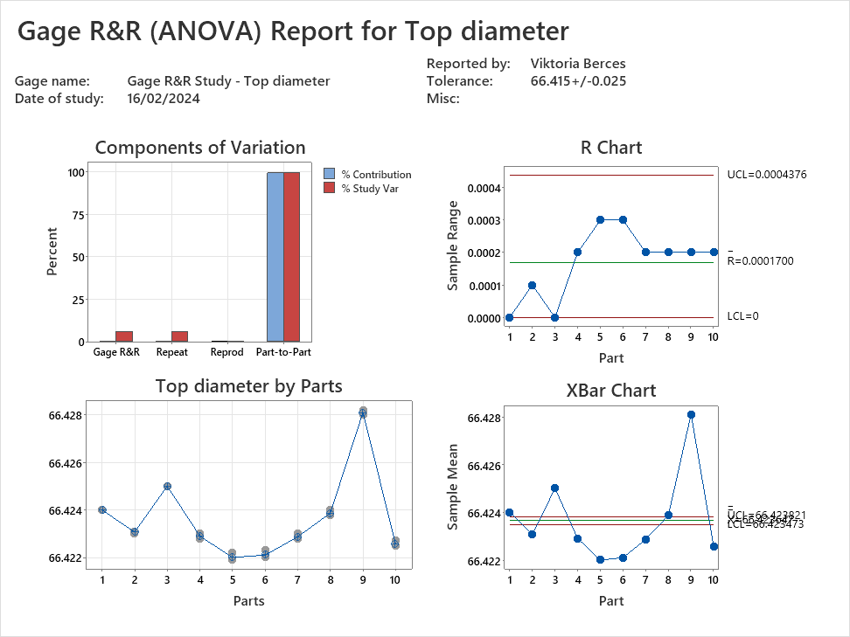
Figure 18 - Gage R&R (Anova) report for top diameter (CMM Gage R&R)

Middle diameter Gage R&R analysis

Table 16 reveals a P-value of 0 for parts component. This suggests that the null hypothesis can be rejected since the P-value is below the significance level, indicating non-random deviation between the components.
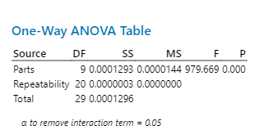
Table 16 - Middle diameter - One-way Anova table (CMM Gage R&R)

Table 17 establishes that the part-to-part component is responsible for 99.69% of the variance observed in the measurement system.

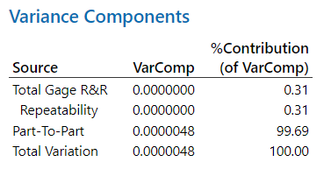
Table 17 - Middle diameter - Variance components (CMM Gage R&R)

In Table 18, assessing the measurement system's performance, repeatability accounts for only 5.53% of the variation, while part-to-part constitutes 99.85%.
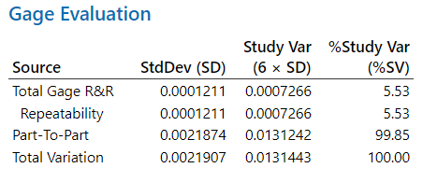
Table 18 - Middle diameter - Gage evaluation (CMM Gage R&R)

Figure 19 presents the Gage R&R report. The first plot, depicting components of variation, visually indicates that all variations stem from the part-to-part factor, suggesting proper functioning of the measurement system.

Examining the middle diameter by parts diagram reveals minimal discrepancy among the three measurements conducted on individual parts, evidenced by the close proximity of data points.

The R chart displays the range between the lowest and highest measurement values of each component, with an average value of 0.00017, signifying exceptionally low variability.

Similarly, the Xbar chart illustrates the average measurements by the CMM for individual components, with a narrow gap between the lower and upper control limits.

Collectively, these observations affirm the effective performance of the measurement system, as indicated by the figures.

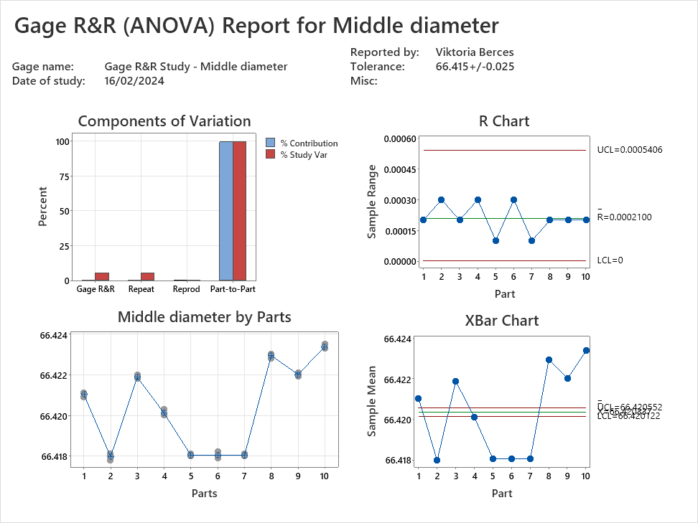
Figure 19 - Gage R&R (Anova) report for middle diameter (CMM Gage R&R)

Bottom diameter Gage R&R analysis

Table 19 presents the values for the bottom diameter. The P-value for the components is 0, signifying their significant contribution to the variance in the measurement system due to the rejection of the null hypothesis.

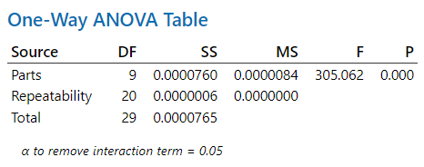
Table 19 - Bottom diameter - One-way Anova table (CMM Gage R&R)

In Table 20, the part-to-part component accounts for 99.02% of the variance, while the repeatability, representing the R&R portion of the total gage, is 0.98%.

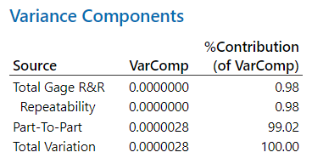
Table 20 - Bottom diameter - Variance components (CMM Gage R&R)

Table 21, the gage evaluation table, further dissects the deviation. Repeatability is responsible for 9.88% of all errors in the measurement system, while the part-to-part component accounts for 99.51%. These findings collectively indicate proper functioning of the measurement system.

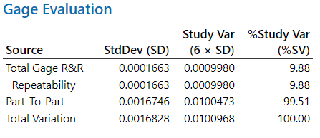
Table 21 - Bottom diameter - Gage evaluation (CMM Gage R&R)

Figure 20 illustrates the Gage R&R report for the bottom diameter. The components of variation diagram visually indicate that part-to-part variability plays a significant role, while total Gage R&R variation is minimal, affirming the system's efficacy.

Examining the bottom diameter by parts figure reveals minimal differences among the three measurements performed by the CMM on individual parts.
The R chart displays minimal differences between the smallest and largest measurement values.
Similarly, the Xbar chart indicates a narrow gap between the lower and upper limits, with outliers suggesting the measurement system's ability to distinguish between components.

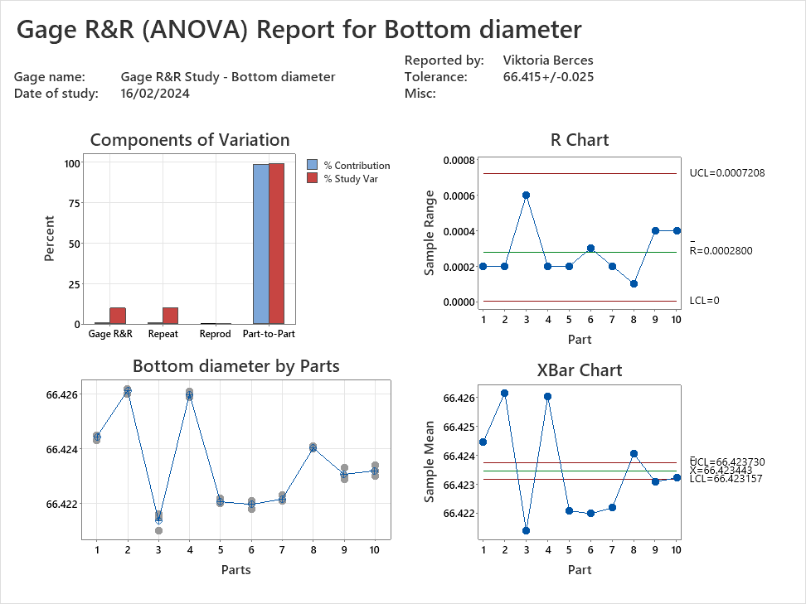
Figure 20 - Gage R&R (Anova) report for bottom diameter (CMM Gage R&R)

Flange thickness Gage R&R analysis

From Table 22, the One-way ANOVA table for flange thickness, it's evident that the P-value of the parts component is zero, indicating its statistical significance.

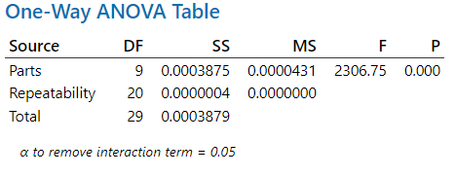
Table 22 - Flange thickness - One-way Anova table (CMM Gage R&R)

Table 23, which displays the variance components, reveals that the part-to-part element is responsible for 99.87% of all variances within the system.

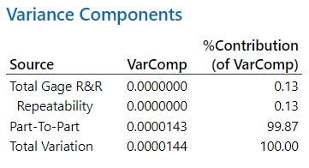
Table 23 - Flange thickness - Variance components (CMM Gage R&R)

In Table 24, the Gage evaluation table, further scrutiny of the deviation concludes that repeatability contributes to 3.6% of all variations, while the part-to-part component accounts for 99.94%. This reaffirms the proper functioning of the measurement system in this scenario.

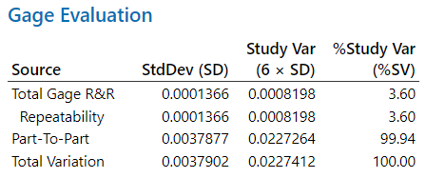
Table 24 - Flange thickness - Gage evaluation (CMM Gage R&R)

Figure 21, the components of variation graph in the Gage R&R report for flange thickness, visually reinforces the effective operation of the measurement system.
The flange thickness by parts graph illustrates minimal differences among the three measurements per part conducted by the CMM.
The R chart indicates minor discrepancies between the smallest and largest measured values of individual components.
Similarly, the Xbar chart for flange thickness suggests a narrow gap between the limits, with outliers indicating the measurement system's ability to discern individual points.

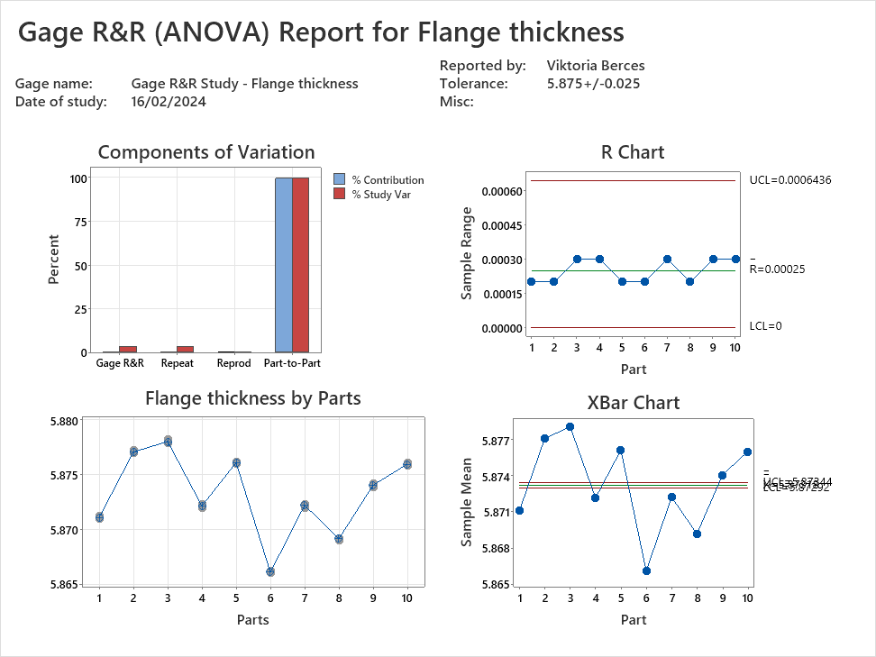
Figure 21 - Gage R&R (Anova) report for flange thickness (CMM Gage R&R)

Conclusion

Following the Gage R&R study conducted for manual inspection, the examination of the top diameter exposes shortcomings in the measurement system's performance, primarily due to the predominant variation originates from both repeatability and reproducibility components. Additionally, notable differences are evident among the measured values of different components, with the measurements conducted by the first operator consistently exceeding those obtained by the second and third operators.
It can be determined from measurements of the middle diameter that the measurement system shows significant variation, given the considerable disparity between the measurement values of individual components and their corresponding points.
The examination of the bottom diameter reveals that total Gage R&R contribute significantly to the variation in the measurement system, indicating its malfunction. Additionally, inconsistencies are observed in the measurements conducted by the operators.
The evaluation of flange thickness measurement reveals significant flaws in the measurement system, primarily highlighted by the dominance of repeatability in the variance analysis. Moreover, inconsistencies in measurement techniques among operators and the system's inability to differentiate between variations originating from components and those from the system itself further underscore the system's shortcomings.

The $C_{g}$ and $C_{gk}$ indices assessing variation and tolerance obtained during CMM Gage R&R analysis show values above the generally accepted standard of 1.33, indicating effective operation of the measurement system. Repeatability and bias values were within acceptable limits, further confirming the suitability of the measurement system for production use.
Overall, the analysis emphasizes the reliability and precision of the CMM in capturing dimensional characteristics, thus validating its role in quality assurance within manufacturing processes.

A CMM loop program was utilized to measure the 10 components. Inspection results from the CMM affirm the proper functioning of the measurement system. Across top, middle, bottom diameters, and flange thickness measurements, the CMM demonstrates highly favourable repeatability and reproducibility values, crucial for aerospace component measurement.

Conclusion and Recommendations

Conclusion

Based on the manual inspection workflow, it appears that the process entails several steps, suggesting that it could be streamlined by integrating coordinate measuring machine (CMM) inspection.

During manual inspection, multiple measuring devices are required, which can consume time for collection and setup. These devices are manually calibrated by the inspector, introducing the potential for errors. In contrast, CMM calibration is automated by a program, eliminating the risk of human error. This is crucial for components with tight tolerances, especially in aerospace applications. Additionally, manual inspection requires calibration before each use, while CMM calibration once daily suffices. Moreover, calibration results and data are logged in the CMM system, ensuring traceability, a critical aspect in aerospace quality control.

Based on the conducted time and motion studies, it can be determined that CMM inspection took only a few minutes longer than manual inspection. However, during CMM inspection, the operator isn't required to remain at the machine once the program starts. Additionally, while manual inspection typically involves measuring at a single point for diameters and fixing values at 3 points for flange thickness as per the data card instructions, CMM inspection measures 16 points for each diameter and flange thickness. This significantly enhances accuracy and reduces the likelihood of errors compared to manual inspection, where the risk of error is substantial due to measuring at only one point.

The outcomes of the manual Gage R&R assessment carried out by three operators clearly indicate that the measurement system is not functioning properly. This is evident as all variations within the system stem from factors such as repeatability, reproducibility, and operator differences. It can be inferred that the measurement outcomes for individual components are operator dependent. Conversely, the Gage R&R analysis conducted by the CMM reveals that the measurement system operates flawlessly during automated assessments without human involvement. The measurement outcomes for individual components remain consistent irrespective of the machine. During the execution of the program written for the parts by the CMM, the machine meticulously measures the part at predetermined locations, following the same trajectory and minimizing the likelihood of errors uniformly.

Therefore, the utilization of CMM during inspection presents numerous advantages. These include precision, accuracy, reliability, and repeatability, all of which are crucial, particularly in scenarios involving tight tolerances and aerospace applications.

Limitations

One major limitation of the study is its failure to provide a comprehensive financial breakdown covering all expenses associated with the full utilization and maintenance of the CMM, as well as the training of operators, excluding training for CMM programming.
Additionally, there is no mention of whether the company intends to develop the programs for the components internally or outsource this task to a third-party entity. If the company chooses to develop programs in-house, it will require a trained operator. Since program development is a time-consuming process, it may necessitate hiring additional personnel. Moreover, it's important to note that the CMM will be unavailable for use during program development, further impacting inspection schedules, potentially leading to operational delays.

Recommendations and future work

Integrating the scanning function into CMM inspection processes can enhance efficiency by offering high precision. Moving forward, regular training for CMM operators is crucial to ensure they remain updated and proficient, thereby minimizing potential errors.
Furthermore, obtaining customer feedback concerning the quality improvements resulting from the implementation of CMM is crucial.
Continuous improvement is essential for CMM integration, facilitated by ongoing data collection and analysis.
In the long term, establishing a framework to monitor the impact of CMM on quality metrics and operational efficiency would be prudent.

References

- Anagnostakis, D., Ritchie, J., Lim, T., Sivanathan, A., Dewar, R., Sung, R., Bosché, F., Carozza L. (2016) ‘Knowledge capture in CMM inspection planning: barriers and challenges’ Procedia CIRP (52)16, pp. 216-221 Available at: https://www.sciencedirect.com/science/article/pii/S2212827116307958?via%3Dihub (Accessed: 17/02/2024)
- Andrejiova, M., Kimakova, Z. (2014) ‘Indices Cg and Cgk in the assessment of the measuring device capability’. ANNALS of Faculty Engineering Hunedoara
International Journal of Engineering, 14(4), pp.113-116. Available at: https://www.proquest.com/docview/1623282881?sourcetype=Scholarly%20Journals (Accessed: 08/04/2024)
- Beckert, S. F., Paim, W. S. (2017) ‘Critical analysis of the acceptance criteria used in measurement systems evaluation’, International Journal of Metrology and Quality Engineering 23(2017) pp. 1-9. Available at: https://www.metrology-journal.org/articles/ijmqe/pdf/2017/01/ijmqe170028.pdf (Accessed: 22/04/2024)
- Feldman, K. (2018) Measurement System Analysis (MSA). Available at: https://www.isixsigma.com/dictionary/measurement-system-analysis-msa/ (Accessed: 17/02/2024)
- Filz, M. A., Bosse, J. P., Hermann, C. (2021) ‘Systematic Planning of Quality Inspection Strategies in Manufacturing Systems’, Procedia CIRP, 104(21), pp. 1101-1106. Available at: https://www.sciencedirect.com/science/article/pii/S2212827121010830?ref=pdf_download&fr=RR-2&rr=87f9758bffff23b2 (Accessed: 06/05/2024)
- Gallo, A. (2016) A refresher on Statistical Significance. Available at: https://hbr.org/2016/02/a-refresher-on-statistical-significance (Accessed: 02/04/2024)
- Kumar, N., Hasan, S. S., Srivastava, K., Akhtar, R., Yadav, R. K., Choubey, V. K. (2022) ‘Lean manufacturing techniques and its implementation: A review’ Materials Today: Proceedings 64(22). Pp. 1188-1192. Available at: https://www.sciencedirect.com/science/article/pii/S2214785322018284 (Accessed: 22/04/2024)
- Lorenzo, L., Pelaez, G. and Ares, E. (2017) ’Quality assurance program for CMM in production’ Manufacturing Engineering Society International Conference 13 (17) pp. 616–622. Available at: https://www.sciencedirect.com/science/article/pii/S2351978917307606 (Accessed: 17/02/2024)
- Melichar, M., Kubatova, D. and Kutlwaser, J. (2016) ‘CMM measuring cycle and human factor’ 27th DAAAM International Symposium on Intelligent Manufacturing and Automation, pp. 0371-0376. DOI: 10.2507/27th.daaam.proceedings.055
- Nikam, R. R. (2019) ‘Coordinate measuring machine (CMM)’ International Journal of Mechanical and Industrial Technology 6(2), pp. (13-19) Available at: https://www.researchpublish.com/upload/book/COORDINATE%20MEASURING%20MACHINE-6840.pdf (Accessed: 22/04/2024)
- Qadir, D., Sharif, R., Nasir, R., Awad, A., Mannan, H. A. (2024) ‘A review on coatings through thermal spraying’ Chemical Paper 78(24), pp. 71-91. Available at: https://link.springer.com/article/10.1007/s11696-023-03089-4 (Accessed: 22/04/2024)
- Qadir, D., Sharif, R., Nasir, R., Awad, A., Mannan, H. A. (2024) Classification of thermal spray process [Figure]. Available at: https://link.springer.com/article/10.1007/s11696-023-03089-4 (Accessed: 22/04/2024)
- Shiokawa, H., Ishii, N. (2019) ‘A Method of Collaborative Inspection Planning by Integrating a Production Planning System’, Procedia Manufacturing, 39(19), pp. 727-736. Available at: https://www.sciencedirect.com/science/article/pii/S2351978920305151 (Accessed: 06/05/2024)
- Shiokawa, H., Ishii, N. (2019) An overview of the strategy map [Figure] Available at: https://www.sciencedirect.com/science/article/pii/S2351978920305151 (Accessed: 06/05/2024)
- Shiokawa, H., Ishii, N. (2019) The process of making a collaborative inspection plan with a production plan [Figure] Available at: https://www.sciencedirect.com/science/article/pii/S2351978920305151 (Accessed: 06/05/2024)
- Yadav, A. (2016) ‘Measurement systems analysis and a study of Anova method’, International Journal of Research in Engineering and Technology, 05(2), pp. 123-127. Available at: https://ijret.org/volumes/2016v05/i02/IJRET20160502022.pdf (Accessed: 17/02/2024)
- Zanobini, A., Sereni, B., Catelani, M., Ciani, M. (2016) ‘Repeatability and Reproducibility techniques for the analysis of measurement systems’ Measurement 86(16). pp 125-132. Available at: https://www.sciencedirect.com/science/article/pii/S0263224116001184 (Accessed: 22/04/2024)

Appendix A - Mitutoyo C776

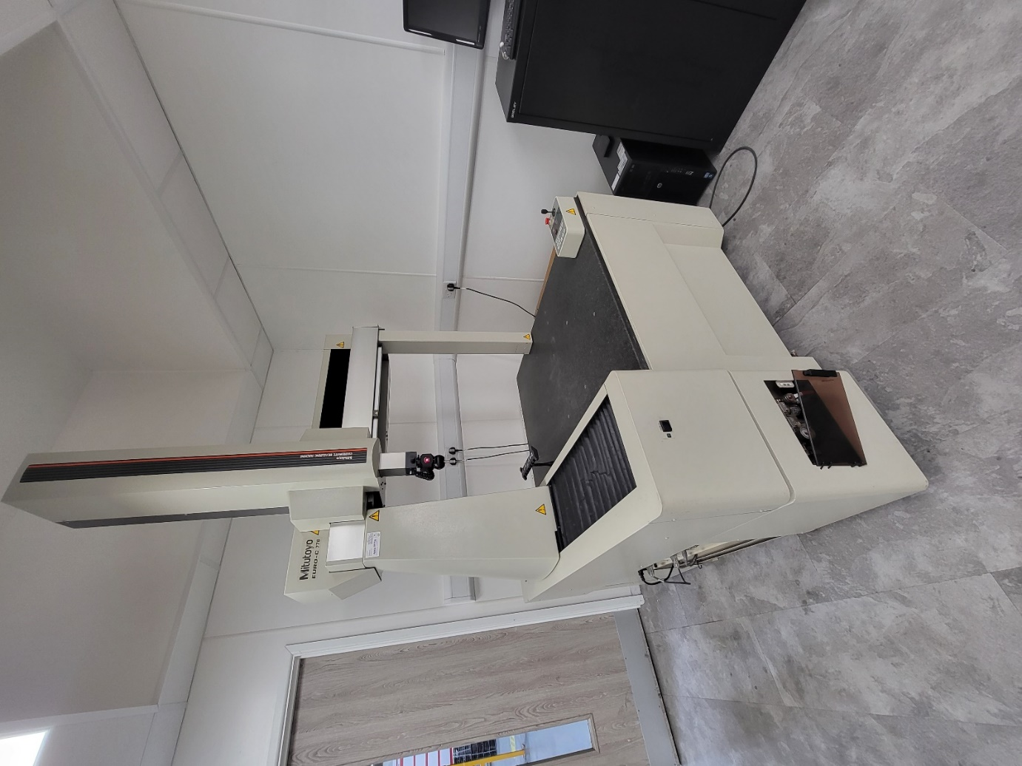

Appendix B – Brake rod drawing

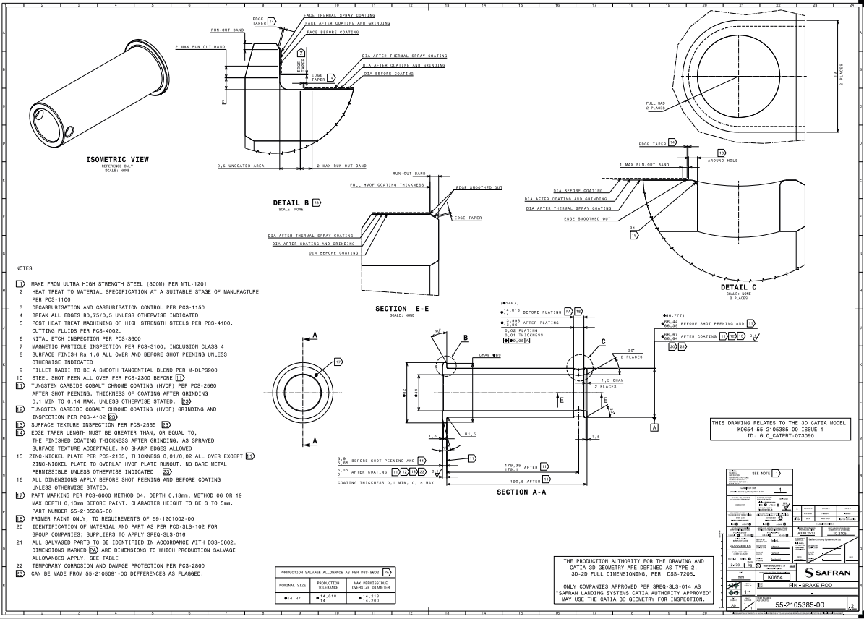

Appendix C - Micrometer

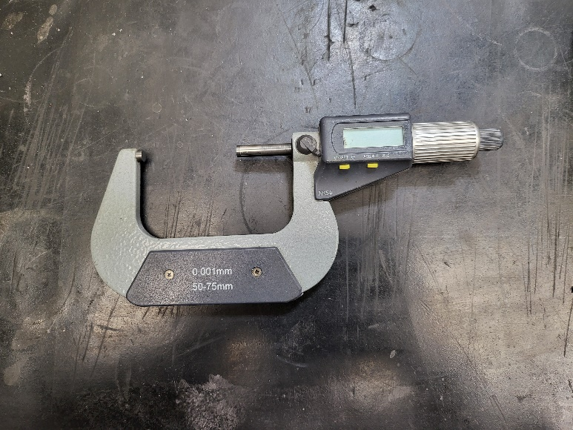

Appendix D – Height gauge

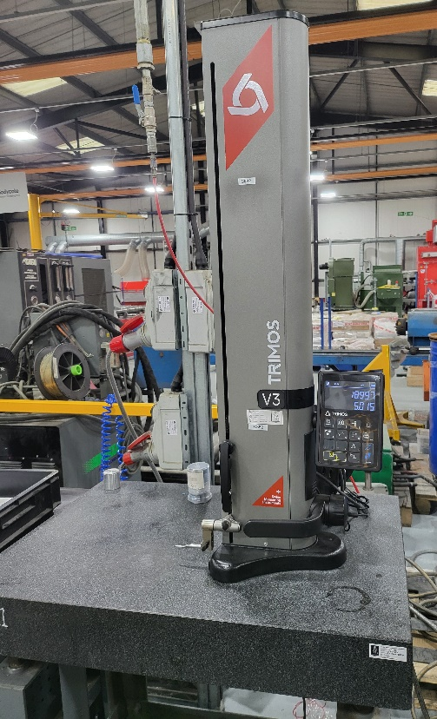

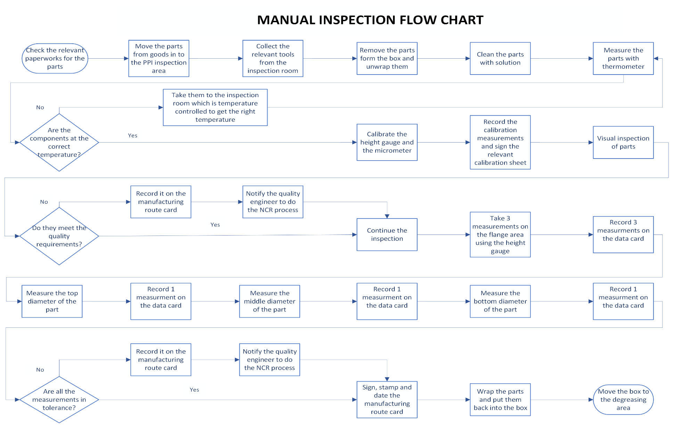
Appendix E – Manual inspection flow chart

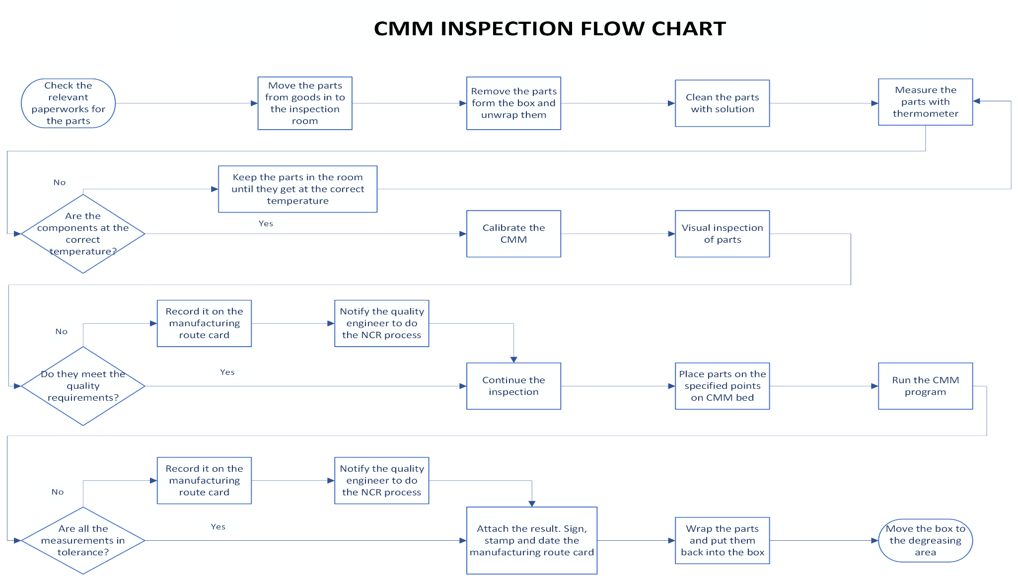
Appendix F – CMM inspection flow chart

Appendix G – Time and motion study – Manual inspection

Time and motion study – Brake rod PPI – Manual inspection
Operator: VB | Pre-Production Inspection (PPI) - Manual inspection
Date: 05/12/2023 | Part name: Brake rod
Task name | Description | Duration (second) | Comments
Checking the relevant paperwork for the parts | Checking if order number and job pack is correct | 90
Moving parts to inspection area | Moving parts (pallet/box) from goods in area to the area used for PPI inspection | 600 | Had to find pallet truck to move the pallet which caused delay
Collecting the relevant inspection tools | Collecting the relevant inspection tools from the inspection room, also the necessary cleaning equipment | 210 | (Could be a problem to find micrometers as they could be used by other operators - waiting time/delay)
Removing the parts from the box and unwrapping them | Removing all 10 parts from the box and unwrapping them | 480
Cleaning the parts with the solution | Cleaning all 10 parts | 870
Checking the temperature of the parts | Checking if the parts' temperature are between 19°C and 21°C | 180 | Temperature of the parts was 19.5°C
Calibrating the height gauge and the micrometer | Calibration of height gauge and micrometer | 150
Recording the calibration measurements on the data card | Recording the calibration measurements on data card and signing it | 20
Visual inspection of the parts | Visual inspection of all 10 parts, looking for damages or any variation | 480
Measuring the flange thickness with height gauge (1 part) | Taking 3 measurements on the flange face | 50
Recording measurements on data card | Recording 3 measurements on data card | 20
Measuring top diameter of the (1 part) | Measuring one point on the top of the diameter | 20
Recording 1 measurement on the data card | Recording 1 measurement on data card | 14
Measuring the middle diameter of the part (1 part) | Measuring one point on the middle of the diameter | 21
Recording 1 measurement on the data card | Recording 1 measurement on data card | 16
Measuring the bottom diameter of the part (1 part) | Measuring one point on the bottom of the diameter | 20
Recording 1 measurement on the data card | Recording 1 measurement on data card | 15
Signing the manufacturing route card | Signing, dating, and stamping the manufacturing route card | 50
Wrapping the parts and putting them back into the box | Wrapping and putting all 10 parts back into the box | 300
Moving the box to the degreasing area |  | 350 | When all the parts are inspected and they are all in tolerance, they need to be moved to the degreasing area which is the next step in the process. If the parts are out of tolerance or any damages or issues found, the quality engineer need to be notified. NCR need to be raised and have to contact with customer before any further processing.
Total time |  | 5090 | 84.8 min

Appendix H – Time and motion study – CMM inspection

Time and motion study – Brake rod PPI – CMM inspection
Operator: VB | Pre-Production Inspection (PPI) - CMM inspection
Date: 05/12/2023 | Part name: Brake rod
Task name | Description | Duration (second) | Comments
Checking the relevant paperwork for the parts | Checking if order number and job pack is correct | 85
Moving parts to inspection room | Moving parts (pallet/box) from goods in area to the area used for PPI inspection | 360
Removing the parts from the box and unwrapping them | Removing all 10 parts from the box and unwrapping them | 470
Cleaning the parts with the solution | Cleaning all 10 parts | 840
Checking the temperature of the parts | Checking if the parts' temperature are between 19°C and 21°C |  | Temperature of the parts was 19.3°C
Calibrating the CMM | Running the calibration program | 180
Visual inspection of all 10 parts | Visual inspection of all 10 parts, looking for damages or any variation | 470
Placing parts on the CMM bed | Placing all 10 parts on CMM bed | 90
Running the CMM program | Running the CMM inspection program | 2280
Attaching the result and signing the paperwork | Attach the printed result to the data card and sign, stamp, and date the manufacturing route card | 60
Wrapping the parts and putting them back into the box | Wrapping and putting all 10 parts back into the box | 310
Moving the box to the degreasing area |  | 300 | When all the parts are inspected and they are all in tolerance, they need to be moved to the degreasing area which is the next step in the process. If the parts are out of tolerance or any damages or issues found, the quality engineer need to be notified. NCR need to be raised and have to contact with customer before any further processing.
Total time |  | 5445 | 90.75 min

Appendix I – CMM loop program

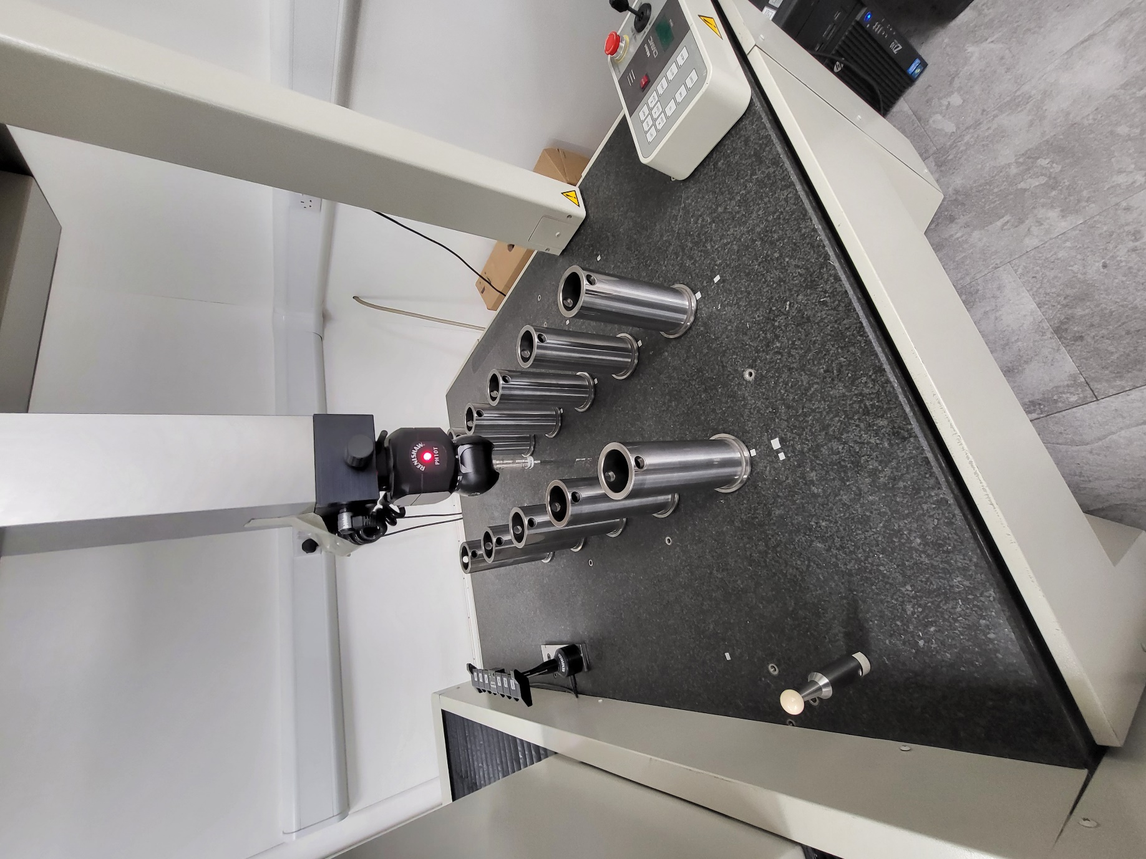

Appendix I – CMM loop program/b



