INFORMATION BOOKLET
TYPE 2 DIABETES: WHOLE-PERSON MANAGEMENT IN THE UK
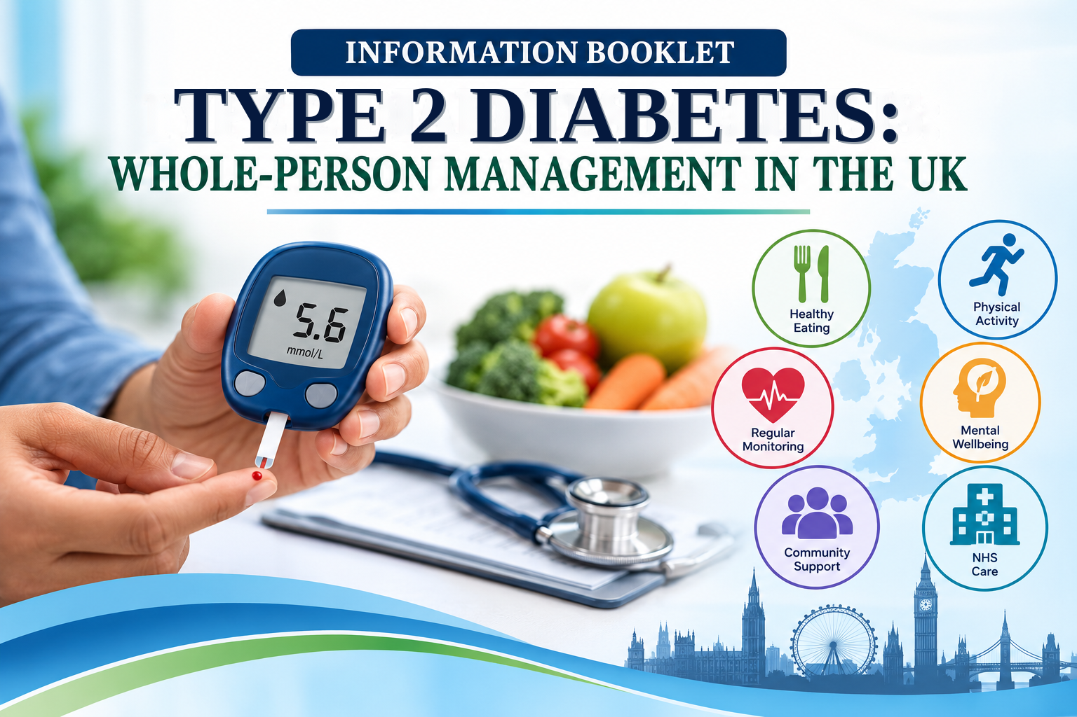

Student name: ____________________
Student number: ____________________
Programme: MSc Public Health and Social Care in Practice
Module: LCHS7003 – Community Care and Management of Longer-term Conditions
Lecturer: Dr Aishat Bakre
Target audience: UK health and care professionals supporting adults with Type 2 Diabetes
Meet | LCHS7003 Booklet

Table of Contents
1. Definition 3
2. Burden / Prevalence 3
3. Risk Factors 4
3.1 Modifiable risk factors 4
3.2 Non-modifiable risk factors 4
4. Aim 6
5. Physical, Psychological and Social Implications 6
5.1 Physical implications 6
5.2 Psychological implications 7
5.3 Social implications 8
6. Evidence-Based Treatment and Management Through the National Health Service 8
7. Theoretical Perspectives and Models for Improving Outcomes 10
7.1 UK model: The House of Care 10
7.2 International model: Chronic Care Model 11
7.3 Critical comparison of the models 12
8. Political, Health and Social Care Agendas 13
9. Recommendations for Person-Centred Care, Self-Management and End-of-Life Care 14
9.1 Person-centred care and shared decision-making 14
9.2 Self-management and health literacy 15
9.3 End-of-life care 16
10. Conclusion 17
References 19

1. Definition
Type 2 Diabetes is a long-term condition in which the body does not use insulin effectively and may not produce enough insulin to keep blood glucose within a healthy range. Symptoms can include increased thirst, frequent urination, tiredness, blurred vision, slow-healing wounds and recurrent infections, although some people have no noticeable symptoms. Persistent high blood glucose can damage blood vessels, nerves, eyes, kidneys and the heart. Type 2 diabetes accounts for approximately 90–95% of diabetes diagnoses (American Diabetes Association Professional Practice Committee, 2025, World Health Organization, 2024).

2. Burden / Prevalence
Worldwide, the World Health Organization estimates that the number of adults living with diabetes rose from around 200 million in 1990 to 830 million in 2022. The estimated prevalence among adults increased from 7% to 14% over the same period. These figures include all types of diabetes, but they demonstrate the scale of the prevention and care challenge because Type 2 Diabetes accounts for most cases (World Health Organization, 2024).

Figure 1: Global diabetes burden and projected growth
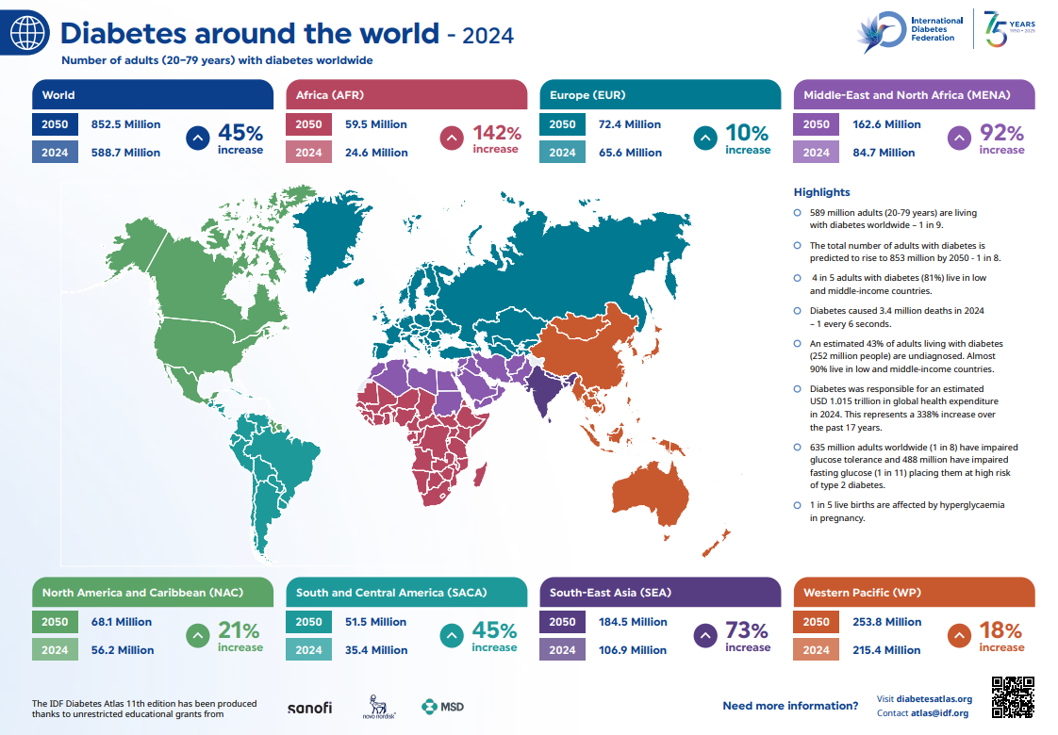

Source: International Diabetes Federation (2025), IDF Diabetes Atlas, 11th edition: Global factsheet.
In the United Kingdom, Diabetes UK reported that approximately 4.6 million people had a diabetes diagnosis in 2025, while around 1.3 million people were estimated to have undiagnosed Type 2 Diabetes and 6.3 million were living with non-diabetic hyperglycaemia or prediabetes. Around 90% of diagnosed diabetes cases are Type 2. These estimates underline the need for accessible risk assessment, earlier diagnosis and prevention support (Diabetes UK, 2025).
In England, the National Diabetes Audit recorded 3,713,155 people with Type 2 and other diabetes in 2024–2025. Only 58.2% of people with Type 2 Diabetes had records for all eight recommended care processes, and Integrated Care Board performance ranged from 38.6% to 73.5%. This variation suggests that national standards do not guarantee consistent local delivery. The audit also changed from 15-month to 12-month reporting periods, so comparisons with earlier reporting periods require caution (National Health Service England Digital, 2025).

3. Risk Factors

3.1 Modifiable risk factors
1. Overweight, obesity and central adiposity. Accumulation of excess weight, particularly around the waist region, is implicated in the reduced sensitivity of insulin. Weight management interventions can improve health outcomes and induce remission in some individuals (International Diabetes Federation, 2019).
2. Low physical activity and sedentary behaviour. Inactivity and prolonged sitting have adverse effects on blood glucose regulation and weight control. Physical activity advice must be individualized, taking into account the participant’s health and lifestyle (World Health Organization, 2024).
3. Unhealthy dietary patterns. The dietary patterns that individuals follow have an impact on their weight and metabolic profile. Physical activity and diet recommendations need to consider the cost and availability of food, as well as cultural and health literacy factors that can influence people’s food choices (Hill-Briggs and Fitzpatrick, 2023).

3.2 Non-modifiable risk factors
1. Increasing age. The likelihood of Type 2 Diabetes increases with age. A person’s assessment also considers other medical and social factors (American Diabetes Association Professional Practice Committee, 2025).
2. Family history and genetic susceptibility. Having a close family member with diabetes increases a person’s risk. However, it does not necessarily mean that one will develop the disease. Family history should be taken into account for assessment (American Diabetes Association Professional Practice Committee, 2024).
3. Ethnicity. The likelihood of developing Type 2 Diabetes varies among ethnic groups. Assessment and prevention should be based on the person’s needs and consider social factors and access to care services (Office for Health Improvement and Disparities, 2025).

A United Kingdom cohort study linked neighbourhood deprivation with higher Type 2 Diabetes incidence. The lowest occupational social class had more than twice the risk of the highest after adjustment. This suggests that inequality partly operates through modifiable pathways. Prevention should improve access to affordable healthy food, safe activity spaces and supportive services rather than relying on individual responsibility alone (Bush et al., 2023, Hill-Briggs and Fitzpatrick, 2023).
High blood pressure, smoking and unhealthy dietary patterns are additional modifiable risks. Age, family history and ethnicity cannot be changed, but they support earlier assessment. Obesity and central adiposity may contribute to insulin resistance, while inactivity can worsen metabolic health. Income, food access, housing, health literacy and safe places to exercise also shape risk. Prevention should therefore combine realistic individual support with action on social barriers (American Diabetes Association Professional Practice Committee, 2025, Hill-Briggs and Fitzpatrick, 2023).

Figure 2: Major risk factors associated with Type 2 Diabetes
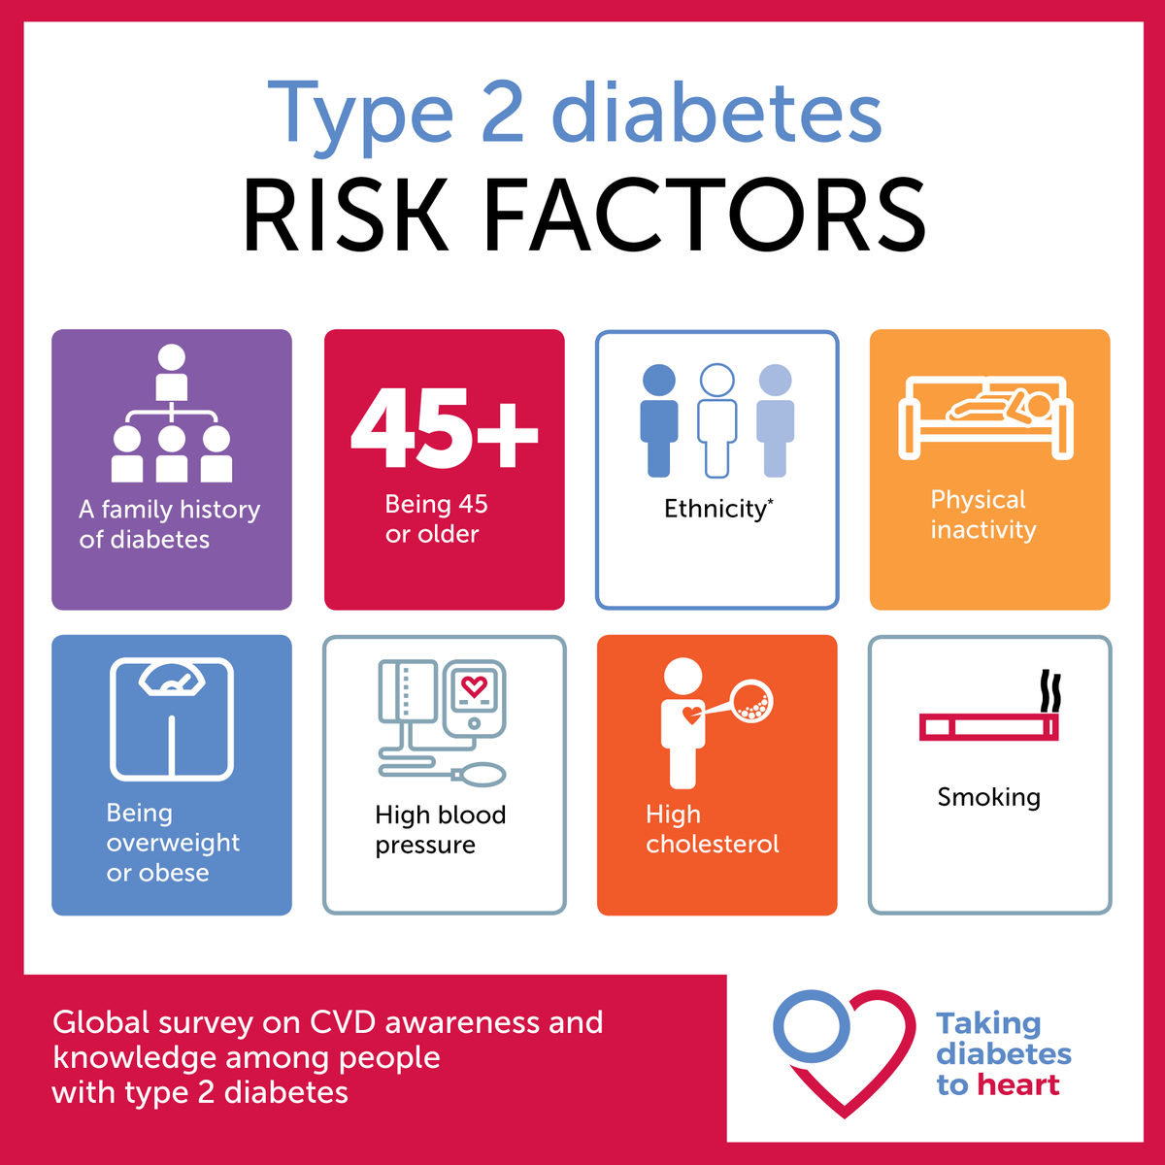
Source: International Diabetes Federation (2019).

4. Aim
This booklet evaluates the burden, biopsychosocial effects and long-term management of Type 2 Diabetes in the United Kingdom, focusing on evidence-based, person-centred care and health inequalities.

5. Physical, Psychological and Social Implications

5.1 Physical implications
The physical effects become cumulative. Hyperglycaemia is associated with damage to the eyes, kidneys and nervous system along with cardiovascular and cerebrovascular diseases (World Health Organization, 2024).
Nerve disorders, vascular disease and wound healing difficulties can cause foot problems. Complications can affect movement, autonomy and quality of life (American Diabetes Association Professional Practice Committee, 2024).
Treatment creates additional burden in the form of medication, management, nutrition, exercise and clinic visits. Comorbidity further complicates the process. Management should take into account the cardiovascular and kidney effects alongside the glycosylated hemoglobin level. For those with Type 2 Diabetes and chronic kidney disease, sodium-glucose cotransporter-2 inhibitors and glucagon-like peptide-1 receptor agonists may help mitigate cardiorenal risks. These decisions are based on renal function, side effects, availability and preference (Yamada et al., 2021; Giugliano et al., 2021).
Figure 3: Diabetes-related complications across body systems
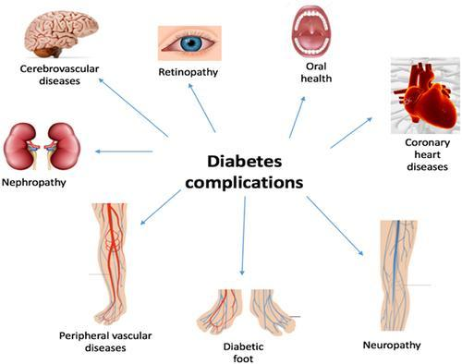

Source: Alqadi (2024), Figure 2, “Shows major clinical complications of DM on different organs”.

5.2 Psychological implications
Psychological effects are also very important. In a study of 1,267 adults with Type 2 Diabetes, patient-centred communication was related to lower diabetes distress, especially when clinicians responded to concerns, explained medicines and were respectful in their decision-making (Peimani et al., 2022).
A meta-analysis from 2024 found that some e-health interventions could decrease diabetes-related distress and depressive symptoms. Effects of e-health interventions differ. Professionals should therefore not interpret poor self-management as lack of motivation (Fernández-Rodríguez et al., 2024).
Daily monitoring and self-management can affect quality of life. Web-based training may help some people, but effectiveness varies and it should not replace person-centred support (Elyeli et al., 2024).

5.3 Social implications
The social impact includes work, income, relationships and participation. Low income, unstable housing, food insecurity, transport barriers and limited health literacy can make clinical advice difficult to follow (Hill-Briggs and Fitzpatrick, 2023).
The same recommendation may be realistic for one person but impossible for another. Person-centred care must assess individual circumstances as well as clinical needs (Bush et al., 2023).
Family members and carers can offer practical and emotional support, but diabetes care can also add household tasks. Research suggests family involvement helps when roles are agreed and the person retains control. Professionals should ask whom the person wishes to involve and what support is useful (Zupa et al., 2022).

6. Evidence-Based Treatment and Management Through the National Health Service
NHS management needs to consider glycaemic control, cardiovascular and kidney complications, treatment and social factors. The quality standards from the National Institute for Health and Care Excellence focus on structured education, risk management, glucose management and complication screening. The treatment needs to be individualised taking into consideration comorbidities, weight targets, adverse effects, accessibility and patient preference (National Institute for Health and Care Excellence, 2023, Davies et al., 2022).
Lifestyle management is vital. Healthy nutrition, physical activity, weight management, adequate sleep and smoking cessation should be available and feasible. In the UK DiRECT extension study, the five-year remission rate was 34% in participants with continuing support, and 12% in those without continuing support, with some weight regain. Therefore, remission is achievable in some patients but with continuing support and cannot be considered a guarantee (Lean et al., 2024).
Medication needs to be reviewed regularly and individualised. Metformin is still indicated in many adults, while the treatment options need to take into consideration heart failure, chronic kidney disease, cardiovascular risk, weight and risk of hypoglycaemia. Sodium-glucose cotransporter-2 inhibitors and glucagon-like peptide-1 receptor agonists may offer additional benefits in addition to blood glucose reduction for eligible patients. It is necessary to take into account the renal function, contraindications, adverse effects, costs and preference of the person (Davies et al., 2022, Yamada et al., 2021, Giugliano et al., 2021).
Structured Diabetes Self-Management Education and Support needs to be offered routinely and revisited at the time of diagnosis, change of treatment and other transitions. A network meta-analysis in 2024 of 108 studies involving 17,735 participants showed a benefit compared to usual care in terms of improvement of glycated haemoglobin, blood pressure and fasting glucose. Nonetheless, about 30% of included studies had quality issues, so services need to monitor quality, attendance and outcomes of programmes rather than assume that all the programs are effective (Romadlon et al., 2024).
Digital interventions can help expand the support, yet human support should not be replaced by digital one. Reviews show potential benefits for self-management and quality of life, although benefits may vary. Services need to consider digital literacy, language barriers, disabilities, connectivity and patient preferences and offer alternative modes including phone, printed and face-to-face consultations (Kerr et al., 2024, Elyeli et al., 2024).
A long-term care plan by the National Health Service should involve an agreement on the yearly review and additional reviews where necessary. The review should be inclusive of glycated haemoglobin, blood pressure, cholesterol, kidney functioning, foot examination, eye testing, medications, smoking status, nutrition and physical and emotional well-being. Goals need to be set that are realistic and any referrals made should be documented and people recalled for reviews. Complicated cases may need specialist help. Review the plan according to changes in health, medications and personal life and assess the clinical and patient outcome (National Institute for Health and Care Excellence, 2023; NHS England Digital, 2025).
Figure 4: National Institute for Health and Care Excellence-based treatment recommendations for adults with Type 2 Diabetes
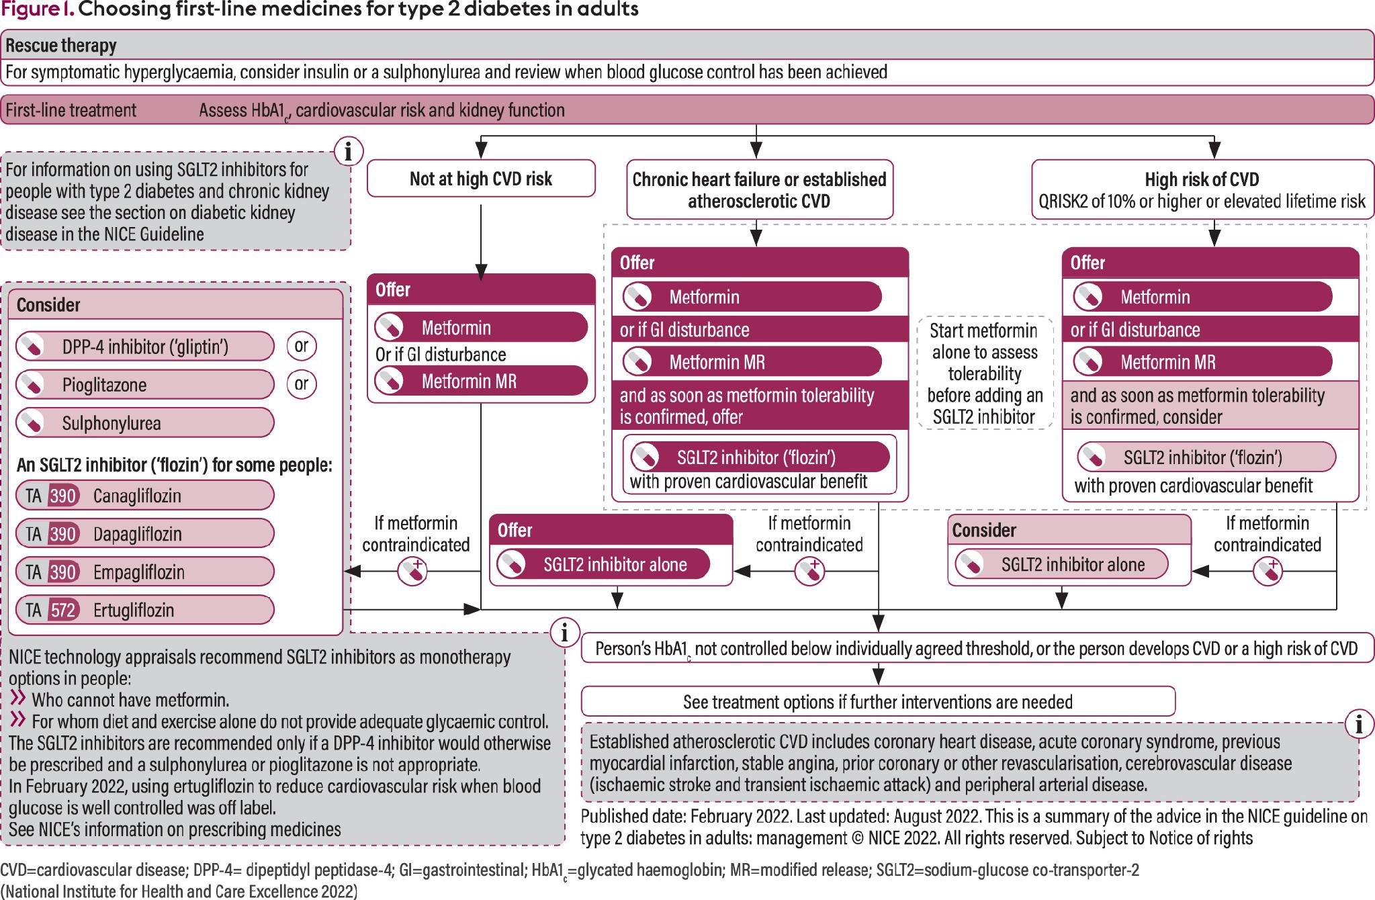
Source: Syed (2023).

7. Theoretical Perspectives and Models for Improving Outcomes

7.1 UK model: The House of Care
The House of Care model facilitates person-centred care and support planning in relation to adults living with Type 2 Diabetes. At the center of this model is a shared discussion that enables the practitioner and person to set realistic goals concerning their management of glucose levels, medications, nutrition, activity, and psychological wellbeing. The left wall is comprised of an active and informed person and selected carer who is backed up by accurate testing and structured education. The right wall is made up of health and care professionals, including GPs, diabetes nurses, pharmacists, dietitians, and podiatrists. The roof indicates dependable organizational systems such as shared records, recalls, planned reviews, and trained workforce. The foundation is made up of commissioned health, social and community services that are able to remove barriers.
Figure 5: House of Care model applied to Type 2 Diabetes
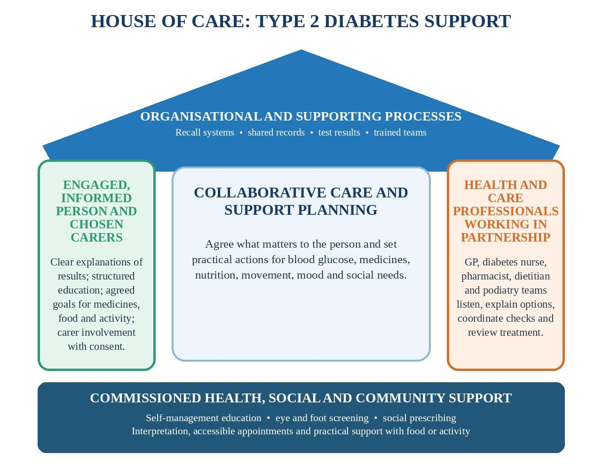

Source: Adapted from British Heart Foundation (n.d.), The House of Care framework.

7.2 International model: Chronic Care Model
The international Chronic Care Model has six connected elements: health-system organisation, delivery-system design, decision support, clinical information systems, self-management support and community resources. A review of 17 studies involving 16,485 adults with Type 2 Diabetes found that model-based interventions reduced glycated haemoglobin by an average of 0.21 percentage points. Results were stronger when four or more components were used, although local resources and implementation quality remain important (Goh et al., 2022).

Figure 6: Expanded Chronic Care Model (international model)
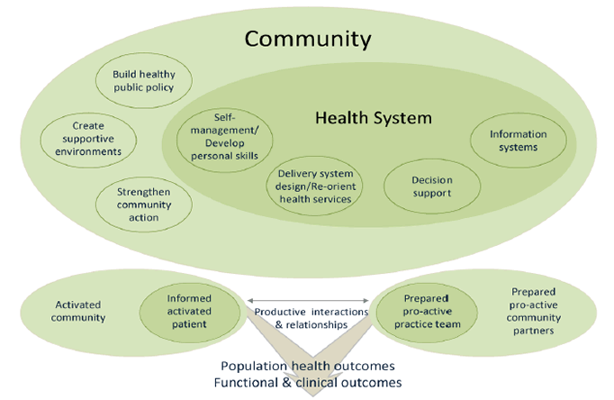

Source: Agency for Healthcare Research and Quality (2013), Figure 3-2, based on Barr et al. (2003). Available at: https://www.ahrq.gov/prevention/resources/chronic-care/clinical-community-relationships-measures-atlas/ccrm-atlas3.html

7.3 Critical comparison of the models
The House of Care and the international Chronic Care Model serve different but related purposes. The House of Care model emphasises people's goals, shared decisions, and coordination of health, social and community services. The Chronic Care Model focuses more on coordination, evidence-informed decision support, information systems, and proactive follow-up. At a practical level, a diabetes pathway can adopt collaborative care planning to establish goals with each person while making use of clinical registers and recalls to identify missed review and screening. This will involve balancing between individual agency and reliable service delivery (Davies et al., 2022; Goh et al., 2022).
Neither of the models is effective alone. The House of Care can be hindered by lack of adequate consultation time, staffing and community capacity. Chronic Care Model can be too much focused on processes and not people's needs due to target setting and reliance on electronic records. Therefore, services must evaluate both clinical and patient-reported experience and adjust implementation to suit the particular context as opposed to using findings in another place to inform practices elsewhere (Goh et al., 2022).
Regarding UK diabetes pathways, the House of Care is most useful during consultations where professionals and patients agree about priorities, treatment options and support. The Chronic Care Model is important at a population planning level where registers, multidisciplinary work, prompts and follow-up are promoted. Both approaches should be applied in primary care and Integrated Care Board pathways with assessment based on care process completion, clinical outcome, patient-reported experience and inequalities (British Heart Foundation, n.d.; Goh et al., 2022).

8. Political, Health and Social Care Agendas
National policy links Type 2 Diabetes with prevention, person-centred care, health inequalities and integration. Integrated Care Systems bring the National Health Service, local authorities and partners together. Diabetes care may involve primary, community and specialist services, pharmacies, podiatry, retinal screening, dietitians, social care and voluntary organisations (NHS England, 2021, Care Quality Commission, 2025).
Core20PLUS5 prioritises the most deprived 20% and locally identified groups facing disadvantage, including ethnic minorities and people with multiple conditions. Its strength is that local data can guide targeted action, although the framework alone does not guarantee improved access or outcomes (NHS England, 2021, Hill-Briggs and Fitzpatrick, 2023).
Implementation is the key issue. Local and Integrated Care Board data can identify gaps in care-process completion, referral pathways and outcomes by deprivation or ethnicity. Teams should use these findings to test service changes and check whether access improves (Office for Health Improvement and Disparities, 2025, NHS England Digital, 2025, Care Quality Commission, 2025).
Implementation is to be assessed by whether patients could use the service and not just whether processes have been done. The service might provide an annual review but still fail to tackle issues of distress, language barriers, medications and so on. Therefore, a better improvement cycle would involve combining audit data with patient feedback, review of health inequalities and discussions within teams. It reflects the Level 7 requirement of linking evidence to practice and making recommendations that are feasible in real life (National Health Service England, 2021a, Care Quality Commission, 2025).

Figure 7: Diabetic eye screening in practice

Source: Healthwatch Bury (2022).

The National Health Service Type 2 Diabetes Path to Remission Programme is an example of policy into practice. This involves total diet replacement, food reintroduction, and support beyond this period. It has been rolled out since April 2024 in England and is not available to everyone. The importance of this programme is its combination of eligibility criteria, clinical oversight, and behavioural support through general practice. The broader point is that evidence requires a safe service pathway rather than an isolated intervention (National Health Service England, 2024b).

9. Recommendations for Person-Centred Care, Self-Management and End-of-Life Care

9.1 Person-centred care and shared decision-making
Person-centred care should begin by identifying what is important to the person and translating it into realistic goals. Shared decision-making is essential in view of differences in the burden, side effects, impact on weight and cardiorenal benefits of treatments. The consensus approach considers the person’s lifestyle, comorbidities, social determinants, and preferences prior to choosing treatment, while National Health Service personalised care emphasises choice and control (Davies et al., 2022, National Health Service England, 2020).

9.2 Self-management and health literacy
Self-management support should continue throughout the condition. Useful approaches include structured education, health coaching, written action plans, medication review, problem-solving and follow-up. Digital contact may improve reach, but people who lack confidence, connectivity or accessible technology need telephone, printed and face-to-face options (Romadlon et al., 2024, Kerr et al., 2024).
Health literacy should be managed as a care issue rather than a patient deficit. Healthcare professionals may use clear language, teach-back technique, accessible written material and ample time for patients’ questions. It may help to make treatment plans easier to implement and to close the gap between recommendations and the actual behaviour. Patient-centred communication is particularly relevant due to the fact that improved communication has been linked to lower diabetes distress (Peimani et al., 2022).

Figure 8: National Health Service Healthy Living campaign for people with Type 2 Diabetes
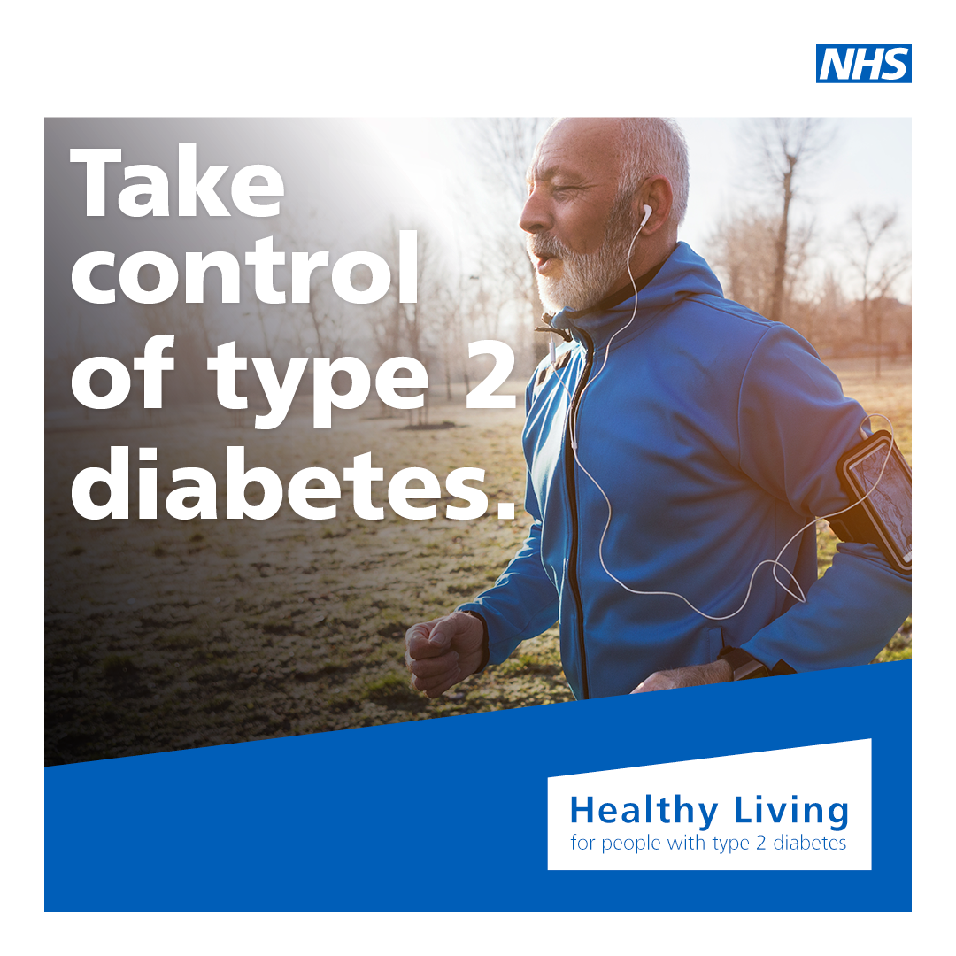
Source: National Health Service Greater Manchester / My Way Diabetes (2022), Healthy Living for people with type 2 diabetes.

9.3 End-of-life care
End-of-life care is important in the case when Type 2 Diabetes coexists with frailty, organ failure, advanced cancer or any other life-limiting illness. Diabetes UK highlights the paucity of evidence in this area and states that treatment goals may shift from risk reduction in the long-term to comfort and quality of life. Care should be simple, priorities discussed and family involved after obtaining consent. Care should minimise burden and avoid unpleasant glucose symptoms (Diabetes UK, 2024, American Diabetes Association Professional Practice Committee, 2024).
The following recommendations translate the evidence into practical actions for United Kingdom services. Each recommendation includes an implementation approach and an outcome that services can monitor.
First, services should close gaps in routine diabetes care through Integrated Care Board dashboards and proactive recall. Prioritise missing foot assessments, kidney checks and retinal screening. Measure progress through completion of all eight care processes and differences between deprivation groups (NHS England Digital, 2025).
Second, care planning should be person-centred. Agree goals with the individual, explain treatment options clearly, check understanding and involve family only with consent. Evaluate progress through patient-reported experience and documented goals (NHS England, 2020, Davies et al., 2022).
Third, offer structured Diabetes Self-Management Education and Support at diagnosis and when needs change, using digital and non-digital options. Monitor attendance, completion and glycated haemoglobin, and assess whether access differs by language, disability or deprivation (Romadlon et al., 2024, Kerr et al., 2024).
Fourth, use Core20PLUS5 and local data to tailor outreach to underserved groups. Support may include interpretation, culturally appropriate education, food and activity support, and community referrals. Review uptake and outcomes by deprivation and ethnicity (NHS England, 2021, Hill-Briggs and Fitzpatrick, 2023).
Fifth, develop safe weight-management and remission pathways for eligible people, alongside early conversations about advanced illness. Remission requires clinical oversight and follow-up. End-of-life care should prioritise comfort, reduce treatment burden and reflect the person's wishes. Monitor remission status where appropriate, treatment burden and documented care goals (Lean et al., 2024, Diabetes UK, 2024).
Taken together, these recommendations combine the relational strengths of personalised care with the service-design strengths of the Chronic Care Model. Local teams should review clinical outcomes alongside patient experience and inequalities, because a national policy may be strong while implementation remains inconsistent (Goh et al., 2022, National Health Service England Digital, 2025).

10. Conclusion
Type 2 diabetes imposes heavy burden on the health sector because of its physical, psychological, and social effects that can even impact the family. There is evidence for an integrated care approach involving lifestyle and weight management, medications, education, screening for complications, and psychological services. The House of Care and the Chronic Care Model are two models which complement each other; one model focuses on shared decision making and partnerships while the other on organizational improvement of services. Adopting both these models together, while considering local disparities and measuring the performance, makes it more likely to deliver holistic care rather than glycemic control (Davies et al., 2022; National Health Service England, 2021a; Goh et al., 2022).

References
Agency for Healthcare Research and Quality (2013) ‘3. What Is the Clinical-Community Relationships Measurement Framework?’, Clinical-Community Relationships Measures (CCRM) Atlas. Rockville, MD: AHRQ. Available at: https://www.ahrq.gov/prevention/resources/chronic-care/clinical-community-relationships-measures-atlas/ccrm-atlas3.html (Accessed: 14 October 2026).
American Diabetes Association Professional Practice Committee (2025) ‘2. Diagnosis and classification of diabetes: Standards of Care in Diabetes—2025’, Diabetes Care, 48(Supplement 1), pp. S27–S49. Available at: https://doi.org/10.2337/dc25-S002
American Diabetes Association Professional Practice Committee (2025) ‘1. Improving care and promoting health in populations: Standards of Care in Diabetes—2025’, Diabetes Care, 48(Supplement 1), pp. S14–S26. Available at: https://doi.org/10.2337/dc25-S001
American Diabetes Association Professional Practice Committee (2024) ‘4. Comprehensive medical evaluation and assessment of comorbidities: Standards of Care in Diabetes—2024’, Diabetes Care, 47(Supplement 1), pp. S52–S76. Available at: https://doi.org/10.2337/dc24-S004
Buse, J.B., Wexler, D.J., Tsapas, A., Rossing, P., Mingrone, G., Mathieu, C., D’Alessio, D.A. and Davies, M.J. (2020) ‘2019 update to: Management of hyperglycemia in type 2 diabetes, 2018. A consensus report by the American Diabetes Association (ADA) and the European Association for the Study of Diabetes (EASD)’, Diabetes Care, 43(2), pp. 487–493. Available at: https://doi.org/10.2337/dci19-0066
Bush, K.J., Papacosta, O., Lennon, L.T., Rankin, J., Whincup, P.H., Wannamethee, S.G. and Ramsay, S.E. (2023) ‘Influence of neighborhood-level socioeconomic deprivation and individual socioeconomic position on risk of developing type 2 diabetes in older men: a longitudinal analysis in the British Regional Heart Study cohort’, BMJ Open Diabetes Research & Care, 11(5), e003559. Available at: https://drc.bmj.com/content/11/5/e003559
Care Quality Commission (2025) The state of health care and adult social care in England 2024/25: integrated care systems. Available at: https://www.cqc.org.uk/publications/major-report/state-care/2024-2025/systems/ics
Davies, M.J., Aroda, V.R., Collins, B.S., et al. (2022) ‘Management of hyperglycemia in type 2 diabetes, 2022. A consensus report by the American Diabetes Association (ADA) and the European Association for the Study of Diabetes (EASD)’, Diabetes Care, 45(11), pp. 2753–2786. Available at: https://doi.org/10.2337/dci22-0034
Diabetes UK (2024) End of life care. Clinical recommendations for professionals. Available at: https://www.diabetes.org.uk/for-professionals/improving-care/clinical-recommendations-for-professionals/diagnosis-ongoing-management-monitoring/end-of-life-care
Diabetes UK (2025) One in five adults now live with diabetes or prediabetes in the UK. Available at: https://www.diabetes.org.uk/about-us/news-and-views/one-five-adults-now-live-diabetes-or-prediabetes-uk
Elyeli, K., Esmaeilzadeh, S. and Bebiş, H. (2024) ‘Is web-based diabetes training effective for quality of life? A systematic review’, Journal of Medical Systems, 48(1), 92. Available at: https://doi.org/10.1007/s10916-024-02112-9
Fernández-Rodríguez, R., Zhao, L., Bizzozero-Peroni, B., Martínez-Vizcaíno, V., Mesas, A.E., Wittert, G. and Heilbronn, L.K. (2024) ‘Are e-health interventions effective in reducing diabetes-related distress and depression in patients with type 2 diabetes? A systematic review with meta-analysis’, Telemedicine and e-Health, 30(4), pp. 919–939. Available at: https://doi.org/10.1089/tmj.2023.0374
Giugliano, D., Longo, M., Caruso, D., et al. (2021) ‘Sodium-glucose co-transporter-2 inhibitors for the prevention of cardiorenal outcomes in type 2 diabetes: an updated meta-analysis’, Diabetes, Obesity and Metabolism, 23(7), pp. 1672–1676. Available at: https://doi.org/10.1111/dom.14374
Goh, L.H., Siah, C.J.R., Tam, W.W.S., Tai, E.S. and Young, D.Y.L. (2022) ‘Effectiveness of the chronic care model for adults with type 2 diabetes in primary care: a systematic review and meta-analysis’, Systematic Reviews, 11, 273. Available at: https://doi.org/10.1186/s13643-022-02117-w
Hill-Briggs, F. and Fitzpatrick, S.L. (2023) ‘Overview of social determinants of health in the development of diabetes’, Diabetes Care, 46(9), pp. 1590–1598. Available at: https://doi.org/10.2337/dci23-0001
International Diabetes Federation (2025) IDF Diabetes Atlas. 11th edn. Brussels: International Diabetes Federation. Available at: https://diabetesatlas.org/resources/idf-diabetes-atlas-2025/
Kerr, D., Ahn, D., Waki, K., Wang, J., Breznen, B. and Klonoff, D.C. (2024) ‘Digital interventions for self-management of type 2 diabetes: systematic literature review and meta-analysis’, Journal of Medical Internet Research, 26, e55757. Available at: https://doi.org/10.2196/55757
Lean, M.E.J., Leslie, W.S., Barnes, A.C., et al. (2024) ‘5-year follow-up of the randomised Diabetes Remission Clinical Trial (DiRECT) of continued support for weight loss maintenance in the UK: an extension study’, The Lancet Diabetes & Endocrinology, 12(4), pp. 233–246. Available at: https://doi.org/10.1016/S2213-8587(23)00385-6
National Institute for Health and Care Excellence (2023) Type 2 diabetes in adults: quality standard QS209. Available at: https://www.nice.org.uk/guidance/qs209
National Health Service England (2020) Personalised Care Institute. Available at: https://www.england.nhs.uk/personalisedcare/workforce-and-training/personalised-care-institute/
National Health Service England (2021a) Core20PLUS5: an approach to reducing healthcare inequalities. Available at: https://www.england.nhs.uk/about/equality/equality-hub/national-healthcare-inequalities-improvement-programme/core20plus5/
National Health Service England (2021b) Integrated care systems: guidance. Available at: https://www.england.nhs.uk/publication/integrated-care-systems-guidance/
National Health Service England (2024a) Performance report 2023/24. Available at: https://www.england.nhs.uk/long-read/performance-report-23-24/
National Health Service England (2024b) National Health Service Type 2 Diabetes Path to Remission Programme. Available at: https://www.england.nhs.uk/diabetes/treatment-care/diabetes-remission/
National Health Service England Digital (2025) National Diabetes Audit (National Diabetes Audit) 2024–25 quarterly report for England, Integrated Care Board, Primary Care Network and GP practice. Available at: https://digital.nhs.uk/data-and-information/publications/statistical/national-diabetes-audit/core-q4-24-25/national-diabetes-audit-nda-2024-25-quarterly-report-for-england-integrated-care-board-icb-primary-care-network-pcn-and-gp-practice
Office for Health Improvement and Disparities (2025) Diabetes profile update: March 2025. London: GOV.UK. Available at: https://www.gov.uk/government/statistics/diabetes-profile-update-march-2025
Peimani, M., Garmaroudi, G., Stewart, A.L., Yekaninejad, M.S., Shakibazadeh, E. and Nasli-Esfahani, E. (2022) ‘Type 2 Diabetes Burden and Diabetes Distress: The Buffering Effect of Patient-centred Communication’, Canadian Journal of Diabetes, 46(4), pp. 353–360. Available at: https://doi.org/10.1016/j.jcjd.2021.11.007
Romadlon, D.S., Tu, Y.K., Chen, Y.C., Hasan, F., Kurniawan, R. and Chiu, H.Y. (2024) ‘Comparative effects of diabetes self-management programs on type 2 diabetes clinical outcomes: a systematic review and network meta-analysis’, Diabetes/Metabolism Research and Reviews, 40(6), e3840. Available at: https://doi.org/10.1002/dmrr.3840
World Health Organization (2024) Diabetes. Geneva: World Health Organization. Available at: https://www.who.int/news-room/fact-sheets/detail/diabetes
Yamada, T., Wakabayashi, M., Sato, Y., et al. (2021) ‘Cardiovascular and renal outcomes with sodium-glucose cotransporter-2 inhibitors versus glucagon-like peptide-1 receptor agonists in people with type 2 diabetes and chronic kidney disease: a systematic review and network meta-analysis’, Cardiovascular Diabetology, 20. Available at: https://doi.org/10.1186/s12933-021-01244-9
Zupa, M.F., Lee, A., Piette, J.D., Trivedi, R., Youk, A., Heisler, M. and Rosland, A.M. (2022) ‘Impact of a dyadic intervention on family supporter involvement in helping adults manage type 2 diabetes’, Journal of General Internal Medicine, 37(4), pp. 761–768. Available at: https://doi.org/10.1007/s11606-021-06946-8
International Diabetes Federation (2025) IDF Diabetes Atlas, 11th edition: Global factsheet. Brussels: International Diabetes Federation. Available at: https://international-diabetes-federation.s3.eu-west-1.amazonaws.com/media/uploads/sites/3/2025/04/IDF_Atlas_11th_Edition_2025_Global-Factsheet.pdf (Accessed: 8 October 2026).
International Diabetes Federation (2019) Type 2 diabetes risk factors infographic. Brussels: International Diabetes Federation. Available at: https://pbs.twimg.com/media/D5kP1tMWAAEXNYP.png (Accessed: 8 October 2026).
Healthwatch Bury (2022) Diabetic Eye Screening Programme in Bury. 16 May. Available at: https://healthwatchbury.co.uk/advice-and-information/2022-05-16/diabetic-eye-screening-programme-bury (Accessed: 8 October 2026).
Syed, H. (2023) ‘Type 2 diabetes: treatment recommendations for reducing the risk of complications’, Nursing Standard, 38(7), pp. 45–50. Available at: https://doi.org/10.7748/ns.2023.e11997 (Accessed: 8 October 2026).
Alqadi, S.F. (2024) ‘Diabetes and its influence on oral health: review’, Diabetes, Metabolic Syndrome and Obesity: Targets and Therapy, 17, pp. 107–120. Available at: https://doi.org/10.2147/DMSO.S426671 (Accessed: 8 October 2026).
British Heart Foundation (n.d.) The House of Care framework. Available at: https://www.bhf.org.uk/for-professionals/healthcare-professionals/innovation-in-care/person-centred-care-and-the-house-of-care/the-bhf-house-of-care-programme/the-house-of-care-framework (Accessed: 22 October 2026).
National Health Service Greater Manchester / My Way Diabetes (2022) Healthy Living for people with type 2 diabetes. Available at: https://manchester.mydiabetes.com/healthy-living-for-people-with-type-2-diabetes/ (Accessed: 8 October 2026).

