Scholarships and Bursaries – new MyTSD application details

- Log into my TSD

- Search for the Scholarships and Bursaries banner on the right hand side of the home screen (screen 1)

- Select ‘search the scholarships and funding catalogue’

- Input your course details (screens 2)

- This is an example of the list that will come up. On this page you can read the eligibility criteria for each of the awards under ‘…more’ and can also make the application if they click on ‘apply’. Please check the eligibility criteria carefully before applying. (screen 3)

Screen 1
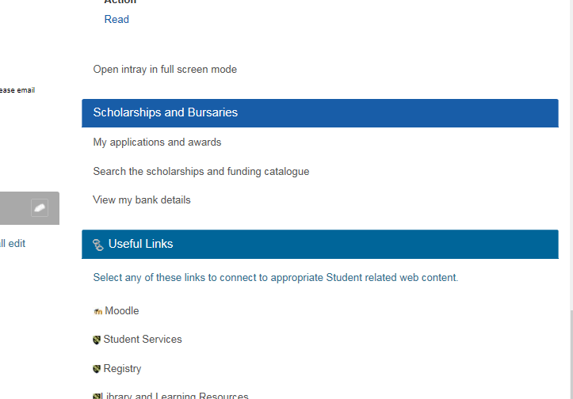

Screen 2

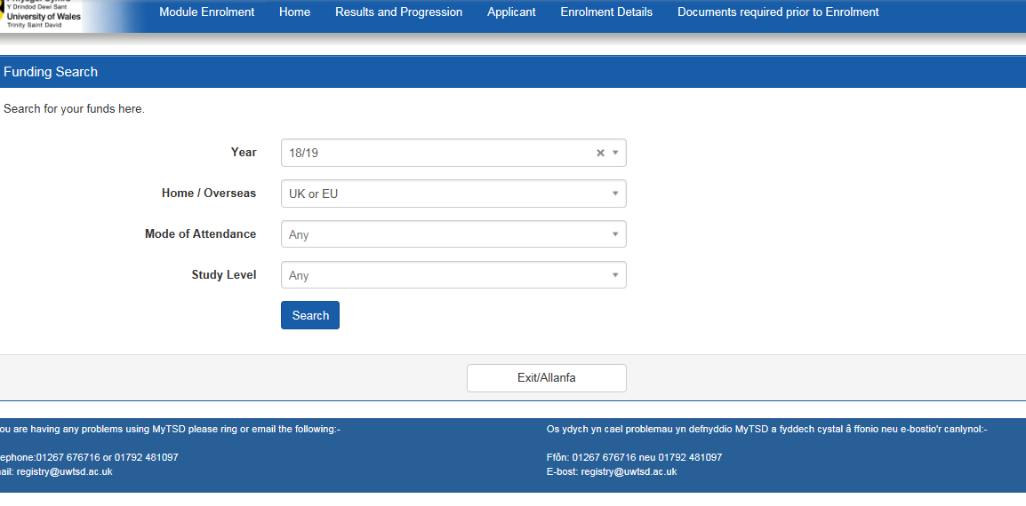

Screen 3



