Networks and Cyber Security Essentials
Student: Josh Archer Student Number: 2011907
Synthesize a solution to a potential real-life scenario
Module code: | ACCA4024
2021
Abstract:
Within this coursework I will be discussing a company’s cybersecurity protocols, what their weaknesses are and how it can be improved. I will look into the different devices & networks that the company are using. I will also identify different styles of attack that the company is most vulnerable from.

Contents
Introduction 3
Networks 4
Attacks, Threats & mitigation 5
Attack scenario 7
Security Policy 9
Conclusion 10
Appendix: 11
References 12

Introduction

Che-Si is construction company and their security chief is worried about the current cybersecurity policies that that have in place. The company operates globally and stays connected online 24/7. They are using advanced communication methods as well as storage devices such as cloud storage. The policies allow for staff and clients to access their network at any given point. They can also gain access from any device as well as any location. This is done to keep productivity and efficiency at a maximum. Doing this, however, increases the likelihood of a cyber-attack. There security Chief would like to have a new policy to be able to improve their cyber security, whilst also keeping the productivity levels the same.

Networks

There are numerous networks that companies can use such as, a flat network. This is where the number of routers and switches are reduced. All devices will be connected to a single switch. This is done to reduce cost & maintenance on the network. However, as the network is so large, this would be counter intuitive. The reason being that any troubleshooting may need to be done on the entire network rather than just a small part of it. This done on a global scale would be inefficient (1). The different appliances needed for this would be laptops or computers, switches, routers and possible personal devices such as smart phones. Overall this would not be a suitable network for a company as large as Che-Si as there network requirements are a lot higher than what this particular network type is used for. The ability to control security would become non-existent.
A segmented network would be more of an appropriate choice for Che-Si. This is where the network is broken into smaller groups and each group acts as its own network. This would allow individual networks, which could be office grouped, improve productivity and efficiency whilst also enhancing security which is exactly what Che-Si have asked for. It would improve traffic as the network size is smaller, improving speed and productivity. The security would improve due to the ability to break the network into smaller groups and having security perimeters around each segmented network. This means that if a malicious attacker was to gain access to the overall network, they wouldn’t be able to gain access to any data, application, asset or services (DAAS) due to the security perimeter around each individual network (2). See Fig 1. An example of how this would work is the Guest WIFI within one of the offices. This network can be segmented from the rest of the networks whilst only allowing access to internet. This will stop anyone using the Guest WIFI with malicious intent, gaining access to the network. Devices needed within this would again be end devices, such as laptops or smart phones. Other devices needed are routers, switches, hubs and wireless devices.

Attacks, Threats & mitigation

Che-Si will come under certain attacks and threats from hackers or people with malicious intent. Probably one of the most common attacks would be a Phishing attack. This is a form of social engineering attack. Its aim is to steal DAAS by sending emails from what seems to be a trusted source. The recipient will then be encouraged to click on a link or give up sensitive information. The link will then install malware or some other malicious content into the network. However, considering Che-Si size, the link will be part of an advanced persistent threat (APT). This will allow an attacker to stay within the network on a long-term basis. This will lead to more sensitive information being stolen or it could even be used to sabotage some of the company’s network. (3) Che-Si policy of allowing anyone from anywhere to be able to access their network through any device, will make this attack a lot more likely. If an attacker can gain access to passwords, they could gain access from anywhere. Some of the ways in which Che-Si can Mitigate this would be to implement some sort of authentication protocol. This is usually done through a 2-factor or multiple authentication way. This means that when an employee or client tries to log into the network from anywhere not only will they have to enter a login they may also have to enter a code sent to a personal device such as their smartphone. Updating security such as firewalls either automatically or on a regular basis is another way (4). Implementing security protocols such as password management will also decrease the risk of a phishing attack being successful. Considering Che-Si use Cloud storage, a Web Application Firewall (WAF). This is a way of monitoring the traffic between the chosen application and the internet. With this Che-Si can choose to block known sources, only allow access from a designated list or have a mix of both (5).
Other types of attacks include that Che-Si will be most vulnerable to due to their network set up are:
- Password Attacks – This is usually done through a phishing attack first or just users not having strong enough passwords. Training users how to identify and avoid phishing methods and also implementing password protocols can avoid this.
- Man in the Middle – This is where a hacker will can actually impersonate users whilst they are communicating. This is a very modern form of eavesdropping. This could potentially effect Che-Si as they try to discuss sensitive information with clients. It could also be used as a way of competitors getting information on the company’s engineering projects and potential bids for jobs. This can be prevented by having Intruder Detection Systems (IDS) and Intruder Prevention Systems (IPS) to not only detect if this is happening but to also prevent it. (6)
Overall the most likely attack on Che-Si’s network will come through a Phishing attack. Roughly 91% of cyberattacks originate with Phishing attacks (6). With this the most likely way these attacks will become successful is due to human error as 95% of attacks will be down to an error of judgment made by the network users. (7)
Lastly, ensuring that the company’s Hypertext Transfer Protocol (HTTP) is secure, thus making it Hypertext Transfer Protocol Secure (HTTPS). This will ensure that the information within are properly encrypted. This along with ensuring other security measures such as firewalls, will stop any sniffing attacks happening (11).
As Che-Si’s clients and employees can communicate with each other 24/7 from anywhere, using digital signatures and data encryption will be a great way to ensure that any communication or data sent isn’t tampered with. A digital signature is unique and are assigned to a specific person or organisation. Using these will ensure that when Che-Si’s employees or clients send digital content, it can be trusted to arrive to the correct recipient and that it can’t be tampered or intercepted. To use signatures, hashing must be understood. This is an algorithm that the content is sent through to give it a unique code, this code is what is known as the hash. When the recipient of the content uses the same algorithm to pass the content through, they should get the same code. However, if the same algorithm is used but a different code is given, the content has been tampered and is now untrustworthy. To then ensure the integrity and verify the sender, a Public Key Cryptography will then be used. A different algorithm to the one that was used for the hash is used and this is done to encrypt and decrypt data. This is known as a key, to encrypt the data is known as a private key and is used only by the sender. The decryption key is known as a public key and is used by the recipient and therefore verifies the sender. Lastly a Certificate Authority (CA) can be used. This is a 3rd party that generates keys on the company’s behalf. A certificate will then be issued that verifies the holder and their keys (8). See Fig 2 for an example.

Attack scenario

Chosen attack:
The attack that will be simulated is showing how a hacker might use sniffing tools to in order to gain access to sensitive information. This information may be found due to the fact that the sites Hypertext Transfer Protocol isn’t secure.
The image below is a random website whose Hypertext Transfer Protocol isn’t secure.

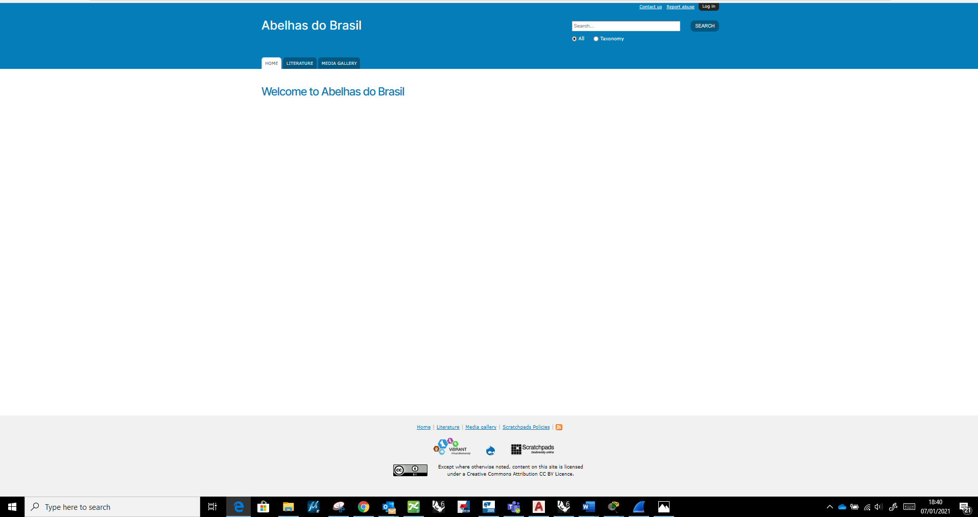

HTTP site:
You can tell this really simply by the padlock icon in the front of the address bar.



The one with a padlock shows that the sites Hypertext Transfer Protocol is properly encrypted and secured.
Any information that is input into a site that isnt secured, can be stolen by hackers using sniffing tools.

The attack:
Information that is stored can be easily stolen. The information I have put into the site can be seen below.
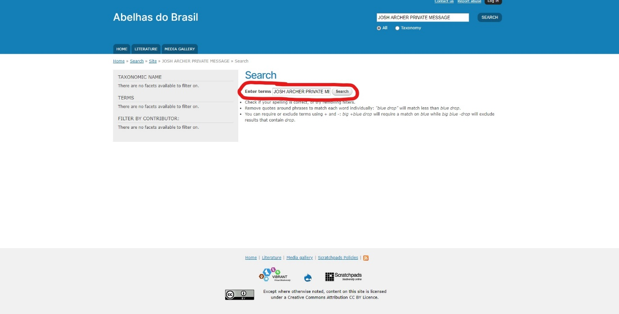
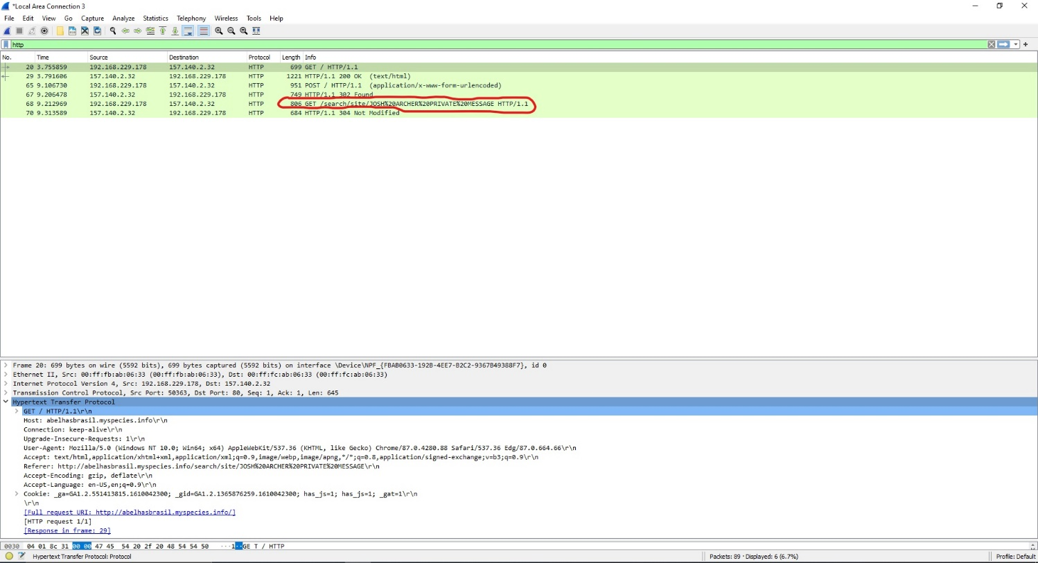
Using a sniffing tool, the information I put into the site has been stolen. For this method I used a sniffing tool such as Wireshark.
Mitigation:
To Mitigate this simply encrypting the data on the site will stop a hacker stealing potentially sensitive information.

Security Policy

To ensure that Che-Si is kept safe from cyberattacks a stringent policy should be put into place. This should be followed by all employees and clients who access Che-Si’s network.
Network:
Firstly, the network set up itself should be looked at. To ensure that efficiency and productivity is kept the same or improved, a segmented network should work best. This will allow the network to cope with the traffic going through it better whilst also mitigating any attacks that it comes under.
Training:
Training shall be provided to all employees in ways to avoid phishing attacks. Firstly, they must learn to tell what a phishing email may look like. Emails from services that they don’t subscribe to, checking to see whether the senders address matches the company the email is representing and whether or not the email has a generic greeting (4). These are all things that employees or anyone accessing the network should be trained to look out for.
Authentication:
Employing multi factor authentication on the network will be a good way to ensure that anyone trying to access the network are who they say they are. Given Che-Si’s current policy of global access 24/7, this will be a quick and cost-effective way to provide extra security.
Ensuring proper password management is in place will also help avoid cyber-attacks. Ensure that passwords meet an acceptable standard such as a multitude of letters, numbers and symbols. If a user forgets their password, they must go through stages of authentication in order to ensure they are verified users in order to retrieve their password. Implementing regular password resets will also help mitigate attacks if a password is compromised (10). Finally, employ a strict policy of the prohibition of password sharing.
Software:
Installing IPS and IDS software will help detect and prevent any intruders within the network. Installing Firewalls and WAFs will also help increase the networks security as well as to its cloud.
Digital Signatures & Data encryption:
Ensuring Data is correctly encrypted, digital signatures and the correct use of Certificate Authority will ensure that data is verified and remains uncorrupted.

Conclusion
For Che-Si to properly ensure their cyber security is as efficient as it should be, a few measures should be taken.
Correctly choosing the way their network is set up will allow for a higher allowance of traffic to pass through. It will also provide a lot of security to the network itself. Ensuring networks are segmented or placed into a hierarchy is a great way to do this.
Identifying the most likely attacks they will come under will also allow for Che-Si to impose their most effective cyber security strategies. As a phishing attack is the most likely way a hacker might gain access to their network, giving their staff the correct training should be able to mitigate this.
Finally Encrypting their data and using digital signatures will help ensure that any communications with sensitive information remains untampered.

Appendix:

Fig1:
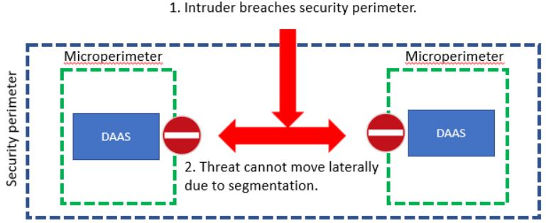
(2)

Fig 2:
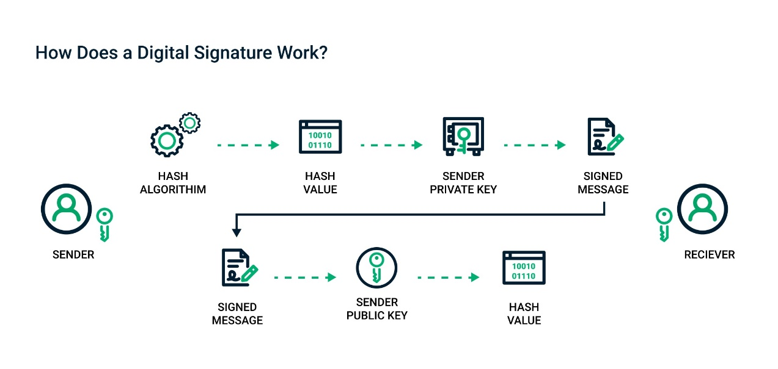

(9)

References

[1] | P. Oppenheimer, Top Down Network Design, Indianapolis: Cisco Press, 2004.
[2] | Paloalto Networks, “What Is Network Segmentation?,” Paloalto Networks, 2020. [Online]. Available: https://www.paloaltonetworks.com/cyberpedia/what-is-network-segmentation. [Accessed 02 01 2021].
[3] | imperva, “Phishing attacks,” imperva, 2021. [Online]. Available: https://www.imperva.com/learn/application-security/phishing-attack-scam/. [Accessed 02 01 2021].
[4] | Federal Trade Commission, “How to Recognize and Avoid Phishing Scams,” Federal Trade Commission, 05 2019. [Online]. Available: https://www.consumer.ftc.gov/articles/how-recognize-and-avoid-phishing-scams. [Accessed 02 01 2021].
[5] | CloudFlare, “What is a WAF? | Web Application Firewall explained,” CloudFlare, 2021. [Online]. Available: https://www.cloudflare.com/en-gb/learning/ddos/glossary/web-application-firewall-waf/. [Accessed 02 01 2021].
[6] | Comtact, “The 8 most common types of cyber attacks explained,” Comtact, 02 12 2019. [Online]. Available: https://comtact.co.uk/blog/common-types-of-cyber-attacks-explained/. [Accessed 02 01 2021].
[7] | D. Milkovich, “15 Alarming Cyber Security Facts and Stats,” Cybint Solutions, 23 12 2020. [Online]. Available: https://www.cybintsolutions.com/cyber-security-facts-stats/. [Accessed 02 01 2021].
[8] | Lincolnshire Chamber of Commerce, “Preventing Cyber Crime & Fraud: Digital signatures,” Lincolnshire Chamber of Commerce, [Online]. Available: https://www.lincs-chamber.co.uk/preventing-cyber-crime-fraud-digital-signatures/. [Accessed 02 01 2021].
[9] | Sectigo, “What Are Digital Signatures & How Do They Work?,” 2021. [Online]. Available: https://sectigo.com/resource-library/how-digital-signatures-work. [Accessed 02 01 2021].
[10] | Manage Engine, “What is password management?,” Manage Engine, 2021. [Online]. Available: https://www.manageengine.com/products/passwordmanagerpro/what-is-password-management.html. [Accessed 02 01 2021].
[11] | Security Metrics, “Are HTTP Websites Insecure?,” Security Metrics, [Online]. Available: https://www.securitymetrics.com/blog/are-http-websites-insecure. [Accessed 02 01 2021].

