

Dissertation – LCBB6000
BA (Hons) Business Management
University of Wales Trinity Saint David (London Campus)

“The Impact of Ecological Policies on Small Businesses in the UK-Northamptonshire: Overcoming Struggles to Achieve Sustainability”

Name: Borislav Nenkov
Student ID:2242940

SUBMITTED ON 27.04.2026
Decleration
I hereby declare that this dissertation is my own original work and has not been submitted, either in whole or in part, for any other degree or qualification at this or any other institution. All sources of information and ideas used in this dissertation have been appropriately acknowledged.I confirm that this work has been completed in accordance with the academic integrity guidelines and regulations of the University.
Abstract
The study examines the effects of the green policies on small enterprises in Northamptonshire and how such enterprises were able to manage the pressure of complying with the maintenance of sustainable practices. The study focuses on the waste management laws, energy efficiency law and the operational, financial and administrative limits of compliance. The research methodology is quantitative, where a structured questionnaire was used to collect data on 50 small business owners or managers in the small business sector of the area. The results indicate that, through awareness of ecological policies, small businesses are usually highly challenged in adopting the ecological policies because of a lack of finance and administrative capacity, coupled with the burden on the administrative manpower. Most of the businesses use cost-minimisation strategies and incremental changes aimed at compliance, and some require the adoption of more holistic sustainability activities. The study finds that in Northamptonshire, even though small businesses seek to meet ecological policies, their practices are simply reactive in nature, focusing on regulatory demands rather than sustainability.The findings show that small businesses are generally aware of ecological policies, but compliance is constrained by financial, administrative, and managerial pressures. The study contributes locality-specific evidence from Northamptonshire, showing that most firms respond through reactive compliance rather than long-term sustainability integration. The study is important to this area of ecological policy impacts on small enterprises, and better communication, an easy compliance process, and support should be provided to them. Future research recommendations entail a study of the long-term impacts of ecological compliance on the sustainability of small businesses, and the research ought to be extended to other regions of business organisations.
Acknowledgements
I would like to express my sincere gratitude to my dissertation supervisor for their guidance, support, and constructive feedback throughout the course of this research. Their academic insight and encouragement were invaluable in shaping the direction of the study and in supporting the successful completion of this dissertation.

Table of Contents
Chapter 1: Introduction 9
1.1 Introduction 9
1.2 Background of the study 9
1.3 Problem Statement 9
1.4 Aims, Objectives, Research Questions, Hypothesis 10
1.5 Rationale of the Research 10
1.6 Methodology 11
1.7 Scope of the Study 11
1.8 Structure of the Dissertation 11
1.9 Summary of Chapter 1 12
Chapter 2: Literature Review 13
2.1 Introduction 13
2.2 Base Theory of the Sub-Discipline 13
2.3 Theoretical Frameworks 14
2.4 Identifying and Comparing Viewpoints 15
2.5 Gaps in Current Literature 17
2.6 Summary of Chapter 2 18
Chapter 3: Research Methods 19
3.1 Introduction 19
3.2 Philosophical Position 19
3.3 Paradigm Position 19
3.4 Research Approach 20
3.5 Methodological Stance 20
3.6 Research Strategy and Design 20
3.7 Research Sample and Population 21
3.8 Data Collection and Data Analysis Tools 21
3.9 Questionnaire Reliability 22
3.10 Potential Response Bias 22
3.11 Ethical Considerations of the Research 22
3.12 Summary of Chapter 3 22
Chapter 4: Data Analysis and Discussions 24
4.1 Introduction 24
4.2 Analysis and Discussions of Findings 24
4.3 Findings 31
4.4 Implications for Policymakers and Small Business Owners 32
4.5 Summary of Chapter 4 32
Chapter 5: Conclusions, Limitations & Recommendations 33
5.1 Introduction 33
5.2 Conclusions on Research Objectives 33
5.3 Conclusions on Research Problem 33
5.4 Summary of the Research Findings and Outcomes 34
5.5 Academic and Practical Contribution of the Research 34
5.6 Limitations of the Research 35
5.7 Recommendations and Areas for Future Research 35
5.8 Summary of Chapter 5 35
References 36
Terms of Glossary 40
Appendices 41
Appendix A: Survey Questionnaire 41
Appendix B: Participation Consent Form 43

Appendix C: Participant Information Sheet 46
Appendix D: Application for Ethical Approval 48

List of Figures
Figure 1: Conceptual Map of Ecological Policy Compliance in Small Businesses 14
Figure 2: Business T1ype of the small businesses 24
Figure 3: Business Characteristics of the Small Businesses 25
Figure 4: Awareness of Waste Management of Small Businesses 25
Figure 5: Awareness of energy efficiency of the Small Businesses 26
Figure 6: Effect of Waste Management Regulations on Small Businesses 27
Figure 7: Change in Business Processes of the Small Businesses 27
Figure 8: Financial Costs of the Small Businesses 28
Figure 9: Administrative and reporting requirements of the Small Businesses 28
Figure 10: Time Management of the Small Businesses 29
Figure 11: Cost minimisation of the Small Businesses 30
Figure 12: Attempts to adapt the Small Businesses 30

Chapter 1: Introduction

1.1 Introduction
The contemporary business regulation in the United Kingdom has taken the form of environmental sustainability (Albitar et al., 2023). The desire and necessity to cut waste rates, enhance the efficiency of energy consumption, and minimise the negative effects on nature gradually determine the structure of the activity of firms (Alkaraan et al., 2024). Especially, the small entrepreneurs are prone to pressure because of the lack of financial, administrative, and managerial skills (Abdelaziz et al., 2024).

1.2 Background of the study
The UK has also stepped up in its sustainable development with a mounting number of ecological laws governing business activity,particularly in waste management, recycling, and energy efficiency (North Northamptonshire Council, 2025). The measures that control waste management, reduction, and energy efficiency protocols have become embedded in the normal compliance in business. In the case of small businesses that work in the service-based arena, like hospitality and retailing, such requirements may lead to operational changes, additional costs, and changes in day-to-day business practices (Alkaraan et al., 2024). The example of Northamptonshire is one of the most topical since its local economy largely depends on the small businesses that run on a very slim profit margin (North Northamptonshire Council, 2025).

1.3 Problem Statement
Ecological policies are often seen as cumbersome and complicated for small businesses in spite of the environmental objectives that they are based on. Compliance can be associated with extra expenditure, managerial and administrative workloads, and interruptions with the existing operating patterns (Belitski et al., 2022). Small firms are less able to absorb the cost of regulation or invest towards a specialist expertise, as do larger organizations (NNBN, 2025). This can lead to the ecological policies having rather devastating impacts on the operation of small businesses than on the sustainability of the transition. While small businesses are important to the Northamptonshire economy, there is limited local evidence on how they experience and manage ecological compliance pressures in practice (Babajide et al., 2023). This creates a clear research gap concerning the practical impact of ecological policies on small businesses in Northamptonshire.

1.4 Aims, Objectives, Research Questions, Hypothesis
Aim
To investigate how ecological policies affect small businesses in Northamptonshire and how small firms cope with the issues concerning sustainability compliance.
Objectives
- To identify the main ecological policies affecting small businesses in Northamptonshire, particularly waste management and energy efficiency requirements.
- To examine how theecological policies affect the operational activities of small businesses.
- To assess the financial, administrative, and managerial challenges small businesses face in complying with ecological policies.
- To examine the strategies used by small businesses to manage ecological compliance pressures
Research Questions
- What ecological policies affect small businesses in Northamptonshire, including wastemanagement and energy-efficiency requirements?
- How do small businesses in Northamptonshire respond to the challenges of complying with ecological and sustainability policies?
- What challenges do small businesses in Northamptonshire face in complying with ecological policies, and how effective is existing support in addressing them?

1.5 Rationale of the Research
The role of small businesses in the UK economy is in the limelight, but has not received much sustainability research, where the attention is mostly on large organisations or national trends (Bianchini and Croce, 2022). Having envisaged the functionality of the ecological policies at local levels, it is critical to establishharmonised regulation frameworks. These successively enhance the environmental agenda as well as ensure business sustainability (Hillary, 2017). The research can provide locality-specific evidence to support local councils, policymakers, and business support services in developing more targeted and practical interventions (Biginas et al., 2022).

1.6 Methodology
To study this aspect, the study takes a quantitative research approach in order to determine the effect of ecological policies on small businesses. The survey-based design will be employed to obtain the standardised data on the characteristics of the business and its awareness of ecological regulations, perceived effects of the operation, and difficulties with compliance (Bryman and Bell, 2015). There is the use of descriptive statistical analysis to summarise the responses and determine the severity of various impacts of policies relative to each other.

1.7 Scope of the Study
Its study area is restricted to Northamptonshire; it targets small service-based enterprises, such as cafes, takeaways, and retail stores. It specifically focuses on ecological policies of waste management and energy efficiency, and not on the greater issues of environmental sustainability and social sustainability (Blumberg and MacRae, 2024).

1.8 Structure of the Dissertation
Five chapters are structured in this dissertation. The first chapter presents the introduction of the work and research framework. The relevant theories and literature are reviewed in Chapter 2. The methodology of the research is given in Chapter 3. The findings are displayed and discussed in Chapter 4. The fifth chapter of this paper makes conclusions and recommendations on the study.

1.9 Summary of Chapter 1
The chapter has set the context, purpose and direction of the research that gave a base on which the subsequent theoretical and empirical analysis will be provided.

Chapter 2: Literature Review

2.1 Introduction
The chapter is a critical literature review of the literature pertaining to ecological policies and their implication on the sustainability of small businesses. It develops the theoretical principles of regulatory compliance and the firm behaviour, analyses the conceptual models of explaining the adoption of sustainability in small businesses, and analyses the empirical evidence of waste management and energy efficiency needs (Lin et al., 2024). Synthesising these strands helps identify gaps in the existing research.

2.2 Base Theory of the Sub-Discipline
Theoretical perspectives are often used to examine ecological policies that influence business activities, which describe how organisations react to environmental pressures of regulation and internal constraints of resources (Olekanma et al., 2024). Institutional Theory focuses on the opportunities that exist in the form of formal rules, norms and regulatory frameworks in influencing organisationalbehaviour. In this light, the ecological policies act as a force of coercion, which forces the firms to align with the demand to remain legitimate and evade punishment (Efobi et al., 2019). There is always a fear that, in the case of small businesses, meeting environmental regulations is not always brought about by a strategic commitment to the environmental aspect, but rather by the standards set by the external force (Lin et al., 2024). Nevertheless, small businesses often have problems in envisioning the regulatory demands as a real action because of the limited administration and specialisation skills. Compliance can thus be either superficial or responsive, besides not being embedded in the long-range strategic planning (Caglar, 2023).
Although the Institutional Theory is used to understand why small businesses are driven to adhere to the ecological policies, the theory fails to explain why there are differences in the ability of firms to do so (Alkaraan et al., 2024). The Resource-Based View is seen as an extension of this view as it takes into account firm-specific resources and capabilities as the key determinants of organisational performance (Biginas et al., 2022). Many small businesses are usually run with limited financial resources, time taken by the administration and very little availability of technical knowledge (NNBN, 2025).These limitations limit their investment in sustainability activities even in the case of high regulatory pressure.
Resource limitationsare reasons why compliance may often be difficult and skewed, whereas regulatory pressure explains that complying is inescapable (Biginas et al., 2022). It especially applies to the Northamptonshire small business, where compliance might be mandatory but is not even noticed in practice, since small businesses vary in financial and managerial ability.

2.3 Theoretical Frameworks
The theoretical frameworks that analyse compliance with ecological policies present systematic accounts of the role of environmental regulation on organisational performance and behaviour. In the studies of small businesses, it is specifically the compliance of cost frameworks that lends weight to the effects of sustainability regulation (Efobi et al., 2019). Direct costs will consist of costs spent on waste management systems, recycling infrastructure, energy-efficient equipment, and monitoring (Omowole et al., 2024). Indirect costs entail administrative work, employee training, management control and failure to maintain the usual working patterns (Jones et al., 2022).
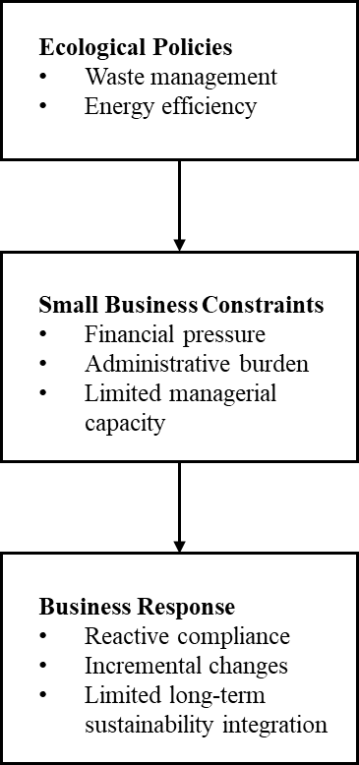
Figure 1: Conceptual Map of Ecological Policy Compliance in Small Businesses
The other noteworthy framework is the sustainability adoption model, in which organisations interact with environmental practices at various levels of development (Bianchini and Croce, 2022). In this model, there is a differentiation of reactive compliance, as opposed to proactive sustainability integration (Omowole et al., 2024). Proactive integration is where sustainability concerns are proactively incorporated in the strategic planning, investment decision-making and organisational culture (Omowole et al., 2024). Small businesses often are left at the reactive stage due to the short-term pressure to survive, uncertainty about the financial returns, and the limited managerial ability, which limits the ability to plan long-term (OECD, 2018).
The policy design and implementation are also related research issues. Most of the theoretical models used presuppose organisational capabilities that small businesses lack access to (Bianchini and Croce, 2022). Small firms can react by showing compliance instead of making any significant change in their operations when ecological policies demand complex reporting, technical skills or capital-intensive investment (Welch et al., 2022). This conflict between regulatory yearning and organisationalbearabilityemphasises the relevance of disproportional policy structures. Unless regulatory expectations are in line with the capacity of the firms at the industry level, ecological policies are likely to create compliance fatigue, opposition and experience negative economic impact on small businesses (Sievers-Glotzbach and Tschersich, 2019).

2.4 Identifying and Comparing Viewpoints
Some studies on the effects of ecological policies on small businesses present an asymmetrical image of the trends in regulations (Zhang et al., 2023). The studies have always shown that the regulation of the sustainability of small firms is different compared to that of larger firms because of the low financial, managerial, and operational capabilities (Xie et al., 2023). Research that addresses the waste management needs shows that small companies are often affected by the pragmatic compliance problem of having little physical space to separate waste, varying in waste collection services, and having to continuously provide training to their staff (Yannan et al., 2022). Such issues are especially acute in service-based industries like hospitality and retail, where the amount of waste generated is enormous, and staff turnover is rapidly increasing.
Similarly, mixed results are on the empirical findings on energy efficiency policy. This suggests that the effect of such policies is not uniform across all small businesses and may depend heavily on sector, finance, and managerial capability. Even though energy efficiency implementations have been greatly advertised as a strategy used in mitigating the long-term operational expenses, numerous microenterprises have encountered considerable obstacles towards adoption (Welch et al., 2022). Some research indicates that the expensive nature of initial investment, uncertainty as to time to breakeven and the lack of technical expertise put off wholesale energy efficiency upgrading (Xie et al., 2023). Due to this, small businesses tend to have incremental or low-cost control methods as opposed to systematic energy control plans. This action is a risk-aversion behaviour which is supported by limited financial resources in the short-term, as opposed to showing ignorance of environmental matters (Omowole et al., 2024).
One of the most critical findings that can be made with regard to the past research is that context plays a central role in determining the effectiveness of ecological policies (Hair et al., 2023). It has been shown that the intensity of enforcement and clarity of regulation advice on the target and availability of advisory support are stronger in some regions and industries than others, and this impacts the way small businesses react to and perceive sustainability expectations (Biginas et al., 2022). Nonetheless, much of the current literature is based on a national-level survey or sector-based analysis, which is more likely to fail to capture these contextual variations. This results in generalisation of findings and could not be a true reflection of the experience of the small businesses that are operating within the local environment of a local authority (Hillary, 2017).
The other identification that is useful is the compliance dimension that relates to behaviour. Research indicates that ecological policies are commonly perceived as an externality that has to be complied with by managers and not a strategic opportunity by small business owner-managers (Bianchini and Croce, 2022). The compliance behaviour is thus often reactive and does not aim at engaging in proactive sustainability efforts.Instead, itcomplies with minimum legal requirements. This trend is supported by the administrative load and the time factor, since owner-managers are not able to cope with the complicated data on regulations (Alkaraan et al., 2024).
Author | Method | Key finding
Revell et al. (2010) | Survey-based empirical study of 220 UK SMEs | Small firms showed growing engagement with environmental practices, but responses were often cautious rather than fully strategic.
Efobi et al. (2019) | Firm-level quantitative study using data from 842 firms | Environmental protection policies affected firm performance, while weak regulatory and institutional settings shaped how small firms responded.
Bianchini and Croce (2022) | Quantitative study using a supervised machine-learning approach | Environmental policies can encourage investment in cleantech, showing that policy design can influence greener business activity.
Alkaraan et al. (2024) | Mixed-method study using UK company and survey data | A green strategy is strengthened when firms have supporting governance structures, innovation capability, and decision-making capacity.
Olekanma et al. (2024) | Systematic literature review of 70 studies | SME carbon-reduction efforts are shaped by capability and resource gaps, but they can still contribute to wider sustainability and green-job outcomes.
Omowole et al. (2024) | Conceptualreview study | SMEs can improve sustainability through practices such as waste reduction, energy efficiency, and greener supply chains, but adoption is constrained by limited resources. (
Comprehensively, the literature indicates that there is wide agreement that ecological policies trigger disproportionate impact on small firms, yet there is inconsistency as to whether the policies motivate significant sustainability shifts or merely the minimum level of compliance. It implies that the environment, available support, and organisational capacity determine the responses of the business, which is why it is reasonable to study these problems on a local level in Northamptonshire.

2.5 Gaps in Current Literature
However, in spite of a growing body of literature on the topics of sustainability and regulation, some gaps are still apparent. To start with, the empirical work concerning small businesses in specific geographic locations is deficient in the locality (Babajide et al., 2023). Local cultures of regulations, enforcement patterns and economies of an area that influence experiences of compliance are not reflected in national and regional research (Alkaraan et al., 2024).
Second, the current studies tend to emphasise the results of environmental impact or the success of policies instead of analysing the operational and managerial issues of the small businesses. Time constraints, administration burden and financial pressure of the owner-managers are areas that have not been properly studied in the day-to-day life of the owner-managers (Albitar et al., 2023). Third, conceptual approaches are often used in isolation, and little to no integration occurs in an analysis between regulatory pressure, resource constraints and managerial behaviour using a single analytical approach (Babajide et al., 2023). This disjointed approach inhibits insight into the interaction between these factors to affect the outcomes of compliance.The gaps discussed in the present study have been addressed by adhering to a quantitative, locality-focused method aimed at discussing the perceived impacts, compliance issues, and adaptive measures among small businesses in Northamptonshire (West Northamptonshire Council, 2026). The combination of several theoretical insights and the analysis based on the local experience makes the research more context-sensitive and adds to the ecological policy implementation.

2.6 Summary of Chapter 2
This chapter has critically discussed theoretical frameworks, empirical evidence and gaps in research with respect to the ecological policies and sustainability of small businesses. It has developed the conceptual basis of the study and made thelocalised focus of the empirically based studies justified, thus giving a clear foundation to the methodological focus taken in the subsequent chapter.

Chapter 3: Research Methods

3.1 Introduction
This chapter presents the methodological grounds of the research and supports the decisions of designing the study. It describes the philosophical and paradigmatic positions taken, the research strategy and approach, methodological position and the general strategy and design (Hair et al., 2023). The chapter also describes the population of the research, sampling procedure, data collection, data analysis procedure, and ethical aspects.

3.2 Philosophical Position
This study is based on a positivist philosophical standpoint. Positivism is the assumption that reality is objective for the researcher and can be observed, measured and analysedobjectively (Blumberg and MacRae, 2024). The positivist approach advocates the adoption of instruments of measurement, standardised questions, and quantifiable data to provide consistency and comparability of the respondents. It will enable the researcher to reduce the level of subjectivity and individual interpretation, which increases the credibility of the findings (Hair et al., 2023).

3.3 Paradigm Position
The study follows an objectivist paradigm, and it presumes the existence of social phenomena and meanings that are outside the social actors. Due to the ontological perspective, according to this position, the effects of ecological policies represent external conditions that influence small businesses, no matter how they are perceived on a personal level (Hair et al., 2023). The objectivist position is open to the adoption of quantitative methods since it allows the researcher to study the phenomena without using subjective accounts (Skinner et al., 2024). The paradigm will guide the survey instrument design in that the questions should be presented in a manner that generates similar responses among the respondents (Omowole et al., 2024).

3.4 Research Approach
The research type used in this study is a deductive one. Deduction entails deriving expectations using a backgroundexisting theory and testing the expectations by investigation (Omowole et al., 2024). A quantitative research design is coupled with the deductive approach; in this case, the researcher has an opportunity to examine whether the theoretical assumptions regarding the effects of ecological policies are borneout in the experiences of small businesses (Hair et al., 2023). This method facilitates the organisation of data and statistical condensation in order to enable the study to determine the extent to which the observed patterns are in line with the theoretical expectations (Skinner et al., 2024).

3.5 Methodological Stance
The methodology of the study is quantitative, and structured measurement and standardised data collection are the key features of the study (Hair et al., 2023). Quantitative techniques are also suitable for studying trends, frequency and perceived severity of problems in a specific sample. In this research, a survey research method will help the researcher gather information on several small businesses in an efficient and consistent way (Bell et al., 2018).

3.6 Research Strategy and Design
The research strategy and design pertain to how the research is to be designed and shaped into the approach to be applied in the research.The study takes a cross-sectional design where the information is gathered at one point in time (Omowole et al., 2024). It enables the researcher to analyse the current state without the need to have longitudinal occurrences, since it would have been inconvenient during the period when the study was conducted (Brännback et al., 2025).
Primary data are collected through the use of a questionnaire-based strategy. Questionnaires are also suitable for conducting quantitative research because this method allows the researcher to collect standardised data from a relatively larger sample of respondents (Blumberg and MacRae, 2024). Through closed-ended questions, it becomes easy to analyse the data and also makes responses clear. The questionnaire design is also consistent with the aims of the research (Brännback et al., 2025).

3.7 Research Sample and Population
The study aims to identify patterns in perceptions and experiences among small businesses in Northamptonshire, rather than to produce statistically generalisable findings. The convenience sampling technique is used to choose the participants (Brännback et al., 2025). The strategy will enable the researcher to sample within a restricted period and the region of the business. Convenience sampling reduces the extent to which the results can be generalised, but in this case, it is suitable for the exploratory research aimed at revealing the local experiences (Welch et al., 2022). This sampling approach is appropriate because the study is exploratory, locality-based, and focused on obtaining responses from accessible small business owners and managers within Northamptonshire rather than producing statistically representative findings (Bell et al., 2018). The sampling method is cheap to implement,and it can capture relevant information about the target population (Bell et al., 2018). Although the sample size of 50 is relatively small, it is adequate for this study because the research is exploratory in nature and is based on descriptive rather than inferential analysis.

3.8 Data Collection and Data Analysis Tools
A structured questionnaire that includes closed-ended questions measures the data that is collected using a five-point Likert scale (Xie et al., 2023). The questionnaire was administered online using Google Forms, which made it easier to reach small business owners and managers across Northamptonshire in a time-efficient and cost-effective manner. Likert scales are useful in quantitative analysis and generate numerical data that can be summarized (Yannan et al., 2022).The various data analysis results are obtained using descriptive statistical analysis through Microsoft Excel. Frequencies, percentages and mean values are employed to determine general trends and determine the severity of various problems in a perceived manner (Welch et al., 2022).

3.9 Questionnaire Reliability
The questionnaire was formulated based on the research objectives and the informative themes of the literature, such as policy awareness, operational impact, challenges of compliance and adaptive responses. Astandardised Likert-scale format was used to ensure the same response consistency as well as comparability in the data. The wording of the questions was kept clear and straightforward to reduce ambiguity in interpretation and improve response consistency in the online survey format. Nonetheless, because the research was based on the self-administered survey results, the reliability of the research is restricted by the extent to which the respondents have uniformly understood the questions.

3.10 Potential Response Bias
The study may be affected by response bias because the data were self-reported, online, by business owners and managers. Respondents may have overstated their awareness of ecological policies or understated compliance difficulties to present their businesses more positively. In addition, participants with stronger views or greater experience of compliance pressures may have been more willing to take part, which could have influenced the overall pattern of responses.

3.11 Ethical Considerations of the Research
The ethical basis is an important part of the research. All of the respondents were given informed consent in their choice to take part in the study (Miller et al., 2024). The participants got the assurance of anonymity and confidentiality, and no identifying data were obtained.The information is kept safe, and it is only utilisedfor academic purposes (Miller et al., 2024). The measures add value to the ethical standards and prevent violation of participants’ rights and interests during the research process.

3.12 Summary of Chapter 3
The methodological decisions that form the basis of the research have been described, and the rationale presented in this chapter, such that there is an agreement between philosophy and design with the mode of analysis.The study is limited by convenience sampling, which reduces the representativeness of the sample. In addition, the use of descriptive statistics means the findings are indicative rather than conclusive.

Chapter 4: Data Analysis and Discussions

4.1 Introduction
The chapter identifies the findings that were produced in the course of the quantitative survey, which involved small business owners and managers in Northamptonshire. The chapter uses descriptive statistical methods to test the level of awareness, perceived operational effects, compliance problems, and coping mechanisms.

4.2 Analysis and Discussions of Findings
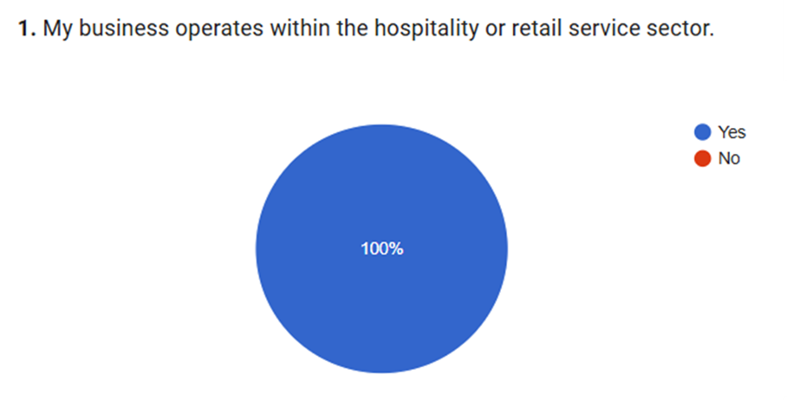
Figure 2: Business Type of the small businesses
According to the outcomes of the survey in Figure 2, the majority of people work in the hospitality or retail service industry. Among the total respondents, 100% businesses affirmed that they are a part of these sectors. The hospitality and retail enterprises usually have a great amount of waste and are often already influenced by the demands of energy efficiency, thus being the most applicable to the discussion on the ecological policies (OECD, 2018).
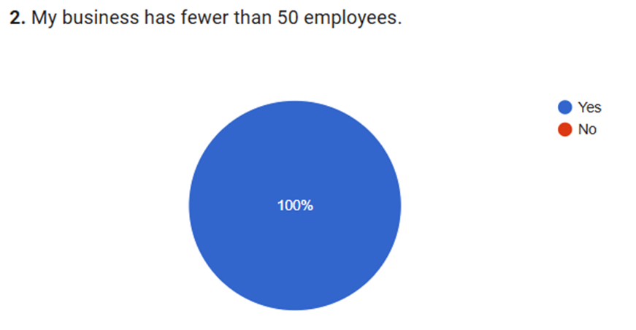
Figure 3: Business Characteristics of the Small Businesses
According to the results in Figure 3, the respondents are small business owners, and 100% of the respondents affirmed that they have fewer than 50 employees in their businesses. This is in line with the focus of the study, which deals with small businesses, which are, as per the UK criteria, small enterprises. Such uniformity in the profile of business size facilitates that the sample of the survey is significantly relevant in the context of the research aims, since small businesses encounter different difficulties in their ability to adhere to ecological policies because of the lack of resources (Omowole et al., 2024).
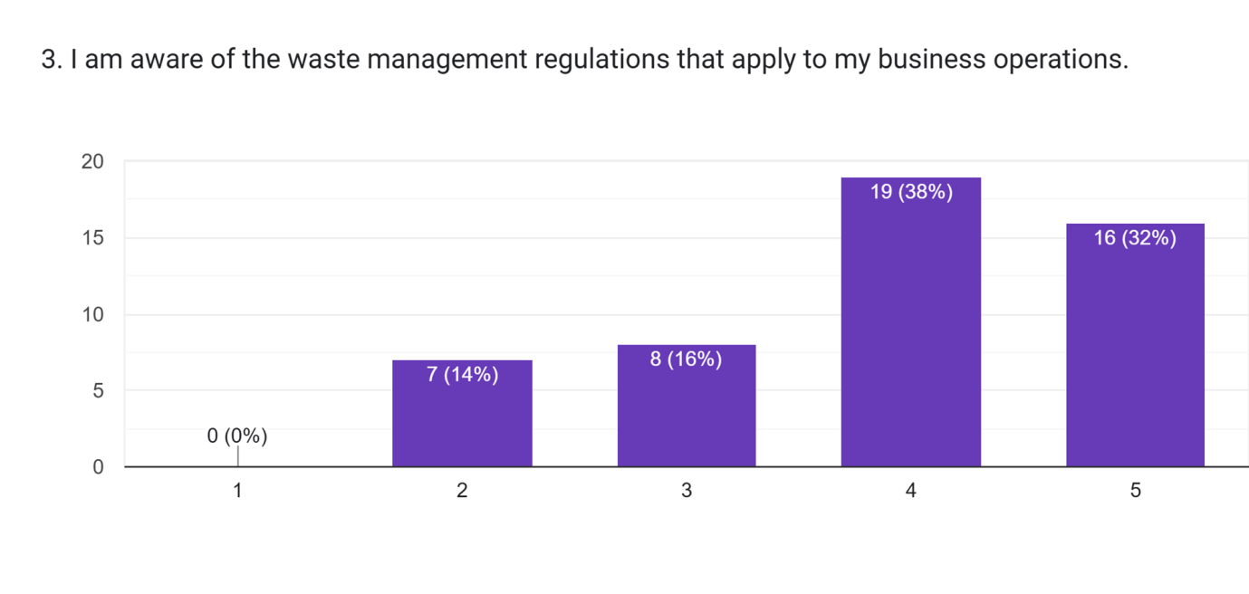
Figure 4: Awareness of Waste Management of Small Businesses
The statistics in Figure 4 indicate that the respondents were less aware of the level of waste management measures. Others, 38% (19 respondents), strongly stated that they were highly aware as they chose the top rating in (5), compared to 32% (16 respondents) who also affirmed that they were aware with the second-highest rating (4). Nevertheless, 16% (8 respondents) of the awareness was moderate (rating 3), and 14% (7 respondents) were low, and 26% chose rating 2. It is worth mentioning that there were no respondents who expressed their absolute lack of awareness (rating 1).
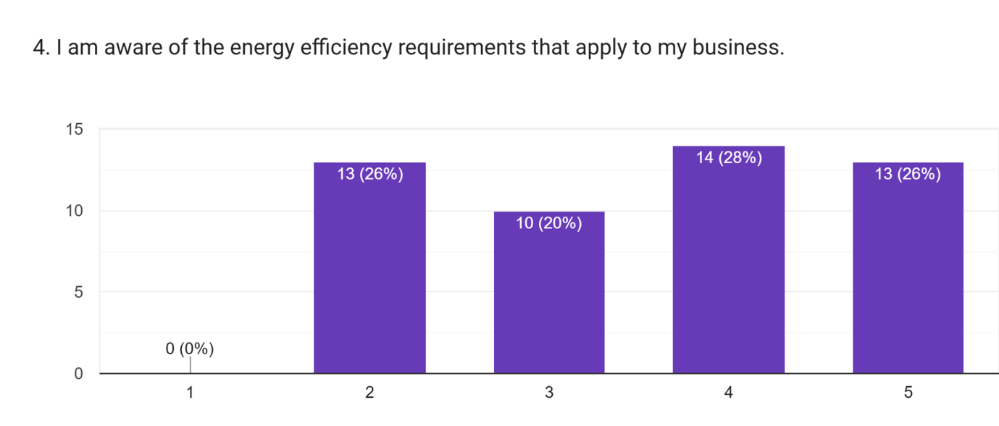
Figure 5: Awareness of energy efficiency of the Small Businesses
The responses in Figure 5 indicate that only 28% (14 respondents) and 26% (13 respondents) had high and good awareness, respectively, selecting the highest and second-highest ratings (5 and 4, respectively). 20% (10 respondents) had an indifferent awareness (rating of 3), so respondents expressed that they were aware of the requirement of energy efficiency. The remaining 26% (13 respondents) were less aware, as the ratings were 2.
This suggests that awareness of energy efficiency requirements is less consistent than awareness of waste-management rules. This may reflect differences in the visibility or communication of these policies, which supports the view in the literature review that small businesses do not always receive clear or accessible guidance.
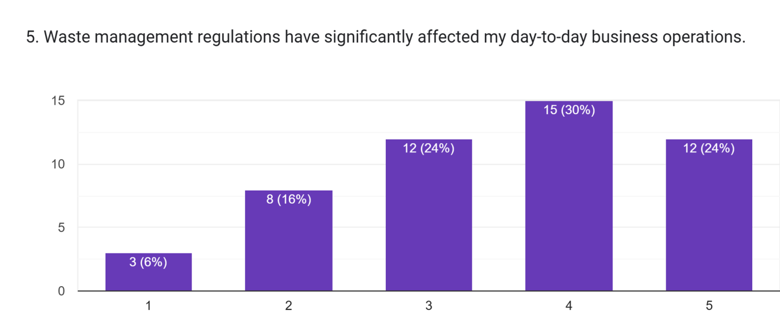
Figure 6: Effect of Waste Management Regulations on Small Businesses
The respondents in Figure 6 indicated that there is a great influence of waste management regulations on the day-to-day running of the small enterprises, with 30% (15 respondents) recording a high impact with a rating of 5 and 24% (12 respondents) or middle impact with a rating of 4. Another percentage of 24% (12 respondents) responded with a rating of 3, showing a neutral position. Nevertheless, 16% (8 respondents) made a low impact with a rating of 2, and only 6% (3 respondents) made an indication of no significant impact with a rating of 1.
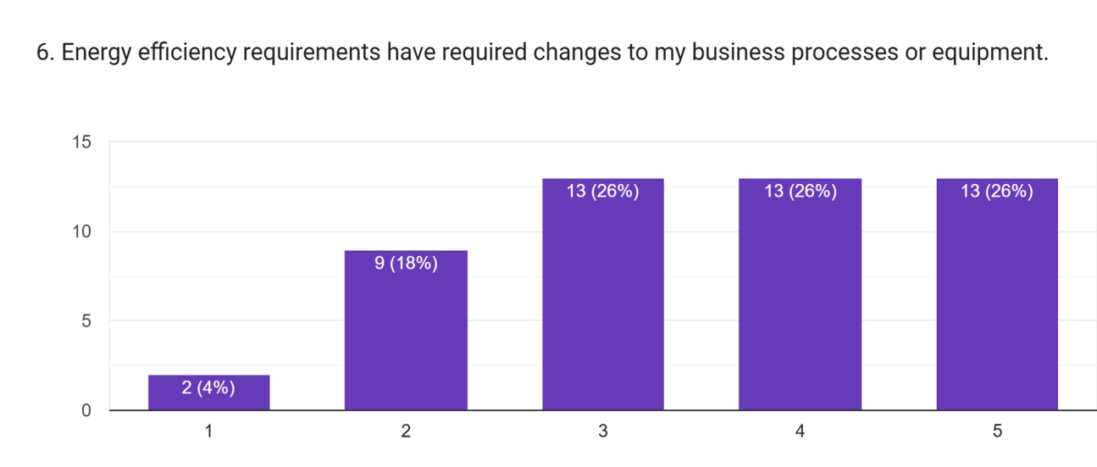
Figure 7: Change in Business Processes of the Small Businesses
The information in Figure 7 shows that the requirement of energy efficiency has a diverse effect on small businesses, with 26% (13) responding that the requirements demanded substantial alterations in their business procedures or gear and made decisions of rating 4 and 5. Nevertheless, 18% (9 respondents) also gave a neutral rating (3), which shows moderate changes, and the 4% (2 respondents) rated the impact to be minimal, selecting rating 1.
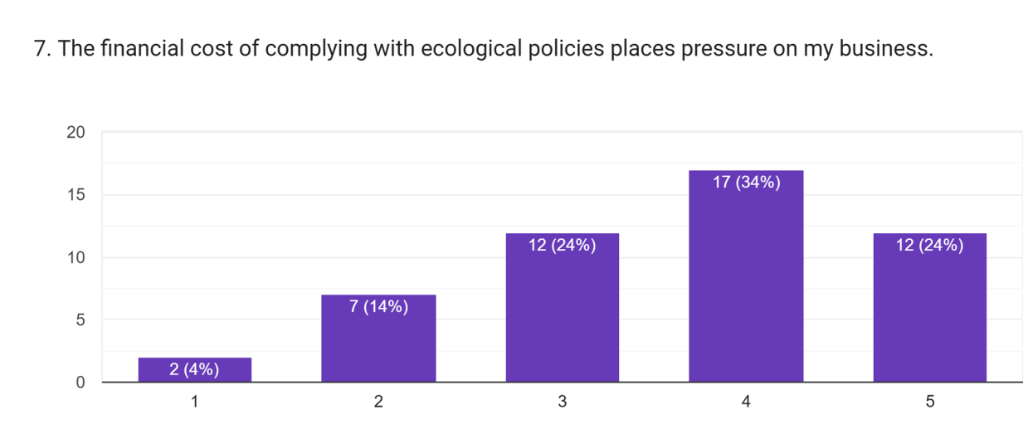
Figure 8: Financial Costs of the Small Businesses
It is indicated in Figure 8 that the financial effect of meeting ecological policies puts significant pressure on small businesses, as 34% percent (17 respondents) rated it high and 24% (12 respondents) rated it as extremely high. Also, 24% (12 respondents) chose a neutral position with a rating of 3, and 14% (7 respondents) selected a lower pressure (rating 2). A few percentage, 4% (2 respondents), said that they had a little financial strain, meaning they selected rating 1.
This pattern suggests that compliance is shaped strongly by cost sensitivity, which is consistent with the Resource-Based View discussed in the literature review. Small businesses with limited financial resources are less able to make substantial sustainability investments, even when regulatory pressure is present.
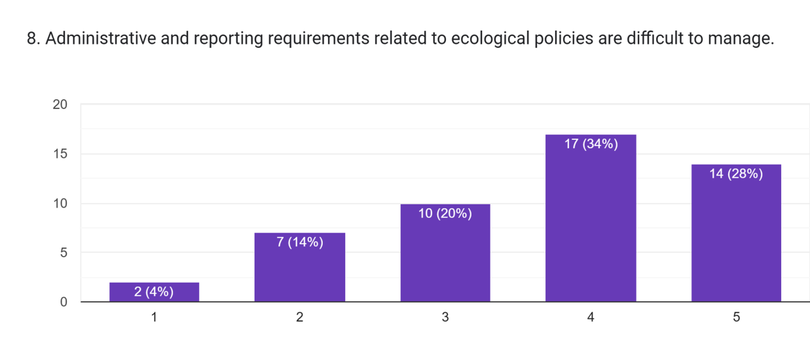
Figure 9: Administrative and reporting requirements of the Small Businesses
According to the data in Figure 9, small businesses are highly challenged with managing the administration and reporting needs in terms of the ecological policies; 34% (17 respondents) will regard managing such tasks as difficult, with a rating of 4, whereas 28% (14 respondents) will consider it as extremely difficult, with a rating of 5. But 14% (7 respondents) said that it was less challenging (rating 2), and 4% (2 respondents) declared the reporting requirements to be just easy to handle. This finding also supports the argument in the literature that ecological compliance can create a disproportionate burden for SMEs because they often lack specialist staff or administrative capacity.
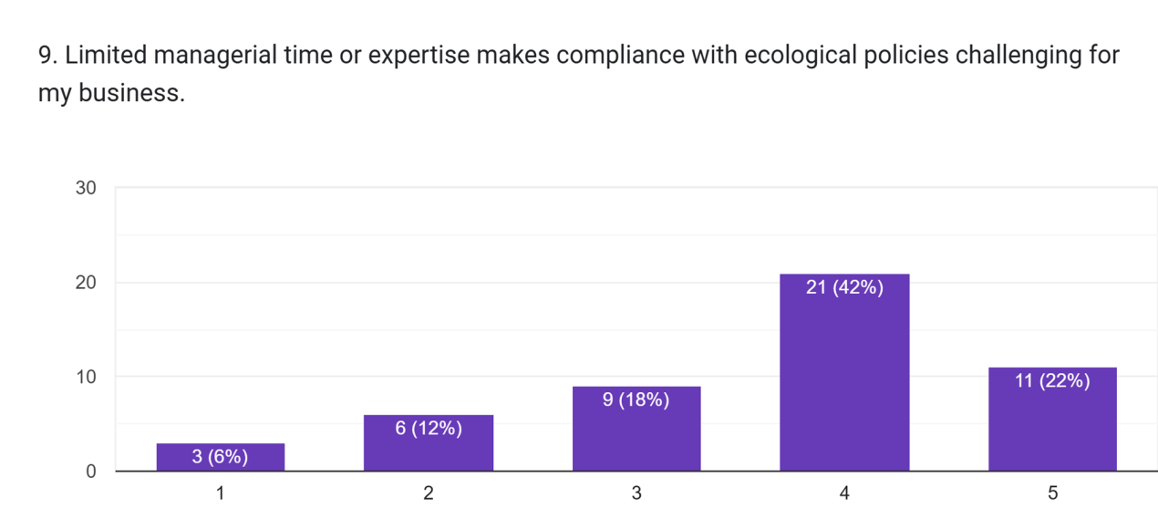
Figure 10: Time Management of the Small Businesses
The survey data in Figure 10 focuses on highlighting that a lack of managerial time/expertise is also a significant barrier to compliance with ecology policies, as 42% (21 respondents) of the respondents claimed that it is a very challenging experience as they learn to manage compliance, with 22% (11 respondents) choosing the highest rating (5) as well. His time/expertise considerations were also not a serious difficulty (rating 1), as only 6% (3 respondents) of them thought otherwise.
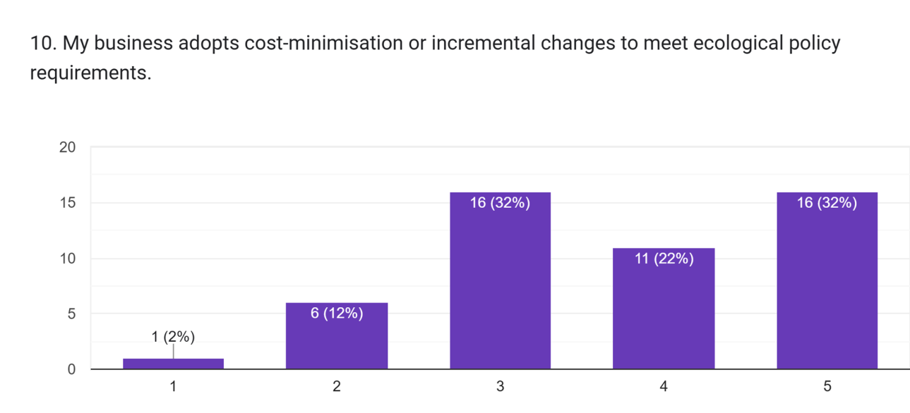
Figure 11: Cost minimisation of the Small Businesses
The information in Figure 11 reveals that cost-minimisation or incremental changes are used by the majority of small businesses to comply with the ecological policy 32% (16 respondents) chose the rating 4 and 5. The rest 32% (16 respondents) used a moderate strategy, and 24% (11 respondents) indicated that there were minimal changes, thus rating 3. The low-impact approach that was rated (2) was chosen by only 12% (6 respondents), and 2% (1 respondent) thought that no action needed to be taken in terms of cost-minimisation or incremental changes.
This indicates that many firms respond through low-cost and incremental adaptation rather than full sustainability integration, which aligns with the literature’s distinction between reactive compliance and proactive sustainability adoption.
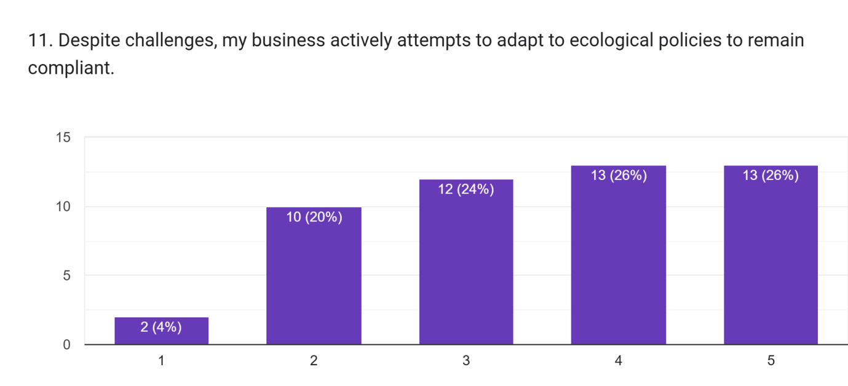
Figure 12: Attempts to adapt the Small Businesses
The findings in Figure 12 demonstrate that despite the number of problems, the small businesses in Northamptonshire are nonetheless trying hard to adapt to the ecological policies so that they can be compliant, with 26% (13 respondents) of the respondents selecting the highest ranking (5) being strong in their attempts, with 26% (13 respondents) also being moderate in the task. 24% (12 respondents) were uncertain and inconsistent in their adaptation efforts (rating 3), with 20% (10 respondents) also responding that they were not trying hard at all.This can be interpreted through Institutional Theory, as businesses appear motivated to meet external requirements, but their responses remain limited by internal capacity constraints. In this sense, compliance is often practical and reactive rather than strategic.

4.3 Findings
The results of the study indicate that awareness among businesses is generally high; nevertheless, the percentage of small companies that could use additional advice is limited.It can be inferred that although not all the small businesses are well informed about the energy efficiency requirements, most of the respondents are generally informed (Yannan et al., 2022).All in all, waste management regulations do affect most respondents in one way or another, but most of them have some level of disruption in their operations (Pratama et al., 2022).
On the whole, as most businesses had to make changes to operate, there is a significant segment where the energy efficiency demands did not affect the operation of the business materially (Revell et al., 2010). Such findings indicate a combination of active and tough adaptation.These results indicate that most of the small businesses are affected by compliance because of its financial burden, and a considerable percentage is affected differently (Yannan et al., 2022).
All in all, the issue of administrative strain seems to be an everyday challenge to small businesses as well (Pratama et al., 2022). This would indicate that small enterprises are frequently incapable of finding the required amounts of managerial resources to comply with the ecological policies (Sievers-Glotzbach and Tschersich, 2019). It means that on the one hand, cost-effective practices are being utilised quite often; on the other hand, a substantial number of companies are eager to implement more intensive changes (Welch et al., 2022).These findings indicate that despite the efforts being made by most businesses, there still exists an aspect in which proactive adaptation can be made better (Xie et al., 2023). Overall, the findings support the discussion in the literature review by showing that small businesses are influenced both by external regulatory pressure and by internal resource constraints, which helps explain why compliance is often uneven, cautious, and reactive rather than fully embedded in long-term business strategy.

4.4 Implications for Policymakers and Small Business Owners
The findings indicate that governments ought to formulate ecological regulations that can be tested on the scale of less robust companies. The reported requirements can be simpler, and financial assistance offered on specific aspects of sustainability would create more active practices and better compliance results. The findings also affect small business owners, who must acknowledge the need to implement sustainability gradually instead of responding to it according to the requirements. Simple energy-saving steps, raising awareness of support schemes, and investing in basic operating energy-saving systems can reduce long-term operational expenses.

4.5 Summary of Chapter 4
This chapter introduced the results of the survey among the small firms in Northamptonshire and discussed them. It pointed out the differences in the general awareness of the ecological policies, such as waste management and energy efficiency needs. It was found that, as the majority of the small businesses struggle to survive through operational and financial pressures brought by compliance, several small businesses choose to aim at minimising the cost or introducing far more incremental changes to comply with the ecological regulations (Pratama et al., 2022).

Chapter 5: Conclusions, Limitations & Recommendations

5.1 Introduction
This chapter sees the findings obtained in the process of the research synthesised, with the conclusions being made based on the purpose of the study and the key research question answered. It also shows the original contributions made to the study, its limitations, and gives recommendations on the practices and future studies.

5.2 Conclusions on Research Objectives
Objective 1: The research has established that the majority of the small businesses in Northamptonshire are conversant with the main ecological policies that influence them, especially policies involved in waste management and energy conservation. Nonetheless, not all businesses are fully aware of their responsibilities, as there are certain levels of awareness (Albitar et al., 2023).
Objective 2: The legislation of wastemanagement was observed to be more imposing on the day-to-day operations than the energy-efficiency regulations, particularly those of the hospitality and retail industry. The businesses were also not exempt when it came to energy efficiency requirements (Alkaraan et al., 2024).
Objective 3: The best impediments to compliance were financial and administrative ones, and the businesses raised concerns about the cost of waste management and energy efficiency measures. Difficulties were also expressed in the administrative burden,such as reporting and documenting (Biginas et al., 2022).
Objective 4: Small enterprises primarily use cost-reduction and gradual modifications to comply with the requirements of ecological policies. A marginal section of the business is also more proactive, as it adopts holistic sustainability within the business (Alkaraan et al., 2024).

5.3 Conclusions on Research Problem
The study supports that there are effects of ecological policies on the small businesses in Northamptonshire, which have great impacts on business operations, finances and management. Although most businesses have to contend with significant hardships, they usually take the policies into consideration, but act in a reactive and short-term compliance manner as opposed to long-term energy sustainability (Yannan et al., 2022). The ultimate interference of finances and administration is still the biggest obstacle towards successful compliance, and the idea that more support systems should be created (Zhang et al., 2023).

5.4 Summary of the Research Findings and Outcomes
The study confirms the fact that small businesses are affected by the ecological policies, especially the waste management and energy efficiency policies, in Northamptonshire. Though there is a general awareness, compliance with the same is hard because of financial and administrative stress (West Northamptonshire Council, 2026). Small businesses generally embrace lowbudgets, developed change as opposed to a more significant adaptation (Cox, 2024). The results bring to light the fact that compliance by businesses is a reactive behaviour directed by the present concerns, but not the long-term strategic objectives. On the whole, the research recommends the need to communicate better and provide more specific assistance to small companies to enable them to overcome these compliance issues (Biginas et al., 2022).This suggests that ecological policy compliance among small businesses is shaped less by resistance to sustainability itself and more by limited capacity to absorb regulatory, financial, and administrative pressures.

5.5 Academic and Practical Contribution of the Research
The study is relevant to the knowledge of the challenges peculiar to small businesses in receiving ecological policies in the local area, Northamptonshire. It provides fresh perspectives on the obstacles of financial strains, administrative load and low managerial capacity (OECD, 2018). This study, unlike much of the literature, is based on a small service-based business, which offers great information to policymakers and business support organizations (Hair et al., 2023). The results underline the necessity of policy provisions taking into consideration the low economic resources of small businesses, and provide viable suggestions on how the regulatory framework and provision of small firms may be enhanced (Miller et al., 2024).

5.6 Limitations of the Research
There are a number of limitations to this study. The 50 small business sample size is, however, enough to carry out an exploratory research work, but may not be representative of the small business population in the county of Northamptonshire. The study has been based on self-reported data, and this may cause bias. Also, the research is done in one locality, and thus it is not possible to generalise the results in other regions (Hair et al., 2023). Lastly, the study does not examine long-term business strategy or other long-term environmental implications of the operations of ecological policies, but only the immediate (Efobi et al., 2019).

5.7 Recommendations and Areas for Future Research
The findings suggest that clearer awareness assistance, such as providing information on the energy-efficiency requirements, grant programs, and reasonable compliance measures, should be offered to small businesses. Those making decisions can help reduce the reporting requirements of small enterprises by applying simplified compliance checklists, more understandable guidance forms, and smoother reporting processes (Bianchini and Croce, 2022).
Future research could expand the sample size, include businesses from other regions, and adopt a mixed-methods approach to explore both measurable patterns and in-depth business experiences (Alkaraan et al., 2024).Longitudinal research might also investigate the enduring impacts of the environmental policy adherence on business sustainability and financial prosperity, whereas comparative research across the counties would reveal whether the issues are peculiar to Northamptonshire or are even more ubiquitous (Blumberg and MacRae, 2024).

5.8 Summary of Chapter 5
The research leads to the evolution of the knowledge of how small businesses manage compliance with ecological policies, outlining the problems they experience and providing specific recommendations on how the policy can be better designed and supported. The results emphasise that specific support to small businesses is required so that the latter could be allowed to adhere to ecological policies without sacrificing their sustainability.

References
Abdelaziz, F.B., Chen, Y.T. and Dey, P.K. (2024) ‘Supply chain resilience, organizational well-being, and sustainable performance: A comparison between the UK and France’, Journal of Cleaner Production, 444.
Albitar, K. et al. (2023) ‘Business environmental innovation and CO2 emissions: The moderating role of environmental governance’, Business strategy and the environment, 32(4), pp. 1996–2007.
Alkaraan, F. et al. (2024) ‘Reinforcing green business strategies with Industry 4.0 and governance towards sustainability: Natural‐resource‐based view and dynamic capability’, Business Strategy and the Environment, 33(4), pp. 3588–3606. Available at: https://doi.org/10.1002/bse.3665.
Babajide, A. et al. (2023) ‘Financial literacy, financial capabilities, and sustainable business model practice among small business owners in Nigeria’, Journal of Sustainable Finance & Investment, 13(4), pp. 1670–1692. Available at: https://doi.org/10.1080/20430795.2021.1962663.
Belitski, M. et al. (2022) ‘Economic effects of the COVID-19 pandemic on entrepreneurship and small businesses’, Small Business Economics, 58(2), pp. 593–609. Available at: https://doi.org/10.1007/s11187-021-00544-y.
Bell, E., Bryman, A. and Harley, B. (2018) Business Research Methods. 5th edn. London: Oxford University Press.
Bianchini, R. and Croce, A. (2022) ‘The role of environmental policies in promoting venture capital investments in cleantech companies’, Review of Corporate Finance, 2(3), pp. 587–616. Available at: https://doi.org/10.1561/114.00000024.
Biginas, K. et al. (eds) (2022) Small business management and control of the uncertain external environment. Bingley: Emerald Publishing.
Blumberg, B. and MacRae, C. (2024) EBook: Business Research Methods 5e. New York, NY, USA: McGraw-Hill.
Brännback, M., Carsrud, A. and Hechavarria, D. (2025) Handbook of research methods and applications in entrepreneurship and small business. Edward Elgar Publishing.
Bryman, A. and Bell, E. (2015) Business Research Methods. 4th edn. London: Oxford University Press.
Caglar, A.E. (2023) ‘Can nuclear energy technology budgets pave the way for a transition toward low-carbon economy: insights from the United Kingdom’, Sustainable Development, 31(1), pp. 198–210.
Cox, S. (2024) SME divide revealed on environmental targets, Northamptonchron.co.uk. Available at: https://www.northantstelegraph.co.uk/business/sme-divide-revealed-on-environmental-targets-4861246 (Accessed: 20.02.2026).
Efobi, U. et al. (2019) ‘Environmental pollution policy of small businesses in Nigeria and Ghana: extent and impact’, Environmental science and pollution research, 26, pp. 2882–2897.
Hair, J., Jr et al. (2023) Essentials of Business Research Methods. 5th edn. London: Routledge.
Hillary, R. (ed.) (2017) Small and medium-sized enterprises and the environment: Business imperatives. London: Routledge.
Jones, S., Krzywoszynska, A. and Maye, D. (2022) ‘Resilience and transformation: Lessons from the UK local food sector in the COVID‐19 pandemic’, The Geographical Journal, 188(2), pp. 209–222. Available at: https://doi.org/10.1111/geoj.12428.
Lin, Z. et al. (2024) ‘Impact of green work–life balance and green human resource management practices on corporate sustainability performance and employee retention: Mediation of green innovation and organisational culture’, Sustainability, 16(15), p. 6621. Available at: https://doi.org/10.3390/su16156621.
Miller, S.R., Moore, F. and Eden, L. (2024) ‘Ethics and international business research: Considerations and best practices’, International Business Review, 33(1).
NNBN (2025) Northamptonshire businesses unite to slash website carbon footprints, NNBN - Supporting Business Growth. NNBN Ltd. Available at: https://nnbn.co.uk/northamptonshire-businesses-unite-to-slash-website-carbon-footprints/ (Accessed: 20.02.2026).
North Northamptonshire Council (2025) Sustainability in business, Gov.uk. Available at: https://www.northnorthants.gov.uk/sustainability-business (Accessed: 20.02.2026).
OECD (2018) OECD green growth studies environmental policy toolkit for SME greening in EU Eastern Partnership countries. OECD Publishing.
Olekanma, O. et al. (2024) ‘Small-and medium-sized enterprises’ carbon footprint reduction initiatives as a catalyst for green jobs: A systematic review and comprehensive business strategy agenda’, Business Strategy and the Environment, 33(7), pp. 6911–6939.
Omowole, B.M. et al. (2024) ‘Conceptualizing green business practices in SMEs for sustainable development’, International Journal of Management & Entrepreneurship Research, 6(11), pp. 3778–3805.
Pratama, F.C. et al. (2022) ‘Visualization of green business research around the world over two decades: a bibliometric perspective’, in Proceedings of the International Conference on Industrial Engineering and Operations Management.
Revell, A., Stokes, D. and Chen, H. (2010) ‘Small businesses and the environment: turning over a new leaf?’, Business strategy and the environment, 19, pp. 273–288.
Sievers-Glotzbach, S. and Tschersich, J. (2019) ‘Overcoming the process-structure divide in conceptions of Social-Ecological Transformation’, Ecological Economics: The Journal of the International Society for Ecological Economics, 164(106361), p. 106361. Available at: https://doi.org/10.1016/j.ecolecon.2019.106361.
Skinner, J. et al. (2024) Research methods for sport management. 2nd edn. London: Routledge.
Welch, C. et al. (2022) ‘Reconciling theory and context: How the case study can set a new agenda for international business research’, Journal of International Business Studies, 53(1), pp. 4–26.
West Northamptonshire Council (2026) Local businesses and Council working together to improve Northampton town centre, Gov.uk. Available at: https://www.westnorthants.gov.uk/news/local-businesses-and-council-working-together-improve-northampton-town-centre (Accessed: 11.02.2026).
Xie, B.-C., Stucchi, K.A. and Li, H.-Z. (2023) Economics and policies in formulating renewable power development plans. Frontiers Media.
Yannan, D. et al. (2022) ‘Impact of CSR, innovation, and green investment on sales growth: new evidence from manufacturing industries of China and Saudi Arabia’, Economic Research-EkonomskaIstraživanja, 35(1), pp. 4537–4556. Available at: https://doi.org/10.1080/1331677x.2021.2015610.
Zhang, A. et al. (2023) ‘Carbon neutrality drivers and implications for firm performance and supply chain management’, Business Strategy and the Environment, 32(4), pp. 1966–1980. Available at: https://doi.org/10.1002/bse.3230.

Terms of Glossary
Ecological Policies
Regulations aimed at reducing environmental impact through sustainability measures, such as waste management and energy efficiency.
Energy Efficiency
Practices or technologies that reduce energy use while maintaining operational output.
Operational Impact
The effect of regulations on daily business activities and processes.
Resource Constraints
Limitations in financial, managerial, or technical resources affecting business operations.
Small Business
An enterprise employing fewer than 50 employees.
Waste Management
The handling, segregation, and disposal of waste in line with regulatory requirements.

Appendices

Appendix A: Survey Questionnaire
Q1. My business operates within the hospitality or retail service sector.
- Yes
- No
Q2. My business has fewer than 50 employees.
- Yes
- No
Q3. I am aware of the waste management regulations that apply to my business operations.
(1 = Strongly disagree, 2 = Disagree, 3 = Neutral, 4 = Agree, 5 = Strongly agree)
Q4. I am aware of the energy efficiency requirements that apply to my business.
(1 = Strongly disagree, 2 = Disagree, 3 = Neutral, 4 = Agree, 5 = Strongly agree)
Q5. Waste management regulations have significantly affected my day-to-day business operations.
(1 = Strongly disagree, 2 = Disagree, 3 = Neutral, 4 = Agree, 5 = Strongly agree)
Q6. Energy efficiency requirements have required changes to my business processes or equipment.
(1 = Strongly disagree, 2 = Disagree, 3 = Neutral, 4 = Agree, 5 = Strongly agree)
Q7. The financial cost of complying with ecological policies places pressure on my business.
(1 = Strongly disagree, 2 = Disagree, 3 = Neutral, 4 = Agree, 5 = Strongly agree)
Q8. Administrative and reporting requirements related to ecological policies are difficult to manage.
(1 = Strongly disagree, 2 = Disagree, 3 = Neutral, 4 = Agree, 5 = Strongly agree)
Q9. Limited managerial time or expertise makes compliance with ecological policies challenging for my business.
(1 = Strongly disagree, 2 = Disagree, 3 = Neutral, 4 = Agree, 5 = Strongly agree)
Q10. My business adopts cost-minimisation or incremental changes to meet ecological policy requirements.
(1 = Strongly disagree, 2 = Disagree, 3 = Neutral, 4 = Agree, 5 = Strongly agree)
Q11. Despite challenges, my business actively attempts to adapt to ecological policies to remain compliant.
(1 = Strongly disagree, 2 = Disagree, 3 = Neutral, 4 = Agree, 5 = Strongly agree)

Appendix B:
Participation Consent Form
University of Wales Trinity Saint David (London Campus)
Winchester House
11 Cranmer Road
London – SW9 6EJ
Tel: +442075667600
Email: info.london@uwtsd.ac.uk
londonstudentservice@uwtsd.ac.uk



RhifAdnabodCyfranogwr:
Participant Identification Number:
FFURFLEN GANIATÂD CYFRANOGIAD | PARTICIPATION CONSENT FORM
Teitl Y Prosiect: /Project Title:
Enw'rYmchwilydd / Name of Researcher:

1 | I confirm that I have read and understand the information sheet dated _________for the above study. I have had the opportunity to consider the information, ask questions and have had these answered satisfactorily.
2 | I understand that my participation is voluntary and that I am free to withdraw at any time, without giving any reason.
3 | I understand that any information given by me may be used in future reports, articles or presentations by the research team.
4 | I understand that my name will not appear in any reports, articles or presentations.
5 | I agree to take part in the above study.
Name of Participant |  |  | Signature
Researcher |  |  | Signature

You may decline to participate in this study. You may end your participation in this study at any time. If you decide to remain anonymous, maintaining your anonymity will be a priority and every practical precaution will be taken to disguise your identity. If you prefer anonymity, there will not be any identifying information on audiotapes or transcripts of this or any interview. No one will hear any audiotapes or see any transcripts without your prior consent. All materials generated from this or any interview will remain confidential.
When completed please return in the envelope provided. One copy will be given toyou and the original to be kept on the file of the research team at:

NAME & ADDRESS OF RESEARCHER
University of Wales Trinity Saint David (London Campus)
Winchester House
11 Cranmer Road
London – SW9 6EJ
Tel: +442075667600
Email: info.london@tsd.ac.uk
londonstudentservice@tsd.ac.uk

Appendix C:
Participant Information Sheet
University of Wales Trinity Saint David (London Campus)
Winchester House
11 Cranmer Road
London – SW9 6EJ
Tel: +442075667600
Email:info.london@tsd.ac.uk
londonstudentservice@tsd.ac.uk


RhifAdnabodCyfranogwr:
Participant Identification Number:
FFURFLEN GANIATÂD CYFRANOGIAD | SAMPLE PARTICIPANT INFORMATION SHEET
Teitl Y Prosiect: /Project Title:

Dear Sir/Madam,

My name is ………………………..and I am a ………………………..student in the School of Business, Finance and Management (London Campus), Faculty of Business and Management in University of Wales Trinity Saint David, United Kingdom. At present, I am conducting a research on………………………... The purpose of this research is to ………………………..

I would like to invite you to participate in my research project by answering the attached short questions developed by the researchers. Those questions will assess your opinions, experiences, knowledge, suggestions and views. Through your participation in the interviews, I hope to ascertain my research purpose to get the best opinion from you. I believe your opinion will be extremely helpful to me to carry out this research.

All questions will be kept strictly confidential to the researchers involved and at NO time will individualquestions will be released to the general public. This gives you a chance to express your views on your programme a confidential and anonymous forum and still be able to make a difference. Your participation in thisstudy is completely voluntary so you can withdraw from the questionnaire at any stage.

Please note, questionnaire should take no more than 30 minutes to complete but however, there is no time constraint. There are alsono right or wrong answers. Attached to this letter along with the questionnaire there is a consent form where you will better understand researchers intension As this is a new project, your feedback is also important to me and I would bemuch obliged if you could also complete the feedback sheet along with the questionnaire. I understand thatyour time is at a premium, but your opinions are very valuable to me.
After careful and precise analysis of the data obtained from this questionnaires/interviews, I will be happy to provide youwith a copy of the findings at your request. The results of this questionnaire will hopefully enhance my understanding of current level of knowledge and future findings. The results of the research will be feedback to Director of Studies, Supervisor, University and British Library.

I thank you in advance for your time and participation. If any questions do arise, feel free to contact me at your convenience.
NAME & ADDRESS OF RESEARCHER
University of Wales Trinity Saint David (London Campus)
Winchester House
11 Cranmer Road
London – SW9 6EJ
Tel: +442075667600
Email: info.london@tsd.ac.uk
londonstudentservice@tsd.ac.uk

Appendix D:
APPLICATION FOR ETHICAL APPROVAL – INTRODUCTORY NOTES

In order for research to result in benefit and minimise risk of harm, it must be conducted ethically. A researcher may not be covered by the University’s insurance if ethical approval has not been obtained prior to commencement.
The University follows the OECD Frascati manual definition of research activity:
“[C]reative work undertaken on a systematic basis in order to increase the stock of knowledge, including knowledge of man, culture and society, and the use of this stock of knowledge to devise new applications”.
As such this covers activities undertaken by:
- Members of staff (academic staff or support staff);1
- Individuals holding honorary title from the University;
- Postgraduate research students;
In all of these cases ethical review is required regardless of discipline.
The individual undertaking the research activity is known as the lead researcher.
Ethical approval is not required for routine audits, performance reviews, quality assurance studies, testing within normal educational requirements, and literary or artistic criticism.
For most projects you will only need to complete sections in the main part of the form. A few projects will need more detailed ethical consideration and will need you to fill in sections in an appendix. At some points in this form you will be asked questions about your research in the following way:
1 | Does your research involve <<something specific>>? | YES | Click to continue to appendix <<N>> | NO √ | Continue to the next section
2 | Have you completed appendix <<N>>? | YES | ☐ | NO | ☐

Clicking in the appropriate box will take you to the appropriate location in the text. At the end of each appendix is a box. Clicking on this will return you to the question that originally took you to the appendix.

Return to the main form

NB These clickable links will only work if you are editing the document in the desktop version of Word, not the browser version. Please download and save the form before editing it.

Guidance notes are provided as comments or as text IN GREEN throughout this form. Please ensure that the comments are removed and that the green text is replaced by your own text or removed as appropriate BEFORE submitting this form.

Please ensure that you have read the UWTSD Research Ethics and Integrity Policy and the UWTSD Research Data Management Policy BEFORE submitting this form.

APPLICATION FOR ETHICAL APPROVAL
SECTION A: About You (Lead Researcher)
1 | Full Name: |  | Borislav Nenkov
2 | Tick all boxes that apply: |  | Member of staff: |  | ☐ | Honorary research fellow: |  | ☐
2 | Undergraduate Student | √ | Taught Postgraduate Student |  | ☐ | Postgraduate Research Student |  | ☐
3 | Institute/Academic Discipline/Centre: |  | University of Wales Trinity Saint David
4 | Campus: |  | London
5 | E-mail address: |  | 2242940@student.uwtsd.ac.uk
6 | Contact Telephone Number: |  | 07378658347
7 | Project Title |  | The Impact of Ecological Policies on Small Businesses in the UK-Northamptonshire: Overcoming Struggles to Achieve Sustainability
8 | Proposed Start Date |  | 01.02.2026 | Proposed End Date |  |  | 10.04.2026
For students:
9 | Student Number: |  | 2242940
10 | Programme of Study: |  | BA Business Management
11 | Director of Studies/Supervisor: |  | Mr. Afzal Munna

SECTION B: Grant or Contract Funding
1 | Has your research been awarded, applied for, or intend to apply for external funding? | YES | Click to continue to appendix 1 | NO √ | Continue to the next section
2 | Have you completed appendix 1? | YES | ☐ | NO | ☐

SECTION C: Internal and External Ethical Guidance Materials
Ethical Guidance Documents
Please list the core ethical guidance documents that have been referred to during the completion of this form (including any discipline-specific codes of research ethics, location-specific codes of research ethics, and also any specific ethical guidance relating to the proposed methodology). Please tick to confirm that your research proposal adheres to these codes and guidelines. You may add rows to this table if needed.
1 | UWTSD Research Ethics & Integrity Policy | √
2 | UWTSD Research Data Management Policy | √
3 | UWTSD Open Access Publications Policy | √
4 | UWTSD Export Control Policy  Required ifAppendix 8completed | ☐
5 | UWTSD Trusted Research and Innovation Policy  Required if research is taking place outside the UK | ☐
6 | [List any other relevant documents here] | ☐

SECTION D: External Collaborative Research Activity
1 | Does your research involve collaborating partners at another institution or organisation? | YES | Click to continue to appendix 2 | NO √ | Continue to the next section
2 | Have you completed appendix 2? | YES | ☐ | NO | ☐

SECTION E: Details of Research Activity
Aims, Vision and Approach of the Research (maximum 200 words per section)
Please outline what are you hoping to achieve with your proposed work and how will you deliver it?
1 | Research aims and objectives
Aim - To investigate how ecological policies affect small businesses in Northamptonshire and how small firms cope with the issues concerning sustainability compliance
Objectives:
- To determine the ecological policies applicable to the small businesses in Northamptonshire.
- To investigate the impact of waste-management laws and energy-saving demands on the operational activities of small businesses.
- To examine financial challenges, administrative challenges, and logistical challenges in the process of compliance of small businesses.
- To investigate the approaches employed by small businesses to get through the sustainability-related strains.
2 | Vision
- This research has an important role in enabling small companies to cope with challenges and achieve sustainable development
- It has the potential to improve the understanding of small businesses in dealing with constraints, as well as the prerequisites for development by finding a solution to these constraints
- In view of the increasing requirements related to environmental protection, this research is in response and in the context of these requirements
- It provides an opportunity to improve the environment, while also leading to a favorable economic situation for small businesses

3 | Approach
This study used a quantitative research approach to examine how ecological policies affect Northamptonshire's small enterprises. Since it enables the systematic quantification of perceptions, experiences, and reported behaviours on a bigger sample than would be feasible with a qualitative approach, the quantitative method will be suitable.
The study relies on the numerical data to make generalisable conclusions concerning the actualities of the operation of the small firms

4 | Location of research activity  Identify all locations where research activity will take place.
United Kingdom, Northamptonshire

5 | Will any of your research be undertaken outside of the UK? | YES | Click to continue to appendix 3 | NO √ | Continue to the next section
6 | Have you completed any of appendix 3? | YES | ☐ | NO | ☐

SECTION F:Research Methods
Will the research activity include: |  | YES | NO
1 | Use of a questionnaire or similar research instrument? | √ | ☐
2 | Use of interviews? | ☐ | √
3 | Use of focus groups? | ☐ | √
4 | Use of participant diaries? | ☐ | √
5 | Use of video or audio recording? | ☐ | √
6 | Use of computer-generated log files? | ☐ | √
7 | Participant observation with their knowledge? | ☐ | √
8 | Participant observation without their knowledge? | ☐ | √
9 | Access to personal or confidential information without the participants’ specific consent? | ☐ | √
10 | Administration of any questions, test stimuli, presentation that may be experienced as physically, mentally or emotionally harmful / offensive? | ☐ | √
11 | Performance of any acts which may cause embarrassment or affect self-esteem? | ☐ | √
12 | Investigation of participants involved in illegal activities? | ☐ | √
13 | Use of procedures that involve deception? | ☐ | √
14 | Administration of any substance, agent or placebo? | ☐ | √
15 | Working with live vertebrate animals? | ☐ | √
16 | Procedures that may have a negative impact on the environment? | ☐ | √
17 | Other primary data collection methods. Please indicate the type of data collection method(s) below. | ☐ | √
Details of any other primary data collection method |  | ☐ | √

SECTION G: Research Participants

Research participants include people who will be taking part in your research as providers of research data (e.g. being interviewed, answering questionnaires, or doing user testing of hardware or software). This includes animal participants.
1 | Does your research involve human or non-human participants? | YES √ | Continue this section | NO | Click to continue to section N

Participant numbers and source
How will you ensure an appropriately convened sample group in order to meet the aims of the research? Give details for subgroups separately, if appropriate. How will any potential pitfalls, for example dual roles or potential for coercion, be addressed?
1 | How many participants will be recruited and how was the number decided upon? | For more reliable information and interpretation of the data, the number of participants should be over 20.
2 | Who will the participants be? | Independent cafes, coffee shops, takeaways, small restaurants and retail outlets
3 | How will you identify the participants? | Through direct observations related to my work
4 | Will you be excluding any groups of people, and if so what is the rationale for that? | No
5 | Will the research involve any element of deception? If yes, please describe why this is necessary and whether participants will be informed at the end of the study | No
6 | Describe whether participants will be able to withdraw from the study, and up to what point (eg if data is to be anonymised). If withdrawal is not possible, after a certain point, explain why not. | Yes, participants will be able to withdraw at any time if they wish.
7 | How long will the participant have to decide whether to take part in the research? | The Researcher will complete the data collection by the end of February 2026
8 | What arrangements have been made for participants who might have difficulties understanding verbal explanations or written information, or who have particular communication needs that should be taken into account to facilitate their involvement in the research? | No verbal communication, just a form  Simplified Language, using an online translator

SECTION H: Research with Vulnerable People
1 | Are your participants classed as vulnerable people? | YES | Click to continue to appendix 4 | NO √ | Continue to the next section
2 | Have you completed appendix 4? | YES | ☐ | NO | ☐

SECTION I:Research Involving Animals
1 | Are your participants non-human animals? | YES | Click to continue to appendix 5 | NO √ | Continue to the next section
2 | Have you completed appendix 5? | YES | ☐ | NO | ☐

SECTION J:Research with the Prison Service or the Probation Service
1 | Are your participants staff or offenders within the Prison Service or the Probation service? | YES | Click to continue to appendix 6 | NO √ | Continue to the next section
2 | Have you completed appendix 6? | YES | ☐ | NO | ☐

SECTION K:Health and Social Care Research
1 | Are your participants selected due to their health or social care needs? | YES | Click to continue to appendix 7 | NO √ | Continue to the next section
2 | Have you completed appendix 7? | YES | ☐ | NO | ☐

SECTION L:Types of Personal Data
Personal Data  Does the research activity involve personal data (as defined by the General Data Protection Regulation 2016 and the Data Protection Act 2018)? |  | YES | NO
1 | Personal data means any information relating to an identified or identifiable natural person (‘data subject’). An identifiable natural person is one who can be identified, directly or indirectly, in particular by reference to an identifier such as a name, an identification number, location data, an online identifier or to one or more factors specific to the physical, physiological, genetic, mental, economic, cultural or social identity of that natural person. Any video or audio recordings of participants and transcription of such are considered to be personal data. | ☐ | √
1 | If you ticked YES, provide a description of the data and explain why this data needs to be collected: | ☐ | √

Special Category Data  Does the research involve the processing of special category data (as defined by the General Data Protection Regulation 2016 and the Data Protection Act 2018)? |  |  | YES |  | NO
2 | Racial or ethnic origin |  | ☐ |  | √
3 | Political opinions |  | ☐ |  | √
4 | Religious or philosophical beliefs |  | ☐ |  | √
5 | Genetic, biometric or health data |  | ☐ |  | √
6 | Sex life or sexual orientation |  | ☐ |  | √
7 | Trade union membership |  | ☐ |  | √
If you ticked YESto any of questions L2-L7, provide a description of the data and explain why this special category data needs to be collected to support the research and that it is in the public interest to do so:
8
9 | Please describe how the research has been designed to gather the minimum amount of personal data necessary for the specified research purpose:
10 | Demonstrate that the processing is not likely to cause substantial damage or distress to individuals and that their interests will be safeguarded:
Researcher will use anonymous survey questionnaire, and no personal data will be collected
11 | Demonstrate that the data will not be used to take any action or make decisions in relation to the individuals concerned:
The data will be used only for the dissertation; no other action will be taken.
12 | Data should be anonymised wherever possible, either at point of capture or once collated. If the data cannot be anonymised, and if pseudonymisation is not possible, demonstrate why the that is possible. If special category data cannot be anonymised, explicit consent to share that data must normally be obtained.
Data will be anonymised
13 | If special category data cannot be anonymised, will you obtain explicit consent to share that data? | YES |  | NO |  | N/A
13 |  | ☐ |  | ☐ |  | √

SECTION M: Participant Information and Consent

Information for participants  It is normally expected that those participating in research should do so having given their informed consent. If this is not appropriate or practical, explicit justification must be provided, in line with prevailing disciplinary conventions. Please note however, that informed consent to participate in the research is separate from consent to process (e.g. collect, analyse, store, reuse or share) personal data, as the University’s lawful basis for processing personal data in research activities is part of its ‘public task’. |  | YES |  | NO |  | N/A
1 | Will you obtain written consent for participation? | √ |  | ☐ |  | ☐
2 | Will you describe the main research procedures to participants in advance, so that they are informed about what to expect? | √ |  | ☐ |  | ☐
3 | Will you tell participants that their participation is voluntary? | √ |  | ☐ |  | ☐
4 | Will you explain to participants that refusal to participate in the research will not affect their treatment or education (if relevant)? | √ |  | ☐ |  | ☐
5 | If the research is observational, will you ask participants for their consent to being observed? | ☐ |  | ☐ |  | √
6 | Will you tell participants that they may withdraw from the research at any time and for any reason? | √ |  | ☐ |  | ☐
7 | Will participants be made aware of how you will treat any information that may reasonably by considered as confidential? | √ |  | ☐ |  | ☐
8 | If your research requires your participants to sign up for a service provided by an external company or organisation will you inform them that their data may be stored and processed outside UWTSD? | ☐ |  | ☐ |  | √
9 | Will you give participants the UWTSD Privacy Notice for Research? | √ |  | ☐ |  | ☐
If you have answered NO to any ofquestions M1-M8, please provide justification detailing why this is necessary for the research.
10
Informed consent: Describe the arrangements to inform potential participants, before providing consent, of what is involved in participating. Describe the arrangements for participants to provide full consent before the research begins. If gaining consent in this way is inappropriate, explain how consent will be obtained and recorded.
11 | All the participants will be provided all the information of the study before they join the research, full consent will be obtained
Confidentiality: Confidential information refers to information that can be related to an identifiable individual, whether living or deceased, which is not in the public domain and which is given with the expectation that it will be kept confidential. Under Common Law when an individual entrusts a researcher or research team with confidential information, the team must handle this in line with ‘reasonable expectations’. In other words, confidential information should only normally be shared when there would be ‘no surprises’ for the individuals concerned. Where participants would not expect the researcher to be sharing their confidential information with others, researchers can manage their expectations by informing them of their intentions (e.g. in the participant information sheet or during discussions about participation) and asking them if they are happy with these plans. They should understand what is being proposed and what this might mean for them, before they decide whether the researcher can share their confidential information with others.
Please detail how you will treat confidential information:
12 | The data set (collected data) will be stored confidentially and will not be shared with any third party, and the data will be stored in UWTSD personal one drive folder that is password protected. Questionnaire will not include any questions to collect personal data from the participants
Copies of any written consent form, written information and all other explanatory material should accompany this application. If you have included these then please list the documents included here.
13 | Sample information sheets and consent forms are available from the University ethical review intranet page at https://intranet.uwtsd.ac.uk/research/research-integrity-and-ethics
14 | Consent form attached? |  | YES  √ |  | NO  ☐ |  | N/A  ☐

SECTION N: Research with Potential Military Application
1 | Does your research have any potential military application? | YES | Click to continue to appendix 8 | NO √ | Continue to the next section
2 | Have you completed appendix 8? | YES | ☐ | NO | ☐

SECTION O: Use of Artificial Intelligence Tools
Use of generative AI and other AI-based tools  There are a number of ethical issues relating to the use of generative AI and other AI-based tools, including data security, output bias, and output errors. In general you should assume that any generative AI or other AI-based tool that you pay to use is more secure and accurate than one which is free to use.  Will the research use AI tools to do any of the following: |  | YES | NO | N/A
1 | Capture data? | ☐ | √ | ☐
2 | Generate and/or edit text? | ☐ | √ | ☐
3 | Generate graphics? | ☐ | √ | ☐
4 | Generate video? | ☐ | √ | ☐
5 | Generate sound/music? | ☐ | √ | ☐
6 | Generate code? | ☐ | √ | ☐
7 | Generate synthetic data? | ☐ | √ | ☐
8 | Analyse data? | ☐ | √ | ☐
9 | Analyse personal or sensitive data? | ☐ | √ | ☐
10 | Classify data? | ☐ | √ | ☐
11 | Do you intend to use the free version of any AI tools? | ☐ | √ | ☐
If you have answered YES to any of questions O1-O11, please provide justification detailing why this is necessary for the research.
12

Section P: Research Data Management Plan

1 | Data Summary
The research will generate primary quantitative data
2 | Responsibilities
The lead researcher (the student) will be responsible for data collection, storage, management, and analysis under the supervision of the dissertation supervisors.
3 | Assessment of existing data
The study will use secondary data from academic journals and industry reports for the literature review
4 | Management and curation of data
The researcher will use PC to store and analyse the data
5 | Quality assurance of data
The researcher will follow UWTSD ethical code of conduct
6 | Short-term data storage
Personal computer password protected
7 | Long-term data storage and preservation
Data will be stored only until dissertation results are released
8 | Documentation and metadata
Not applicable
9 | Data sharing
The researcher will no share data with anyone
10 | Copyright and intellectual property ownership
The copyright and intellectual property of the data generated will belong to the researcher and the University, in accordance with UWTSD policies.
11 | Resources
Not applicable

SECTION Q: Risk Assessment

Outline any anticipated risksthat may adversely affect any of the participants, the researchers and/or the University, and the steps that will be taken to address them.

If you have completed a full risk assessment (for example as required by a laboratory, or external research collaborator) you may append that to this form.
1 | Full risk assessment completed and appended? |  | YES | NO
1 |  |  | ☐ | √
Risks to participants, researchers, and the University
2 | Social risks: disclosures that could affect participants standing in the community, in their family and their job. |  | YES | NO
2 |  |  | ☐ | √
Risk: |  | How will youaddress any risks?
3 | Legal risks: activities that could result in the participant, researchers and / or University committing an offence; activities that might lead to a participant disclosing criminal activity to a researcher which would necessitate reporting to enforcement authorities; activities that could result in a civil claim for compensation |  | YES | NO
3 |  |  | ☐ | √
Risk: |  | How will youaddress any risks?
4 | Economic harm:financial harm to participant, researcher and / or University through disclosure or other event. |  | YES | NO
4 |  |  | ☐ | √
Risk: |  | How will youaddress any risks?
5 | Reputational risk: damage to public perception of University or the University / researchers’ reputation in the eyes of funders, the research community and / or the general public. |  | YES | NO
5 |  |  | ☐ | √
Risk: |  | How will youaddress any risks?
6 | Safeguarding risks: Risk to young people, vulnerable adults and / or researcher from improper behaviour, abuse or exploitation. Risk to researcher of being in a comprising situation, in which there might be accusations of improper behaviour. |  | YES | NO
6 |  |  | ☐ | √
Risk: |  | How will youaddress any risks?
7 | Sensitive, embarrassing or upsetting topics. If research activity may include sensitive, embarrassing or upsetting topics or issues likely to disclose information requiring further action (e.g. criminal activity), give details of the procedures to deal with these issues, including any support/advice (e.g. helpline numbers) to be offered to participants. Note that where applicable, consent procedures should make it clear that if something potentially or actually illegal is discovered in the course of a project, it may need to be disclosed to the proper authorities. |  | YES | NO
7 |  |  | ☐ | √
 | Health and safety risks
8 | Location hazards: for example: fire; visiting or working in participant’s homes; working in remote locations and in high crime areas; overseas travel; hot, cold or extreme weather conditions; working on or by water. Also hazardous work locations, such as construction sites, confined spaces, roofs or laboratories. For overseas travel, researchers will need to check country / city specific information, travel health requirements and consider emergency arrangements as part of their research planning. In all cases the University’s International Travel Policy must be followed. |  | YES | NO
8 |  |  | ☐ | √
Risk |  | How will youaddress any risks?
9 | Activity hazards: for example: potentially mentally harmful activities; distressing and stressful work and content; driving; tripping, or slipping; falling from height; physically demanding work; lifting, carrying, pushing and pulling loads; night time and weekend working. |  | YES | NO
9 |  |  | ☐ | √
Risk: |  | How will youaddress any risks?
10 | Machinery and equipment: for example: ergonomic hazards, including computer workstations and equipment; contact with electricity; contact with moving, rotating, ejecting or cutting parts in machinery and instruments; accidental release of energy from machines and instruments. |  | YES | NO
10 |  |  | ☐ | √
Risk: |  | How will youaddress any risks?
11 | Chemicals and other hazardous substances: the use, production, storage, waste, transportation and accidental release of chemicals and hazardous substances; flammable, dangerous and explosive substances; asphyxiating gases; allergens; biological agents, blood and blood products. |  | YES | NO
11 |  |  | ☐ | √
Risk: |  | How will youaddress any risks?
12 | Physical agents: for example: excessive noise exposure, hand-arm vibration and whole body vibration; ionising radiation; lasers; artificial optical radiation and electromagnetic fields |  | YES | NO
12 |  |  | ☐ | √
Risk: |  | How will youaddress any risks?
13 | Environmental risks: for example: accidental spillage of pollutants, damage to local ecosystems |  | YES | NO
13 |  |  | ☐ | √
Risk: |  | How will youaddress any risks?

SECTION R: Disclosure and Barring Service

Disclosure and Barring Service
1 | If the research activity involves children or vulnerable adults, a Disclosure and Barring Service (DBS) certificate must be obtained before any contact with such participants. | YES | NO | N/A
 | Does your research require you to hold a current DBS Certificate? | ☐ | √ | ☐
2 | If YES, please give the certificate number. If the certificate number is not available please write “Pending”; in this case any ethical approval will be subject to providing the appropriate certificate number.

The information which I have provided is correct and complete to the best of my knowledge. I have attempted to identify any risks and issues related to the research activity and acknowledge my obligations and the rights of the participants.

In submitting this application I hereby confirm that I undertake to ensure that the above named research activity will meet the University’s Research Ethics and Integrity Policy which is published on the website: https://www.uwtsd.ac.uk/research/research-ethics/

1 | Name of applicant | Borislav Nenkov
2 | Electronic or written signature of applicant: | Borislav Nenkov
3 | Date | 19.12.2025
4 | Name of Director of Studies | Dr. Anupam Mazumbar
5 | Electronic or written signature of Director of Studies:
6 | Date

Checklist: Please complete the checklist below to ensure that you have completed the form according to the guidelines and attached any required documentation:
1 | √ | I have read the guidance notes supplied before completing the form.
2 | √ | I have completed all relevant sections of the form in full.
3 | √ | I have attached a copy of the Participant Information Sheet (PIS) or Consent Form
4 | √ | I have attached a completed copy of the Trusted Research and Innovation Checklist (where applicable)
5 | √ | I have attached a full risk assessment (where appropriate)
6 | √ | I understand that it is my responsibility to ensure that the above named research activity will meet the University’s Research Ethics and Integrity Code of Practice
7 | √ | I understand that it is my responsibility to ensure that the above named research activity will meet the University’s Research Data Management Policy
8 | √ | I understand that it is my responsibility to ensure that the above named research activity will meet the University’s Research Export Control Policy
9 | √ | I understand that it is my responsibility to ensure that the above named research activity will meet the University’s Open Access Research Policy
10 | I have completed the following appendices: |  | 1 | ☐ | 2 | ☐ | 3 | ☐ | 4 | ☐
10 |  |  | 5 | ☐ | 6 | ☐ | 7 | ☐ | 8 | ☐

All communications relating to this application during its processing must be in writing and emailed to pgresearch@uwtsd.ac.uk , with the title ‘Ethical Approval’ followed by your name.

APPENDIX 1 – Grant or Contract Funding

A1.1 | Has your research been awarded external funding? | YES | ☐ | NO | ☐
A1.2 | Have you applied for funding / awaiting decision? | YES | ☐ | NO | ☐
A1.3 | Are you intending to apply for funding? | YES | ☐ | NO | ☐
A1.4 | Funding Body
A1.5 | Lead institution (grant holder)
A1.6 | If awarded, grant reference
A1.7 | If awarded, grant value
A1.8 | If awarded, start date and duration

Return to the main form

APPENDIX 2: External Collaborative Research Activity

INSTITUTION 1
A2.1 | Name
A2.2 | Researcher name and position
A2.3 | Role in project (e.g. co-investigator)
A2.4 | Contact e-mail address
A2.5 | External Ethical Approval  Please detail the ethical approval required and arrangements for this partner.See Section 14 of the UWTSD Research Ethics and Integrity Policy. If approved, please supply confirmation. | Obtained? | YES | NO | PENDING
A2.5 |  | Obtained? | ☐ | ☐ | ☐

INSTITUTION 2
A2.6 | Name
A2.7 | Researcher name and position
A2.8 | Role in project (e.g. co-investigator)
A2.9 | Contact e-mail address
A2.10 | External Ethical Approval  Please detail the ethical approval required and arrangements for this partner.See Section 14 of the UWTSD Research Ethics and Integrity Policy. If approved, please supply confirmation. | Obtained? | YES | NO | PENDING
A2.10 |  | Obtained? | ☐ | ☐ | ☐

INSTITUTION 3
A2.11 | Name
A2.12 | Researcher name and position
A2.13 | Role in project (e.g. co-investigator)
A2.14 | Contact e-mail address
A2.15 | External Ethical Approval  Please detail the ethical approval required and arrangements for this partner.See Section 14 of the UWTSD Research Ethics and Integrity Policy. If approved, please supply confirmation. | Obtained? | YES | NO | PENDING
A2.15 |  | Obtained? | ☐ | ☐ | ☐

Add additional collaborators as needed

Return to the main form

APPENDIX 3: Research Undertaken Outside of the UK

A3.1 | Research activity outside of the UK  If research activity will take place overseas, you are responsible for ensuring that local ethical considerations are complied with and that the relevant permissions are sought. Specify any local guidelines (e.g. from local professional associations/learned societies/universities) that exist and whether these involve any ethical stipulations beyond those usual in the UK (provide details of any licenses or permissions required). Also specify whether there are any specific ethical issues raised by the local context in which the research activity is taking place, for example, particular cultural and/or legal sensitivities or vulnerabilities of participants. Describe the measures you have taken to comply with these and provide evidence of approvals etc. If you live in the country where you will do the research then please state this. If you have a local research supervisor or research advisor then please give their contact details here.
A3.2 | Responsible Research and Innovation  If research is taking place overseas please refer to the UWTSD Trusted Research and Innovation Policy and complete the Trusted Research and Innovation Checklist and submit it with this form.
A3.3 | Confirm that you have read the Trusted Research and Innovation Policy | ☐

If you are a postgraduate research student working with a research supervisor or research advisor at your local university then you do not need to fill in any more sections of this appendix.  If you are working in a research collaboration with an overseas partner please complete the remaining sections of this appendix. | Return to the main form

Organisational Details
A3.4 | Name of Organisation
A3.5 | Country where organisation is based:
A3.6 | Registration number and name of registration body (examples of relevant registration bodies are government, tax, corporation, charity, educational authority):
A3.7 | What is the legal status of the organisation? (for example: public university, private university, charity, private company, non-profit making company, government research organisation, independent research organisation) Please include the date of foundation. Note: We may be required to ask for evidence of this at a later stage.
A3.8 | Is your organisation affiliated to any other organisation? (i.e. is the organisation legally part of a larger organisation or a group of larger organisations).
A3.9 | Name(s) of investigators in the organisation who will be responsible for the collaborative research and innovation

About New Partners
A3.10 | Why does a partner want to work with you?
A3.11 | What are they expecting in return for their financial support or involvement?
A3.12 | Is the organisation associated with a country which may be viewed as hostile to the UK or one which has different democratic and ethical values from our own?If you have ticked YES, please briefly describe below how you will maintain the UK’s democratic and ethical values within the research. | YES | NO
A3.12 |  | ☐ | ☐
A3.13 | Has due diligence into the partner identified any involvement in research on behalf of the military or police with links to a hostile state?If you have ticked YES, please summarise below how you will prevent information from this research from being released to these organisations. | YES | NO
A3.13 |  | ☐ | ☐
A3.14 | Set within the context of any information gained from due diligence, could your research be misused or have unintended applications which would be negative?If you have ticked YES, please summarise below how this might occur. | YES | NO
A3.14 |  | ☐ | ☐
A3.15 | Are there any legal, regulatory or university policy constraints on undertaking your research with this partner?If you have ticked YES, please summarise these below. | YES | NO
A3.15 |  | ☐ | ☐
A3.16 | Having considered the answers to questions A3.10-A3.15, are there potential reputational or ethical risks to you or the university?If you have ticked YES, please summarise these risks below. | YES | NO
A3.16 |  | ☐ | ☐

About Research Relationships |  | YES | NO
A3.17 | Are the terms of any proposed Memorandum of Understanding (MoU) in keeping with the expectations of your department and university? | ☐ | ☐
A3.18 | Are you providing existing intellectual property (IP), research data, confidential or personally identifiable data to the project? If so, how is this going to be protected? | ☐ | ☐
A3.19 | Who will own any IP that is generated?
A3.20 | What plans do you have in place for protecting the resulting IP?
A3.21 | What contractual requirements are you able to put in place to protect the interests of your academic institutions?
A3.22 | What access will the research partner have to your IT network? If they do have access, what broader visibility might this provide?
A3.23 | Is there any physical separation or protection required between research in similar fields?

About Existing Partners
A3.24 | Would proceeding with the research raise potential conflicts of interest with existing research partners? If you have ticked YES, please explain these conflicts below. | YES | NO
A3.24 |  | ☐ | ☐
A3.25 | Have you spoken with your existing partners about any potential conflict of interest? If you have ticked YES, please briefly summarise their response(s) below. | YES | NO
A3.25 |  | ☐ | ☐
A3.26 | Does any non-disclosure agreement for this project include an expectation that you will need to provide visibility to existing partners? If you have ticked YES, please explain below how this will be managed. | YES | NO
A3.26 |  | ☐ | ☐
A3.27 | Will this research breach any existing contractual agreements that you, your department or university already have? If you have ticked YES, please explain below how this will be managed. | YES | NO
A3.27 |  | ☐ | ☐

Return to the main form

APPENDIX 4: Research with Vulnerable People

Will the research involve data processing involving the following data subjects: |  |  |  |  | YES |  | NO
A4.1 | Children under 16 |  |  |  | ☐ |  | ☐
A4.2 | Adults with learning disabilities |  |  |  | ☐ |  | ☐
A4.3 | Adults with other forms of mental incapacity or mental illness |  |  |  | ☐ |  | ☐
A4.4 | Adults in emergency situations |  |  |  | ☐ |  | ☐
A4.5 | Prisoners or young offenders |  |  |  | ☐ |  | ☐
A4.6 | Those who could be considered to have a particularly dependent relationship with the investigator, e.g. members of staff, students |  |  |  | ☐ |  | ☐
A4.7 | People who have not given their explicit consent to participate in the project |  |  |  | ☐ |  | ☐
A4.8 | People engaged in illegal activities |  |  |  | ☐ |  | ☐
A4.9 | Any other people who can be considered vulnerable in the context of this project |  |  |  | ☐ |  | ☐
Please justify the inclusion of the above people (if applicable), explaining why the research cannot be conducted on non-vulnerable people.
A4.10
Please give details of extra steps taken to assure the protection of vulnerable people participating in the research. You should describe any arrangements to be made for obtaining consent from a legal representative.
A4.11
It is the researcher’s responsibility to check whether a DBS check (or equivalent) is required and to obtain one if it is needed. Please confirm:
A4.12 | DBS Check required? | YES |  | NO
A4.12 | DBS Check required? | ☐ |  | ☐
A4.13 | DBS certificate obtained? | YES | NO |  |  | N/A
A4.13 | DBS certificate obtained? | ☐ | ☐ |  |  | ☐

Return to the main form

APPENDIX 5:Research Involving Animals
The use of animals in research is tightly governed and monitored by law and by the Home Office, specifically under the Animals (Scientific Procedures) Act 1986 and its accompanying codes of practice and processes. The Act regulates procedures that are carried out on protected animals for scientific or educational purposes that may cause pain, suffering, distress or lasting harm. Under the Act, a protected animal is ‘any living vertebrate, other than man, and any living cephalopod’. The University does not hold a Home Office issued Establishment Licence and therefore researchers must ensure that any proposed work involving animals is either exempt from the Act or falls outside of its scope. Exempted research, for example involving routine veterinary practice or clinical veterinary research, may still require external ethical approval from the Royal Society of Veterinary Surgeons. When undertaking collaborative research involving animals, the UWTSD Research Ethics Committee must be assured that the partner institution(s) conform to the appropriate regulatory framework or legislation, and have approval from their local Research Ethics Committee. Any such work must follow the guidance of the National Centre for the Replacement, Reduction and Refinement of Animals in Research, known as the 3Rs. In all cases, advise must be sought from INSPIRE for any proposed research involving animals, either at UWTSD, or by research collaborators in partnership with UWTSD. This should be at the very early stages of research design, so that an appropriate due diligence exercise can be undertaken.
Will the research involve any work with any of the following animals (including observation in their natural habitat) |  | YES | NO
A5.1 | Any living vertebrates, other than humans? | ☐ | ☐
A5.2 | Any living cephalopods? | ☐ | ☐
A5.3 | Has INSPIRE undertaken an initial due diligence exercise? | ☐ | ☐
A5.4 | Due diligence assessment appended to this application? | ☐ | ☐
Please provide a summary of the due diligence exercise, noting arrangements for compliance with the necessary regulatory frameworks and legislation. Please append the full due diligence assessment from INSPIRE.
A5.5

Return to the main form

APPENDIX 6: Research with Staff or Offenders in Prison Establishments and Probation Services

Research with staff and/or offenders in prison establishments, the Probation Service or within His Majesty’s Prison and Probation Services requires additional approvals.
Will the research involve any of the following? |  | YES | NO
A6.1 | Staff in prison establishments | ☐ | ☐
A6.2 | Offenders in prison establishments | ☐ | ☐
A6.3 | The Probation Service | ☐ | ☐
A6.4 | His Majesty’s Prison and Probation Services | ☐ | ☐
All researchers wanting to conduct research with staff and/or offenders in prison establishments, the Probation Service regions or within HM Prison and Probation Service (HMPPS) Headquarters are required to formally apply for research approval to the HMPPS National Research Committee (NRC). Before doing so, INSPIRE must undertake an initial due diligence exercise. If you have not contacted INSPIRE, please do so immediately. If YES to any of the above, please confirm:
A6.5 | Has INSPIRE undertaken an initial due diligence exercise? | ☐ | ☐
A6.6 | Have you applied to the HMPPS National Research Committee (NRC)? | ☐ | ☐
A6.7 | Has HMPPS National Research Committee approval been granted? If yes, please append to this application. | ☐ | ☐
A6.8 | Due diligence assessment appended to this application? | ☐ | ☐
Please provide a summary of the due diligence exercise, noting arrangements for compliance with the necessary regulatory frameworks and legislation. Please append the full due diligence assessment from INSPIRE.
A6.9

Return to the main form
APPENDIX 7: Health and Social Care Research
All health and social care research must have a sponsor as defined by the Health Research Authority UK Policy Framework for Health & Social Care. The University will under no circumstances act as the sponsor of health and social care research (i.e. that which requires approval by a NHS Research Ethics Committee). In all cases, therefore, an appropriate collaborating partner must lead the research. Any health and social care research therefore requires an initial due diligence exercise, which will be undertaken by INSPIRE. The purpose of the due diligence exercise is to ensure that the University has the capability to undertake the research, either independently or in collaboration with research partners. This will include advice on suitable collaborative arrangements and the appropriate involvement of UWTSD researchers in the proposed research study. This is likely to apply to the following areas:
Will the data processing involve: |  |  |  | YES |  |  | NO
A7.1 | Participants who have been recruited on the basis of medical and health conditions, life stage or other physical or mental attribute. |  |  | ☐ |  |  | ☐
A7.2 | Participants who will engage in physical exercise, activity or exertion of any kind, or who use exercise equipment, assistive devices or other apparatus for the purposes of the research study. This includes interventions that are minimally invasive. |  |  | ☐ |  |  | ☐
A7.3 | Patients and users of the NHS (including NHS patients treated in the private sector). |  |  | ☐ |  |  | ☐
A7.4 | Individuals identified as potential participants because of their status as relatives or carers of patients and users of the NHS. |  |  | ☐ |  |  | ☐
A7.5 | Patients who are cared for in private and voluntary sector nursing homes. |  |  | ☐ |  |  | ☐
A7.6 | Confidential patient information. |  |  | ☐ |  |  | ☐
A7.7 | Clinical trial of a medicinal product or medical device. |  |  | ☐ |  |  | ☐
A7.8 | Access to organs or other bodily material of past and present NHS patients, or any material consisting of or containing human cells. |  |  | ☐ |  |  | ☐
A7.9 | Use of human tissue (including non-NHS sources) where the collection is not covered by a Human Tissue Authority licence. |  |  | ☐ |  |  | ☐
A7.10 | Foetal material and IVF involving NHS patients. |  |  | ☐ |  |  | ☐
A7.11 | The recently deceased under NHS care. |  |  | ☐ |  |  | ☐
A7.12 | NHS staff or premises. |  |  | ☐ |  |  | ☐
A7.13 | Practising midwives conducting a clinical trial. |  |  | ☐ |  |  | ☐
A7.14 | Investigational medicinal product. |  |  | ☐ |  |  | ☐
A7.15 | Medical devices that are not CE-marked or CE-marked medical devices that have been modified or are being used for a new purpose. |  |  | ☐ |  |  | ☐
A7.16 | Exposure to ionising radiation. |  |  | ☐ |  |  | ☐
A7.17 | Other health and social care related research. |  |  | ☐ |  |  | ☐
Please specify |  |  |  |  |  |  | ☐
Researchers proposing to work on projects involving health and social care research must check whether their study meets the HRA definition of research and whether it should undergo ethics review by a NHS Research Ethics Committee. If you have answered YES to any of questions A7.1-A7.17 then this is likely to be the case and sponsorship by a third party will be required. This can be checked via the Health Research Authority’s Decision Tool : https://www.hra-decisiontools.org.uk/research/
A7.18 | Does the research meet the HRA definition of research? | YES | NO |  |  | N/A
A7.18 | Does the research meet the HRA definition of research? | ☐ | ☐ |  |  | ☐
A7.19 | Is the Research being sponsored by a collaborating partner? | YES | NO |  |  | N/A
A7.19 | Is the Research being sponsored by a collaborating partner? | ☐ | ☐ |  |  | ☐
A7.20 | Has NHS ethics approval been granted? | YES | NO |  |  | N/A
A7.20 | Has NHS ethics approval been granted? | ☐ | ☐ |  |  | ☐
A7.21 | Has INSPIRE undertaken an initial due diligence exercise? | YES |  |  | NO
A7.21 | Has INSPIRE undertaken an initial due diligence exercise? | ☐ |  |  | ☐
Please provide a summary of the due diligence exercise, noting arrangements for compliance with the necessary regulatory frameworks and legislation. Please append the full due diligence assessment from INSPIRE. If you have not contacted INSPIRE, please do immediately.
A7.22

A7.23 | Have you been granted NHS ethical approval? | YES | Click to continue to Section R | NO | Return to the main form

APPENDIX8: Export Control for Research with Potential Military End Uses
Export controls apply to the physical, electronic or oral transmission outside the UK of applied research, sensitive technology, software and equipment that could potentially be misused, either directly or indirectly, for military purposes. These legal controls are a serious obligation and UWTSD researchers must actively manage the risks of these being misused to fuel conflict, threaten national security, support terrorism and crime, violate human rights or proliferate Weapons of Mass Destruction. UWTSD’s Export Control Policy provides a clear six step process to determine if your research is covered by export controls. Please complete the following screening to judge if you need to compete a full export control assessment. If you are in any doubt, then please contact INSPIRE. Any research in UWTSD involving the following high-risk areas must be screened.
Will the research involve:
Defence |  | YES | NO
A8.1 | Military equipment and munitions | ☐ | ☐
A8.2 | Defence equipment, including satellites | ☐ | ☐
A8.3 | Technical data, including some border and port information | ☐ | ☐
A8.4 | Dual use research | ☐ | ☐
Materials and Technologies |  | YES | NO
A8.5 | Nuclear materials, facilities and equipment | ☐ | ☐
A8.6 | Chemicals, microorganisms and toxins | ☐ | ☐
A8.7 | Electronics design, development and production | ☐ | ☐
A8.8 | Computers | ☐ | ☐
A8.9 | Telecommunications | ☐ | ☐
A8.10 | Sensors and lasers | ☐ | ☐
A8.11 | Navigation and avionics | ☐ | ☐
A8.12 | Marine technology | ☐ | ☐
A8.13 | Composite materials | ☐ | ☐
A8.14 | Aerospace and propulsion | ☐ | ☐
Sensitive Information |  | YES | NO
A8.15 | Cryptology | ☐ | ☐
A8.16 | Counterterrorism | ☐ | ☐
A8.17 | Counternarcotics | ☐ | ☐
A8.18 | Cyber-related | ☐ | ☐
A8.19 | Non-proliferation | ☐ | ☐
A8.20 | Transnational criminal organisations | ☐ | ☐

Genetic Resources |  | YES | NO
A8.21 | Genetic material of actual or potential value | ☐ | ☐
A8.22 | Organisms, or parts thereof | ☐ | ☐
A8.23 | Populations (or organisms) | ☐ | ☐
A8.24 | Other biotic components of ecosystems | ☐ | ☐
A8.25 | Domesticated or cultivated species in which the evolutionary process has been influenced by humans | ☐ | ☐

Will you be exporting military or dual-use technology, now or possibly in the future? This information may take many forms, including: |  | YES | NO
A8.26 | Physical transfer of goods, technologies, material or equipment | ☐ | ☐
A8.27 | Blueprints | ☐ | ☐
A8.28 | Plans | ☐ | ☐
A8.29 | Diagrams | ☐ | ☐
A8.30 | Models | ☐ | ☐
A8.31 | Formulae | ☐ | ☐
A8.32 | Tables | ☐ | ☐
A8.33 | Engineering designs and specifications | ☐ | ☐
A8.34 | Manuals and instructions | ☐ | ☐
A8.35 | Software | ☐ | ☐
A8.36 | Know-how | ☐ | ☐

Will your project transfer technology using any of the following physical methods? |  | YES | NO
A8.37 | USB flash drives | ☐ | ☐
A8.38 | Portable hard drives | ☐ | ☐
A8.39 | Laptops | ☐ | ☐
A8.40 | Tablets | ☐ | ☐
A8.41 | Intangible forms by using electronic media, such as email, phone storage and cloud file sharing | ☐ | ☐
A8.42 | Physical exports | ☐ | ☐

Will your project involve any of the following? |  | YES | NO
A8.43 | Oral transfer by phone or videoconferencing or presentations | ☐ | ☐
A8.44 | Travelling overseas for any purpose, while unintendingly carrying any of the above. | ☐ | ☐
A8.45 | Will you be hosting foreign visitors? | ☐ | ☐

If you answer YES to any of questions A8,1-A8.45 then you should complete a full export control assessment and append that to this application. Before doing this please contact INSPIRE who will advise further. |  | YES | NO
A8.46 | Full export control assessment required? | ☐ | ☐
A8.47 | Full export control assessment completed? | ☐ | ☐
A8.48 | Full export control assessment appended? | ☐ | ☐

Return to the main form

