Introduction to Web and Database Concepts Database design - ACCA4018
Sam Edwards – EDW18838709

Table of Contents
Introduction 2
Initial Design 3
Normalisation 3
0NF 3
1NF 3
2NF 3
3NF 3
Data Dictionary 4
Entity Relationship Diagram 5
Menu Design 6
Form Design 6
Creating Tables Using SQL 7
Customer 7
Office 7
Damage 7
Tool 7
Reservation 8
Hire 8
Access Forms 9
Customer 9
Damage 9
Hire 10
Office 10
Reservation 11
Tool 11
Main Menu 12
Suitable Data in Each Table 13
Customer 13
Damage 13
Hire 13
Office 13
Tool 13
Reservation 13
Report Calculations 14
Menu Displayed When Database Opens 14
User Documentation 15
Function of the Database 15
Using the Main Menu 15
Adding a record 16
Navigating Records 17
Deleting a record 18
Using the Reports 19

Introduction
This report will show how I have created a database system for the hire of tools around the Swansea, Llanelli and Neath area for the company Herbert and Howells.

The report will contain parts of database creation using SQL, screenshots of form design and creation to make the system user friendly and documentation on how to use the system.

Initial Design

Normalisation

0NF
Hire (HireID, HireDate, ExpectedReturnDate, ActualReturnDate, TotalPrice, CustomerID, Forename, Surname, Address1, Address2, Postcode, PaymentDetails, OfficeID, Location, ToolID, Tool, Description, Available?, Price, ReservationID, ReservationStartDate, ReservationEndDate, DamageID, PartsDamaged, Fixable, Cost)

1NF
Hire (HireID, HireDate, ExpectedReturnDate, ActualReturnDate, TotalPrice, OfficeID, Location, ToolID, Tool, Description, Available?, Price, ReservationID, ReservationStartDate, ReservationEndDate, CustomerID, DamageID, PartsDamaged, Fixable, Cost)

Customer (CustomerID, Forename, Surname, Address1, Address2, Postcode, PaymentDetails)

2NF
Hire (HireID, HireDate, ExpectedReturnDate, ActualReturnDate, TotalPrice, OfficeID, Location, ReservationID, ReservationStartDate, ReservationEndDate, CustomerID, ToolID, DamageID, PartsDamaged, Fixable, Cost)

Customer (CustomerID, Forename, Surname, Address1, Address2, Postcode, PaymentDetails)

Tool (ToolID, Tool, Description, Available?, Price)

3NF
Hire (HireID, HireDate, ExpectedReturnDate, ActualReturnDate, TotalPrice, OfficeID, CustomerID, ToolID, DamageID)

Customer (CustomerID, Forename, Surname, Address1, Address2, Postcode, PaymentDetails)

Tool (ToolID, Tool, Description, Available?, Price)

Office (OfficeID, Location)

Reservation (ReservationID, ReservationStartDate, ReservationEndDate, CustomerID, ToolID, OfficeID)

Damage (DamageID, PartsDamaged, Fixable, Cost)

Data Dictionary

Table | Entity | Data Type | Default | Not Null
Customer | CustomerID | int | Primary Key | Y
Customer | Forename | varchar(20) |  | Y
Customer | Surname | varchar(20) |  | Y
Customer | Address1 | varchar(20) |  | Y
Customer | Address2 | varchar(20)
Customer | Postcode | varchar(10) |  | Y
Customer | Payment Details | varchar(50) |  | Y
Office | OfficeID | int | Primary Key | Y
Office | Location | varchar(20) |  | Y
Office | TelNumber | int |  | Y
Tool | ToolID | int | Primary Key | Y
Tool | Tool | varchar(10) |  | Y
Tool | Description | varchar(20)
Tool | Available? | bit | ‘Y’ | Y
Tool | Price | int |  | Y
Hire | HireID | int | Primary Key | Y
Hire | HireDate | date | Now() | Y
Hire | ExpectedReturnDate | date | Now() | Y
Hire | ActualReturnDate | date |  | Y
Hire | TotalPrice | int |  | Y
Reservation | ReservationID | int | Primary Key | Y
Reservation | ReservationStartDate | date | Now() | Y
Reservation | ReservationEndDate | date | Now() | Y
Damage | DamageID | int | Primary Key | Y
Damage | PartsDamaged | varchar(20) |  | Y
Damage | Fixable | bit | ‘Y’ | Y
Damage | Cost | int |  | Y

Entity Relationship Diagram

There is a one to many relationship from the damage to hire table.
There is a one to many relationship from the office to hire and reservation tables.
There is a one to many relationship from the customer to hire and reservation tables.
There is a one to many relationship from the tool to hire and reservation tables.

Menu Design

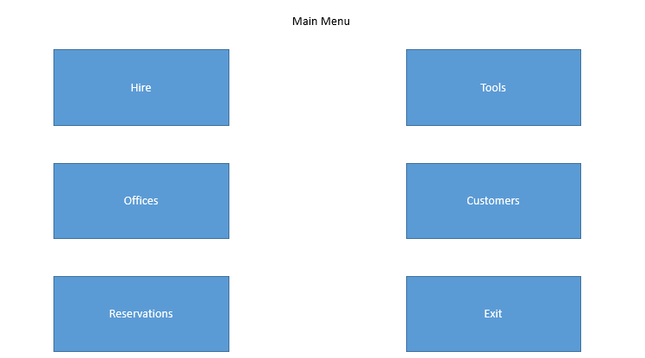

Form Design

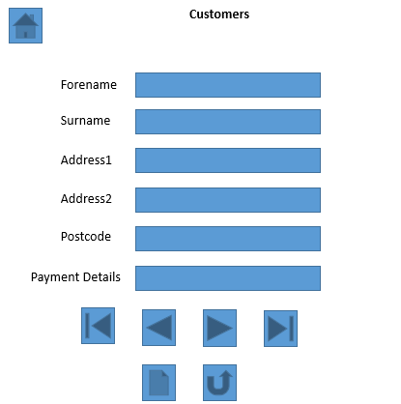
These buttons are used to add or delete records.
These buttons are used to navigate through records.
Data is entered into these text boxes.

All of the forms used in the database will follow this same design.

Creating Tables Using SQL
This is the SQL code that I have used to create each of the tables in my database.

Customer
CREATE TABLE Customer(
CustomerID varchar(3),
Forename varchar(12),
Surname varchar(12),
Address1 varchar(15),
Address2 varchar(15),
Postcode varchar(10),
PaymentDetails varchar(20),
primary key (CustomerID)
);

Office
CREATE TABLE Office(
OfficeID varchar(3),
Location varchar(10),
Address1 varchar(15),
Address2 varchar(15),
Postcode varchar(10),
TelNo varchar(11),
primary key (OfficeID)
);

Damage
CREATE TABLE Damage(
DamageID varchar(3),
PartsDamaged varchar(10),
Fixable varchar(1),
Cost varchar(5),
primary key (DamageID)
);

Tool
CREATE TABLE Tool(
ToolID varchar(3),
Tool varchar(10),
Description varchar(15),
Price varchar(5),
Available varchar(1),
primary key (ToolID)
);

Reservation
CREATE TABLE Reservation(
ReservationID varchar(3),
StartDate Date,
EndDate Date,
OfficeID varchar(3),
CustomerID varchar(3),
ToolID varchar(3),

primary key (ReservationID),
foreign key (OfficeID) References Office(OfficeID),
foreign key (CustomerID) References Customer(CustomerID),
foreign key (ToolID) References Tool(ToolID)
);

Hire
CREATE TABLE Hire(
HireID varchar(3),
HireDate Date,
ExpectedReturnDate Date,
ActualReturnDate Date,
TotalPrice varchar(5),
OfficeID varchar(3),
CustomerID varchar(3),
ToolID varchar(3),
DamageID varchar(3),

primary key (HireID),
foreign key (OfficeID) References Office(OfficeID),
foreign key (CustomerID) References Customer(CustomerID),
foreign key (ToolID) References Tool(ToolID),
foreign key (DamageID) References Damage(DamageID)
);

Access Forms

Customer
This form is used to navigate and add/delete customers in the Customer table.
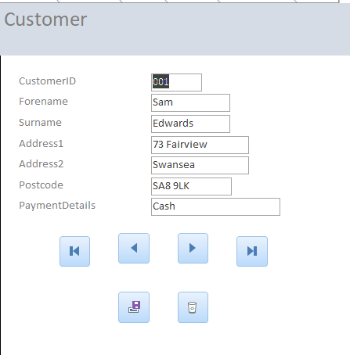

Damage
This form is used to navigate and add/delete damages in the Damage table.
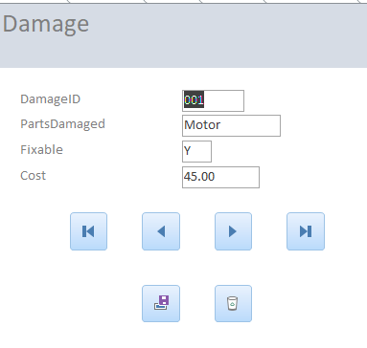

Hire
This form is used to navigate and add/delete hires in the Hire table.

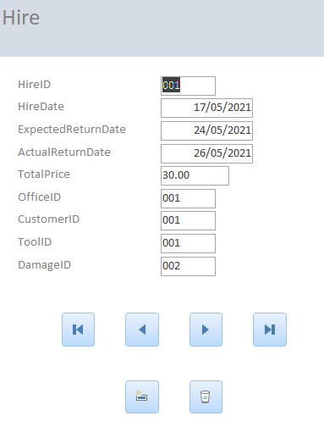

Office
This form is used to navigate and add/delete offices in the Office table.

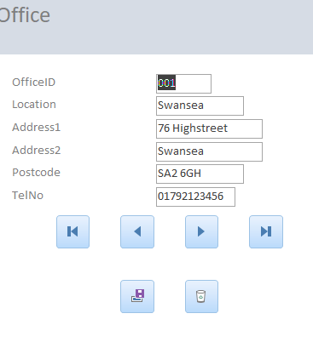

Reservation
This form is used to navigate and add/delete reservations in the Reservation table.

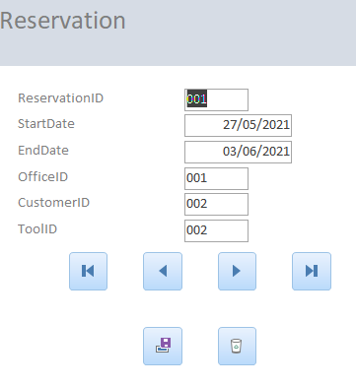

Tool
This form is used to navigate and add/delete tools in the Tool table.

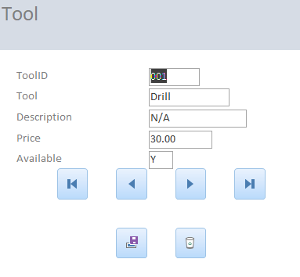

Main Menu
This form is used to navigate each of the forms in the system.

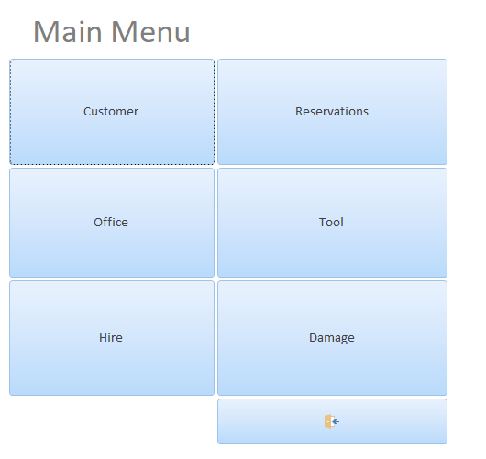

Suitable Data in Each Table

Customer
This is the data stored for each customer.
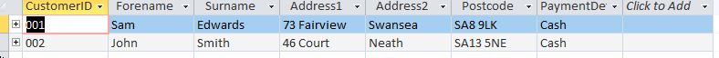

Damage
This is the data stored for the damages to tools.

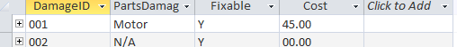

Hire
This is the data stored for each customer hiring a tool.

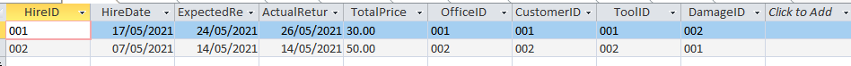

Office
This is the data stored for each of the offices.

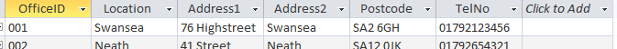

Tool
This is the data stored for each of the tools.

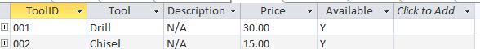

Reservation
This is the data stored for each customer making a reservation to hire a tool.

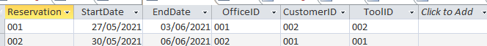

Report Calculations

This report calculates the total cost from the rate of hire for the tool plus and additional cost for any damages to the tool hired.

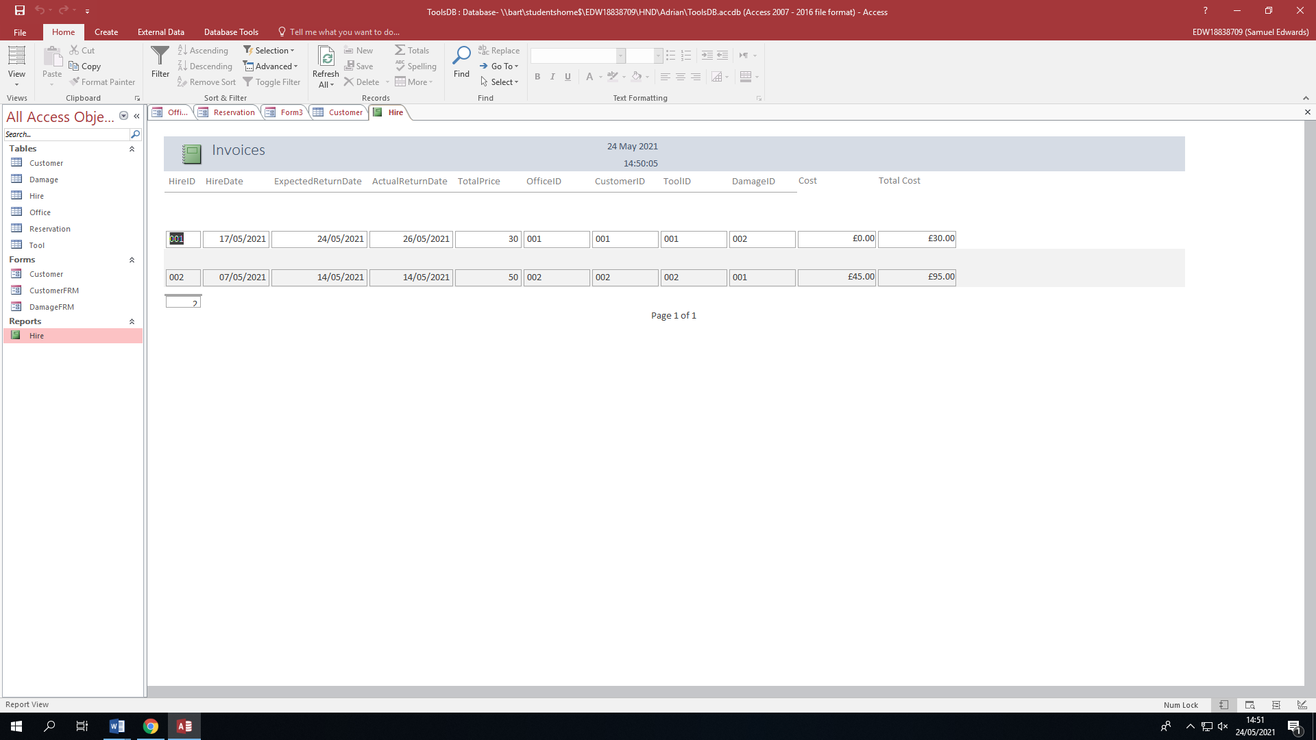

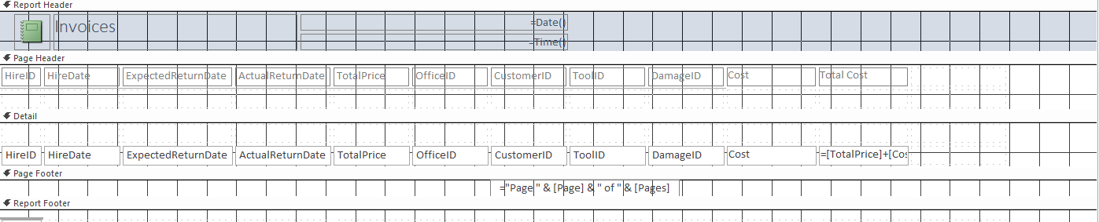

Menu Displayed When Database Opens
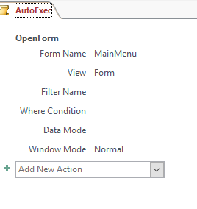
The ‘AutoExec’ macro will automatically run when the database opens, the macro opens the MainMenu form.

User Documentation

Function of the Database
This database will store the information on any customers, tools, hiring’s, reservations, offices and any damages to the tools. This documentation should allow you to use the all of the functions of this database system with ease.

Using the Main Menu
This will be the first form that you will be greeted with when you open the Access system, it will allow you to navigate through each form included in the database system.

Form Navigation
To navigate to each of the other forms, press any one of the buttons highlighted in green, this will open the corresponding form.

Exiting the System
To exit the Main Menu press the exit button highlighted in red.

Adding a record
As an example I will be using the customer form, however this applies to all forms.

Step 1: Enter Data
Enter the relevant information into the text boxes highlighted in blue.

Step 2: Save Data
To store the entered information to the database press the save button highlighted in green.

Navigating Records
As an example I will be using the customer form, however this applies to all forms.

First Record
To navigate to the first record in the table, press the first button highlighted in green.

Previous Record
To navigate to the previous in the table, press the previous button highlighted in red.

Next Record
To navigate to the next in the table, press the next button highlighted in blue.

Last Record
To navigate to the last record in the table, press the last button highlighted in purple.

Deleting a record
As an example I will be using the customer form, however this applies to all forms.

Step 1: Find the Record
Navigate to the record you wish to delete using the previous instructions.

Step 2: Delete the Record
Press the delete button highlighted in red to delete the chosen record.

Using the Reports
This report is an invoice to customers that have hired tools from the company.

HireID
The ‘HireID’ column is the primary key for identifying each unique hire.

HireDate
The ‘HireDate’ column is the date the tool was hired to the customer.

ExpectedReturnDate
The ‘ExpectedReturnDate’ column is the date that the tool was expected to be returned.

ActualReturnDate
The ‘ActualReturnDate’ column is the date the tool was returned.

TotalPrice
The ‘TotalPrice’ column is the rate of hire for the tool.

OfficeID
The ‘OfficeID’ column is the office that the tool was hired from.

CustomerID
The ‘CustomerID’ column is the customer that hired the tool.

ToolID
The ‘ToolID’ column is the tool that has been hired.

DamageID
The ‘DamageID’ column states the type of damage the tool was returned with.

Cost
The ‘Cost’ column states the price for repair of the tool.

TotalCost
The ‘TotalCost’ column states the total cost paid by the customer.

