‘

Independent project research proposal
Yifan Liu (2213804)
University of Wales, Trinity Saint David
Supervisor: Davina Wyn Evans & Garths Huges
December 11th, 2023.

Table of contents:
- Introduction to the Purposed Research…………………………………………..1
1.1. Contemporary Management & Transformational Leadership………………1
1.2. Employees’ Engagement……………………………………………………2
1.3. Research Purpose……………………………………………………………2
1.4. Research Objective…………………………………………………………..2
- Research Methodologies…………………………………………………………4
2.1. Research Approach………………………………………………………….4
2.2. Research Strategy……………………………………………………………4
2.3. Sampling Population & Methods……………………………………………4
2.4. Results & Data Collection Methods…………………………………………5
2.5. Reliability & Validity………………………………………………………..5
2.6. Limitations & Implications……………………….…………………………5
- Resources & Planning …………………………………………………………...6
3.1. Ethical Considerations………………………………………………………6
3.2. Resources Required …………………………………………………………6
3.3. Research Timescale………………………………………………………….6
3.4 Gantt Chart & research planning………………………….………………….7
- References………………………………………………………………………..8

- Introduction to the Purposed Research
  - Contemporary Management & Transformational Leadership
In terms of the work of Atiku (2019), globalization and internationalization makes business environment change rapidly and thus the complexity of operating corporations increases that drives managers to orient globally. Therefore, strategic leadership is required seeking to resolve issues about people, performance and so forth (Lussier & Achua, 2016). Additionally, corporations currently face more competitions and how to lead companies to successfully win in market competition becomes essential. Therefore, many leadership types emerge in these years including transactional, servant, humble, transformational and so forth. Specifically, based on Lussier & Achua (2016), greater needs are required for managers to successfully apply strategies enabling organizations to accomplish profits and competitiveness. Additionally, DuBrin (2010) suggests that leaders sometimes need to change whole organizations from lower-level performance to the acceptable-level of performance to overcome difficulties brought by macro-business environment. Thus, transformational leadership rises recently that demonstrates a vision creation transforming at both individuals and organizational level (Antonakis & Dessi, 2023). However, debates around transformational leadership also exists, for example, people would make comparisons between transformational and transactional leadership (Antonakis & House, 2014). Therefore, whether transformational leadership is, in fact, beneficial for employees is worth exploring.

  - Employee’ Engagement
Employees’ engagement could be defined from many aspects. Gennard & Judge & Bennett & Saundry (2016) states that employees’ engagement could be viewed based on whether employees have personal attachments to organizations. If employees were motivated having positive outcomes on jobs, then these employees are highly engaged. However, Gennard & Judge & Bennett & Saundry (2016) also states that approximately one third of employees among the labor market is not fully engaged currently. Additionally, Alfes & Truss (2010) demonstrates that merely 8 percent of employees are strongly engaged, in general, under some survey results. Soane & Stanton (2015) indicates that employee’ engagement is usually the outcome of managerial activities. Therefore, leadership style is highly related with employees’ performance at workplace. Appropriate leadership type could largely engage employees’ participation. Thus, this research project is established mainly to explore whether positive impact exists between transformational leadership and employees’ engagements.

  - Research Purpose
Easterby-Smith & Thorpe & Jackson & Jasperson (2018) suggests that purpose of research projects should aim to achieve one or more aspects such as contributions to knowledge and impact on practice. Thus, this research project mainly has two aims including theoretical and practical aim. Theoretically, it is carried out based on secondary research with knowledge gap because this research will apply a different research methodology. Thus, this research outcome could potentially fill up the knowledge gap. Additionally, it could be treated as a guide for both current and potential managers that would enter into the workplace by informing positive impact between transformational leadership and employees’ engagement.

  - Research Objectives
A few objectives that break down the general aim into parts:
- Apply a detailed research methodology examining the relationship between transformational leadership and employees’ engagement.
- Compare and contrast with secondary research.
- Make evaluations with the relationship between two variables and make solid conclusion.
- Guide managers with better leadership types at workplace.

- Research Methodologies
  - Research Approach
In terms of the work of Easterby-Smith & Thorpe & Jackson & Jasperson (2018), questionnaires are generally applied in research set-up and helpful for getting quantitative results. Therefore, to get representative results, questionnaires should be created with comprehensive questions, and should be sent to university students and staff that are major in or have solid experience on this discipline. Also, this research involves positivism because conclusion will be made through objective methods.
  - Research Strategy
Since questionnaires should be created, the research strategy should be utilizing surveys and questionnaires to have a better view about the perspectives of current and potential employees on transformational leadership. Based on Easterby-Smith & Thorpe & Jackson & Jasperson (2018), some guidelines will be followed when creating questions for questionnaires and surveys such as grouping similar questions with similar topics and asking questions about facts before viewpoints. This research will exactly follow these rules purposed.

  - Sampling Populations & Methods
For participants, the estimated sampling populations would be 100, the more people participating into answering questionnaires, the more representative results would be. Additionally, cluster sampling, based on the work of Alfes & Truss (2010), it is widely used in sampling and the reason why researchers have a preference on it is that it could rise an effect as a cycle. Thus, it would be the most appropriate one because for university students, the questionnaires would be sent to the close friends for the first round, and then these friends would then spread questionnaires to their friends or families.

  - Results & Data Collection Methods
Survey data could be collected through self-completion of questionnaires by participants (Easterby-Smith & Thorpe & Jackson & Jasperson, 2018). Since all questionnaires will be created by the Microsoft Forms, tracking data regularly is essential. Response rate cannot be 100% because no personal contact between researcher and participants (Heerkens, 2002). After collecting the majority of data, data analysis process will carry on. The combination of SPSS and Excel would be a better way for to best visualize these collected data.

  - Reliability & Validity
Reliability and validity are significant for this research. O’Dwyer & Bernauer (2016) suggests that validity refers to the accuracy of research data and reliability highlights consistency. Additionally, the instrument used to support valid inferences must be reliable (O’Dwyer & Bernauer, 2016). This research will focus on the consistency for collecting data.

  - Limitations & Implications
This research will have limitations and implications. The results could not be sufficiently representative if response rate is relatively low. Additionally, problems could exist in the experimental design that affects results. The research conclusion would contribute to fill up knowledge gap and guide for employers.

- Resources & Planning
  - Ethical Considerations
Easterby-Smith & Thorpe & Jackson & Jasperson (2018) states that carrying out business-related research needs to make sure that the investigated organizations cannot be affected financially. Additionally, researchers require to ensure that no harm comes to participants. This experiment will treat the protection of participants and corresponding organization as main focus, specifically, data storage is the main concern.

  - Resources Required
In terms of Haniff & Salama (2016), project resources are defined as any entity used for accomplishing a successful project including all people working for project and all equipment utilizing in the process of carrying out research. Therefore, 100 participants are required for contributing results. Additionally, SPSS & Excel will be used for analyzing data. Furthermore, accessing to online journals will be required because compare original result with other scholars’ findings is vital. Last, questionnaires will be created for participants.

  - Research Timescale
Haniff & Salama (2016) stresses that completing research project on time is one of the main goals that researchers should follow. Additionally, creating a detailed research timescale before starting is required (Haniff & Salama, 2016). Therefore, timescale is created that runs from October 2nd, 2023 to May 3rd, 2024. The Gantt chart below demonstrating the exact time planning.

  - Gantt chart & Research Planning
Joana & Thomas (2012) suggests that Gantt chart is the most useful way to plan and control tools in research projects. According to a recent survey, the Gantt charts are the fourth most used tools out of seventy tools and techniques related to the project management (Joana & Thomas, 2012). Therefore, for this specific experiment, the following Gantt chart is created to demonstrate the detailed time plan.

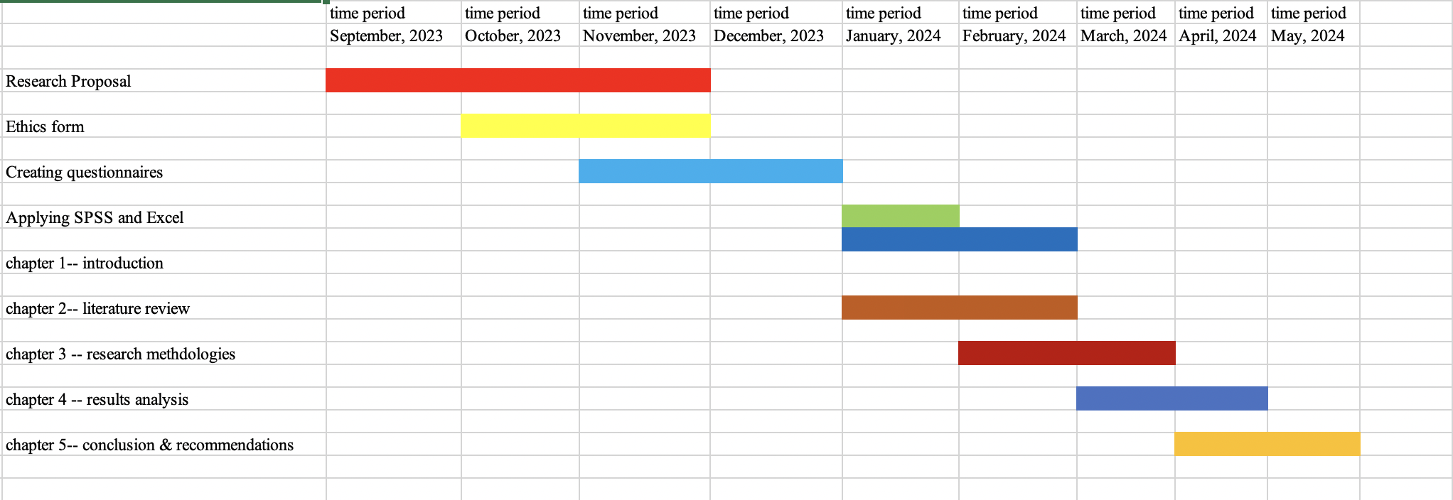

- References
Ahn, J. & Lee, S. (2018). Leaders’ Core Self-Evaluation, Ethical Leadership, and Employees’ Job Performance: the Moderating Role of Employees’ Exchange Ideology. Journal of Business Ethics. Vol 148 (2). pp. 457-470.
Alfes, K. & Truss, C. (2010). Creating An Engaged Workforce: Findings from the Kingston Employee Engagement Consortium Project. London CIPD Press.
Antonakis, J. & Dessi, R. (2023). Theory leadership and management. The leadership quarterly. Vol 25.
Antonakis, J. & House, R-J. (2014). Instrumental Leadership: Measurement and Extension of Transformational-Transactional Leadership Theory. The Leadership Quarterly. Vol 25. pp. 746-771.
Atiku, S-O. (2019). Contemporary Multicultural Orientations and Practices for Global Leadership. IGI Global Press.
Bass, B-M. & Riggio, R-E. (2005). Transformational Leadership (Second Edition). Taylor & Francis Group Press.
Dubrin, A-J. (2010). Principles of Leadership—International Edition (Seventh Edition). South—Western Cengage Learning Press.
Easterby-Smith, M. & Thorpe, R. & Jackson, R-J. Jaspersen, L-J. (2018). Management & Business Research (Sixth Edition). Sage Press.
Gennard, J. & Judge, G. & Bennett, T. & Saundry, R. (2016). Managing Employment Relations (Sixth Edition). Charted Institute of Personnel and Development Press.
Haniff, A. & Salama, M. (2016). Project Management. Goodfellow Publishers Press.
Heerkens, G-R. (2002). Project Management. McGill Hill Press.
Joana, G. & Thomas, L. (2012). Gantt Charts Revisited: A critical Analysis of Its Root and Implications to the Management of Projects Today. International Journal of Managing Projects in Business. Vol 5 (4). pp. 578-594.
Lussier, R-N & Achua, C-F. (2016). Leadership: Theory, Application and Skills Development (Sixth Edition). Cengage Learning Press.
O’Dwyer, L-M. & Bernauer, J-A. (2016). Quantitative Research for the Qualitative Researcher. Sage Press.
Soane, E. & Stanton, E. (2015). Followers’ Personality, Transformational Leadership and Performance. Journal of Sports, Business and Management. Vol 5 (1).
Stock, G. & Banks, G-C. & Voss, E-N. & Tonidondel, S. (2022). Putting Leader (Follower) Behavior Back into Transformational Leadership: A Theoretical and Empirical Course Correction. The Leadership Quarterly. Vol 25.

