Specification - General design

Cladding

The main cladding consists of predominantly natural and reconstituted stone façades with aluminium framed windows and curtain walling. All glazed elements will have clear double glazed units

Floor to ceiling heights:

Eighth floor
2.60m
Seventh floor
2.75m
Sixth floor
2.75m
Fifth floor
2.85m
Fourth floor
2.85m
Third floor
2.85m
Second floor
2.85m
First floor
2.85m
Ground floor (entrance)
4.50m
Ground floor (office)
4.50m
Lower ground (office)
2.85m
Typical raised floor void
150mm

Planning grid: 1.5m × 1.5m

Floor loading

Office floors: 3.5 +1kN per sq m live load + partitions

All office floors also have an allowance for 0.85kN per sq m super-imposed dead load allowance for finishes and services

Bicycles/Car parking

1 disabled car parking space at ground floor

Secure cycle spaces: 160 cycle spaces complemented by 160 lockers and 18 showers. Access to cycle store via service bay from South Place

Vertical transportation

Lift design density

Hall call destination control. 1:8 sq m (assuming 20% absenteeism). Providing an average waiting time of less than 25 seconds with a five minute handling capacity of approximately 15% .

Lift types

Main lobby lifts:6 × 21 person 1,600kg passenger lifts

Goods lift: 1 goods lift (2,500kg capacity)

Firefighter lift: 1 of the main core passenger lifts will act as a firefighting lift
Internal finishes

Offices
The offices will be completed to Category A condition.

Entrance hall

Walls: Illuminate feature natural stone wall

Floors: Grey natural stone with white stone detail and recessed walk off mat, minimum 3m depth to entrance doors
Lifts: Feature light-backed translucent glass lift enclosure

Doors: Revolving doors at the South Place entrance and draught lobby on Finsbury Circus entrance

Lift lobbies

Walls: Feature light-backed glass panelling, back-painted glass panelling and plaster finish
with bronze finish detailing

Electrical services
Electrical supply
Electrical power is provided to the building by UKPN at 11kV. The incoming UKPN HV switchgear is in the lower ground floor area. Metering is provided by UKPN at their
incoming room at 11kV level.

Design criteria
Lighting: 7W sq m
Small power: 25W sq m
Supplementary small power: 10W sq m
A landlord’s generator will provide full life safety backup Provision has been made at roof level for a tenant standby generator(s) with a tenant oil storage plantroom
available at basement level.
Mechanical services

The design is based on a 4-pipe fan coil air conditioning system with 2-pipe in internal spaces. The system has been designed in accordance with BCO guidance
Design criteria

Internal blinds: Provided for comfort and glare
Occupancy: 1 person/8 sq m

Fresh air: 12 l/s/person for 1 person/8 sq m
Summer internal temperature: 22 ̊C ± 2 ̊C
Winter internal temperature: 22 ̊C ± 2 ̊C
Toilet and circulation spaces: 18 ̊C (Winter) 22 ̊C (Summer)
Means of escape — 1:6 sq m

WC design density
Office floors: 1:8 sq m (assuming a ratio of 60:60 male:female) 20% absenteeism

Provision for tenant kitchenette

Allowance for future tenant kitchenette is provided with a boosted cold water supply and drainage stack to each office tenancy floor

For a single larger kitchen facility a natural gas supply rises up the building and space is available at roof level for 1 office tenant kitchen extract fan with dedicated riser serving first to eighth floors

Building Management System (BMS)

The BMS will provide an intelligent interface between the controls for the landlord and tenant services. The system is capable of extension (20%) by the tenant
The BMS will allow monitoring and direct billing of services to each tenancy including electrical power, CHW (cooling), LTHW (heating) and potable water

Security/Sustainability/Amenities
A CCTV system, linked to the security room, monitors the loading bay and all entrances
/ exits. Conduits linked to the security room will allow later installation
of additional monitoring system. The base build system will allow extension to allow use by tenants in a multi-let situation

Sustainability performance
The building is targeting a BREEAM 2011 ‘Excellent’ rating
and EPC B score

Grey water system
A complete greywater system is provided, comprising greywater collection from the changing room showers, storage, treatment and boosted supply to the buildings WCs

Terraces
Terraces are provided on the fifth floor, 2 terraces on the eighth floor and 9 individual Juliet balconies to the sixth floor

BCO specification: the incredible shrinking office
22 May 2009 | By Mark Shepherd
- 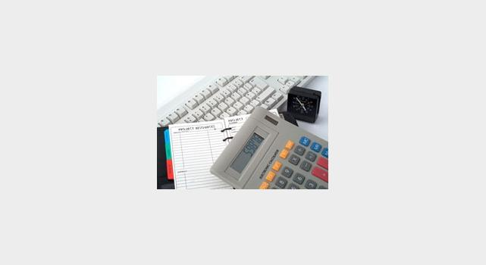
- 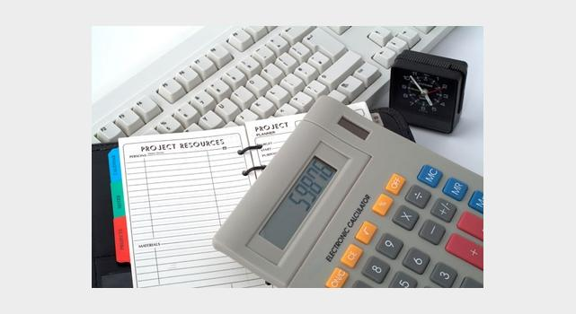

New trends in office building and development
The latest British Council for Offices specification is the leanest and greenest yet
The office developments of the future will need to meet toughening legal standards governing their environmental performance and deal with the rapidly changing needs of occupiers as they adjust to changes in work practices.
That is the message that the British Council for Offices is sending through the publication this year of its office specification guide - a document that appears every four years and has become the industry standard in how office developments should be designed, built and valued.
Since the last guide was published in 2005, a raft of environmental legislation introduced by the European Union has come into force in the United Kingdom. Energy Performance Certificates and Energy Display Certificates are now a reality for landlords and occupiers, whose buildings can now be judged for their impact on the environment.
The last four years have also witnessed the rapid decline of the United Kingdom economy. This means that finically pressed occupiers are cutting back on staff and space and wanting to use the premises they have more efficiently. This means the issue of occupancy costs is once again at the forefront of a developer's mind when they are looking for tenants.
Neil Pennell, director of project engineering at Land Securities and a director of the board of management at BCO, says the revised guide will reflect the growing influence of environmental legislation on the property industry.
"If you look at the timing of the last guide in 2005 there was a lot of legislation that was about to come through and there was a lot of talk about what those requirements would probably contain and what they might mean," says Pennell. "What we've had since then is a period of time where we have been using those requirements as well as the other aspects of the Energy Performance of Building Directive has come in. We've lived through four years of implementing those requirements and understand their impact on design, at the same time there has been a driver for the quality of design to be improved."
Climate change has now become accepted wisdom and the government is looking towards the developers of new buildings and landlords of existing assets to assist in cutting carbon emissions. Real estate is responsible for 40% of the UK's total emissions.
"There has been a growing realisation that our energy policy needs to be reviewed," reflects Pennell. "There is climate change on one hand and then there is energy security on the other. Buildings are big part of that and are responsible for getting on for half of the UK's emissions."
The guide will deal with bringing developments into line with the new legal structure and the standards that refurbished buildings should also attain. "Both the built asset base and the new buildings are affected," he says. "The focus has been on new buildings, but there has to be a growing attention on the built base. That will happen over the next few years and that's where the focus is moving, especially when the amount of new development is slowing down as well."
The spectre of climate change looms large in the latest BCO specification. It sets out that the adaptability and flexibility of buildings will have to increase so they can cope with hotter and longer summers, and colder and wetter summers. In short, they need to be able to deal with the extremes - a perennial problem for the United Kingdom's infrastructure, which was designed for more benign weather conditions rather than plummeting winter temperatures and heavy snowfall, coupled with summers that would rival the French Riviera.
"The envelopes - the glass and skin of a building - will have to work harder," says Pennell. "We all like to have a great view and see daylight, which also offsets the use of artificial light which saves energy. On the other hand it can let in the sun which creates a lot of heat to deal with, particularly in commercial buildings."
Such considerations have implications for the development of statement architecture, which have typically been glass towers, such as the Gherkin in the City of London and the Shard at London Bridge. Pennell says there will need to be a more pragmatic approach in the future.
"You can still get a good solution to this in building with glass," he says. "What you need to do is use it in combination with solar shading, and other solid materials. There will be a greater emphasis on slightly less glazing in buildings than perhaps we have seen in the past. The key is making it perform in the high temperature conditions. Less glazing is an equally valid solution, but the trade-off is you then need more artificial light."
In the intervening years between the last BCO guide, the economic climate for those who will use it has changed beyond recognition. Since those heady days of 2007 when the champagne flowed recklessly at MIPIM in Cannes, the outlook has deteriorated with unprecedented pace.
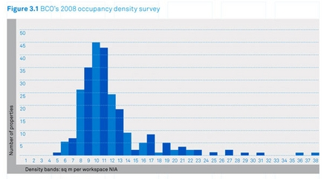
While developers have born the brunt and have had to mothball projects, the recession has forced occupiers to re-think how they use their space. Pennell says the guide advocates that work practices have moved away from a hierarchical structure - where bosses sat in offices and workers sat in cubicles toiling away - to more open plan structures. This is even true for the more traditional firms such as accountants, financial services firms and lawyers.
This means that space is being used much more intensively by occupiers that have a knock-on effect to office design.
"There is no doubt there has been an intensification in use of buildings and a general movement from different styles of office working," says Pennell. "In the past working practices were more regimented and hierarchical. These have now been broken down and the environment is now much more knowledge driven to create value from the staff in the building."
This change, says Pennell, has led to "open plan, interaction space", which is proving a challenge, particularly if buildings are to be refurbished. 'A building that could support cellular layout was a driver in the past,' he says. "Now it still has to be recognised that it could be part of a requirement, but predominantly when people fit out space they want open plan with all the supporting space they need."
Research carried out by the BCO to be included in the guide shows that the amount of space each employee uses in a building has dramatically fallen. In the last decade, it stood generally between 12-17m² per person. Today, it is closer to 8-13m² per person. "There has been a significant shift," says Pennell. "There are more people in the same space. It is a cost of occupancy issue. The users of space want efficiency out of what they lease and buy. It was always important and it is important now."
Alongside the obvious economic considerations, particularly during a time of recession, Pennell says there have also been changes in attitudes by employers. They now believe workers will be more productive in office spaces conducive to the free exchange of ideas.
"There's been an evolution in the way we work. When you move away from one type of layout you can fit more people into that space," he says. "If you move from cellular type and hierarchical structures and use a more open plan working, that is better for sharing information and getting people to work together and releasing the intelligence. We are no longer in a production office where rows of people type out invoices all day long. That is now done by computers. The actual value comes from workers producing new ideas and new products going forward."
Technology has also played it part in the direction that office design and specification will take. The war on paper has taken a decisive turn in recent years as more offices become reliant on IT. The in and out trays have been replaced by the PCs and the laptops.
This has led to two consequences. One, workers generally need less office space to do their work. Second, while the amount of paper may have fallen, the power levels that needed to be available in the building to run the office technology has had to increase.
"The accepted wisdom was that we can't have intensified the people in the space without the same happening in technology," says Pennell. "You go into some areas of working where people have got two or three screens in front of them, or a trading floor where a dealer is looking at five screens. But if the technology becomes more efficient, we could see power levels starting to drop away. The flip side is we could see another technology must-have enter the office environment which takes it the other way - it is very difficult to know."
While the atmosphere at the BCO conference this week in Edinburgh may be more subdued than in previous times, the once constant has been the emergence of the Specification Guide. This year it is published amid a market tumult. But as in previous incarnations, it will set the agenda for the next several years.

The US office is still a mad world

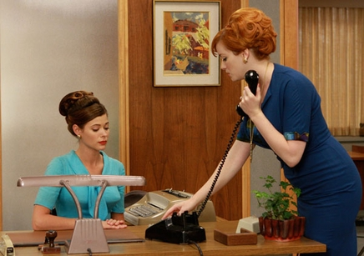
The American television series Mad Men now showing on BBC2 offers an insight into New York office life in the early sixties, complete with chain-smoking, rampant alcoholism and institutional sexism.
Yet it also offers an insight into present day working practices in the United States that will be brought to light in a significant piece of research carried out by the British Council for Offices and to be published next month.
The report - The next generation of global cities: pointers for successful economies - analyses office specification standards in London, New York, Abu Dhabi, Bangalore, Moscow and Shanghai.
Among its findings is that the use of office space in the United States is far less efficient in the UK because of the highly rigid management structures like those portrayed in Mad Men.
"Mad Men is a very good example of some of the issues that are still inherent today in the way office space is utilised in the United States," says Richard Kauntze, chairman of the BCO. "You have an established hierarchy where the most senior people get the biggest offices with windows and the secretaries sitting outside the door. Those that are further down the food chain are packed in, sometimes in windowless rooms. Not much has changed in that regard in the United States over the last four decades."
These types of office layout are increasingly being rejected in the UK. In April, Stephen Hester, the chief executive of the Royal Bank of Scotland, ordered his senior directors to give up their office suits and “go back to the floor”. The bank's executive wing at its Edinburgh headquarters is being knocked down.
The BCO research found that a standard office specification - part of everyday life in UK development - is largely an alien concept in other parts of the world. A key finding is that there is no definition of Grade A office space that helps international occupiers choose in which international city they should sign up for leases.
"You would think it was an obvious thing, but what comprises Grade A office space differs depending on where you are in the world," says Kauntze. "This makes it very difficult for occupiers to benchmark what they should be expecting."
The report will show that there is potential for the BCO specification guide to be expanded internationally. "It would be very difficult to have an international standard in that a building in Moscow has to withstand different extremes of temperatures than a building in New York," says Kauntze. "But there may be areas where some form of international standard may be possible."

BCO Specification Guide at a glance
Occupancy
The previous Specification used an average occupancy density of 12-17 m² per person as the basis of design, the new research has found workplace densities of 8-13 m² per person.
The new Specification interprets the impacts of these two different measures on many of the key parameters that drive office design.
Technology
Wider adoption of flexible working patterns has been made possible through advances in workplace technology.
Modern offices are highly dependant on IT systems to drive the business functions. Base building design has to be flexible and adaptable to meet the demands of different user requirements and how these may change during their tenure in the building. The Specification provides the user with a path through the maze of trying to design for the unknown.
Environment
As carbon reduction targets start to bite and as corporate social responsibility rises up the boardroom agenda the environmental impact of buildings will grow in importance as a differentiator and value driver. The new Specification explains how to design sustainability into all aspects of the built form.
Buildings account for about 40% of the worlds energy use and in the UK are responsible for approximately 50% of national carbon emissions. Commercial office buildings produce a significant part of these emissions. In the future mandatory carbon budgets will have far reaching effects on building design.
In the 2008 budget the Government set aspirational targets for zero carbon new non domestic buildings by 2019.

Postscript:This article is from the recent Skyline supplement. Read more in the digital edition of Skyline: new trends in office building and development

The Co-op's HQ: Have you heard the buzz?
Building, 23 November 2012 | By Ike Ijeh

3D Reid’s beehive-inspired HQ for the Co-op in Manchester is not simply another new office block with a slightly unusual form. It is the top BREEAM-rated office in the UK and might just have redefined the corporate atrium
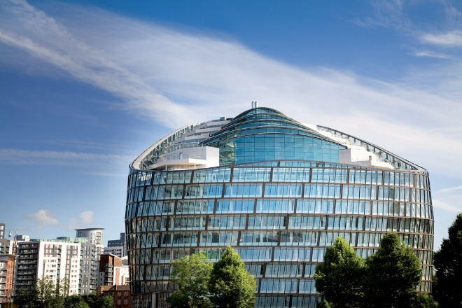
‘Isn’t all this a bit fancy for the Co-op?” So spoke a Cabe commissioner during a planning-stage design review for the group’s new Manchester headquarters. The quip probably says more about Cabe than it does about the retail collective founded in nearby Rochdale in 1844 and now the world’s largest co-operative consumer organisation. But it is useful nonetheless for highlighting how the Co-op’s new building both challenges popular perceptions of the brand and projects the principles on which that brand is based.
Sustainability, for example - a cornerstone of the Co-op’s commercial ethics - has been energetically embedded into the architecture of the new building in a way that extends far beyond the shallow compliance that is still the mark of much environmental design. A slew of energy-efficient features, ranging from a trio of giant earth tubes to a ventilated double-skin glass facade, has helped the Co-op achieve the highest BREEAM “Outstanding” score of any UK office.
It is this enlightened environmental philosophy, combined with a distinctive architectural form that cleverly reinterprets the British architectural tradition of commercial symbolism, that identifies the Co-op HQ as a significant milestone in the evolution of the office workplace.
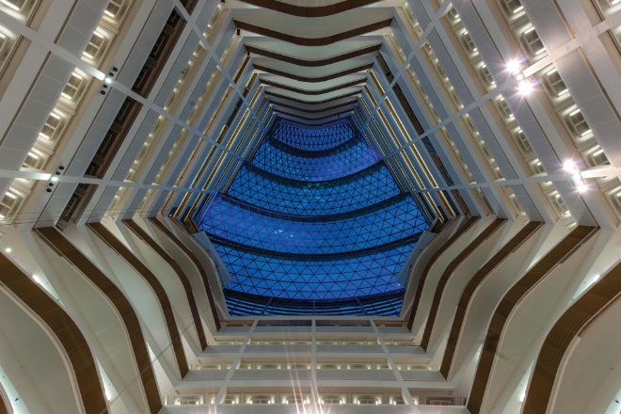
The ‘honeycomb’ atrium extends the full height of the building

A rich heritage
The £100m building has been designed by 3DReid and is the first and anchor phase of a wider 4 million ft2 redevelopment of Co-op owned land. The masterplan’s title, NoMa - like the short-lived and egregiously abbreviated NoHo development in London’s Fitzrovia - indicates its position on the northern rim of Manchester city centre.
When the building officially opens as One Angel Square next year, its 500,000ft2 will provide a single base for the organisation’s 3,500 office employees for the first time. Currently, staff are disparately housed in an eight-building campus located opposite the new building. Despite being severed from each other by a sprawling, soon to be narrowed, four-lane dual carriageway, this listed cluster of buildings formed the conceptual starting point for the new HQ’s design.
The most prominent building on the original campus is the 25-storey, 118m-high CIS Tower, Manchester’s second tallest building and briefly the UK’s tallest when it was completed in 1962. While this dour, angular slab now appears to be yet another example of insensitive sixties urbanism, when it was conceived its clean lines and simple geometries were proudly affiliated with the chic international style perpetuated by the likes of Mies van der Rohe.
Equally, the earlier Co-op HQ next to the CIS Tower is a virtuoso study in the layered horizontality and dramatic massing of thirties Dutch Dudok-style modernism. For a former 19th-century slum neighbourhood once dubbed by Friedrich Engels as “hell on earth”, this represents a remarkable architectural heritage.
But, as 3DReid divisional director Mike Hitchmough explains, it is one that did not arise by accident. “Historically, the Co-op has always wanted its buildings to be the best possible examples of the architectural style of the day and for them to make a positive civic contribution to an area that has known difficult times in the past. The new HQ is merely the latest chapter in this long, ongoing sequence.”
However, while the new and old buildings may be historically linked by civic altruism and architectural prestige, aesthetically the new building is a radical breach with the past. A first glance reveals a modern glazed three-sided double skin office that curves gently outwards before the upper third is sharply thrust backwards like a diagonally sliced egg.
“The ribbed, weaved basket quality to the outer skin is partially inspired by the striped vertical and horizontal banding and modulation on the facade of the CIS Tower,” he says. But the overriding visual analogy is a corporate one. “The Co-op symbol is a beehive and this is the main inspiration for the building’s exterior form.”
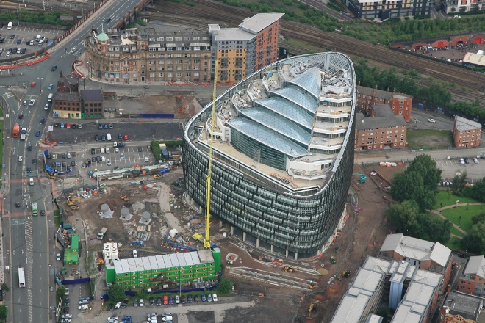
The building has been ‘future-proofed’ against forecasted 2050 UK temperatures, which anticipate a 3%-5% increase in summer temperatures and a 30% reduction in winter temperature

Enter the beehive
This beehive concept, with its intrinsic premise of strength in numbers, is also intended as a physical representation of the Co-op’s values, and is strongly evident within the building’s interior. After passing through the main entrance, the visitor is plunged into a soaring atrium that extends the full height of the building. The cellular structure of the white-painted concrete columns and balconies that enclose the atrium on all sides, as well as its hexagonal shape, immediately recalls the honeycomb aesthetic first suggested by the exterior.
Most impressive of all is the enormous amount of natural daylight present. Light not only pours in through the glass “eyelid” ceiling but over the balconies themselves. This is because, with the exception of the three cores on alternate sides of the atrium, (accentuated by oak rather than white balconies), every balcony fronts onto entirely open-plan offices on the lower nine floors, allowing light from the external wall to permeate into the heart of the building.
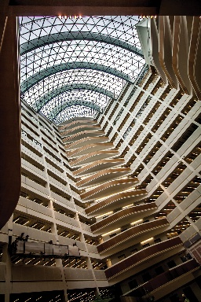
“No desk is situated more than 7m from a window,” says Hitchmough, “and the light levels within the area are so high - sometimes higher than average Manchester daylight levels - that the balcony edges constitute a window. Also, although most architects like exposed concrete, most people don’t. So we painted the concrete white, which not only softens the character of the space but enables the artificial lighting’s lux levels to be reduced from 550 to 300, representing a significant cost and energy saving. Finally, the white surfaces create something of a blank canvas which the workers will be able to personalise over time to evolve the identity of their workplace.”
Atriums are the ubiquitous and frequently insipid corporate insignia of every large modern office. But this one is a stirring and emphatic metaphor for the democratic, collaborative principles that drive the Co-op’s corporate ideology.
This cavernous central volume is afforded spatial and social primacy at every possible instance. The restaurant on the 12th floor looks down on it. Meeting rooms face onto it. The stepped terraces clustered around the staggered rooftop prow radiate from it. It provides myriad oblique and direct views into workspaces from virtually every corner of the building. Critically, it also preserves panoramic views through the building out towards the city - Hitchmough points out that the height of office cabinets and even the balcony baluster profiles were determined so as to not impede workers’ views even when sitting at desks. It is the atrium where the Co-op plans to hold its AGMs.
Environmentally, it even acts as a giant extract for displacement air that moves up the building.
The office spaces themselves continue the atrium’s theme of transparent equanimity by being as open and uncluttered as possible. Structurally this meant expansive column-free spans of up to 16.5m and Hitchmough clearly revelled in the liberation of dealing with clients who insisted on a structural frame that actually necessitated fewer rather than more columns. Double-height open “winter gardens” are also cut into the floorplate on alternate floors on the opposite side of the core from the atrium.
Hitchmough adds that the building’s core, ceiling and window configurations have been designed to accommodate future floorplate subdivision if necessary. “Obviously there’s a level of freedom and certainty present when designing for an owner-occupier that doesn’t apply to speculative development. But the building still represents a significant commercial investment for the Co-op, which they may one day wish to sell and occupy as tenants. The challenge was to make the building bespoke but not too bespoke.”
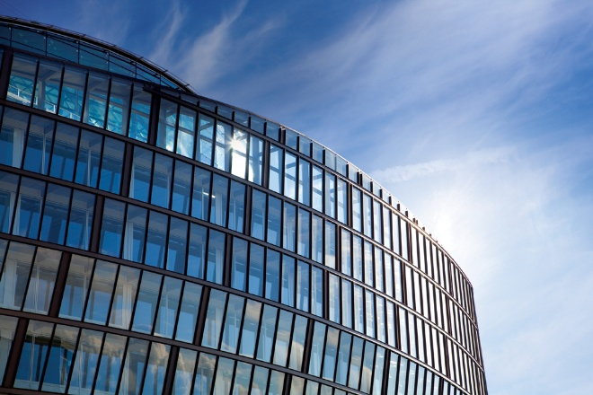

But does it work?
Hitchmough summarises his practice’s design approach to the Co-op as one marked by flexibility, resilience and sustainability. “There’s no such thing as timeless architecture,” he maintains. “But this building is not a fashion statement, it’s an investment. By using a sober palette
of external materials - bronze, glass and concrete - we’re hopefully creating a building that’s both memorable and enduring.”
The Co-op HQ certainly represents a dynamic and expressive projection of the organisation’s principles, enriching the architectural heritage it established on the same site generations ago. It also marks a spirited extension of the once great British civic tradition - most evident in the ornate 19th-century mercantile palaces of cities like Manchester, London and Leeds – of buildings that form a carefully scripted symbolic representation of the corporate ideology of their owners.
Furthermore, for all the deference to its predecessor across the road, this is clearly a defiant piece of object architecture; it is designed to soar in isolation rather than to merge into context, and can trace a lineage from such projects as Ralph Erskine’s Hammersmith Ark and Norman Foster’s Greater London Building.
Although this autonomous approach and the figurative literalism of the design may both have been grounds for criticism, the building is ultimately redeemed and given character by the strength of its aesthetic, environmental and civic convictions, both inside and out. While
its swirling facade and playful rooftop massing make exciting contributions to the city’s streetscape and skyline, the exterior is still controlled enough to comprise a discernible top, middle and bottom, making a potentially chaotic composition comprehensible. As with the “ziggurat” rooftop terraces and the chasm-like atrium, this is a key example of how the building essentially packages radical gestures in a human and empathetic way.
For some, including perhaps our aforementioned Cabe commissioner, the Co-op is considered a rather boring brand, a safe pair of hands. Well, what may have been dismissed as prudish before our current economic maelstrom is increasingly valued as prudent. And now the Co-op’s new HQ is a perfect metaphor for the progressive reinvention on which the brand was founded.
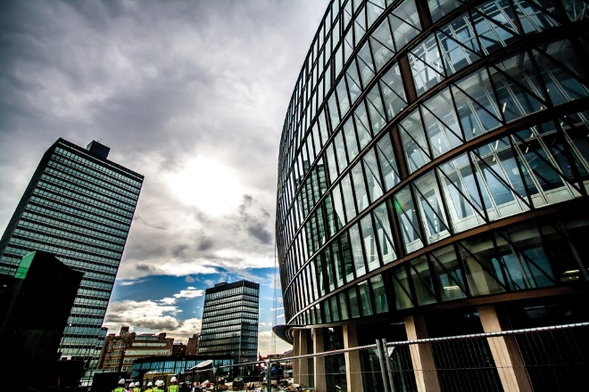

SUSTAINABLE TECHNOLOGY
3DReid divisional director Mike Hitchmough summarises the approach to sustainability at the Co-op, the UK’s highest rated BREEAM “Outstanding” offices (94.32%), as “pragmatic innovation”.
“It’s not about environmental ‘add-ons’ like wind turbines and solar panels. Sustainability here is a truly integrated part of the building and is also in line with the Co-op’s ethical corporate approach. It’s not about eco-bling,” he says.
The building has been designed to actually become more efficient as temperature rises. This resilience is achieved through an array of energy efficient features.
Fifty thousand litres of fresh air are sucked into the building every second via the three giant earth tubes poking up above the ground in the building’s landscaped forecourt. A stack system then distributes the air through the building via displacement vents, absorption into the thermal mass of the concrete and vertical extraction through the atrium. As the air below the ground retains a fairly stable temperature of about 12°C throughout the year, the amount of energy required to temper it to comfortable levels is also minimised.
The building’s double skin facade also acts as a duvet that insulates the building in the winter and facilitates ventilation in the summer. The gap between the single-glazed outer skin and the weatherproofed inner skin is open at the bottom but vented by louvers at the top. Solar control is also achieved by solar coating to the glass and the ingenious modulation of blade depths to the bronze mullions on the inner face of the outer skin. The depths are determined by the mullion’s position in relation to the building’s orientation, which essentially enables them to act like blinds that minimise solar glare when necessary.
That said, as Hitchmough wryly points out that “Manchester gets such little sunlight that the building is deliberately tilted to face southwards to grab as much energy as possible”. This is principally achieved through a heat recovery system in the atrium.
Other energy efficient measures include locally sourced materials (except for the bronze cladding), low-energy LED lighting in the atrium and a cogeneration CHP biofuel boiler running on waste cooking oil and rapeseed grown on the Co-op’s own farms. The waste heat from the boiler provides cooling via absorption chillers and chilled beams.
But Hitchmough is keen to stress that the building’s sustainability agenda has not just been delivered by features but by the attitude
of the clients. On the external outer skin, they paid an additional £120,000 for a bronze anodised rather than powder-coated finish as this came with a lifetime guarantee that would reduce maintenance costs.
Furthermore, their insistence on such a high degree of internal flexibility will ensure the building’s adaptability for future uses, delivering a more sustainable long-term structure.

PROJECT TEAM
client The Co-operative Group
architect 3DReid
contractor Bam
project manager Gardiner & Theobald
quantity surveyor Gardiner & Theobald
structural engineer Buro Happold
M&E engineer Buro Happold

