

MODULE CODE: Digital Skills for Personal Development and Business Growth BMSW4008

ASSESSMENT COMPONENT: PORTFOLIO

STUDENT NAME: KLAUDIA RUTKOWSKA
STUDENT NUMBER: 2515611
LECTURER: PHILIPPA FITZGERALD
DATE: 12/12/2025

I confirm that I have not presented any AI generated materials as my own work.
I confirm that I have copies of my drafts, notes, and other resources I used, which I may be asked to provide in evidence.

Contents
Task 1 3
Assessment of Digital Skills 3
References 7
Task 2 8
LinkedIn Learning Certificates for Office365 8
Task 3 11
Essay on Relevance of Excel in professional and personal life. 11
References 14
Task 4 15
Reflective Presentation 15

Task 1

Assessment of Digital Skills
Image 1
Screen shot of my JISC report.
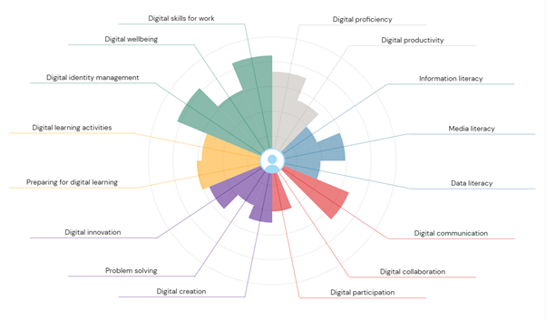
(JISC Digital Tool, 2025)

Digital Skills play a crucial role in the economy and in productivity across personal and professional life. Research has shown that most employers prefer the entry-level graduate employees to have already developed digital skills (Tee at al., 2024). Furthermore, the demand will be increasing due to the technology evolution and introduction of new tools (Tee at al., 2024). Regarding education, older adult learners are more likely to enrol for online courses than younger adults (Gardner, et al., 2022), which suggests that they should be capable of utilising online tools for successful study journey.

I am satisfied with the results of my JISC test. My digital skills for work have already been developed and the results confirmed that. The test has given me confidence and motivated me to work on other skills that are less developed. I strongly believe that the basic knowledge I have provides a good start for further improvement. My only unexpected insight was a weakness in problem-solving which I strongly consider to be my big strength in real life and work environment. However, I am aware that I usually seek help from others with IT issues, therefore, I would like to improve and become more independent.
My biggest strength is Digital Identity Management. I have experience in managing my identity in face-to-face and online interaction. I am aware of the numerous training opportunities available online and I take part in them whenever possible. As a result, I maintain my social identity very carefully across online platforms. My profiles on LinkedIn, Facebook and Instagram are synchronised.
My second strength is Digital Skills for Work. ‘’Digital skills are observed as a necessary precondition of a person’s employment status’’ (Dordevic, Milanovic and Radosavljevic, 2025). I had a good understanding of digital skills by the time I finished high school, and I developed them further during my work experience. I utilise my already good knowledge and I am committed to excelling further. University tasks and lectures often remind me of tools that I had forgotten about or had not considered using them previously.
My main area for improvement is Digital Collaboration. I have a good understanding of the basic tools available for digital collaboration. However, I plan to use them more often and explore other options, as I believe it can help the development of my people-management skills. I have avoided digital collaboration for the past few years, but the JISC test helped me understand its importance. Froese (2025) discusses how virtual work is replacing international business travel which highlights the importance of online collaboration among employees.
Second area for development is Information and Data Literacy. I experience difficulties finding and understanding academic or professional sources supporting my research. I am aware of my critical thinking limitations; hence I make the use of the tools provided by the university and practice them. Regarding data literacy, I consider it essential to understand how to evaluate the data online. Especially for my and my client’s safety. I also utilise online forms, questionnaires for my professional and personal purposes, which helps to learn through practical application. Ghodoosi (2025) states that data literacy can be improved by exploring the perspectives and expectations of stakeholders, educators and business leaders.

By improving these skills, I will benefit from higher productivity at professional and academic life, enhanced quality leadership and improved decision-making based on my data literacy and analysis skills. In my academic journey, the primary goal is to produce quality academic work, such as reports and data analysis. Therefore, engaging with other students and improving my information literacy will lead me to my success.

Improvement is achieved through practice; hence I set out a SMART goals plan below to improve my skills in the coming semesters.

Specific | Measurable | Achievable | Relevant | Time-bound
Using three tools to improve my data literacy | Complete weekly research on the content from the lectures. | Using digital tools, I learnt about at the university and courses. | Improving my critical thinking skills and writing my reports. | Achieve this goal at the time of my next assignment.
Committing to volunteer work to improve collaboration with others | Being a part of a team each semester and asking feedback from the leaders. | Open access to group via university. | Improving my online collaboration with others and my management skills. | Achieve this goal by the end of next semester.
Taking part at online debates to improve online communication | Interacting online with five people every week. | Using social media platforms allows me to debate about subjects of my interest. | Improving online collaboration and exploring online tools. | Achieve this goal by July 2026.

Image 2
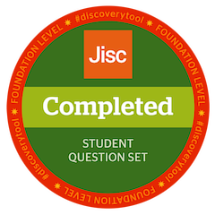
(JISC Digital Badge, 2025)

Image 3

(JISC Digital Badge, 2025)

References

Dordevic, B., Milanovic Zbiljic, S. and Radosavljevic, M. (2025) ‘Impact of the digital skills on employability: Cross-sectional analysis’, Economies, 13(7), pp. 1–16. Available at: https://doi.org/10.3390/economies13070196.

Froese, F.J. et al. (2025) ‘Global virtual work: a review, integrative framework, and future research opportunities’, Journal of international business studies, 56(6), pp. 691–719. Available at: https://doi.org/10.1057/s41267-025-00775-1.

Gardner, A. C. et al. (2022) ‘Online Postsecondary Adult Learners: An Analysis of Adult Learner Characteristics and Online Course Taking Preferences’, American Journal of Distance Education, 36(3), pp. 176–192. doi: 10.1080/08923647.2021.1928434.

Ghodoosi, B. et al. (2025) ‘Perceptions of data literacy and data literacy education’, Journal of librarianship and information science, 57(3), pp. 822–832. Available at: https://doi.org/10.1177/09610006241246789.

TEE, P.K., WONG, L.C., MORAKINYO, D., SONG, B.L. and NG, C.P., 2024. Demand for digital skills, skill gaps and graduate employability: Evidence from employers in Malaysia. F1000Research, 13.

Task 2

LinkedIn Learning Certificates for Office365
My LinkedIn certificate for Power Point:


My LinkedIn certificate for Word:


My LinkedIn certificate for Excel:


Task 3

Essay on Relevance of Excel in professional and personal life.

Microsoft Excel program is recognised worldwide for its extensive areas of use across professional, educational and personal environments. Its wide range of tools has been utilised for both simple and more extensive datasets. It supports calculation, presentation and organisation of big datasets which can be stored in one place. As part of Microsoft 365 stands next to applications such as PowerPoint and Word and is accessible on computers, laptops, tablets and mobile phones. The comfortable format makes it a universal tool suitable for different users with differences such age, experience or profession.
Program performs many important tasks for different organisations.
Rosener (2024) explains that ‘’MS Excel offers a comprehensive suite of features including advanced formulas, powerful charting capabilities, data analysis tools, and visualization options. It also supports macros, and other automation and customization features. For example, it can employee’s tracker with personal information, training records and attendance. This supports structuring and organising the resources in the business. Organisations such as schools, GPs, social groups benefit from these advantages. Visualisation is another benefit. Utilisation of tools such pivot tables and charts help the communication by providing simple visual information, for example providing a break down of people hired in each region or breakdown of people based in each company office. These tools are especially helpful for people with preferences of visual content rather than data spreadsheet.
Productivity is essential for any institution and Excel provides options of reducing repetitive tasks. Formulas are the main tool decreasing the time of manual calculations and data input, pivot tables allow to summaries data automatically and filter options allow to search for a specific data in one sheet avoiding the need of creating several lists. Main point supporting productivity is the fact that the worksheet can be saved as a template and utilised at any point in time.
Automation allows employees to utilise their skills on tasks that require human impact. Olafusi (2024) supports the importance of automation such as Excel that allows for constantly updated information data for any organisation. For example utilisation of advanced formulas such as vlookup allowing to match the data even between two different files. This saves time, increases productivity and reduces the risk of mistakes, especially while working under pressure.
OneDrive, as part of Microsoft 365 allows Excel files to be saved, shared and edited by multiple other users at the same time. This supports online collaboration which is becoming very important in workplaces around the world. Remote work, international travels and teamwork require tools allowing people to work together from different locations. Collaboration within users is not the only advantage of the program, it can also be integrated in other applications which allows more extensive use. ‘’ Microsoft Excel has powerful capabilities, which are strongly valued and used both by individuals and in every company for a large diversity of tasks.’’ (Ramos, 2021). In the research author discusses the possibility of integrating other programs into Excel which improves its collaboration with other platforms and helps extending the range of tools (Ramos, 2021). That is a big benefit for every industry using management systems like logistics, construction or hospitality. Research shows that combining Excel with other software has a significant advantage on project management, which mainly focuses on the excess of calculations and graphical needs (Hu, 2020).
Everyone at least once in their life must make an important financial decision such as investing in a business, buying a house or renovating already owned house, even purchasing a new car. Excel is widely used in financial decision-making by supporting individuals in tracking their expenses, forecasting income and creating financial plans. For years electronic technologies supported reducing the amount of manual calculations and helped people avoiding mistakes. Therefore, Microsoft Excel helps optimising savings and investments costs which can affect the final investment decision (Hordei, et al., 2021). A spreadsheet can calculate costs, keep track of progress, create a timeline and help organise the required steps. Combining all this data together allows individuals to analyse their situation and helps making informed decisions.
Following the financial aspect, time management is another area where Excel provides strong support. In both professional and personal use, effective planning can save time and improve organisation. Research shows that Excel tools can assist with planning events, organising work hours, scheduling meetings, or manging lunch breaks and annual leave. Business using Excel planning tools has been using it since January 2019 and reported significant reduction of the time required for daily scheduling to be under four hours (Bailey, 2020). Another study shows that the time of production plan papers was reduced by 1.36 minutes using the automated tools (Kalwar, et al., 2023). The main goals for the business were decreasing the chances of errors and increasing the reporting efficiency (Kalwar, et al., 2023). At a personal level, Excel provides templates such calendars, task lists and planners supporting time efficiency and organisation.
In conclusion, Microsoft Excel can be a very basic tool or an advanced spreadsheet depending on user requirements. With its support of data management and analysis, financial planning, automation and visualisation, decision-making support and being so universal in use across industries all around the world, it helps people communicate the information more effectively and most importantly – with reduced chances of mistakes. From planning daily tasks and creating household expenditures, to advanced data trackers in business – Microsoft Excel is one of the most thoughtful tools combining a range of options to support personal and professional life.

Please see below attached Excel expenditure for a family of four. The spreadsheet demonstrates the importance of Excel and its support in real life.

References

Bailey, M.D. and Waddell, L.A. (2020) ‘Daily Tutor Scheduling Support at Hopeful Journeys Educational Center’, INFORMS journal on applied analytics, 50(5), pp. 287–297. Available at: https://doi.org/10.1287/inte.2020.1039.

Hordei, O. et al. (2021) ‘Optimization of the Investment Portfolio in the Environment of Table Processor MS Excel’, Estudios de economía aplicada, 39(5). Available at: https://doi.org/10.25115/eea.v39i5.4983.

Hu, W. and Panthi, K. (2020) ‘Project status reporting system (PSRS) for pipeline relocation programs’, Built environment project and asset management, 10(5), pp. 693–708. Available at: https://doi.org/10.1108/BEPAM-09-2019-0075.

Kalwar, M.A. et al. (2023) ‘Automation of production plan generating workbook at leather footwear company of Lahore Pakistan by using VBA in Microsoft Excel’, Journal of applied research in technology & engineering, 4(2), pp. 111–129. Available at: https://doi.org/10.4995/jarte.2023.18941.

Olafusi, M. and Oyinbooke, O. (2024) Building Interactive Dashboards in Microsoft 365 Excel: Harness the new features and formulae in M365 Excel to create dynamic, automated dashboards. 1st edn. Birmingham: Packt Publishing.

Ramos, P., Botelho, L. and Martins, A.G. (2021) ‘Enhancing Excel business tools with additional relational and recursive capabilities’, International journal of information technology and management, 20(4), pp. 356–376. Available at: https://doi.org/10.1504/IJITM.2021.119894.

Rosener, W.J. (2024) ‘Comparative Analysis of Google Sheets and Microsoft Excel: A Discussion Case in Spreadsheet Software’, Journal of cases on information technology, 26(1), pp. 1–21. Available at: https://doi.org/10.4018/JCIT.351672.

Task 4

Reflective Presentation
Slide 1
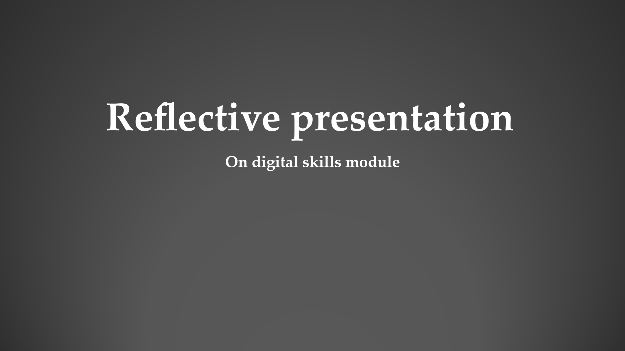
Slide 2
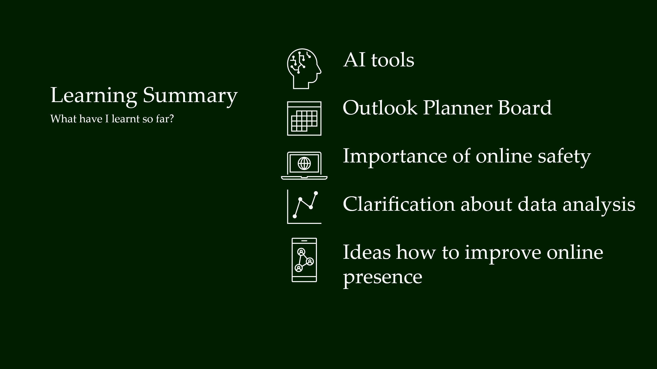

Slide 3
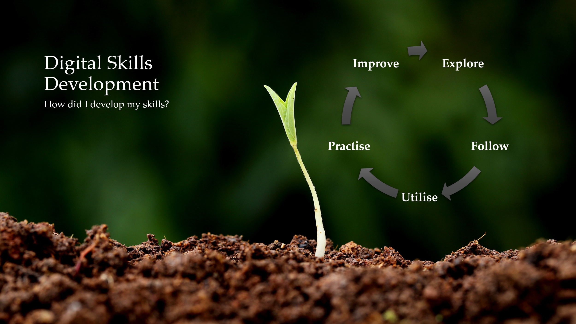
Slide 4
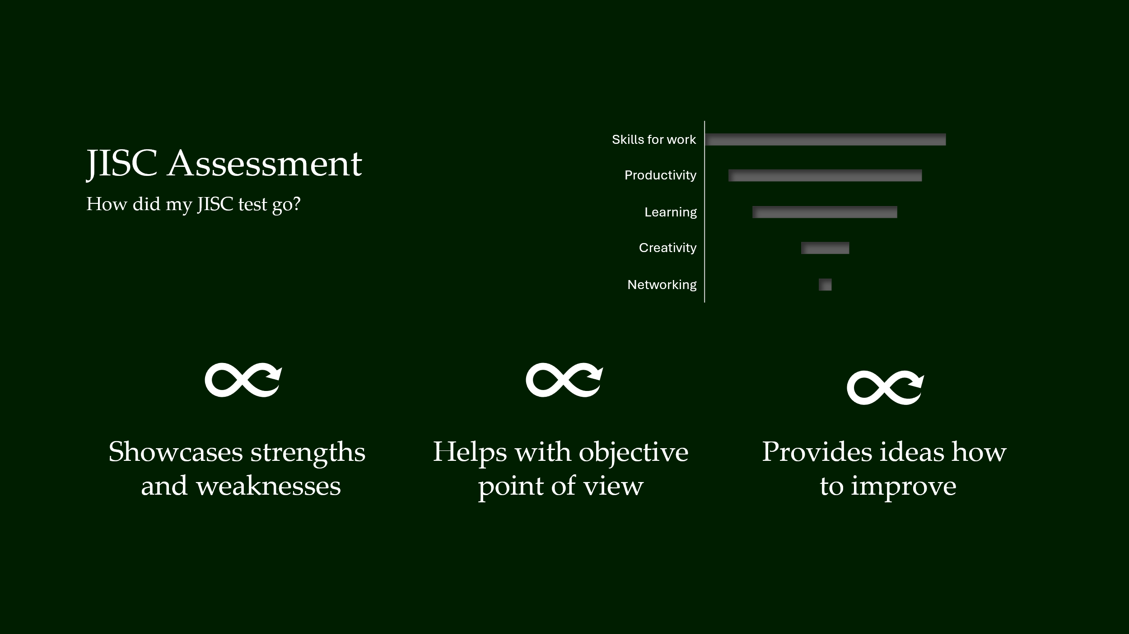

Slide 5
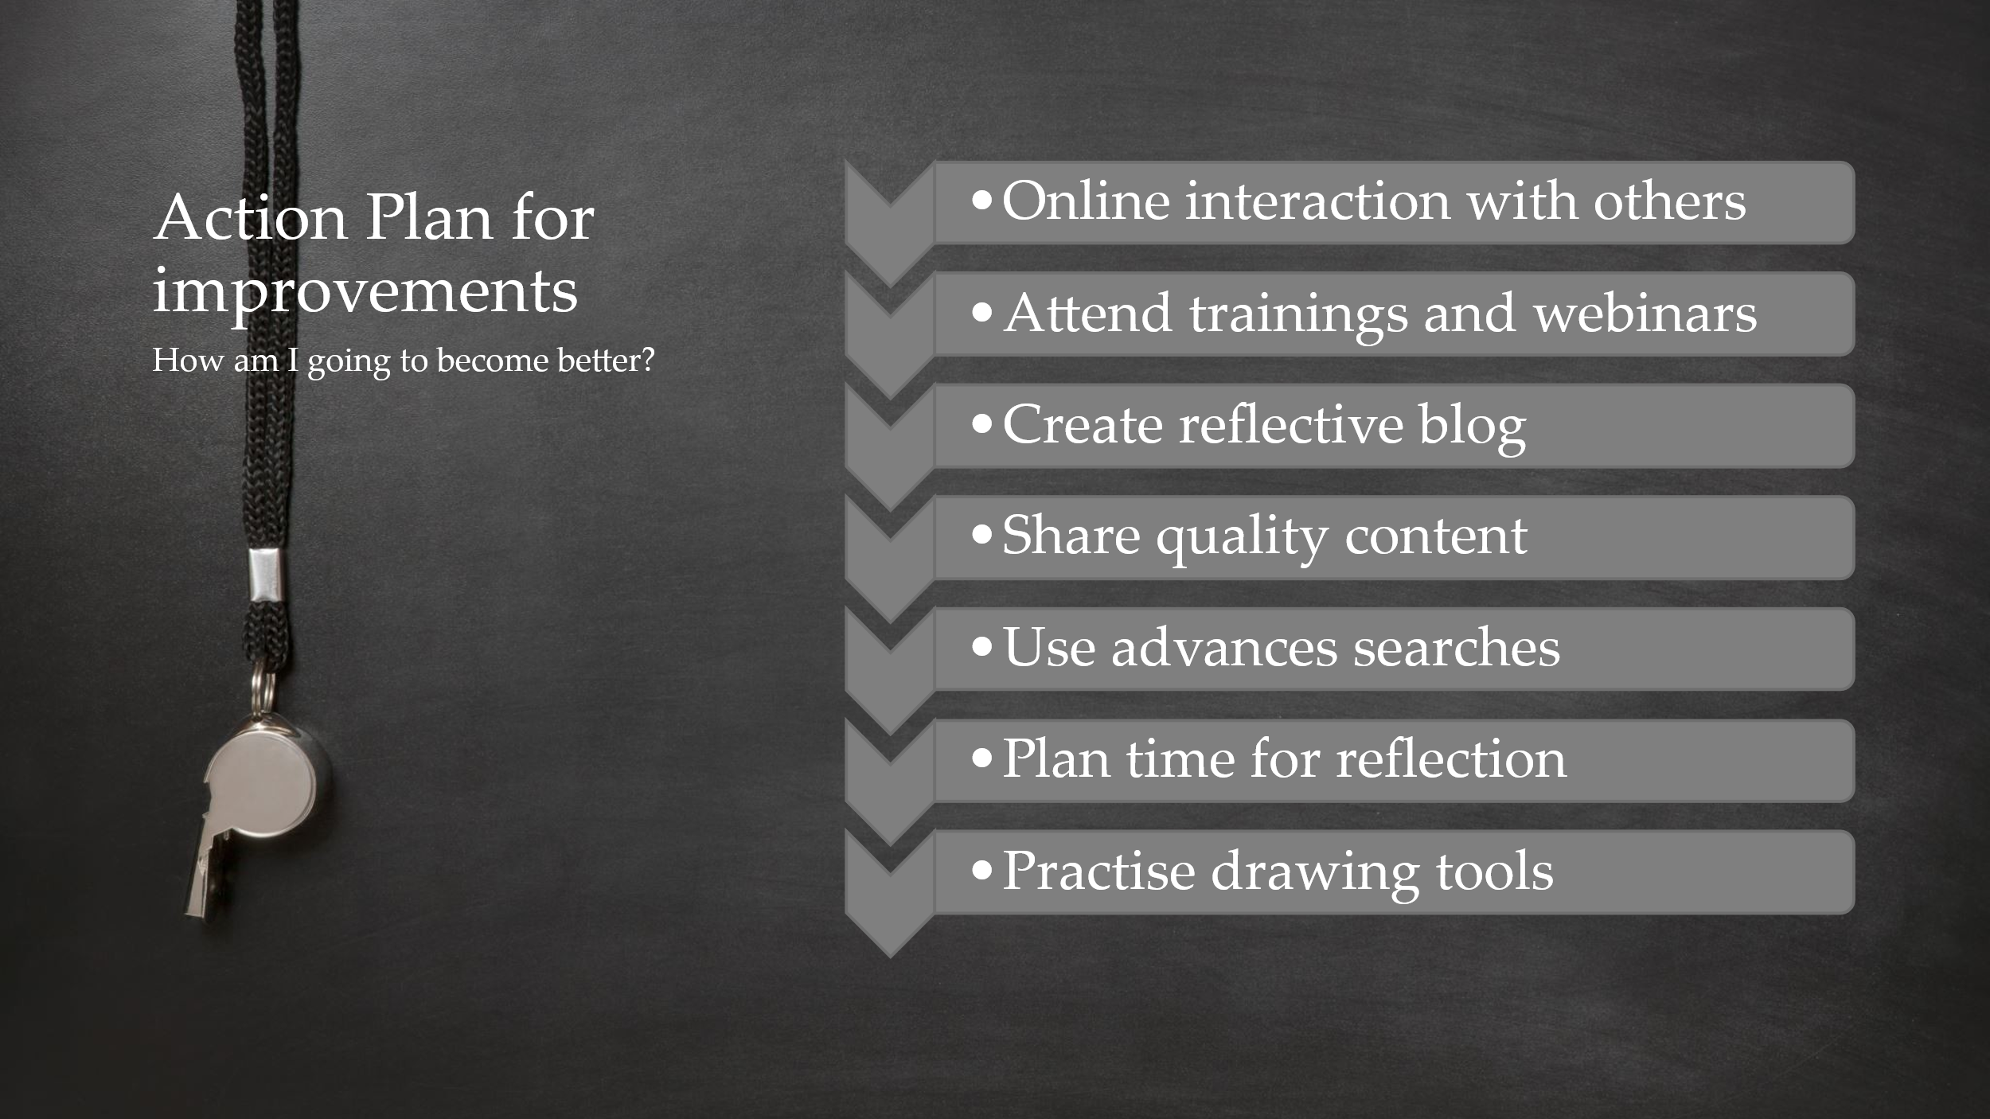
Slide 6
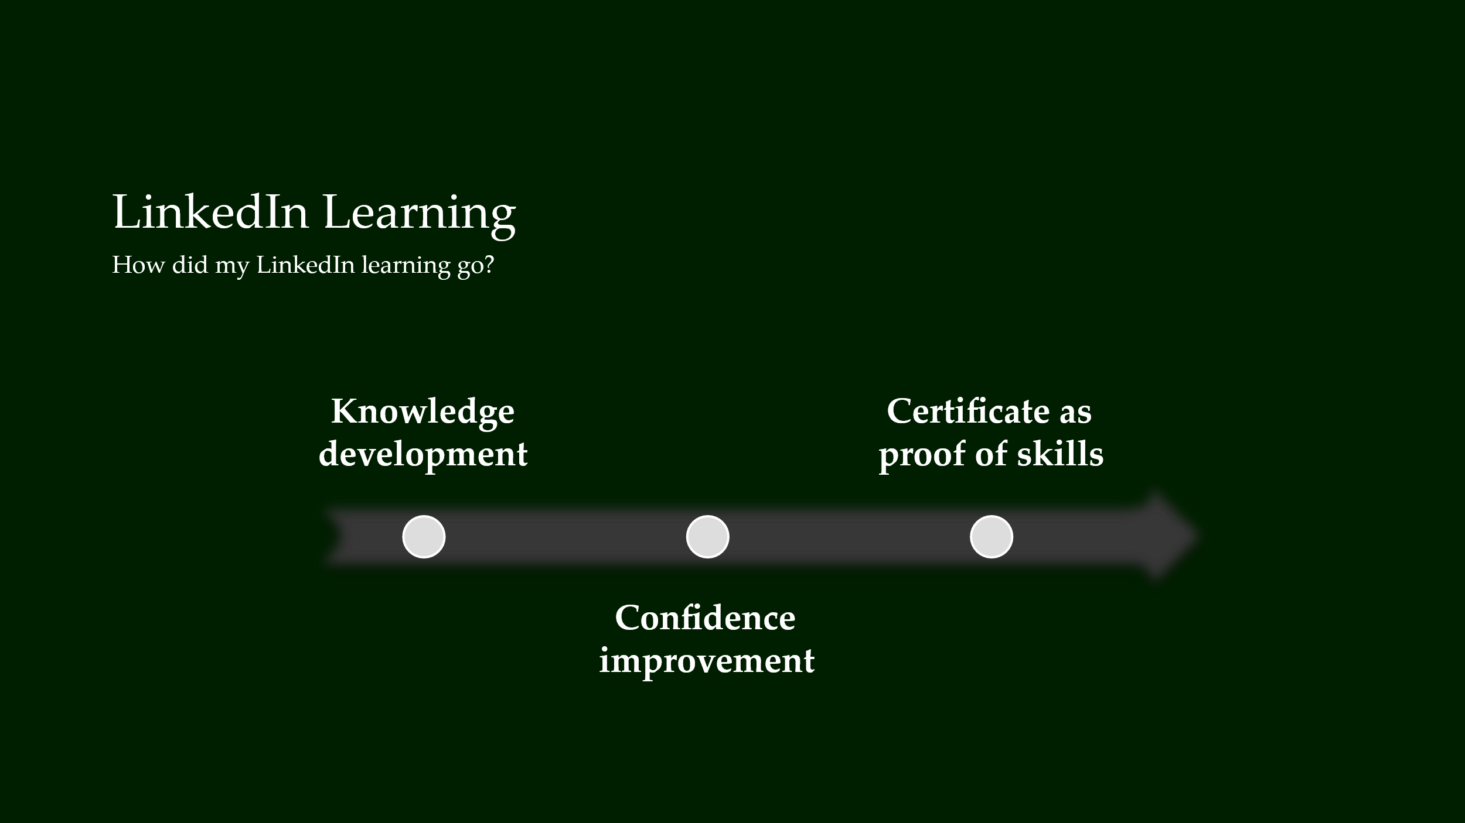

Slide 7
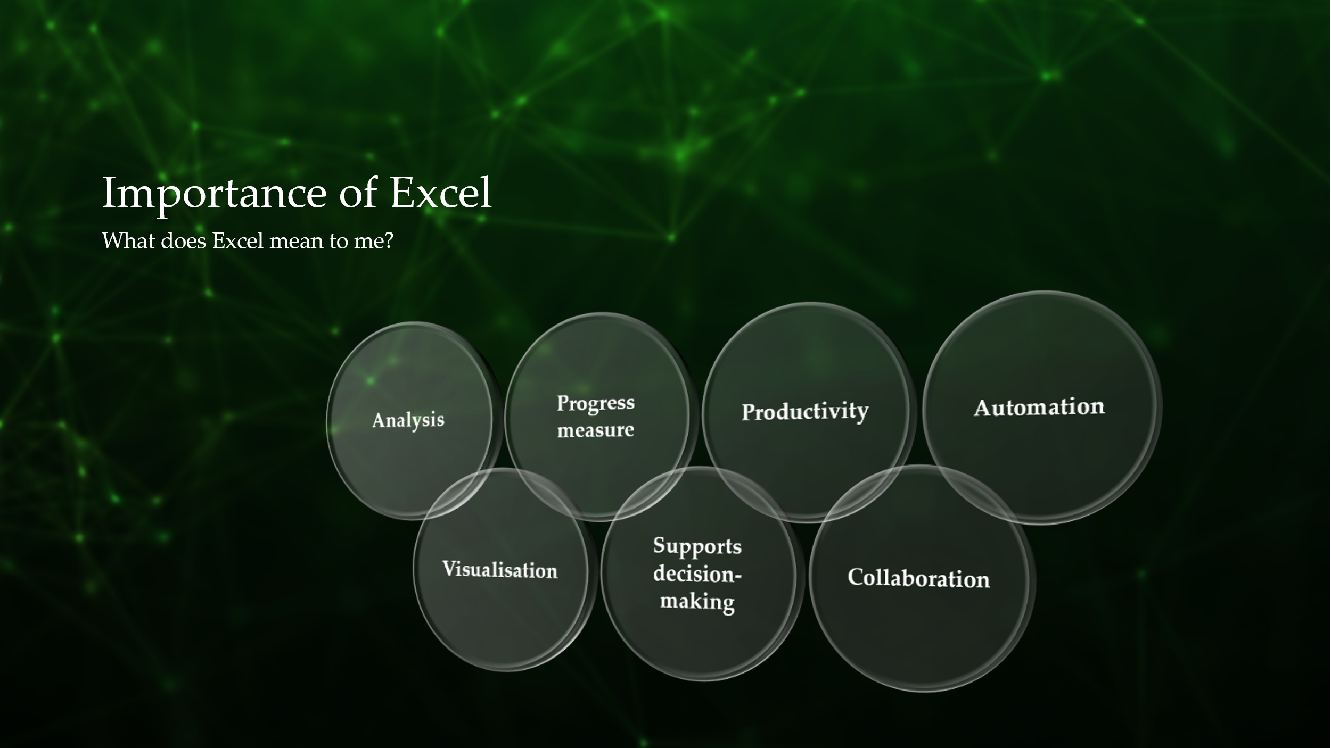
Slide 8
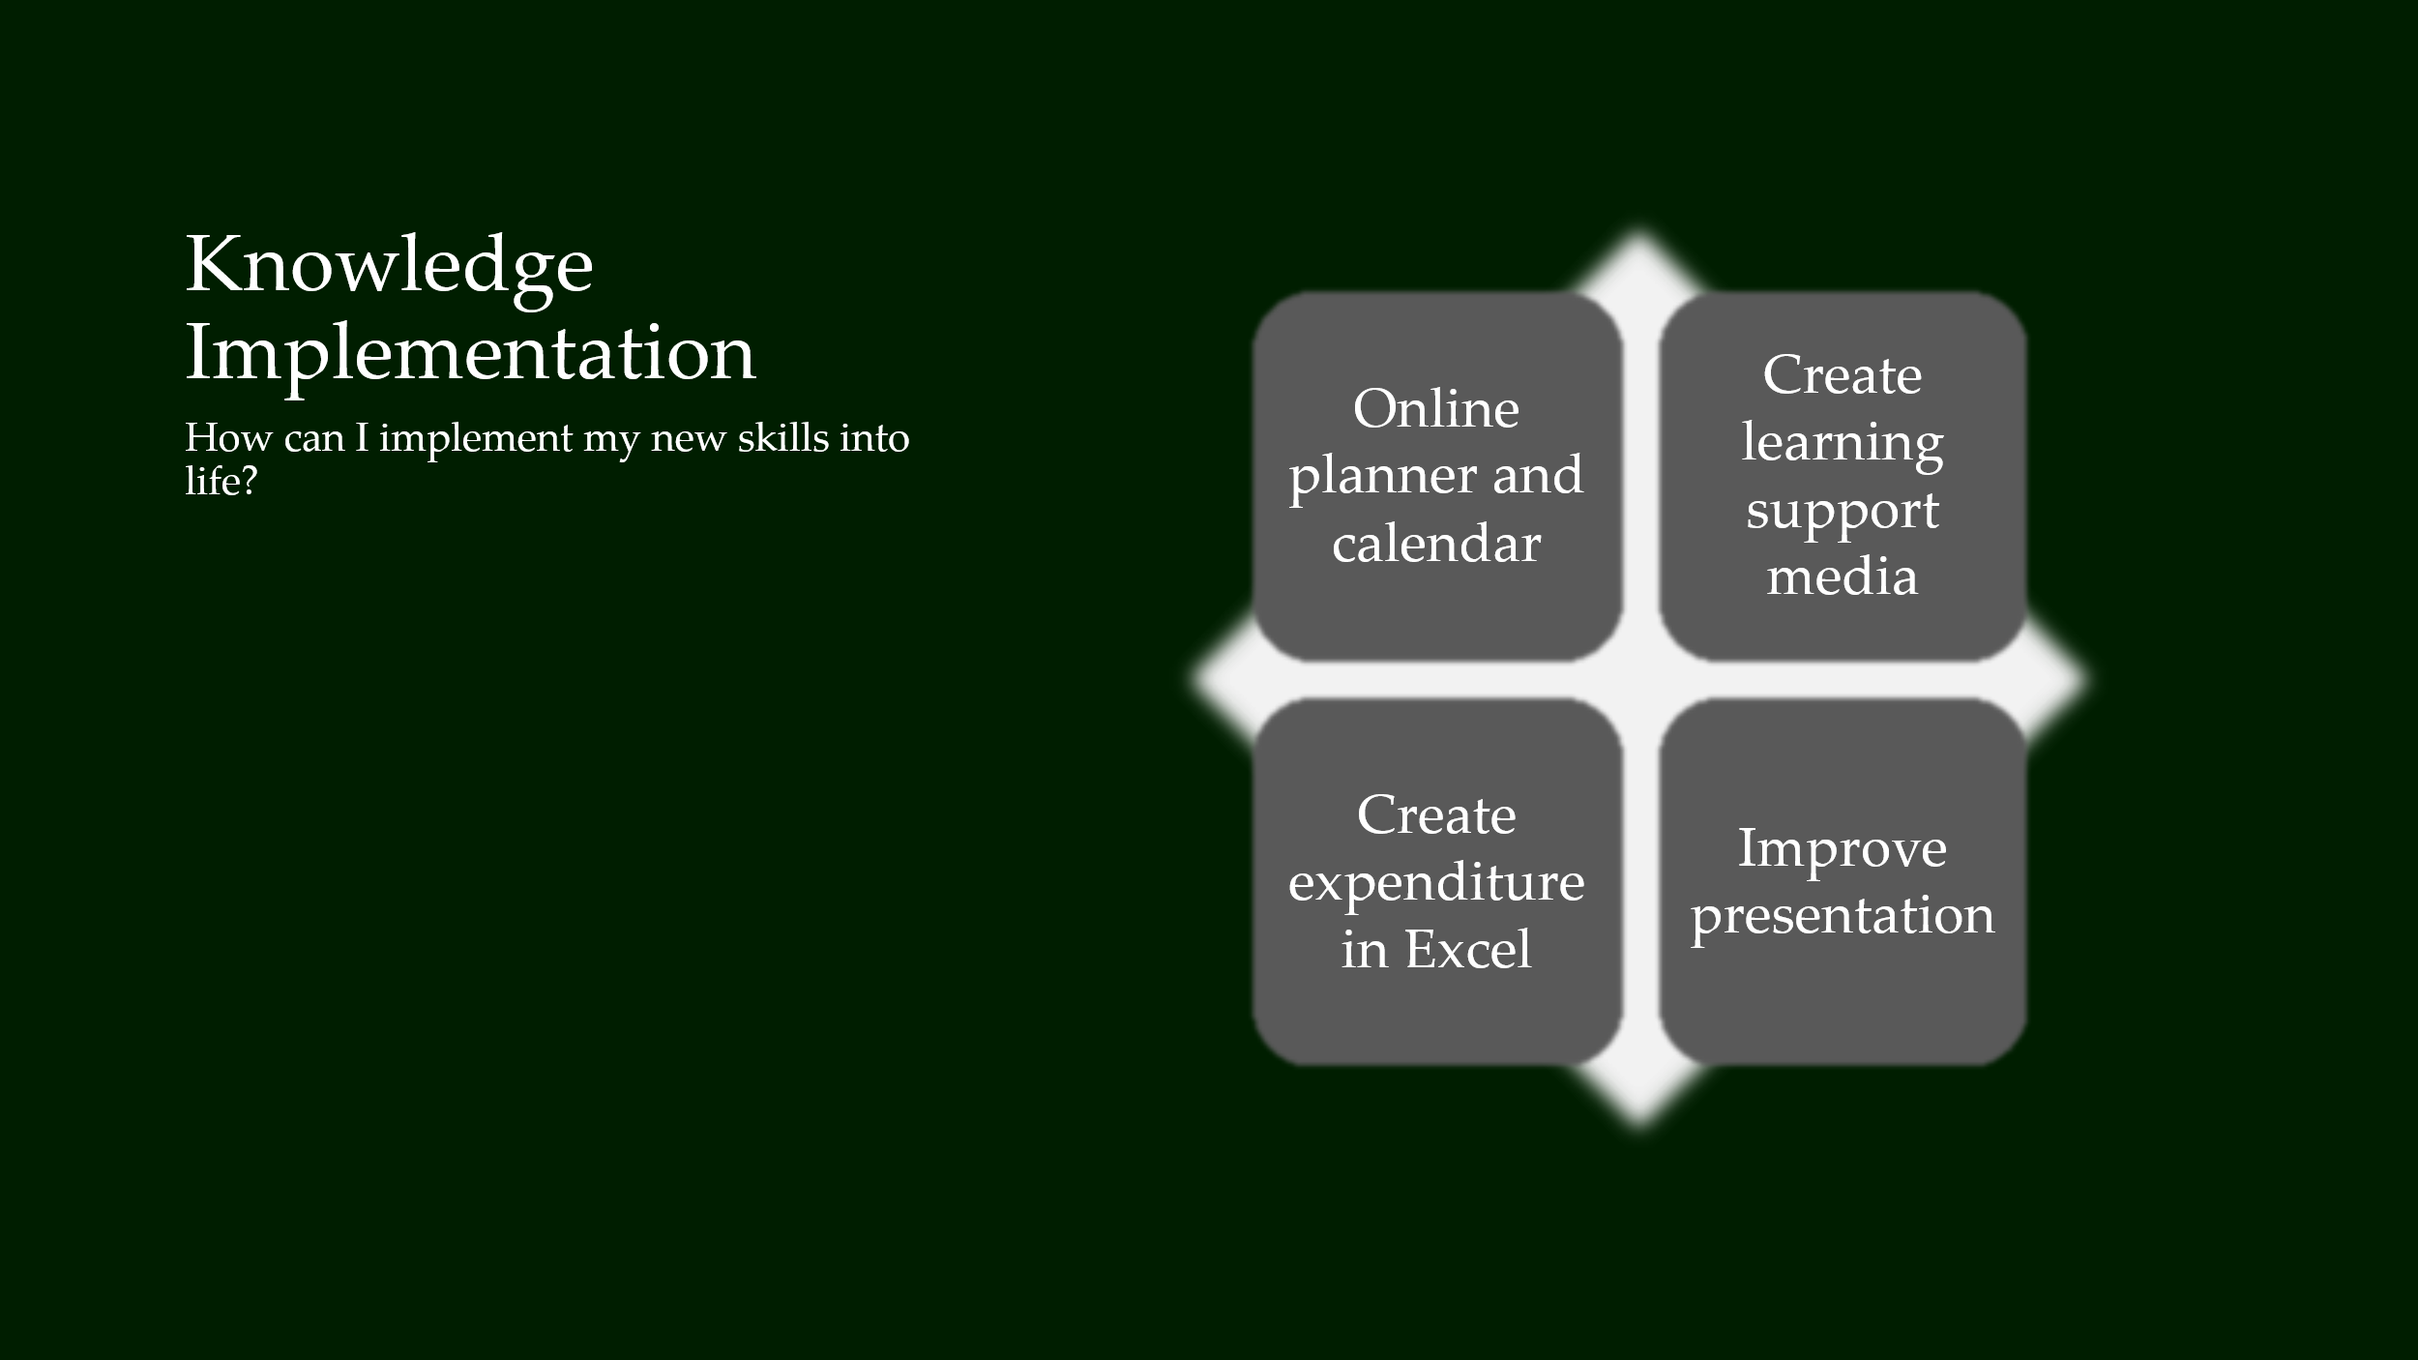

Slide 9

Slide 10


Slide 11


