
What does ‘Age’ mean?
Aging is an evitable process, that is experienced by everybody. With age, there are changes that occur physically, intellectual, emotionally and socially (WHO, 2021). For instance, WHO (2021) highlight that with age, there is an increased likelihood of health risks, poor mental well-being and death (WHO, 2021). Additionally, physical changes can occur with an individual’s skin, bones, hair, height, muscles, teeth and weight (University of Cincinnati, 2011).

(Image 1, 2021)
Congratulations! You have reached the Retirement Age, what happens next?

What does ‘Well-being’ mean?
Well-being refers to an individual’s happiness, it explores the factors that can have an effect; it explores a person’s ability to function for everyday tasks, their engagement to social relationships, and their self-actualisation (Mental Health Foundation, 2021). However, it is important to recognise that wellbeing does not consist of being happy all the time (MIND, 2021) it reinforces an individual to build their mental wellbeing to cope with positive, and negative experiences (MIND, 2021).

‘...I love the unhurried pace of life and the freedom to choose what I’ll do on any particular day. I’m time rich, and almost never hurried or tired. If I get tired, I’m free to rest...’ (Retirement Stories, 2012).

Planning Retirement
Plan financially
It has been recommended that financial planning should start two years before you are planning to retire, this will prepare the individual to have a realistic picture of their retirement. Firstly, you should look how much have you contributed to national insurance (The Money Advice Service 2021). Additionally, research the potential benefit support once you are officially retired; they follow as, a senior pass, cold weather payments / fuel payments, free TV licence, support with care needs, lone pensioner benefit, and carers allowance (ni Government Services, no date). Equally important, The Money Advice Service (2021) have stated alongside national insurance and possible benefit support, the individual should seek any savings they have or investments they are not aware of, which may affect their retirement date (The Money Advice Service, 2021).
Explore a new hobby
Hobbies are not limited by age, or subject area for example, they are led by the person’s interest, for instance, gardening, learning a new language, knitting, bowling, or arts and crafts (Acts Retirement Life Communities 2021). Furthermore, Age UK highlight that having a hobby can replace an individual’s life purpose once they get older, and retire (Age UK, 2019). Moreover, having hobbies provide physical and mental advantages (Act Retirement Life Communities, 2021).
Engage with activities that enable socialisation
It is important to note that hobbies can encourage an individual to socialise or have an independent interest (Umberson and Montez, 2010). However, it is paramount when an individual reaches retirement age for instance; their main social interaction stems from their work environment (Umberson and Montez, 2010). Moreover, in order to replace that communication, engaging in a hobby or an activity will be beneficial to their health and mental wellbeing (Umberson and Montez, 2010).

‘...I love the unhurried pace of life and the freedom to choose what I’ll do on any particular day. I’m time rich, and almost never hurried or tired. If I get tired, I’m free to rest...’ (Retirement Stories, 2012).

Volunteering
Once retired, many people seek the comfort of routine and socialisation which they do not have when they have finished working (Age UK, 2013) Additionally, Volunteering offers a sense of giving, Age UK (2013) interviewed an individual who revealed that his days felt empty, and he was missing the company of other people (Age UK, 2013).
Stay in Employment
When looking at retirement opportunities, it may appear that retirement may not be realistic to many individuals for example, financial aspects or / and emotional attachments (Age UK, 2020). In the past, there was no policy or legislation to protect people who did not want to retire at a certain age, previously it was Sixty-Five. Then, Age UK (2020) campaigned to have the law altered, in modern society there is now a law that states an employer can not dismiss you due to your age. It is important to recognise that employers do have right to end employment because of poor performance, or limited abilities in the job role (Age UK, 2020). This enables the person to stay in work, while actively planning retirement in a timeline that suits their current, and future lifestyle (Age UK, 2020).
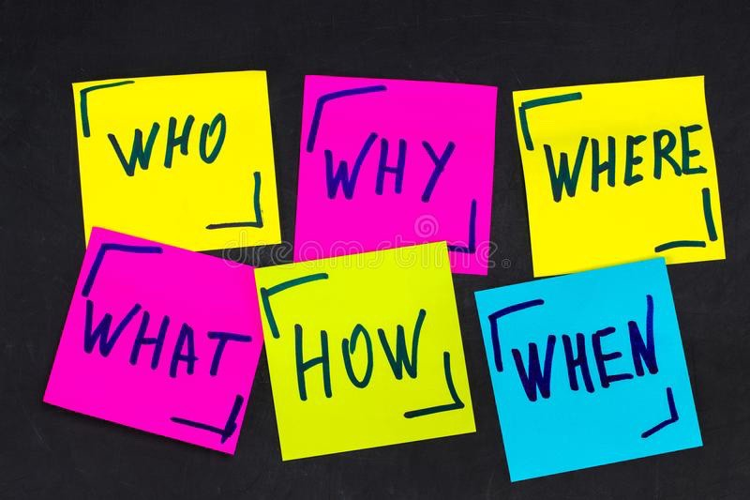

(Image 2, 2019)

Legislation and Policy
The Equality Act (2015)
The Act was introduced to merge previous legislation into a simpler format that covers all the relevant information, one of the main intentions of the act is to protect those who have a protected characteristic; they follow as, age, sexual orientation, disability, gender reassignment, gender, religion, race, marriage/partnership, pregnancy, and maternity (Equality Human Rights, 2020). Furthermore, discriminating an individual due to their age is against the law, this shields individual from harassment, victimisation, direct, indirect discrimination (Age UK, 2020).
National Service Framework for Older People (2001)
This framework relates to those who reside in Wales, the main of the policy is to polish and maintain the foundations of the Health and Social Care sector, in order to support and address the needs of the older generation effectively (Welsh Assembly Government, p7. 2006). The Welsh Government (2006) reveal that there are many older individuals and groups that lead a heathy life with no posing health risks in Wales However, they express concern as with age, there is an increased likelihood of impairments, disability, and loss of independents that will need the intervention of National Health Service (NHS) services (Welsh Assembly Government, 2006. p7-p8). It may be beneficial to check a heath check to explore if you are entitled to any support from your local government.
Employment Equality (Age) Regulations (2006)
The Act was formed in 2006, this legislation recognises that discrimination of age can occur with individuals who are young, middle aged, or elderly (University and College Union, 2006). Moreover, the act protects those who are employed, seeking for jobs, participating in vocational training, and agency contracts (Local Government Association, 2021). Additionally, it is important to recognise that those who are undertaking voluntary work are not included within the legislation (Local Government Association, 2021).

Supporting Organisations
There is a list below of charities and organisations within the United Kingdom, who are currently providing guidance and support to individuals that are placed in the ‘Older Age’ category. For instance, they support those who may be lonely, distressed, worried, activities / events and mental and physical health (Associated Stairlifts, 2019).

Hierarchy of Needs – Abraham Maslow
Maslow (1954) introduced a theory entitled ‘The Hierarchy of Needs’. The concept places attention on human needs and their motivation. Additionally, the theory is presented in a triangle shape which illustrates the different levels (Johnson 2009. p22). To begin, Maslow (1954) has stated that a person’s Physiological needs are placed at the bottom of the model; they follow as, access to fresh air, clean water, food, warmth, housing, sleep and clothing (Johnson 2009. p22).

Age International
Friends of the Elderly
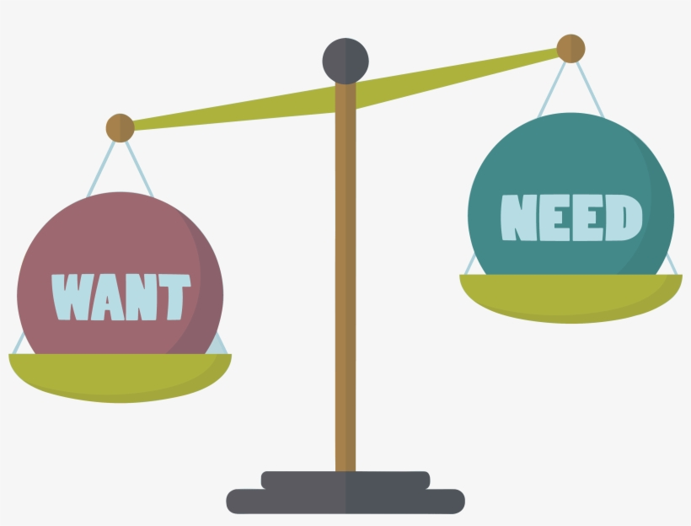
Age Space
The Cinnamon Trust
Social Services
National institute of Aging
Independent Age
Age UK
Citizens Advice
(Image 4, no date)

Support and Guidance
Secondly, the next stage is called Safety this compromises of an individual’s ability to acquire financial stability, property, items and security (Johnson 2009. p22). Additionally, the third stage refers to Love, for instance, this involves developing, and maintaining intimate relationships and friendships (Johnson 2009. p22).
Furthermore, the fourth stage explores an individual’s esteem needs; for example, their mental wellbeing, feelings, respect for themselves, and recognitions (Johnson 2009. p22). To end, the final level is entitled Self-Actualisation, according to Maslow (1954) this is when a person achieves all four of lower levels, and they recognise and achieve their full potential (Johnson 2009. p22).

(Image 3, 2018)
Rationale
This piece of work was produced to educate and highlight positive living when an individual approaches retirement age. Age UK (2020) report that the retirement age is gradually, but steadily progressing as society grows; by 2028, the age for retirement will reach Sixty-Seven (Age, UK). The reason I chose to explore this topic is because everybody will age, and experience some, or all of the issues and ideas raised in the leaflet. Furthermore, in contrast to previous generations life expectancy has improved drastically. I think it is important to recognise and inform individuals on aging, it’s mental wellbeing and physical affects (McGuire, 2017. p1879).
This leaflet is intended to individual’s starting from young adulthood, through to middle adulthood and ending at maturity. Erikson (1902) explored psychological development in all stages of life, the information in the leaflet may interest individuals aged between Nineteen, to death in Erikson’s (1902) proposed stages (Syed and Mclean, 2017. P2). Additionally, his work concluded that individuals experience milestones throughout their life, he categorised these events by age, conflict important occasions and the final outcome (Syed and Mclean, 2017. P3) Furthermore, while planning, or taking retirement Erikson (1902) has revealed that in young adulthood the individual will encounter events for example Intimacy versus Isolation (Syed and Mclean, 2017. P3). Secondly, notably middle adulthood poses a similar experience, but the individual may have a disagreement between Generativity versus Stagnation (Syed and Mclean, 2017. P3). Lastly, when an individual reaches maturity, they may have to choose between Ego Integrity versus Despair (Syed and Mclean, 2017. P3). Taking into account all these conflicts and changes, it highlights the importance of support during the process of aging and retirement.
When designing the leaflet intended for the older generation, it was paramount to ensure that the individuals would be attracted it, and the leaflet would be easy understand for the reader. In order to do this, choosing the correct colour pallet; Sunrise Senior Living (2021) states that establishing a colour theme will draw attention to the piece of work, creating ‘rooms’ (Sunrise Senior Living, 2021). However, it is essential to pick a colour pallet that agrees with the audience, in this instance the audience is older people; it has been proven that a person’s eyes age the eyes find it difficult to differentiate between similar colours, for example, telling a red colour from a purple (Sunrise Senior Living, 2021). In the leaflet, I have chosen a main colour theme of yellow and green, I have also used black to emphasize a quote as I wanted to bring attention its attention to the reader. When exploring the style of the leaflet, I needed to think about the font, that is the centre of the leaflet, that is how the information is produced. UX Matters (2010) recommend that sans serif fonts are ideal for those will older vison. In particular, they name fonts like Helvetica or Ariel (UX Matters, 2010). In addition to this, they have also advised creators to use a reasonable sized font such as, 11 or 12 sized fonts. (UX Matters, 2010). Within the leaflet, I have used the Helvetica font and I have not used font under 11.5 in my work to ensure the information is read easily. When looking at the layout of the text, Clear Sight Books (2017) guide people on how to make their headings stand out of the text; for instance, bigger font, bold, centring and underlining (Clear Sight Books, 2017). In my piece of work, I used subheadings to break up the text for the reader, I used headings that were centred, and the font was bold. Using images in a leaflet, can incise the reader, Digital Printing (2013) said that the right image can make more of an impact than a block of words on a page, the readers eyes will divert to the images and connect, or want to carry on reading the leaflet (Digital Printing, 2013). However, they highlight that a leaflet should not be overpowered by images, they recommend using no more than Six images. In my leaflet, I have decided to use four images to represent my talking points and attract the reader. Northumbria University (2019) have praised the use of mind maps, the benefits they have listed; memories, the ability to recall information, problem solving, gathering information, stimulation, time management and note taking (Northumbria University, 2019). On the final page of my leaflet, I decided that I was going to present a mind map of charities and organisations that guide and support individuals who are at the old age category. Referring back to the Northumbria Universities findings, I found it necessary to produce a mind map so it the important information is easy to look may at and aids in their memory and recall.

References
Retirement Stories.com (2012) My Retirement Story. Available: http://www.retirement-stories.com/my-retirement-story.html (Accessed: 16 February 2021).
World Health Organisation (2021) Aging and Heath. Available: https://www.who.int/news-room/fact-sheets/detail/ageing-and-health (Accessed: 1 February 2021).
University of Cincinnati (2011) Aging: Age Related Physical Changes. Available: https://nursing.uc.edu/content/dam/nursing/docs/CFAWD/Aging%20Series/Part%202%20Aging%20Physical%20Changes.pdf (Accessed: 1 February 2021).
Mental Health Foundation (2021) What is wellbeing, how can we measure it and how can we support people to improve it? Available: https://www.mentalhealth.org.uk/blog/what-wellbeing-how-can-we-measure-it-and-how-can-we-support-people-improve-it (Accessed: 1 February 2021).
MIND (2021) How to improve your mental wellbeing. Available: https://www.mind.org.uk/information-support/tips-for-everyday-living/wellbeing/wellbeing/ (Accessed: 1 February 2021).
Acts Retirement Life Communities (2021) The Importance of Retirement Hobbies. Available: https://www.actsretirement.org/latest-retirement-news/blog/2017/11/21/the-importance-of-retirement-hobbies/ (Accessed: 1 February 2021).
Age UK (2019) The importance of hobbies. Available: https://www.ageuk.org.uk/discover/2019/october/the-importance-of-hobbies/ (Accessed: 1 February 2021)
Umberson D. and Montez, J, K. (2010) ‘Social Relationships and Health: A Flashpoint for Health Policy’ Journal of Health and Social Behaviour. Vol 51 pp. 54-66 Doi: 10.1177/0022146510383501.
The Money Advice Service (2021) Checklist – Preparing for Retirement. Available: https://www.moneyadviceservice.org.uk/en/articles/checklist-things-to-do-as-retirement-approaches (Accessed: 1 February 2021).
Age UK (2013) Millions Volunteering in Retirement. Available: https://www.ageuk.org.uk/latest-news/archive/millions-volunteering-in-retirement/ (Accessed: 1 February 2021).
Ni Government Services (no date) In Retirement. Available: https://www.nidirect.gov.uk/information-and-services/benefits-and-financial-support/retirement (Accessed: 7 February 2021).
Associated Stairlifts (2019) A list of UK charities for the elderly. Available: https://www.associatedstairlifts.co.uk/a-list-of-charities-for-the-elderly/ (Accessed: 11 February 2021).
Age UK (2020) Changes to State Pension Age. Available: https://www.ageuk.org.uk/information-advice/money-legal/pensions/state-pension/changes-to-state-pension-age/#:~:text=State%20Pension%20age%20is%20gradually,as%20changes%20in%20life%20expectancy. (Accessed: 23 February 2021).
McGuire, S, L. 2017. Aging Education: A Worldwide Imperative. Creative Education. 08(12) pp. 1878-1891.
Syed, S, L., Mclean, K, C. 2017 Erikson’s Theory of Psychosocial Development. pp 1-7.
Sunrise Senior Living (2021) Design insider: what colours should you use for aging eyes? Available: https://www.sunriseseniorliving.com/blog/may-2015/what-colors-should-you-use-for-aging-eyes.aspx#:~:text=Avoid%20using%20predominately%20cool%20colors,red%20and%20yellow%20are%20best! (Accessed: 23 February 2021).
UX Matters (2010) Designing for senior citizens | organising your work schedule. Available: https://www.uxmatters.com/mt/archives/2010/05/designing-for-senior-citizens-organizing-your-work-schedule.php#:~:text=%E2%80%9CAs%20for%20fonts%2C%20sans%20serif,to%20make%20the%20type%20larger. (Accessed: 23 February 2021).
Clear Sight Books (2017) Tips for creating effecting headings. Available: https://clearsightbooks.com/tips-creating-effective-headings/ (Accessed: 23 February 2021).
Digital Printing (2013) The role of image for your flyer. Available: https://www.digitalprinting.co.uk/blog/the-role-of-images-for-your-flyer/ (Accessed: 23 February 2021
Northumbria University (no date) quick guide to mind mapping. Available: https://cragside.northumbria.ac.uk/Everyone/skillsplus/database_uploads/55388192.pdf (Accessed: 23 February 2021).
Images
Image 1 Available: http://www.forbes.com/sites/stevevernon/2020/11/16/what-if-you-havent-saved-enough-for-a-comfortable-retirement/?sh=469c3a18722b (Accessed: 16 February 2021).
Image 2 Available: https://uxdesign.cc/the-5-ws-and-1-h-for-ux-writing-9a5786a80b95 (Accessed: 16 February 2021).
Image 3 Available: https://www.nicepng.com/ourpic/u2e6r5i1q8i1t4o0_needs-and-wants-illustrations/ (Accessed: 16 February 2021).
Image 4 Available: https://webstockreview.net/explore/support-clipart-helping-hand/ (Accessed: 16 February 2021)

