Developing Relationships and Workplace Achievement

Student name: MIHAITA GHEORGHE
Student ID: 2120440
Lecturer’s name: Charles Nwaogwugwu
Module code: BMSW5102 A2
UNIVERSITY OF WALES TRINITY SAINT DAVID

JACKSON FENCING

Table of Contents
Introduction 1
Potential benefits to the organisation of developing individuals in the workplace 4
Development vehicles available to an organisation for the development needs of the individual 5
Professional Development Plan 7
Conclusion 10
References 11

Introduction
Developing individuals refers to the phenomena where a workplace in and itself recognises its employee’s competencies and skills, then help them enrich those skills in order to cope up with the newer world. As it is a highly futuristic way of operating it brings some potential benefits with it. Nowadays it is quite important for a corporation not just to survive but to compete with others and secure a greater position to sustain in the corporate world for a longer period. For that reason, it is highly recommended that they adapt to such programs like developing individuals. In order to efficiently develop an individual working in a corporate setting, a firm must provide them with job enrichment programs (Assey, 2022). It is crucial that organisations and other organisations foster a friendly atmosphere where individuals can interact and be appreciated for their hard work. They may do this through performing things such as engaging in activities together to improve their teamwork, having seasoned individuals assist and mentor newcomers, and motivating others to cooperate as well as recognise when someone accomplishes something particularly admirable.

Development vehicles available to an organisation appropriate to the development needs of the individual.
Jackson Fencing understands the importance of staff motivation in maintaining development and satisfying customer demands. It examines the variables that inspire employees, including remuneration, recognition for dedication, an overwhelming feeling of accomplishment, as well as advancement prospects. The text also emphasises the significance of creating a healthy work environment, giving chances for training and growth, and providing appropriate incentives and recognition. The statement emphasises the necessity of motivated, adaptable, well-trained, and customer-focused employees. It emphasises the importance of employee inspiration in increasing productivity, lowering labour costs, and improving customer satisfaction. Programs that allow them to experience job enrichment which includes not only to enjoy increased satisfaction but also to have more on the list. As an HR trainee of Jackson Fencing, I feel that clearly defining the goal and objectives a firm has to attain and providing them with training and development programs for that is a basic line requirement.
Along with this job rotation and cross functional assignments can be there. A particular job is always monotonous and often decreases the productivity of an employee. Therefore rotating their duties to make them work in various field of the office can help from the both ends. From their end, they will be feeling adventurous. From our end, we will have a diversified experience from different individuals who can share another dimension from where the work can be viewed. In case of cross functional teams, it often increases their skills by teaching them how to deal with others from different backgrounds (Kim, 2022). In 21st century where every company has to deal with globalization and work with people from different countries, it is nevertheless crucial to learn cross functional assignments. Cross functional assignments can decrease stereotyping or not to get affected by the halo effect or horn effect.
Giving them the autonomy of their work is another important dimension that adds value to the individual development. As a customer focused company where employees have to deal with merchandises, inventories, accounts, human resource and other significant sectors, it is quite possible that they are continuously being supervised or mentored by someone else (Mikkola & Nykänen, 2019). At this very point, when we as a company is giving them the autonomy to work with their own conscience, they themselves become aware of their duties and do so with proper finishing. This happens because of, in autonomy there is a sense of self-accountability. Here, employees feel obligated to do a work properly to let the authorities know that they are capable enough. Therefore, autonomy plays an important role. Self-assessment also makes it easier for the executives to operate with much ease.
To improve the capabilities further, PCMM (Principles of People’s Maturity Management) program can be introduced. Dived in five levels, it describes how the management should be done to properly engrain any skill, competency or capability into any employee or employees.

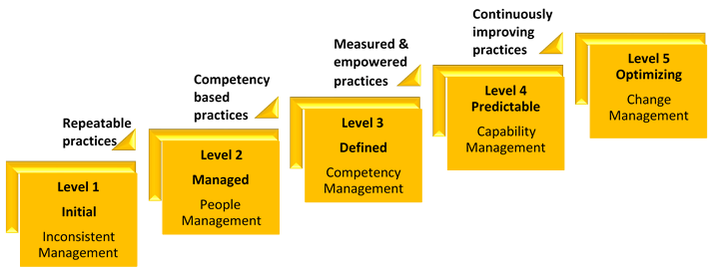
Source: (Bovée & Thill, 2012)
Recently an event very much hyped by the workplace environment is “360-Degree Feedback”. Gathering formal complains from the customers is a way old method to effectively work. Rather by having feedbacks from peers, supervisors, subordinates, and customers will be useful and can give an overall view of an employee’s work (Noe, 2020). It helps avoid the nepotism or discrepancies created by corrupt employees. It gives them the job satisfaction as well by letting the overall fit employee have the job.

Potential benefits to the organisation of developing individuals in the workplace
A corporation always has to deal with various problems. Challenging times give the opportunity to find new solution, to introduce something better. The individual development can be a tool like that. There is a plethora of advantages of individual development in the workplace.
The most feared event is employee turnover and absenteeism. Individuals tend to be oblivious towards their duties, often get absent from their work days. They do not hesitate to switch their job for any other job with similar pay-scale. By giving them the autonomy, job rotation, and other development programs, they will feel responsible at the same time accountable, conscious, sensible, and significant by the job enrichment of their work (Bognar & Hirose, 2022). This will encourage them to remain with the company and have a higher level of job commitment. As they are satisfied they will have a higher productivity due to feel important in where ever they are.
We use TQM (Total Quality Management), inventory management, lean manufacturing to increase productivity of the firm and reduce the wastages of labour, resources, and supplies. Making the employees technologically sound and helping them to be more advanced, these programs can enrich the overall job responsibility.
The core reason of individual development in the workplace is to enhance upcoming changes and make the employees capable enough to face that. Therefore, this comes with an automatic assurance of adaptability and innovation. Learning to embrace diversification, openness to experience, adventurous work challenges, full control of their job makes them carefree and tensionless. Both of this, results in higher creativity, innovative thinking, generation of new, mind-boggling ideas (Richards et al., 2022). The world is changing very fast. Therefore we better pace rapidly to cope up with it. By this development of individuals, we ensure new ways of marketing, management in introduced. The new brains can generate such policies that will turn the whole scene around. Experimenting and trying new ways to solve any problem can be done by these innovative individuals.
Knowledge sharing and learning can be seen pretty negligible at first. However, the epiphany of learning something new everyday through job rotation or autonomy always gives an upper hand to learn more and gather knowledge with pleasure. Therefore in the development program learning must be there. It can cause internal satisfaction that is intangible yet very much impacting on the employee’s mind to take favourable decisions for the company.
Overall, the performance of the firm also increases due to this development of individuals. Satisfied, committed, and self-aware employee’s can bring greater good with their new ideas and competent skills.

Development vehicles available to an organisation for the development needs of the individual
As a HR trainee in Jackson Fencing, ADDIE model was a successful one. Implementation of this development vehicle has ensured proper development within the organization and to ensure proper development plan for the employees. This model has integrated well along with the job enrichment method chosen for the organization (Smith et al., 2016). The company can successfully analyse, create, develop, execute, and evaluate its employee development programmes by implementing the ADDIE model. This method guarantees that the programme stays on track with Jackson Fencing strategic goals while also meeting the unique development needs of its workers.
I spent a lot of time and effort throughout the lengthy study phase going over and analysing Company's goals and needs for staff development. This laborious procedure involved looking deeply into the business's growth plans, recognising the distinct developmental requirements of various jobs within the organisation, and carefully picking out and understanding the precise areas where workers were weak. I was able to get priceless insights into Jackson Fencing extensive development objectives, the diversity of its staff members, and the crucial role played by motivated, well-trained people in attaining organisational success through a thorough analysis of the relevant document.
In this part of the design phase, The company had to ensure proper program design and implementation to ensure effective job enrichment program. I worked together with HR experts and managers to create a comprehensive staff development programme that would significantly improve the abilities as well as expertise of our personnel after performing a thorough examination. To guarantee that our programme would be of the greatest calibre, we carefully reviewed numerous training techniques, tools, and delivery formats during this collaborative process (Swanson, 2018). We realised the criticality of implementing a blended learning strategy, one that seamlessly combines classroom instruction, distance-learning programmes, apprenticeships, as well as mentorship programmes, taking inspiration from the text. By doing this, we hoped to provide a learning environment that would take into account the various learning styles and unique needs of each of Jackson Fencing workers.
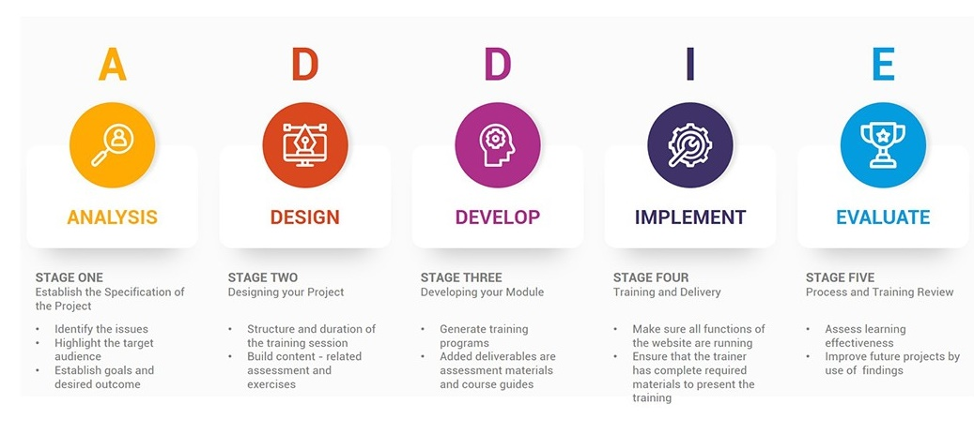
Source: (Thacker, 2018)
Jackson Fencing was always focused on the development stage. I worked closely with subject matter specialists, instructional designers, and other team members during the development process to create engaging, practical training materials. We effectively designed training modules, e-learning courses, and performance support materials by making use of the insightful information found in the text. These materials were specially created to target the areas that needed development and to perfectly match the company objectives.
We took the essential actions to start the employee development program's execution after the development phase was finished. We carefully planned and organised training events, matched mentors with workers, and made sure everyone had access to several digital educational platforms while collaborating alongside my HR associates (Williams, 2009). We made a concerted effort to clearly explain the program's goals, advantages, and requirements to every employee throughout this process, stressing the value of their active involvement and participation. Creating a culture of ongoing learning and growth inside the Jackson Fencing organisation was the key objective of this program's implementation.
In order to guarantee that the employee development program is successful, we implemented a comprehensive evaluation framework. This involved gathering valuable insights and feedback from participants through surveys, conducting thorough performance assessments, and carefully analysing post-training evaluations (Mikkola & Nykänen, 2019). These evaluation methods enabled us to accurately measure the program's impact on both the individual growth of employees and the overall success of the organization. By consistently evaluating the program, we were able to identify its strengths and weaknesses, and make necessary improvements to align it with Jackson's strategic objectives.

Professional Development Plan
According to the current structure of Jackson Fencing, the business organization has to focus on different approaches to understand and meet the development needs. The professional development plan will help the employees to meet both individual and professional success in every organizational level.
Training refers to the concept where different skill sets and knowledges are combined. On the other hand, the performance level on the job sector and ensuring the competencies of an employee is determined by the development programmes (Bovée & Thill, 2012). The following professional development will increase the opportunity of ensuring more job rotations and proper mentoring for the employees under the project of job enrichment to gain further opportunities in functioning.

Development  Objectives | Priority | Activities  to be  undertaken | Resources | Target  Start  Date | Target  End  Date | Evaluation
Enhance Leadership Skills | High | Ensuring the opportunity of Attending leadership training workshops or seminars. | - Training budget  - Guidance from mentors and leaders within the organization | 01/08/23 | 31/12/24 | - Conduct self-assessment to evaluate leadership growth.  - Seek feedback from colleagues and supervisors.
Develop Technical Skills | Low | Every employee has to be engaged in hands-on projects to apply and enhance technical skills. | - Access to technical training or certification programs.  - Opportunities for hands-on projects | 01/09/23 | 31/12/23 | - Monitor successful completion of hands-on projects.  - Seek feedback from colleagues and supervisors.
Improve Communication Skills | Medium | Providing the opportunity of engaging cross-functional projects to enhance collaboration and communication. | - Training budget  - Access to communication skills workshops  - Opportunities for presentations and cross-functional projects | 01/8/23 | 31/05/23 | - Monitor progress through self-reflection and self-assessment.  - Evaluate improvements in communication during team collaborations.
Improve Time Management Skills | Low | Seek guidance from time management experts or colleagues with strong time management skills. | - Productivity tools and techniques  - Access to time management workshops or webinars  - Guidance from time management experts | 01/10/23 | 31/12/23 | - Monitor adherence to schedules and deadlines  - Assess productivity and efficiency improvements

According to the development plan, all development objectives are properly defined and measured based on the implication of SMART objective approach. Each target is a goal that concentrates on a specific talent. We can tell if we have achieved improvements towards these objectives by soliciting input and assessing our performance. These are objectives that we can attain with what assets we possess (Noe, 2020). They are critical to our job and to the needs of our organisation. We have a set time frame to work on this set of goals, including a start and a finish date. We will continue to monitor our efforts and solicit input to ensure that we continue to make progress. We may adjust our objectives if necessary. This approach benefits Jackson Fencing since it demonstrates that the company cares about helping its people to succeed in their employment.

Conclusion
JACKSON FENCING has become the most important British Manufacturer. The statement emphasises the need for highly motivated, adaptable, and well-trained employees in ensuring Jackson's continuing success. The company emphasises the importance of employee motivation by recognising that engaged workforce members are more likely to give exceptional customer service, high productivity and make significant contributions to the organization's overall success. We recognised the significance of assessment throughout the process of verifying the program's efficacy. We were able to analyse the program's influence on both individual as well as organisational achievement by gathering feedback through questionnaires, performing performance assessments, and analysing post-training evaluations. We were able to recognise strengths, and areas for development, and assure compatibility alongside Jackson's future objectives as a result of this.

References
Assey, G. (2022) Managing Relationships at Work: Building Effective & Healthy Working Relationships. Amazon Digital Services LLC.
Bognar, G. and Hirose, I. (2022) The Power of Professional Relationships: Unleashing the Potential of Networking for Workplace Achievements. Abingdon, Oxon: Routledge, Taylor & Francis Group.
Bovée, C.L. and Thill, J.V. (2012) Business Communication today. Boston: Pearson.
Kim, S.Y. (2022) ‘Pandemic ethics: The Intersection of Technology, Trust, and privacy, and implications for marginalized communities’, Creating a Positive Work Environment: Strategies for Developing Strong Relationships, pp. 204–215. doi:10.4337/9781900449415.00021.
Mikkola, L. and Nykänen, H. (2019) ‘Workplace relationships’, Workplace Communication, pp. 15–27. doi:10.4324/9780429196551-2.
Noe, R. (2020) Employee Training and Development: Principles and Practices. McGraw-Hill Education.
Richards, B., Taylor, M. and Jacobson, S.S. (2022) The Role of Interpersonal Relationships in Achieving Workplace Goals. Cheltenham, UK: Edward Elgar Publishing.
Smith, K.E., Hill, S.E. and Bambra, C. (2016) Relationship Quality and Workplace Performance. Oxford University Press.
Swanson, R. (2018) Human Resource Development: Talent Development. Routledge.
Thacker, B. (2018) Designing Effective Training Programs: A Guide to Development and Delivery. Pearson.
Williams, L. (2009) ‘Organizing workplace relationships’, Organizing Relationships: Traditional and Emerging Perspectives on Workplace Relationships, pp. 1–18. doi:10.4135/9781452213031.n1.

