Thais Da Silva
2323117
Programme: CertHE in Digital Skills
Computer Systems Fundamentals (ACCA4028)
Computer System component specification

Task 1:
Parts | Model | Reasons
CPU | Intel Core i3-12100 | - It is a cheap component (it is around 120 pound).  - It has a good performance for the price.  - It is a component where it can be used for basic tasks but it is a modern technology so it will work faster.  - It is a good option for daily tasks such as research information, edit documents, light multitasking, office work, watch videos and for videocalls.  - It can manage HD videos and videocalls.  - It is easy to use.  - It has a snappy and accessible experience in general use scenarios.  - It is low energy consuming (TDP of 60W), which coverts it to an excellent option for users who wants a cheaper PC´s parts and a part which does not consume too much energy.  - It has compatibility with new technology.  [1]
- Motherboard | MSI MAG B660M MORTAR WIFI DDR4 | - Compatibility with intel.  - The board supports PCIe 4.0 with one x16 slot for graphics cards and two M.2 slots for fast storage, along with six SATA ports.  - integrated WIFI for convenience, which is a good thing to save money because it does not need to get a separate WIFI card or adapter.  - The WIFI which include this mother board is WI-FI 6.  - It also includes USB 3.2 Gen 2x2 (20 Gbps), multiple USB Type-A and Type-C ports, and 2.5 GbE Ethernet for fast wired connectivity  - compact component that makes it perfect for small pc cases, which is a convenient idea if they want to save space or if they can move the pc to another place.  - security and updates.  - It is easy to install, it is good if the users want to change it in the future.[2]
Ran | 8gb | - it is enough for simple tasks.  - Good performance and price.  - it will be able to do simples tasks with a good velocity  Overall, 8GB ran is an enough amount for the requirements for this pc, it will allow the users have a great experience for work or daily use. The performance won’t be slow if the use is for simple tasks.
Storage | Crucial P3 250GB NVMe SSD | For the work that they will need, it is a perfect option because it will be not too less capacity, but it won’t be unnecessary capacity.  As well, in the future they have too many pictures or something like that and they need more space they can update it with cloud storage, so they can save as many as they want for a great cost.  Fast performance: improve applications loading speed.
Graphics Card | Integrated Intel UHD Graphics 730 | - It has a medium performance for a basic GPU.  - It performs well for general computing, light gaming, and media consumption.  For the simple tasks as watch videos, videocalls or write emails, this graphics card is an great option. Another dedicated GPU will increase the pc price and the power, but on this case do not need a greater power.[3]
Monitor | Samsung LC24F390FHNXZA 24” Curved LED Monitor | - It offers a Brillant experience, because the pc will stay in an accessible price but with a HD experience.  - It is comfortable for people who spend too much time in front of the monitor.  - The design of the monitor will make a modern experience for low price.  - The curve monitor makes it more functional.  - The monitor is environmentally friendly and energy efficient.[4]
Network Connectivity | Wi-Fi | - A technology that helps devices to connect to the internet and helps communicate people from different places of the world.  - It will improve and faster the experience of browsing.  - It includes with a motherboard that allows it to connect to wireless networks.  - It is also a key component in connecting the digital gap between isolated and rural areas of the world and provides a plan of action for free internet use in evolving economies.
OS | Microsoft Windows 11 Home | - It is the latest operating system which means long term support and it will have updates.  - It is easy to use, that is an amazing choice for elderly and people who do not have many experiences with technology.  - It includes feature that protect the system from viruses.  - It has Artificial intelligence include. It is shows by Copilot assistant (which is an artificial intelligence), this feature can help to improve the experience of the users because it can help them to research something in an easy way. This is a good option for elderly people because this assistant can help them to use their device, for example, if the do not know about technology and they want to find an application or how to do something on their device this assistant can guide them.[5]
Security Software | Bitdefender Antivirus Plus | - It is good rated for defending the pc against viruses and other things (malware, ransomware, and others).  - It is a good antivirus for light users  - Lightweight for performance, it is means that it won’t make the system slow.  - Easy to use. It offers an easy way to use this antivirus, and this will make it easier for people who are not experts in technology.  - Easy to check.[6]
Case | Thermaltake Versa H21 | - It is a compact open design, so it will allow a good ventilation, and it will be easier to make a compact machine.  - It easy to install, that feature will be great for the person who will builder and for the users. So In the future if they want to update it or changed it won’t be a hard problem.  - It has a good quality and price. Because on this pc is not just important the price, as well it is important the quality and the long-term life.  - Size: Medium tower with dimensions of 429 x 209 x 480 mm and a net weight of 4.2 kg.  - Great compatibility with high-performance parts.  - Additional space which allows better cable management.[7]
Power Supply | Thermaltake Smart 500W 80+ White PSU | - Enough power for all components.  - It consumes less energy which is good to reduce energy cost.[8]  - Hight quality components, it converts it in a good investment because of the hight quality it will a longer durability.  - It has a silent fan, which mean that the users will have noise free while using the pc.
Ports and connectivity | USB port  HDMI port  Ethernet port  Audio jacks | - USB: it is necessary for the keyboard, mouse, or pen drives (if they want to see, edit, save or send any information)  - HDMI port: To connect to the monitor or other display.  - Ethernet port: wired internet connectivity (Which it is a good option if they do not want to have WIFI this will be another option)  - Audio jacks: To connect headphones or microphone  (to have greatest videocalls experience and audio quality).  In general, every port provides a comfortable experience for their needs. As well, it helps to make the pc suitable for different occasions (for example, this pc is perfect for elderly people because they can have any hearing problem or just because of the age they cannot hear clear, or in another case they cannot speak too loud so add a microphone should be perfect for the situation.

Prices and where to find them:

Parts | Price | Link
Intel Core i3-12100 | £94.43 | Amazon[9]
MSI MAG B660M MORTAR WIFI DDR4 | £130 | Amazon[10]
8GB RAM | £15.99 | Amazon [11]
Crucial P3 250GB NVMe SSD | £18 | amazon[12]
Integrated Intel UHD Graphics 730 | 0
Samsung LC24F390 24” Curved LED Monitor | £106 | amazon[13]
WI-FI | 0
Microsoft Windows 11 Home | 20 | Software Kent[14]
Bitdefender Antivirus Plus | £20.00 | Bitdefender[15]
Thermaltake Versa H21 | £110.41 | Amazon [16]
Thermaltake Smart 500W 80+ White PSU | £60.25 | Ebay[17]
Total | £464.67

Task 2:
Model: LAPTOP-5EQ4CJRH
This is a basic laptop which it is good for basic task such as Internet browsing, simple educational and entertainment (watch videos on YouTube, reply emails, watch movies, do my homework and others).
RAM: 4GB
Processor: intel(R) Celeron(R) N4500 @ 1.10GHz 1.11 GHz
- Single-core: Roughly 300–400 points.
- Multi-core: Around 600–800 points.
On the picture show where to find the information provided before, which it is not difficult to find it.
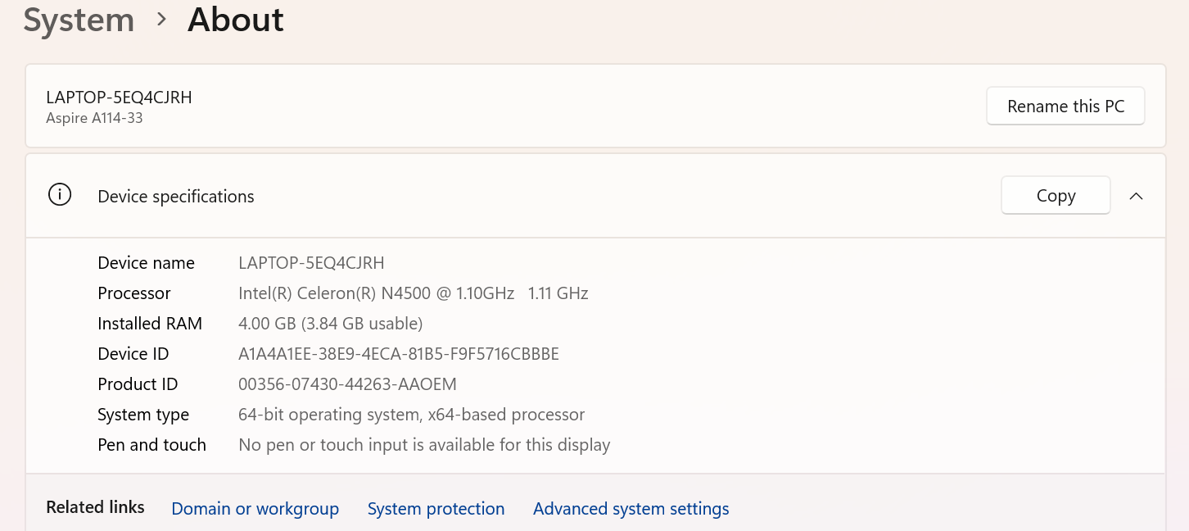
Storage: 115GB
This can be a bit difficult to find and sometimes to understand (depend of the knowledge about pc) but basically, it shows the storage used (which is 48.5) and free storage (66.7). It can look like too less but for basic tasks this storage is enough.
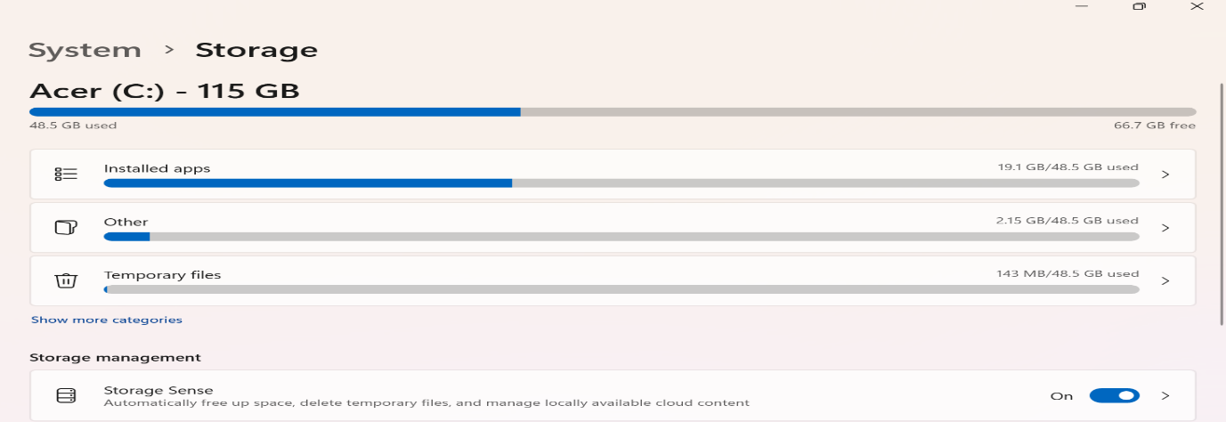
The various I/O devices:
- Display: 15.6-inch.
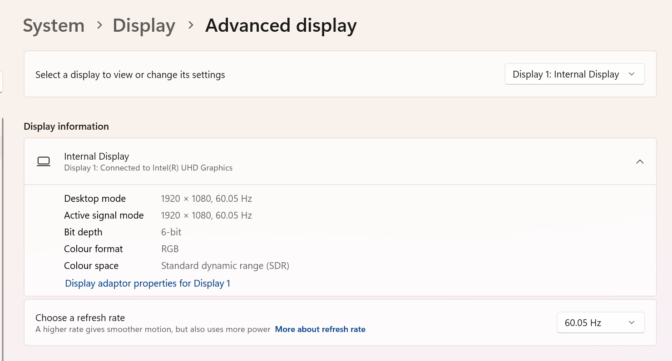
- Keyboard: Standard keyboard.
- Ports: includes USB Type-A, USB Type-C (for charging/data), HDMI (for external display), and a headphone/microphone combo jack.
- Mouse: Standard mouse.
- OS: Windows 11 home.
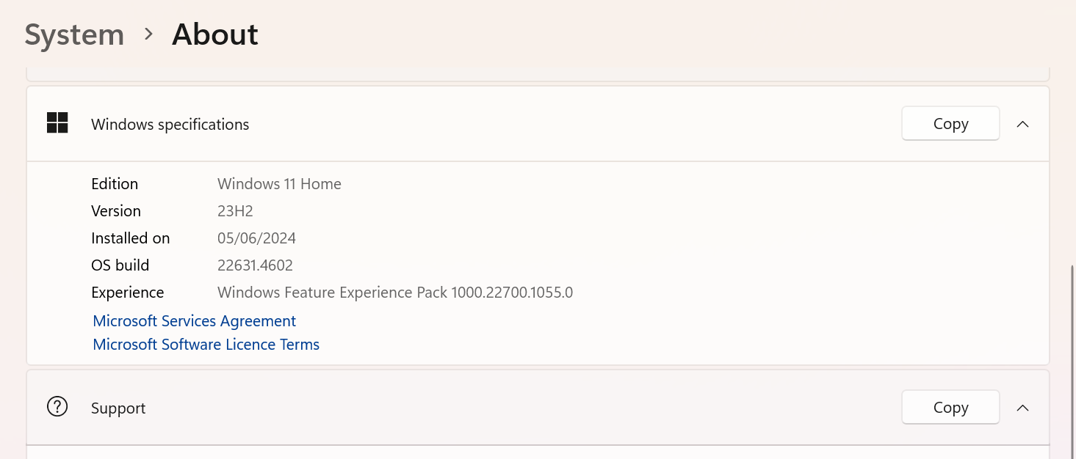
Internet connectivity:
- Wi-Fi: Likely 802.11ac (Wi-Fi 5) or 802.11b/g/n for wireless connectivity.
- Ethernet: Unlikely to have an Ethernet port, or if present, speeds will be limited (likely 1000Mbps).
- Bluetooth: Most likely Bluetooth 4.0 or 4.2 support.
Some pictures of internet connectivity and where to find information about them on this device.
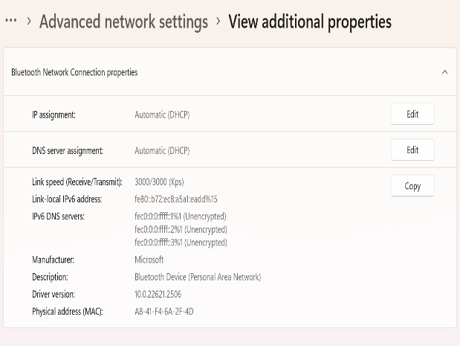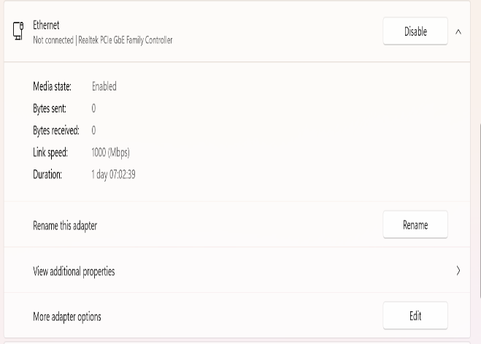
Wi-Fi: Likely 802.11ac (Wi-Fi 5) or 802.11b/g/n for wireless connectivity.
Graphic card: Intel UHD Graphics.
How it shows in the picture, it is a simple graphic card but it still good enough for daily use.
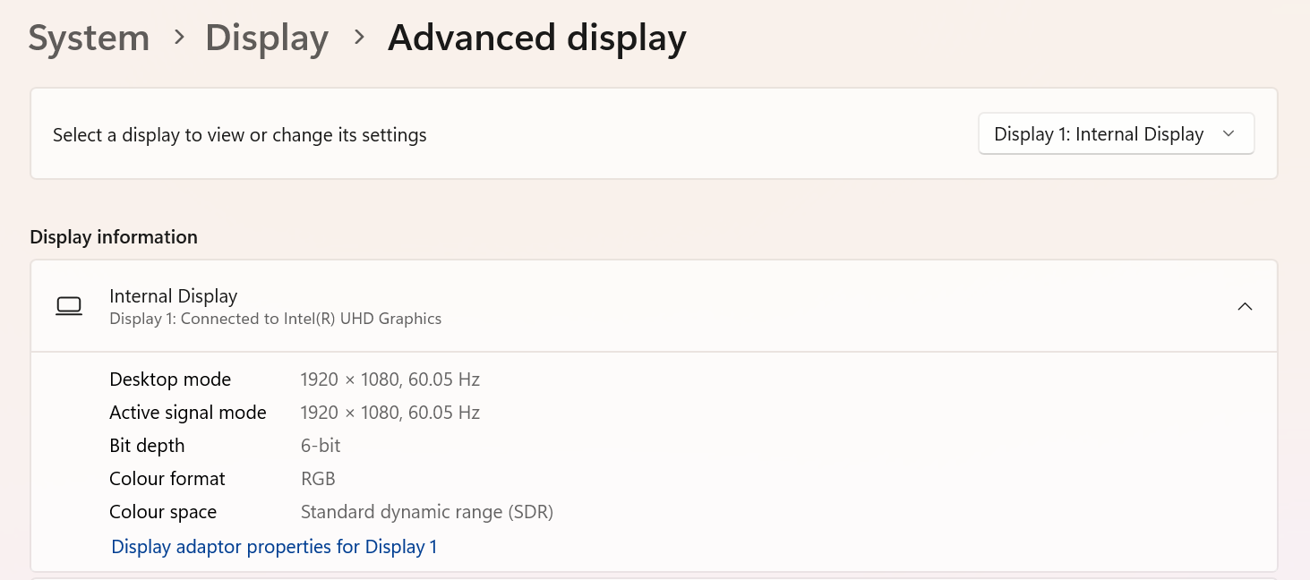
Installed applications
- Copilot.
- Outlook
- Microsoft 365.
- VCL media player.
- Calculator.
- Camara.
- Evernote.
- Notepad.
- Media Player.
- Paint.
- Power Automate.
- Snipping Tool.
- Sound Recorder.
- Weather.
- Windows Clock.
- Acer Sence.
- Photos.
- Apps Explorer.
- Dropbox Lite.
- Feedback Hub.
- Intel Graphics.
- Maps.
- OpenCL.
- Quick Assist.
- Terminal.
- Sticky Notes.
- Xbox.
- ExpressVPN.
- Microsoft Edge.
- News.
- People.
- Cortana.
- Web Media.
- Family.
- Microsoft To Do.
- Xbox Live.
- Spades.
- AV1 Video extension
- AcerSense.
- Weather.
- Windows Clock.
On the pictures, it shows some examples of the applications find it on this device.
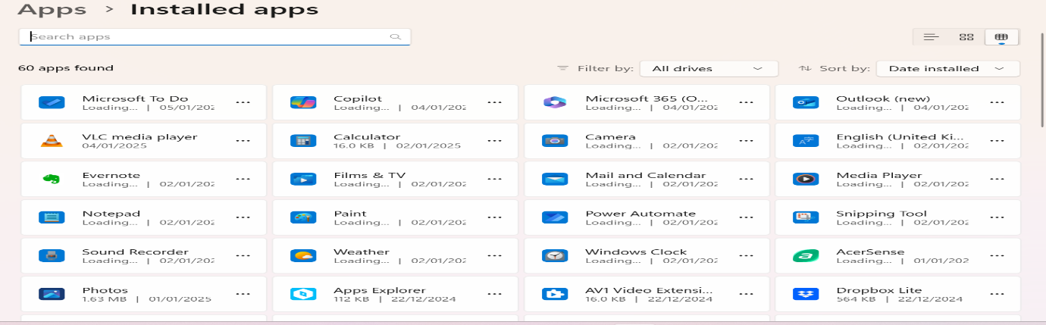
On the following pictures you can see the performances of GPU, CPU, DISK and memory which shows how all these works on this system.
CPU´s performance picture
It shows that the CPU has a base speed of 1.1 GHz, but on the time when it was checking and took the picture it was 1.67GHz. This means that when the CPU has a bigger demand will increase the frequency. The used on that moment was 79%, which shows that the CPU was doing significant responsibilities. As well, it shows the capacity that this CPU must manage process.
GPU´s performance picture
It has a current use of 3%, this is means that this component is not running intensive applications (such as games, programs to edit videos o pictures and different types of software which needs an intensive graphic running).
DISK´ performance picture
It shows that on that moment the used was 0% and the transfer speed 0KB/s. This is means that on that moment the system was not running read operations intense writing.
Memory´s performance picture
It shows the RAM available, which is 452 MB and the used one which is 3.4 GB. As well, it shows the speed which is 2933 MT/S which guarantee a faster access to data.
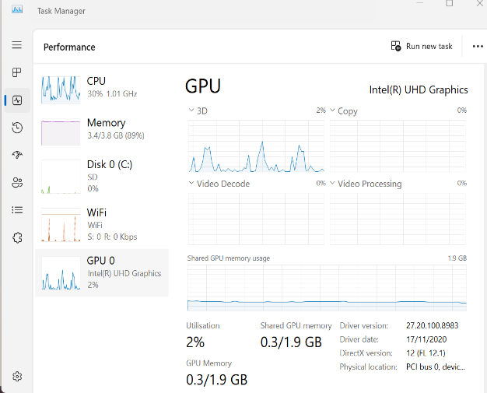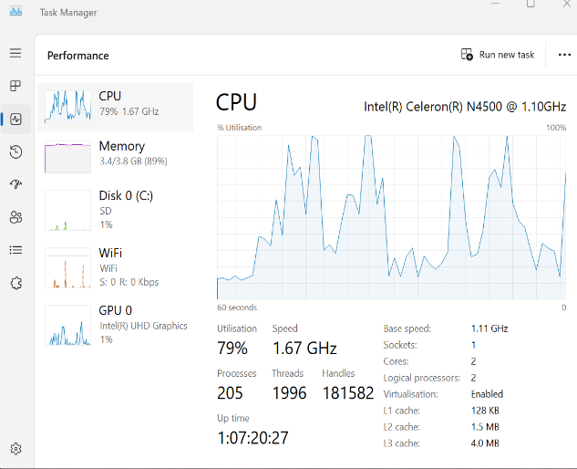
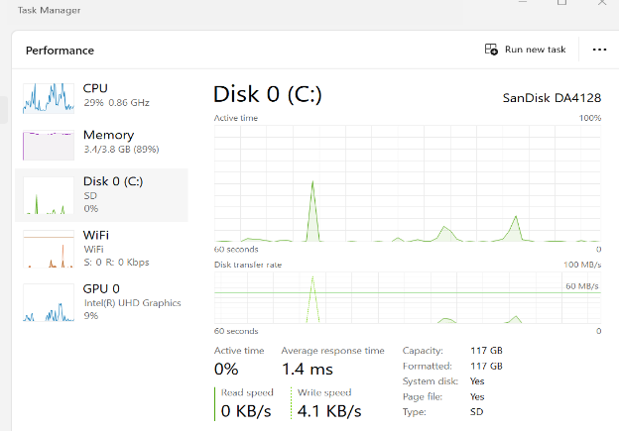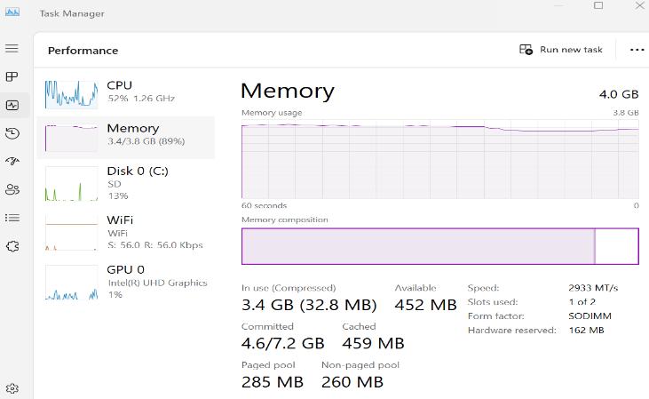

References
[1] A. cunningham, ‘Intel Core i3-12100 and i5-12400 review: Fast, affordable, and hard to criticize’. [Online]. Available: https://arstechnica.com/gadgets/2022/04/review-intels-12th-gen-core-i3-and-i5-are-its-best-midrange-cpus-in-years/
[2] joe shields, ‘MSI MAG B660M Mortar WIFI DDR4 Review: B660 Chipset Bliss?’ [Online]. Available: https://www.tomshardware.com/reviews/msi-mag-b660m-mortar-wifi-ddr4
[3] reserved, ‘Intel UHD Graphics 730’. [Online]. Available: https://nanoreview.net/en/gpu/intel-uhd-graphics-730#:~:text=In-depth%20review%20of%20Intel%20UHD%20Graphics%20730,with%20gaming%20tests%2C%20performance%20benchmarks%2C%20and%20full%20specifications.
[4] reserved, ‘SAMSUNG LC24F390FHNXZA 24-inch Curved LED Gaming Monitor’. [Online]. Available: https://www.dontwasteyourmoney.com/products/samsung-lc24f390fhnxza-24-inch-curved-led-gaming-monitor/#allproducts
[5] Michael Muchmore, ‘Microsoft Windows 11’. [Online]. Available: https://uk.pcmag.com/operating-systems/134264/microsoft-windows-11
[6] Reserved, ‘Stay Safe with the Most Consistently Top-Rated Antivirus of the Last 10 Years (and Counting) Pick the perfect plan for your needs.’ [Online]. Available: https://www.bitdefender.com/pages/consumer/en/new/cl-offer-premium?locale=en-GB&vcampaign=BRD25&cid=ppc|c|Bing&gclid=6aff4bd203f4178dc42c2cafcead1c3a&gclsrc=3p.ds&&s_kwcid=AL!6076!10!77447025617659!77447089324209&msclkid=6aff4bd203f4178dc42c2cafcead1c3a
[7] Reserved, ‘Unboxing & Review: Thermaltake Versa H21’. [Online]. Available: https://www.tech-critter.com/unboxing-review-thermaltake-versa-h21/
[8] Reserved, ‘Thermaltake Smart 500W 80+ White Certified PSU Review’. [Online]. Available: July 23, 2023
[9] Amazon, ‘ntel® CoreTM i3-12100 Desktop Processor 12M Cache, up to 4.30 GHz’. [Online]. Available: https://www.amazon.co.uk/Intel%C2%AE-CoreTM-i3-12100-Processor-Cache/dp/B09MDDX29R/ref=sr_1_2?crid=1R3DCEQJ1DA3M&dib=eyJ2IjoiMSJ9.p7tQkR1UZaAcVDUvrvAfaNj-5ifLZUktnItbCzeAA3-P0FBJ0k6yXMgy6HEkF2RcqVMNIPG8RmRUtDFyg32hpvUukGxiutWmmho_UZHoVbbXBZJXM8wv61GGz1-Ge8YzdRUNCZ1e1OZl9iRSDMTfEFQ7_lv6_Ppv1RmtR-FD03UqLG9VYn-fVMaHCTHCP74FuqrYNYh9xnsPEGLHTPru0m06DG3Hoa6PeM98phApW6w.OgmTWgLge8EeC_peRTVe4kHxT6-0O5qbbsbBH5lcRkg&dib_tag=se&keywords=Intel%2BCore%2Bi3-12100&nsdOptOutParam=true&qid=1736380937&sprefix=intel%2Bcore%2Bi3-12100%2Caps%2C152&sr=8-2&th=1
[10] Amazon, ‘MSI MAG B660M MORTAR WIFI DDR4 Motherboard, Micro-ATX - Supports Intel 12th Gen Core Processors, LGA 1700 - DDR4 Memory Boost 4800+MHz/OC, PCIe 4.0 & 3.0 x16 Slots, 2 x M.2 Gen4 Slots, Wi-Fi 6’. [Online]. Available: https://www.amazon.co.uk/MSI-B660M-MORTAR-Motherboard-Micro-ATX/dp/B09NTNCGMV
[11] Amazon, ‘Crucial RAM 8GB DDR4 3200MHz CL22 (or 2933MHz or 2666MHz) Portable Memory CT8G4SFRA32A’. [Online]. Available: https://www.amazon.co.uk/Crucial-CT8G4SFRA32A-PC4-25600-SODIMM-260-Pin/dp/B08C4Z69LN/ref=sr_1_3?crid=2OB5G0W1O2RFL&dib=eyJ2IjoiMSJ9.gKdrM1hjlwFU5W1TVacCWj3TsrEf-9S_j_Qnre_wEkpeT_JMndYQpaaaHPjRF-p5ikcHL_8PR1PCtj0VeAgpSf6Hp1cOp-n-_Nqh3RPBrTV7HYNRaTPgjIDwMVZFTNsCX9EP39KfRpyZckRwC54SjAbur1kCx2Q5NzmLR6089CRvS_nkRJ0X0vqBOU9447xSqHqiMI0SJ8XDGVoPx-jLxyPBwPNr3EvpZDaQJL4m23WRCnsWmflwvVboC-uHERoz3BPnxIBkISfnwzE5enUd4vEqsYJ8JEpZDZFBesLmJnKcvmv7kVon6GYqBaXPDIRgTEfynJcu4F_OwNSGGw7npiZb3AQJ9bXUu9GMjNUuABQ.Qhim0_N9uoSpN_3ebEYlQlhn1mJw12LWODYQkuee8LQ&dib_tag=se&keywords=8+gb+ram&nsdOptOutParam=true&qid=1736381523&s=computers&sprefix=8+gb%2Ccomputers%2C100&sr=1-3
[12] Amazon, ‘gb’. [Online]. Available: https://www.amazon.co.uk/Crucial-CT240BX500SSD1-Internal-Solid-State/dp/B07G3YNLJB/ref=sr_1_21?crid=1HC857UNEEJPL&dib=eyJ2IjoiMSJ9.f-PC9bgdCf_kFlduPDV9bmT__y6L6MbsNYUN9kMTtgjy762Q7YfSO09y_Ulmc_TsJTmdjqhOVpIUXo7b4Icm00y9nLy6xOR3yLZN9v_vaK705v9j8iG5k4Xn3aaV2SbvRXTiKUjpz61YXHwj8UmW39zJP5FToZ8XaB7u7qdqODI9odYP7608KKlhcnVK8g3hVTIW0C9VlvPlLna3WxvahUpJiQe8cUJWynUFnbFGGfwMXibLT4K4GU52_CQkT8XEDHKkb2du9t7nx5cwO9im98alf9WHBHwzx96cSRZcBzkMOAAf2V2GHe-XyakgDNwMjC0j609eA3Y2224P4HBd-lUQCqvtvLnz9eeJmg1IQgk._MPOVtuAlT6qFZCMneArv4T1-q0PmbO-5wK02vQHLxM&dib_tag=se&keywords=Crucial+P3+250GB+NVMe+SSD&nsdOptOutParam=true&qid=1736381646&s=computers&sprefix=crucial+p3+250gb+nvme+ssd%2Ccomputers%2C216&sr=1-21
[13] Amazon, ‘Samsung LS24C360EAUXXU 24" Curved FullHD 1080p Monitor - 1920x1080, HDMI, VGA’. [Online]. Available: https://www.amazon.co.uk/dp/B0BS1PH5N3?tag=track-ec-bing-uk-86011-21&linkCode=osi&th=1&psc=1&ascsubtag=ecSEP44le0jm5ol0297
[14] Sofware kent, ‘Microsoft Windows 11 Home Product License Key’. [Online]. Available: https://softwarekent.com/products/microsoft-windows-11-home-product-license-key?utm_medium=cpc&utm_source=bing&utm_campaign=Bing%20Shopping&msclkid=db2eba61844d16924f8add1e928ed9f1
[15] Bitdefender, ‘Bitdefender ANTIVIRUS PLUS’. [Online]. Available: https://www.bitdefender.com/pages/consumer/en/new/av-opt?locale=en-GB&vcampaign=NBR25&cid=ppc|c|Bing&gclid=e9543ffd62c3171e492558827ac58a9b&gclsrc=3p.ds&msclkid=e9543ffd62c3171e492558827ac58a9b
[16] Amazon, ‘Thermaltake Versa H21 Tower Case with Side Window USB 3.0 and 12cm Interior Fan - Black’. [Online]. Available: https://www.amazon.co.uk/Thermaltake-Versa-Tower-Window-Interior/dp/B00JQCZD2S?th=1
[17] Reserved, ‘Thermaltake Smart 80 Plus 500w Power Supply SPD-0500P’. [Online]. Available: https://www.ebay.co.uk/itm/156585296361?chn=ps&norover=1&mkevt=1&mkrid=710-153316-527457-8&mkcid=2&itemid=156585296361&targetid=4584619899329649&device=c&mktype=&googleloc=&poi=&campaignid=555133854&mkgroupid=1296325363661425&rlsatarget=pla-4584619899329649&abcId=10053750&merchantid=87779&msclkid=1b58b04b7cc31d5b8181d734641c6cbd

