Student: Stefan-Leonard Bitu
UWTSD
Module: Cloud Computing Architecture
Lecturers: Koushik Modak, Suneth Fernando
TABLE OF CONTENTS
PART 1 2
RESOURCES ASSOCIATED WITH A VIRTUAL MACHINE 2
CREATING AND MANAGING A VIRTUAL MACHINE 2
vNETs & NETWORK SECURITY GROUPS 4
PART 2 6
USE OF IMAGES 6
USE OF IMAGES IN AZURE 8
ADDITIONAL EXERCISE 9
DEPLOYMENT OF FIRST VIRTUAL MACHINE 9
DEPLOYING SECOND VIRTUAL MACHINE 10
COMMUNICATION 13
REFERENCES 14

PART 1

RESOURCES ASSOCIATED WITH A VIRTUAL MACHINE
Virtual machine is a virtual environment which is set up using several hardware components, that is, memory, CPU, network interface and storage of a single physical computer. These components are separated into a lot of virtual computers through the use of virtualization software to build a layer of abstraction on the computer hardware. Even though by running on portions of the computer hardware which is underlying, every virtual machine has its own OS and behaves like a separate computer. Resources are differentiated from the hardware system and properly provisioned so that the virtual machine can use those and is achieved by the software known as hypervisor [1]. In accordance with the way the hypervisor and virtual machines have been set up, it also plans and modifies the distribution of resources, and it may reallocate resources as changing requirements.
Physical machine termed as the host computer, or host operating system, or host machine, or simply host is outfitted with the Kernel-based Virtual Machine (KVM). Virtual machines that utilize the components of a physical machine are known as the guest computers, or guest machines, or guest operating system, or simply guests [2]. Computing resources, like memory, CPU and storage, are seen by the managing hypervisor like a resource pool which could be readily shared amongst already-running guests or added to new virtual computers.

CREATING AND MANAGING A VIRTUAL MACHINE
Virtual machine running on a window’s host machine gives the user a same experience as if using a separate computer. The technique of sandboxing helps in isolating virtual machines from the host machine. Nothing that is executed within the virtual machine may have an influence on the host computer, so to speak [3].
In order to create a virtual machine, a physical computer with virtualization compatible processor, minimum of 8–20 GB of disk space and 1 GB of RAM (depending on the OS being installed), installation media – either a CD/DVD or an ISO file, a product key if a virtual machine that runs Windows is being created, and an internet connection or an installation file is required [4].
Through virtualization technologies, the possibility of virtual machines is realized. A few virtual machines (VMs) can run on a single computer, which mimics virtual equipment utilizing computer program. The genuine machine is alluded to as the have, and any virtual machines running on it as the visitors [1].
A server frequently employs a software known as a hypervisor to control numerous concurrently operating virtual machines. Virtual machines contain virtual memory, CPUs, hard drives, and other components. On the host computer, every piece of virtual machine is mapped to actual hardware.
The hypervisor is in charge of controlling and distributing assets, such as memory and capacity, from the have to guests. Too, it plans VM operations to avoid asset abuse clashes between them. As it were the nearness of a hypervisor to virtualize and designate have assets makes VMs utilitarian. In virtualization, two diverse sorts of hypervisors are utilized [5].
Sort 1 hypervisors, moreover known as uncovered metal hypervisors, are put straightforwardly on the basic physical machine. To apportion equipment assets, VMs communicate specifically with has without the utilize of extra computer program layers. As it were sort 1 hypervisors on have computers are utilized for virtualization. They can as often as possible be experienced in server-based settings like commerce datacenters. The Microsoft Hyper-V and Citrix Hypervisor are two illustrations of sort 1 hypervisors. To oversee visitor activities like setting up unused VM occurrences or controlling rights, a diverse administration instrument is required [6].
Sort 2 hypervisors, frequently known as facilitated hypervisors, work with the working framework of the have machine. The have working framework at that point apportions the physical assets to each visitor after accepting VM demands from facilitated hypervisors. The have OS must be counseled some time recently performing any VM activities, making sort 2 hypervisors slower than sort 1 partners. Visitor OS is autonomous of the fundamental equipment, in differentiate to bare-metal hypervisors. Clients may work VMs whereas proceeding to utilize their computers ordinarily. Since of this, sort 2 hypervisors are suitable for domestic clients and little endeavors without committed servers for virtualization [6].

vNETs & NETWORK SECURITY GROUPS
A virtual network (vNet) is one in which software and wireless technologies are used to link all the servers, data centres, devices, and virtual machines. Together along with the other merits, this ensures that the network's reach could be extended as required for highest efficiency [7].
In physical networking, a local area network, sometimes known as a LAN, is a type of wired connection that typically can only connect devices inside of one particular building. Another type of wired network is a wide area network (WAN), in which the distance between the computers and other connected devices is sometimes over a half-mile.
On the other hand, a virtual arrange doesn't follow to the conventional organizing measures since it isn't indeed associated. As a result, all organized gadgets communicate with one another through web innovation, which gives them a more extensive run of communication than they would have had on been associated. Just like the web, the arrange has no boundaries. When a benefit supplier conveys third-party networking services to businesses, this can be commonly alluded to as Networking-as-a-Service, or NaaS, rather like numerous of the cloud administrations [8].
Through virtual networking, devices in several places can operate with the same abilities as a regular physical network. Network administrators now have new, more effective options, such as the ability to quickly change the network as needs change without having to replace or purchase additional hardware, increased flexibility in providing the network to specific needs and applications, and the ability to move workload across the network set-up without sacrificing security, service, or availability [3].
A network security group, usually known as NSG, is a collection of security rules that control network access to virtual networks (vNet). Network security group can be connected to specific network interfaces (NIC) connected to virtual machines or subnets. All resources linked to a subnet are subject to the regulations when an NSG is associated with that subnet, further limiting traffic by connecting an NSG to a virtual machine or NIC [9].
Inbound and outbound sets of rules are present in NSGs. Within each collection, a rule's priority must be distinct. Properties of each set include address prefixes, protocol, priority, source and destination port ranges, access type and direction of traffic. Default guidelines are present in all NSGs. These rules are not modifiable and can’t even be deleted, receiving the lowest possible priority and are not subject to the regulations established [10].
The network access rules in an NSG are only applied to the NIC to which it is associated. In a virtual machine with several NICs, traffic to the other NICs is unaffected if an NSG is applied to just one of them. Depending on the deployment strategy, several NSGs can be linked to a NIC or virtual machine (VM) as well as the subnet that it is connected to. According to the flow of traffic, priority is assigned [10].
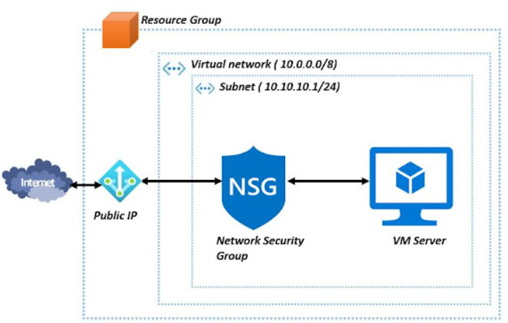

PART 2

USE OF IMAGES
An operating system that can be booted from a virtual disk is contained in a single file known as a virtual machine image.
Several formats are available for virtual machine images. The arrangement of the bits that make up a file on the storage medium is described by a format. To accurately comprehend the file's content, user has to be familiar with the format.
There are two different formats that might be used for a virtual machine image.
- Container format: The virtual disk may be contained in the saved file, which might be a container. For instance, the virtual disk may be stored as a tar file that needs to be opened in order to be accessed. Yet, it's likely that the virtual disk is just saved as-is by the Image Service and not included in a file.
- Disk format: The bits on the virtual drive are formatted in some way. Before using the virtual disk efficiently, the service that is using the disk must understand what this format is.
A virtual machine image is a resource that holds all of a virtual machine's (VM) instance's configuration, permissions, metadata, and data from many disks. A virtual machine image may be used in a variety of scenarios including backup and recovery, instance cloning, and system maintenance.
Virtual images are most appropriate for multiple disk backups and instance cloning.
- Multiple disk backup: The VM instance level backups are supported by machine images. The backup of disks is done using differential snapshots. Compute Engine ensures that the data across discs is recorded in a crash-consistent way at a certain moment when a virtual machine image is used to replicate discs. To make this promise, Compute Engine employs globally consistent timestamps. If the virtual machine instance is operating and to make sure that the backup position across disks is preserved, this consistency is essential. While restoring a computer image, user can go back to the same point in a specific time across disks if the backup point across disks is preserved.
- Instance cloning: Cloning instances is possible using machine images. Making duplicates of an instance that includes the majority of the virtual machine settings from the originating instance is possible using machine images. These duplicates can then be utilized for scaling virtual machine instances, system upkeep, troubleshooting and debugging.

USE OF IMAGES IN AZURE

With Azure, images are utilized to provide an operating system to a new virtual machine. One or more data disks might potentially be present in an image. Images records every piece of information that the virtual machine will have. Images are used to store all data and system information. Even the OS is captured using a specific technique.
There are two types of images in Azure, VM image and OS image. Operating system and every disk connected to a virtual machine at the time the image was produced are included in a VM image. This kind of images are recently introduced. Earlier, an image in Azure could only include a generic operating system and no extra drives until VM images were made available. The original kind of image, that is, the OS image, is essentially the same as a VM image which simply includes a generic operating system.
The images can be generalized or specialized. Generalized pictures act as a kind of VM template. After creating a suitable VM template, users can generate instances of VMs using these templates. Using generic images, users may produce VM-A, VM-B, or numerous clusters of VM from the same image. The generic Azure Marketplace pictures are all used to make the virtual machine. System generalization is similar to resetting machine identifiers and getting them ready to be used in another system.
Specialized images are just like the system's gold edition. It resembles to a snapshot of your existing system only better. An identical replica of the current system on Azure is created when VMs are built using customized images. That is equivalent to copying the system from the moment snapshot is taken of it.

ADDITIONAL EXERCISE

DEPLOYMENT OF FIRST VIRTUAL MACHINE
The first Virtual Machine needs to be deployed with a nginx server.
A Virtual Machine with Ubuntu Image is created on Azure Portal selecting appropriate region and resources. The security type chosen is SSH. The inbound ports are taken to be HTTP and SSH. The username taken here is, azure-user. The key is downloaded after the “Review + Create” step and the deployment is proceeded.
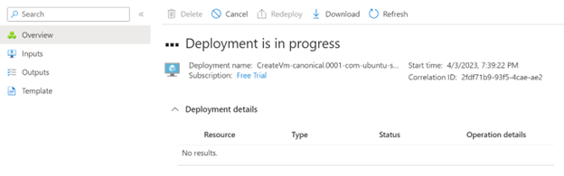
Upon the completion of deployment, the public IP is copied from the resource center, which is used for further implementation. The command used for logging into the Virtual Machine is:
ssh -i <path of private key in system> username@PublicIP
Here, <path of private key in system> is replaced with the path of the downloaded key file prior to the deployment of the virtual machine. The “username” is replaced with the username entered while creating the virtual machine, which is, “azure-user”. The “PublicIP” is replaced by the IP Address present in the overview section of the resources tab in the Virtual Machine section.
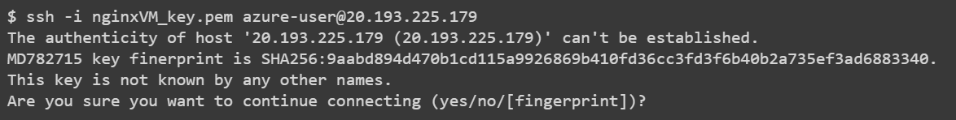
Input “yes” to continue the command and wait for the completion of the process. Once done, the next process would be to setup the nginx webserver on this virtual machine.
For deploying the nginx webserver, the following values need to be entered in the terminal:
sudo apt-get -y update
sudo apt-get -y nginx
After both commands are completed, enter “exit” in the bash terminal to close the terminal. The nginx webserver would be setup on the said public IP. Browse to the Public IP in web browser to check if installation is done.
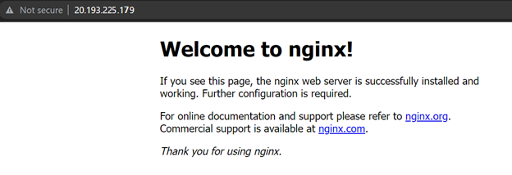
The prompt confirms the installation of nginx.

DEPLOYING SECOND VIRTUAL MACHINE
In second virtual machine, a database needs to be implemented in a vNet and a Network Security Group will be implemented. For database, postgresql will be setup.
Create a new virtual machine. Select username and password in security option and allot an appropriate username and password. Also, the image should be Red Hat Enterprise for best working of postgresql in the Virtual Machine environment.
The Network Security Group will be setup in the Networking Section, by selecting the option of Network Security Group to Advanced.
Apply a network security group with a priority higher than the existing rule to allow only the machine’s IP address and deny all other IP addresses for best security. Enabling all IP’s is disastrous and a major security flaw. The service must remain PostgreSQL while adding the network security group.
Click on “Review + Create” option to check for possible errors. Since, validation is passed, deploy the virtual machine.
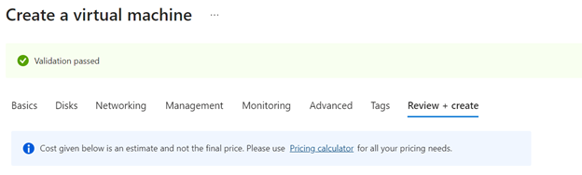
Once deployment is done, the setup is done in PuTTy. The IP address should be entered as in the virtual machine resources.
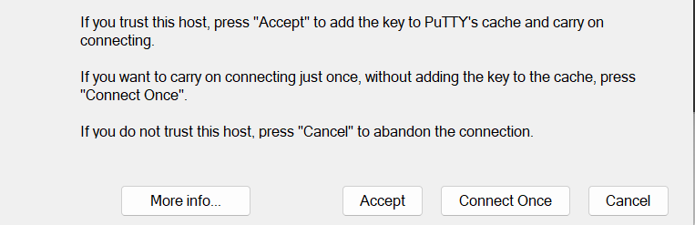
Click on “Accept”. Enter the username and password entered during the virtual machine creation. It would prompt the virtual machine name once the details are entered.
Install Postgre SQL using the commands available on the official site for Postgre SQL. Select the OS version, which is RedHat and the version of PostGre SQL which is required to be installed. For version 15 and RedHat 9, following script is valid for installation:
sudo dnf install -y https://download.postgresql.org/pub/repos/yum/reporpms/EL-9-x86_64/pgdg-redhat-repo-latest.noarch.rpm
sudo dnf -qy module disable postgresql
sudo dnf install -y postgresql15-server
sudo /usr/pgsql-15/bin/postgresql-15-setup initdb
sudo systemctl enable postgresql-15
sudo systemctl start postgresql-15
Let the installation complete. Once the installation is done, that status can be confirmed using the sudo systemctl status postgresql-15 command, if required.
Open pgAdmin to add the server.
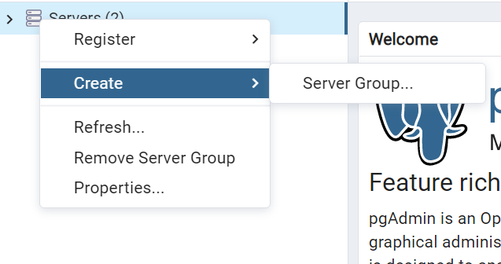
Enter the server details in the following wizard to connect.

COMMUNICATION
To show the communication from first virtual machine to the second can be done by installation of an appropriate Postgre SQL client in the first virtual machine and connecting it to the Postgre SQL server setup on the second Virtual Machine.
An open source client, “pgcli” can be installed by running the command “pip install pgcli”, if python is already present on the system. Otherwise, python needs to be installed prior running the command.
Connect the virtual machines using the script:
pgcli -h <IP of second virtual machine> -U <USERID> -w <PASSWORD>
Replace the <IP of second virtual machine> by the IP address of the virtual machine 2, that is, the server IP. Username and password would be the database credentials created while making the virtual machine. Running the command would confirm that the connection is setup, as it would show up the operating system of the second virtual machine, server address and name of database.

REFERENCES

[1] | M. Masdari and M. Zangakani, "Green cloud computing using proactive virtual machine placement: challenges and issues," Journal of Grid Computing, vol. 18, no. 4, pp. 727-759, 2020.
[2] | S. G. Sutar, P. J. Mali and A. Y. More, "Resource utilization enhancemnet through live virtual machine migration in cloud using ant colony optimization algorithm," International Journal of Speech Technology, vol. 23, no. 1, pp. 79-85, 2020.
[3] | I. Mavridis and H. Karatza, "Combining containers and virtual machines to enhance isolation and extend functionality on cloud computing," Future Generation Computer Systems, vol. 94, pp. 674-696, 2019.
[4] | N. Balashov, R. Kuchumov, N. Kutovskiy, I. Pelevanyuk, V. Petrunin and A. Tsaregorodtsev, "Cloud integration within the Dirac interware," in Proceedings of the 27th International Symposium Nuclear Electronics and Computing (NEC’2019), Budva, Becici, Montenegro, 2019.
[5] | S. Y. Hsieh, C. S. Liu, R. Buyya and A. Y. Zomaya, "Utilization-prediction-aware virtual machine consolidation approach for energy-efficient cloud data centers," Journal of Parallel and Distributed Computing, vol. 139, pp. 99-109, 2020.
[6] | K. Rai, B. Sahana, A. N. Pai, S. Gautham and U. Dhanush, "Vertical scaling of virtual machines in cloud environment," in 2021 International Conference on Recent Trends on Electronics, Information, Communication & Technology (RTEICT), Bengaluru, 2021.
[7] | S. S. S. Reddy, "Cloud computing in a distributed environment implemented with networking technologies," in ICT Analysis and Applications, Singapore, Springer, 2022, pp. 557-563.
[8] | H. Soh, M. Copeland, A. Puca and M. Harris, "Microsoft Azure and Cloud Computing," in Microsoft Azure: Planning, Deploying, and Managing the Cloud, Washington, Springer, 2020, pp. 3-20.
[9] | T. Alam, "Cloud Computing and its role in the Information Technology," IAIC Transactions on Sustainable Digital Innovation (ITSDI), vol. 1, no. 2, pp. 108-115, 2020.
[10] | H. Tabrizchi and M. Kuchaki Rafsanjani, "A survey on security challenges in cloud computing: issues, threats, and solutions," The Journal of Supercomputing, vol. 76, no. 12, pp. 9493-9532, 2020.

