Creating a nurturing school through an inclusive approach to wellbeing
Print this page
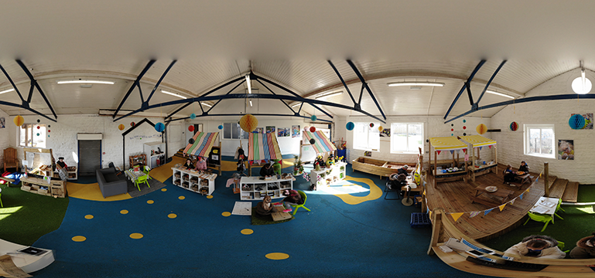

Cadoxton Primary School’s positive approach to wellbeing has created a nurturing community where pupils are ready to learn.

Number of learners: 497
Age range: 3-11
Date of inspection: January 2018
Information about the school
Cadoxton Primary School is situated in the east end of Barry in the Vale of Glamorgan. The school amalgamated with Cadoxton Nursery School in September 2016. Currently, there are 497 pupils on roll, aged from 3-11, including 65 part time nursery pupils, rising to 100 in the summer term. There are 14 single-year classes and four nursery classes.
Around 38% of pupils are eligible for free school meals. This is well above the local authority and national averages. Thirty-eight per cent of pupils are identified as having additional learning needs, which is higher than the local authority and national averages. No pupils have a statement of special educational needs.
The school is currently a pioneer school and is working with the Welsh Government and other schools to take forward curriculum developments within the Health and Wellbeing area of learning experience and professional learning.
Context and background to sector-leading practice
Cadoxton Primary School is committed to creating a nurturing and inclusive community for all. All stakeholders within the school understand the importance of promoting pupils’ wellbeing. The school expresses the importance of addressing pupils’ wellbeing within education, resonating with the World Health Organisation’s statement that “to achieve their potential, school children must participate fully in educational activities. To do this they must be healthy, attentive and emotionally secure.” The school reflected on this statement against what they were seeing in the classroom and decided that they needed a different approach, “one that provided a nurturing environment for all”.
Previously, the school established ‘nurture group’ sessions that ran throughout the week in a designated nurture room. These were led by two learning support assistants for pupils who were identified as needing support. These pupils have then followed a nurture schools programme and are reassessed at the end of each term.
However, the school found that pupils who received this intervention rarely ‘graduated’ (meaning that they met exit criteria and no longer required intervention) and often needed nurture not just at the designated times but at varying times throughout the day – most notably at the start and end of the day. Another consideration by the school was “Are we setting our pupils up for potential failure?” by creating a nurture room where pupils were able to eat, drink and feel supported. Once their time was completed in the nurture group, pupils had to return to the classroom environment, which did not necessary reflect that of the ‘nurture room’. Staff considered the positive benefits for all pupils, by taking what they had learnt from the nurture groups and applying the same philosophy to all classrooms, where pupils feel safe and secure at all times of the day.
Description of nature of strategy or activity identified as sector-leading practice
One of the aims at Cadoxton Primary is to “ensure that all learners and staff are healthy, confident individuals”. The school consider nurturing pupils’ wellbeing to be a responsibility for all within the school community and have created an ethos that “every classroom is a nurture classroom”, a place where pupils are able to achieve their potential by learning and growing together.
School leaders discussed with pupils who had previously been a part of nurture groups what they found to be successful in helping them feel safe, secure, and ready to learn and engage with others. Their main responses were around having a safe place to go if they felt upset or needed space, which included sofas, bean bags, pillows, and blankets, and not feeling hungry or thirsty. With this in mind, leaders worked with the school’s action group ‘Leaders of Learning’ to draw up a list of non negotiables for every classroom. This included communication spaces, pillows and blankets, a snack area of healthy food and drink and calming music. Pupils use these facilities sensibly and this helps nearly all pupils to engage well with their learning throughout the day.
Pupils who may have additional emotional needs are supported through the emotional literacy support assistant (ELSA) within the classroom environment by a member of the nurture team. The school redeployed their nurture team to enable one learning support assistant to provide a check-in for pupils who need time, space and a place for them to understand and consider the impact of their actions when making choices. This is self-regulated by the pupils, who inform the teacher when they feel that they need to use this space known as the ‘The Cwtch’. This has had a huge impact on all the pupils that need this support. This team also provides check-ins for most vulnerable pupils in the morning when they arrive, throughout the day, if they begin feeling overwhelmed, and before they leave school.
The school also considers the wellbeing of pupils within the home environment and its impact on pupils’ learning. Therefore, leaders use the pupil development grant to fund family engagement learning support assistants, who provide opportunities for families to take part in the life and work of the school. For example, the ‘dads, uncles and grandads group’ engages male family members to support pupils’ learning, particularly boys’. Learning support assistants run a series of valuable programmes for parents to help them support their pupils’ learning and wellbeing.
Attitudes to learning and wellbeing for all pupils are assessed at interim points of the year by class teachers. These are monitored as part of the school’s data tracking system. Parents and pupils also complete attitudes to learning and wellbeing questionnaires and both are discussed together as part of the school’s termly parents’ evenings. This ensures effective tracking, monitoring and feedback on all pupils’ wellbeing.
The whole-school approach to wellbeing goes beyond the learning and teaching in the classroom to pervade all aspects of the life of a school including:
- culture, ethos and environment: the health and wellbeing of pupils and staff are promoted through the ‘informal’ curriculum, including leadership practice, the school’s values and attitudes, together with the social and physical environment
- learning and teaching: using the curriculum to develop pupils’ knowledge, attitudes and skills about health and wellbeing
- partnerships with families and the community: proactive engagement with families, outside agencies, and the wider community to promote consistent support for pupils and young people’s health and wellbeing
What impact has this work had on provision and pupils’ standards?
The whole-school approach to wellbeing has enabled pupils to take responsibility for their own learning, and to foster social and emotional development and positive relationships that encourage collaboration. This has means that nearly all pupils are ready to learn at the start of every lesson.

How have you shared your good practice?
Many schools across Wales have visited the school’s provision through open days and in school training programmes that are run for the Central South Consortium. The school is also part of the Health and Wellbeing area for learning as part of the developments for the new Curriculum for Wales.
Links: https://www.cadoxtonprimaryschool.com

