Digital Skills and Research Methods

ASSIMENT 2

Name. Carolina Lopez Alvarez
Student ID. 1909637
Group 3 BWSM 4002
Tutor. Ms Joy Botu

Index

1. Introduction . . . . . . . . . . . . . . . . . . . . . . . . . . . . . . . . . . . 3

2. Background. . . . . . . . . . . . . . . . . . . . . . . . . . . . . . . . . . . . 3

3. Aims and Objectives . . . . . . . . . . . . . . . . . . . . . . . . . . . . 4

4. Method . . . . . . . . . . . . . . . . . . . . . . . . . . . . . . . . . . . . . . 4

5. Result . . . . . . . . . . . . . . . . . . . . . . . . . . . . . . . . . . . . . . . . 4

6. Discussion . . . . . . . . . . . . . . . . . . . . . . . . . . . . . . . . . . . .11

7. References . . . . . . . . . . . . . . . . . . . . . . . . . . . . . . . . . . . 11

Introduction
In order to improve academic performance, Moodle was invented, a platform that serves as a working tool for students and teachers to create online learning, but above all collaborative learning, which would benefit both distance learning and to strengthen education face -to- face. Thanks to the importance of the development given to it by information and communication technologies, they have revolutionized the teaching method, making it more dynamic, flexible and creative both in schools and universities. Looking at its advantages and disadvantages and how this can affect our learning and our way of learning through different questions you ask students by doing a survey.

Background
Moodle is an lMS learning management, also called virtual learning environment, it was created by Martín in Australia. In which they realized that the systems that were being used for distance education at that time had many shortcomings, one of them was that what the teachers shared with the students were only linked sheets from other pages without offering much multimedia content and other features. In which Martin went to the task of creating a software according to the creator of Mauro Martín, this platform has been designed to enable collaborative learning as well as the ideas of pedagogical constructivism, we can say that number is based on five principles, we are all teachers and apprentices in which we potentially learn a lot by observing another, we transform ourselves by understanding another we learn through creation and from others we learn better when the environment is flexible and adapted to our needs. The modular design facilitates the procedure of adding activities and specific characteristics to the course, that is how each part can be configured, that is, adapted to the user's needs. The modular design facilitates the procedure of adding specific activities and characteristics to the course, that is how each part can be configured, that is, adapted to the needs of the user, it is also multilingual so that it can be added. A virtual course must set objectives specific so that it does not contain unnecessary materials and that the evaluation activities allow verifying the fulfilment of these objectives. In addition, the design and materials of the virtual course must favour the creative action of the student, guiding him to search, research and integration of content. One of the drawbacks that we can find is that the same content is shown to all users, it lacks some pedagogical tools and that the options of many administration and platform configurations are exposed to many users. The resources used to display the course content are web pages and links to Word and PDF documents that facilitate the download and printing of the content. Other Moodle modules can be used to present the content of a course, which can be more dynamic and interesting. Among these are books and lessons.

Aim and Objectives
To start I would like to say why this platform is important since it facilitates learning in a more dynamic way using many applications such as videos. Power Points and images and others for a more fluid learning etc. It is the model of today leaving behind methods such as only written sheets that are obsolete and that the objectives of these surveys are the knowledge in percentages of the knowledge of the users that if the platform seems easy or difficult, as if it is useful and how often do they usually use them.

Method
The methods that I had to use to be able to do the survey was by an application called Survey monkey as well as all our classmates and asking questions that we thought or might seem convenient about the platform that we should use minimally 15 people from classes to be able to carry out the survey correctly and thus be able to do the complete surveys. The questions that we used to ask our colleagues, who were my colleagues, many of the accounts, as well as the ones I asked, were the years, because for us it is important to know the average age and gender of the person to posterity. To know how much difficulty the Moodle platform might seem to them and if as a consequence of this it could be of age or not and it generated the difficulty. Many of us wondered among ourselves whether or not we would recommend this platform to other people who need help like this. Like how often you go to visit it for to get information or if you were satisfied or not with the platform and with everything that comes within the applications or if in the future we could reuse the Moodle platform.

Results
The results of my surveys were the presenters here below where a graph of how my results were with the respective for each question asked was shown.

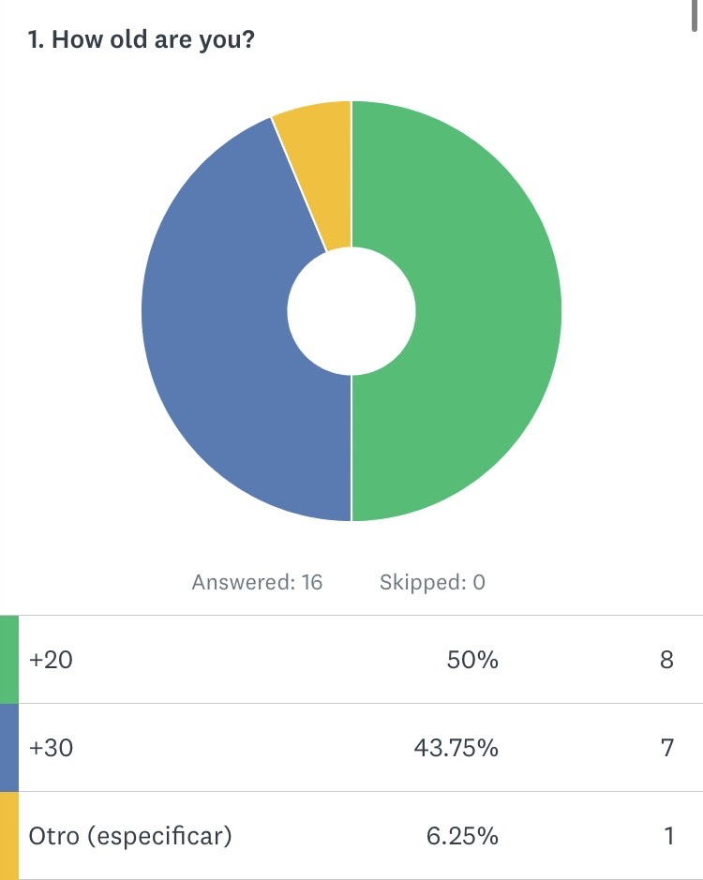
- How old are you? I thought that it was important to know the years that my colleagues could have for the graph and later to know with more questions if this could mean that it could cost more or less the Moodle platform.

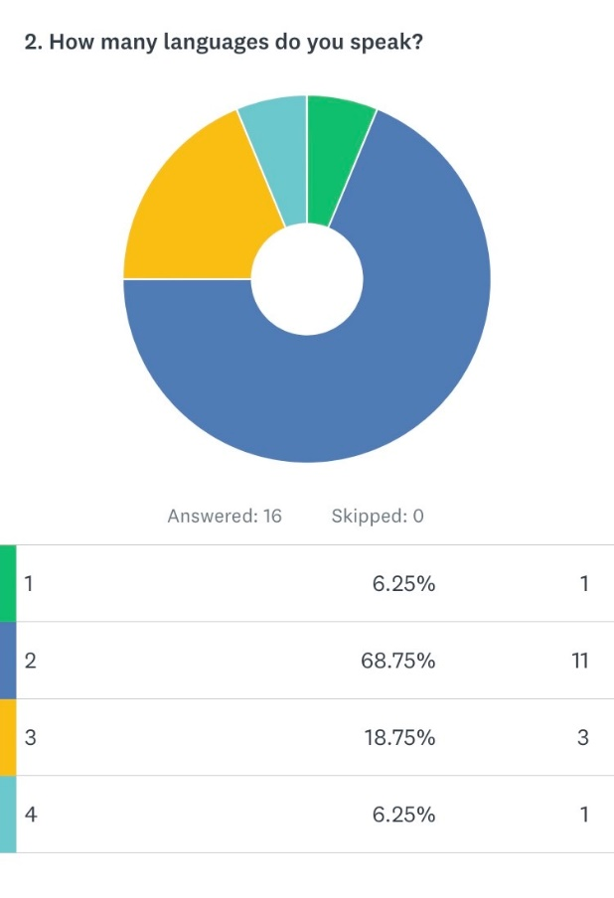
- How many languages do you speak? In this question he wanted to reflect the number of languages that the person can have.

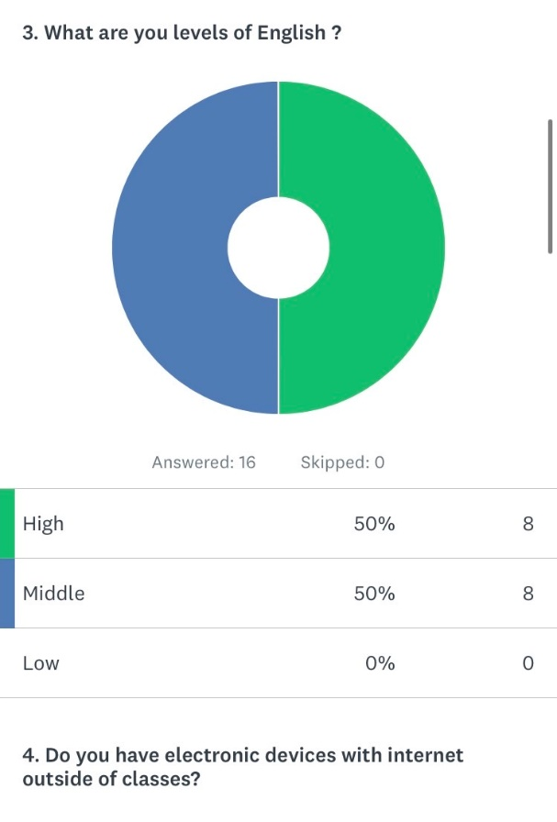
- What are you levels of English? Here I wanted to know the level of English that my colleagues could have to know if it could make it difficult for them when searching.

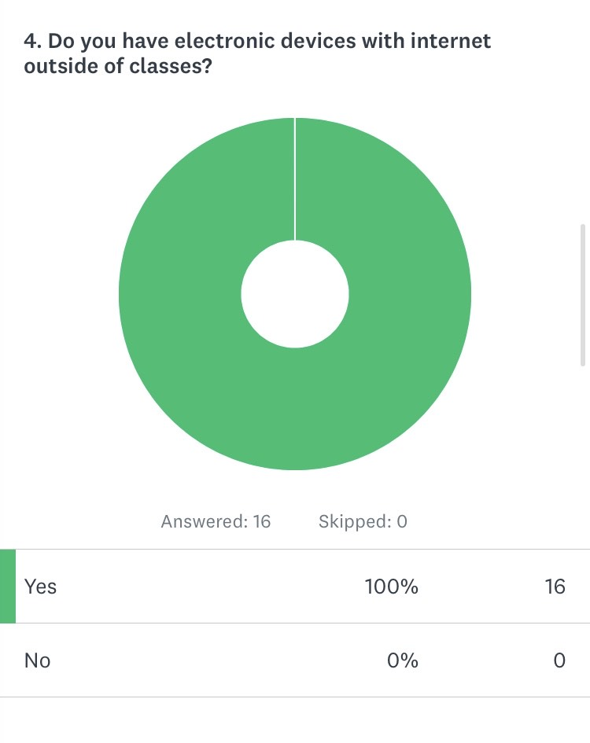
- Do you have electronic devices with internet outside of classes? Here I wanted to know since it is important to have the internet as many as they had when it came to connecting and using the platform.

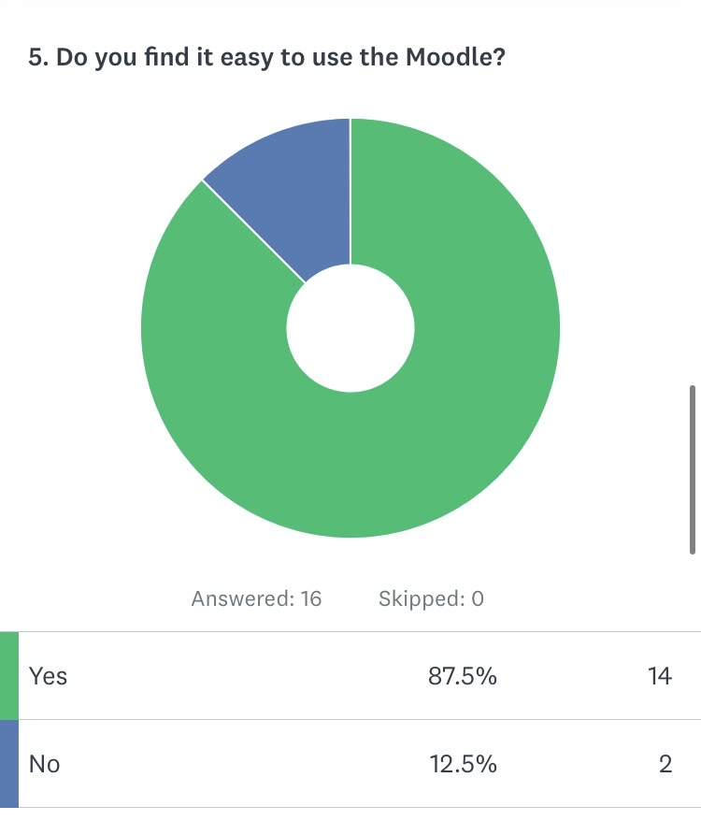
- Do you find it easy to use the Moodle? This question is important because depending on how easy or not the Moodle platform will be, they can use it well and more frequently.

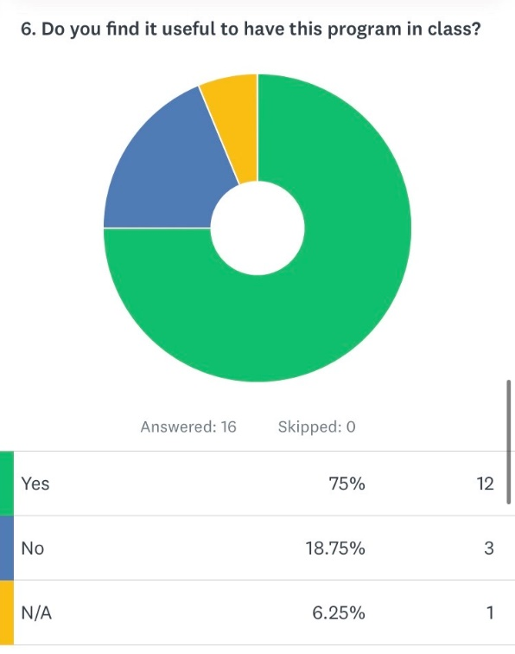
- Do you find it useful to have this program in class? This question depending on this we will know if people seem to use the Moodle platform to intellect and thus get the most out of it.

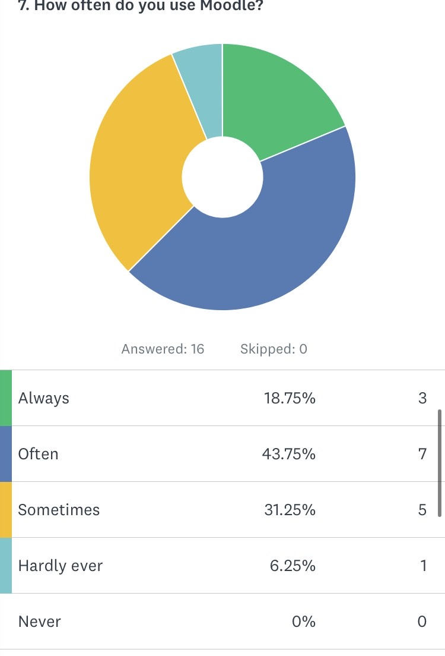
- How often do you use Moodle? I think it is important to know how often students enter to see everything that is exposed on the Moodle platform to know if they are asking for modifications.
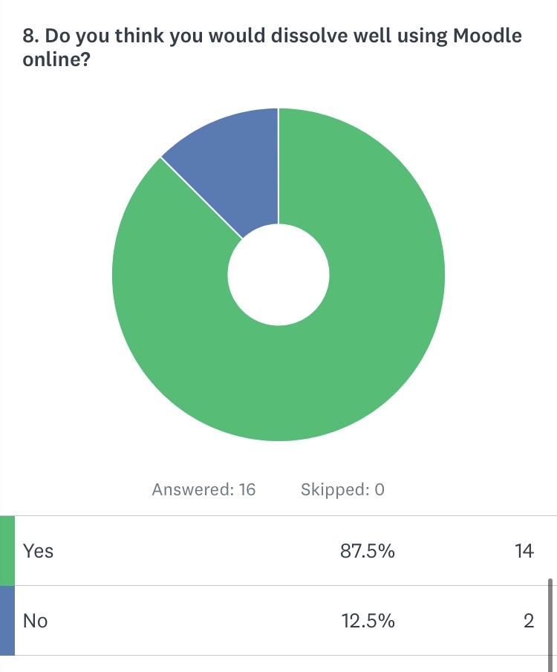
- Do you think you would dissolve well using Moodle online? We can find this question we can know if there is inside each tool that it finds in the Moodle platform and thus find it faster without having to be entering each of the applications that it finds.

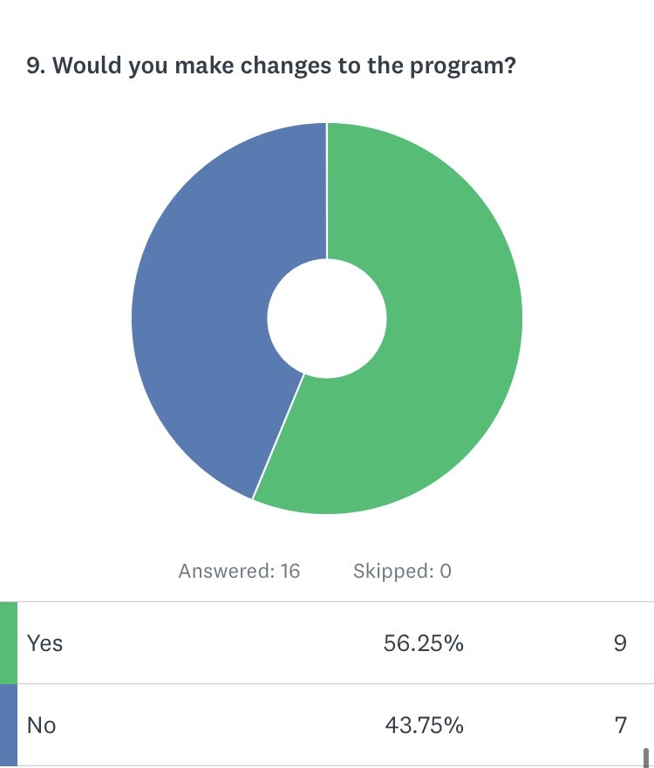
- Would you make changes to the program? It is important in this question to know what changes the Moodle platform needs for the best operation and make changes in the future with ideas that are established and thus better performance.

Discussion
This has been my job in which I made an effort to finish, I could not do it through Exel for personal constituencies but it is but that the images are not bad since they are from the survey that I did. I hope my work is understandable.

References
http://laboratorios.fi.uba.ar/lie/Revista/Articulos/050510/A1mar2008.pdf
https://www.youtube.com/watch?v=rkweuyI8nkU

