
APPENDIX GA36d

LEVEL 7 ASSESSMENT SPECIFICATION

Student name: | Jordan Townsend | Student ID number: | 1804401
Programme: | Secondary PGCE
Module: | Curriculum Development and Enhancement
Module code: | ECSP7002 | Contribution to Overall Module Assessment (%): | 100%
Lecturer: | Helen Denny | Internal Verifier:
Assignment Title: | Research Study including Ethics Form | Word count (or equivalent): | 10.000 words in total including an Ethics form (to be given in on January 11th 2019)
Submission deadline: | May 13th 2019 | Return date of provisional marks & written feedback: | June 10th 2019
Submission method: | All written assessments, where practical and possible, must be submitted via Turnitin unless otherwise instructed by the Lecturer. (Please DO NOT put this assessment specification into Turnitin or it will match many similarities with other students’ submissions.)  Alternative submission method (if applicable):  Late submission of the assessment will result in a late penalty mark. Penalties for late submission: Up to one week late, maximum mark of 50%. Over one week late, 0%. Only the Extenuating Circumstances Panel may approve a change to submission dates.
Academic honesty / referencing: | Academic honesty is required. In the main body of your submission you must give credit to authors on whose research and ideas your work is based. Append to your submission a reference list that indicates the books, articles, etc. that you have used, cited or quoted in order to complete this assessment.
An Investigation of Common Misconceptions in Fractions
This research project was undertaken in a year 7, mixed-gender, set 2 class, over a series of 5 one-hour lessons. While regarded as ‘bright’ pupils, their inexperience of the secondary setting in mathematics, all but guarantees a misconception has followed them from primary school. The lack of mathematics specialists in primary schools (Giles, 2015) could very well be to blame here, but regardless the prevalence of mathematical misconceptions, especially in fractions, is noted by Sealy (2019) and demonstrated by the National Assessment of Educational Progress (NAEP) tests, conducted in the U.S.A. (Sowder & Wearne, 2006; Wearne and Kouba, 2000). I have decided to research the area further, in order to gain a more thorough understanding of the issue, and use this new insight to inform my future practice.
While there is no specific reference to the combat of misconceptions in school x’s policy or their year 7 scheme of work, there are statements which directly target issues that when addressed, would hopefully eradicate many of the misconceptions found in the school. For example, the school’s statement on ‘Teaching and Learning’ highlights their high quality and supportive classrooms, and emphasises their use of feedback being vital in pupil progress. Marzano, Pickering, and Pollock (2001) concur that feedback is essential for pupils to develop their understanding of a concept – but they call for timely feedback, which is specific and corrects students with regards to subject knowledge, something the school recognises and demonstrates in its policy on assessment. If this feedback really does play a key role in pupil progress and understanding concepts, one might see how, if done effectively, misconceptions would indeed be minimised.
Skemp (1976) discusses two types of understanding – instrumental (which he describes as ‘rules without reason’) and relational (a deeper understanding of not just what, but why?). Skemp continues, a student who has a relational understanding of a concept, is more likely to remember that concept, whereas a student who only remembers the rule, may forget, and due to a disconnection in his or her schema, apply further rules incorrectly, leading to a misconception – The scheme of work for school x calls for students to be able to explain and justify their solutions. This is something which would certainly be easier for someone with a relational understanding, and thus implies lessons should be taught in a relational manner. Furthermore, the scheme of works insists students should be able to interpret their answer’s sensibility. If a child finds $\frac{3}{7}+\frac{2}{7}=\frac{5}{14}$ but recognises $\frac{1}{2}+\frac{1}{2}≠\frac{2}{4}$ then they can apply this knowledge to their answer and refute its credibility. However, this is unlikely when a student is blindly applying incorrect rules; it will be a lot more likely for someone who connects his or her concepts, as in a relational understanding. In summary, the scheme of work seems to imply a relational understanding is necessary for its students, and in teaching this way, misconceptions will be less common.
The class chosen for this research was done so by the use of convenience sampling, as the researcher was already timetabled with the class, and the class were due to move on to fractions as their next topic. Dudovskiy (no date) argues that this method is simple to do, and allows for a swift gathering of information. However, it is faulted in that it can often give unreliable data due to selection bias. Bornstein, Jager, and Putnick (2013) agree the selection bias is so great that any results cannot be generalised, and can only be assumed within the sample – in this case, a high mathematics set in a perhaps a year 7 or 8 class. Moreover, a control group is a replica of the research group, except they do not experience one variable which is to be investigated. Pithon (2013) describes the control group as being essential, and thus, the absence of a control group in this investigation again hinders the reliability and usability of its findings. For example, if an improvement is made in a test score, we cannot be certain that this is due to the style of lessons delivered, as there is no control group – perhaps an improvement would have been made regardless.
The research conducted involves a pre-intervention test (pre-test) and a post-intervention test (post-test), with the intervention consisting of several hours of teaching and learning techniques. While Dartmouth College (no date) recognise a pre-test validates any findings considerably more than a research project with no such test, due to the possibility of a comparison, they recognise it is far from perfect. Knapp (2016) asks why one-group pre-test-post-tests are still used as he analyses the numerous disadvantages. For example, while exposed to the intervention stage, there may be multiple reasons for of an improvement in a grade, but they may not be considered in the evaluation. Simply an exposure to fractions, for example. Marsden and Torgerson (2012) argue the need for a control group to account for this. Given that the pre and post-test in this instance is identical, any improvement may be down to practice over intervention (Knapp, 2016). Specifically, certain questions may cause participants to remember the intervention stage, but perhaps with a different question, the misconception may have still been demonstrated (Marsden and Torgerson, 2012). Another phenomena that affects nearly all pre-test experiments, when repeated data is collected, is ‘Regression to the Mean’ or RTM. This phenomena is heightened if some data is particularly high or low scoring when compared to the mean (Cook and Campbell, 1979; Barnett, van der Pols, and Dobson, 2005). Barnett, van der Pols, and Dobson (2005) note RTM occurs due to random error – here this means a student may perform particularly poorly in the pre-test for whatever reason (an illness or distraction, for example) and in the post-test it is more likely a pupil will tend towards the mean than to move further away from it. Thorndike (1942) too, argues that RTM does affect research, particularly in education. Instead the Solomon four-group design is recommended (Marsden and Torgerson, 2012). This design involves two control groups and two experimental groups. All groups are subject to a post-test, but only one control and one experimental group sit the pre-test. By having a group who do not sit the pre-test, Marsden and Togerson (2012) argue the effects of the familiarity of the pre-test can be evaluated, and as aforementioned, the use of the control group is essential (Pithon, 2013). Furthermore, Barnett, van der Pols, and Dobson (2005) suggest that if these groups are selected randomly, the effect of RTM would be present in both the intervention and control group (that sat the pre-test) and thus any differences between each group would more likely be down to the intervention. However, Shuttleworth (2009) reasons that this method is very complex and to have access to four separate classes, in the same context (age, ability etc.) would not be expected, so the one-class pre-test-post-test method is preferred here.
The research also involved the observation of students throughout the 5-lesson period. One of the disadvantages of this method, Bell (2005) tells us, is danger of bias or misinterpretation – especially when the observer, as in this case, is on their own. Yet still, the method gives solid qualitative data on the research topic that might have been otherwise left undiscovered; here, this specifically refers to student comments and attitudes. Even an interview would not necessarily reflect the truth of how each student interacts with the topic but rather how they perceive their interaction; an observation gives the researcher a chance to see what actually happens (Nisbet and Watt, 1980).
Ojose (2015) states that misconceptions are common in various mathematical concepts, across all levels. Fractions, in particular, are a concern, as students struggle to comprehend individual fractions as numbers; it is often that students identify a fraction as a simple division or in perhaps the worst case scenario, two separate, natural numbers (Cramer and Whitney, 2010). One reason for the confusion regarding rational numbers might be put down to the numerous ways of expression; for example, by a ratio or parts of a whole. Students apply complex rules to fractional calculations, with often little understanding of the rule, and it is feasible that the difficulty students have in relating fractions to their daily lives plays its part in this (Alghazo and Alghazo, 2017). This is exactly what Skemp (1976) means when he discusses the need for a relational understanding – a well-developed schema will help students to connect their knowledge, so when more information is absorbed, it will slowly find its place in the existing schema, and then rules will not be applied without a good understanding so misconceptions are less likely.
Siebert and Gaskin (2006) suggest that visual representation in developing fractional concepts is of utmost importance, yet Hodges, Cady, and Collins (2008) find that textbooks will very rarely incorporate a pictorial model, and even when they do, the standard area model is preferred (e.g. 3/4 of a circle or 1/5 of a rectangle is shaded). But why, when research indicates physical models are vital in developing a concept (Cramer & Whitney, 2010), are visual tools not being used more to build understanding of fraction and prevent misconceptions? Models include the area model, as well as a number line and a subset of objects relating to the whole set (set model), but perhaps due to the lack of mathematics specialists in primary schools (Giles, 2015) these modelling tools are not being used, and students are relying on limited knowledge to aid their answering of Question 1 of the diagnostic test. The question concentrates on the area model. The final circle is split into 6 non-equal parts and is designed to test understanding of fractions as being equal parts of the whole. Wong and Evans (2011) note that this concept is frequently misunderstood amongst pupils. Furthermore, Siegler et al. (2010) suggest that sharing and proportionality should be used to aid students in their understanding of fractions consisting of equal parts but the question is included to see if students can connect this knowledge to a visual model or whether a misconception has arisen.
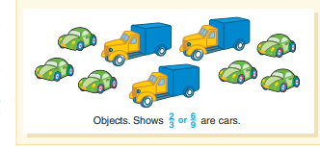
Van der Walle, Karp, and Bay-Williams (2016) warn that a common misconception regarding the set model is that students interpret the size of each subset as being the fraction, as opposed to how the subset relates to the whole. While similar to what is previously mentioned (Wong and Evans, 2011; Siegler et al., 2010) this specific model relates to ratios in fractions. What is interesting is when given Figure 1 (Van der Walle, Karp, and Bay-Williams, 2016), we might expect a student to note 6/9 or 2/3 of the vehicles are cars, or that the ratio of lorry to car is 1:2, but when asked to write 1:2 as a ratio (without any real life context) the answer of 1/2 might be given due to the misconception already discussed.

Figure 1

Question 2 in the test is designed to uncover this misconception, and a shading exercise has accompanied the question. The point of this added task was to encourage pupils to check their answer in both the written and visual form, but also for those pupils which Saundry and Nicol (2006) describe; students who use pictures as their primary method for problem solving, in order to “support the thinking process.”
Question 3 is designed to test numerous misconceptions on the size and comparison of fractions. Van der Walle, Karp, and Bay-Williams (2016) believe the reader has more than likely learned a set of rules to be used when comparing fractions, and the question tests whether these rules have been taught with context and by the use of models, as Chubb (2016) recommends, or if they are stand-alone rules that are being forgotten or misapplied. Each answer provided is unique in terms of the misconception it might reveal: 9/10 is clearly correct. The Australian Association of Mathematics Teachers (aamt) (no date) state that an incorrect response here, might be that 2/3 is the biggest, as thirds are bigger than any other denominator of the five possible answers – in other words, students do not recognise that the numerator must also be taken into consideration as this will refer to the number of parts, and not just the size of those parts; this could very well be down to the lack of clarity when moving from the comparison of unit fractions to more complicated ones and the need to access this prior knowledge in order to build on it is described by Wenk (2017), so if not done effectively, might this cause a student to choose 2/3? Figure 2 is a further example that aamt (no date) give of a common misconception that may result in the answer of 2/3. America’s Choice (no date) note it is often that students apply their natural number concepts to fractions, hence the inclusion of 15/19 and 5/25; a student might choose these if he or she is merely comparing numerators or denominators, and 13/24 if they are adding the two and comparing.

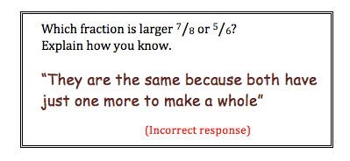

Figure 2

Question 4 is similar to Question 3, but it concentrates on unit fractions, and gives students a chance to extend their thinking, via the use of explanation or picture, for the benefit of the researcher. Aksoy and Yazlik (2017) investigate a similar question, where they found 10% of participants failed the question, and of those 10%, the majority were wrong due to the thinking that the bigger the denominator the bigger the number. Mack (1995) mirrors these findings with an example of student thinking: “Seven is more than four, so sevenths should be bigger than fourths.” Many attempted to model their solution but did so incorrectly, as their partitioning of their shape did not result in equal pieces, perhaps due to a lack of understanding or poor drawing skills. Aliustaoğlu, Tuna, and Biber (2018) too, found a misconception in this area; a student explains that in a fraction where the denominators are equal, the smaller the “nominator,” the larger the fraction. One might argue that this child was taught ‘if the denominators are equal, the smaller the numerator, the smaller the fraction’ but without an underpinning context, the child may have mixed up this idea with ‘the smaller the denominator, the larger the pieces.’ Question 4 was set up in a similar way to this research, to further investigate the issue.
Question 5 is taken from Wong and Evans (2011) who identify two types of tasks – procedural and conceptual. Procedural tasks test a skill that is related to the application of routine knowledge whereas conceptual tasks test if that knowledge can be transferred and applied. They find that in most cases, students are comfortable comparing numerator and denominator to determine if a fraction equals 1 (although not always!), but even for those who recognise this, and therefore complete the procedural task correctly, they can struggle with the conceptual task. Individual student responses correctly declare 2/2 is equal to the whole but when faced with the conceptual task (Question 5) many students resort to a part-to-part visualisation of a fraction (Van der Walle, Karp, and Bay-Williams, 2016) and thus shade only half of the 4 pieces. Given the fact that a misconception seemed to go ‘under the radar’ in the procedural task, the researcher has decided to only include the conceptual task here.
Durkin and Rittle-Johnson (2015) studied pupil misconceptions in mathematics, and found most students were unable to place a number on a number line. Students struggle with this type of activity, as they may fail to see fractions as real numbers on a number line, but instead they are seen as a set of numbers with their own rules (Alghazo and Alghazo, 2017). Question 6 is designed such that an incorrect answer will reveal if students do have this misconception that fractions are somehow different, and don’t classify as standalone numbers. Aliustaoğlu, Tuna, and Biber (2018) gave an interesting example, whereby students had to mark 2/3 on a number line that went from 0 to 6. Over half of participants in the study failed this question, and one answer given was to mark where 4 should be, presumably because this is two thirds of 6. A standard fraction wall model given in Figure 3 (tes, 2017) shows how a number line is often used to aid learning. The pupils in this study would have more than likely marked the correct location on this number line, but when the number 1 is changed to a 6, they fail to conceptualise the problem. Siegler et al. (2010) state a number line is a useful tool in helping students visualise fractions as real numbers, but the research has indicated that even this can lead to misconceptions, and Question 6 will further test this.
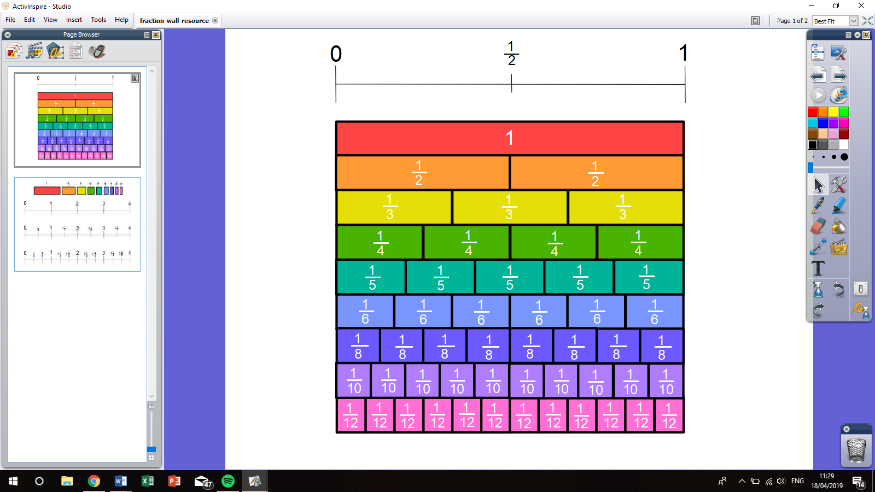

Figure 3

Trivena et al. (2017) investigate the addition of fractions. They conclude that many of students misconceptions come in this area of fractions, and more research should be done as a result. In particular, the addition of fractions, especially when the denominators are different, leads to students adding numerators and denominators separately, in order to find the answer (Aksoy and Yazlik, 2017; Alghazo and Alghazo, 2017). Daro (2014) highlights a reason for this: Figure 4 shows the “butterfly method” for solving addition of fractions; the method, if learnt by rote would of course give you the answer, but Daro argues the answer is not what is important. In fact, he gives an example of his daughter who, when in high school, was not interested in learning, but only wanted to know how to get the right answer. While it may work for some, others who choose to learn through instrumental means (e.g. the butterfly method) or are only given the option to learn in such a way, may suffer as a result of forgetting or mixing up rules. A child taught in this manner might not even know how to add three or more fractions (Also Daro, 2014) due to rigidity of the model. Question 7 is chosen to obtain a greater depth of the issue, and to investigate whether the students try to apply their knowledge of natural numbers to the rationals, as Ojose (2015) records.
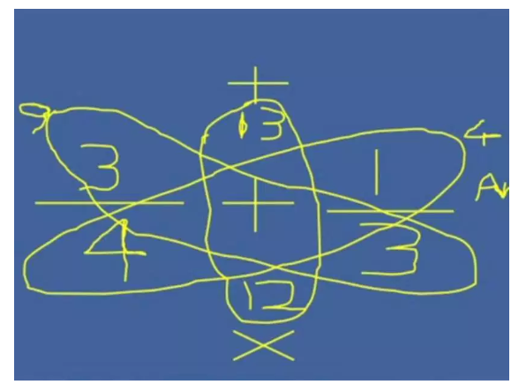

Figure 4

“Students cannot be successful in fraction computation without a strong understanding of fraction equivalence” (Van der Walle, Karp, and Bay-Williams, 2016). Yet in an italk2learn (2014) study, a common misconception in 9-11 year olds was to take a fraction a/b and try to simplify it by 1/ab. The concept of the equivalent fraction should be emphasized (Aliustaoğlu, Tuna, and Biber, 2018) but perhaps this was not the case for the children of the study, as they hold a misconception which would not even hold for a simple case; for example, 2/4 ≠ 1/8. A second misconception held in this important area is that 6/10 = 5/9 as 6 – 1 = 5 and 10 – 1 = 9 (America’s Choice, no date). Furthermore, a simple search on Google for “simplifying fraction strategies” gives a well presented education blog with a plethora of tips. Perhaps most importantly, Camden (2019) gives several instructions on simplifying fractions and checking the fraction is actually in its simplest form. Of course, if used to aid learning, with a variety of models, to enhance a student’s conceptual understanding, then the benefits might outweigh the possible drawbacks (Chubb, no date; Skemp, 1976). But despite pupils consistently meeting fractional operations in their school life, they often forget how to “do them” as when they do try to learn them, they do so by memorising formulas and algorithms (Şiap and Duru, 2004). So any teacher who comes across Camden’s site might misinterpret the point of the blog and thus deliver a lesson which traps students in this cycle Siap and Duru describe. For example, Camden states in her class they “like to just say, ‘divide them both in half’ and see what that leaves us as our fraction” but this leads to misconceptions which the researcher has seen first-hand such as 5/10 being 2.5/5 in its simplest form. Question 8 focuses on the issue of equivalence of fractions.
Question 9 is a test of student understanding, by Skemp’s (1976) definition. The question in not a standard question, so requires students to use what they know about fractions, and the rules and models they should be familiar with, in order solve the relatively simple problem. Donaldson (2015) believes children should have the knowledge and competence to solve a range of mathematical problems, and it can be argued that those students who incorrectly answer this question do not have this knowledge or competence. As a result, the researcher aims to compare data between pupils who successfully answer Question 9 and those who do not, to see if those who fail to transfer their knowledge to an unseen question perhaps hold more misconceptions, possibly due to an instrumental learning technique.
The final question (Question 10) is a typical fraction of an amount question. America’s Choice (no date) find several misconceptions in this area, including: pupils who ignore the denominator and find 3/4 of 12 to be 3 objects out of 12, and those who are likely told the denominator is the number of total parts and misapply the idea, hence visualising 3/4 of 12 as 3/12 of 4 total parts and simply put 3/12 as the answer. Usiskin (2007) has found that this topic is not being pushed enough in school, and this is disappointing given the importance of the concept in further areas of mathematics (Johanning, 2008). Barton (2018) finds a further misconception in finding a fraction of a fractional amount, but given the age of the sample, this area will not be explored here.
A danger, Taylor (2017) writes, of actively addressing a misconception, is that you can actually end up reinforcing it for your students. Therefore, she suggests the best way to teach is to first focus on the facts, in order to establish why ‘right is right.’ In this case, that might involve using a variety of models and contexts, or putting a greater emphasis on number sense and the meaning of a fraction, as opposed to giving a rule to learn (Van der Walle, Karp, and Bay-Williams, 2016). Once that has been established, it is okay to discuss the misconception, and why in fact it is a misconception, or in other words why ‘wrong is wrong.’ If you start with the misconception, students will more likely remember it and then switch off during the correction, or in some cases repeat back the correct information, but forget it shortly after, therefore returning to the misconception (Skurnik et al., 2005; Danielson, Sinatra, and Kendeou, 2016). Taylor (2017) continues, that as you expel the misconception, you must bridge the new gap in knowledge with the correct information, before finally reaching the ‘inoculation’ stage. Ideally here, the researcher discusses the reasons for why the misconception was held and refutes them, using the new information provided, in order to prevent any further misconception arising in this area. Where possible, this model was followed throughout the intervention stage.
Given the importance of expressing fractions through the use of various models (Van der Walle, Karp, and Bay-Williams, 2016), the researcher and class first discussed what ways a fraction could be thought of. Horn (1937) argued the importance of student’s prior knowledge in accepting new ideas, and more modern research seems to corroborate; Given that people “learn information in the context of their prior knowledge,” Sidney and Alibali (2015) find that drawing on a child’s prior knowledge certainly supports them in their intake of new concepts in some contexts. However, van Loon et al. (2013) suggest that an activation of inaccurate prior knowledge can actually be detrimental to their learning as they might discard future concepts in favour of their inaccurate prior knowledge. (Here, this might refer to a misconception). Thus, as suggested by van Loon et al., care was taken, to the best of the researcher’s abilities, in detecting any inaccuracies in prior knowledge, in order to prevent any negative effects in future learning. Once the discussion had taken place, Figure 5 was created and issued to all students, to glue in their books, as a reference point for future concepts.
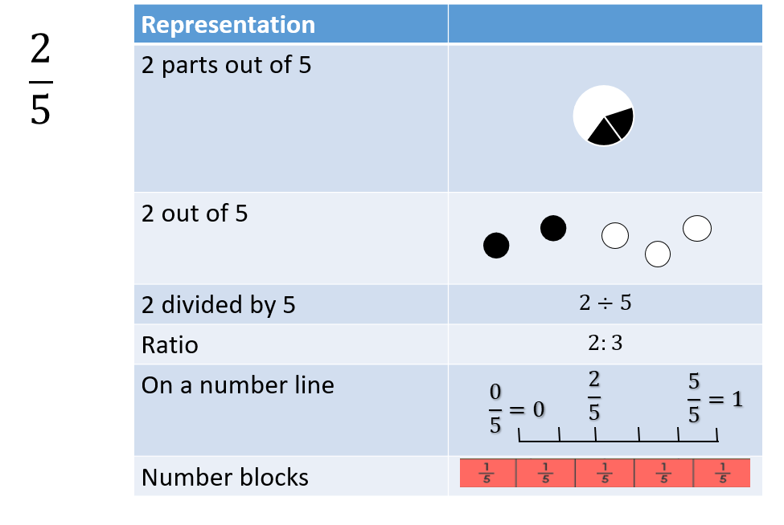
Figure 5

Question 1 of the pre-test indicated two areas of interest – the misconception that 1/6 always means 1 out of 6 parts, regardless of the size of the parts, and the inability to express an equivalent fraction in visual form. Given that equivalent fractions are related to a later question, discussion will be omitted here. Van der Walle, Karp, and Bay-Williams (2016) recommend students create their own representations of fractions to combat the first misconception here. They also suggest examples be given where parts are unequal. The researcher spent approximately 10 minutes straight after the pre-test on a similar activity, where the need for a partition leading to equal pieces was stressed and a variety of examples were given. From pre to post-test there was a 0% improvement in this misconception, with the number of correct answers (from a possible 27) staying at 5. While the suggestion of Van der Walle, Karp, and Bay-Williams (2016) was taken, the time for independent study was not given. Students did not have ample opportunity to create and compare their own examples and as such there was minimal room for exploration of the topic and students could be regarded as fairly passive in their own learning (Steed, 2013). This, coupled with a week long period before the post-test could have led to the absence of any improvement.
The relationship between fractions and ratios was also discussed directly after the pre-test. Immediately, the misconception became apparent, and this was confirmed with just 2 out of the 27 students getting the correct answer in Question 2. Kobrin (2015) declares the teacher’s responsibility, with regards to misconceptions, is to guide and challenge their students, in the hope of causing a conceptual change. One strategy suggested is that of cognitive conflict. Kang, Scharmann, and Noh (2004) explain that many agree the concept is “indispensable” to learning. Class discussion is a good means for this, due to the combined knowledge of the class being greater than that of any individual (Sayce, 2010) so that method was preferred. However, in the post-test only 4 students had put the correct answer. The improvement here was minor, and might be put down to limited opportunity for cognitive conflict. Sayce (2010) tells us, where possible, students should be exposed to this conflict in various scenarios, including individual and group work, but again due to time constraints, class discussion was the only method used. While this one experience may have worked for a minor misconception, the magnitude of the issue was clear here, and longer time for conflict to occur might have wielded better results.
A lack of understanding is often cause for students to blindly apply rules (aamt, no date) and that has been demonstrated. 10 students correctly answered Question 3 of the pre-test, but of those that didn’t, it was common for pupils to turn to one method they were more than likely taught to use in more simple cases – namely, drawing a segmented circle. When dealing with denominators as large as 25, there is no wonder mistakes were made. It appears students were not equipped with various methods for comparison of non-unit fractions. Strategies should be used regularly in lesson, in order for students to be able to use them confidently and creatively (aamt, no date). As discussed by Van der Walle, Karp, and Bay-Williams (2016), the standard approach to find a common denominator, and cross-multiply, while giving the correct answer, does not give students any sense of fraction size and may not be the most appropriate method; for example, 5/25, when compared to 1/2, can instantly be disregarded, before using the cross-multiply method. This is in line with America’s Choice (no date) who declare students will often lead to guessing or doing difficult computations when faced with these questions. This research was used in the intervention period, as a variety of strategies for comparison were debated amongst the group, including pros and cons of each. Little opportunity was given to test out these strategies, and as aamt (no date) explain, there is little use of teaching the strategies, without giving students a chance to see how and why, hence the post-test only showed 13 correct answers, an improvement of 3. Every type of incorrect answer was given, in both tests, but by far the most common was 2/3, possibly due to students ignoring the numerator and noticing the denominator gives the biggest pieces, as is quite common (aamt, no date).
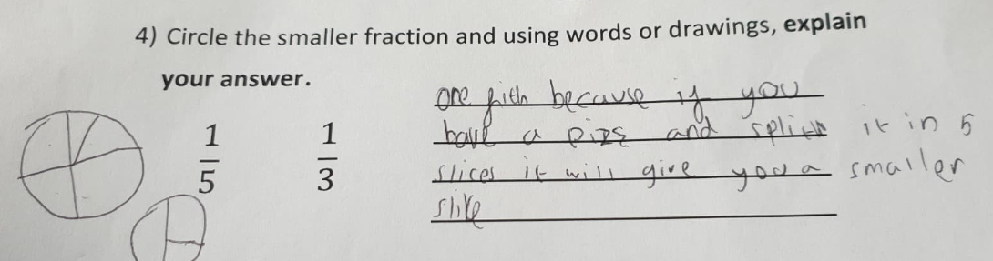
Teacher Education through School-based Support in India (TESS India) (no date) believe children should be taught to ask ‘a fraction of what?’ when given a fraction, as a half of x may be smaller than a quarter of y. However, student B, whom incorrectly answered both Question 3 and 4 raised a concern during the pre-test. “Sir, what does Question 4 mean? A third of what?” It appears this child was taught as TESS India suggest, but this in itself has caused a misconception that America’s Choice (no date) pick up on – a student’s conception of fractions is restricted to a certain model or situation. Here, student B struggles to imagine a fraction as being a single number, but instead sees fractions as operators. Student C correctly obtained the answer, but Figure 6 shows the method given. While seemingly correct reasoning, the drawing demonstrates that this student may not recognise these
Figure 6
pieces need to be equal in order to make the comparison, hence they may get the correct answer, but still hold the misconception that Wong and Evans (2011) report. Given the nature of Question 3 and 4, the intervention stage was identical. Interestingly though, the improvement on Question 4 was more evident. Student B gave a perfect answer while student C correctly converted the two fractions into fifteenths and compared them, in this more effective manner.
25 pupils correctly answered Question 5, in both the pre and post-test. Of the two incorrect answers, 2/4 of the shape was shaded, as expected (Wong and Evans, 2011; Van der Walle, Karp, and Bay-Williams, 2016). Sealy (2019) discusses the importance of the relationship between the numerator and denominator, in developing number sense in pupils. A think, pair, share activity was used, with pupils physically moving around the classroom, in order to promote clear thinking (as Sayce (2010) suggests). The aim was to allow cognitive conflict to occur in those that incorrectly answered the pre-test question, but also benefit those that correctly answered as “repetition helps to improve speed, increases confidence, and strengthens the connections in the brain that help children learn” (Nemours, no date). However, on completion of the post-test, it was noted that while 25 pupils still answered correctly, these were not the same 25 pupils. Gneezy (2005) states the prevalence of academic dishonesty, and it is highly likely, given that the two incorrect answers given in the pre-test were from students sitting next to each other, that one influenced the other in some way, and thus it is difficult to assess the misconceptions associated with this question any further.
Question 6 explores fractions on a number line. Taylor’s (2017) model of addressing a misconception was demonstrated here, as students were given the opportunity to add quarters on a number line that stretched beyond the number 1, so the class could see 1/4 did not necessarily mean 1/4 of the line. Next, in an effort to focus on why wrong is wrong the researcher asked where one half would lie on the number line and one student still held the misconception that it would be half way across the line. The researcher explained 1/2 is 1 divided by 2, which is of course 0.5, so would actually be between 0 and 1. Finally, the researcher moved back to the example of adding fractions across the number line to solidify the fact that one half would be at the start of the number line given, not half way.
Unlike the previous misconceptions, a total of 1 hour was spent on adding fractions and the results of Question 7 reflect this well. An improvement of 3, to 20 correct answers. More impressively, two pupils missed the lesson on addition of fractions and both retained their misconception (adding both the numerator and denominator separately), and a third student appeared to overcome their misconception but simply made a numerical error, which differs from a misconception in that is just a deviation from accuracy (Bala, 2013). Sealy (2019) suggests that content is not rushed through, if a misconception is to be overcome, and the evidence here shows that when more time is spent on a misconception (which was very strongly held by the participants) then the intervention is a lot more effective. The researcher heavily relied on questioning to gage where the students were, in terms of their misconception, and used this to encourage a cognitive conflict. The resource used is provided in Figure 7. By building on the common knowledge that a half plus a half is a whole, the researcher was able to dispel the idea that 1/2 + 2/3 could be less than 1 as most students presumed, thanks to their misconception. From here, pupils were able to explore the area further, via a worksheet, a chance which they did not have with previous misconceptions, possibly leading to this change in conception (Ojose, 2015).
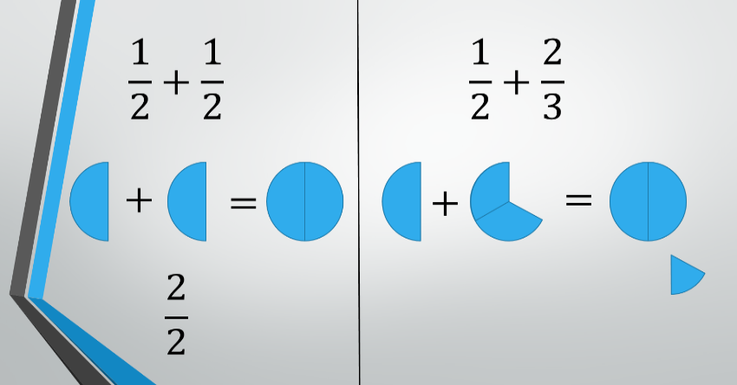

Figure 7

Question 8 was answered fairly well in the pre-test (15 students) but an improvement was still made in the post-test (20 students). Again, one hour of intervention was used to work on fraction equivalence, so an improvement is more likely than if less time was spent (Sealy, 2019). Mini whiteboards were used in order to engage pupils, something which Martin (2001) believes is key to academic success. However, some pupils still appeared to hold a misconception – aamt (no date) state “A lack of understanding of how and why a procedure works is usually the underlying cause” of a misconception, and this can lead to the blind application of rules. Here, this was shown as students divided top and bottom by 2 and gave their answer as 4.5/18. Other students seemed to understand that dividing by 2 would not be appropriate, but still left their answer as 3/12, which is of course isn’t in its simplest form. While in general, an improvement was made, it seems more work is needed in helping these students understand the ‘why’s of the procedure, in order to develop their understanding of the concept, and further eradicate the misconceptions in this area.
Figure 8 shows the comparison of student M and student B, two students who made the biggest improvements from pre to post-test. Due to the various tickbox options in Question 1, the student answers for Question 9 correspond to Question 13 in the graphs. A 1 indicates the correct response, and a 0, the incorrect response. You might recall that this question was designed to compare the overcoming of misconceptions, with the application of knowledge to an unseen question. Student M correctly answered Question 9 in both assessments, and also saw the greatest improvement. This may indicate that the student does hold the relational understanding Skemp (1976) discusses, but still appeared to slip into common misconceptions amongst the class, until his memory was refreshed during the intervention stage. Naep (2007) note the importance of revision of material in bettering one’s performance, and this is perhaps what occurred in this instance. Furthermore, student B, the very same who was unable to compare fractions in the pre-test, realised that 1/10 is not 2 lots of 1/5 but actually one half of it. They too, improved their performance dramatically, and would have further, if not for missing that 3/12 could be cancelled further in Question 8. This research indicates, as Skemp (1976) suggests, that those who develop a relational understanding of a concept, can apply their knowledge to new situations, and as a direct effect, are less likely to hold misconceptions.

Figure 8

18 students correctly answered Question 10 in the pre-test. It was difficult to evaluate the incorrect responses, due to a severe lack of workings from those who did put the wrong answer. However, the researcher developed an activity to combat any misunderstandings. Sayce (2010) tells us that group work is important as it takes the accountability from the individual, so pupils are more likely to put forth their ideas and engage with the learning; as a result, the activity involved groups of 3 or 4. The activity involved cutting up paper and using it to aid in solving 3/4 of 16. While the researcher had a particular way of doing this in mind, the creativity of solutions given was awe-inspiring. The United States Department of State (no date) state that if a child is having fun, they are a lot more likely to learn and retain information, as they are enjoying, so the experience becomes more memorable. Moreover, the activity stimulated kinaesthetic learning. Nepean Tutoring (no date) write: “Kinaesthetic learning has the advantage of letting children gain self-knowledge by letting them learn at their own comfort level, confidence level and with their own creative potentials. With this style of learning, children are also engaged in positive social interaction, develop problem solving skills and can apply creativity through self-expression.” While the article presents its arguments in terms of learners being either, visual, audio or kinaesthetic, an idea which has long been disproved (Franz, 2017), the benefits of multisensory learning are recognised by Shams and Seitz (2008) and thus it was important to include an activity such as this. Astonishingly, 26 out of the 27 students ended up correctly answering Question 10 in the post-test. The only who didn’t, omitted an answer on both occasions. This highlights the importance of well thought-out activities, consciously provided by the teacher, to eliminate misconceptions (Ojose, 2015).
While the frequency of misconceptions in mathematics, and even just in fractions is too great to evaluate in this study (Ojose, 2015; Sealy, 2019; Sowder & Wearne, 2006; Wearne and Kouba, 2000), the most common seems to be that students conceptualise fractions as two separate numbers (Cramer and Whitney, 2010), possibly caused by the lack of models used in the teaching of mathematics (Hodges, Cady, and Collins, 2008), which is strange given the importance of physical models in learning (Siebert and Gaskin, 2006).
The research has further strengthened this idea, as Question 7 (addition of fractions) showed over 80% of the sample held the misconception that you can add the top and bottom of a fraction separately. Furthermore, Question 6, which assesses the use of a more unfamiliar model confirmed Durkin and Rittle-Johnson’s (2015) study that most students were unable to place a number on a number line, possibly due to their conception that fractions aren’t standalone numbers so 2/3 must be two thirds of something (Alghazo and Alghazo, 2017).
The study also highlights the importance of well thought-out, multisensory activities, discussed by Ojose (2015). When an activity was given of this type, the results were near-perfect in terms of a turnaround in misconception. Furthermore, with this activity, students had time to engage in the concept with their peers. Sealy (2019) advises teachers to not rush through material when hoping to eliminate a misconception, and Sayce (2010) confirms group work is a useful tool in cognitive conflict; the difference between improvement in Question 10 and Question 2, where pupils spent approximately 20 minutes in a group activity, and 3 minutes in a class discussion, respectively, cannot go untold. While a class discussion is of course useful due to the combined knowledge of the class, cognitive conflict best occurs when targeted in various forms (Also Sayce, 2010). In addressing Question 10, pupils had a chance for group work as well as to feedback to the class, and the result were reflected in line with Sayce’s theory. Steed (2013) also values the idea that students should be active in their learning, in order to explore and fully understand a topic, and where students were so (for example, when adding and simplifying fractions) the improvement was much greater than when students were seen to be more passive (for example, when comparing fractions).
However, it is important to remind ourselves of the circumstances of the study. Due to the necessity of a control group, it is difficult to gage the reliability of the findings without one (Pithon, 2013). Furthermore, the RTM phenomena discussed by Cook and Campbell (1979) and Barnett, van der Pols, and Dobson (2005) could very well play its part in the apparent improvement. For example, student D performed the worst in the pre-test with a score of 4 out of 14 (this includes the division of Question 1 into 5 sub-questions) whereas the mean was 7.25 – this child then achieved a score of 7 in the post-test, while the mean was closer to 9. It could be argued that the phenomena was demonstrated here, and that the student’s improvement was not as great as seems at first glance. It is also possible that the exposure and practice of fractions in general, was cause for this improvement (Knapp, 2016; Marsden and Torgerson, 2012). This might be shown in student U who, as previously mentioned, showed a good understanding of fractions, by correctly answering Question 9, but then overcame many more misconceptions than his or her peers – perhaps they were just reminded, as opposed to developing their concept of fractions entirely, via the techniques discussed in the previous paragraph.
The prevalence of academic dishonesty (Gneezy, 2005) is also good reason to refute the authenticity of the study’s findings, and the concern Evans and Wong (2011) hold for students giving a correct response but an incorrect reasoning should also be taken into consideration. For example, while asked to explain their answers to Question 4, many reasons did not quite match up with the final answer given, but the correct answer was often given so had to be included in the data.
Sealy (2019) tells us “you can only overcome one misconception at a time” or there is a risk of cognitive overload, and this study hopes to address a plethora of misconceptions, in a topic which is riddled with them, in a limited time period (Ojose, 2015; Sealy, 2019; Sowder & Wearne, 2006; Wearne and Kouba, 2000), thus in the future the researcher hopes to break up the intervention, and spend more time in each area, so each child can be an active learner on their journey to overcome each misconception which of course Steed (2013) accentuates. If this approach is taken, and a second class is used as a control group, the researcher also hopes to develop a similar pre and post-test in different areas where misconceptions are rife (such as algebra and decimals (Ojose, 2015; America’s Choice, no date)). The researcher will also use the findings of this study to inform future practice. Examples include the use of multisensory activities, group tasks, class discussions, and when suiting the topic, a variety of models including set and number line models.

Aamt (no date) Fractions Available at: https://topdrawer.aamt.edu.au/Fractions (Accessed: 12th May 2019).
Aksoy, M. and Yazlik, D. (2017) Student Errors in Fractions and Possible Causes of These Errors Journal of Education and Training Studies, 5(11).
Alghazo, Y. and Alghazo, R. (2017) Exploring Common Misconceptions and Errors about Fractions among College Students in Saudi Arabia. International Education Studies, 10(4).
Aliustaoğlu, F., Tuna, A., Biber, A. (2018) Misconceptions of Sixth Grade Secondary School Students on Fractions International Electronic Journal of Elementary Education 10(5), pp. 591 – 599.
America’s Choice (no date) Misconceptions and Errors Available at: https://www.westada.org/cms/lib/ID01904074/Centricity/Domain/207/Misconceptions_Error%202.pdf (Accessed: 12th May 2019).
Bala, R. (2013) A study of errors and misconceptions in mathematics at elementary school stage INTERNATIONAL JOURNAL OF INFORMATIVE AND FUTURISTIC RESEARCH, 1(1).
Barnett, A., van der Pols, J., and Dobson, A. (2005) Regression to the mean: what it is and how to deal with it. International Journal of Epidemiology, Volume 34, Issue 1, Pages 215–220.
Barton, C. (2018) Available at: https://medium.com/eedi/fraction-of-an-amount-guess-the-misconception-46b304e8d749 (Accessed: 12th May 2019).
Bell, J. (2005) Your Research Project Available at: http://elearning.ufl.udn.vn/home/esp/pluginfile.php/3274/mod_resource/content/1/Judith%20Bell%20-%20Doing_Your_Research_Project.pdf (Accessed: 12th May 2019).
Bornstein, M., Jager, J., and Putnick, D. (2013). Sampling in Developmental Science: Situations, Shortcomings, Solutions, and Standards. Dev Rev, 33(4), pp 357–370.
Camden, S. (2019) Simple Strategies for Simplifying Fractions Available at: https://thereflectiveeducator.com/simple-strategies-for-simplifying-fractions/ (Accessed: 12th May 2019).
Chubb, M. (2016) Focus on Relational Understanding Available at: https://buildingmathematicians.wordpress.com/2016/07/31/focus-on-relational-understanding/ (Accessed: 12th May 2019).
Cook, T. and Campbell, D. (1979) Quasi-experimentation: design and analysis issues for field settings (Boston, MA, Houghton Mifflin).
Cramer, K.A. and Whitney, S. (2010) Learning rational number concepts and skills in elementary classrooms: Translating research to the elementary classroom. in DV Lambdin & FK Lester (eds), Teaching and learning mathematics: Translating research to the elementary classroom. NCTM, Reston, VA, pp. 15-22.
Danielson, R. W., Sinatra, G. M., and Kendeou, P. (2016) Augmenting the refutation text effect with analogies and graphics, Discourse Processes, 53, 5-6, 392-414.
Daro, P. (2014) Against Answer Getting Available at: https://vimeo.com/79916037 (Accessed: 12th May 2019).
Dartmouth College (no date) Types of Experimental Design Available at: https://www.dartmouth.edu/.../Types_of_Experimental_Designs_Handout.doc (Accessed: 3rd May 2019).
Donaldson, G. (2015) Successful Futures. Available at: https://gov.wales/docs/dcells/publications/150225-successful-futures-en.pdf (Accessed 16th April 2019).
Dudovsky, J. (no date). Convenience Sampling Available at: https://research-methodology.net/sampling-in-primary-data-collection/convenience-sampling/ (Accessed: 12th May 2019)
Durkin, K. and Rittle-Johnson, B. (2015). Diagnosing misconceptions: Revealing changing decimal fraction knowledge. Learning and Instruction, 37, 21-29.
Franz, J. (2017) Consider yourself a 'visual' or 'auditory' learner? Turns out, there’s not much science behind learning styles Available at: https://www.pri.org/stories/2017-09-17/consider-yourself-visual-or-auditory-learner-turns-out-there-s-not-much-science (Accessed: 12th May 2019).
Giles, S. (2015) Maths teacher shortages: the real elephant in the classroom Available at: https://blogs.royalsociety.org/in-verba/2015/05/06/elephant-in-the-classroom/ (Accessed: 12th May 2019).
Gneezy, U. (2005) Deception: The Role of Consequences American Economic Review, 95(1), pp. 384-394.
Hodges, T., Cady, J., Collins, R. (2008) Mathematics Teaching in the Middle School 14 (2), 78 – 84.
Horn, E. (1937) Methods of instruction in the social studies. New York: Scribners.
Italk2learn (2014) Fractions Misconceptions and Thinking-in-Change: Samuel and the Equivalent Fractions Available at: http://www.italk2learn.eu/fractions-misconceptions-thinking-change-samuel-equivalent-fractions/ (Accessed: 12th May 2019).
Johanning, D. (2008) Learning to use fractions: Examining middle school students' emerging fraction literacy Journal for Research in Mathematics Education, 39(3), pp. 281-310.
Kang, S., Scharmann, L., Noh, T. (2004) Reexamining the Role of Cognitive Conflict in Science Concept Learning Research in Science Education, 34(1), pp. 71-96.
Knapp, T. (2016) Why Is the One-Group Pretest–Posttest Design Still Used? Clinical Nursing Research, Vol. 25(5) 467–472.
Kobrin, J. (2015) Learning from Student Misconceptions Available at: https://www.pearsoned.com/learning-from-student-misconceptions/ (Accessed : 12th May 2019).
Mack, N. (1995) Learning Fractions with Understanding: Building on Informal Knowledge Journal for Research in Mathematics Education, 21(1).
Marsden, E. and Torgerson, C. (2012) Single group, pre- and post-test research designs: Some methodological concerns. Oxford Review of Education Vol. 38, No. 5, pp. 583–616.
Martin, A. (2001) The Student Motivation Scale: A tool for measuring and enhancing motivation Australian Journal of Guidance and Counselling, 11, pp. 1-20.
Marzano R., Pickering D., & Pollock J. (2001). Classroom Instruction That Works.
National Assessment of Educational Progress. (2007). NAEP 2007 writing report card: Findings from the National Assessment of Educational Progress. Washington, DC: U.S. Department of Education, Institute of Education Sciences, National Center for Education Statistics.
Nemours (no date) Let’s Do It Again . . . and Again! Why is Repetition Important to Learning? Available at: http://www.readingbrightstart.org/articles-for-parents/lets-repetition-important-learning/ (Accessed: 12th May 2019).
Nepean tutoring (no date) Benefits of Kinaesthetic Learning Available at: https://nepeantutoring.com.au/benefits-of-kinesthetic-learning/ (Accessed: 12th May 2019).
Nisbet, J.D. and Watt, J. (1980) Case Study. Rediguide 26, University of Nottingham School of Education.
Ojose, B. (2015) Students’ Misconceptions in Mathematics: Analysis of Remedies and What Research Says Available at: https://kb.osu.edu/bitstream/handle/1811/78927/1/OJSM_72_Fall2015_30.pdf (Accessed: 12th May 2019).
Pithon, M. (2013) Importance of the control group in scientific research. Dental Press Journal of Orthodontics, 18(6) Available at: http://www.scielo.br/scielo.php?script=sci_arttext&pid=S2176-94512013000600003 (Accessed: 12th May 2019).
Saundry, C. and Nicol, C. (2006) DRAWING AS PROBLEM-SOLVING: YOUNG CHILDREN'S MATHEMATICAL REASONING THROUGH PICTURES.
Sayce, L. (2010) The Way out of Cognitive Conflict Available at: https://www.ncetm.org.uk/public/files/695450/TEFP0901+Toolkit+The+Way+Out+of+Cognitive+Conflict.pdf (Accessed: 5th May 2019)
Sealy, C. (2019) Common Primary Maths Misconceptions and Errors (And How to Overcome Them) Available at: https://thirdspacelearning.com/blog/common-errors-misconceptions-primary-maths-ks1-ks2/ (Accessed: 12th May 2019)
Shamz, L. and Seitz, A. (2008) Benefits of Multisensory Learning Available at: https://l2l.school/pdfs/Multisensory%20Learning%20Benefits.pdf (Accessed: 12th May 2019).
Shuttleworth, M. (2009) Pretest-Posttest Design Available at: https://explorable.com/pretest-posttest-designs (Accessed: 12th May 2019).
Şiap, İ. and Duru, A. (2004) The ability to use geometric models in fractions Gazi University Kastamonu Education Journal, 12(1), 89-96.
Sidney, P. and Alibali, M. (2015) Making Connections in Math: Activating a Prior Knowledge Analogue Matters for Learning Journal of Cognition and Development, 16(1), pp. 160-185.
Siebert, D. and Gaskin, N. (2006) Creating, naming and justifying fractions. Teaching Children Mathematics, 12, 394-400.
Siegler, R., Carpenter, T., Fennell, F., Geary, D. (2010) Developing Effective Fractions Instruction for Kindergarten through 8th Grade.
Skemp, R. (1976). Relational Understanding and Instrumental Understanding. Available at: https://alearningplace.com.au/wp-content/uploads/2016/01/Skemp-paper1.pdf (Accessed: 28th April 2019).
Skurnik, I., Yoon, C., Park, D., and Schwarz, N. (2005) How warnings about false claims become recommendations. Journal of Consumer Research, 31, 713–724.
Sowder, J., and Wearne, D. (2006). What do we know about eighth-grade student achievement? Mathematics Teaching in the Middle School, 11(6), 285–293.
Steed, M. (2013) Importance of Independent Learning Available at: http://independenthead.blogspot.com/2013/07/independent-learning.html?m=1 (Accessed: 12th May 2019).
Taylor, A. (2017) GUEST POST: How to Help Students Overcome Misconceptions Available at: http://www.learningscientists.org/blog/2017/7/25-1 (Accessed: 12th May 2019).
Tes (2017) Fraction Wall resource Available at: https://www.tes.com/teaching-resource/fraction-wall-resource-11770201 (Accessed: 12th May 2019).
TESS India (no date) Asking questions that challenge thinking: fractions Available at: http://www.open.edu/openlearncreate/pluginfile.php/134935/mod_resource/content/3/EM05_AIE_Final.pdf (Accessed: 12th May 2019)
The United States Department of State (no date) MAKING LEARNING FUN Available at: https://americanenglish.state.gov/files/ae/resource_files/background_1.pdf (Accessed: 12th May 2019).
Thorndike, R.L. (1942) Regression fallacies in the matched groups experiment, Psychometrika, 7, 85–102.
Trivena, V., Ningsih, A., Jupri, A. (2017) Misconception on Addition and Subtraction of Fraction at Primary School Students in Fifth-Grade Journal of Physics: Conf. Ser. 895 012139.
Usiskin, Z. (2007) The arıthmetıc operatıons as mathematıcal models. Modelling and Applications in Mathematics Education, 257.
Van de Walle, J., Karp, K., Bay-Williams, J. (2016) Elementary and Middle School Mathematics: Teaching Developmentally, Loose-Leaf Version, 9th Edition. Available at: https://www.pearsonhighered.com/content/dam/region-na/us/higher-ed/en/products-services/course-products/vandewalle-9e-info/pdf/0133768937.pdf (Accessed: 12th May 2019).
Van Loon, M., de Bruin, A., Gog, T., van Merriënboer, J. (2013) Activation of inaccurate prior knowledge affects primary-school students’ metacognitive judgments and calibration Learning and Instruction, 24, pp. 15-25.
Wearne, D., and Kouba, V. (2000). Rational numbers. In E. A. Silver & P. A. Kenney (Eds.), Results from the seventh mathematics assessment of the National Assessment of Educational Progress (pp. 163–191). Reston, VA: NCTM.
Wenk, L. (2017) The importance of engaging prior knowledge Available at: https://sites.hampshire.edu/ctl/2017/09/14/the-importance-of-engaging-prior-knowledge/ (Accessed: 12th May 2019).
Wong, M. and Evans, D. (2011) Assessing Students’ Understanding of Fraction Equivalence Fractions: Teaching for Understanding pp. 81 – 90.

