  Title page | Programme  Cert HE Business Skills for the Workplace  Module  Employability and Career Development  Module Code  LCLM4005  Lecturer  Trinh Nguyen Thi Ngoc (Jessie)  Student Name  Zeeshan Ali  Student Id  2511467

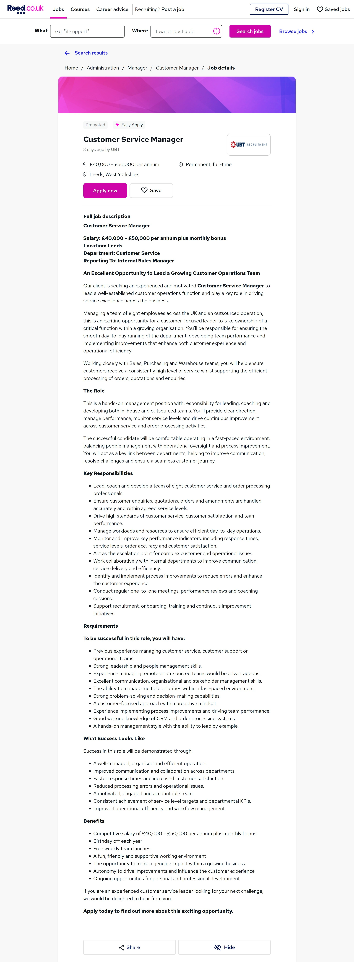

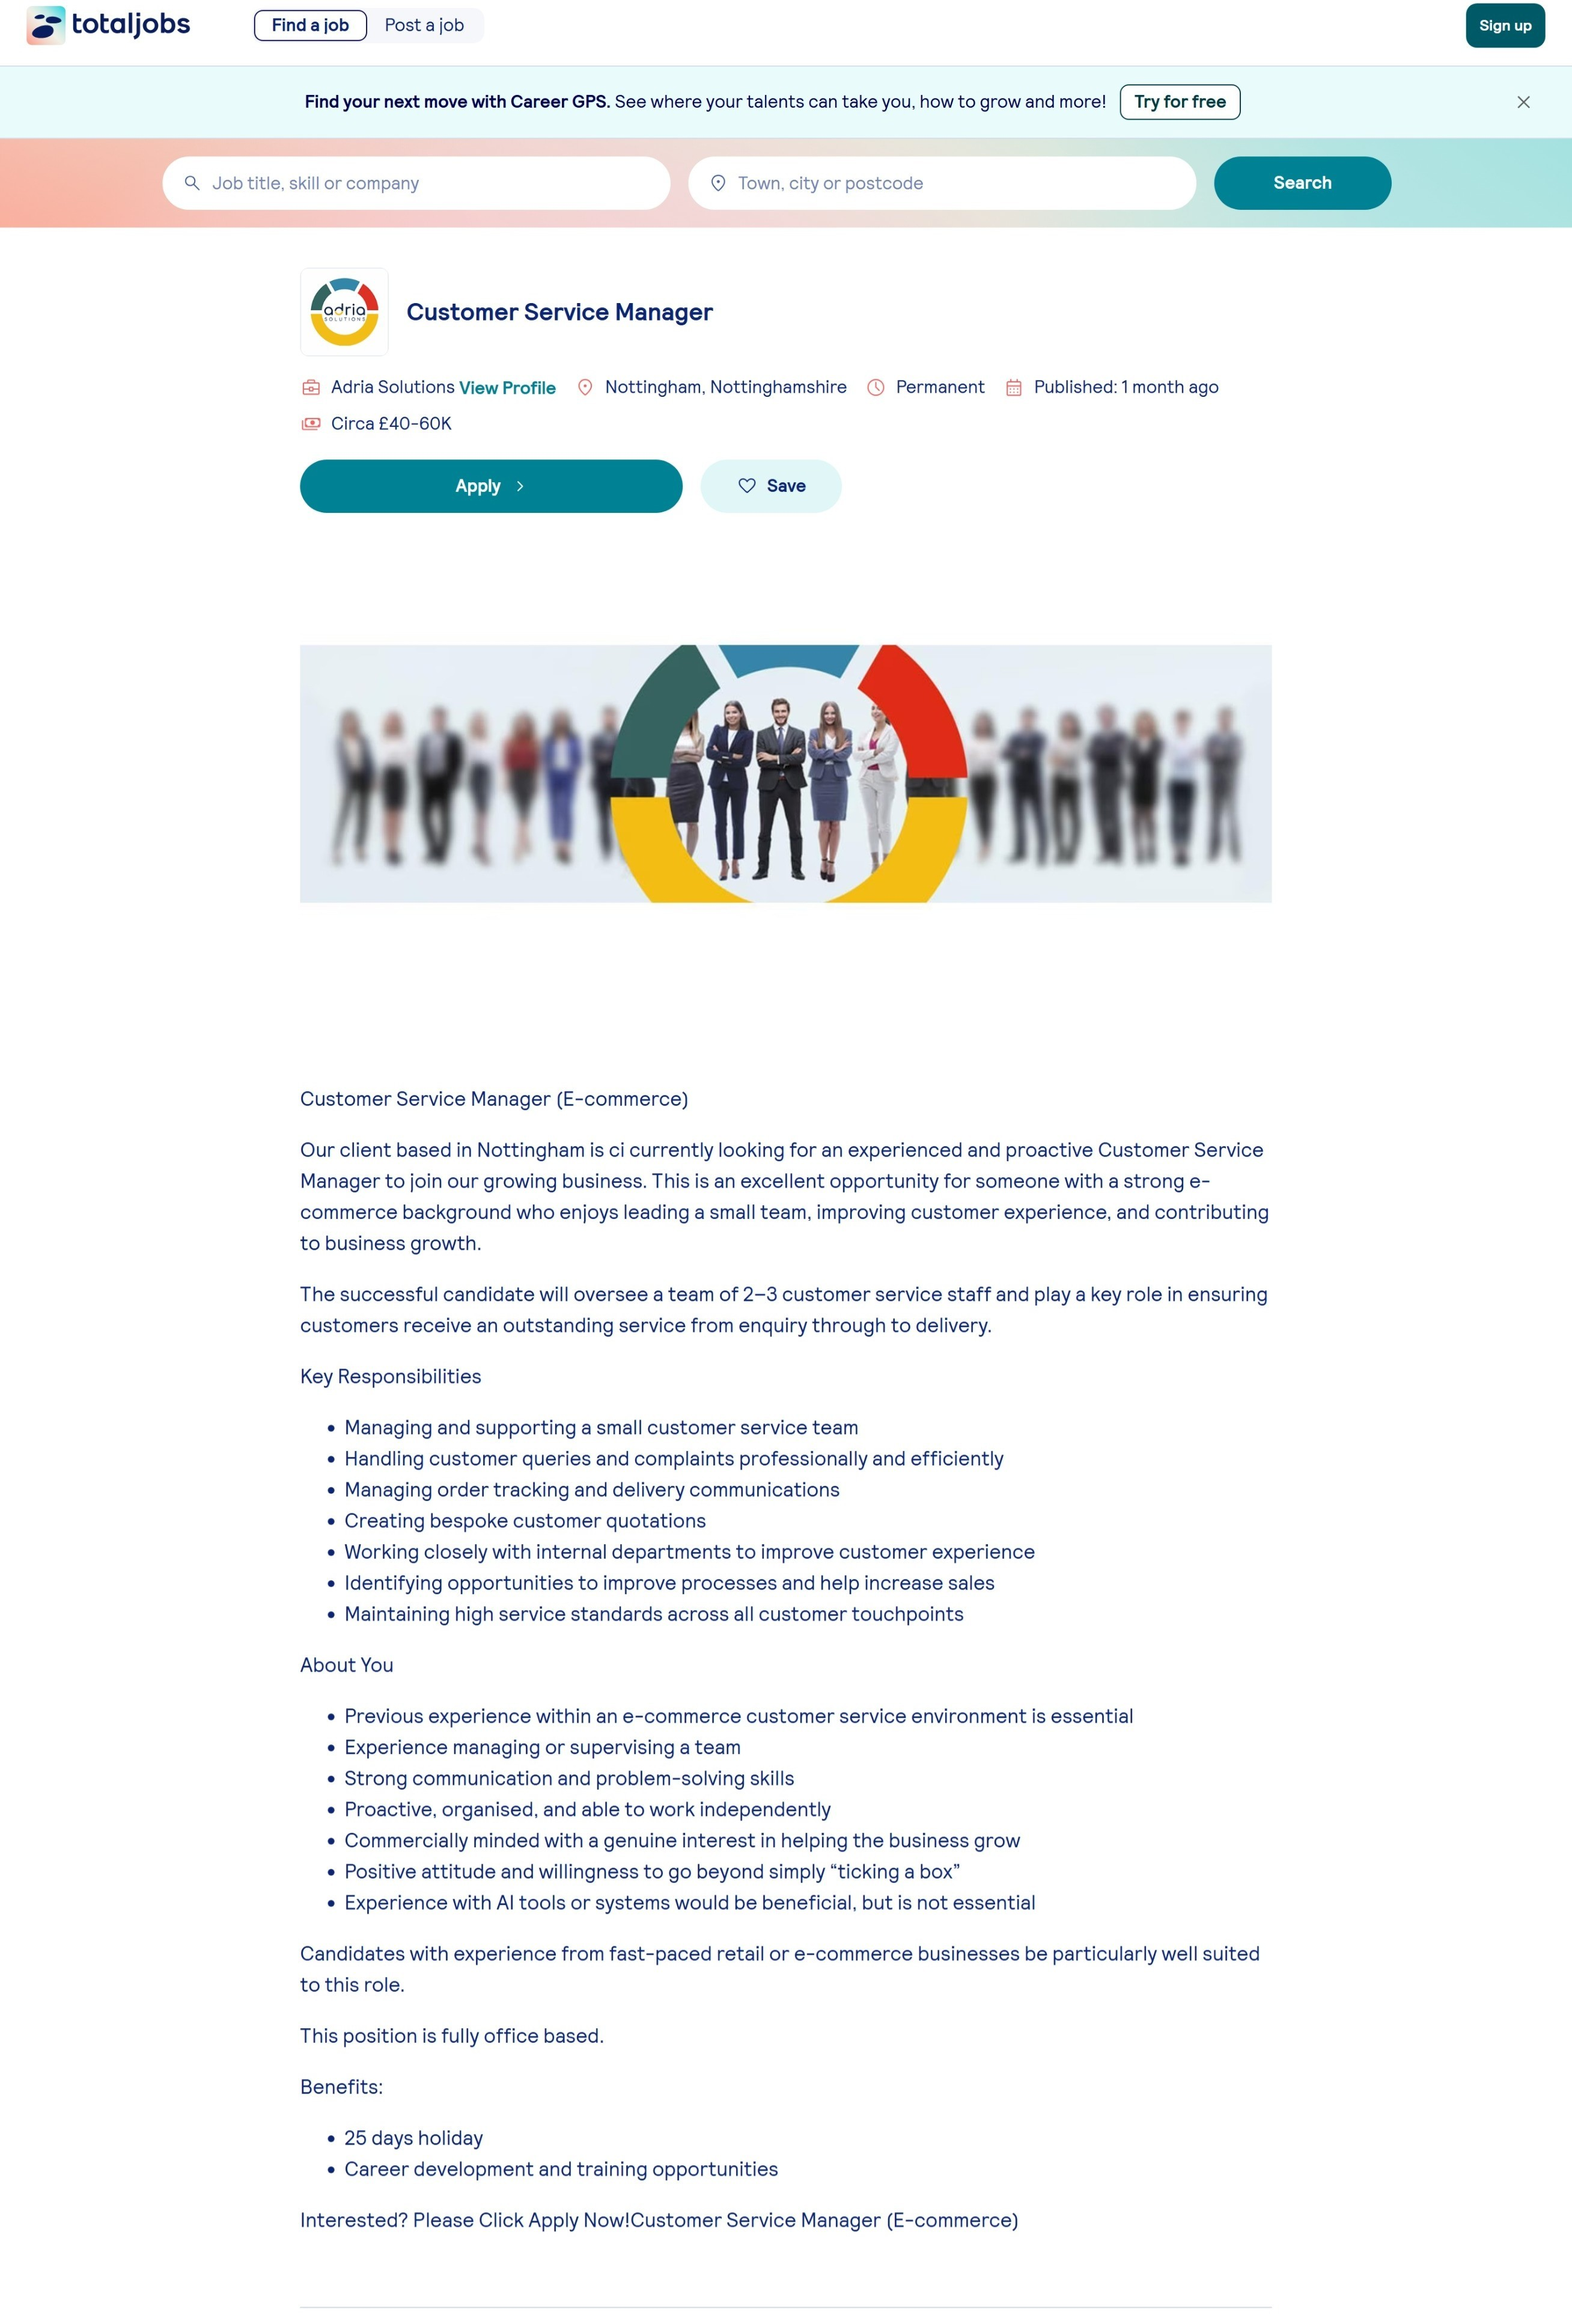

Task A

For this task, I selected two Customer Service Manager job advertisements, one published on TotalJobs by Adria Solutions in Nottingham and the other on Reed.co.uk by UBT Recruitment in Leeds. Both positions are within the customer service management profession and require candidates to lead customer service teams while ensuring high standards of customer satisfaction and operational performance.
After comparing both job adverts, several common skills and areas of knowledge are clearly identified. The most significant requirement is leadership and people management. The TotalJobs advert requires the successful candidate to manage a team of two to three customer service staff, whereas the Reed advert involves leading a larger team of eight employees. Despite the difference in team size, both employers expect the manager to motivate staff, monitor performance, provide coaching, and ensure customer service objectives are achieved.
Another key skill highlighted in both advertisements is effective communication. Customer service managers are expected to communicate professionally with customers, colleagues, suppliers, and other departments. Strong communication skills are essential for resolving customer complaints, handling enquiries, and building positive working relationships across the organization.
Both employers also emphasise problem solving and decision making. Managers must identify customer issues, respond to complaints efficiently, resolve operational challenges, and continuously improve processes. This demonstrates that employers value individuals who can analyse situations, make informed decisions, and implement practical solutions that improve customer satisfaction and business performance.
In addition, both job adverts require excellent organisation and time management skills. The successful candidate must manage workloads, monitor customer enquiries and orders, coordinate with different departments, and ensure service standards are consistently maintained. Knowledge of customer relationship management (CRM), business operations, customer service principles, and performance management is also expected. The TotalJobs advert additionally values experience within an e-commerce environment and mentions knowledge of AI tools as desirable, while the Reed advert places greater emphasis on performance indicators (KPIs), process improvement, and stakeholder management.
Among these skills, leadership is the one I believe will be most valuable in my future employment. I have developed strong leadership abilities through more than ten years of experience managing business operations and customer relationships. My responsibilities have included supervising staff, resolving customer complaints, improving operational efficiency, and maintaining high standards of customer service. Alongside my professional experience, studying Business Management at the University of Wales Trinity Saint David (UWTSD) is strengthening my understanding of leadership theories, organizational behavior, and business management. These experiences have prepared me to lead teams effectively, support continuous improvement, and contribute positively to organizational success as a future customer service manager.

Task B

A self-assessment is an important process that helps individuals understand their current abilities, recognise areas for improvement, and prepare for future career opportunities. Conducting a SWOT analysis (Strengths, Weaknesses, Opportunities, and Threats) has enabled me to evaluate my personal and professional capabilities while identifying areas that require further development. This reflection has also helped me assess my readiness for employment as a customer service manager.
SWOT Analysis
Strengths
One of my greatest strengths is my extensive experience in customer service and management. I have over ten years of experience working in customer relations, where I have developed strong communication, leadership, and problem-solving skills. My current role as manager, customer relations officer, and management director at Zee & Brothers has given me responsibility for supervising staff, managing daily operations, resolving customer complaints, and ensuring high standards of customer service. These responsibilities have strengthened my ability to lead teams, make decisions under pressure, and maintain positive customer relationships.
Another important strength is my communication skills. I can communicate confidently with customers and colleagues from different cultural backgrounds. In addition to English, I speak Urdu, Punjabi, Hindi, and Mirpuri, which enables me to build relationships with a diverse range of customers. My multilingual ability is particularly valuable in today's multicultural workplaces, where effective communication contributes to better customer satisfaction and teamwork.
I also consider myself to be adaptable, organized, and reliable. Balancing full-time work with studying for a business management degree at the University of Wales Trinity Saint David (UWTSD) has improved my time management, organisational skills, and ability to meet deadlines. My studies have enhanced my understanding of leadership, marketing, business strategy, and organizational behavior, allowing me to apply academic knowledge to real workplace situations.
Weaknesses
Although I have strong management experience, I recognize that there are several areas where I need further development. One weakness is my limited experience with advanced customer relationship management (CRM) software and artificial intelligence (AI) technologies used in modern customer service environments. Many organizations are adopting digital systems to improve efficiency, so gaining practical knowledge of these technologies will increase my competitiveness in the job market.
Another area for improvement is my public speaking and presentation confidence. While I communicate effectively in one-to-one conversations and team meetings, I sometimes feel less confident when delivering presentations to larger audiences. As a future manager, I understand that presenting business information confidently is an important leadership skill.
I also have limited experience working within large corporate organizations. I have gained most of my management experience in smaller businesses. Although this has allowed me to take responsibility for a wide range of tasks, I would benefit from understanding the structures, procedures, and management practices used in larger organizations.
Opportunities
Completing my Business Management degree provides an excellent opportunity to improve my qualifications and increase my employability. My university studies continue to develop both my theoretical knowledge and practical understanding of business management.
There are also opportunities to undertake professional training in leadership, CRM software, AI tools, and customer service management. These additional qualifications would strengthen my professional skills and prepare me for management positions within larger organizations.
Furthermore, my previous management experience, combined with my degree, places me in a strong position to apply for customer service manager roles and progress towards more senior leadership positions in the future.
Threats
One external challenge is the competitive employment market, where many applicants possess similar qualifications and experience. To remain competitive, I must continue improving my professional knowledge and practical skills.
Another threat is the rapid development of technology, particularly AI and automation within customer service. Managers who fail to keep their digital skills up to date may find it more difficult to progress in their careers. Economic uncertainty and changing business conditions may also reduce recruitment opportunities, making continuous professional development increasingly important.
Evidence of Readiness for Employability and Personal Advancement
My professional experience, academic studies, and transferable skills have prepared me well for employment.
Professionally, I have demonstrated my ability to manage teams, maintain customer satisfaction, resolve complaints, improve operational efficiency, and build long-term customer relationships. My experience has taught me how to remain calm under pressure, make effective decisions, and motivate colleagues to achieve organizational objectives.
Academically, studying business management at UWTSD has expanded my understanding of leadership, strategic management, marketing, and business operations. Completing assignments, participating in group projects, and balancing academic work alongside employment have strengthened my research, teamwork, critical thinking, and time management skills.
In addition, my voluntary work within community and charity activities has strengthened my interpersonal skills, teamwork, and commitment to helping others. Working alongside different people has strengthened my adaptability and communication abilities, which are essential qualities for successful managers.
Overall, my self-assessment shows that I possess many of the skills required for a successful career in customer service management, particularly leadership, communication, and customer relationship management. At the same time, I recognize the importance of continuous learning to improve my digital knowledge, presentation skills, and understanding of larger organizational environments. By building on my strengths and addressing these development areas, I am confident that I am well prepared to progress into a customer service manager role and continue advancing towards senior leadership positions in the future.

Task 3

Employment Goals
Based on my SWOT analysis, I have identified several areas for improvement, including developing my knowledge of customer relationship management (CRM) systems, artificial intelligence (AI) tools, and presentation skills and gaining experience within larger corporate organizations. Addressing these weaknesses will help me achieve my long-term career ambitions.
My short term employment goal is to secure a customer service manager position within a reputable organization where I can apply my management experience while continuing to develop professionally. In this role, I aim to strengthen my knowledge of CRM software, AI technologies, and business systems that are increasingly used to improve customer service and operational efficiency. This goal is important because it will allow me to gain practical experience in a larger organization while building on the leadership and customer service skills I have already developed through my previous management roles and business management studies at UWTSD.
My long term employment goal is to progress into a senior customer service manager or operations manager role, where I can lead larger teams, contribute to business strategy, and support organizational growth. Achieving this goal will enable me to take on greater leadership responsibilities while continuing to improve customer experience and business performance. It also aligns with my career aspiration of becoming a respected business leader who can positively influence both employees and organizational success.

Personal Development Plan

Development Area | Action | Timeline | Resources Required | Measure of Success
CRM and AI knowledge | Complete online CRM and AI training courses and practise using business software. | Within 6 months | LinkedIn Learning, Microsoft Learn, online tutorials | Course certificates and confidence using CRM systems.
Presentation skills | Attend presentation workshops and volunteer to deliver presentations during university group work and workplace meetings. | 6–12 months | UWTSD workshops, lecturer feedback, online courses | Improved presentation confidence and positive feedback.
Corporate management experience | Apply for Customer Service Manager roles within medium and large organisations to gain wider management experience. | Within 12 months | Job websites, recruitment agencies, networking | Securing a management position in a larger organisation.
Leadership development | Read leadership books, attend management training, and seek mentoring from experienced managers. | Ongoing | Professional development courses, mentors, management literature | Improved leadership performance and regular positive feedback from managers and colleagues.
By following this personal development plan, I will strengthen the weaknesses identified in my SWOT analysis while building on my existing strengths. Continuous learning, practical experience, and regular self reflection will improve my employability and support my progression towards senior management positions in the future.

