

Module Name: Academic Skills in the Digital Era
Module Code: BMSW4013
Assesment 1: E-Portfolio
Student Name: Viviana Zaharia
Student Number: 2522333
Lecturer: Ffion Cumberpatch
Deadline: 27 February 2026, 23:59

AI Acknowledgement

I confirm that I have not presented any AI-generated text as my own work. I confirm that I have retained copies of drafts, notes, and resources used before and after the use of AI tools.

Contents
Component 1 – Development of Academic Skills 4
Component 2 – Application of Academic Skills 8
Component 3 – Academic Poster 12

Component 1 – Development of Academic Skills
Evaluating Academic Sources Using the CRAAP Test
Source 1
Autor and year of publication: Kayyali, M. (2024)
I found this source on Google Scholar

Using the CRAAP Test, briefly evaluate:
- Currency: This article is updated as it was published in 2024, which shows the information to be recent.
- Relevance: The paper pointed out one of the crucial issues of the importance of digital literacy in the higher education system and how it does enhance the contemporary needs of the corporate market to be suited.
- Authority: Mustafa Kayyali is the author of the paper, who holds the position of Higher Education Ranking, thus having good knowledge on the issue.
- Accuracy: Through the use of systematic review, it is mapped that the global workforce has changed, where digital technology is playing a profound role, including data analysis, conducting digital communication and knowing the ethical nature of the use of the technology. Hence, if the digital skills are good, it will help meet the demands, too.
- Purpose: To teach the importance of increased digital skills to be taught in higher education.

Full reference (Harvard style): Kayyali, M. (2024) ‘Digital literacy in higher education: Preparing students for the workforce of the future’, International Journal of Information Science and Computing, 11(1), pp. 53-73.
Source 2
Author(s) and year of publication: Dang, T.D., Phan, T.T., Vu, T.N.Q., La, T.D. and Pham, V.K. (2024)
I have accessed this source through Google Scholar

Using the CRAAP Test, briefly evaluate:
- Currency: The article was published just 2 years back, which is recent and updated as well.
- Relevance: As the question is on the use of digital skills in higher education, this article reviews the relationship that exists between the lecturers‘ digital competencies and the learning value to be fostered in students in higher education.
- Authority: Various authors are involved in the preparation of the article, all of whom are from dignified positions. Like, Tran Dong Dang belongs to the faculty of Economics and Management at the University of Hai Duong, while Thanh Tú Phan represents the Centre of Science and Technology Research and Development.
- Accuracy: It fits the recent question as if the lecturers are enabled of digital competencies, they can inculcate the same among the learners too.
- Purpose: The purpose is to educate the teachers to enhance their competencies for helping out the students in learning digital value and skills.
Full reference (Harvard style): Dang, T.D., Phan, T.T., Vu, T.N.Q., La, T.D. and Pham, V.K. (2024) ‘Digital competence of lecturers and its impact on student learning value in higher education’, Heliyon, 10(17).
Synthesis of Academic Sources
The shared theme that both articles represent is the importance of digital skills in the enhancement of the students’ learning environment and preparing them for real-life scenarios and digital demands.
Kayyali (2024) argues on the relevance of digital skills in higher education, as today's market demands much more than that of computer knowledge and includes analysis, communication and handling of ethical challenges too. While the study of Dang et al. (2024) emphasised that teachers should be competent in digital knowledge, which would help the students to learn the same.
Combining the sources will improve the understanding of what digital learning needs to include and teach, which is beyond just computer technology being taught as basic.
Identifying a Key Challenge and Opportunity
- One key challenge for students in the digital era: One key challenge, as identified by Kayyali (2024), is the resource constraints where disparities in access or resistance for the students to adopt the change highly matter. The study of Dang et al. (2024) points to the inefficiencies of the lecturers with digital knowledge, which affects the students too, raising questions about the challenge.
- One key opportunity for students in the digital era: Both studies pointed to the opportunity for students being able to not only perform well in the market environment but also use digital tools for enhancing their own skills and knowledge as well.

Academic Planning for Component 2
Component 2 will prioritise the opportunities which are present and then map out the challenges to be aware of, thus helping to suggest strategies to work out. Academic literature from the recent data published will be utilised to gain relevance. The key concepts like digital literacy, digital analysis, digital communication, critical evaluation and academic planning will help. The report will be framed in a structured format where introduction, challenges, opportunities, adaptation strategies and finally conclusion will be presented.
Timeline
Task | Date/ Deadline
Finish research | 05/02/2026
Draft first section | 10/02/2026
Complete first draft | 15/02/2026
Final editing | 18/02/2026

Reference List – Component 1
Dang, T.D., Phan, T.T., Vu, T.N.Q., La, T.D. and Pham, V.K. (2024) ‘Digital competence of lecturers and its impact on student learning value in higher education’. Heliyon, 10(17).
Kayyali, M. (2024) ‘Digital literacy in higher education: Preparing students for the workforce of the future’. International Journal of Information Science and Computing, 11(1), pp. 53-73.

Component 2 – Application of Academic Skills
Introduction
Digital learning today acquires a crucial position to be educated in higher education to prepare and pave the way for learners to excel in the corporate environment. Digital learning now includes much more than the concept of learning basic computer skills, and it includes wider horizons. The wider learning involves analytics, communication, ethical use of the tools and performing services with quality. The opportunities need to be understood to generate motivation among the learners to participate and learn digital skills. The challenges contrastingly show what barriers students or lecturers in higher education must be aware of and take measures to address. The structure of the report outlines the challenges, opportunities and adaptation strategies that can be incorporated for a better digital environment in higher education to be created for the learners, including the lecturers.
Challenges for Students in the Digital Era
Resource constraints, as argued by Kayyali (2024) adds to the ineffectiveness for the learners to be fully equipped with the knowledge and conduct practical experiments too. For fostering better digital literacy, the faculties even need to be prepared and have strong knowledge of the tools, but this has also been considered as one of the challenges which pulls behind the capacity for learners to learn about the digital tools or the software. Programs if not designed effectively within the institutions, they can cause challenges for the learners to be aware of the modern needs of the business and hence face a gap in performance for the tasks in future. Jamil et al. (2025) conducted a quantitative study that showed teachers require further Digital Learning Training to be enhanced, which will lead to the adoption of certain practices and enable teachers to teach the learners of the digital tools effectively. The challenges do impact the academic success, since if internally the institution is not equipped, it will fail to offer the students the same environment as well and create a gap in the delivery of the services. For academic success, the teachers and the students both need to be on the same platform, which will standardise the outcomes. Classroom discussion pointed to the significance of digital literacy in higher education and critical evaluation that helped to work out the challenges.
Opportunities in the Digital Era
Digital tools maximise the skills of the learners to work on different tactics, like analytics, which is now highly trending in business operations. Digital skills pave critical tasks to be performed, which are also required in the educational area that assesses students' capabilities largely. Graham et al. (2023) argued that blended learning today has enhanced the outlook of the learners and increased the expectation from higher education for effectively enabling learners to meet corporate requirements. As Dang et al. (2024) pointed at competence of the teachers helps in gauging and providing the students with an updated learning environment. Similarly, if the teachers are aware of the tools, they can apply the same for the students to gain knowledge as well. Even for educational purposes today, digital literacy is contributing that itself points to the opportunities lying with the digital skills. As argued by Aydınlar et al. (2024), digital learning fosters collaboration and effective communication to be practiced which impacts the decision-making process. The digital era is crucial, where learners, after completing their educational course do look out for jobs, and the job market highly demands digital skills to be inbuilt among them. Therefore, digital literacy is highly crucial for managing tasks and even working in different areas in both educational and corporate institutions.
How Students Can Adapt to Succeed
- Self-Assessment is one of the strategies that students could develop to enhance digital literacy. As viewed by Georgopoulou et al. (2025), university students can understand their ability to critically engage with digital tools and technologies, which will help to boost professional and personal development. This will certainly address the challenge of students pointing out to the teachers of their areas of loopholes and lead the teachers to make informed decisions regarding the technologies to be taught and fill the gap.
- Secondly, teachers can increase their awareness and focus on the curricula being developed for the integration of the digital literacy program to be facilitated, as et al. (2025) agreed to such practice, where teachers can develop the curricula and include training for lecturers, and students can facilitate digital skills to be promoted. It will act as an opportunity to build digital efficacy both for the learners and the teachers.
- Dang et al. (2024) in the article referred to the competencies of the teachers being emphasised, which will nurture students to be equipped with digital skills. Thirdly, therefore, students can learn digital skills by participating in workshops or seminars hosted by the institutions, where they can improve their knowledge about digital tools and how they can be applied in the market environment too. It will address resource constraints to be overcome when such tools and measures are implemented in higher education.
Conclusion
The key challenges lie in the inadequacies of the faculty members and the lack of competencies among teachers that can hinder the learning of digital skills for the students. The opportunity lies in allowing the learners to upgrade their knowledge and skills for managing professional tasks like analytics and digital communication to be enhanced and boost their own confidence as well. The digital literacy points to knowledge which will allow doubts and self-capabilities to be measured in comparison to the modern trends and needs of the corporate environment. Teachers and students both have roles in gauging the digital literacy and creating a competitive environment for the present and the future. Thus, the use of digital skills in higher education navigates in progressing in present and future conditions to be met by the students, enhancing their self-esteem and capabilities.

Reference List – Component 2
Aydınlar, A., Mavi, A., Kütükçü, E., Kırımlı, E.E., Alış, D., Akın, A. and Altıntaş, L. (2024) ‘Awareness and level of digital literacy among students receiving health-based education’. BMC Medical Education, 24(1), p. 38.
Dang, T.D., Phan, T.T., Vu, T.N.Q., La, T.D. and Pham, V.K. (2024) ‘Digital competence of lecturers and its impact on student learning value in higher education’. Heliyon, 10(17).
Georgopoulou, M.S., Troussas, C., Krouska, A. and Sgouropoulou, C. (2025) ‘Digital literacy in higher education: Examining university students’ competence in online information practices. Computers, 14(12), p. 528.
Graham, C.R., Danaa, G., Purevsuren, T., Martínez, A., Spricigo, C.B., Camilotti, B.M. and Batsukh, T. (2023) ‘Digital learning transformation in higher education: International cases of university efforts to evaluate and improve blended teaching readiness’. Education Sciences, 13(11), p. 1143.
Jamil, B., Shaoan, M.R., Lahinta, A.N., Irfan, S. and Arif, M. (2025) ‘Empowering future educators: digital literacy competence and preservice teachers’ practices in middle schools of Pakistan’. Cogent Education, 12(1), p. 2541444.
Jayadi, A., Ikawati, H.D., Abdurrahman, A. and Irawan, M.A. (2025) ‘Digital literacy development strategy in higher education institutions. Jurnal Teknologi Pendidikan: Jurnal Penelitian dan Pengembangan Pembelajaran, 10(1), pp. 30-37.
Kayyali, M. (2024) ‘Digital literacy in higher education: Preparing students for the workforce of the future’. International Journal of Information Science and Computing, 11(1), pp. 53-73.

Component 3 – Academic Poster
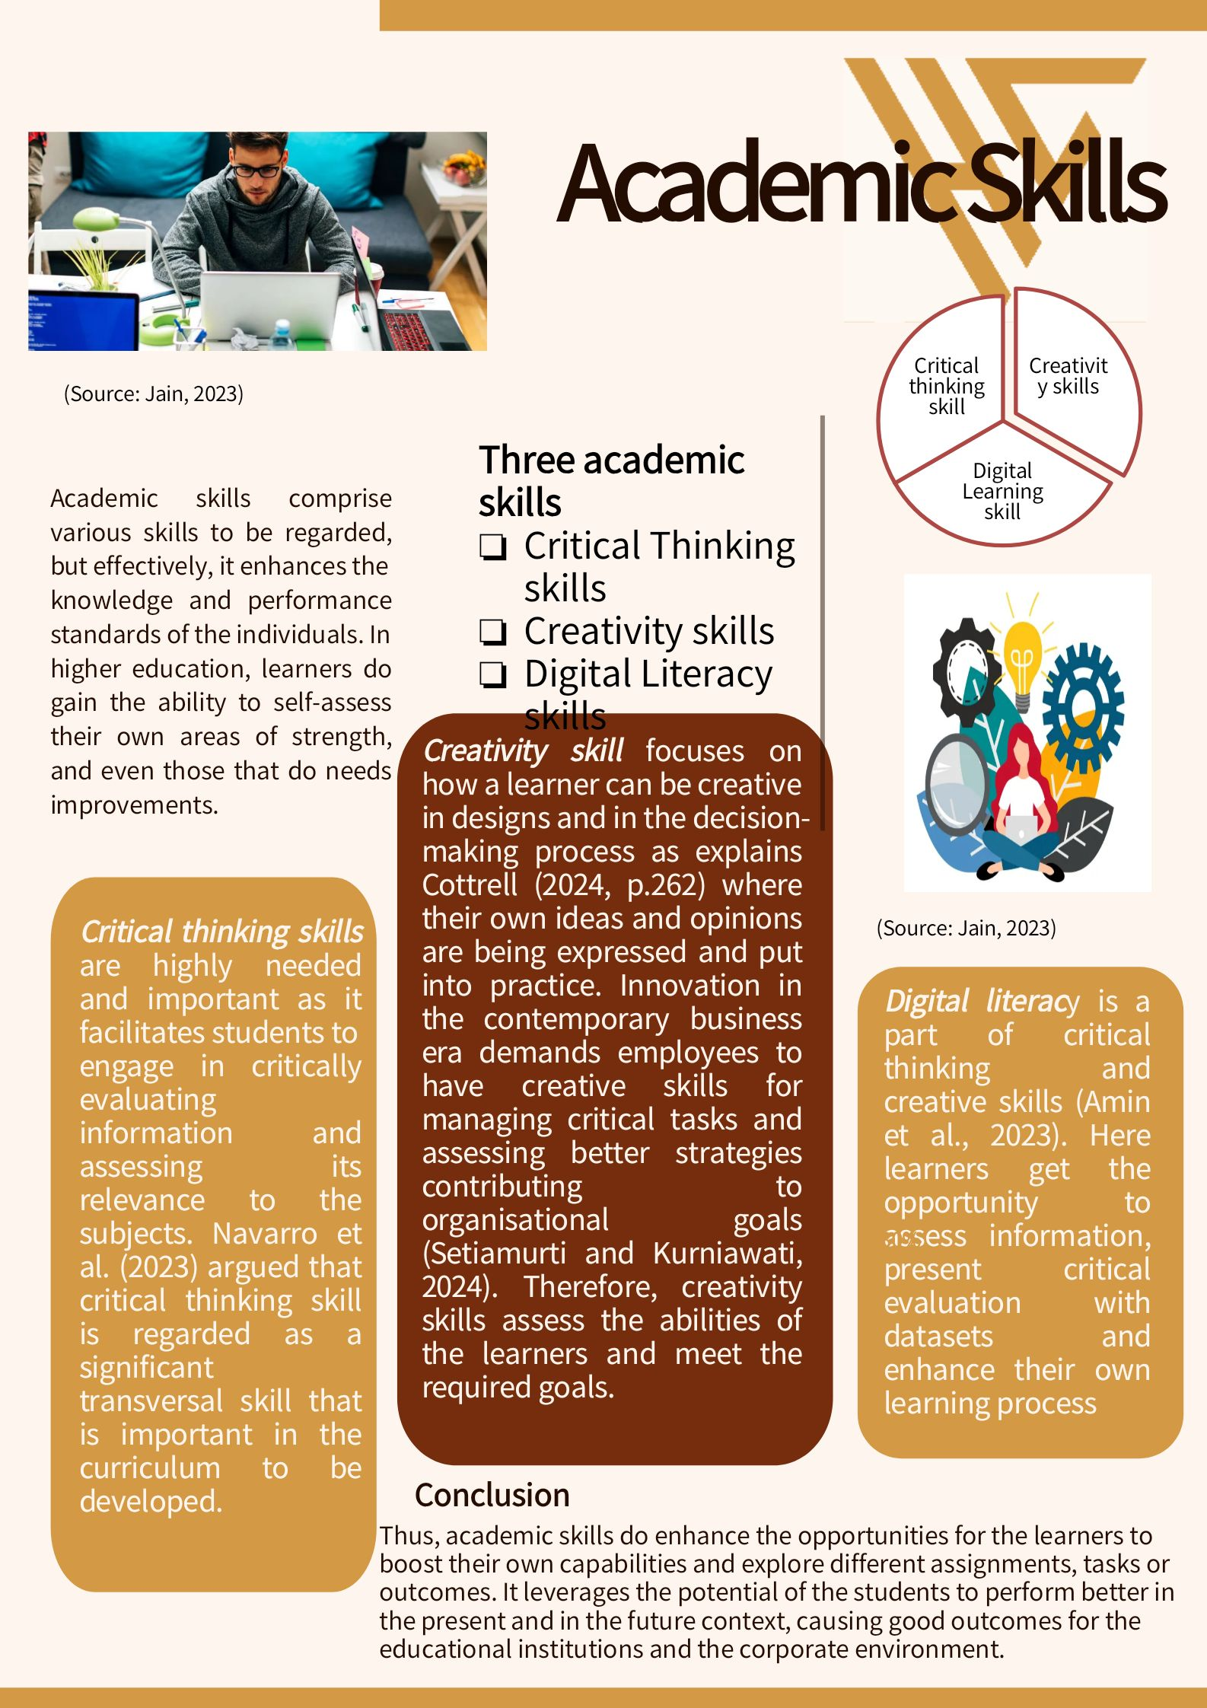
Reference List – Component 3
Amin, A.M., Adiansyah, R. and Hujjatusnaini, N., 2023. The contribution of communication and digital literacy skills to critical thinking. Jurnal Pendidikan Sains Indonesia (Indonesian Journal of Science Education), 11(3), pp.697-712.
Cottrell, S. (2024). The study skills handbook (Sixth edition.). Bloomsbury Academic, Bloomsbury Publishing Plc., 12, pp. 261-262.
Jain, C. (2023) The Top 7 Essential Skills Every College Student Need. Available at: https://medium.com/@jainchelisha03/the-top-7-essential-skills-every-college-student-need-eeb7700e278a (Accessed: 22 February 2026).
Navarro, I.J., Marti, J.V. and Yepes, V. (2023) ‘Evaluation of higher education students’ critical thinking skills on sustainability’. International Journal of Engineering Education, 39(3), pp. 592-603.
Setiamurti, A. and Kurniawati, F. (2024) ‘Fostering creativity in higher education institution: A systematic review (2018–2022)’. Open Education Studies, 6(1), p. 20220221.

