
AS1 Ana Da Costa
Assessment 1 – Reading Task Template
PART 1: Upload your photo of your A3 in-class notes here:

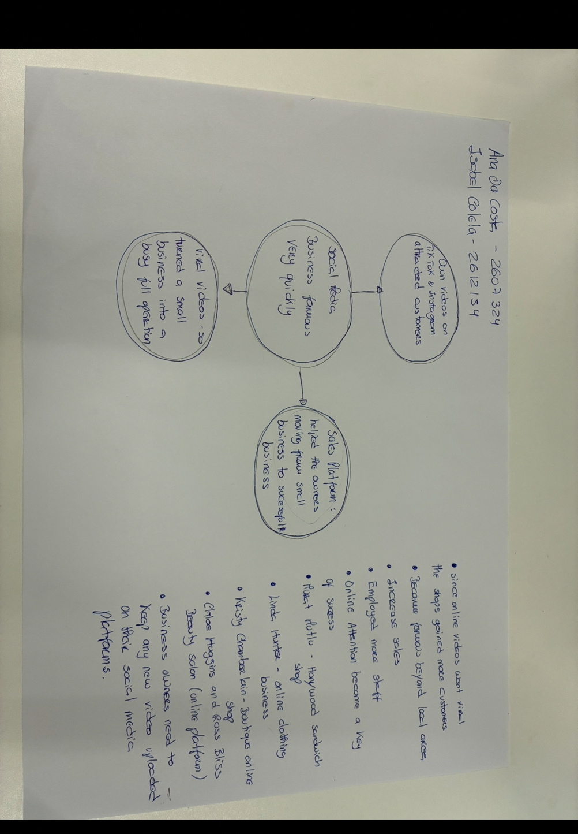

PART 2:
- Answer every question below in 1-3 full sentences.
- Use your own words. Do not use generative AI to answer these questions.
- Include a specific detail from the text when asked.
REMINDER
- The main idea is the overall message of the whole text.
- A key point helps to explain the main idea.
- A specific detail or example from the text shows that the key point is true.

- What is the main idea of the whole text?
- The main idea of the whole text is to show how social media is an excellent platform to advertise business and make it profitable.
- People sharing posts, likes and comments helps businesses reach more customers.
- Some people are willing to travel long distances to try products in person.
- Other customers discover online businesses, order products without visiting the shop, all thanks to the popularity on social media.

- What is one key point that supports the main idea, and which specific example from the text shows this?
- One-way social media helps businesses become more visible and attracts new customers.
- For example, Kirsty Chamberlain’s dress shop attracted customers who travelled from places including the Channel Islands and Cyprus after seeing the videos of the shop.

- What is a different key point that supports the main idea, and which specific example from the text shows this?
- A different point, I’m going to use Linda Hunter’s online clothing business, how social media helped the business successfully since she moved her business fully online and sends orders across the world without having a in person face to face business.

- Which part of the text do you think is most important, and why?
- I think the most important part of the text is all about social media, the importance of digital marketing, social media is a digital platform on demand, with millions of viewers that can easily share, comment and help businesses attract more customers, visit the shop in person even if involves travel from long distance, influencers and reviews helps bringing success to business.

Reflection:
- What did you find difficult in this task (including in-class components), and why was it difficult?
- I have found it more difficult to organise my ideas and write them, because I can understand the content of the articles and the questions asked, is just put the ideas down and explain I find it challenging.

- What helped you with this difficulty, and how did it help you?
- Reading the articles more than once
- Exercise and discuss it in class
- Using assessment template and I have also reviewed my writing and tried to organise my thoughts

