
Assignment on Human Resource strategies of ADP

Name: Ismail Hussain
Student No: 2132179
Module: LCMB7000
Lecturer: Gladius Kulothungan
Course: Masters in General Management
Submission date: 14/09/2022
Assignment – 2 (50%)

Contents:
- Human resource strategies:

- Introduction
- Background information of ADP
- Human resource strategies in HR effectiveness measurement
- Human resource strategies in Learning and development
- Human resource strategies in Leadership
- Strategies that support

- Valuing team members
- Appreciation
- Sense of belonging to the organization

- Appreciation of the current HRM and IHRM theories its principles, models and concepts of
- Conclusions
- Recommendations
- References

Report on Developing and deploying Human resource strategies of ADP:
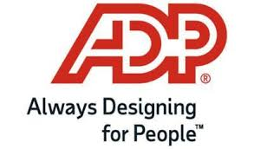
Introduction:
In this report will discuss Human resource strategies in HR effectiveness measurement, Learning and development and Leadership.
ADP offers solutions that simplify life and transform the world of work. ADP is a comprehensive international provider of cloud-based human capital management (HCM) answers that connect human resources, payroll, talent, time, tax and benefits, and a leading provider of business outsourcing offerings and analytics. Our experience, deep insights and the modern generation have transformed human resources from a workplace management function into a strategic business advantage.
For 70 years they have been at paved the way for defining the fate of business reactions. ADP is proud to have been named to FORTUNE magazine's list of the “World's Most Admired Companies” for 15 consecutive years.(Carlos Rodriguez, President and Chief Executive Officer of ADP)

Background information of ADP
In 1949, Henry Taub and his brother Joe Taub founded Automatic Payrolls, Inc. as a payroll company. Frank Lautenberg joined the brothers in the agency's infancy. In 1957, after working successfully in sales and marketing, Lautenberg became a full partner of the two brothers. In 1961, the agency changed its name to Automatic Data Processing, Inc.(ADP) and began using punched card machines, proofing machines and mainframe computers. ADP went public in 1961 with three hundred customers, one hundred and twenty-five employees and approximately $400,000 in revenue US SEC: Annual Form 10-K (2020), Automated Data Processing, Inc (PDF). US Securities and Exchange Commission
The agency established a UK subsidiary in 1965. In 1970, Lautenberg was appointed chairman of the agency. Also in 1970, the agency's inventory changed from buying and selling on the American Stock Exchange to buying and selling on the New York Stock Exchange.
By 1985, ADP's annual sales reached $1 billion, processing paychecks for approximately 20% of the United States. United Statesworker. In September 1998, AD received the UK-based Chessington Computer Centre, which made administrative contributions to the UK Government.
In October 2017, ADP received the Global Cash Card, a virtual settlement agent (" USSEC: Annual Form 10-K (2020), Automated Data Processing, Inc" (PDF). USA Securities and Exchange Commission).
In 2020, ADP substantiated by using income. In addition, ADP has been named to Fortune Magazine's list of the “World's Most Admired Companies" for 14 consecutive years.
- Founded: Paterson, New Jersey, U.S. (as Automatic Payrolls, Inc.) 1949;
- Founder by Henry Taub
- Headquarters is at Roseland, New Jersey, U.S.
- Key people are Carlos A. Rodriguez (CEO), Maria Black (President), John Ayala (COO) and Gus Blanchard (CMO)
- Services are Human resource, administration tools, payroll, tax and benefits
- Revenue is US$14.59 billion (2020)
- Number of employees are 58,000 (2020)
Source: (Automated Data Processing, Inc" (PDF). U.S. Securities and Exchange Commission).

Human resource strategies:
HR strategy meaning: HR approach is a roadmap for fixing a company’s largest demanding situations with humans-centric answers. This method calls for HR enter throughout coverage introduction and elevates the significance of recruitment, skills control, repayment, succession making plans and company culture.
The useful human resource (HR) approach maximizes the capacity of an organization's human capital to enable it to achieve its broader business goals. However, for some employers, the transition of human resources from a primarily transactional role to a strategic role can be challenging.

Source: https://www.adp.com/resources/articles-and-insights/articles/h/hr-strategy.aspx.
HR department a seat at the desk right from the start. Research locations that might be the best from an employment standpoint, then develop a long-term plan to network with highly qualified passive candidates in your chosen regions.
The different agency takes transactional techniques to fixing problems. Instead of together with HR in its growth discussions, it delegates a hiring supervisor to recruit candidates without understanding if the favoured skills exist in that marketplace or if the employment regulations upload a substantial wide variety of sudden obstacles.

Human resource strategies in HR effectiveness measurement:
HR refectivity is the process of measuring how effective an HR department's activities are for the organization. A company's human resources department, no matter how small, plays an important role in the overall success of an organization. For example, a successful hiring strategy helps attract top talent into the company, which increases productivity and results in a % increase in revenue. Similarly, a dynamic performance management system provides metrics and guidance to employees that help achieve the organization's goals to be reached. (By PrestonSharpston)

Measuring Effectiveness of a Human Resource Strategy:
Quality of New Hires:
One manner to degree the effectiveness of your HR techniques is to have a look at the best of the brand-new personnel you’re capable of hire. Start with the introduction of an in-depth organizational chart that fills all of your useful needs. Create targeted activity descriptions for every role and the capabilities and talents wished for everyone. Doing this for modern personnel permits you to decide in case you’ve stuffed every role with the excellent employee possible. If your studies unearth your personnel are missing a few capabilities and talents, you may recognize you want to reconsider your activity descriptions, need ads, interviewing strategies or repayment packages (through Steve Milano).
Productivity of Employees:
Each role you fill need to have a goal contribution to the company. Some personnel may have measurable goals, including a manufacturing employee who you need to make wide variety of gadgets in keeping with day, or a sales rep who you need to promote really well worth of commercial enterprise in keeping with month. Other positions have intangible goals, including a receptionist or IT person. Creating targeted activity descriptions for every role will assist to put favoured outcomes on the group of workers that may evaluate to decide in case your techniques are generating the consequences expected. Reviewing the education regulations will assist to decide if that’s a place that’s contributing to employee productiveness as you expected (through Steve Milano).
Retention:
The better your group of workers turnover, the weaker your HR techniques may also be. If you mayn’t preserve personnel, it is probably because of reasons such as a loss of verbal exchange or admire among control and group of workers, inability to supply guarantees made for the duration of hiring, non-competitive repayment or poor control and education of personnel as soon as they’re on board. Employee delight surveys will let you pinpoint regions in which the firm needs to improve. Conduct interviews with departing employees to understand why the firm is losing group of workers and whether or not the organization needs to improve its retention techniques (through Steve Milano).
Costs
A key dimension for any HR method is cost. Conduct a finances variance evaluation of employee’s costs, which include the ones associated with recruiting, hiring, education, control, compliance and repayment. Determine in case to outsource any of those regions to get greater fee for the finances. If over finances, decide if that’s a case of inaccurate projections or loss of control of your HR function (through Steve Milano).

Human resource strategies in Learning and development:
A learning and development (L&D) strategy defines the skills, abilities and competencies of the workforce that the organization needs and how they can be developed to ensure a sustainable and successful organization.
Organizations must adapt to changing labour markets and our Creating Learning Cultures report highlights the critical role of L&D in this. The report also emphasizes the importance of strategic human resource management aligned with overall business strategy.
The L&D strategy should be the business strategy and driver reflect directly work towards it. When developing a strategy, it helps to adopt the financial and operational language of business. This helps ensure that L&D is widely understood throughout the organization. With sound financial and operational knowledge, L&D professionals can also challenge decisions that could jeopardize company value and employee engagement.
The core of an L&D strategy is to meet the performance needs of the organization through the development of its people.
How to create a powerful L&D approach
There are numerous key issues while you need to expand a stable L&D approach. the system may be complex or compound, and there are numerous elements to don't forget alongside the way.
1. Create a bendy L&D structure
A mastering and improvement approach should be bendy. Successful agencies are dynamic.
Winning mastering and improvement techniques are similarly nimble and agile. An employer's approach to control and improvement must be evaluated and revised from time to time to be applicable. Ongoing evaluation and development is critical (Continue April 19, 2022).
2. Identify organizational priorities
A control and improvement approach should be an organizational priority. Essentially, it should be an organizational improvement plan.The training needs to be formalized, which means higher control wants to buy and sell attendance.
The HR department or team of Control of a company Wants to create and expand on clean dreams and goals. The formal control and improvement approach must include benchmarks for key performance signals consistent with the organization's objectives (by April 19, 2022)
3. Recognize the general commercial enterprise approach
The organization's improvement and control plan should be consistent with its standard business approach (Continued April 19, 2022).
4. Adopt a tailor-made technique to mastering
It is important to understand that a single technique is required for an organizational improvement and an improvement plan may not be valid. Various positions within the organization have a wonderful desire for education and understanding.
One prevailing approach applies to all, however, consider the different roles employees and managers play within the employer and how best to grow each position (continued April 19, 2022).
5. Improve worker recruitment and retention
Recruitment and retention go hand in hand. An effective L&D approach includes recruitment and retention as part of the employee award offering. When employees master and evolve, they are much more likely to live (Bycontinu, April 19, 2022)
6. Assess inner stakeholders
Evaluate internal stakeholders for a refinement and improvement approach to be effective, employee buy-in is essential. The training must be applicable and useful to persuade people.
Chances are that you have trained the mandatory organization training for your part, It wasn't particularly exciting or useful, but became part of marking a box on an organizational form. Such training is a useless waste of the hired worker's time. It can even be demoralizing.
Consider ongoing reviews. The business environment is changing rapidly and employees need continuous training and improvement to keep up. What works today as an organizational improvement and development plan may not work next year (continued April 19, 2022).

7. Provide enough sources and budgeting
Resource and budget issues must be part of an exceptional approach to mastering and improving (by April 19, 2022
8. Choose accurate mastering equipment and strategies
There are many mastering strategies and equipment that contribute to a mastering and enhancement approach be combined. Some examples are: leadership exercises and coaching, distance, hands-on and on-site learning (by continuing April 19, 2022)
9. Examine future requirements
In designing an effective learning and development strategy, future needs are an important consideration. Just as an organization must adapt to future thinking, it must develop a learning and development strategy framework and adapt to new requirements. Predicting future staffing needs can guide this process (By continu, April 19, 2022)

Human resource strategies in Leadership:
In this report will discuss Human resource strategies in Leadership. The Leadership Development Program (LDP), primarily based totally at the version proven and is stranded at the notion if top management and controlled may be discovered and practiced :
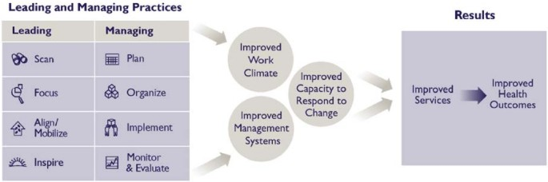
Source: Human Resources Health volume 6, Article number: 10 (2008)
Leading and dealing with consequences version – how do control and management make contributions to stepped forward provider delivery?
For example, the design of the LDP has been adjusted to deal with people from rural areas. The software has been translated into French, Spanish, Portuguese and Arabic. An important point is that members regularly reflect ideas in their work and spread them to others in many regions.
The LDP is making a profound difference in the attitude of fitness managers to his paintings. Instead of feeling crushed by a workplace climate that lacks the motivation, hope, and dedication to switch, people report they have mobilized to switch the popularity quote lesson is that without this capacity at all levels, global coverage and nationwide HR techniques will not make a difference (Human Resources for Health Volume 6, item number: 10 (2008).
- specializing in fitness outcomes
- operating in groups to resolve problems
- making use of management practices to actual challenges
- developing a weather that encourages alternate
- maintaining alternate via way of means of grounding answers in control structures.

Strategies listed below supports to make the team members valued, appreciated and can bring a sense of belonging to the organisation.
Most businesses run a few kinds of worker-reputation programs, however regularly they fall flat, losing resources. Many grow to be simply some other container for managers to test or are visible as elite possibilities for a favoured few, leaving the relaxation of the staff feeling left out. Meanwhile, a whole lot of man or woman managers additionally fail to adequately explicit appreciation, mistakenly assuming that reviews recognize how they experience or suffering to stability gratitude with developmental feedback. In cognizance groups and interviews, however, personnel display that making them experience valued and identified isn’t all that complicated. It basically comes right all the way down to a whole lot of small, common-experience practices. (Article written by Liz Alton).
1. Stand out with the aid of using Offering Employee Appreciation
HR leaders must assess whether or not their groups experience favoured. There are several approaches to do this which include annual worker surveys, devoted inner marketplace studies and exploring the problem in the course of worker interviews or group conferences. Based on the data, it is feasible to determine (Article written by Liz Alton):
- How favoured your personnel experience
- Where the gaps exist, mainly inside positive departments or locations
- What techniques you can enforce to make a nice effect on morale and reputation
2. Focus on Individual Recognition
Many groups cope with the want for worker reputation with the aid of using imposing large-scale provider programs. Give personnel the maximum flexibility to experience their rewards in a manner that's constant with their personal pursuits and priorities (Article written by Liz Alton)..
3. Meet Employees Where They Work
One of the demanding situations of powerful worker reputation is that during modern-day groups, groups are dispensed around the world or paintings in diverse time zones or shifts. Think of approaches to "meet personnel wherein they paintings" to reveal them you appreciate their contributions and assist growth the effect of your efforts (Article written by Liz Alton).
4. Incorporate High-Level Workers into Appreciation Efforts
There are distinct approaches to contain those people into your reputation program. For instance (Article written by Liz Alton),
- Implement hearth chats and skip-stage conferences that offer get right of entry to to pinnacle management in your excessive appearing personnel
- Encourage your CEO or management group to ship handwritten notes or playing cards for provider reputation or main achievements
- Incorporate a non-public touch, along with signed excursion playing cards, to an annual excursion birthday party or reputation program
- Look for approaches to contain one-on-one management conferences to foster more potent relationships among workers and groups, along with an annual paid lunch for every supervisor and direct report
5. Build a Strong Culture
By that specialize in humans and transferring past static notions of what tradition can be, it is feasible to develop an organizational tradition that allows your group carry out at its excellent. Attracting and maintaining the excellent personnel probably begins off evolved with constructing a sturdy tradition of appreciation and reputation (Article written by Liz Alton).
To construct an experience of belonging remove outsiderness, convey everybody on board and demonstrate care via benefits and initiatives.
Most groups actively attempt for various illustration in their workplace. However, many additionally now attempt to make certain that each one personnel experience included there. Creating an experience of belonging a worker’s belief of acceptance inside a given group offers HR leaders with a very good possibility to re-evaluate their inclusion method and goals (April 29, 2022, Contributor: Jordan Turner and Jackie Wiles).
“Belonging is a key element of inclusion. When personnel are without a doubt included, they understand that the organisation cares for them as people their real selves. HR allows make that happen,” says Ania Krasniewska, Group Vice President at Gartner. “It’s suitable for personnel — and in the end improves commercial enterprise performance.”
Gartner studies suggests that groups with sustainable DEI initiatives demonstrate a 20% growth in inclusion, which corresponds to more on-the-process attempt and cause to stay, in addition to excessive worker performance (April 29, 2022, Contributor: Jordan Turner and Jackie Wiles).

- Appreciation of the principles, models and concepts of current HRM and IHRM theories

HRM Theories: Human resource theories are known for the strategies, methods and goals used by business owners and managers to manage the rules and processes related to employees. Human help theories provide an explanation of how control systems and practices can positively or negatively affect worker behaviour (article published on HUM).

small business owners can optimize the productivity and creativity of 's workforce while reducing employee turnover by having and appearing in fundamental information about organizational behaviour and people theories (Article published by Human HUM).

Principles, concepts and models:

The basic first principle is the ‘Recruitment and selection’ this involves the process of selecting the right skill to fit in the organisation by considering the knowledge and prior skills of the candidates by (ICEHRM, 16 June 2021).

Second principle is the ‘Performance management’, which means managing his performance to measure if the candidate is meeting the goals and is suiting the given role and responsibilities (ICEHRM, 16 June 2021).

This is an important principle, Learning and development this helps the employees to learn more to keep themselves motivated and continue in the organisation for a long period (ICEHRM, 16 June 2021).

The fourth one is ‘Succession planning’ which means providing the feedback to the candidates on their performance to help them achieve success at the set targets (ICEHRM, 16 June 2021).

The fifth is ‘Compensation and benefits’ to keep the employees satisfied, these are the added benefits, this is the principle that contributes to it (ICEHRM, 16 June 2021).

The sixth is ‘Human resources information systems’ recording the required data into the information systems to abide by company rules and regulations (ICEHRM, 16 June 2021).

The last one is ‘HR data and analysis’ the data help to analyse the employee’s behaviour towards the organisation (ICEHRM, 16 June 2021).

The basic concept of the Human resources is, it is a process of employing or hiring people, developing and using their skills as resources, maintaining and compensating their services, with the job and the requirements if the organisation with an opinion to contribute to the organisation goals, company’s vision, to the individuals & the society (Human resource library).

The HR Value Chain Advanced is one of the basic Model used by the companies:
This model describes the organization's overall performance within the Balanced Scorecard. The Balanced Scorecard contains the important overall performance signals from a monetary perspective, a buyer perspective and a form perspective. These flow into the personnel cost chain. This record makes it possible to reconcile and show the cost of the human resources made available to the company (published by Erik van Vulpen, Academy to innovate human resources).

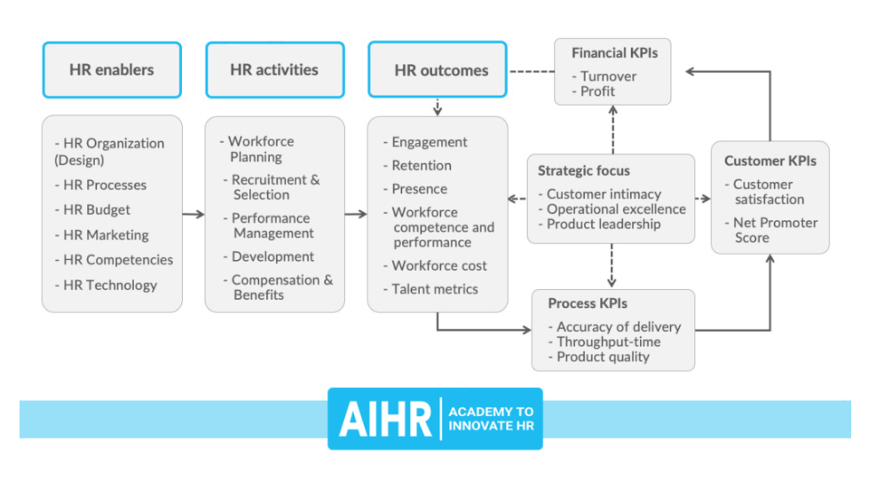
Secondly, the version begins with some facilitate human resources.These enablers are key to what RR. HH. does within the company. This consists of human resources structures, finances, successful professionals and various key elements. The question is whether these enablers need to be found for the cost chain to work effectively.

If HR lacks well trained Professionals, when finances are low or when structures are old and holding back innovation, HR could be a lot less green when it comes to achieving its HR and business consequences (Posted by Erik van Vulpen, Academy for HR Innovation)

IHRM Theories: IHRM is basically about managing human resources at Multi-National Companies, where there are 3 types of employees the Home, host and third country employees:

The concept of IHRM International HRM theory (by Nankervis et al., 2012) emphasises or focusses on the challenges associated with the transference or the interference of the strategies of Western management and their systems to non-Western and developing country frameworks or contexts.

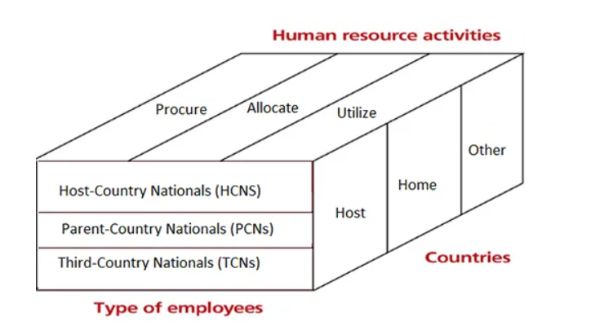
Source: theintactone, Medallia

They are 4 main principle that are considered in international Human resource management:

The first principle ‘The Cultural factors’ includes the beliefs, norms, moral by the people (theintactone, Medallia).

The next principle is the ‘Economic conditions’ includes economic differences (theintactone, Medallia).

The third one is the ‘Labour cost factors’ includes labours efficiency and their costs (high and low) (theintactone, Medallia).

The last one is ‘Labour relations factors’ includes the relationships between the employees, employers and the government (theintactone, Medallia).

The Models of IHRM include procure, allocate and utilize.

Procurement deals with the recruitment and selections process of the labours (theintactone, Medallia).

Allocate deals with the allocation or distribution of labour to different division according to their skill they’re given with their roles and responsibilities (theintactone, Medallia).

Utilization delas with their skill to put into practice to achieve the desired goals (theintactone, Medallia).

Conclusion:
This report covers the importance of a competitive advantage of having Human resource strategies developing and deploying these strategies can make the organisation effective and stand out in the Global market. It also describes the Strategies that supports the employees of the company like how to make the team members valued, appreciated and to bring a sense of belonging to the organisation to achieve the set target of the company.
Strategic human resource control is "vital significance of human assets to approach, organizational functionality to develop to achieve and the goals of the company”. In different words, that is an approach that intends to evolve the dreams of a company and is constructed off of different theories consisting of the contingency principle in addition to institutional principle which in shape below the umbrella of organizational principle.
"Colbert indicates that SHRM need to awareness at the interactions and methods of the company's social machine the intentions, picks and movements of humans withinside the machine and on HR structures as a coherent whole.”
Recommendations:
After measuring HR effectiveness, an organisation must replicate on deficiencies and attempt to enforce new techniques to enhance HR performance. Here are a few beneficial suggestions for enhancing HR effectiveness.
- Improve organizational verbal exchange, enhancing organizational verbal exchange is depending on the scale and shape of the firm.
- Develop a powerful education application, growing a powerful education application calls for the precise quantity of recent personnel and their specialties
- Provide greater ordinary remarks to personnel, to bring the continuous improvement in the performance.
- Build an organisation cultural imaginative and prescient to retain the employees for a long period
- Use to have technology because in the global market technology helps in doing the work easier and quickly.
- Take benefit of data to review anytime in the future to fix the issue and be up to date.

References:
- Sikora, David M.; Ferris, Gerald R. (September 2014). "Strategic human resource practice implementation: The critical role of line management". Human Resource Management Review.
- https://www.adp.com/spark/articles/2018/03/employee-appreciation-focus-on-people.aspx
- Tariq, Sanober; Jan, Farzand Ali; Ahmad, Muhammad Shakil (14 December 2014). "Green employee empowerment its systematic literature review in green human resource organization". Quality & Quantity. 50 (1): 237–269. doi:10.1007/s11135-014-0146-0.
- Tran, Henry (19 June 2015). "Personnel vs. strategic resource management in public education". Management in Education. 29 (3): 112–118. doi:10.1177/0892020615584107.
- Tung, Rosalie L. (January 2016). "New perspectives on resource management in a global context". Journal of World Business.
- Kaufman, Bruce E. (May 2012). "Strategic Human Resource Management Research in the United States: A Failing Grade". Academy of Management Perspectives.
- Employee Appreciation Day 2021: Know The History, Significance And Theme For The Day".
- Jump up to:a b c "Guide to Employee Appreciation Day 2022". HALO.
- "Time and Date — Employee Appreciation Day in United States". Timeanddate.com.
- Quast, Lisa. "5 Ways to Celebrate Employee Appreciation Day". Forbes.
- "Inc - 5 Great Ideas for Employee Appreciation Day". Inc.com.
- "Inc - 7 Last Minute Ideas for Employee Appreciation Day". Inc.com.
- "Forbes - 25 Low-Cost Ways to Reward Employees". Forbes.com.
- Boston.com - What Would You Actually Appreciate? . Boston.com.
- Jump up to:a b The Benefits of Employee Recognition. FineAwards.com.
- Natlawreview.com. Retrieved 2015-03-30.
- MODELS OF INTERNATIONAL HUMAN RESOURCE MANAGEMENT Sanchitha S S 2nd M.com. with the guidance of Sundar B. N. Asst. Prof. & Course Co-ordinator GFGCW, PG Studies in Commerce Holenarasipura
- Guest Model of HRM, model was developed by David in 1997.
- Spillane, James P., Richard; Halverson, John B. (2004) Diamond. "Towards a theory of leadership practice". Journal of Curriculum Studies.

