

Master of Business Administration

Module Code: LCMB7002
Module: Financial Management
Assignment Title: Financial performance and management

Student I’D: 2523538

Student Name: Vidhi solanki

Professor Name: MD Kalam

Table of Contents
1. Financial Health Check 4
1.1 Introduction to Financial Performance 4
1.2 Financial Statement Trend Analysis 4
1.3 Ratio Analysis 6
1.3.1 Profitability Ratios 6
1.3.2 Liquidity Ratios 7
1.3.3 Gearing Ratios 8
1.3.4 Efficiency Ratios 9
1.3.5 Market Ratios 10
1.4 Industry Benchmark Comparison 11
1.5 Overall Financial Evaluation 11
2. Working Capital Management 11
2.1 Introduction 12
2.2 Cash Operating Cycle 12
2.3 Liquidity Improvement Strategies 14
2.4 Short-Term Financing 14
2.5 Long-Term Financing 15
2.6 Recommendation 15
3. Strategic Financial Restructuring Plan 15
3.1 Need for Financial Restructuring 16
3.2 Financial Restructuring Options 17
3.3 Impact on Shareholder Value 18
3.4 Debt Structure 18
3.5 Operational Flexibility 18
3.6 International Considerations 18
3.7 ESG and Ethical Issues 19
4. Investment Appraisal and Capital Budgeting 19
4.1 Introduction 20
4.2 Project Information 20
4.3 Payback Period 20
4.4 Accounting Rate of Return 22
4.5 Net Present Value 24
4.6 Profitability Index 26
4.7 Internal Rate of Return 28
4.8 Comparison of All Projects 29
4.9 Recommended Project 29
4.10 Capital Rationing 30
5. Critical Reflection on AI Usage 30
5.1 AI Tools Used 31
5.2 Verification of AI Outputs 31
5.3 Identification of Hallucinations 31
5.4 AI Contribution vs Personal Analysis 31
5.5 Ethical Reflection 32
References 32
Appendix 37

1. Financial Health Check

1.1 Introduction to Financial Performance
Analysis of the financial performance helps to evaluate the effectiveness of the company for generating profit, managing assets and financial growth, along with maintaining financial stability. Intercontinental Hotel Group recovered from the COVID-19 pandemic and made subsequent expansion in the market (Radivojević et al., 2023). The section includes the analysis of the income statement and balance sheet to complete the trend and ratio analysis for demonstrating the profit, liquidity, efficiency and financial position. The findings of the section are supported by the annual report and current hospitality industry evidence that provides the basis for the evaluation of the financial strengths, weaknesses, and future sustainability of the company.

1.2 Financial Statement Trend Analysis
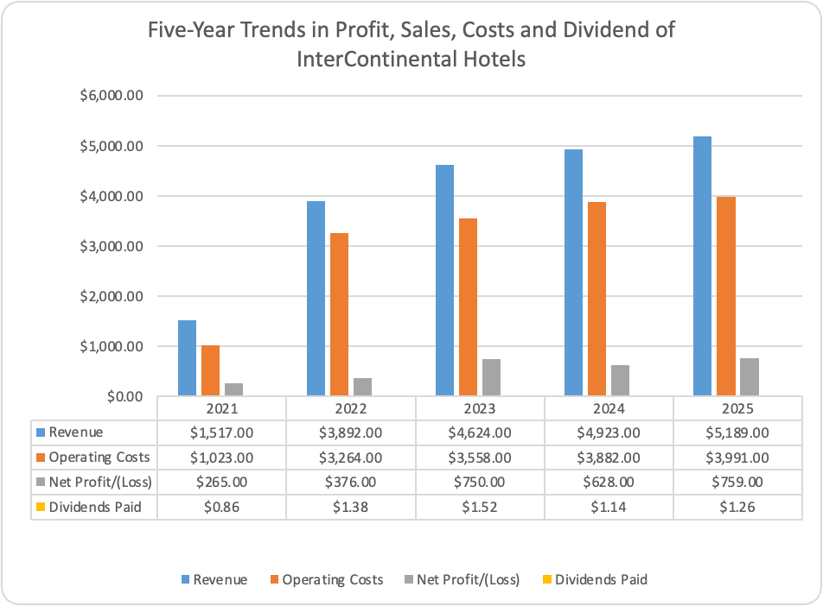
Figure 01: Trend Analysis
Source: (Ms-Excel)
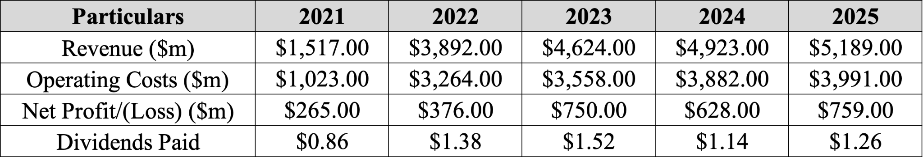
Table I: 5-Year Revenue, Operating Profit, Net Profit and Dividend
Revenue increased from 1,517 million US dollars in 2021 to 5,819 million US dollars in 2025, representing growth of approximately 242%. The revenue of the company increased by approximately 3,892 million USD, mainly due to the removal of international travel restrictions, high occupancy levels, and an increase in the average daily room rate. The 2025 annual report of the company demonstrates the growth of 5% in the total revenue from the last year due to higher fee income and continued expansion of its global hotel pipeline.
Gross profit increased from 1031 million USD in 2021 to 4425 million USD in 2025, reflecting IHG's franchise-led business model, where management and franchise fees generate relatively high margins because hotel owners bear most operating costs. The company is also getting the benefit from the high average daily rates and improvement in efficiency, which allows for growth without any proportional increase in direct operating expenses.
The operating profit of Intercontinental Hotel Group increased from 494 million USD in 2021 to 1,198 million USD in 2025 even after the temporary decline of 1,041 million USD in 2024. It was mainly associated with the high admin expenses and continuous investment in the digital platform along with the loyalty program. Intercontinental Hotel Group opened 443 hotels in 2025 as the growth of 10% year on year and the operating leverage offset the rise in costs (IHG, 2026).
Net profit increased from 265 million USD to 759 million USD in the last 5 years, but the earnings fluctuated due to finance costs and taxation. At the same time, the total assets increased from 4,716 million USD to 5,345 million USD, which indicates continuous investment in technology and expansion of the business. The growth of the assets and earnings of the Intercontinental Hotel Group suggests they are maintaining the financial capital for supporting future expansion. After reporting an increase in U.S. room revenues that exceeded competitors', InterContinental Hotels Group (IHG.L), the owner of Holiday Inn, stated that it is on track to achieve analysts' profit estimates. In contrast to a 1.9% decline the previous year, IHG reported a 3.5% increase in U.S. room revenue for the three months ending March 31, 2025 (Reuters, 2025). Both Hilton's regional performance and Marriott's aggregate growth in the United States and Canada were surpassed by its growth.

1.3 Ratio Analysis

1.3.1 Profitability Ratios
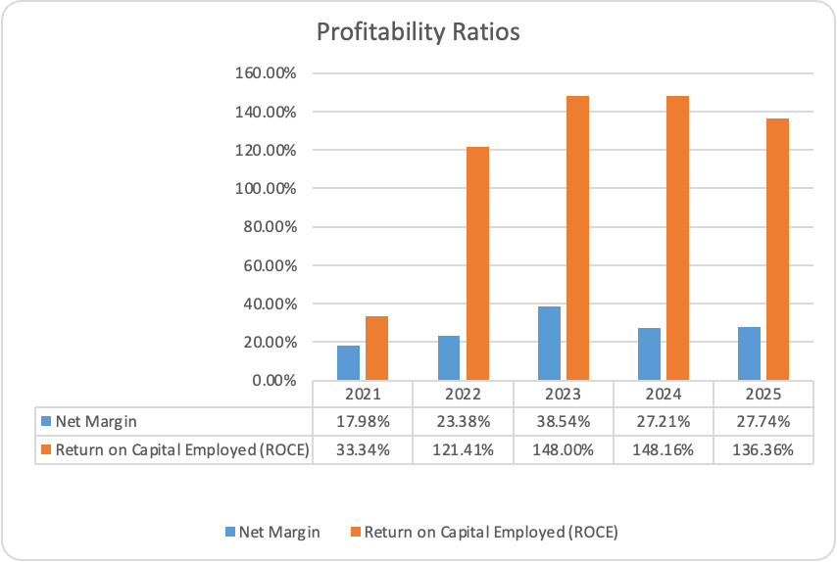
Figure 02: Profitability Ratio
Source: (Ms-Excel)
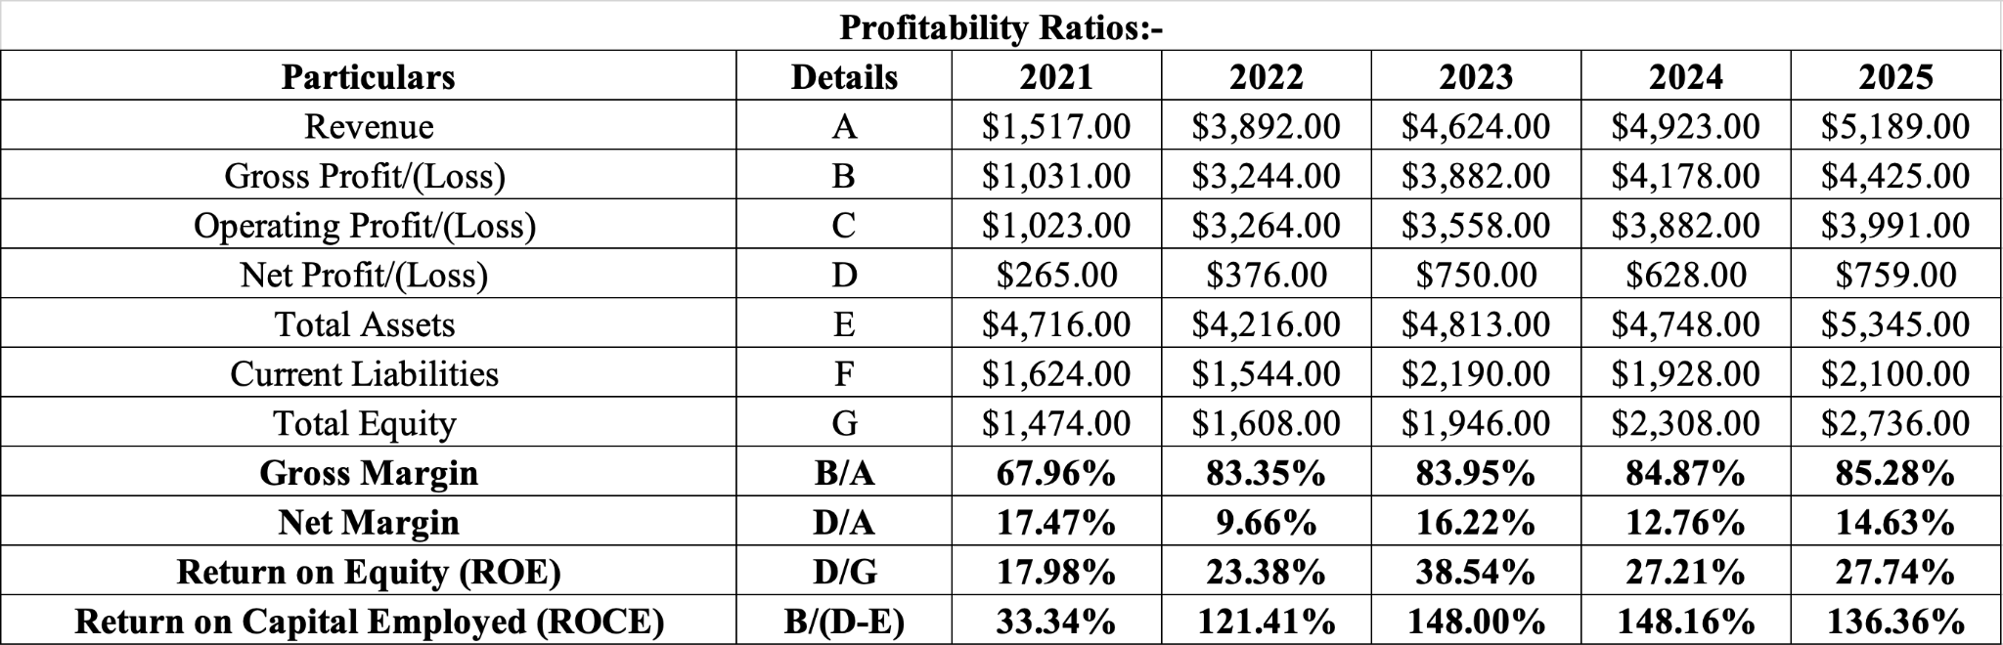
Table II: Profitability Ratio Calculation
The profitability of the Intercontinental Hotel Group improved, demonstrating the effectiveness of the asset-light business model and post-pandemic recovery strategy. Gross profit margin increased from 67.96% in 2021 to 85.2 % in 2025, which indicates revenue outpaced the increase in the cost of sales. Revenue also increased approximately 242%, with the cost of sales increasing by only 57%, as it reflected the high operational efficiency. Net profit margin recovered from 9.66% in 2022 to 14.63% in 2025 even after inflation and high finance costs. Return on equity increased from 17.98% in 2021, while ROCE exceeded 136% in 2025, indicating efficient utilisation of shareholders' funds and capital employed. A loyalty program aids in the acquisition, retention, and expansion of a base of valuable clients who stay longer, spend more, and spend less, resulting in high-quality revenue growth for owners and IHG (IHG, 2026).

1.3.2 Liquidity Ratios
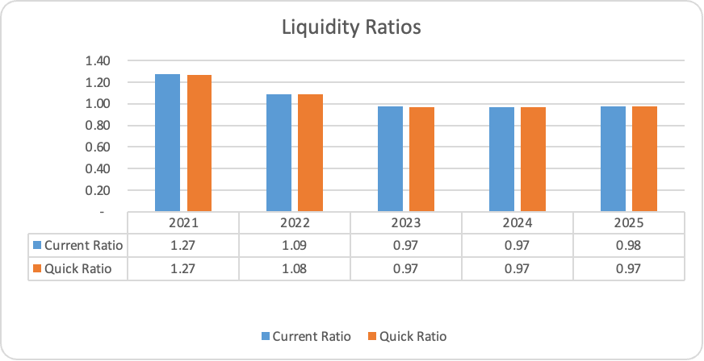
Figure 03: Liquidity Ratios
Source: (Ms-Excel)
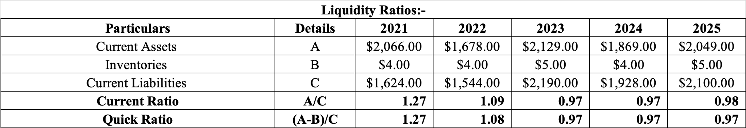
Table III: Liquidity Ratio Calculation
Intercontinental Hotel Group's liquidity remains stable, but the current ratio declined from 1.27 in 2021 to 0.98 in 2025. The quick ratio also reduced from 1.27 to 0.97, as a ratio less than 1 indicates short-term liquidity concerns in the organisation. The asset-light business model of the Intercontinental Hotel Group allows for minimal inventory, generating recurring management and franchise income, which reduces the dependency on the high working capital balance. Strong operating cash flow and available liquidity in the organisation indicate that they are financially stable even after the low liquidity ratio.

1.3.3 Gearing Ratios
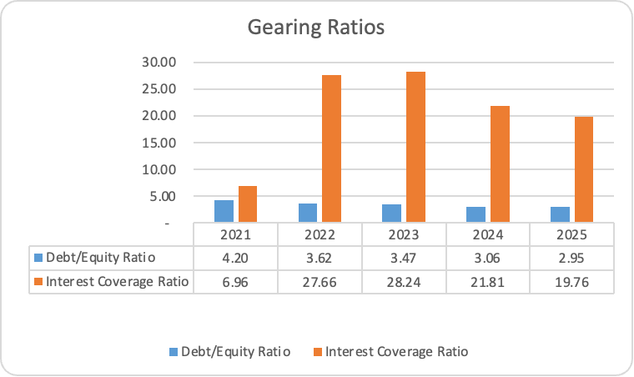
Figure 04: Gearing Ratios
Source: (Ms-Excel)
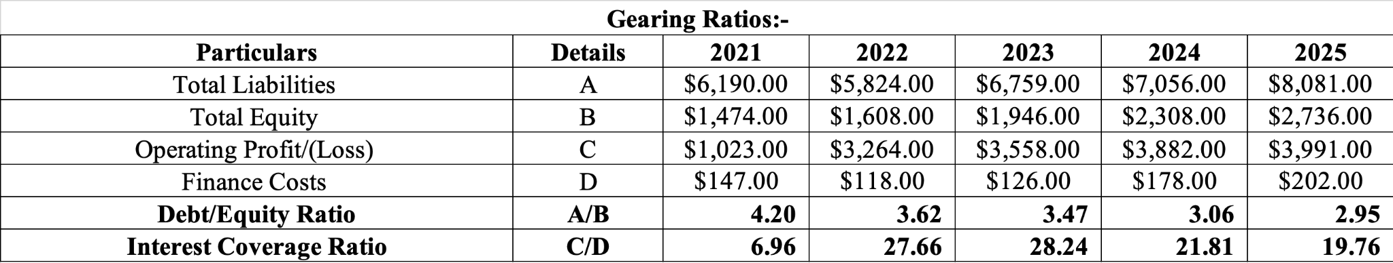
Table IV: Gearing Ratio Calculation
The decline of the debt-to-equity ratio from 4.2 in 2021 to 2.95 in 2025 indicates that the equity of the shareholders increased faster than the total liabilities in the organisation. The finance cost also increased from 147 million USD to 202 million USD, as it reflected high global interest rates, but the ratio was strong approx 19.76 times in 2025. Corporate financing expenses have significantly increased since the post-pandemic spike in consumption, inflation, and interest rates (BNY, 2026). Management teams must strike a balance between managing borrowing costs and investing in future growth due to tighter monetary policy and an increasing array of geopolitical concerns that further complicate short- and long-term financial planning.

1.3.4 Efficiency Ratios
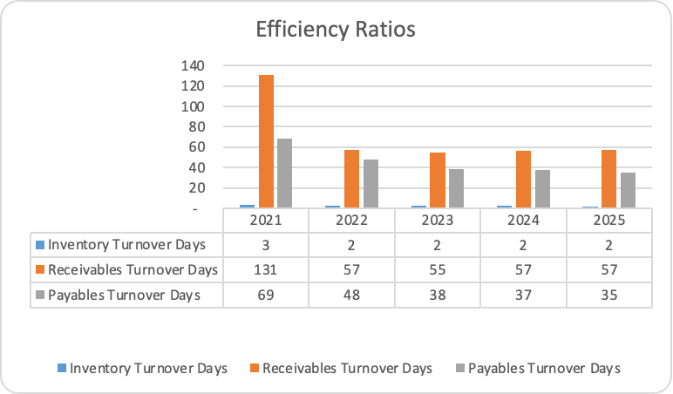
Figure 05: Efficiency Ratios
Source: (Ms-Excel)
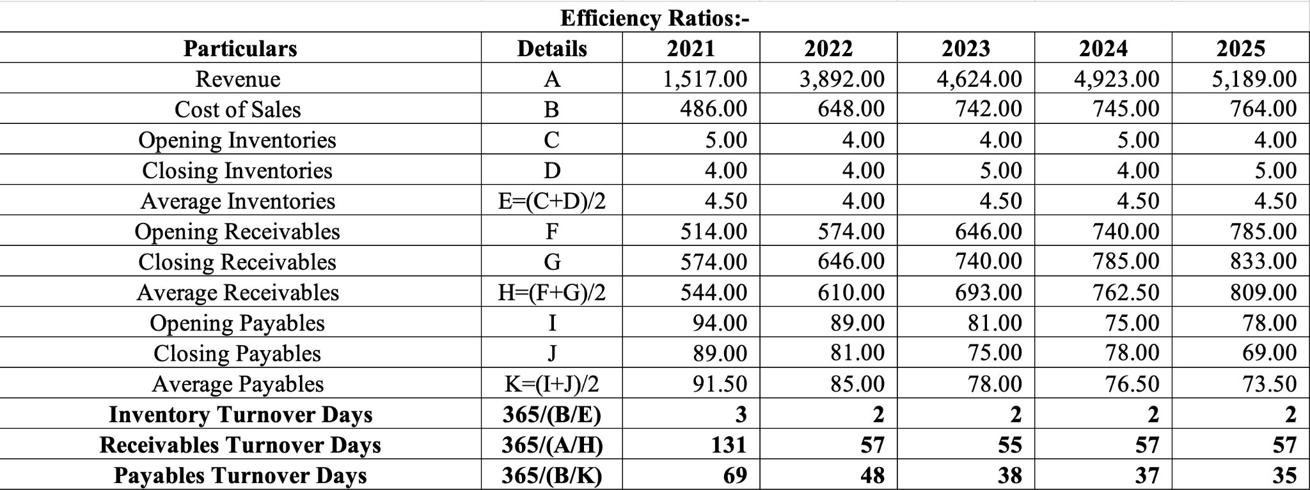
Table V: Efficiency Ratio Calculation
The inventory turnover ratio was between 2 and 3 days, which reflects the low inventory of the hotel industry. The receivable days also declined from 131 days in 2021 to 57 days in 2025 and demonstrate improvement in credit management in the fast collection of cash after recovery of international travel. The payable is reduced from 69 days to 35 days, suggesting that the strong operating cash flow allows the company to settle the obligations of the suppliers.

1.3.5 Market Ratios

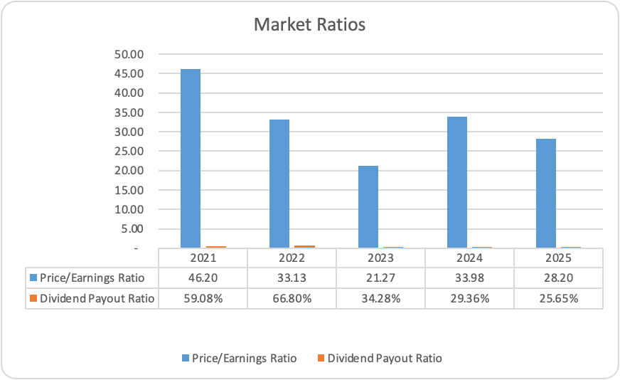
Figure 06: Market Ratios
Source: (Ms-Excel)
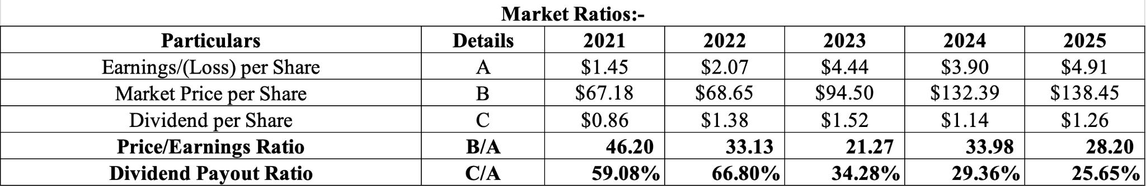
Table VI: Market Ratio Calculation
The earnings per share increased from 1.45 USD in 2021 to 4.91 USD in 2025, which reflects high profit and improvement in the return of the shareholders. The price-to-earnings ratio fluctuates, being 28 in 2025, as it continues to support investor confidence in the long-term growth prospects of the Intercontinental Hotel Group. The dividend payout ratio was approximately 59.08% to 25.6%, which suggests that the company is retaining a large proportion of the earnings for supporting the expansion of the hotel.

1.4 Industry Benchmark Comparison
Intercontinental Hotel Group is maintaining a strong competitive position in comparison to the major international competitors such as Marriott International and Hilton Worldwide. The gross profit margin of 85.28% of the Intercontinental Hotel Group is supported by the franchise-based business model that generated high fee income and low operating costs. In Q4 2025, Marriott International Inc.'s total gross fee revenues rose by 7% to $1.4 billion (Yahoo Finance, 2026). With the addition of almost 800 hotels and 100,000 new rooms to its global portfolio in 2025, a full-year net unit growth of 6.7%, while Hilton had an incredible year of expansion (Hilton, 2026). IHG reports a 13% increase in operating profit and a 16% increase in adjusted earnings per share in 2025. The company has a strong worldwide pipeline with 340,000 rooms while setting records for hotel openings with 443 new hotels (Hotel Online, 2026).

1.5 Overall Financial Evaluation
Intercontinental Hotels' strong financial performance between 2021 and 2025 was characterised by growth in revenue, improved profit and operational efficiency. The company is successfully using their asset light business model for increasing the fees income while maintaining high margins despite inflation pressure. The liquidity is less than the market level, but the stability in operating cash and interest coverage indicates short-term obligation payment efficiency. A slight decline in financial leverage and improvement in the return for the shareholder improved the financial position of Intercontinental Hotel.

2. Working Capital Management

2.1 Introduction
Working Capital Management is necessary for maintaining the short-term financial stability of the organisation, supporting the daily operations of the business (Reyad et al., 2022). It focuses on the efficient management of the current assets and liabilities to ensure sufficient liquidity along with minimising unnecessary capital investment. Effective Working Capital Management is necessary for Intercontinental Hotel Group, which is important due to their asset-light business model dependent on the continuous cash inflow from franchise and management fees.

2.2 Cash Operating Cycle
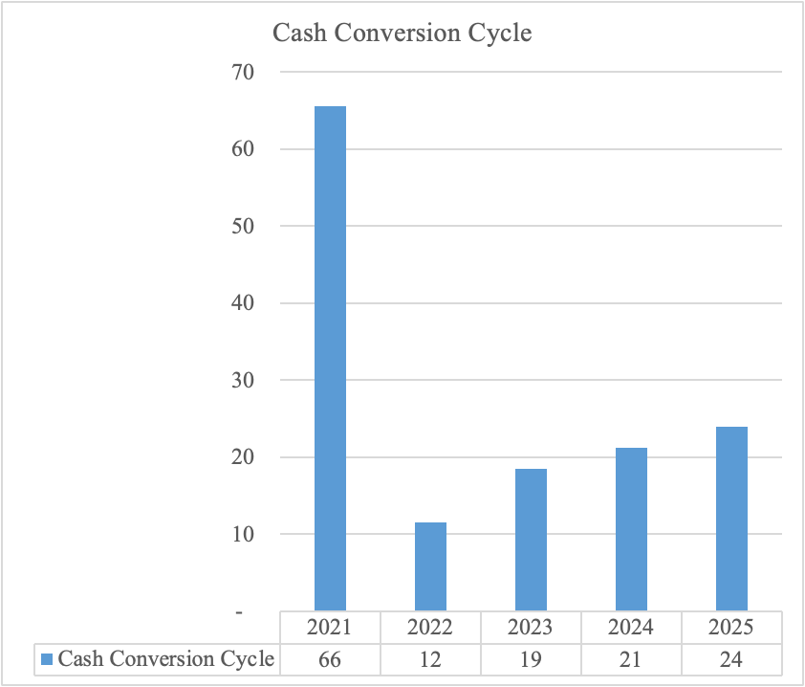
Figure 07: Cash Operating Cycle
Source: (Ms-Excel)
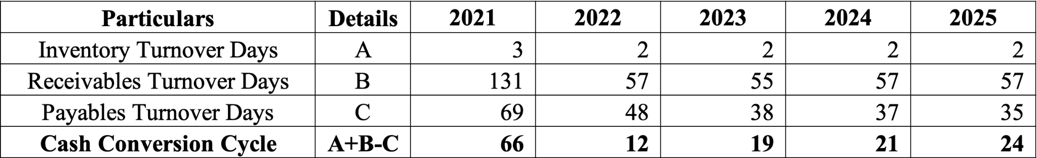
Table VII: Cash Operating Cycle Calculation
Cash operating cycle reduced from 66 days in 2021 to 12 days in 2022 before increasing to 24 days in 2025. The improvement in 2022 results from the reduction in receivables turnover is as it declined from 131 days to 57 days due to the recovery of international travel and customer resume towards the normal payment patterns. The improvement allows for cash inflow and reduces the amount of capital aligned with the outstanding receivables.
Inventory management is also effective throughout the period, with the inventory turnover days decreasing from 3 days in 2021 to 2 days in 2025. It shows the franchise-led operating model of the Intercontinental Hotel, which requires less inventory because the hotel owners are responsible for the operational supplies. Payable turnover has also declined from 69 days in 2021 to 35 days in 2025 as the company has to provide fast payment to its suppliers.
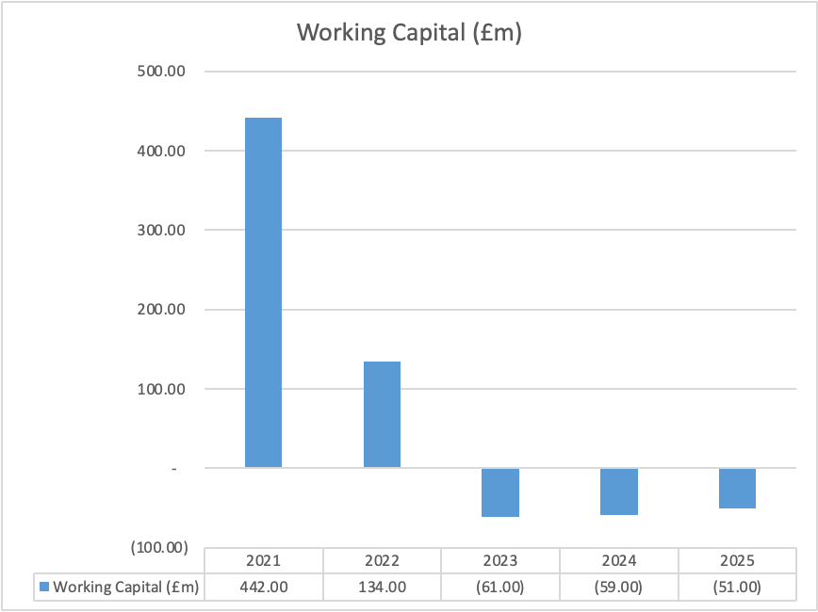
Figure 08: Working Capital
Source: (Ms-Excel)
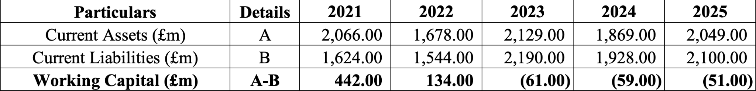
Table VIII: Working Capital Calculation
Improve the commercial relationship, which further allowed for favourable purchasing patterns, but reduced the length of the finance available for the company. It contributed to the increase in the cash operating cycle after 2022 and, with the negative working capital balance, improved from £61 million in 2023 to £51 million in 2025. Investments to spur expansion are supported by cash creation and a solid balance sheet (IHG, 2026). They also consistently return excess capital through share buybacks and sustainably raise the quarterly dividend. In 2026, it is anticipated that worldwide travel and tourism would continue to outpace broader economic growth, contributing $12 trillion to the global economy, or 9.9% of GDP (WTTC, 2026).

2.3 Liquidity Improvement Strategies
Intercontinental Hotel Group generated strong operating cash flow despite the decline in the current and quick ratios and negative working capital.
AI-driven cash flow forecasting: Implementation of the AI base cash flow forecast can help improve the accuracy of short-term liquidity planning. An advanced forecast system in the organisation helps for the identification of the seasonal fluctuations in demand for the optimisation of cash allocation across regions. Forecasting speed is increased, and manual reporting work is decreased through digital integration (Atlas, 2026).
Receivable management: Automation in the invoice and payment collection is considerable for improving receivable management for the Intercontinental Hotel Group. The receivable days of the organisation reduced substantially in 2021, but maintaining the collection period is still below the industry average, which would allow for further acceleration in the operating cash. Expansion of the digital payment system solutions and integrated billing system across the franchise partners can support the objective.
Effective supplier payment strategies: There is a reduction in the number of payable days from 69 to 35, which indicates that the cash leaves the business more frequently than in previous years. It is suggested that the Intercontinental Hotel Group negotiate long payment terms with the strategic supplier to reduce the finance pressure along with preserving the continuity in the operation.

2.4 Short-Term Financing
Intercontinental Hotel Group has to focus on short-term finance sources for supporting the seasonal cash flow requirements and operating expenditure. Commitment for the revolving credit facilities, trade credit and short-term bank borrowing can provide the immediate liquidity without any requirement of long-term commitment (Bartholdy and Olson, 2023). There is negative working capital between 2023 and 2025, as short-term finance can facilitate the reduction of the temporary funding gap along with maintaining the continuity in the operation.

2.5 Long-Term Financing
Intercontinental Hotel Group should continue to finance strategic expansion through the balance combination of retained earnings and long-term debt. Retaining a large proportion of the profit is consistent with the decline in the dividend payout ratio, as it would allow investment in hotel development, digital transformation and brand expansion without dependency on external finance. Long-term borrowing could also be appropriate for the acquisition of funding and large-scale projects because it can match the long-term nature of these investments.

2.6 Recommendation
Intercontinental Hotel Group should adopt the balanced working capital strategy by combining disciplined cash management with flexible short-term funding and sustainable long-term finance. Maintaining the strong operating cash flow, optimising supplier payment terms and conditions, and reinvesting the return earnings will improve liquidity (Barnabas and Oloyede, 2024). It could also support global expansion and improve financial resilience, along with preserving long-term value for the shareholder.

3. Strategic Financial Restructuring Plan

3.1 Need for Financial Restructuring
Restructuring is necessary for maintaining financial resilience in the volatile hospitality market even after the strong financial performance of IHG. The liabilities of the company have increased from 6.19 billion USD to 8.08 billion USD, as the working capital also went negative from 2023 onwards. It shows the major dependency of IHG.
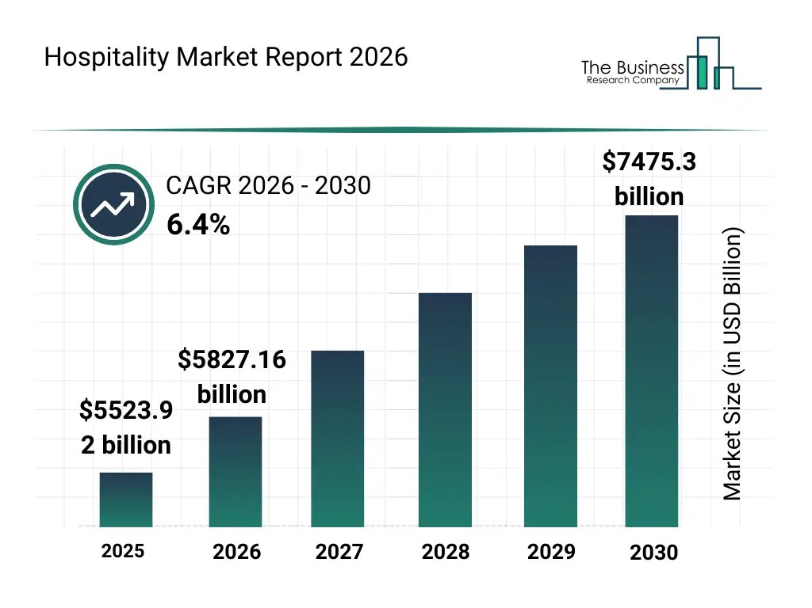
Figure 09: Hospitality Market Size
Source: (The Business Research Company, 2026)
The size of the hospitality market was $5523.92 billion in 2025 and is projected to increase at a compound annual growth rate (CAGR) of 6.4% to $7475.3 billion in 2030 (The Business Research Company, 2026). It shows significant growth of the industry, and IHG has to ensure a positive capital structure to support future growth without increasing financial risk. IHG's global pipeline of 340k rooms (2,292 hotels) represents 33% of the current system size and is rising +4% year over year (IHG, 2026).

3.2 Financial Restructuring Options
Retained earnings: IHG has to focus on continuous expansion with their retained earnings. The dividend payout ratio declined from 59.08% in 2021 to 25.65% in 2025, as it provides the internally generated funds for investment. The approach would be considerable for reducing the dependency on debt and preserving the capacity to borrow for future opportunities.
Portfolio optimisation strategy: Concentration of the investment in the high-growth region is another option for the IHG by the optimisation of the portfolio. IHG surpassed multiple milestones in FY 2026 and opened more hotels than ever before, with 4,100 open hotels in the US, 800 in Greater China, and 50 in India (IHG, 2026). It suggested that IHG should redirect the capital towards its high-growth market to improve returns on investment and strengthen long-term profitability.
Share buyback programmes: IHG Corporation repurchased 3,834,735 shares for US$475 million between July 1, 2025, and December 29, 2025, for a total of US$900 million, or 4.87% of the issued share capital (Simply Wall, 2025). They could also continue the use of their share buyback programmes selectively when they have excessive cash available, as it reflects confidence in future cash generation along with improving earnings per share and capital efficiency.
Technology-enabled capital efficiency:
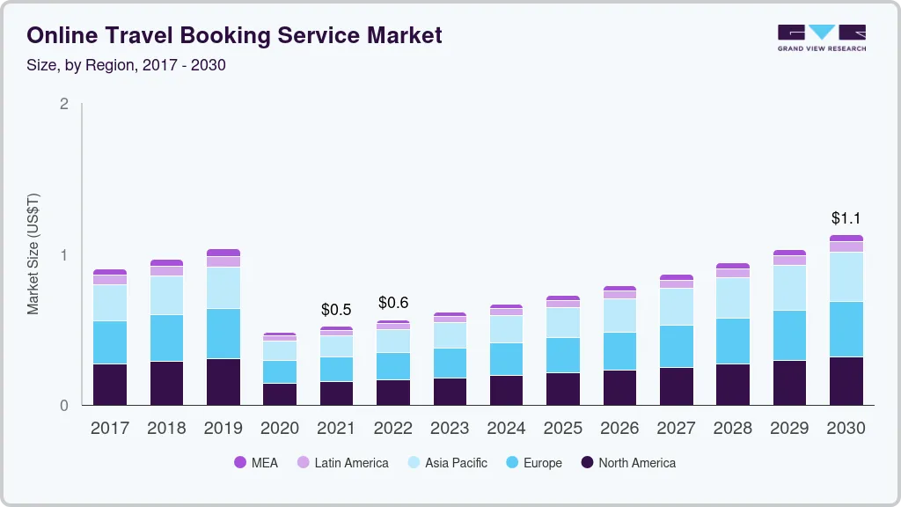
Figure 10: Online Travel Booking Service Market
Source: (Grand View Research, 2026)
The market for online travel booking services was estimated to be worth USD 519.1 billion in 2021 and is expected to increase at a compound annual growth rate (CAGR) of 9.0% from 2022 to 2030, reaching USD 1.13 trillion (Grand View Research, 2026). This is increasing the importance of investing in revenue management systems, customer analytics and loyalty platforms in place of capital-intensive property ownership. This is aligned with the asset-light strategy and allows sustainable growth for IHG without increasing financial leverage.

3.3 Impact on Shareholder Value
The proposed restructure in IHG is expected to improve the long-term value for the shareholder by improving capital efficiency rather than increasing business size. Use of retained earnings and investment allocation could generate high returns along with limiting additional borrowing (Gautam and Purohit, 2024). Significantly, the buyback programme could show the confidence of management in future cash generation and support the increase of earnings per share. Moreover, expansion in high-growth markets such as India and the Middle East can provide opportunities for sustainable growth.

3.4 Debt Structure
IHG has to maintain its debt structure by reducing the dependency on short-term borrowing and aligning debt maturities with the long-term investment projects. The debt-to-equity ratio of IHG improved with the increase in total liabilities, highlighting the need for prudent debt management. IHG is maintaining strong liquidity and investment-grade metrics, which would allow for access to the capital market along with supporting future expansion.

3.5 Operational Flexibility
Maintaining adequate liquidity and internally generated funds in the organisation can allow for the acceleration of development and the existing properties. Operators are increasingly looking for solutions to meet the demand for luxury hotels, which have emerged as the hospitality industry's main growth driver. In a market where AI is increasingly acting as the initial point of contact between travellers and hotels, early adoption of AI will put you in the greatest position to meet demand (PWC, 2026).

3.6 International Considerations
Intercontinental Hotels operates in more than 100 countries, which exposes the business to exchange rate movements, political risk and differences in regulatory requirements. By 2028, West Asia is expected to have recovered at the fastest rate in the Asia Pacific region, with visitor numbers expected to reach 133.64% of 2019 levels (PATA, 2026). Doing the restructuring to make strategic diversification can support the investment in the high international market along with maintaining effective foreign currency risk management.

3.7 ESG and Ethical Issues
The financial structure of the organisation should be aligned with the environmental, social and governance commitment of IHG. A ten-year action plan called IHG's Journey to Tomorrow aims to promote long-term development throughout its international operations. Its three main pillars promoting an inclusive culture for its people, enhancing the lives of 30 million people in local communities, and safeguarding the environment are in line with the UN Sustainable Development Goals (Reuters, 2024). Integration of sustainable investment in capital allocation can improve corporate reputation and respond to increasing demand for responsible business practice.

4. Investment Appraisal and Capital Budgeting

4.1 Introduction
Investment appraisal is the fundamental element for the capital budget, which allows the organisation for the evaluation of the project which is capable of generating an acceptable financial return (Jain, 2024). The investment decision includes capital commitments, as it is necessary for the business to apply the techniques for minimising risk and maximising the value for the shareholders. Organisations evaluate the project with the use of multiple appraisal techniques because each of the methods can provide different information related to profit, liquidity and investment risk.

4.2 Project Information
IHG is evaluating the three exclusive investment projects as each of them requires an initial investment of £50 million and has an expected life of five years. The future inflow of the gas could be different, but the technique includes an 8% discount rate as the required rate of return. Use of the multiple investment appraisal method helps to improve decision quality because each of the techniques measures the different dimensions of the project performance and risk.

4.3 Payback Period
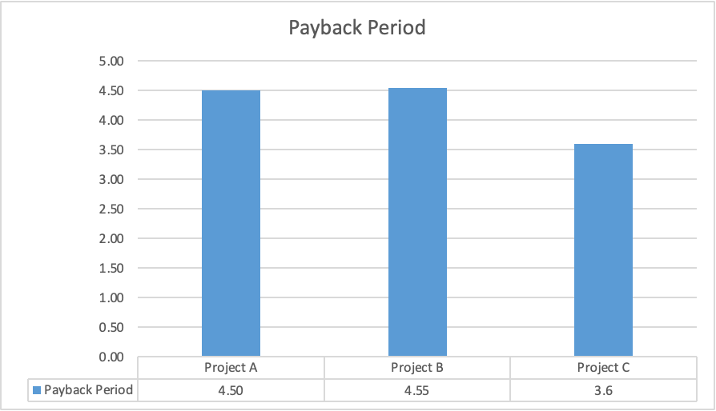
Figure 11: Payback Period
Source: (Ms-Excel)
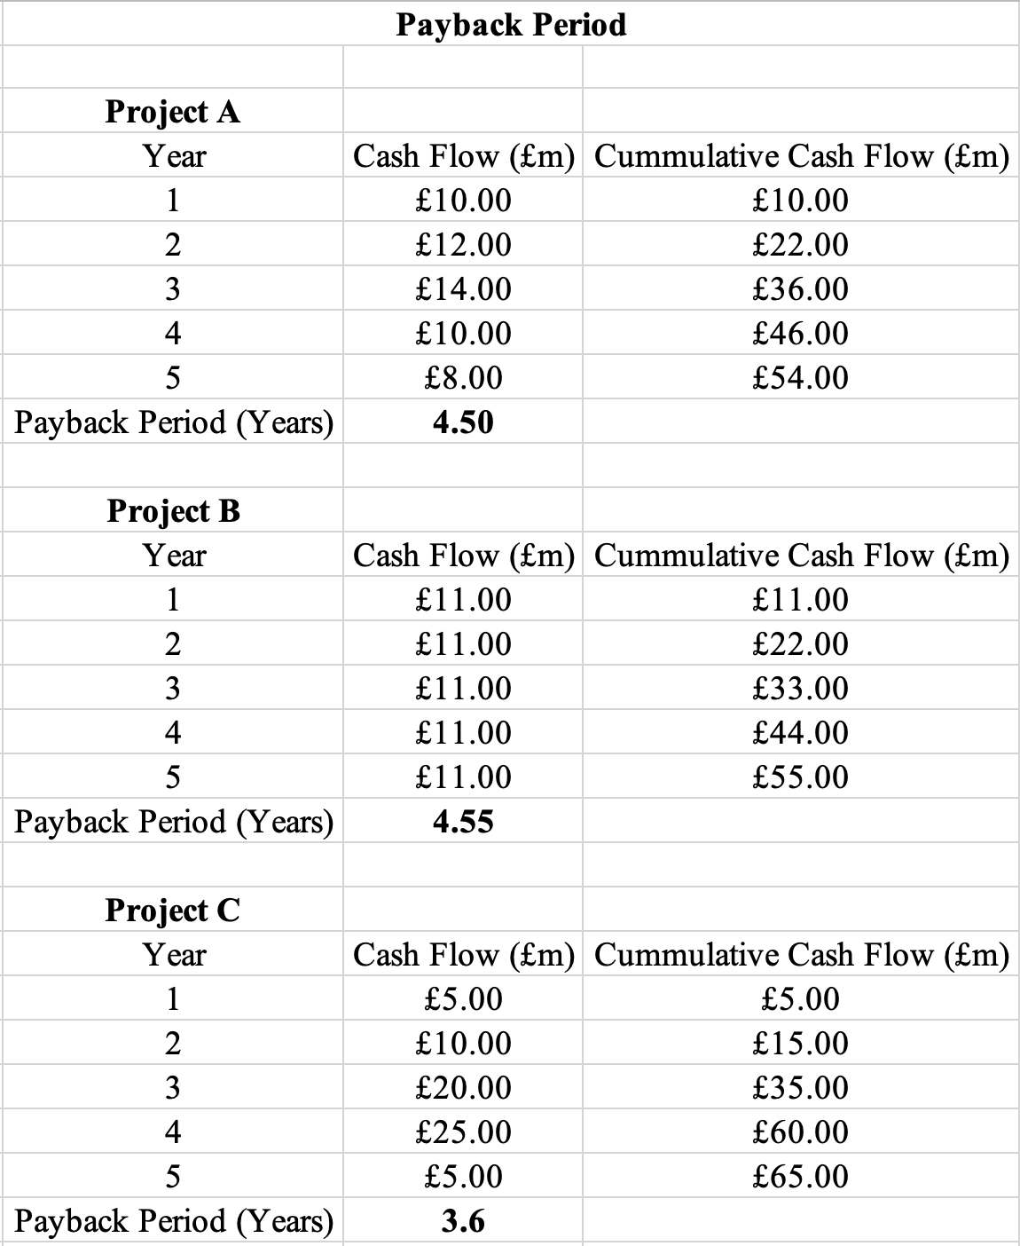
Table IX: Payback Period
Payback period evaluates the time required for cumulative cash inflow to recover the initial investment, as it is a useful measurement of liquidity and investment risk (Sokolov, 2026).
Project C achieved the shortest payback period of 3.6 years that was followed by Project A (4.50 years) and Project B (4.55 years). Project season writes the highest inflow of cash during years 3 and 4, which allows the investment to be recovered 1 year earlier than the alternative options. Early recovery of cash can reduce exposure to inflation and changes in market conditions in uncertain operations that are important in the hospitality industry, as demand fluctuates with economic conditions.
Payback period ignores the time value of money and excludes the cash generated after the investment has been recovered. Project C performs the best using this method, but the payback period cannot alone determine whether the project can create shareholder value.

4.4 Accounting Rate of Return
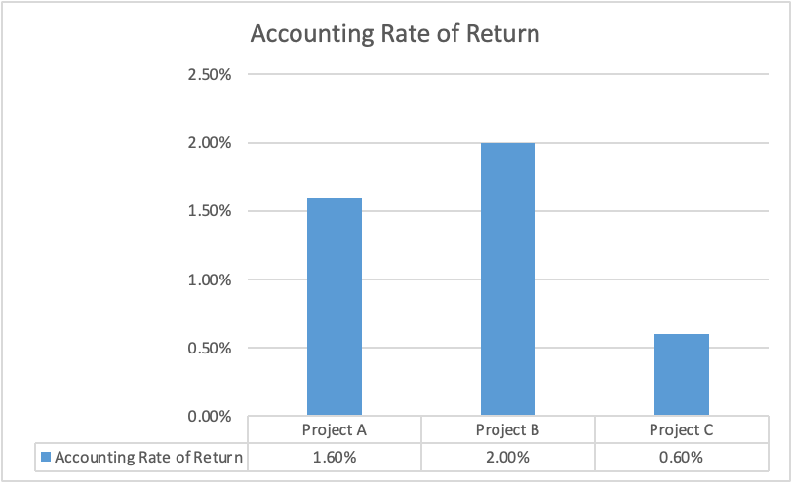
Figure 12: Accounting Rate of Return
Source: (Ms-Excel)
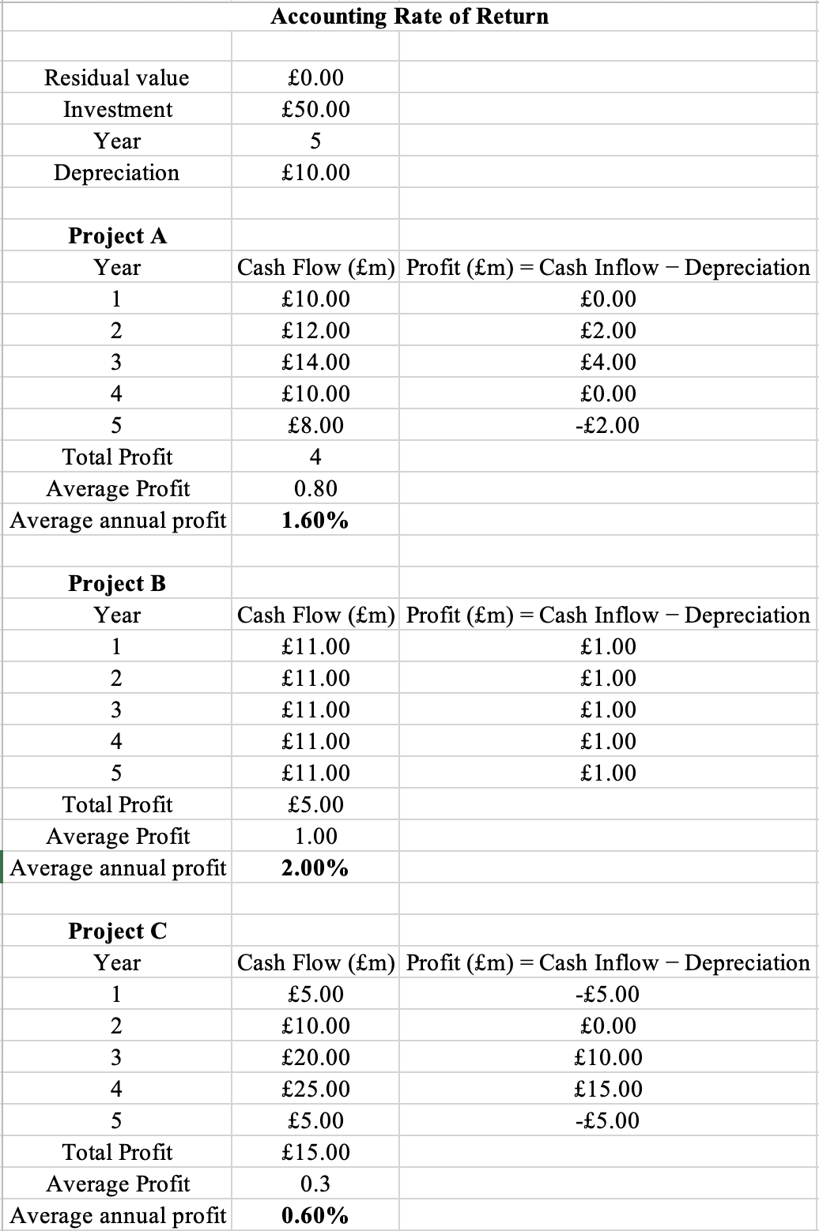
Table X: Accounting Rate of Return
The accounting rate of return measures the accounting profit generated by the project as the percentage of the initial investment. It focuses on the accounting profit in place of the cash condition, as it is the standard for calculating and aligning with financial performance.
Project B achieved the highest accounting rate of return of 2% which is followed by Project A of 1.6%, and C has the lowest ARR. Project B is producing consistent annual profit throughout the investment in the 5 years, which is the reason for the stable accounting return even after the uniformity in the cash.
The accounting rate of return does not recognise the time value of money and is influenced by the accounting policies, including depreciation. A project with the highest accounting rate of return of necessary maximizes the value for a shareholder.

4.5 Net Present Value
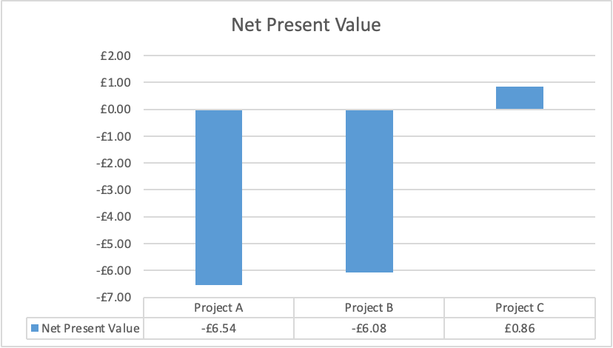
Figure 13: Net Present Value
Source: (Ms-Excel)
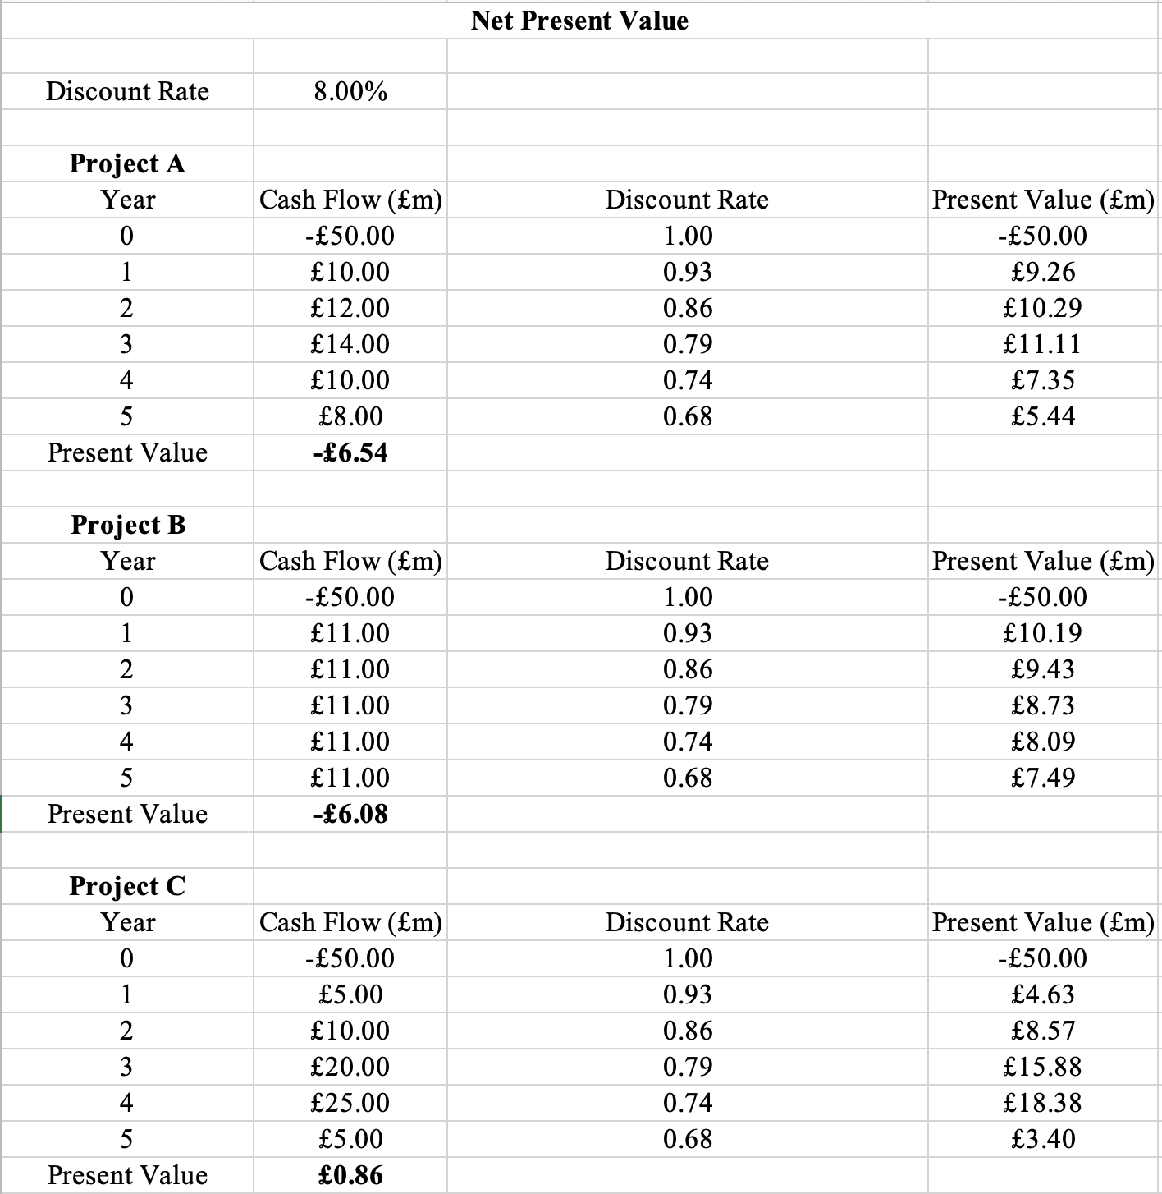
Table XI: Net Present Value
Net present value is the most widely used investment appraisal technique because it measures the present value of the inflow of future cash after deducting the initial investment (Dai et al., 2022). Projects with a positive net present value increase the wealth of the shareholders, while those with a negative should be rejected.
With the use of the discount rate of 8%, Project C generated the highest present value of £0.86 million, while Project B and Project A produced negative NPVs of –£6.08 million and –£6.54 million, respectively. The positive net present value indicates that Project C is expected to generate a return of the required rate of return for the company by creating additional economic value. Project A and B fail to recover the discounted investment cost and thereby reduce the value for the shareholder.
Project C achieves the superior present value because of the large inflow of cash received during years 3 and 4, generating the discounted value despite the low receipt during the first 2 years. The outcome demonstrates the importance of considering the timing of the cash flow while evaluating the long-term investment. Net present value directly measures the creation of corporate time value as it ranks the mutually exclusive projects. Project C represents the stone investment opportunity based on the analysis of the net present value.

4.6 Profitability Index
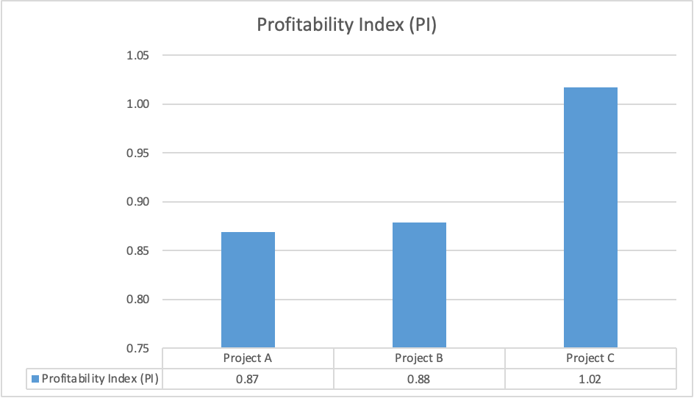
Figure 14: Profitability Index
Source: (Ms-Excel)
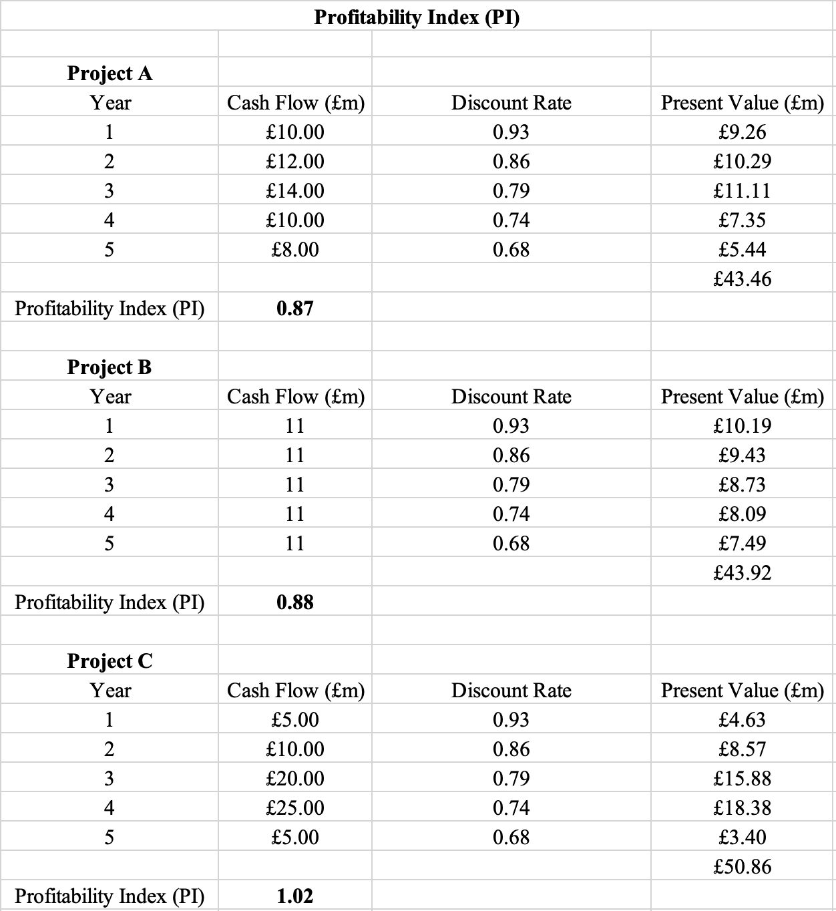
Table XII: Profitability Index
Profitability index measures the present value generated for every £1 invested and is particularly useful when investment funds are limited (Olayinka, 2022). A profitability index greater than 1 creates value, but less than 1 should be rejected because they feel they need to recover the initial investment on the discount basis.
Project C has the highest profitability index of 1.02, but Project B and Project A recorded 0.88 and 0.87, respectively. Project C generated £1.02 of discounted benefits for every £1 invested, exceeding the company's required return. Project A and B produced discounted inflows of cash which were insufficient for recovering the initial investment. Profitability index results are consistent with the net present value basis, confirming that only Project C is capable of generating positive economic value.

4.7 Internal Rate of Return
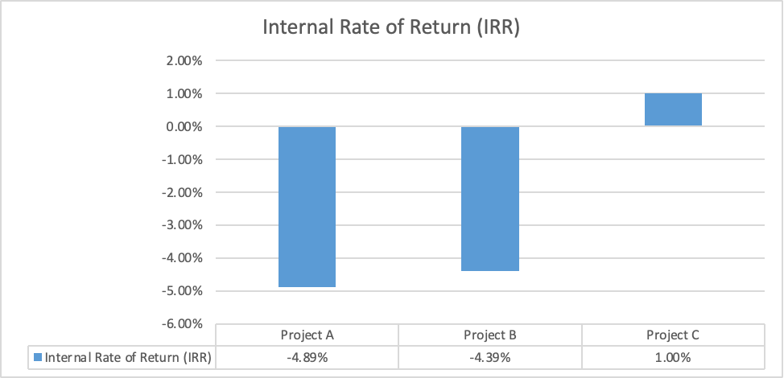
Figure 15: Internal Rate of Return
Source: (Ms-Excel)
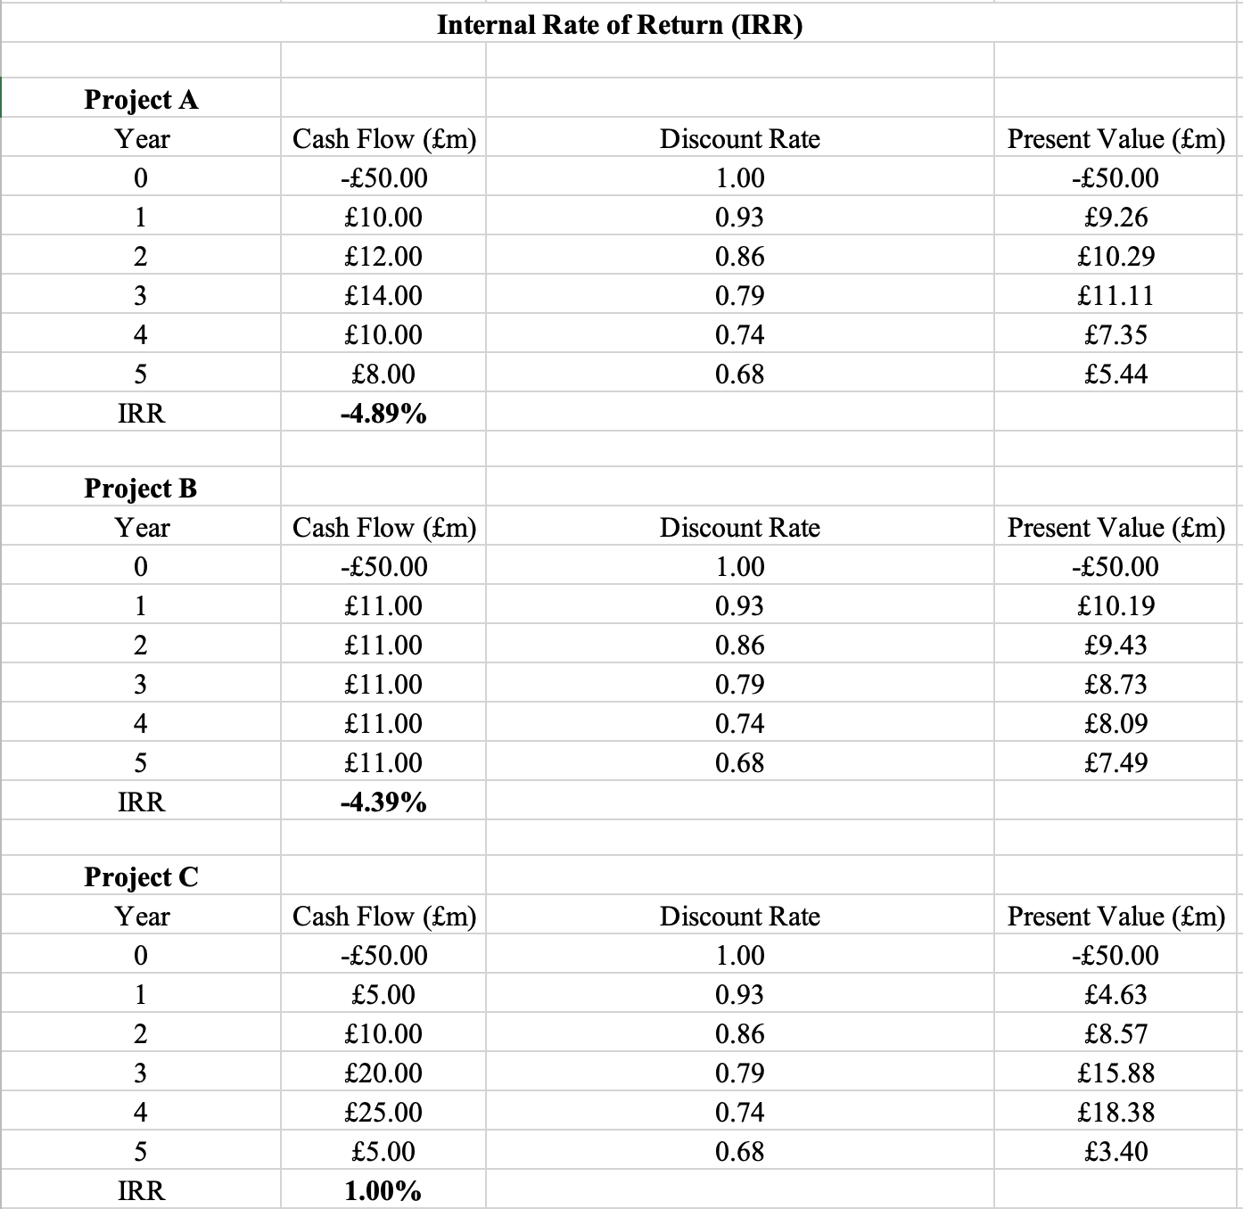
Table XIII: Internal Rate of Return
Internal rate of return identifies the discount rate at which the net present value of the project is equal to zero and is compared with the required rate of return of the company (Arjunan, 2022). A project should not be accepted only when the internal rate of return exceeds the cost of capital because this indicates that the expected return compensates the investors for the associated investment risk.
The highest internal rate of return is calculated for Project C, which is approximately 1%, as Project B and Project A produced negative IRRs of -4% and -5%, respectively. Project C achieves the highest internal rate of return, but it is still less than the required rate of return by the company. It is a less risky investment because it generates strong discounted cash and flow, which should be financially acceptable among the alternatives.

4.8 Comparison of All Projects
Project A: Although Project A produced variable yearly cash inflows and an ARR of 1.6%, its negative NPV of £6.54 million, PI of 0.87, and IRR of −5% show that it is unable to generate value for shareholders. As a result, even though the investment was recovered in 4.5 years, it shouldn't be chosen.
Project B: Project B demonstrated sustained accounting profitability by generating steady yearly cash inflows and achieving the highest reported ARR (2.0%). However, because discounted cash flows are still insufficient to repay the investment, its negative NPV (£6.08 million), PI of 0.88, and IRR of −4% show that accounting gains alone do not ensure financial viability.
Project C: In contrast, Project C had the highest NPV (£0.86 million), the highest PI (1.02), the shortest payback period (3.6 years), and the highest IRR (1%). Discounted appraisal techniques consistently rank Project C as the best investment since it generates positive economic value while recovering capital more quickly, even if its reported ARR is lower than Project B. Project C clearly surpasses the competing options since NPV is regarded by finance theory as the most trustworthy criterion for making decisions.

4.9 Recommended Project
Project C should be selected because it is the best across the majority of the investment techniques. The positive net present value and more than 1 profitability index demonstrate that it is expected to increase the wealth of the shareholder. It also has the shortest payback period, which allows the initial investment to be recovered quickly and reduces the exposure to long-term uncertainty. The internal rate of return is also less than the required rate of return but higher than the alternative project, which is supported by the superior discounted cash flow performance.

4.10 Capital Rationing
Capital rationing occurs in organisations due to limited financial investment and the inability to undertake every profitable project (Ofoeda et al., 2025). The project should be focused on the ability for maximising the wealth of the shareholder with the use of discounted cash flow techniques, including NPV and PI. Project C is Preferable for IHG because it is only projected with a positive NPV and a PI greater than 1.

5. Critical Reflection on AI Usage

5.1 AI Tools Used
Artificial intelligence was used only to provide general guidance in the preparation of the report. It helped in assisting the understanding of the report structure, improving the clarity of the academic writing and explaining the financial management concepts. All of the calculations, including ratio analysis, working capital and investment techniques, were completed with the use of Microsoft Excel based on the financial data collected from the report of the company. Company-specific information, including financial statements and evidence obtained from the InterContinental Hotels Group's Annual Reports, Statista, Reuters and other academic sources. Artificial intelligence served only as a supplementary learning resource in place of the tool for producing the financial analysis of the report or conclusions.

5.2 Verification of AI Outputs
Any information generated through artificial intelligence is verified before being included in this report. Financial data was not taken from artificial intelligence, along with all trend information and news. The result of the investment appraisals, ratio calculations and working capital helps for the verification with the use of the Microsoft Excel for ensuring the numerical consistency. Academic theory related to financial performance, capital budget in financial restructure also compared with the use of the course materials and recommended textbook. The verification process ensured that all of the confusion presented in this report were supported by the evidence in place, solely on the AI-generated evidence.

5.3 Identification of Hallucinations
The AI generator response in this report contains a general explanation that was not sufficient for supporting the company-specific evidence. It provided a broader interpretation of financial performance without considering the financial data and requirements of the assignment briefs. Suggested analysis by artificial intelligence also required modification to ensure consistency with the financial calculation process in Excel. Limitations highlighted the need for improvement in the review of AI outputs, critically in place of accepting without any evaluation.

5.4 AI Contribution vs Personal Analysis
The report is prepared with independent analysis and personal judgement. Calculation of the financial ratios, working capital and investment techniques were completed with the use of Microsoft Excel, and the conclusion and recommendations were also developed through the interpretation of the calculator results and published financial information by the company. Artificial intelligence only assists in the organisation of the content, improving the presentations and explaining the selected financial concept with further clarifications. The analysis of the company, Evaluation of the financial performance and recommendations were also selected based on independent assessment with the help of the annual reports, academic literature and industry evidence. The artificial intelligence acted as a supplementary learning analysis, and the critical analytical content and professional judgement were completely based on my own work.

5.5 Ethical Reflection
Responsible use of artificial intelligence requires transparency, critical evaluation and compliance with the academic integrity principles. Artificial intelligence was only used to support understanding and improving the presentation of the work throughout this assessment. All of the financial calculations, everytimes and conclusion independently verified with the use of academic and professional sources in this report. The approach was highly considerable for ensuring that the report reflected independent thinking and critical thinking, along with benefiting from the technology support. The experience demonstrates that Artificial Intelligence can improve efficiency during academic work, but the responsibility for the accuracy, analysis and financial decision-making remains with the student.

References
Arjunan, K., (2022). A new method to estimate NPV and IRR from the capital amortization schedule and the advantages of the new method. Australasian Accounting, Business and Finance Journal, 16(6). Available at: https://www.uowoajournals.org/aabfj/article/id/941/
Atlas, (2026). Why Hospitality Businesses Need Stronger Financial Forecasting After 2025. Available at: https://www.atlasca.com.au/hospitality-financial-forecasting/
Barnabas, B. and Oloyede, J., (2024). Cash flow optimization: Strategies for enhancing short-term liquidity. Available at SSRN 5004465. Available at: https://papers.ssrn.com/sol3/papers.cfm?abstract_id=5004465
Bartholdy, J. and Olson, D., (2023). Do trade credits finance long-term investments?. Heliyon, 9(10). Available at: https://www.cell.com/heliyon/fulltext/S2405-8440(23)07656-9
BNY, (2026). Demand Notes: Beyond the Traditional Corporate Financing Playbook. Available at: https://www.bny.com/corporate/global/en/insights/demand-notes-flexible-corporate-financing.html
Dai, H., Li, N., Wang, Y. and Zhao, X., (2022), March. The analysis of three main investment criteria: NPV IRR and payback period. In 2022 7th International Conference on Financial Innovation and Economic Development (ICFIED 2022) (pp. 185-189). Atlantis Press. Available at: https://www.atlantis-press.com/proceedings/icfied-22/125971510
Gautam, S. and Purohit, A., (2024). Debt Or Retained Earnings: Whichever Is Optimum for The Growth of The Firm. Russian Law Journal, 12(1), pp.125-129. Available at: https://cyberleninka.ru/article/n/debt-or-retained-earnings-whichever-is-optimum-for-the-growth-of-the-firm
Grand View Research, (2026). Online Travel Booking Service Market (2022 - 2030). Available at: https://www.grandviewresearch.com/industry-analysis/online-travel-booking-service-market-report
Hilton, (2026). Hilton Delivers Strong 6.7% Net Unit Growth in 2025, Closes Year with Record 520,000 Rooms Under Development. Available at: https://stories.hilton.com/releases/hilton-delivers-strong-net-unit-growth-in-2025-closes-year-with-record-520000-rooms-under-development
Hotel Online, (2026). IHG Delivers Strong 2025 Results With Double-Digit Profit Growth and Record Hotel Openings. Available at: https://www.hotel-online.com/news/ihg-delivers-strong-2025-results-with-double-digit-profit-growth-and-record-hotel-openings
IHG, (2022). Annual Report 2021. Available at: https://www.ihgplc.com/~/media/Files/I/Ihg-Plc/investors/shareholder-center/annual-reports-and-responsible-business-reports/annual-reports/2021/ihg-2021-annual-report.pdf
IHG, (2023). Annual Report 2022. Available at: https://www.ihgplc.com/~/media/Files/I/Ihg-Plc/investors/shareholder-center/annual-reports-and-responsible-business-reports/annual-reports/2022/annual-report-2022.pdf
IHG, (2024). Annual Report 2023. Available at: https://www.ihgplc.com/~/media/Files/I/Ihg-Plc/investors/annual-report/2023/annual-report-2023.pdf
IHG, (2025). Annual Report 2024. Available at: https://www.ihgplc.com/~/media/Files/I/Ihg-Plc/investors/annual-report/2024/annual-report-2024-IHG-144ppi.pdf
IHG, (2026). A powerful loyalty programme. Available at: https://development.ihg.com/hotel-development/owner-value/powerful-loyalty-programme
IHG, (2026). Annual Report and Form 20-F 2025. Available at: https://www.ihgplc.com/~/media/Files/I/Ihg-Plc/investors/annual-report/2025/ihg-ar25-interactive.pdf
IHG, (2026). Full Year Results for the year to 31 December 2025. Available at: https://www.ihgplc.com/en/news-and-media/news-releases/2026/full-year-results-for-the-year-to-31-dec-2025
IHG, (2026). Full Year Results for the year to 31 December 2025. Available at: https://www.ihgplc.com/en/news-and-media/news-releases/2026/full-year-results-for-the-year-to-31-dec-2025
IHG, (2026). InterContinental Hotels Group PLC. Full Year Results to 31 December 2025. Available at: https://www.ihgplc.com/~/media/Files/I/Ihg-Plc/results/2026/full-year-2025/full-year-results-for-the-year-to-31-dec-2025.pdf
Jain, Y.K., (2024). Financial management and market dynamics. Xoffencerpublication. Available at: https://books.google.com/books?hl=en&lr=&id=XIsrEQAAQBAJ&oi=fnd&pg=PA1&dq=Investment+appraisal+is+the+fundamental+element+for+the+capital+budget,+which+allows+the+organisation+for+the+evaluation+of+the+project+which+is+capable+of+generating+an+acceptable+financial+return.&ots=JYBdhXH4ys&sig=GZnRzO36EnNOm75gwNXvF2fifwM
Ofoeda, I., Doku, J.N. and Vanderpuye, S.O., (2025). Firm investment decisions. In The Elgar Companion to Financial Economics (pp. 92-113). Edward Elgar Publishing. Available at: https://www.elgaronline.com/abstract/book/9781035341405/chapter5.xml
Olayinka, A.A., (2022). Financial statement analysis as a tool for investment decisions and assessment of companies’ performance. International Journal of Financial, Accounting, and Management, 4(1), pp.49-66. Available at: https://www.researchgate.net/profile/Aminu-Olayinka/publication/361292771_Financial_statement_analysis_as_a_tool_for_investment_decisions_and_assessment_of_companies'_performance/links/62a90366a3fe3e3df8778ac8/Financial-statement-analysis-as-a-tool-for-investment-decisions-and-assessment-of-companies-performance.pdf
PATA, (2026). Asia Pacific Tourism Outlook 2026–2028: Expected Growths, Trends, and Challenges. Available at: https://www.pata.org/blog/asia-pacific-tourism-outlook-20262028-expected-growth-trends-and-challenges
PWC, (2026). Headwinds and AI in a Two-Speed Hotel Economy. Available at: https://www.pwc.com/us/en/industries/financial-services/asset-wealth-management/real-estate/emerging-trends-in-real-estate-pwc-uli/property-type-outlook/hospitality.html
Radivojević, V., Dimovski, J. and Mitić, G., (2023). Quantifying the financial impact of COVID-19 on the largest global companies in the hotel industry. Менаџмент у хотелијерству и туризму, 11(1), pp.165-176. Available at: https://cyberleninka.ru/article/n/quantifying-the-financial-impact-of-covid-19-on-the-largest-global-companies-in-the-hotel-industry
Reuters, (2024). Driving a sustainable future: a journey to tomorrow. Available at: https://www.reuters.com/plus/acumen/vision-2045/ihg-hotels-resorts-sustainability-leader
Reuters, (2025). Holiday Inn owner IHG confident US domestic demand will deliver profit growth. Available at: https://www.reuters.com/business/intercontinental-hotels-global-room-revenue-rises-first-quarter-2025-05-08/
Reyad, H.M., Zariyawati, M.A., Ong, T.S. and Muhamad, H., (2022). The impact of macroeconomic risk factors, the adoption of financial derivatives on working capital management, and firm performance. Sustainability, 14(21), p.14447. Available at: https://www.mdpi.com/2071-1050/14/21/14447
Simply Wall, (2025). IHG: Future Returns Will Rely On AI Execution And Capital Returns. Available at: https://simplywall.st/community/narratives/gb/consumer-services/lse-ihg/intercontinental-hotels-group-shares/1g8p0r44-ihg-improved-business-resilience-will-offset-us-market-headwinds/updates/22-the-updated-analyst-price-target-for-intercontinental-hotels
Sokolov, M.V., (2026). Defining the payback period for nonconventional cash flows: An axiomatic approach. The Engineering Economist, 71(2), pp.159-173. Available at: https://www.tandfonline.com/doi/abs/10.1080/0013791X.2026.2644849
The Business Research Company, (2026). Hospitality Market Report 2026. Available at: https://www.thebusinessresearchcompany.com/report/hospitality-global-market-report
WTTC, (2026). Global Travel & Tourism Growth to Outpace Wider Economy by 1.5 Times Over the Next Decade. Available at: https://wttc.org/news/global-travel-tourism-growth-to-outpace-wider-economy-by-1-5-times-over-the-next-decade
Yahoo Finance, (2026). Marriott International Inc (MAR) Q4 2025 Earnings Call Highlights: Strong Fee Revenue Growth. Available at: https://finance.yahoo.com/news/marriott-international-inc-mar-q4-210229166.html

Appendix

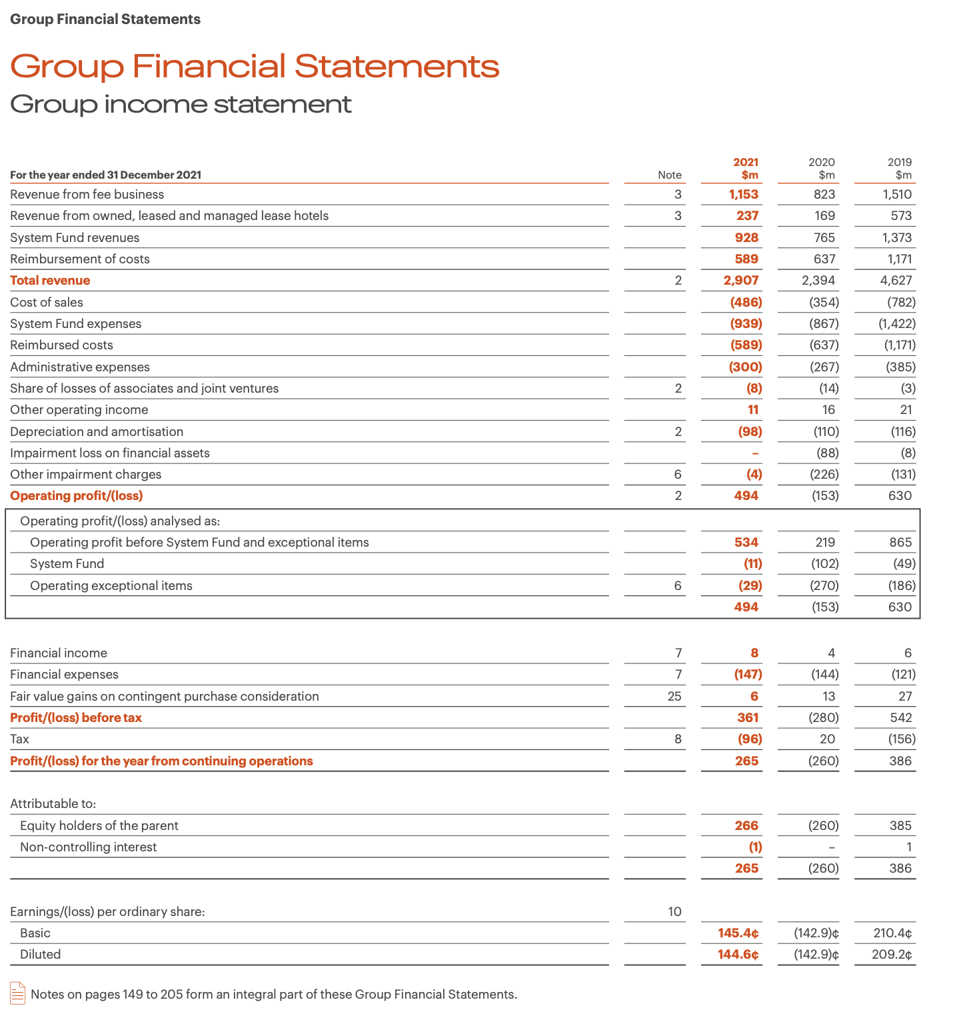
Figure: 2021 Income Statement
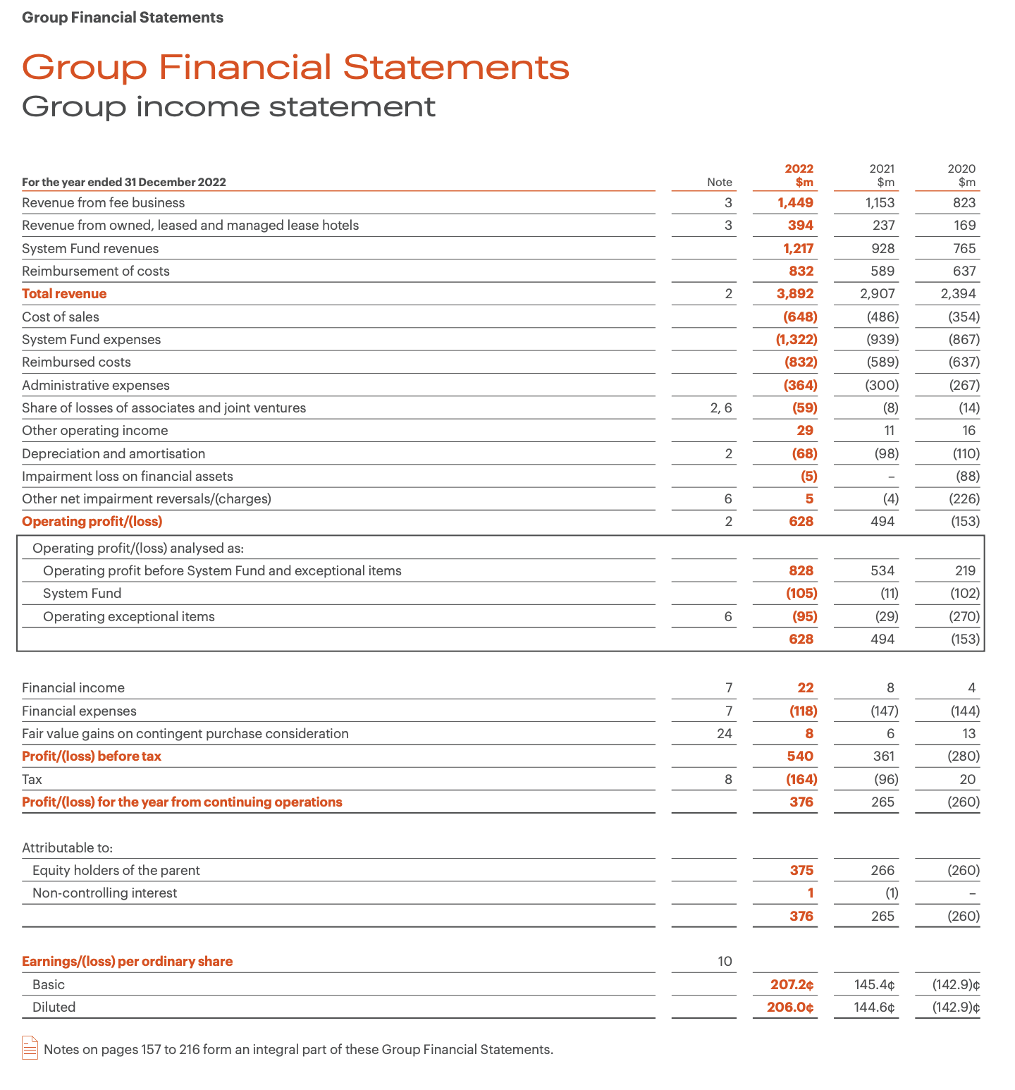
Figure: 2022 Income Statement
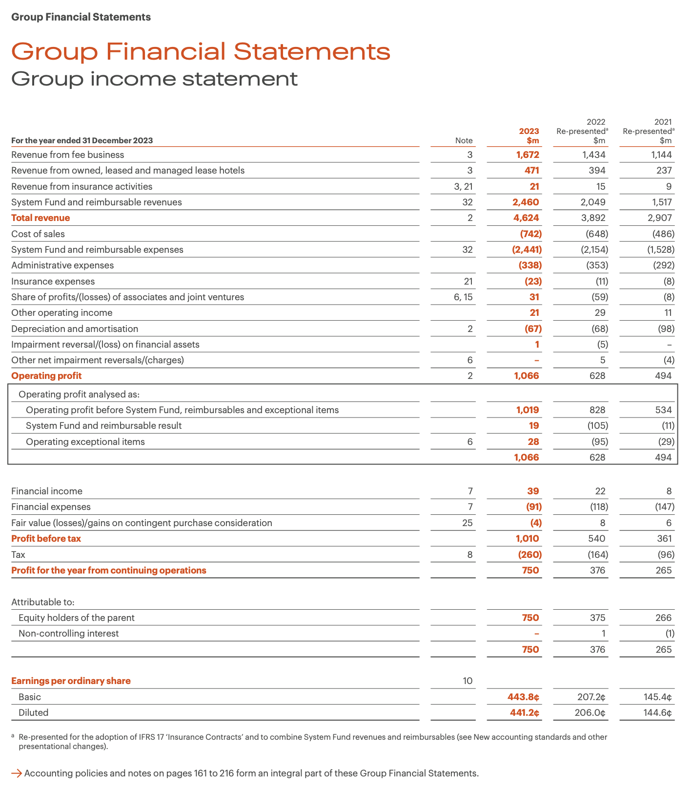
Figure: 2023 Income Statement
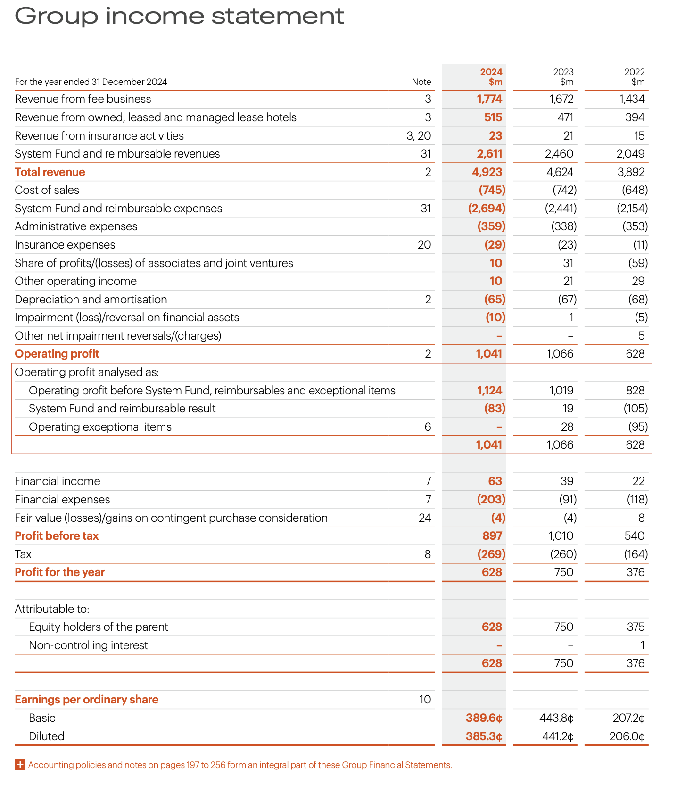
Figure: 2024 Income Statement
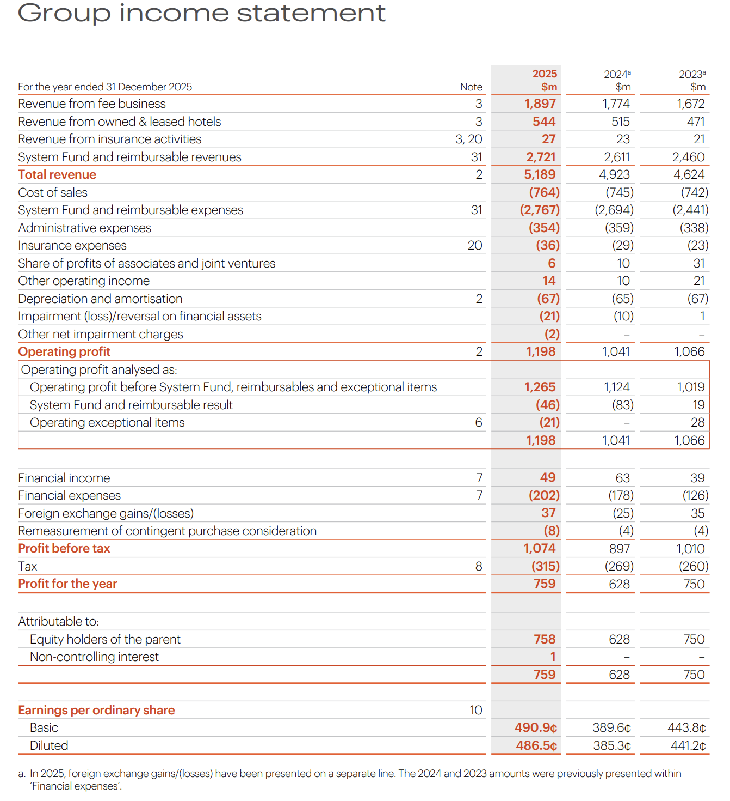
Figure: 2025 Income Statement
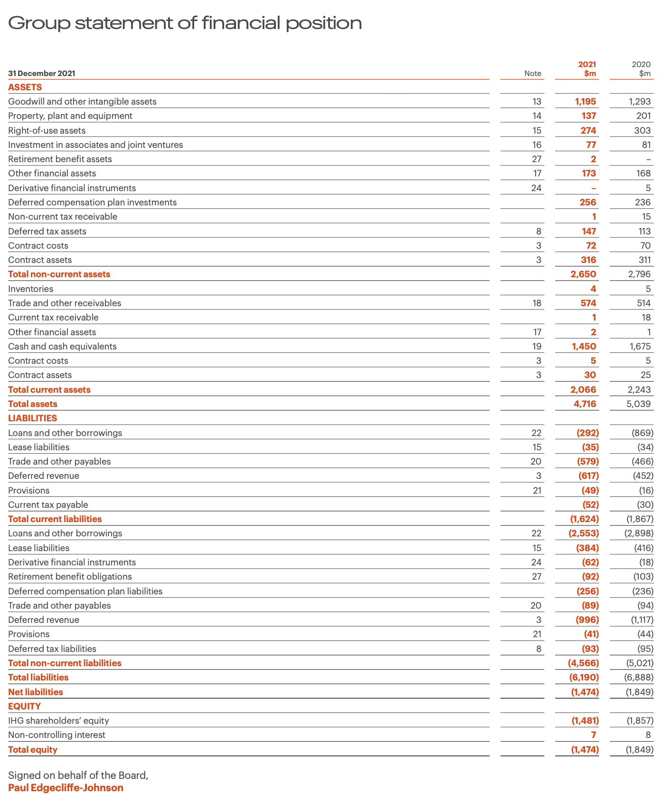
Figure: 2021 Balance Sheet
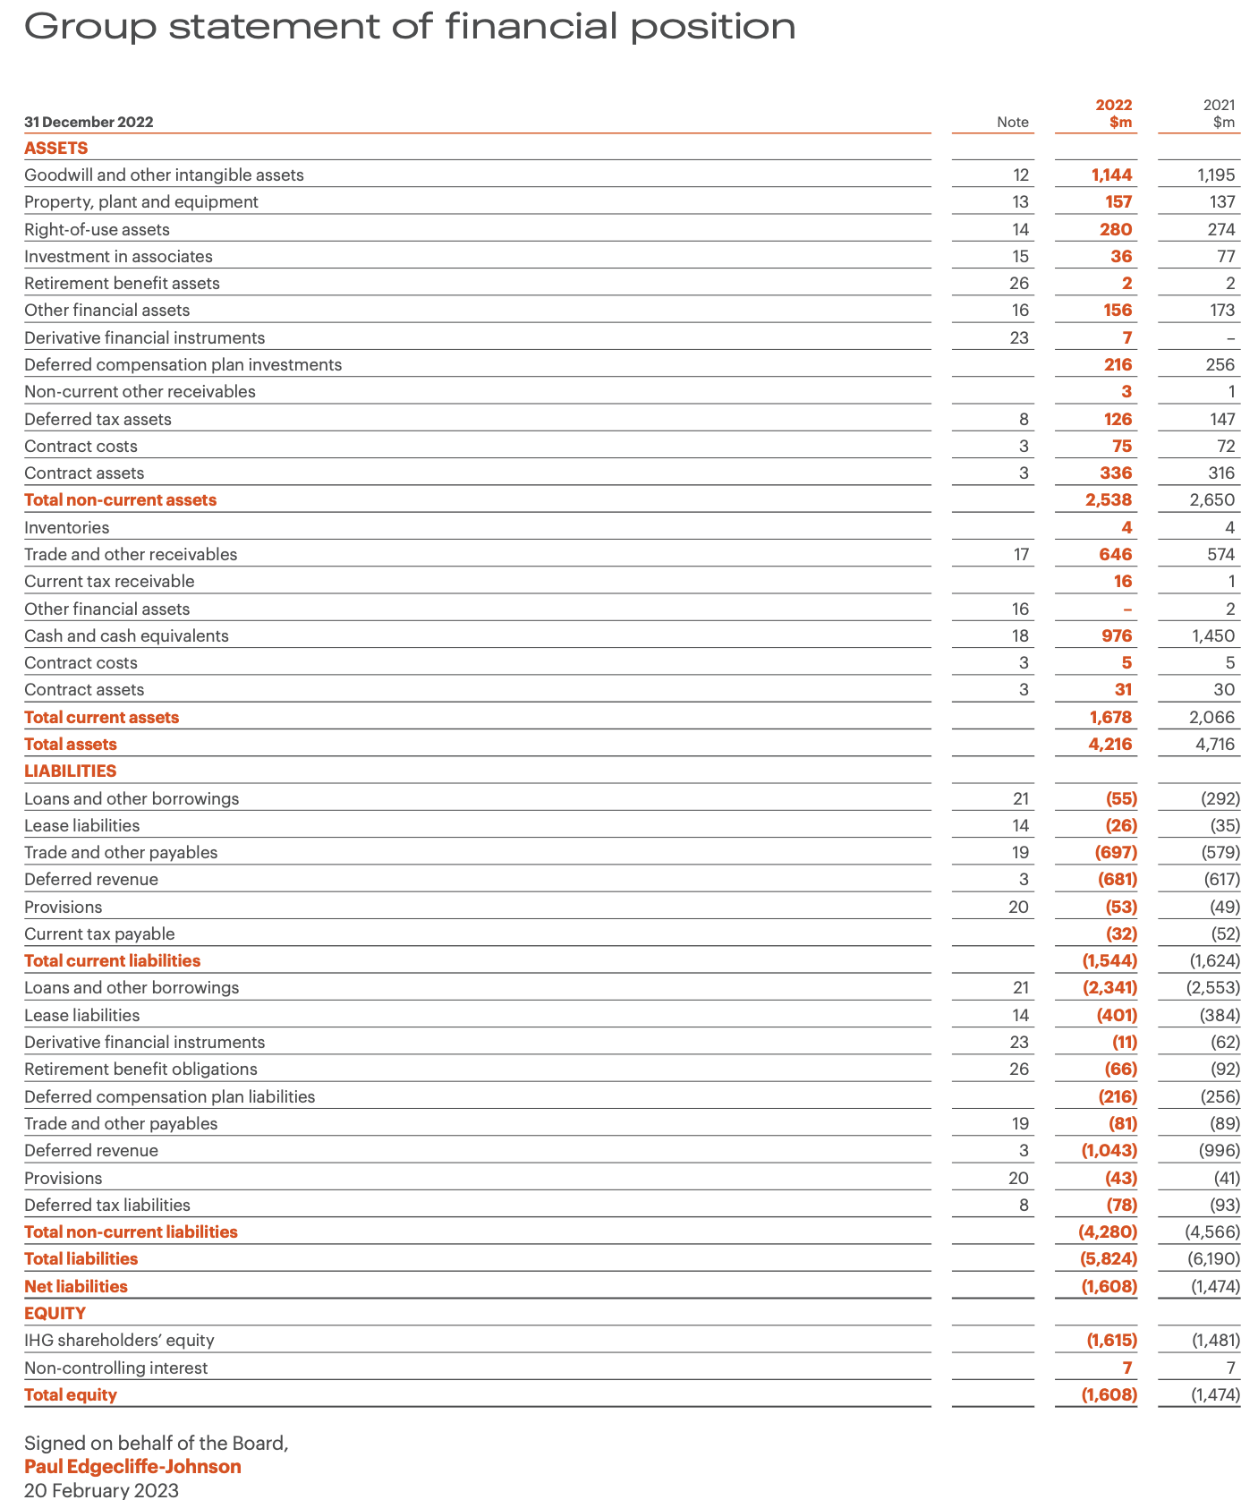
Figure: 2022 Balance Sheet
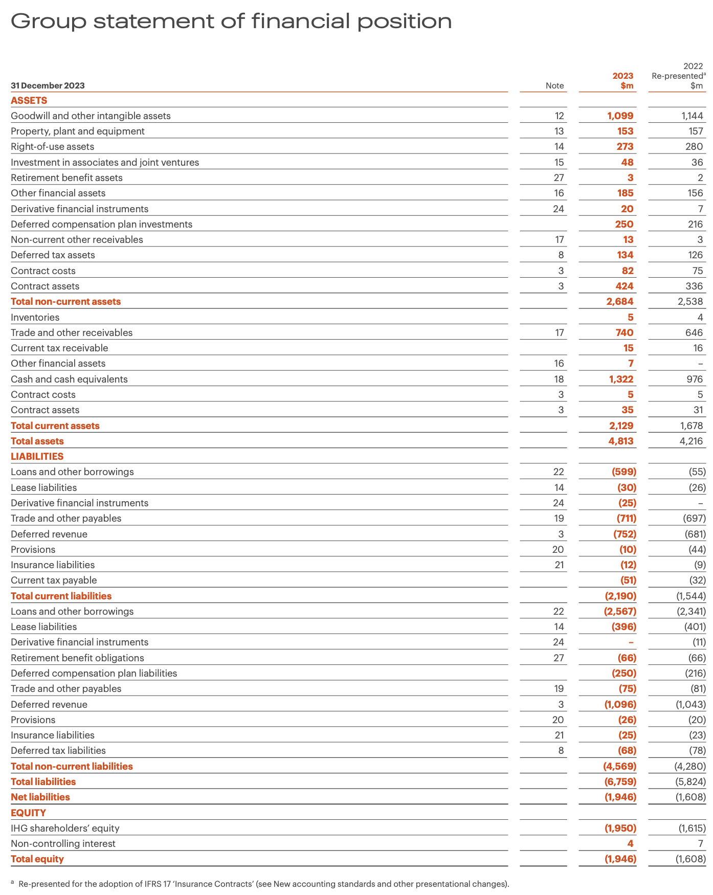
Figure: 2023 Balance Sheet
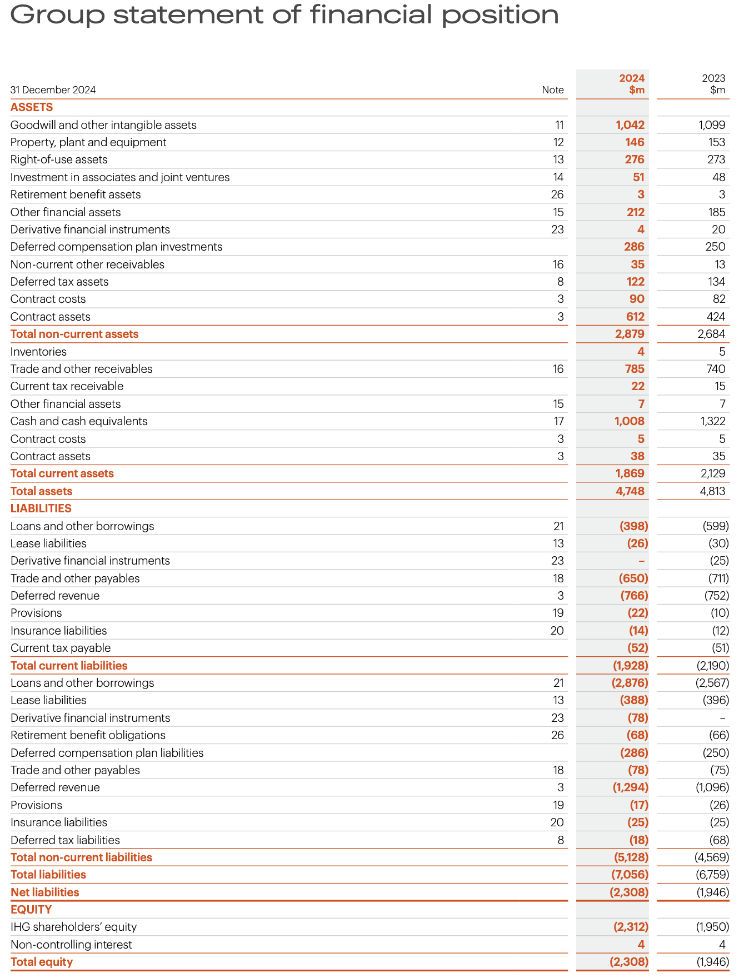
Figure: 2024 Balance Sheet
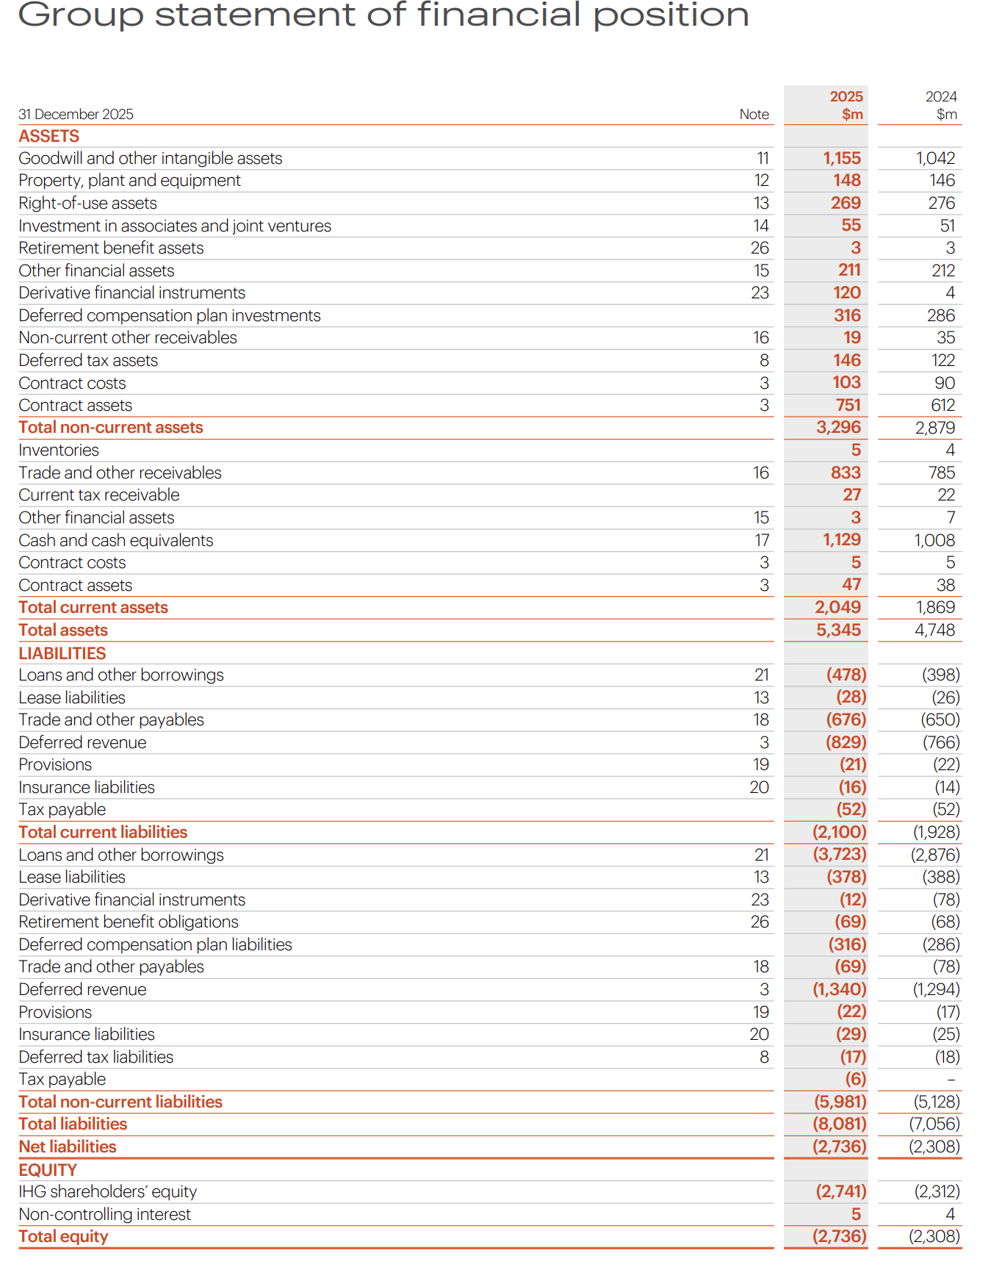
Figure: 2025 Balance Sheet
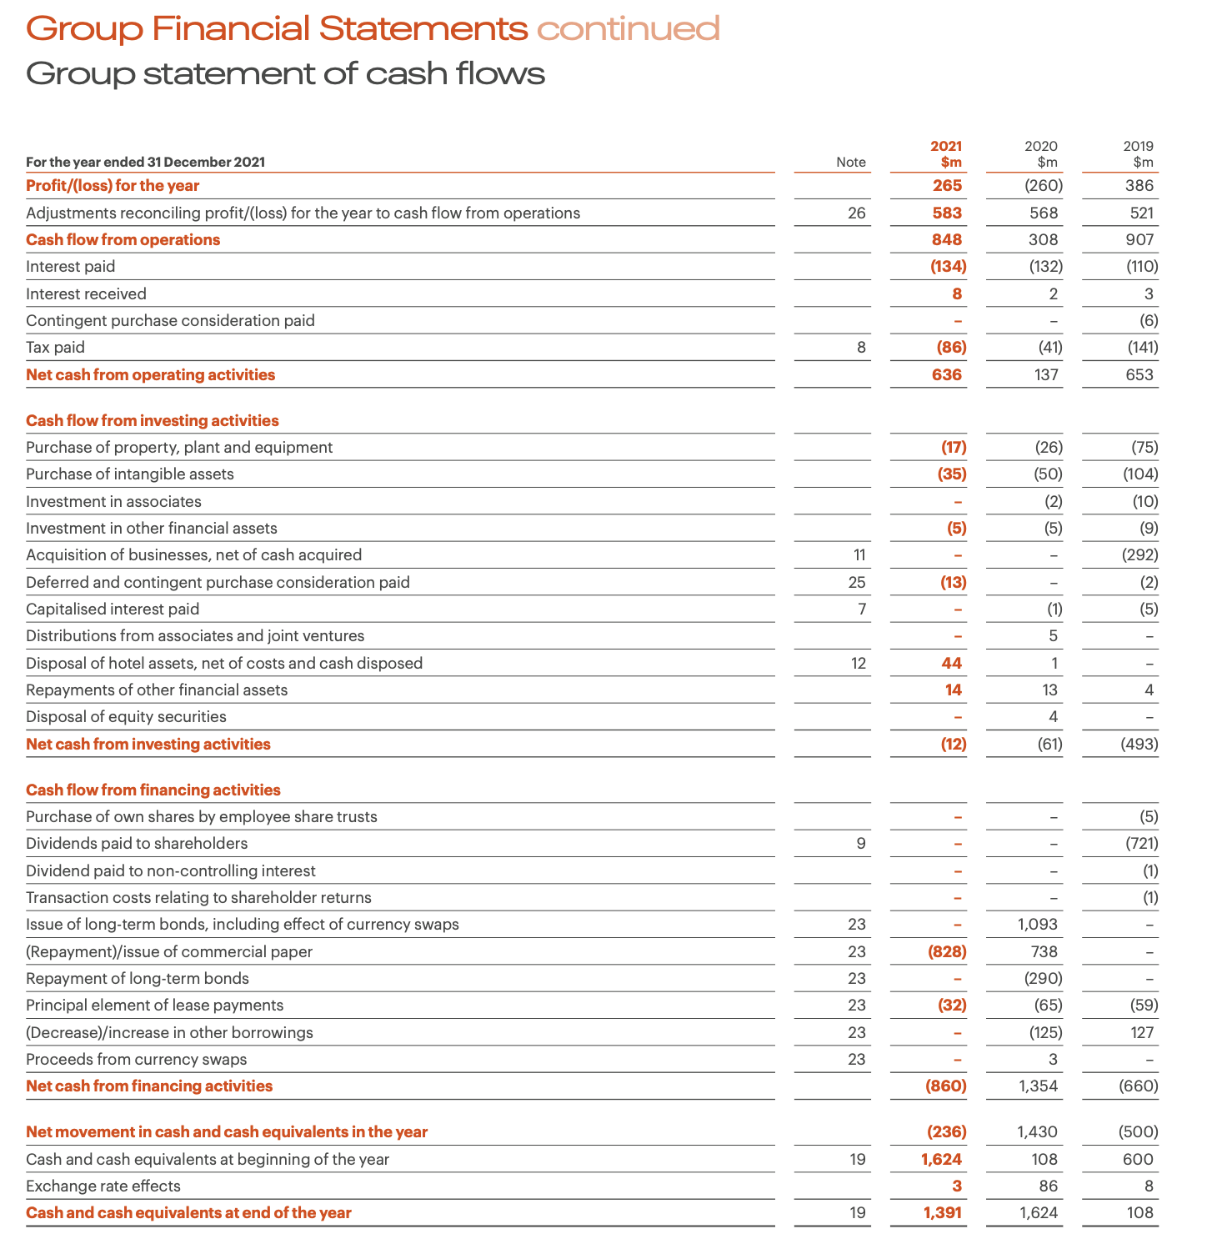
Figure: 2021 Cash Flow
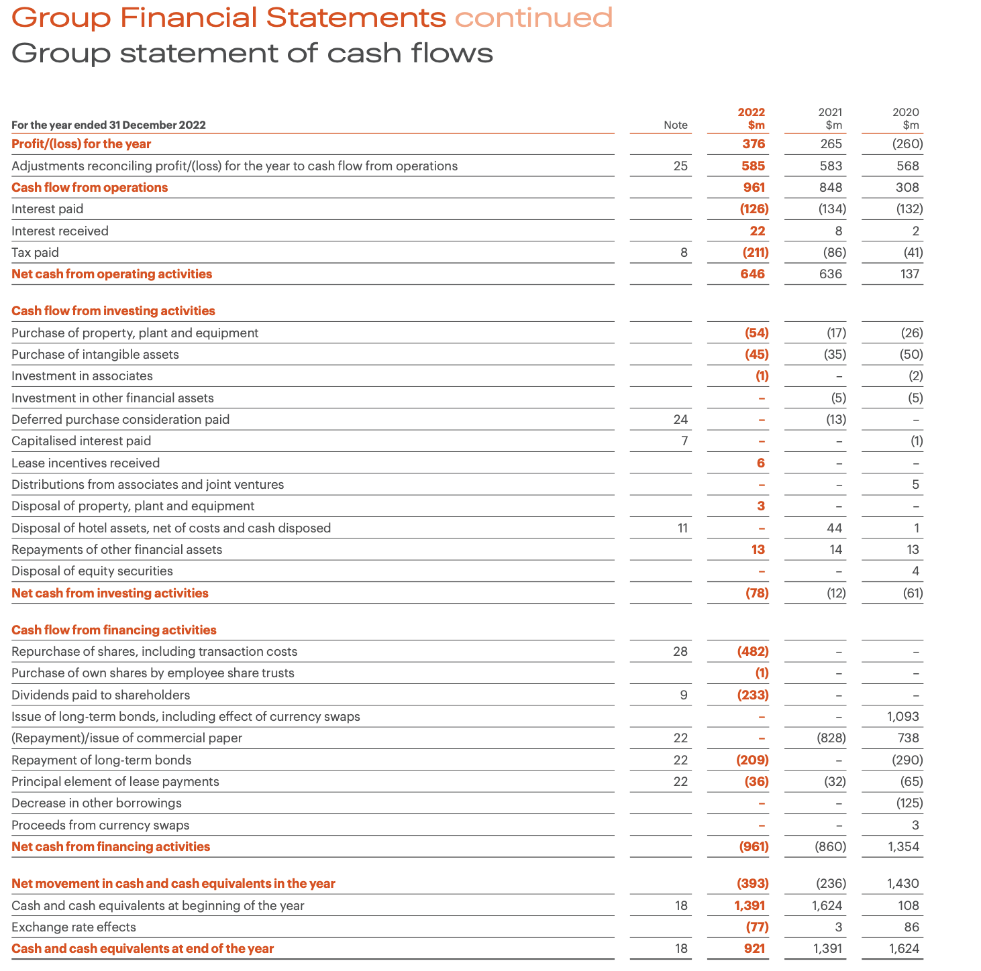
Figure: 2022 Cash Flow
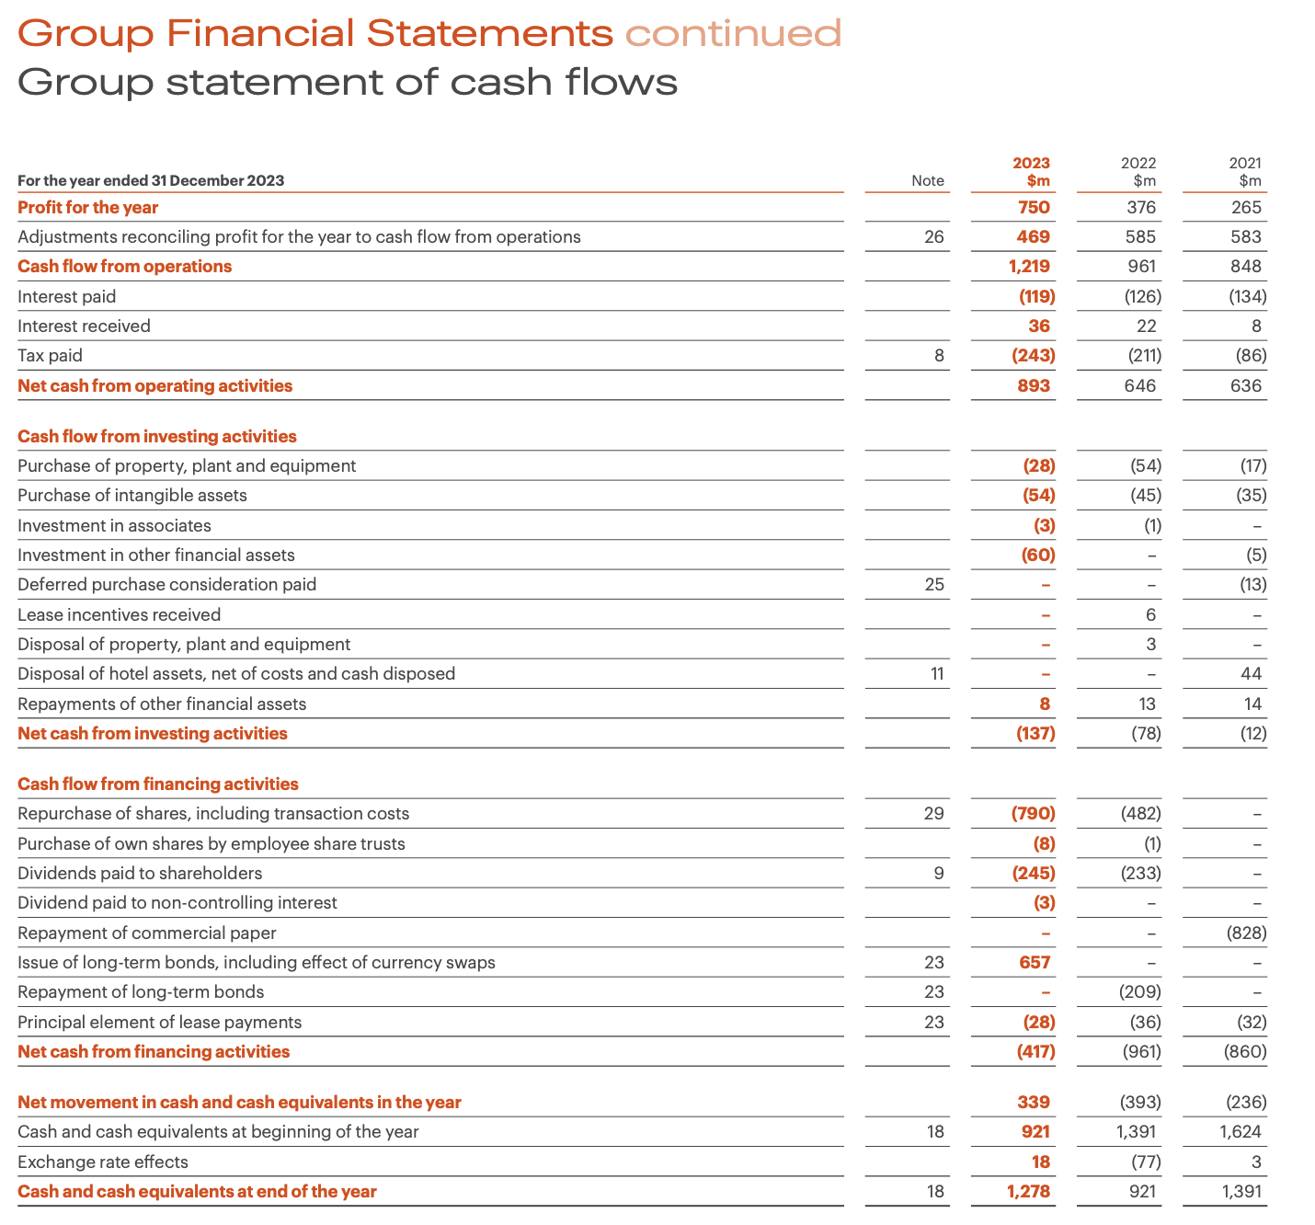
Figure: 2023 Cash Flow
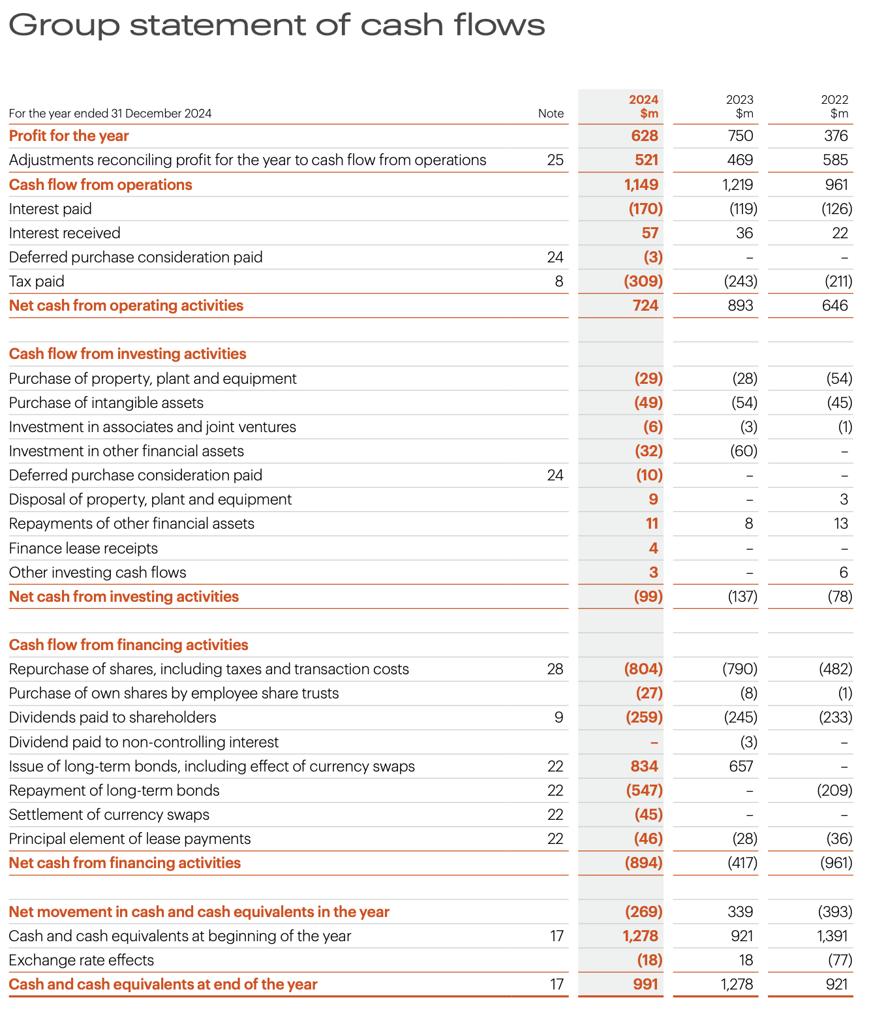
Figure: 2024 Cash Flow
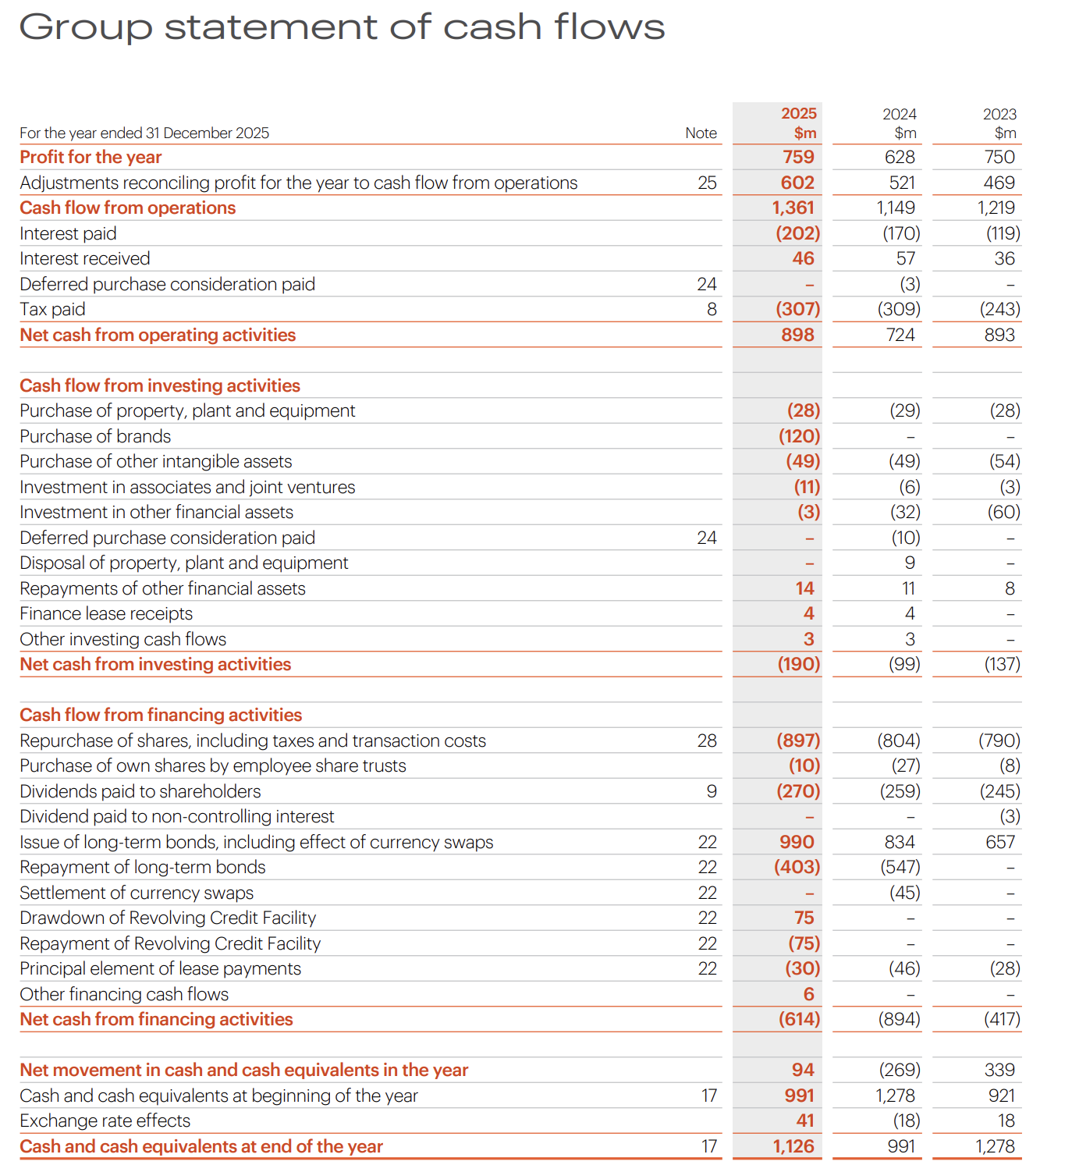
Figure: 2025 Cash Flow

