Andreea Mirica
2028692
ASSESSMENT 2 MARKET RESEARCH & WEBSITE
BMSW4003 Digital Skills & Research Methods
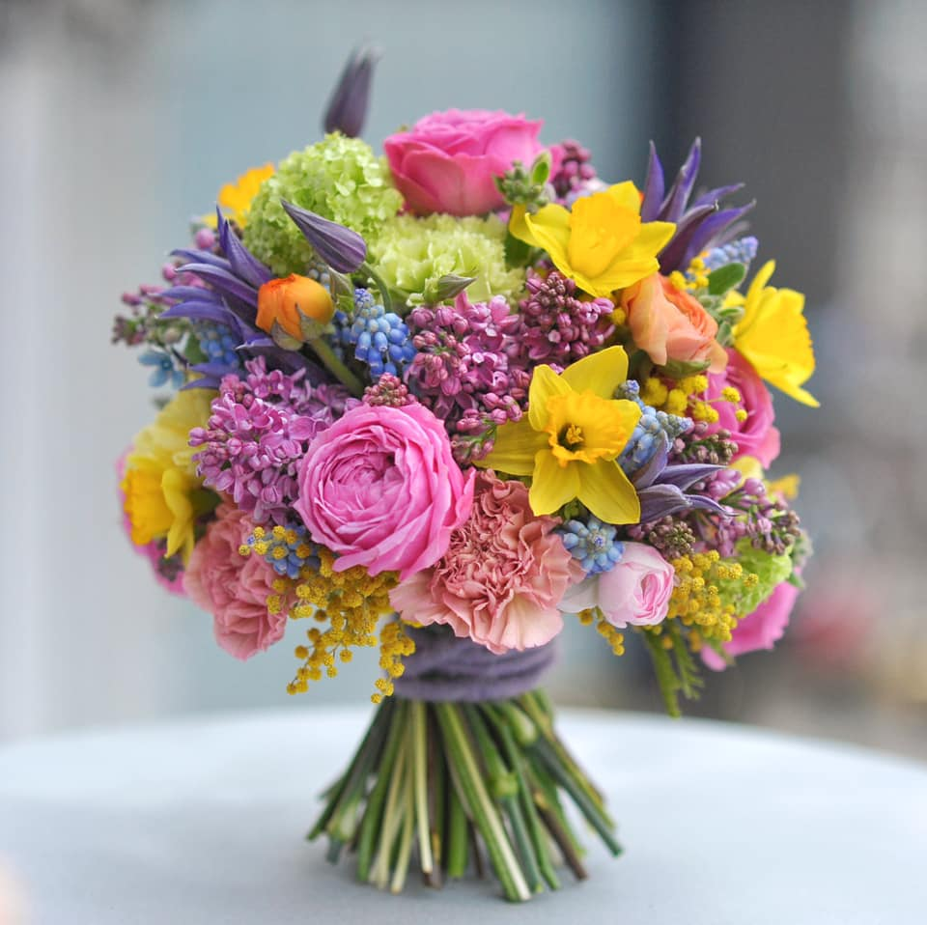 [Document subtitle]

Website login details

Email address: 2028692@student.uwtsd.ac.uk
Password: dob04.04.84

Contents
Website login details 1
1.0 Introduction 2
1.1 Questionnaire design and analysis 3
2.0 Website Design 7
3.0 Conclusion 12
4.0 References 13

1.0 Introduction

The purpose of this report is to share my analysis of a questionnaire that has been created for a business idea. The aim of this survey is to improve the business and gather customer opinions. This is so that the business can continue to grow by continually improving the quality of their products and services. To understand customers' preferences, likes, and dislikes, an online survey is the key to success. We can make better decisions about improving our business based on insights about our relevant market segment. Getting information from appropriate questions is more powerful than word of mouth recommendations.

In order to determine trends and relevant information obtained from the questionnaire, the primary questionnaire data will be explained, and there will be 5 questions analysed in this report. Furthermore, it will be shown how the information gathered from the questionnaires will be used to create a website that will be a real benefit for the company. This will contribute significantly to the success of the business.

1.1 Questionnaire design and analysis

By conducting primary research, all information and data collected will be up to date and relevant, allowing accurate trends to be demonstrated. Furthermore, individuals and organizations have control over their own data. (Smart Survey, 2022)
Primary research is any study that is conducted either by us or by others on our behalf. Primary research can be done in a variety of ways, but the most common methods are interviews and surveys, as well as observations, analyses, and focus groups. In most cases, primary research is used to complement data obtained from secondary sources such as articles in journals, magazines, and books.
Globally, organizations conduct extensive market research to understand their customers better and to discover what motivates them. Market researchers have the duty of sifting through the results, whether they are primary, secondary, quantitative, or qualitative, and drawing meaningful conclusions.
GCL (2020) stated that a business can benefit greatly from primary research. Through it, we can create a dialogue with our target audience, gaining insight into our consumers and then leveraging that insight to improve our marketing collateral Primary research offers unique facts and insights that can allow us to make smart decisions and outperform your competitors.

In order to determine why primary research is essential and how our business can benefit from it, we will analyse the 5 most crucial questions pertaining to BLOSSOM BOUTIQUE separately.

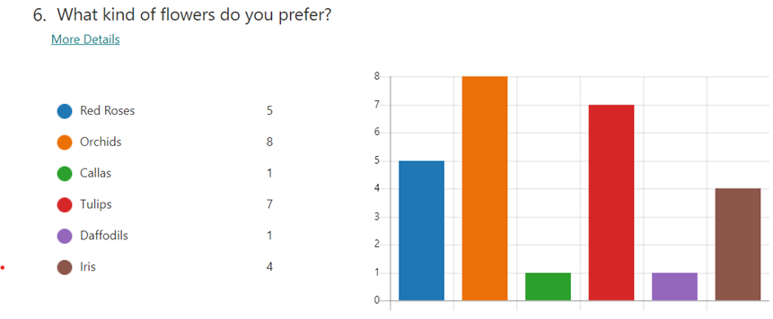

As a result of an analysis of market research, I discovered that orchids have proved more popular than any other flower among my customers, thanks to their colourful foliage, durability, and ability to bring life into our homes. In addition, I discovered that tulips are special among my clients too because they symbolize love and spring. Knowing which flowers to purchase more of will help my business thrive, and my clients will enjoy every exquisite bouquet I create for them.
Tulip time, according to Bennett and Davidson (2015), is in the spring when tulips bloom. In addition to their sweet scent, they can be as short as a couple inches or as tall as two feet and their bloom lasts just a few days. In the 1634-1637 period, the tulip was the world's most expensive flower. It was valued at the equivalent of real money in those days.

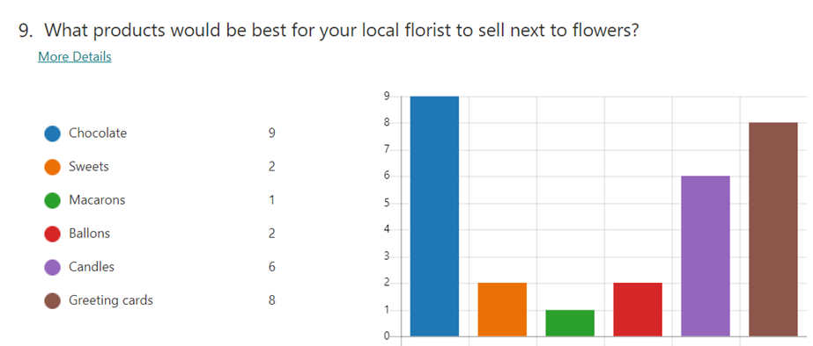
Based on the survey results, we know exactly what types of products go well with floral arrangements; chocolate is popular and is one of the things I sell for free alongside flowers and greeting cards aren't too far behind either, never losing their appeal.
Chocolate, according to Ah Sam Florist (2020), is one of the best romantic gifts that complements flowers. In his opinion, the fragrance of favourite flowers and the taste of cream-filled, decadent chocolates are delights for every woman's nose and eyes. They're a tasty treat for all the senses!

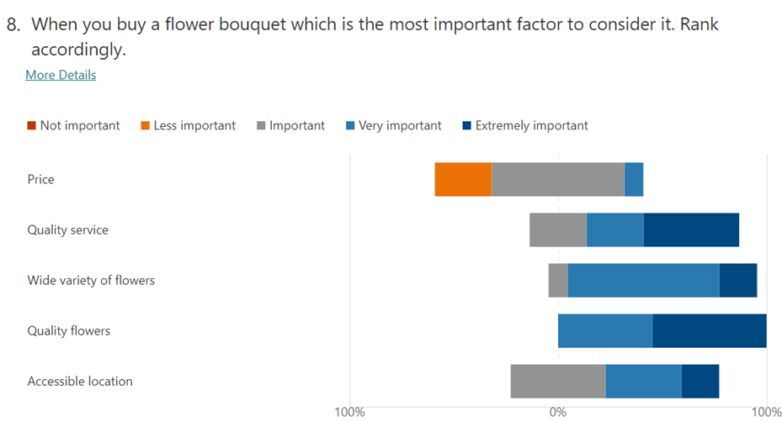
According to the graph above, 54.4% of respondents felt that flower quality is extremely essential when buying flowers. Jones (2001) reveals that customers would return to flower vendors who provided them with the highest quality if a bouquet lasted longer. On the other hand, 27,3% of customers did not see price as significant when buying flowers.

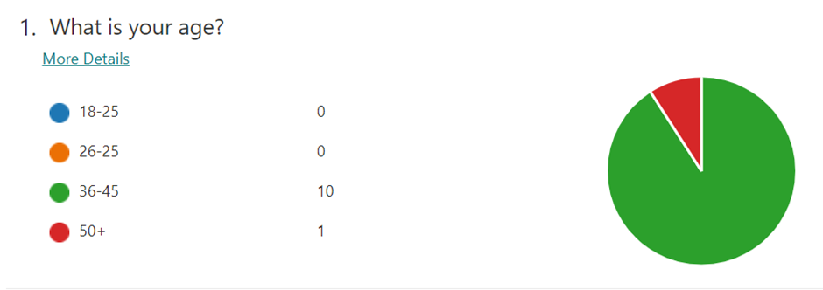

According to the results, 91% of the respondents are aged 36-45, and 9% are aged 50+. From what we know, a successful marketing campaign should employ multiple approaches, including social media, to advertise and market my unique bouquets. This will ensure that as many people as possible across all generations purchase my unique bouquets.

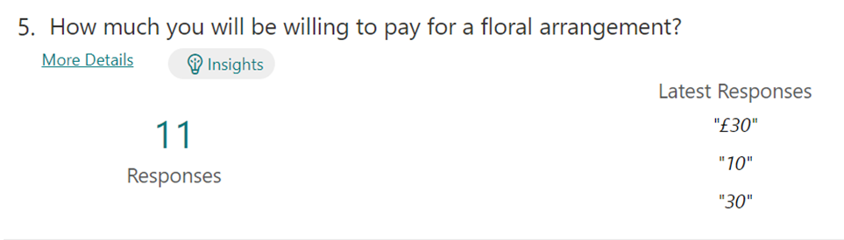

From the findings above, more than 60% of respondents were willing to spend £30. However, just 40% want to spend less than £30. This means people are willing to shell out more for a unique bouquet of flowers. Our passion and unique designs make a difference even with a bouquet of flowers. We strive to offer our customers fresh flowers of the highest quality, as well as keeping the price at a level that allows them to be satisfied.

2.0 Website Design

The questionnaire indicated that my ideal customer is a female, aged 36-45, from Cardiff, interested in purchasing my customized bouquets. Among my lovely flowers, orchids and tulips are the two most popular choices, with my customers willing to spend £30 or more on my exquisite floral arrangements. As to the preferred thing to sell with my flowers, everyone has chosen chocolate as their most desired sweet. The quality of flowers is the most significant factor that customers consider when buying a bouquet of flowers. Understanding what customers want and who the target market is helped my business a lot in developing the website and how to improve the business to be successful.

The website design is built around keywords such as: flowers, floral arrangements, unique, fragrance, beautiful, bouquets, emotions, boutique, Cardiff, florists, happy customer, colours, special occasion, and Blossom Boutique.
Due to this information, certain colours were chosen such as green, purple, pink and yellow, and certain images such as different exquisite bouquet of flowers.
Contour (2019) asserts that 90% of product judgements are based solely on colour. Additionally, he said that colour influences our first impressions. We notice colour the first time and remember it the last, so it is critical to make the right choice.


There are a lot of bright colours on the Blossom Boutique's homepage. These include green, which represents balance, refreshment, love, and peace, white, which symbolises purity and sophistication, and purple, which signifies luxury, quality, ambition, and vision. Pink is another colour that is commonly used on the website, and it signifies kindness, calm, love, and femininity, while yellow suggests optimism, confidence, and creativity, reflected in all the special bouquets that we make for our customers. (Wright ,2010)

Bright and bold colours complement the tone of the business, while the font blends well with the tone. There is a wide variety of flowers in this first page, perfect for every occasion, and waiting to be chosen by the customer to make his or her special bouquets or floral arrangements.

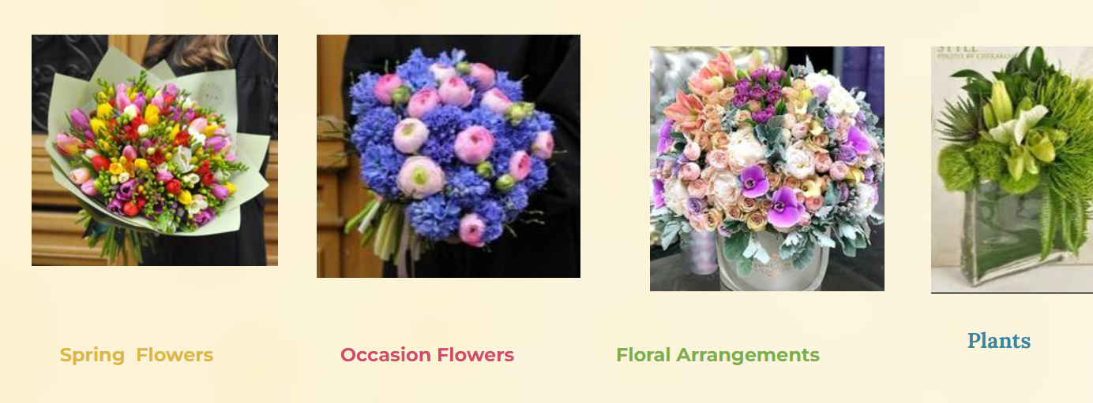

Blossom Boutique offers a promotion every month for all its customers. Because March is a special month, the store is dedicating this month to all the mothers out there, offering discounts on all the beautiful arrangements and bouquets purchased on this special day.

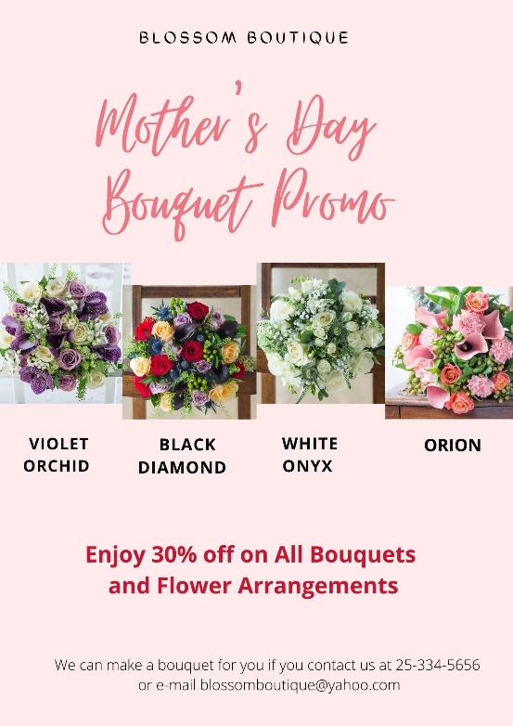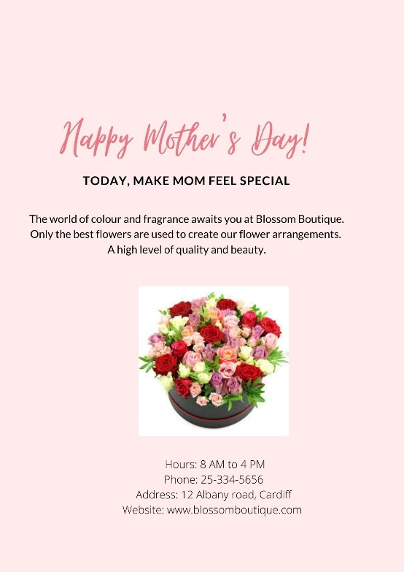

Flowers are medicine for the soul, and they can be found on the product and service page in the form of remarkable bouquets that are colourful, beautiful, and fragrant, images that make you want to buy them all because of their beauty and ability to make people happy.

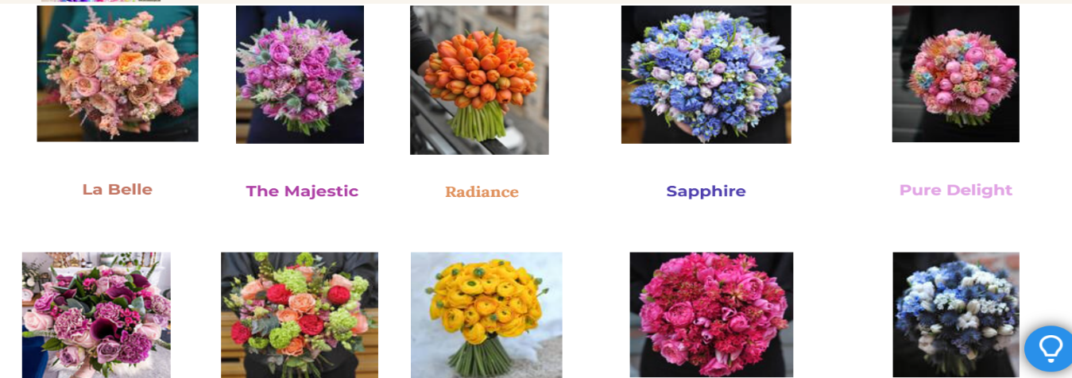

On the same page, a price range is specified so that everyone may afford and enjoy those one-of-a-kind flowers.
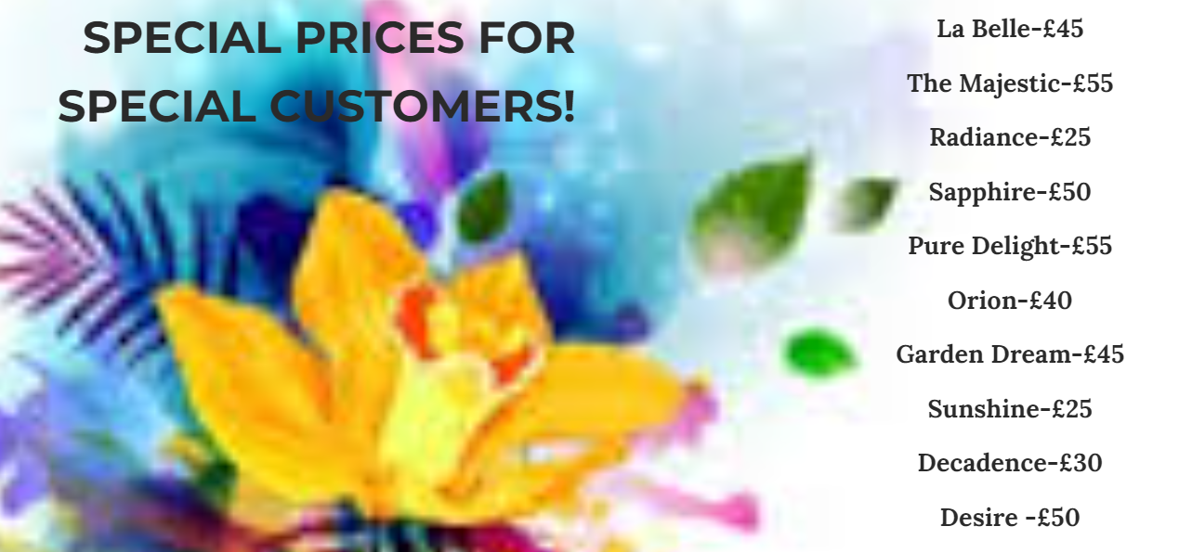

Throughout the year, Blossom Boutique offers discounts on fresh flowers, and guarantees flower freshness for seven days.
Deliveries can be made same-day or next-day upon request in Cardiff.


The last page details Blossom Boutique's location as well as the hours during which consumers can acquire a magnificent bouquet tailored to their specific needs. Furthermore, a dedicated section has been created for anyone who wishes to make a comment or ask any questions.

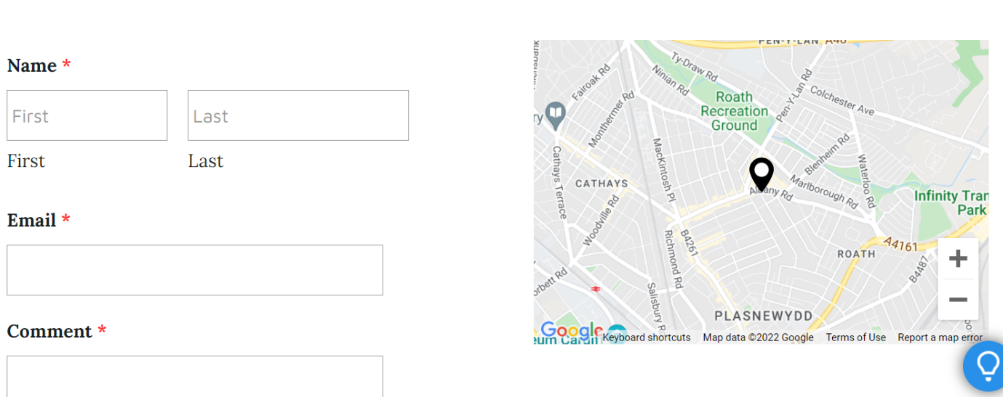

3.0 Conclusion

The necessity for a questionnaire is critical for any business that wants to expand and succeed, because knowing all of the facts based on that questionnaire allows any firm to become more powerful and blossom day by day. Furthermore, a website assists a business by providing correct information about all of the products and services they provide, allowing the products to be sold and all of the clients to be satisfied and return to that website.

4.0 References

Ah Sam Florist (2020) BEST GIFT IDEAS TO GO ALONG WITH FLOWERS Available from:
https://www.ahsam.com/blog/best-gift-ideas-to-go-along-with-flowers/
(Accessed 22March 2022)

Bennett, K., Davidson, J. Beautiful (2015) Flowers for Kids. (n.p.): Mendon Cottage Books

Contour (2019) Colour Psychology - Coloured LST Radiator Guards Available from:
https://www.contourheating.co.uk/blog/colour-psychology-coloured-lst-radiator-guards
(Accessed 23 March)

GCL (2020) 5 Reasons Why Primary Market Research is Essential Available from:
https://blog.gclb2b.com/blog/info/5-reasons-why-primary-market-research-is-essential (Accessed 21March 2022)

Jones, R. (2001) Caring for Cut Flowers Landlinks Press

Smart Survey (2022) Primary Research Methods Explained Available from:
https://www.smartsurvey.co.uk/articles/primary-research-methods#:~:text=Primary%20research%20guarantees%20that%20the,control%20ownership%20of%20the%20data.
(Accessed 20 March 2022)

Wrigh, A. (2010) Colour Psychology (the “Colour Affects” system) Accessible from:
http://micco.se/wp-content/uploads/2010/05/Micco-Groenholm-on-Color-Affects-System.pdf (Accessed 23March 2022)

