

Marketing Environment Analysis

Programme: Master of Business Administration
Student Name: Merajur Rahaman Wahid
Student ID: 2505508
Module Name: Marketing Management
Module Code: LCMB7024
Lecturer Name: Dr Laila Maazouz
Word Count: 2541

Date of Submission: 21 November 2025

Table of Contents
Introduction 3
Task 1: Critical Analysis of the Macro Marketing Environment 4
1.1 Introduction to the Macro Environment 4
1.2 Technological Change 5
1.2.1 Opportunities for Pioneers 5
1.2.2 Threats for Pioneers 6
1.2.3 Opportunities for Followers 6
1.2.4 Threats for Followers 7
1.3 Economic Environment 7
1.3.1 Opportunities for Pioneers 8
1.3.2 Threats for Pioneers 9
1.3.3 Opportunities for Followers 9
1.3.4 Threats for Followers 9
Task 2: Strategic Responses by Pioneers and Followers 11
2.1 Introduction 11
2.2 Strategies for Pioneering Organizations 12
2.2.1 Marketing Strategies 12
2.3 Strategies for Follower Organizations 13
2.4 Real-life examples 14
Conclusion 15
References 16

Introduction
In the constantly changing world of international business, companies have to negotiate the external environment that affects their strategies in business operations. These are the external macro factors, which are in most cases out of control of individual companies and pose opportunities as well as threats. This report shall critically examine two macro marketing aspects namely Technological Change and the Economic Environment. Technological changes can change the industries and the economy conditions changes can make the businesses successful or unsuccessful. The impact of these on pioneering (first-mover) and follower (imitator) organisations will be understood and aid in the identification of the strategies that can modify competitive advantage (Yaneva, 2020). In Task 1 the report will also explore the effect of Technological Change and the Economic Environment on both types of organisations examining the opportunities and threats faced by them. Subsequently, the Task 2 will assess the way pioneering and follower organisations respond to these external forces strategically with a real-world example of industry leaders. The approaches of Apple, Tesla, Samsung, and Toyota will be analysed in order to determine how their reaction to these macro changes could help the companies to retain their competitive niche.

Task 1: Critical Analysis of the Macro Marketing Environment

1.1 Introduction to the Macro Environment
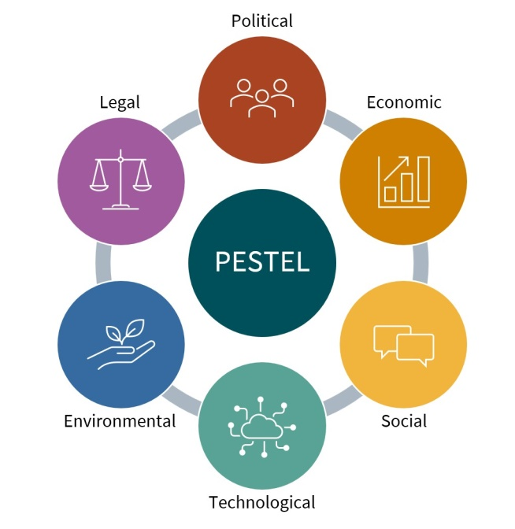
Figure 1: PESTEL framework
Macro marketing environment is a group of external forces which define the business conditions and cannot be affected by single companies. Such forces are Political, Economic, Social, Technological, Environmental, and Legal (PESTEL) factors (Pan et al., 2019). These aspects are critical in businesses that are aimed at making well-informed decisions and being strategic in responding to changes. These elements may be opportunities and threats to the pioneer and follower organisations.
Two of the most influential external factors in organisations in different industries are the Technological Change and Economic Environment. The technological innovations offer new markets as well as the threat of oblevation to organisations that do not innovate. Economic environment influences aspects of consumer buying habits and operational expenses of any business as well as market demand. The following section will examine how these two forces influence the strategies in organisations with reference to the consequences to both pioneers and followers.

1.2 Technological Change
The technological breakthroughs have been the main source of the competitive advantage in the majority of industries. The high rate of innovations provides business with a chance to launch innovative products, services, and processes. Meanwhile, it is also dangerous to businesses that cannot keep Pace with emerging technological trends (Ali et al., 2023).

1.2.1 Opportunities for Pioneers
- Innovation and Market Leadership: Embracing innovation is crucial for achieving and maintaining market leadership. Innovative business strategies are at the heart of this process, enabling companies to stay ahead of competitors and meet evolving customer needs (Le and Le, 2022). Apple and Tesla companies are the best examples. Investment in research and development (R&D) has helped Apples to continually launch innovative products such as iPhone that changed the smart phone business landscape. Tesla, however, has taken advantage of battery technology and electric vehicle (EV) manufacturing to emerge as the top player in the electric cars market, with the increasing need to find an alternative to the traditional combustion engine vehicles that are more environmentally friendly.
- Market Creation: Technology is contributing to market creation and expansion in emerging markets. As an example, the emergence of artificial intelligence (AI) has provided new areas of business in finance, healthcare, and customer support (Ali et al., 2023). A change in business models and value propositions is occurring due to the impacts of AI as companies change the way businesses interact with their customers.

1.2.2 Threats for Pioneers

Figure 2: Disruptive Technologies
- Disruptive Technologies: Disruptive technology refers to innovations that significantly change how consumers, industries, or businesses operate, often supplanting older processes. In as much as pioneers are likely to be on the forefront in terms of leading the market in innovation, they also run the risk of being phased out by new technologies. One such incident is that of Nokia that was once a force to reckon with in the mobile phone industry but failed to adjust to the smartphone revolution that was started by Apples iPhone. The unwillingness of the company to adapt to the touchscreen technology, as well as its old-fashioned operating system, eventually caused its demise (Anderson and Tushman, 2018).

1.2.3 Opportunities for Followers
- Adoption and Imitation: Adoption benefits the followers in that they have a chance to observe and adapt such innovations to the examples of other people and eliminate the financial and developmental risks. Other firms like Samsung have taken advantage of the innovations that have been put forward by innovators like Apple by promptly copying and bettering the designs. The Galaxy smartphones were in close competition with the iPhones but had an advantage in that they had larger screens, customizable software (Android OS) and lower prices, which made Samsung, earn a huge market share (Bo-Seong et al., 2021).
- Operational Efficiency: The followers are also able to embrace the best technologies that are used to optimise their operations. Companies such as Ford and General Motors in the automotive industry have taken the lesson of automation in their production lines to reduce expenditure and enhance efficiency in their production lines, among others, due to the technological breakthrough of their competitors.

1.2.4 Threats for Followers
- Absence of Innovation: The followers who only copy the pioneers without making many innovations might be at risk of being rendered useless. Although the imitators such as Samsung have been able to capture a significant market share, those who fail to differentiate and innovate may face difficulties in the market. The main difficulty of the followers is to make sure that they are adding value rather than just copy it.

1.3 Economic Environment
Economic environment is a critical factor that influences the viability or failure of businesses because it has a direct influence on consumer buying patterns, demand and operational expenses in the market. Both pioneering and follower organisations are highly affected by economic factors including the inflation rates, exchange rates, and the economic growth.

1.3.1 Opportunities for Pioneers
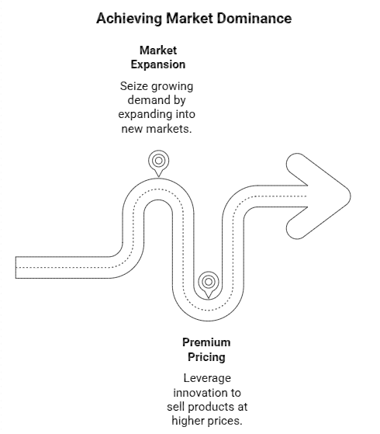
Figure 3: Opportunities for Pioneers
- Market Expansion: Economic growth is an increase in the production of goods and services in an economy. The pioneering organisations have an opportunity to exploit the increasing demand in the market during the phase of economic growth. There is an example of Amazon that expanded greatly by taking advantage of the economic growth and increased consumer confidence globally (Krizanova et al., 2016). Amazon has revolutionised the retail industry in the world by investing strategically in the logistical infra-structure and increasing its product range to become a formidable force in the market.
- Premium Pricing: Innovative or high quality products can be sold at premium rates especially in robust economies by the pioneers. Tesla has a competitive edge in being a premium car brand in the electric vehicle market, because of the rising popularity of eco-friendly cars. The value proposition of the company is what gives it an opportunity to sell its cars at a premium price to a market of wealthy consumers who are ready to pay luxury and sustainability.

1.3.2 Threats for Pioneers
- Economic Downturns: Economic downturns or economic recessions may cause low consumer expenditure and this is especially injurious to high-priced products. The 2008 world financial crisis has led to a major drop in the demand of several luxury brands, such as Rolex and Louis Vuitton (Worrell, 2018). On the same note, Tesla has struggled to sustain its sales growth even when the economy is uncertain, although it has innovative products.
- Currency Fluctuations: In organisations that have international businesses, the currency exchange rates may either wipe out profits or raise the cost of doing business. Indicatively, Apple being a company that has global supply chain would have to contend with the changes in currency exchange rates in sourcing its materials or selling its products in other countries.

1.3.3 Opportunities for Followers
- Cost Leadership: The followers can use cost cutting measures to stay competitive at the times of economic recession. Walmart, in particular, has been able to sustain its competitiveness by providing cheap substitutes of the expensive products and was able to serve the increasing number of price-sensitive customers when economic times are bad. Walmart can provide its cost-effective products to a large number of consumers due to its economies of scale, which is why it makes a good choice during a financial crisis (Roy, 2019).
- Targeting Emerging Segments: The followers will be able to capitalise on the market changes and attack market segments that are not as sensitive to economic fluctuations. Indicatively, Toyota has managed to establish itself in the low-end automobiles industry, attracting cost-sensitive buyers at times when the economic sun is shining.

1.3.4 Threats for Followers
- Price Wars: With competitors placing price competitions with first-movers, they will engage in risky price warfare that will ultimately destroy profit margins. This is more so in the consumer electronics where the features and price are the common area of rivalry between the companies. In these situations, followers are not able to make considerable cost efficiencies and distinguish their products; hence, they might not remain profitable.

Task 2: Strategic Responses by Pioneers and Followers

2.1 Introduction
After discussing the effects of technological and economical macro factors on pioneering and follower organisations, one would need to know how these organisations react strategically to such changes. Innovation centred, differentiation centred, and market expansion is some of the strategies embraced by the pioneers who normally spearhead the innovation in the market (Yaneva, 2020). Conversely, follower organisations live by imitation, cost leadership and strategic alliance strategies. The following section will discuss the strategic reactions of such companies as Apple, Tesla, Samsung, and Toyota with a focus on how these companies manage to cope with the changes in technology and economy.

2.2 Strategies for Pioneering Organizations
Innovation and Differentiation: Pioneering organisations make use of changes in technology to create a curve of their own. The case of Apple, it has been engaging in unrelenting research and development in a bid to innovate and launch products that transform markets. The capability of the company to incorporate new technologies into its environment, including facial recognition and augmented reality, is what will make the company a market leader (Dreiling and Bican, 2022).

2.2.1 Marketing Strategies
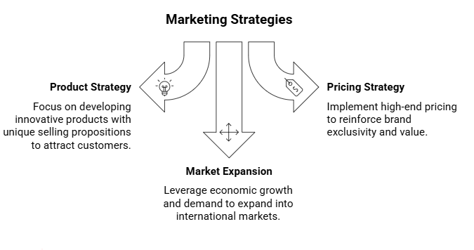
Figure 4: Marketing Strategies
- Product Strategy: A product strategy is a sophisticated plan describing what a business hopes to achieve with its product and how it plans to do so. Innovative products that are benchmarks in the industry are developed by the pioneers, such as Tesla. The EVs of Tesla are one such case of the advanced design and technology that contribute greatly to environmental advantages. The business has developed a unique selling proposal (USP) that is its sustainability, coupled with performance, which makes its cars extremely demanded.
- Pricing Strategy: Innovators have the tendency of providing high prices to indicate uniqueness and value of their products. Pricing strategy of Apples, that makes its products luxurious and exclusive, serves to retain a strong brand identity. The high-end pricing of Tesla cars is attributed to the fact that the cars are of premium quality, as they are loaded with the latest technology and are also more comfortable to drive (Pourmirza et al., 2024).
- Market Expansion: Innovators, such as Tesla, take advantage of the economic growth and rising demand of products based on environmentally friendly activities. Tesla has gone international and it is leveraging this increased demand of electric cars in Europe and China. Tesla can be more competitive by concentrating on international markets, which guarantees its leadership status in the industry.

Strategies for Follower Organizations
- Imitative Strategies: An imitative strategy trusts on the designs of other companies in creating its designs. Follower such as Samsung concentrates on copying and enhancing the innovations that were brought out by the pioneer. Samsung has gone ahead to lead by example by release of smartphones which compete with the iPhone in terms of performance and designs (Castiglioni et al., 2019). Samsung has been in a position to take away the market share that belongs to Apple by providing more features like bigger screens, expansion storage and increased battery life.
- Cost Leadership: Cost leadership is the first of the business level strategies. The message that it shows is that our product is less expensive than others (Fiet, 2025). Toyota is a classic example of a follower organisation that competes on the cost leadership. When the economy is performing poorly, Toyota concentrates on providing high quality but low cost cars in line with the needs of the cost-effective consumers. Its effective manufacturing process and excellent supply chain management has helped Toyotas to provide its vehicles at affordable prices and still make profits.
- Strategic Alliances: The other strategy that the followers develop is forming alliances with the pioneers to have access to technology without incurring the full cost of research and development. The early years of the computing industry saw the alliance of Microsoft and Intel, and through this alliance, the two companies succeeded in taking over the market in terms of software and hardware (Samorodov et al., 2023). Such alliances enable the followers to enjoy already developed technologies and concentrate on other business strategy elements, like marketing or distribution.

2.4 Real-life examples
Pioneering Strategy (Apple): The fact that Apple has managed to be ahead of the market through its innovative products such as the iPhone has enabled it to become a leader in the consumer electronics market. The competition can never stop because Apple constantly launches new technologies that transform the industry standards, forcing the competition to do the same. It has been very attractive to consumers all over the world because of its strong marketing concept which focuses on product exclusiveness, quality and a complete ecosystem (Jiang, 2024).
Follower Strategy (Samsung): Samsung has been able to leverage of the innovations made by Apples by swiftly moving into the smartphone market with better features and competitive pricing. The capability of Samsung to imitate the success of Apple and in concentrating on its products has made it a force in the smartphone market. The use of hardware, software, and user experience to enhance the offerings has earned Samsung’s loyal customers (Haizar et al., 2020).

Conclusion
To sum up, the macro marketing environment is important to the organisations that want to achieve long term success. Both pioneering and follower organisations have opportunities and threats that are associated with technological change and the economic environment. One of the advantages of pioneers is that they are able to innovate and provide the trend that other people follow, but there is also a danger that they could be disrupted by the new technologies. The followers are able to use the innovations of the pioneers and spend less in their R&D activities, although they need to differentiate their products and concentrate on efficiency in order to compete. Innovation, differentiation, cost leadership, and strategic alliance can be emphasised in keeping the company in the game based on strategic responses of such companies as Apple, Tesla, Samsung, and Toyota (Castiglioni et al., 2019). When organisations are able to respond well to macro environmental changes, it will find it easier to position them to achieve long-term success.

References
Ali, O., Osmanaj, V., Kwiatek, P., Chimhundu, R., Alryalat, M. and Dwivedi, Y.K., 2023. The impact of technological innovation on marketing: individuals, organizations and environment: a systematic review. Economic research-Ekonomska istraživanja, 36(3).
Anderson, P. and Tushman, M.L., 2018. Technological discontinuities and dominant designs: A cyclical model of technological change. In Organizational innovation (pp. 373-402). Routledge.
Bo-Seong, Y., Sang-Gun, L. and Aoshima, Y., 2019. An analysis of the trilemma phenomenon for Apple iPhone and Samsung Galaxy. Service Business, 13(4), pp.779-812.
Castiglioni, M., Marchesi, A. and Gatti, N., 2019, August. Be a Leader or Become a Follower: The Strategy to Commit to with Multiple Leaders. In IJCAI (pp. 123-129).
Dreiling, A. and Bican, P.M., 2022. Pioneer or follower: Which strategy to choose?. In The Routledge companion to technology management (pp. 100-115). Routledge.
Fiet, J.O. (2025). Cost Leadership Strategy. pp.173–178. doi:https://doi.org/10.1007/978-3-031-79014-0_36.
Haizar, N.F.B.M., Kee, D.M.H., Chong, L.M. and Chong, J.H., 2020. The impact of innovation strategy on organizational success: A study of Samsung. Asia Pacific Journal of Management and Education, 3(2), pp.93-104.
Jiang, B., 2024. Apple’s Journey: The strategic evolution from startup to tech Giant. In SHS Web of Conferences (Vol. 207, p. 01027). EDP Sciences.
Krizanova, A., Majerova, J., Bugaj, M. and Madlenak, R., 2016. International environment analysis: basic assumption for effective international marketing in globalized economy. Autobusy: technika, eksploatacja, systemy transportowe, 17.
Le, P.T. and Le, P.B. (2022). Influence of knowledge-oriented leadership and knowledge sharing on radical and incremental innovation: the moderating role of market turbulence. VINE Journal of Information and Knowledge Management Systems. doi:https://doi.org/10.1108/vjikms-07-2022-0238.
Pan, W., Chen, L. and Zhan, W., 2019. PESTEL analysis of construction productivity enhancement strategies: A case study of three economies. Journal of management in engineering, 35(1), p.05018013.
Pourmirza, M., Boozary, P. and Sheykhan, S., 2024. Evaluation of Sustainable Marketing Strategy Based on Product Perceived Value in Attracting Brand Loyalty Using FCM & Rough BWM Methods Case study: TESLA Motors. Power System Technology.
Roy, S.N., 2019. Cost leadership strategy enhancing competitiveness: A critical study on MNC retails. Journal of Cross-functional Business Research (JCBR), 1(2), pp.1-10.
Samorodov, B., Zastola, Y. and Lyashenko, V., 2023. Analysis of the Dynamics of Prices for Shares of Leading IT Companies: IBM, Intel, Apple, Microsoft, Casio Computer Co.
Worrell, J.H., 2018. Exploring luxury fashion brands' strategic response to crisis: a multiple case study on surviving the Global Financial Crisis (Master's thesis, Colorado State University).
Yaneva, D., 2020. Importance of the marketing environment analysis in the process of Strategic Marketing Decision making. Economics and Law, 2(2), pp.24-32.

