

STUDENT NAME: Joyce Ebihor
STUDENT ID NUMBER:2323239
PROGRAMME: BSC (HONS) HEALTH AND SOCIAL CARE
MODULE: CHANGEMAKERS: BUILDING YOUR PERSONAL BRAND FOR SUSTAINABLE EMPLOYMENT MODULE CODE: BMHP5015
LECTURER: Brian Mashumba

Table of Contents
Introduction
Job description of the selected job
Analyse the skills needed for the job and assess your skills and experience
Development of personal skills and resources
Action plan and timeline
Communication skills for potential employers
Conclusion
References

Introduction
The report is going to focus on developing a personal brand for sustainable employment and also promoting the professional identity for a specific opportunity. Health and social care refer to the integrated services where both the health and social requirements of individuals are met to develop the overall well-being. I want to be a health professional assistant in the UK at a reputed health care organisation like Royal Trinity Hospice. To become a health care professional is not only a professional path, but it is also an important and respected role at the heart of the UK’s health care system, including the NHS. It provides opportunities to save people's lives every day and is able to deliver excellent patient care outcomes. This service is promoted by different professionals to provide care, promote health and well-being, prevent disease, and also assist rehabilitation for all kinds of age groups.
The study has included an excellent job description, analysed the skills for the jobs, along with my skills and experience. It also includes the development of personal skills and resources with an action plan and timeline. Therefore, the significance of communication skills is illustrated effectively to be a potential employee in the workplace.

Job description of the selected job
As a health care assistant, I can provide front-line patient care, including essential mental and physical support to vulnerable people. This helped me to help people to feel less anxious, and effectively offered a friendly conversation, which drove me to excel in my path after completing the BSc (Hons) Health and Social Care. I also believe that the healthcare sector gives me the opportunity for consistent learning, a varied work environment and job stability that drives me in this profession. I am excited to handle different kinds of jobs in various work environments, such as hospitals, care homes, clinics and patients’ homes as well as.
There are some characteristics as a person which drive me towards this profession: compassion and empathy, personal satisfaction in building trust and helping someone to cope with a difficult situation, personal experience, job satisfaction and a high interest in health and social care. For the long-term interest towards the medical world, to start the profession as a health care assistant is the biggest opportunity for me to gain firsthand clinical experience and confirm my passion for health and social care as well.
The following screenshots are evidence of current job vacancies in the health and social care
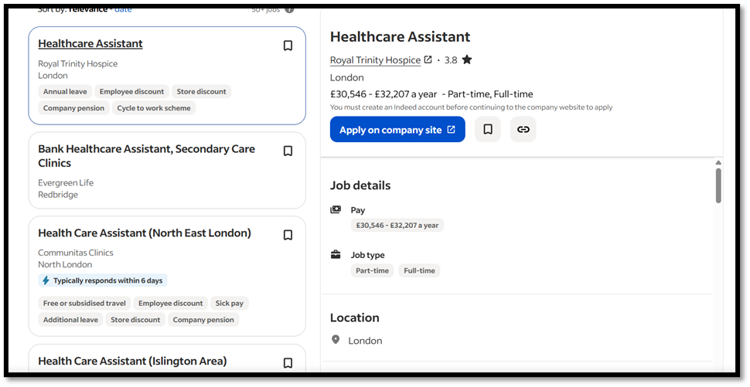
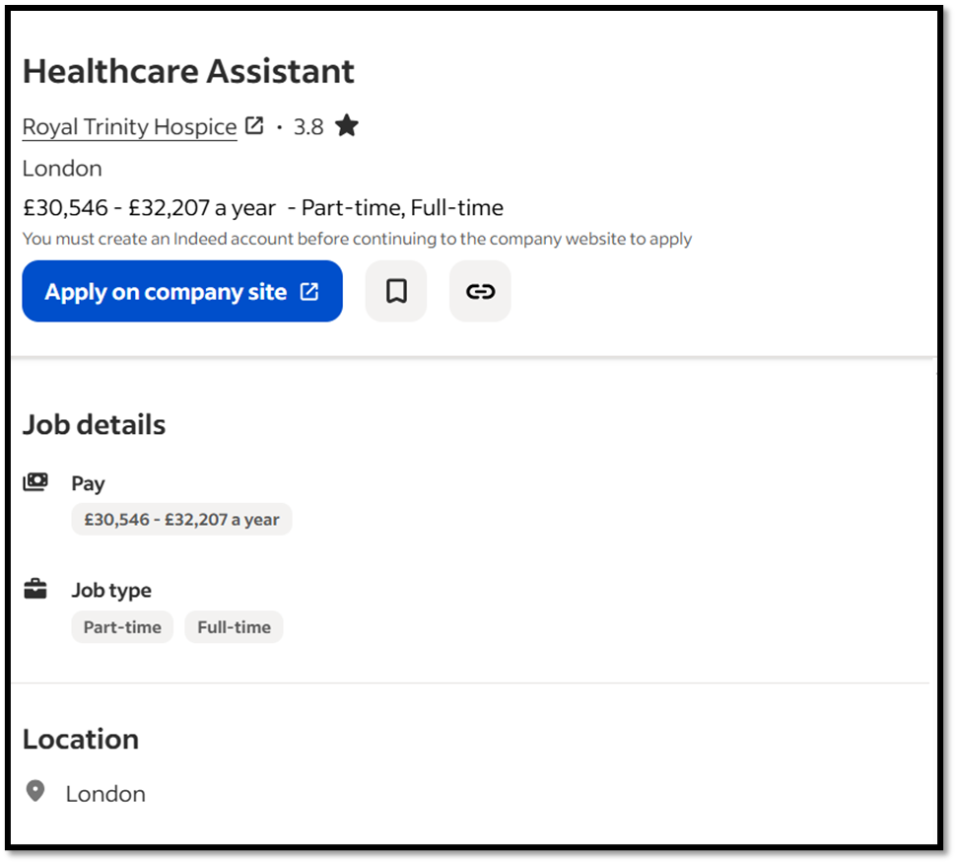
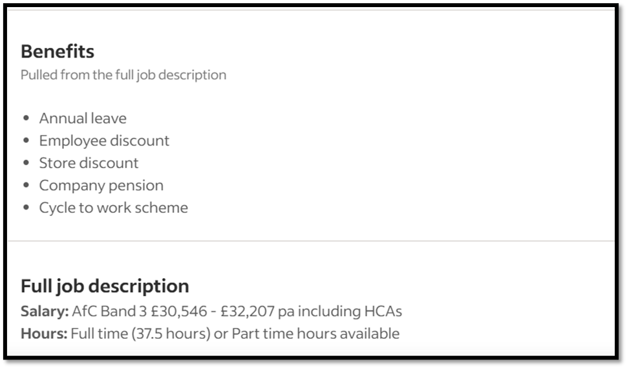
Figure 1: Screenshots of the published vacancy
(Source: Uk.indeed.com, 2025)
The above vacancy’s screenshot has been taken from Indeed, and this site helped to be part of the UK’s health and social care industry, like Royal Trinity Hospice.
Job description and person specification: Health care assistant (HCA), control of the care and support of the patients (Uk.indeed.com, 2025).
This job is available full-time, and one can also access this opportunity part-time. This hospital is looking for a dynamic and enthusiastic Health Care Assistant who is able to lead Trinity's vision and values and ensure safe, outstanding care for patients. On the other side, together, the inpatient unit (IPU) team at Trinity makes a real difference to the lives of people impacted through serious long-term situations and sets the standard for specialist palliative and end-of-life care. This organisation is also given the training, personal development and support where individuals are able to do their best. The person should be compassionate about the patient's physical, psychosocial and spiritual care and give importance to them.
Skills and experience are required: Level 2 Diploma in Health and Social Care or equivalent (Band 3 HCA requirement). Ability to work within the nursing and multi-professional team.
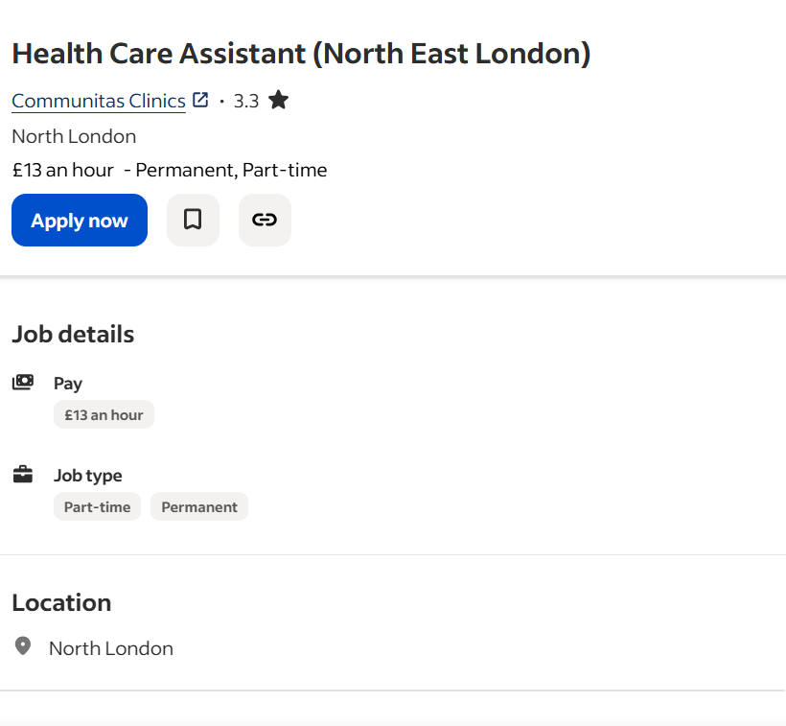

Figure 2: Screenshot of the current vacancy in the UK
(Source: Uk.indeed.com, 2025)
The above screenshot is showing the job vacancy for the Communitas Clinic, and it is also offering part-time and permanent jobs.
Job description and person specification: Health care assistant. Here, individuals should be able to manage patient data entry efficiently and preparation of the clinic rooms. Assisting the clinicians during minor operation procedures and supporting sample preparation for histology. Balanced and managed the clinic rooms with adequate stock levels and ensured cleanliness. Therefore, act as a chaperone and support the patients with queries and lift usage when necessary. Also, I attended the training sessions and increased my skills to stay competitive and updated.
A person should be able to handle these responsibilities calmly and maintain a positive behaviour with the patients. Therefore, politeness and positive body language are necessary to fit this job role.
Required skills are not mentioned in this job vacancy.

Analyse the skills needed for the job and assess your skills and experience
I am interested in the Royal Trinity Hospice job vacancy, where I can advance my career by working with the multidisciplinary team and working under the nursing guidance for betterment at work. The organisation is actively looking for a healthcare assistant job who is able to drive Trinity’s vision and help them to achieve their business goals (McFadden et al. 20021). The organisation strictly explained their patient care and how this is important to them. I should be handling the serious long-term conditions and helping set the standard for specialist palliative and end-of-life care. The organisation is providing training, personal development and always gives assistance to handle my responsibilities and give the best results.
Here I will be able to handle patients effectively and support people in monitoring their physical and mental health well-being. I can be compassionate about my work and able to cope with the demands of working on the inpatient unit at the hospice. Level 2 Diploma in Health and Social Care or equivalent (Band 3 HCA requirement) is required for this job. Therefore, excellent communication is required for this job and to collaboratively work with the multi-disciplinary team.
I have excellent communication skills, which is my greatest strength to join this industry and be able to excel in career progression. Therefore, I have worked in a multi-disciplinary team, which increased my teamwork ability and helped me to adapt to any kind of environment. Strong ethics are my main priority, and I always respect the autonomy across health and social care, which can build my professional network and support me to get rewarded (Anderson et al. 2021). But I realised during my unit session that problem-solving skills and critical thinking skills need to be improved, as both of them are required to handle different cases across the organisation and be able to deal with patients. Empathy is another skill which is also a room for improvement, as it helps me in the future to understand another person's experience and feelings is fundamental for developing trust and improving outcomes. I also followed the self-determination theory, which makes me determined to take a step and able to cope with a specific situation (Huang et al. 2022). It's a psychological framework implemented in health and social care to develop motivation by focusing on satisfying individuals' primary psychological requirements such as autonomy, competence and relatedness.
I mainly believed in the reflective practices to understand my strengths, weaknesses, opportunities and threats in the specific health and social care sector. Reflecting on my own experience helped me identify what my challenging situation was, and also consider what I enjoyed and what I found difficult (McKinlay et al. 2021). I have done an internship session, which increased my experience and made me aware of my strengths and weaknesses.
Feedback is the best strategy to identify your own situation in a particular phase. I seek feedback from my supervisor based on the internship session, which I have been doing. Therefore, colleagues are also helped to learn new things and are supported in finding challenges. Regular supervision with a senior colleague offers a reflective practice that helps in learning from suicides and challenges.
Qualifications and training in relevant fields such as health and social work helped me to consider this job role. BSc (Hons) Health and Social Care certificate and online training session certificates also support me to be eligible for the health care assistant post at Royal Trinity Hospice. Therefore, transferable skills such as communication, positive attitude, patience and resilience, attention to detail, teamwork, time management and flexibility support me to fit for this role.

Development of personal skills and resources
To develop a personal brand in health and social care as a health care assistant, it is required to build a strong reputation, showcase skills, and define unique value propositions to both employees and employers (Barraclough et al. 2021). A strong brand can advance my career progression, increase opportunities and support new ones established as a trustee professional.
To build brand identity, I should be focused on some major attributes
Defining my strength, pinpointing my core skillsConsistent motivation and developed why for each function, which makes me unique
Determine the value and what my core features such as compassionate care, attention to detail, or positive attitude
I should cultivate both professional presences, such as in person and online (creating a platform like LinkedIn), as well as. I also focused on developing my own content based on my expertise areas, by creating short, educational videos on topics such as personal hygiene or patient mobility, which makes me popular (Atmaja et al. 2022). Also, I have focused on building a network such as joining a professional association, and engaging with mentors.
My unique selling point: I have an excellent ability to connect with nonverbal patients and can compassionately and effectively relay their requirements to the clinical teams. The other strength of mine is that I focused on the technological approach, which helped me to streamline the communication, manage the medical records and be able to improve documentation.
The resources which are required to improve my future skills are such as attending a course or training, such as pursuing specialist training in areas such as palliative care, dementia care, or mental health, to enhance my skills (Marques et al. 2024). I also focused on the mentoring approach, which helped me to aspire as a senior HCA. Their guidance and feedback also helped me navigate the career advancements and able to identify the areas for improvement.

Action plan and timeline
Timeline and action plan for developing the skills required for this job role within the next five years.
Skill needs to be improved | Action | Impact | Timeline
Increased critical thinking | Improved by asking queries, challenging assumptions, actively listening and considering the different perspectives. | It helps to make better decisions, leading to better patient outcomes, identify the root cause, and safely handle any situation. | 1 year
Problem-solving approach | Developed by evidence-based practice (EBP) and creativity. | Ensure better patient care, improved efficiency, and enhanced critical thinking for clinicians. | 10 months
Developed leadership skills | Attending the leadership activities and participating in an online leadership and management course. | boosting staff morale and fostering innovation, and developing patient outcomes | 1-2 years
Excellent communication skills | Online course | Influenced patients and their families | 1 years

Communication skills for potential employers
In the CV, I have included
My academic certificate and credibility score
Convey my transferable skills (communication, leadership skills, teamwork ability) and compassion for this work
Internship session, I will add
I also included my online presence on LinkedIn
I also share my blogging channel, where I create content and develop a professional brand identity
In the LinkedIn profile,
Up to date, my LinkedIn profile includes my career interests, a professional photo and a background image
A compelling headline
A summary that tells your story
Detailed sections for experience
Education and skills
Volunteer Experience

Conclusion
The study concludes that in health and social care, empathy, compassion and excellent communication skills are required to develop patient outcomes. A healthcare assistant plays an essential role in healthcare, which helps to take care of the patients and report to the clinical team as well. Therefore, the study defines how effective care and a positive attitude of the health care assistant helped to promote inclusivity and increase the patient's satisfaction rate. The report incorporates an effective action plan for the HCA and achieve the future goals to fit in the desired job position.

References
Anderson, M., O'Neill, C., Clark, J.M., Street, A., Woods, M., Johnston-Webber, C., Charlesworth, A., Whyte, M., Foster, M., Majeed, A. and Pitchforth, E., 2021. Securing a sustainable and fit-for-purpose UK health and care workforce. The Lancet, 397(10288), pp.1992-2011.
Atmaja, D.S., Fachrurazi, F., Abdullah, A., Fauziah, F., Zaroni, A.N. and Yusuf, M., 2022. Actualization of performance management models for the development of human resources quality, economic potential, and financial governance policy in Indonesia Ministry of Education.
Aveyard, H., 2023. Ebook: Doing a Literature Review in Health and Social Care: A Practical Guide 5e.
Barraclough, F., Smith-Merry, J., Stein, V. and Pit, S., 2021. Workforce development in integrated care: a scoping review. International journal of integrated care, 21(4), p.23.
Huang, H., Wang, H.H., Donaghy, E., Henderson, D. and Mercer, S.W., 2022. Using self‐determination theory in research and evaluation in primary care. Health Expectations, 25(6), pp.2700-2708.
Marques, L., Costa, B., Pereira, M., Silva, A., Santos, J., Saldanha, L., Silva, I., Magalhães, P., Schmidt, S. and Vale, N., 2024. Advancing precision medicine: a review of innovative in silico approaches for drug development, clinical pharmacology and personalized healthcare. Pharmaceutics, 16(3), p.332.
McFadden, P., Ross, J., Moriarty, J., Mallett, J., Schroder, H., Ravalier, J., Manthorpe, J., Currie, D., Harron, J. and Gillen, P., 2021. The role of coping in the wellbeing and work-related quality of life of UK health and social care workers during COVID-19. International journal of environmental research and public health, 18(2), p.815.
McKinlay, A.R., Fancourt, D. and Burton, A., 2021. A qualitative study about the mental health and wellbeing of older adults in the UK during the COVID-19 pandemic. BMC geriatrics, 21(1), p.439.
Uk.indeed.com, 2025. Indeed Available at: https://uk.indeed.com/jobs?q=health+care+assistant+nhs&l=London%2C+Greater+London&from=searchOnDesktopSerp%2Cwhereautocomplete&vjk=8f96cafc7d9a5864 [Accessed on: 30/10/2025]

