5/8/2024
Assessment
Portfolio Report on Contemporary Software Applications for Business

Module NaMe: Software solutions for business
Module Code: ACCA 4026
Lecturer: AMITAVE MODAK
STUDENT NAME: PETER MILES MASWERE
STUDENT ID: 2532060
Trinity saint david University of Wales (London Campus)



Table of Contents
Introduction 0
Task 1 …………………………………………………………………………………………………….…..1
e-Commerce Website builders/software solutions 2
Task 2 2
Mind-map of Contemporary Software Applications 2
Task 3 3
Office Applications for Creating, Storing, Presenting, and Analysing Data 3
a. 3
b. 3
Task 4 4
Communication and Collaboration applications 4
a. 4
b. 4
Conclusion 4
References 4
Appendices 4

Introduction
This report looks at software used in today’s business operations. It covers e-commerce website builders, mind mapping tools, office software, and communication and collaboration platforms. The goal is to review their features, benefits, and uses in business.
Task 1: E-commerce Website Builders and Software Solutions
Shopify is an e-commerce platform that helps businesses set up and run online stores. It offers tools for store design, payment processing, and marketing. Users can choose from customizable templates to create attractive storefronts without needing much technical skill, and the built-in payment system makes transactions easier [1]. Shopify also offers inventory and order management tools to track stock and fulfil orders efficiently. Its app marketplace lets users add more features through third-party apps, and built-in SEO and marketing tools help boost online visibility and customer engagement [2].
Shopify has many advantages, especially for businesses focused on e-commerce. Its easy-to-use interface and professional templates help customers find what they need, building trust and leading to more sales and fewer abandoned carts. Shopify can also grow with a business, so companies do not need to switch platforms as they expand [3]. It offers secure, reliable hosting, which is important for secure payments and customer trust. However, Shopify does have some drawbacks. There are monthly fees and extra charges for using third-party payment gateways. It also offers less flexibility for customisation than open-source platforms, which might be a problem for advanced users who want more control [1].
Wix is a website builder with e-commerce features, making it a good choice for people who want something simple and well-designed. Its drag-and-drop builder lets users create websites easily without knowing how to code. Wix also supports online selling and includes built-in SEO and marketing tools to help businesses appear in search results and attract customers [4]. Its mobile-friendly design means websites work well on any device, which is important for today’s online shoppers.
Wix is easy to use and affordable, making it appealing to beginners and small business owners with little technical experience. Users can quickly build and manage websites, and the flexible design options let them customise layouts as they like. Wix’s pricing is usually lower than that of more advanced platforms. However, Wix is not as scalable as Shopify, so it may not be as well-suited to large or fast-growing businesses. It also has fewer advanced e-commerce features, which could be a problem for businesses with more complex needs [4].
In short, Shopify is best for businesses that need advanced features, room to grow, and strong support for online sales. Wix is better for smaller businesses or individuals who want an easy, flexible, and affordable way to set up a website with basic e-commerce features.

Task 2: Mind Mapping
Description of Mind Mapping
Mind mapping is a visual thinking tool used to capture, organise, and prioritise information in a non-linear format. Unlike traditional notetaking, which relies on a vertical, top-to-bottom structure, mind mapping begins with a central idea, the "nucleus" and radiates outward into related sub-topics [5]. This "radial" layout mimics the way the human brain naturally processes information through association rather than strict hierarchy. By combining keywords, short phrases, and spatial arrangements, mind mapping bridges the gap between creative brainstorming and logical planning.
b. Benefits in Business
In a professional setting, mind mapping is more than just a creative exercise; it is a strategic asset that improves the efficiency of daily operations.
- Managing Information Overload
Modern businesses are often overwhelmed by big data and complex reports. Mind mapping serves as a cognitive filter, allowing professionals to distil massive amounts of information into a single, digestible view. Research suggests that the visual nature of these maps, specifically the use of colour and spatial cues, significantly improves a person’s ability to recall facts and retrieve information compared to reading standard text [6]. For operations such as staff training or policy reviews, this means employees can grasp complex procedures more quickly and retain them longer.
- Strengthening Project Planning and Scope
One of the biggest risks in business operations is "scope creep," in which small details are overlooked during the initial planning phase. Mind mapping allows project managers to visualise the Work Breakdown Structure holistically. By mapping out a project, a team can see all moving parts simultaneously, making it easier to identify dependencies and potential bottlenecks [7]. This "big picture" view ensures that every operational task is aligned with the central business goal, reducing the likelihood of wasted resources or missed deadlines.
- Enhancing Collaborative Problem Solving
Meetings are often criticised for being unproductive or confusing. When a mind map is used as a live, collaborative document during a meeting, it acts as a "shared external memory" [7]. It allows team members from different departments to see how their specific roles intersect. This visual transparency encourages more active participation and helps teams reach a consensus faster. Instead of sifting through pages of meeting minutes, the team leaves with a visual roadmap of who is responsible for what, which streamlines the transition from "idea" to "execution.
Conclusion
By aligning with the brain's natural tendency toward association, mind mapping transforms complex business data into actionable knowledge. It moves beyond simple list-making to provide a structured, yet flexible, framework that improves memory, clarifies project goals, and fosters more effective teamwork across all levels of an organisation.
Task 2: b
Link: https://mm.tt/map/3992042008?t=KKqLiga8Ix
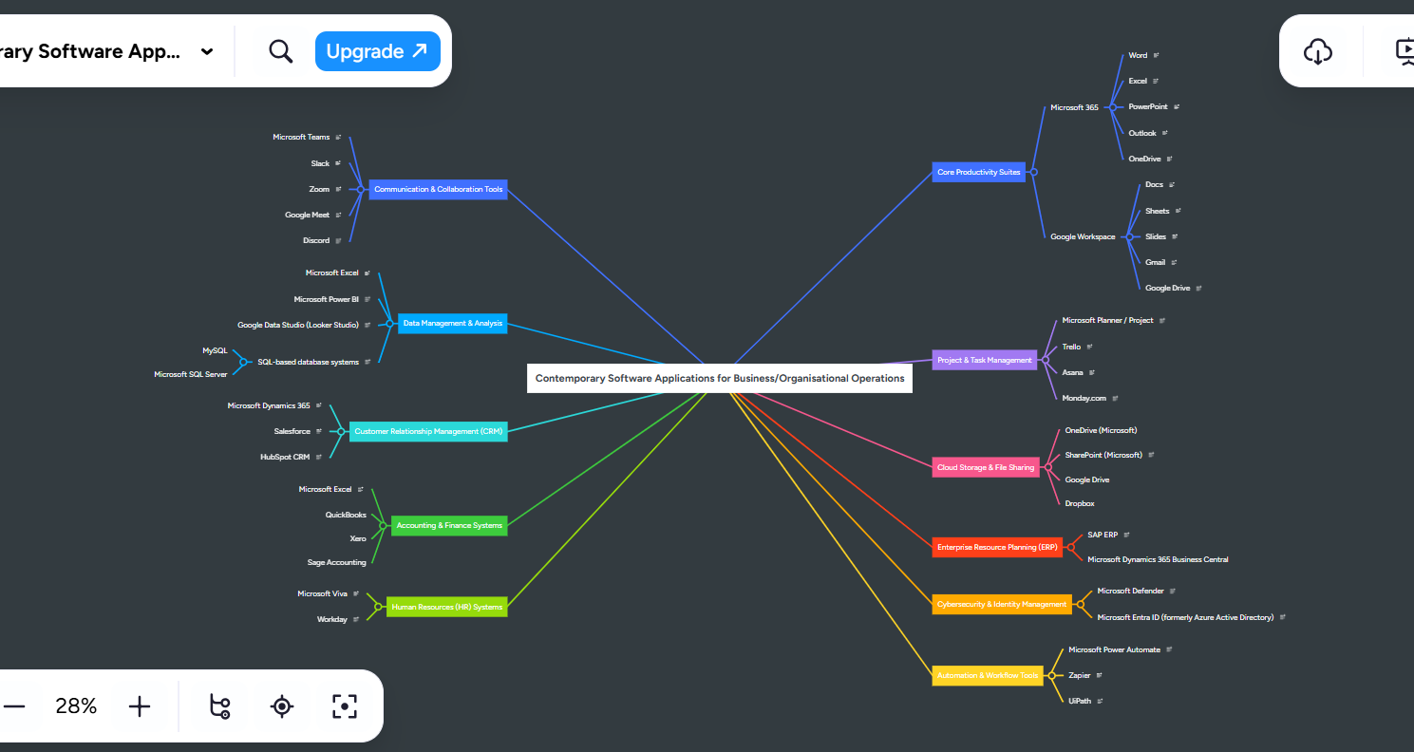

Modern organisations rely on integrated software ecosystems that combine productivity tools, communication platforms, data analytics, cloud storage, and enterprise systems. Microsoft applications form a core part of many business environments, especially through Microsoft 365, Teams, Dynamics 365, Power Platform, and Azure-based services.

Task 3
Microsoft Word
In most offices today, Microsoft Word is the go-to tool for writing [8]. People use it for everything from basic letters to long business proposals. It is popular because it gives you total control over how a page looks—you can easily swap fonts, adjust spacing, and fix layouts to make things look polished. It also catches typos and grammar slips as you go, which is a lifesaver for professional writing [9].
The best part about Word is that it is easy for beginners to pick up, yet it has "Track Changes" and comment features that make collaborating with a team feel seamless [8], [9]. Just keep in mind that while it is great for text, it is not built for heavy data crunching; you will want a spreadsheet for that [10].
Microsoft PowerPoint
When you need to share ideas in a meeting or a pitch, PowerPoint is the standard choice. It lets you mix text with photos, charts, and even video to tell a story through slides [11]. You do not need to be a graphic designer to use it either, as there are plenty of ready-made themes to help you get started.
PowerPoint’s real strength is making complex ideas easier to see and understand. However, there is a "less is more" rule here: if you cram too much text onto a slide or go overboard with flashy animations, you will likely lose your audience’s attention rather than keep it [11].
Microsoft Excel
Excel is a powerhouse for anyone dealing with numbers or big lists of data [10]. At its simplest, it is a grid of rows and columns where you can type in information, but its real magic lies in its formulas. It can automate math and handle massive amounts of data in seconds, which is why it’s the backbone of financial reporting and forecasting [10].
While Excel is amazing for turning data into clear charts and visuals, it does have a steeper learning curve. It can be a bit intimidating for new users, and one must be careful; a small mistake in a formula can throw off the entire result [10].
Microsoft Access
Microsoft Access is designed for those times when a simple spreadsheet is not enough. It is a database tool used to store and organise huge amounts of structured info, like customer lists or inventory tracking [12]. Unlike a basic list, Access lets you link different data sets together, so everything stays connected and organised.
It is much more robust than Excel for long-term data management, but it does have its limits [12]. It is not meant for massive, global-scale corporations, and you might need a bit of technical "know-how" to set up the database properly in the first place [12].

b.
Testing two different software applications.
Mail merge
The following images are screenshots showing how I tested Mail merge step by step.
Step 1.
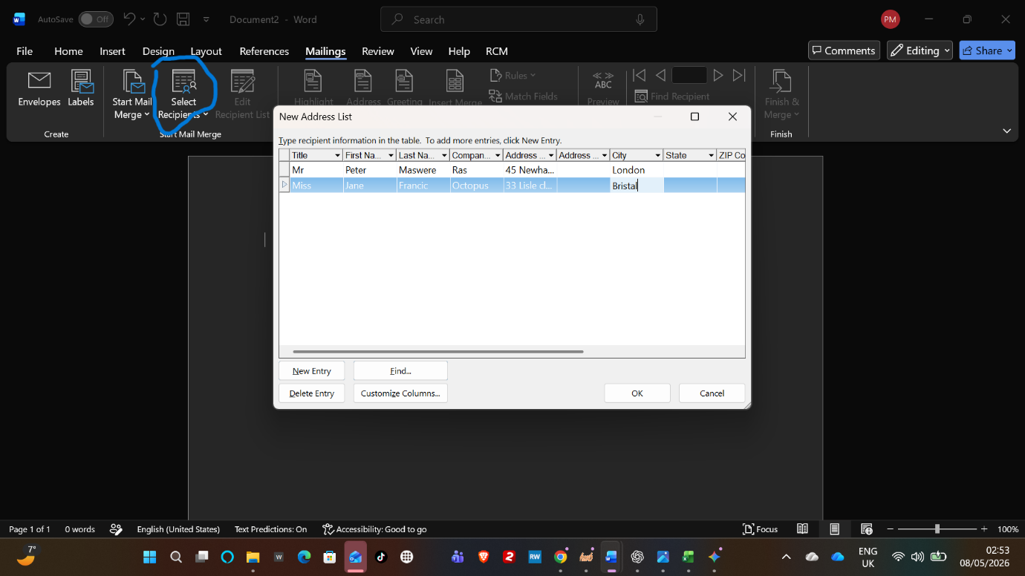
Step 2.
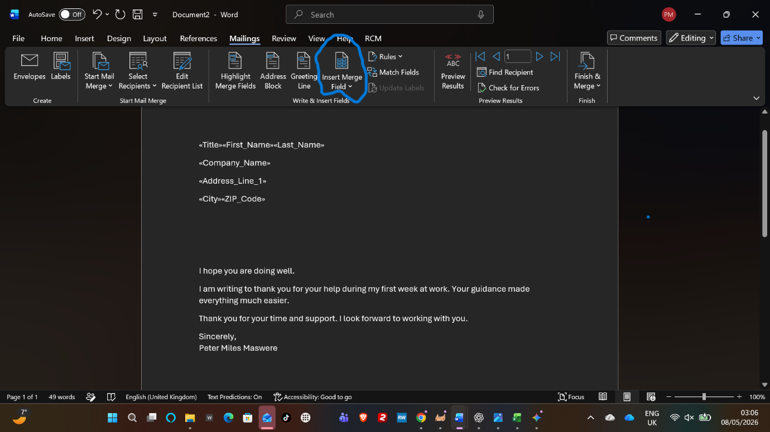
Step 3.
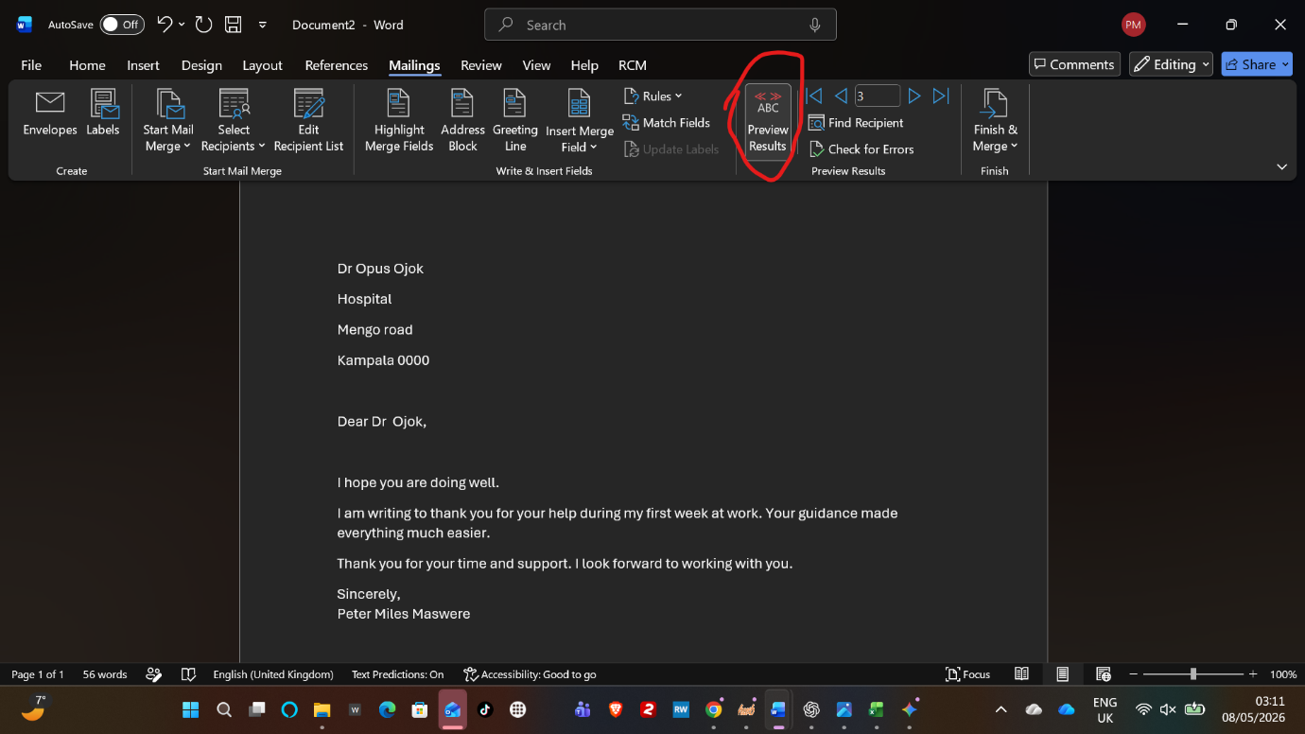
Step 4.
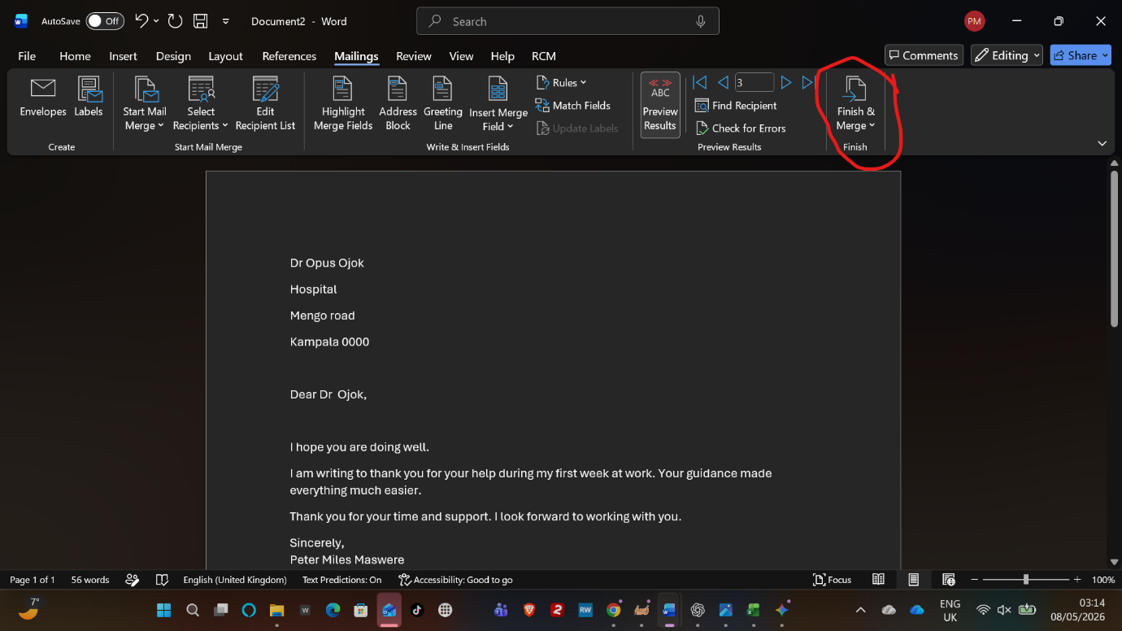
Pivot Table
Microsoft Excel is a tool for summarising and analysing large datasets. It allows users to reorganise data by dragging and dropping fields into different categories, such as rows, columns, and values. This makes it easier to identify patterns, trends, and totals within the data.
Below are screenshots showing how I tested the Pivot Table step by step.
Step 1.
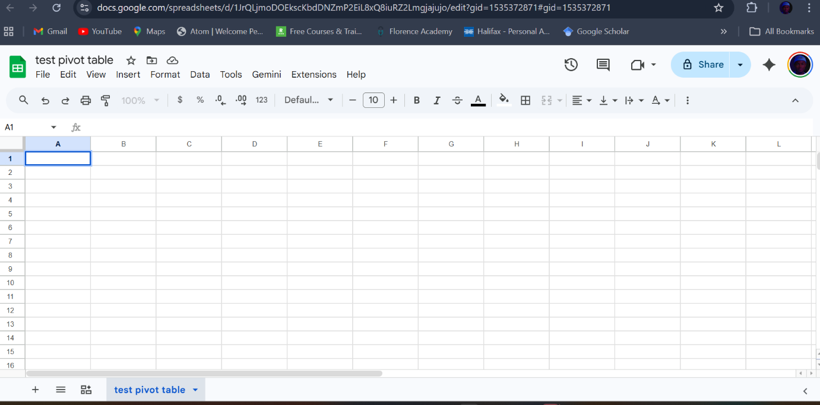
Step 2.
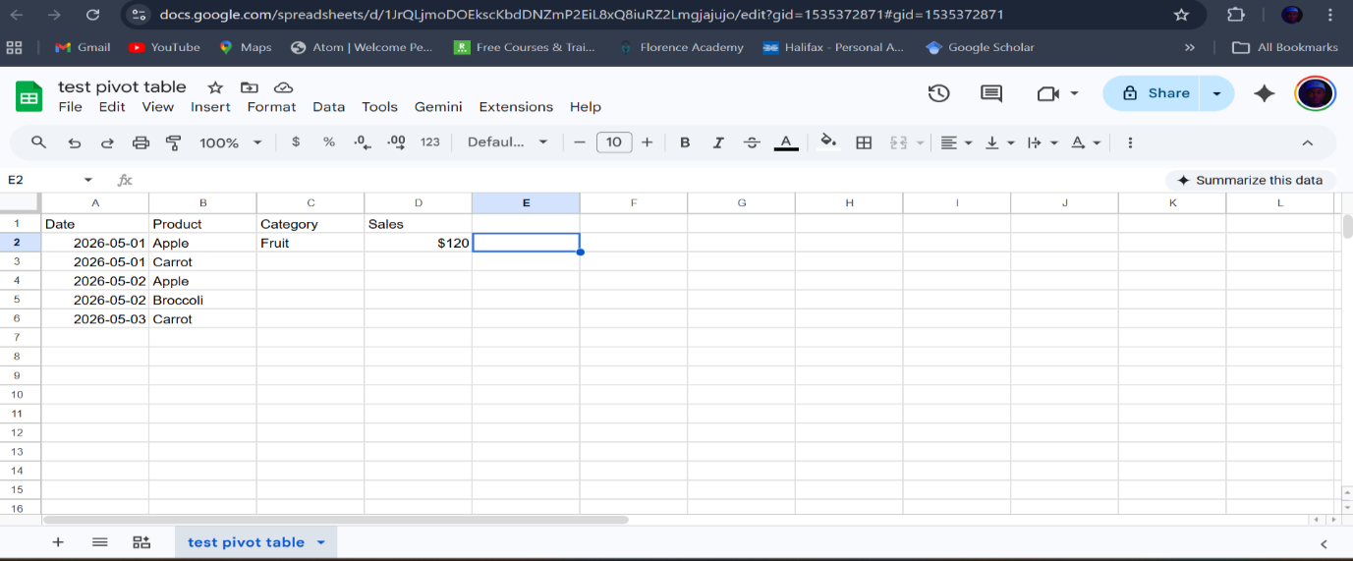
Step 3.
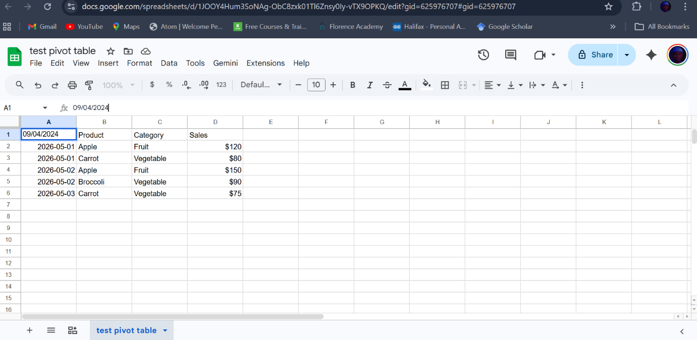

Task 4 a.

Communication and Collaboration applications
Microsoft Teams has emerged as a cornerstone of modern digital transformation, evolving from a simple chat interface into a comprehensive "hub for teamwork" within the Microsoft 365 ecosystem. Launched in 2017 as a competitor to Slack, Teams has successfully leveraged its deep integration with Office 365 to dominate the corporate communication market. As of 2023, the platform reported over 300 million monthly active users, highlighting its critical role in supporting hybrid and remote work models [13]. This analysis explores the architectural strengths, key functional pillars, and the strategic value Teams provide to contemporary organisations.
Core Functional Architecture
The architectural philosophy of Microsoft Teams is built upon the concept of persistent,
threaded conversations combined with real-time collaboration tools. Unlike traditional email,
Teams organises communication into "Channels" within "Teams," allowing for structured data silos that are easily searchable and contextually relevant.
Technical Integration:
Teams is not a stand-alone application but rather a presentation layer that aggregates services from across the Microsoft Cloud. It utilises SharePoint for file storage, Exchange for calendar management, and Azure Active Directory for identity and access management [14].
- Channels and Workspace Organisation
Teams are collections of people, content, and tools centred around different projects or departments. Within these teams, channels act as the actual centres of activity. They can be standard (open to all team members) or private (restricted to specific individuals). This hierarchy ensures that information is decentralised but remains governed by organisational policies.

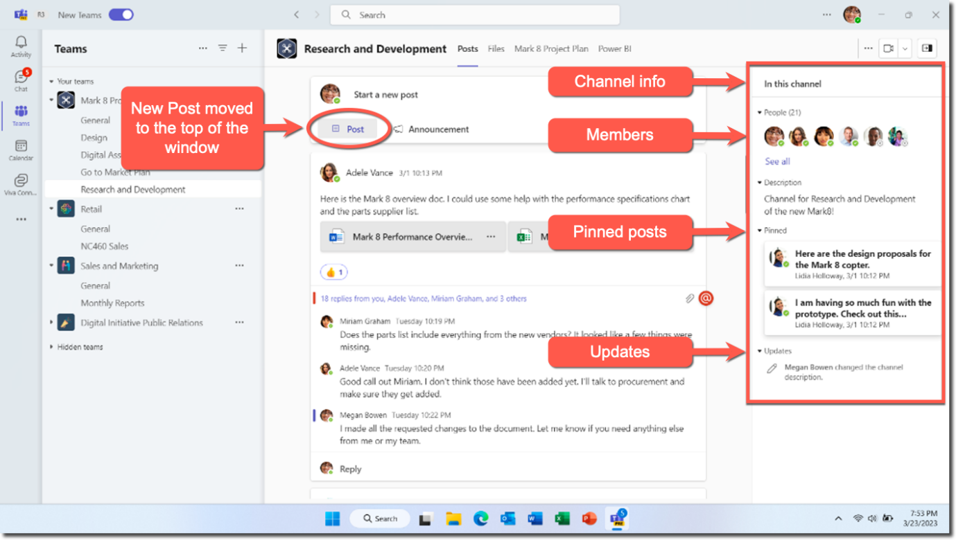
Key Features Summary
- Unified Communication
Teams integrates VoIP, video conferencing, and instant messaging into a single interface. The "Meetings" feature supports everything from one-on-one audio calls to "Town Hall" events hosting up to 20,000 attendees. Advanced features like live captions, noise suppression, and "Together Mode" utilise AI to enhance the user experience and reduce meeting fatigue [15].
- Collaborative Document Co-authoring
One of the most significant advantages of Teams is the ability to collaborate on Word, Excel, and PowerPoint documents without leaving the app. Because the files are hosted in SharePoint/OneDrive, multiple users can edit a document simultaneously while discussing changes in the side chat. This reduces version control issues common in email-based workflows.

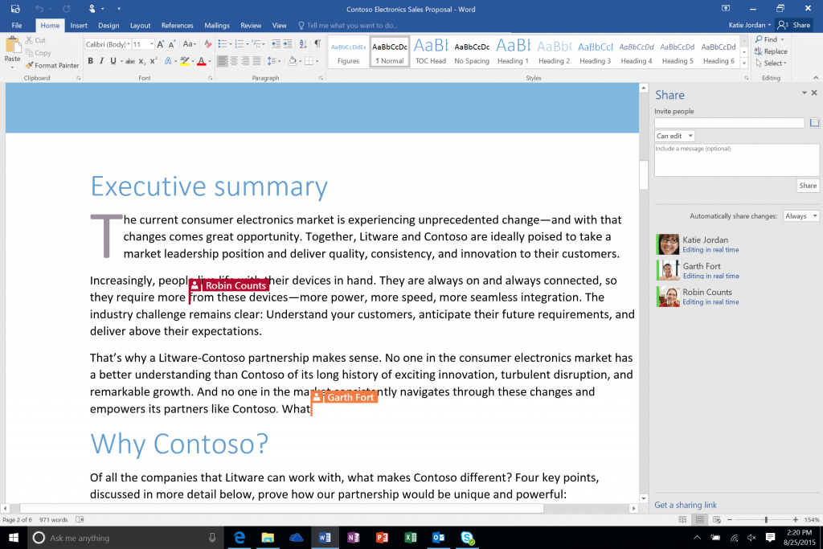
- App Integration and Extensibility
Microsoft Teams acts as a Platform-as-a-Service (PaaS). Through the Teams Store, organisations can integrate third-party tools like Jira, Trello, and Salesforce. Furthermore, the integration of Power Platform allows users to build "Low-code" apps and automated workflows (Power Automate) directly within the Teams interface to manage repetitive tasks [16].
Security and Governance
For enterprise adoption, security is paramount. Microsoft Teams inherits enterprise-grade security from Microsoft 365. This includes multi-factor authentication (MFA), data encryption in transit and at rest, and Compliance Manager features that help organisations meet regulatory requirements such as GDPR and HIPAA [14].
Governance features allow IT administrators to control Shadow IT by managing who can create teams, setting expiration policies, and utilising discovery for legal investigations. This balance between user autonomy and administrative control is a key differentiator for the platform.

Strategic Impact on Productivity
Research indicates that the implementation of Microsoft Teams reduces the volume of
internal emails and shortens the duration of meetings through more efficient asynchronous communication. By providing a "Single Pane of Glass" for all work activities, Teams minimises "context switching"—the cognitive load required to move between different software applications [13].

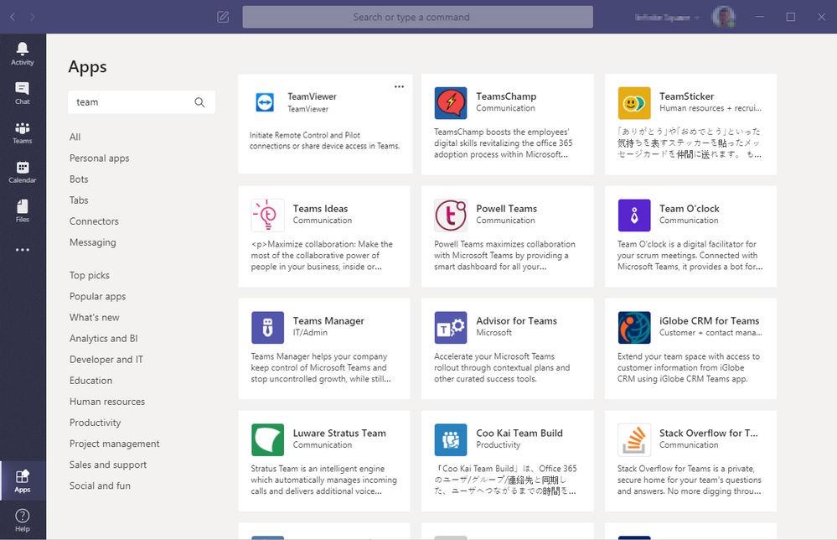

Conclusion
Microsoft Teams has redefined the digital workplace by converging communication and collaboration into a single, secure environment. Its strength lies not just in its individual features but in its ability to unify the disparate threads of corporate work files, chats, meetings, and third-party apps. As organisations continue to move toward permanent hybrid models, Teams' role as the "operating system for work" is likely to expand further, particularly with the integration of AI-driven tools like Microsoft 365 Copilot.
Task 4 b.
Communication application
I tested WhatsApp voice calls, voice messages, and text messaging with Warren and Aunt Joan, as shown in the images below.

Collaboration application
I tested Google Docs by planning a project to develop a comprehensive mobile application designed to help students manage their time more effectively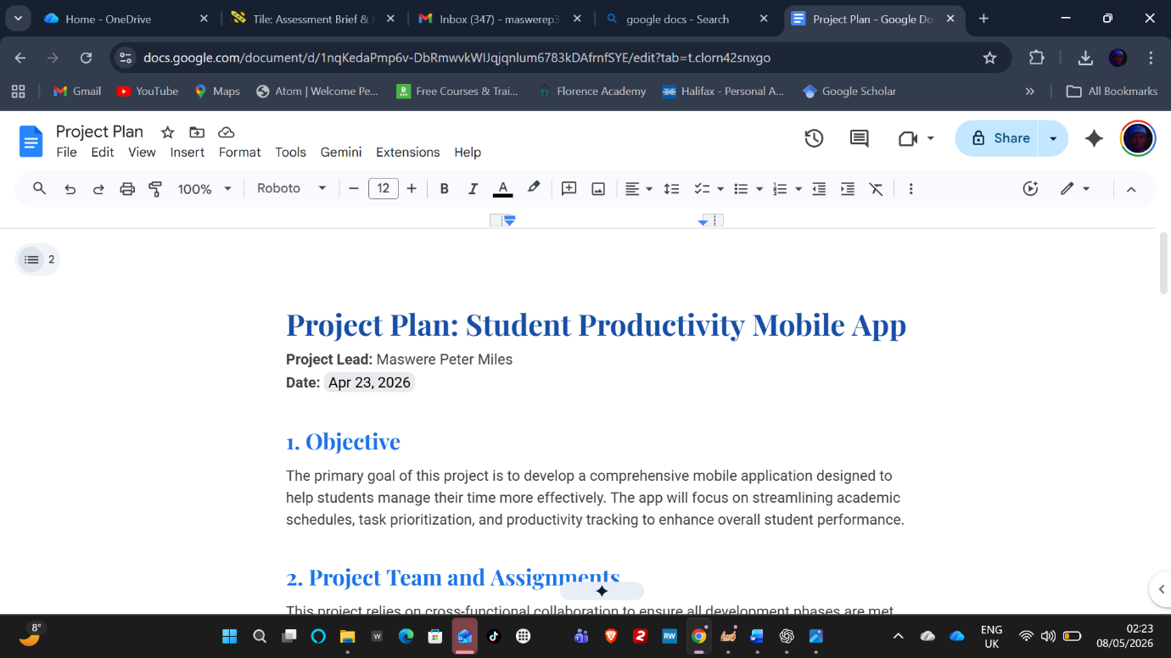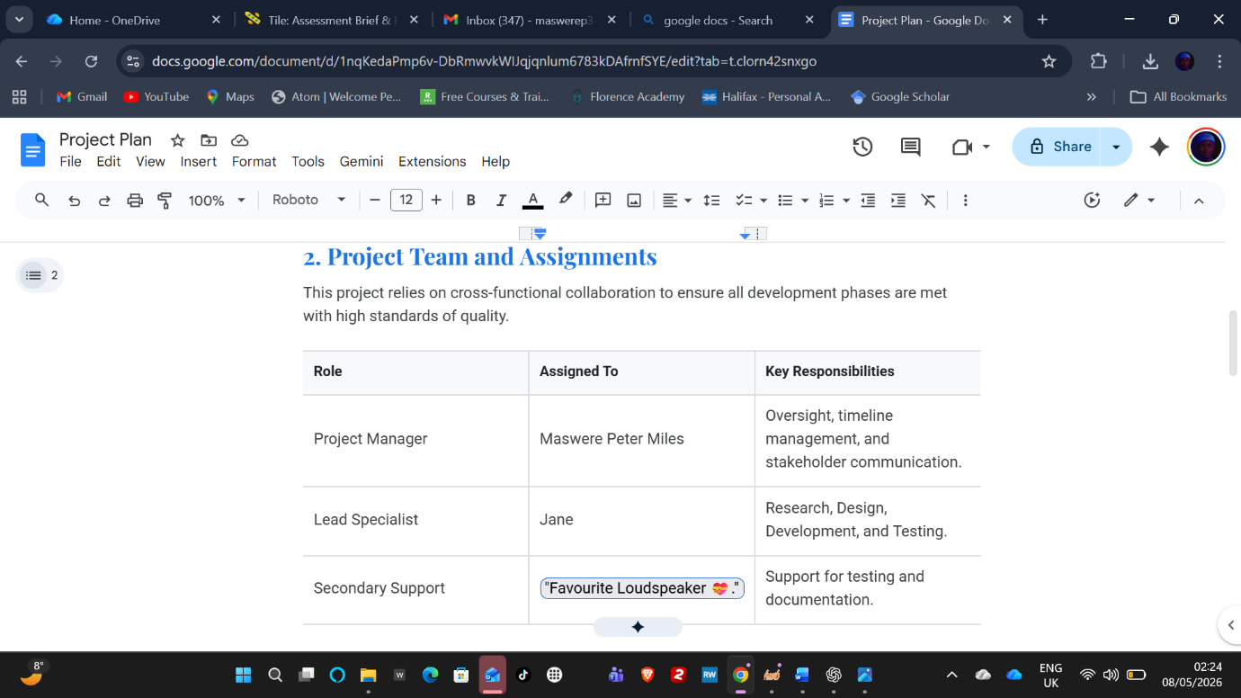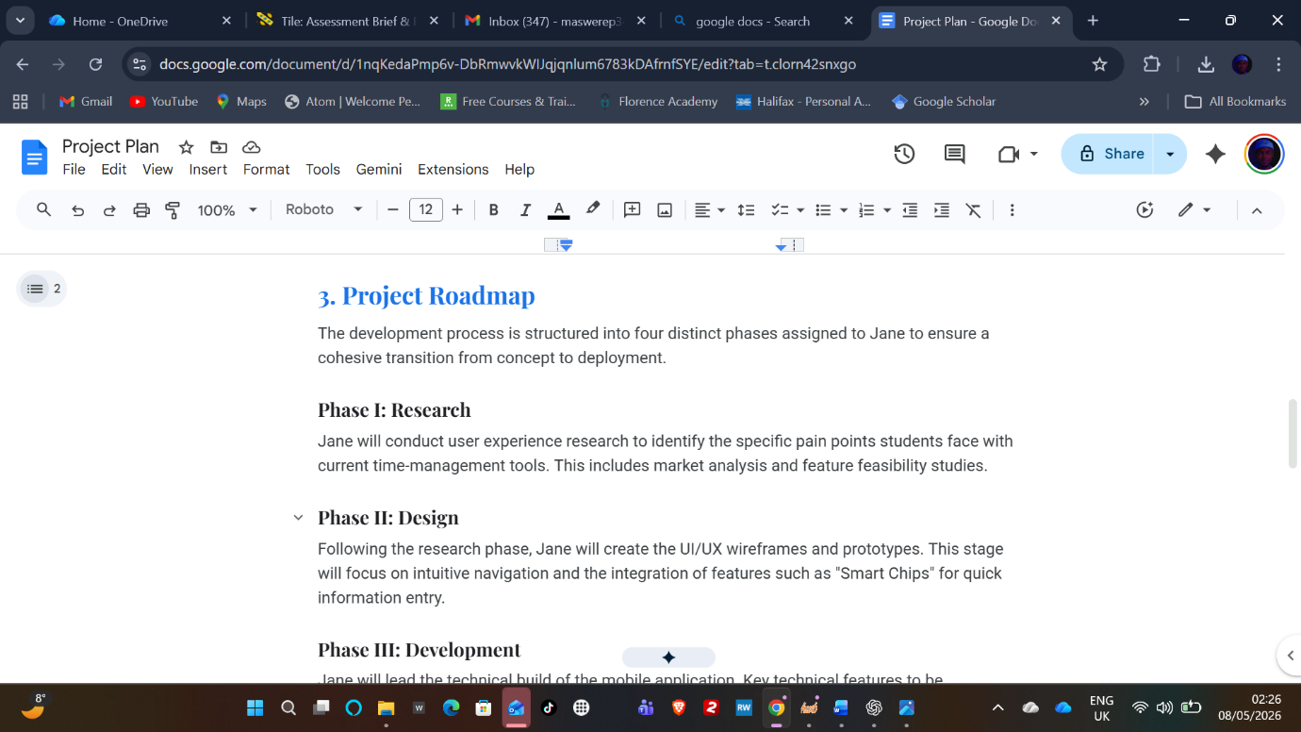

Conclusion
This report demonstrates that contemporary software applications are essential for the efficiency and success of modern business operations. The analysis indicates that selecting an appropriate platform, such as a robust e-commerce solution like Shopify for scalability or a user-friendly builder like Wix for less complex requirements, directly influences a company's capacity to engage customers and manage sales effectively.
Furthermore, integrating visual tools such as mind mapping with core productivity suites like Microsoft 365 enables organizations to refine complex data, enhance information retention, and promote advanced collaboration. Utilizing unified communication platforms such as Microsoft Teams helps enterprises minimize operational silos and respond effectively to the evolving demands of hybrid work environments. The strategic implementation of these digital tools transforms raw data into actionable knowledge, thereby ensuring sustained organizational productivity.

References
[1] Shopify Inc., “Shopify Features,” 2024.
[2] A. Patel, E-commerce Essentials, 3rd ed. New York: TechPress, 2023.
[3] J. Strauss, Digital Marketing Strategy, 2nd ed. London: Pearson, 2022.
[4] Wix.com Ltd., “Wix eCommerce Overview,” 2024.
[5] T. Buzan and B. Buzan, The Mind Map Book: How to Use Radiant Thinking to Maximize Your Brain's Untapped Potential. New York, NY: Plume, 1996.
[6] M. Kalyanasundaram et al., "Effectiveness of Mind Mapping Technique in Information Retrieval Among Medical College Students in Puducherry-A Pilot Study," Journal of Clinical and Diagnostic Research, vol. 11, no. 3, pp. VC01-VC03, Mar. 2017. [Online]. Available: https://www.jcdr.net
[7] G. Cunningham, "Mind mapping: Its short and long-term effects on problem solving," Journal of Organizational Change Management, vol. 18, no. 1, pp. 45-59, 2005. [Online]. Available: https://www.emerald.com/insight/content/doi/10.1108/09534810510579495/full/html
[8] M. Buzov, "Evolution of Collaboration by Using Microsoft Office Applications," in The Future of Information Sciences: e-Institutions and e-Society, Zagreb, Croatia, 2011, pp. 175–184.
[9] T. T. Tran and N. T. Nguyen, "Enhancing Classroom Learning with Microsoft 365 for Education," Keiwa College Research Bulletin, no. 33, pp. 113–124, 2024.
[10] M. Alexander, "The central role of advanced SQL and Excel techniques in enhancing data analysis efficiency and accuracy," Impact International Journals and Publications, vol. 1, no. 1, pp. 1–15, 2025.
[11] Y. Inoue-Smith, "College-based case studies in using PowerPoint effectively," Cogent Education, vol. 3, no. 1, p. 1127745, 2016. doi: 10.1080/2331186x.2015.1127745.
[12] J. Letkowski, "Challenges in database design with Microsoft Access," Journal of System and Management Sciences, vol. 4, no. 3, pp. 51–64, 2014.
[13] J. Spataro, "Microsoft Teams at 6: Overcoming the Hybrid Work Challenges," Microsoft 365 Blog, 2023. [Online]. Available: https://www.microsoft.com/en-us/microsoft-365/blog/
[14] Microsoft Learn, "Microsoft Teams IT architecture and telephony solutions posters," Microsoft Tech Docs, 2024. [Online]. Available: https://learn.microsoft.com/en-us/microsoftteams/teams-architecture-solutions-posters
[15] B. Bucher, "The Evolution of Virtual Collaboration: A Study on Microsoft Teams Features," Journal of Digital Communication, vol. 12, no. 2, pp. 45-58, 2022.[4] Gartner, "Magic Quadrant for Unified Communications as a Service, Worldwide," 2023. [Online]. Available: https://www.gartner.com/en/documents/4008293

