

Lecturer’s name: Gasso Wilson Mwaluseke
Student’s name: Wintana Alem Bihon
ID number: 1916665

Harassment within the workplace
The topic selected for this task will explore the evolving nature of harassment within the workplace, its effects and some possible solutions to consider for this issue. The importance of the wider issue of harassment itself, is a subject that has climbed up the legislative agenda ever since the significant change’s society witnessed within the workplace during the industrial revolution. The introduction of standardisation, unions and the creation of a social contract between the employee and their employers had initiated a changing power dynamic in the workplace. Events over the 20th century such as the Russian Revolution, the second world war, de-industrialisation in the developed world, growth of globalisation and the introduction of 24hr news/tabloid culture have radically changed the work place. These opportunities have resulted in women, ethnic minorities, occupants of the poverty line etc joining the workforce and diversified the work place. The establishment and growth of the field of Occupational Safety and Health from the 1980’s onwards has led to a professionalised multidisciplinary field dedicated to the safety, health, welfare of those in an occupation [1].
The harassment experienced by the victim can be divided into two categories, physical and emotional. Abuse of a physical nature essentially refers to the violence and assault whereas with emotional abuse, it tends to manifest itself as mental stress and psychological bullying [1]. The most widely practised form of physical harassment is sexual assault. The definition of sexual assault is difficult due to the grey legal distinction between sexual harassment and consensual sexual interactions. This grey area is most prominent in roles that require a higher tolerance of behaviours, roles such as waitresses and healthcare [2]. The prevalence of sexual harassment is difficult to accurately quantify due to the clandestine nature of it, but a recent survey by the Trade Union Congress, indicated that more than 50% of women and nearly 70% of LGBT are sexually harassed. Of those women, again more than half stated that the sexual harassment came in the form of frequent unwelcome sexual jokes [3]. Other experiences highlighted by the respondents include unwanted sexual touching, attempts to kiss them and even worse is the horrific statistic of one in eight LGTB women reporting rape at work. A recent survey by Unison also paints a bleak picture within the NHS. One in ten staff members had been sexually harassed, of those a quarter reported assault of a sexual nature such indecent exposure, inappropriate touching and up-skirting [3].
In contrast with physical harassment, emotional harassment is vastly more subtle and discreet. Due to its discreet nature, physical harassment therefore receives more attention, thereby perpetuating the continuation of the emotional harassment, in effect creating a vicious cycle [4]. Emotional harassment is defined as the verbal and non-verbal interactions of a hostile nature that are not explicitly linked to sexual or racial subject matter yet, it is aimed at achieving compliance from other via social manipulation [4]. The most common form of emotional harassment in the workplace is bullying which will be defined as a prolonged, escalating psychological conflict that is re-enforced with frequent harassment and is aimed at an individual. Its prevalence in the British workplace is something that has become more widely understood and seriously investigated at the scholarly level and has resulted in the publishing of a growing body of statistics. In combined survey carried out by the Trade Union Congress and YouGov has found that of respondents, a third have been bullied at work, women are a third more likely to be victims of bullying then men and more than three quarters stated that the bullying is carried out by a manager[3]. Furthermore, the demographic that experiences workplace bullying the most is that of the 40-59-year-old.
However, with the prevalence of work place harassment and its change over time now better understood, the next step is to establish the effect it has on the victim and the workplace itself. Looking at the effects experienced by those who responded to the survey, one can from that infer the possible effects on the business. Most respondents have said that the abuse has had a negative impact on their work performance, detrimental to their mental health and more than a fifth have taken time off work due to the stress of it [3]. From that, one can infer that this translates into morale and productivity, key indicators in the health and prosperity of a business – suffering. Other consequences include reputational damage for firms, staff turnover and the financial impact of employment tribunals. With the wider issue of harassment being more recognised, employers small or large have responded by adopted a zero-tolerance approach and altering the company values to reflect this change in mentality. Yet, despite these adoptions, recent surveys produced by trade unions still show that this behaviour is ongoing. This suggest that, the root cause of this behaviour is not being tackled by the zero-tolerance approach and other said measures due to the difficulty in changing a culture [5]. A culture change is more difficult to implement due to encountering, a resistance to change among some staff, it takes years to completely change the culture of an organisation, interdepartmental rivalries and vested interests.
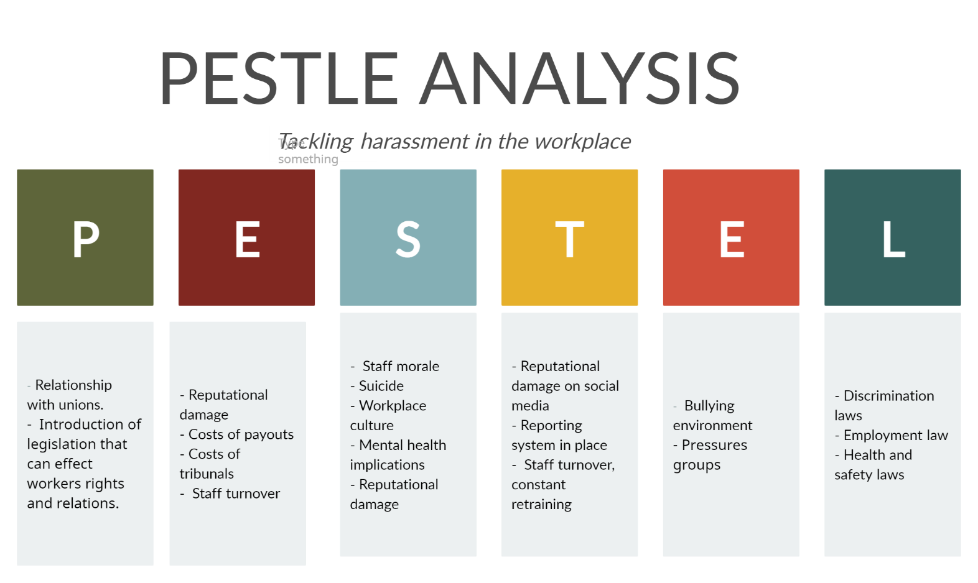
Moving on, the author of this report will now examine proposed solutions alongside a PESTLE analysis to justify the recommendation of the solutions to stake holders.
Figure 1 - PESTLE diagram for harassment within the workplace.
The above figure highlights all the risks to the employer when it comes to harassment and as such a solution is needed that will tackle and negate the variables mentioned. The first proposal involves a dedicated plan that recognises the need for a culture change and the pathway to achieving that. Those who inflict physical and emotional abuse in most cases are able to continue the practise of this due to the culture of an organisation [5]. The unspoken formal/informal agreements, departmental loyalty, and verbal threats are variables that promote the harassment and are able to exist if the organisational culture permits it. The comfortability the abuser feels in practising their abuse, indicates the abuser must feel there won’t be consequences to their actions or any detrimental impact on how their perceived by their peers. The culture also punishes the victim by exacerbating their sense of helplessness due to the perception that ‘the powers that be’ must be condoning this behaviour or turning a blind eye to it. This perception exists so long as the harassment continues in an age wherein most employers use a zero-tolerance approach in their workplaces.
In addition to that, a culture which doesn’t penalise abusers has another more sinister tertiary effect. With any organisation, a principal driving factor is the survival of the institution and having those within that organisation believe in its purpose are crucial to its longevity. This is most harmful to younger and newer hires within a workplace, who can quickly become indoctrinated to the culture within a hypothetical work place and go from being uninvolved participants to the perpetrators of the abuse. This is due to the normalising of behaviours unknown to prospective employees [6]. To illustrate, we use the example of the longevity of the Catholic Church. It is an organisation whose members expressly practise celibacy, yet thousands of young men join the ranks every year of entity that has survived for over two thousand years – this is precisely due to the culture of the organisation.
Successfully implementing a culture change is one of the hardest tasks any organisation can undertake. It requires the co-operation of the vast majority of staff members, reviewing the company values, codes of practise, accountability and also a clear vision of how the culture change is expected to look. This therefore requires a detailed long-term plan encompassing milestones and provisions on how to overcome any obstacles that are known and an agreed upon approach for unknown unknowns. To ensure the uptake of the changes, annual reviews and surveys to be carried out by an external handler to ensure maximum impartiality.
The second proposed solution is for the state to introduce a new preventative duty [6] that moves the emphasis from individuals looking for redress after the assault as happened to instead a system that prioritises and shifts the burden away from the individual. Such an approach would permit enforcement action to be used if an employer is found to have been negligent in their duty. The use of the enforcement option would in an effect incentivise employer complying and present a clearly specified ‘standard of behaviour’ and leave no loopholes.
In the current legislative climate, employers have a duty of care to their employees, however the scope of that obligation at present is not sufficient due to the scale of ongoing harassment nor does the current protections focus the effort on prevention. The current protections offered under the Equality Act 2010 require the occurrence of harassment before the rights of the employee kick in i.e. bringing a legal claim to an employment tribunal [7]. Furthermore, another issue highlighted by critics of the Equality Act 2010, is that the Equality and Human Rights Commission, does not have the legal authority to carry out enforcement action if there is evidence of failings in the taking of preventative measures [7]. There is also no statutory legislation that compels employers you to specifically prevent harassment or bullying in the workplace.
The application of the current legal provisions without the expansion of the responsibilities listed in the duty of care, has shaped the current mindset when it comes to dealing with sexual harassment and the hierarchy that is followed when it comes to assigning responsibility. This has resulted in the perception that sexual harassment is an issue to be dealt with on an individual basis as opposed to it being tackled as a workplace issue. The penalising effect of this following a strategy wherein action is only initiated as a response, once the complaint has been made. The impact highlighted by the Trade Union Congress and the Equality and Human Rights Commission is that those experiencing the assault can encounter an employer that adopts a defensive stand and this can demoralise victims [3].
To conclude, the occurrence of harassment in the workplace, is a topic that has moved up the agenda and is also a topic taken seriously at both the legislative and scholarly level. The impacts of harassment must not be underestimated and can impact any organisation, regardless of its financial muscle, reputation or length of its existence. The statistics provided in this report highlight the prevalence of this issue despite the introduction of the Equality Act of 2010. Furthermore, with the changes to society due to past events and technology have resulted in organisation being at risk from new threats, such as the technological threats highlighted in figure 1. The solutions proposed are expected to change the status quo, however their impacts won’t be comprehensively understood for a few years and therefore it is imperative that the collection of data continues.

References
- SAGE Journals. 2018. Discrimination, Harassment, And Gendered Health Inequalities: Do Perceptions of Workplace Mistreatment Contribute to The Gender Gap in Self-Reported Health? - Catherine E. Hanoi’s, João L. Bastos, 2018. [online] Available at: <https://doi.org/10.1177%2F0022146518767407> [Accessed 1 January 2021].
- Harnois, C. and Bastos, J., 2018. Discrimination, Harassment, And Gendered Health Inequalities: Do Perceptions Of Workplace Mistreatment Contribute To The Gender Gap In Self-Reported Health? - Catherine E. Harnois, João L. Bastos, 2018. [online] SAGE Journals. Available at: <https://doi.org/10.1177/0022146518767407> [Accessed 1 January 2021].
- Tuc.org.uk. 2015. Nearly A Third Of People Are Bullied At Work, Says TUC. [online] Available at: <https://www.tuc.org.uk/news/nearly-third-people-are-bullied-work-says-tuc> [Accessed 1 January 2021].
- McDonald, P., Charlesworth, S. and Graham, T., 2014. Developing A Framework Of Effective Prevention And Response Strategies In Workplace Sexual Harassment.
- McLaughlin, H., Uggen, C. and Blackstone, A., 2017. The Economic And Career Effects Of Sexual Harassment On Working Women - Heather Mclaughlin, Christopher Uggen, Amy Blackstone, 2017. [online] SAGE Journals. Available at: <https://doi.org/10.1177%2F0891243217704631> [Accessed 1 January 2021].
- Neall, A. and Tuckey, M., 2014. A Methodological Review Of Research On The Antecedents And Consequences Of Workplace Harassment.
- Citeseerx.ist.psu.edu. 2015. Sexual Harassment In The Workplace: An Exploratory Study From Lebanon. [online] Available at: <http://citeseerx.ist.psu.edu/viewdoc/download?doi=10.1.1.966.6171&rep=rep1&type=pdf> [Accessed 1 January 2021].
- Thomas, A., 2015. International Journal Of Recent Advances In Multidisciplinary Research. [online] Ijramr.com. Available at: <https://www.ijramr.com/sites/default/files/issues-pdf/148.pdf> [Accessed 1 January 2021].

