
dementia family leaflet
Living with care: The older Person

Newly
1814667)
Joanne Davies
BMHP6009_BIRM

Family a New Dementia Diagnosis
This leaflet is designed to give some information about Dementia (Grossman, Bergmann, and Parker, 2006). This leaflet is not designed to replace medical advice and you would always be encouraged to approach the professional involved in the care, should you need to.
This leaflet will hopefully answer and address some of the questions you may have and provide you with information as to where you can seek further information should you wish to do so as well as signpost you to support services that could assist you and your family in adjusting to accommodate the changing needs of your loved one.
What is Dementia?
Dementia is a Mental Health disorder. it is a syndrome that affects the brain. It is progressive, which means that symptoms will worsen over time: and the rate at which this happens will vary from person to person. Dementia is prevalent across the world. (World Health Organisation, WHO,2019)
It will impair a person’s cognitive functions, it will affect their behaviours, and include changes to their speech, thoughts, and memory. You may feel that you do not recognise the person any longer. (Dementia: definitions and types-ProQuest, no date)
Types Of Dementia
There are several distinct types of Dementia. The most frequently diagnosed are Alzheimer’s and Vascular Dementia, and the differences between these vary from person to person and are also dependent on the stage the diagnosis has been made.
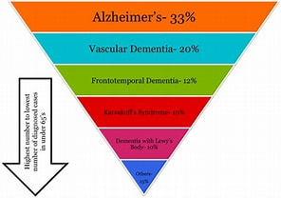
(The Dementia Umbrella,2017)
The cause of Dementia is still not known or understood fully. Through research, developments are being made all the time.
The GP is the possibly first person who will have been approached regarding Dementia. (Alzheimer’s Society, 2019) they will have undertaken different tests, which could identify Dementia. Now that a diagnosis has been made there may be numerous appointments to see different professionals who could become involved in the care, as well as lots of information to digest.
- It is a good idea to make notes of questions you would like to ask the GP or other professionals in the field of Dementia.
- Identifying what stage of Dementia is affecting someone and whether independent living is still possible at this point.
- The GP may also make a referral to a memory clinic for further assessments, you may have accompanied your loved one at these appointments and been involved by sharing information about changes you may have noticed,
- Diagnosis may have come after an MRI or CT scan, or an EEG which would have measured brain activity

What signs may they have been displaying?
- You have noticed recently or for a prolonged period that there have been noticeable changes in the person diagnosed with Dementia. Some of these changes could be physical: for instance, the way in which they walk, you may also have noticed they are becoming more forgetful or confused, a decline in cognitive thinking which affects their independence.
- Other symptoms may be in the way they understand requests and instructions. Others may not recognise themselves or others whom they see regularly.
- Have you noticed signs of anxiety, frustration, and anger? These are known to be associated with Dementia and can be exceedingly difficult to observe happening. Your loved one may have recently been perceived as difficult, or outspoken.
- They may not accept support from you or other caregivers and can at times be violent. It is often difficult to accept that they have been diagnosed with Dementia.
- You have noticed a reluctance to undertake usual routines or a level of aggression, borne by frustration. You may notice they become repetitive, repeating the same thing, or asking the same questions over and over. (Shinkawa and Yomada, n.d)
- Struggling to find the right words during conversations.
What changes can you expect to see
- Initially, there may be subtle changes but as time passes you will notice more significant changes. These could be forgetting people’s names, or not remembering routines, which they may have had for a considerable amount of time.
- You will notice that they become more confused or not able to carry out daily functions. You may notice they begin to shuffle when walking, and their speech and language change. The inability to recognize both themselves and others as elderly people,
- As they speak you will notice their most recent memories are the first to diminish and they may speak about years gone as recent events are the first memories that they lose. It can be devastating for families when the person with Dementia is no longer able to recognise themselves or loved ones.
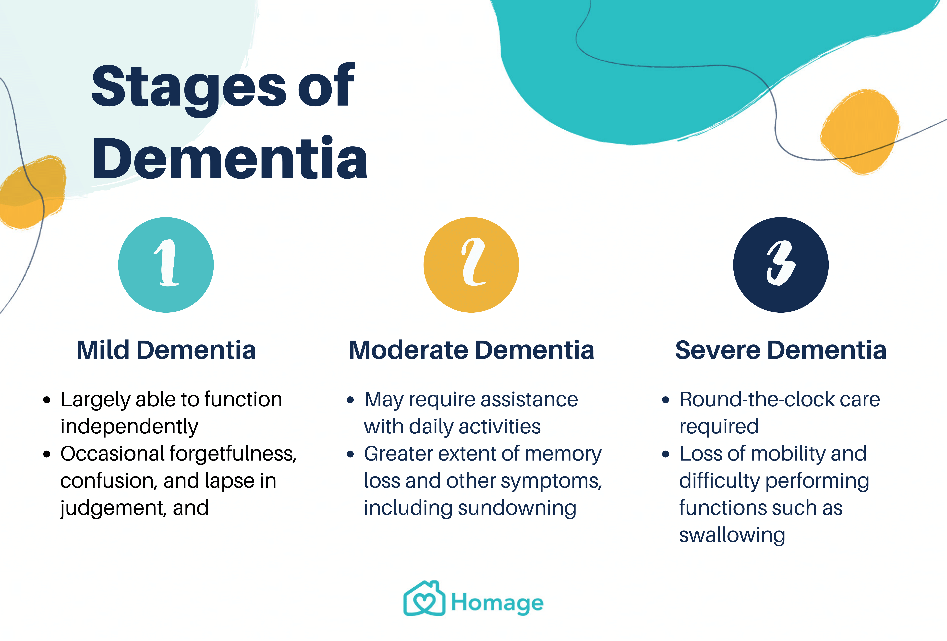
(Hui, 2020)

Who will offer care and support ?
There are many ways in which care and support can be given to your loved one. Some of that may come from the family and a network of friends, Social Care Adults service. They may offer support around living in a safe environment some of this support may involve an assessment from an Occupational Therapist who will be able to offer help and advice. Organizations such as Age UK can offer there may be benefits that can be applied for such as PIP or Attendance allowance, accessed through The Department of Works and Pensions. as a carer you may be able to apply for a Carers Allowance.
Encouraging your loved one to eat a healthy diet and live a healthy lifestyle by keeping a check on Blood Pressure and Cholesterol levels, encouraging them to quit smoking and increase physical activity. Admiral Nurses are a wealth of information and support. Within your local area, there may be charities, support groups, and other agencies offering support. There may be Memory Cafes in your local area to access a safe and calm environment. (AgeUK,2018). There are Dementia Villages, which you may consider if living independently no longer remains the best for the patient. (Yvonne Van Amerongen, 2019) if possible attending a Dementia Bus will allow you some insight as to how life is for someone with Dementia.
What support can the family request?
There are various agencies the family can contact to arrange support. Initially, the General Practitioner could support this. Nurses within the practice could offer support in helping the person to understand Dementia and what to expect. The GP will also offer annual reviews of their health.
If you are caring for the patient, you can request a carer’s assessment for your own needs and support. (Public Health England, 2022)
Consider putting in place domiciliary care, (Age, no date) this involves devising a personalized care package that is Person Centred, this means it is about identifying the areas of support required. that can support your loved one to retain independent living. Some of the support could be offered via Social Care and they can offer care packages. There is financial help and support available for both the person with Dementia and is some circumstances the carer. (NHS Choices, 2019a)
Occupational Therapists could assist in ensuring adaptations are made within the home, to allow the patient to live safely. This will involve a visit to the home and looking at how routine daily tasks are undertaken and if the equipment could enable that to happen. (Bennett et al, 2019)
Dementia treatments
There are different treatments available. (StoriiCare, 2020) Such as drug treatments, which may slow down the progression, or help with some of the symptoms. Alternative therapies such as talking therapies, massage, and sensory rooms are among some of the treatments. (Bastings, 2020) They may be offered alone or in combination to provide a more holistic approach (Alzheimer’s Disease and Dementia, 2016)
It is important to remember it may take some time for the treatments or therapy to work or for a difference to be noticed.
It is important to also remember independence at home is not always able to continue. There are Care Homes and Nursing homes which may need to be considered as Dementia progresses, this is for the safety of the patient (NHS Choices, 2019b).
Useful contacts
GP surgery
Admiral Nurses 0800 888 6678 (Raminder, Sarna, n.d)
Age UK 0800 055 6112
National Dementia Helpline 0300 222 11 22
Carers UK 0808 808 7777
NHS 0300 123 1053
Dementia Research Infoline 0300 111 5 111
NHS Emergency 111
Police 999
You should also get contact details for community transport, and the individual care agencies that may be involved.

‌References

Independent Age (no date). Home care agencies | Independent Age www.independentage.org. Availableat: https://www.independentage.org/get-advice/health-and-care/help-at-home/home-care-agencies?gclid=Cj0KCQiA37KbBhDgARIsAIzce15d0aCFFNoxLO3iL8SXl6aBwuZnrMhhuk9dqiKf80HHzXwlZiWV5hEaAsQDEALw_wcB [Accessed 10 Nov. 2022
‌AGE UK (2018). The UK’s largest charity working with older people.Available at: https://www.ageuk.org.uk/ (Accessed: 10 November 2022).
Alzheimer’s Disease and Dementia. (2016). Alternative Treatments. Available at: https://www.alz.org/alzheimers-dementia/treatments/alternative-treatments.
Alzheimer’s Research UK. (no date). Types of dementia. Available at: https://www.alzheimersresearchuk.org/dementia-information/types-of-dementia/?gclid=Cj0KCQiA37KbBhDgARIsAIzce15CyZKVLwrOJvHD4GIW3N3XQrW6aCB8ahsCf0XiU2CgKn7_Uw4O4YwaAgQUEALw_wcB (Accessed: 10 November 2022).
Alzheimer’s Society. (2019). How the GP can support a person with dementia. Available at: https://www.alzheimers.org.uk/get-support/help-with-dementia-care/how-gp-can-support-person-dementia. (Accessed: 10 November 2022).
Anderson, E. (2018). Being with Older People. Routledge.
Available at: https://www.proquest.com/openview/59b69be6fa356b8362df81720902ad21/1?pq-origsite=gscholar&cbl=2042228 (Accessed: 28 October 2022).
Basting, A. (2020). How to meaningfully reconnect with those who have dementia. TED. Available at: https://www.ted.com/talks/anne_basting_how_to_meaningfully_reconnect_with_those_who_have_dementia (Accessed 14 Apr. 2021).
‌Bennett, S., Laver, K., Voigt-Radloff, S., Letts, L., Clemson, L., Graff, M., Wiseman, J. and Gitlin, L. (2019). Occupational therapy for people with dementia and their family carers provided at home: a systematic review and meta-analysis. BMJ Open, 9(11), p.e026308. doi:10.1136/bmjopen-2018-026308.
College of Occupational Therapists (no date) Occupational therapy helping people to live with dementia. Available at: https://bathneshealthandcare.nhs.uk/wp-content/uploads/2017/03/Occuppational-Therapy-Dementia-leaflet.pdf. (Accessed: 8 November 2022).
‌Dementia Matters. (no date). Types of dementia. (online) Available at: https://www.dementiamatters.net/Pages/Category/types-ofdementia?gclid=Cj0KCQiA37KbBhDgARIsAIzce17H9gLSeFXrg34zyR5vSiHJzqe9atjiyPv7kd20WJlDP2jsy1pUI88aAgXmEALw_wcB (Accessed: 10 November 2022).
Dening T. and Sandilyan MB. (2015) Dementia: definitions and types. Nursing Standard. 29 (37), pp.37-40.
Dr Colin Tidy (2018). Medication and Treatment for Dementia. Available at: https://patient.info/brain-nerves/memory-loss-and-dementia/medication-and-treatment-for-dementia. (Accessed: 10 November 2022).
Feldman, H.H., Jacova, C., Robillard, A., Garcia, A., Chow, T., Borrie, M., Schipper, H.M., Blair, M., Kertesz, A. and Chertkow, H. (2008). Diagnosis and treatment of dementia: 2. Diagnosis. Canadian Medical Association Journal, (online) 178(7), pp.825–836. doi:10.1503/cmaj.070798.
Hui, T.J. (2020). Dementia 101: Symptoms, Types, Stages, Treatment and Prevention. Homage. Available at: https://www.homage.sg/health/dementia/.
Independent Age, (no date). Home care agencies Available at: https://www.independentage.org/get-advice/health-and-care/help-at-home/home-care-agencies?gclid=Cj0KCQiA37KbBhDgARIsAIzce15d0aCFFNoxLO3iL8SXl6aBwuZnrMhhuk9dqiKf80HHzXwlZiWV5hEaAsQDEALw_wcB (Accessed: 10 November 2022).
‌Knopman, D.S. (1998). The Initial Recognition and Diagnosis of Dementia. The American Journal of Medicine, 104(4), pp.2S12S. doi:10.1016/s0002-9343(98)00022-9.
NHS Choices (2019a). Dementia and care homes - Dementia guide. Available at: https://www.nhs.uk/conditions/dementia/care-homes/.
NHS Choices (2019a). Dementia and managing money - Dementia guide. Available at: https://www.nhs.uk/conditions/dementia/finances/ (Accessed: 8 November 2022).
Nordoff Robbins. (no date). Music Therapy for Dementia | Music, and Dementia. Available at: https://www.nordoff-robbins.org.uk/music-therapy-and-dementia/?gclid=Cj0KCQiA37KbBhDgARIsAIzce16IkHjDnH6zMiyPmx_2MojSajCWEh1qR1tcJuVcOpDrVonyUoPLUVkaAhDXEALw_wcB. (Accessed: 8 November 2022).
Public Health England (2022). Dementia: Applying All Our Health. GOV.UK. Available at: https://www.gov.uk/government/publications/dementia-applying-all-our-health/dementia-applying-all-our-health.
‌Raminder Sarna, R.T. (no date). Admiral nurses’ role in a dementia carers’ information programme. (online) journals.rcni.com. Available at: https://journals.rcni.com/nursing-older-people/admiral-nurses-role-in-a-dementia-carers-information-programme-nop2008.11.20.9.30.c6810 (Accessed: 1 November 2022).
‌Sinkawa and Yamada (no date). Studies of Health Technology and informatics. (online) pp.641–645. Available at: https://ebooks.iospress.nl/doi/10.3233/978-1-61499-852-5-641 . (Accessed: 8 November 2022).
StoriiCare (2020). Have You Tried These Alternative & Complementary Therapies for Dementia? Available at: https://www.storiicare.com/blog/alternative-therapies-dementia (Accessed: 8 November 2022).
‌The Dementia Umbrella.” Spring Chicken, Spring Chicken, 25 July 2017, springchicken.co.uk/guest-posts/the-dementia-umbrella/. Accessed 1 November 2 Grossman, H., Bergmann, C. and Parker, S. (2006). Dementia: a brief review. The Mount Sinai journal of medicine, New York, (online) 73(7), pp.985–992. Available at: https://europepmc.org/article/med/17195884 (Accessed: 8 November 2022).
World Health Organization: WHO (2019). Dementia. (online) Who.int. Available at: https://www.who.int/health-topics/dementia#tab=tab_1.
www.mha.org.uk. (no date). Dementia Nursing Care | Care Homes Tailored To You | MHA. (online) Available at: https://www.mha.org.uk/care-homes/dementia-nursing-care/.
‌Yvonne van Amerongen (2019). The ‘dementia village’ that is redefining elder care. TED. Available at: https://www.ted.com/talks/yvonne_van_amerongen_the_dementia_village_that_s_redefining_elder_care. (Accessed: 8 November 2022).

