Mikolaj Michalski (1900885)
1900885@student.uwtsd.ac.uk
Networking and CyberSecurity

Networking programmability
Assignment 2: Code implementation report

Table of Contents
1. Introduction 2
2. RESTful API 2
3. Code plan 2
4. The code 2
4.1. First commit 2
4.2. Second commit/change 4
4.3. Third change in code 5
4.4. Final code 7
5. Finished application (Code cleaned up) 10
6. Conclusion 11

Introduction
This assignment covers the API used, the way that the code was planned at the start, along with the code itself. This also covers the mistakes and things that could not make it to the final program that would be nice to add in the future.

RESTful API
This assignment required the use of a RESTful API. This was used to pull specific data from the API and then used within the code. The API that was used in the code was a “Guild Wars 2” API. This is then used to pull information from the account. The individual who uses the application will require an API token of their own so that the information can be displayed. This is an authentication feature to ensure only people who have the tokens should be able to access and view their account features through their accounts.

Code plan
The idea for the code was to make an anime news program that would display the recent news along with the top 10 anime of the week or something along those lines that was possible. However, after several small tests , no API was easy enough to use. The idea then moved to make the Guild Wars 2 API.

The code

First commit
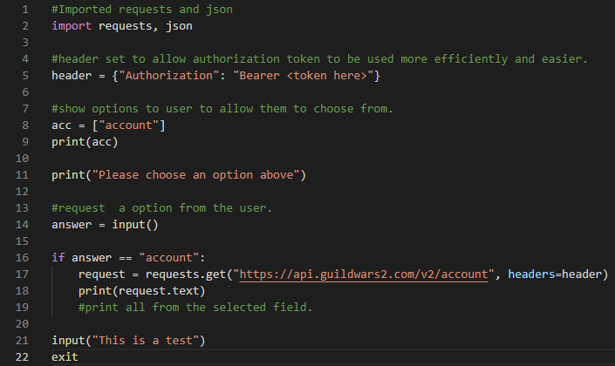
This is my first commit of the code. This code was set up in a way to be able to see if everything works. The typical “hello world” test is not used as its obvious that something of that ease would work as a code. Moving on to the first direct code would be printing whatever possible from the API. Following this code, the output of weird json was returned. This helped as it showed the code works and can be used later.
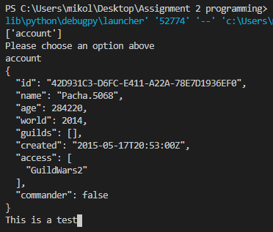

Second commit/change
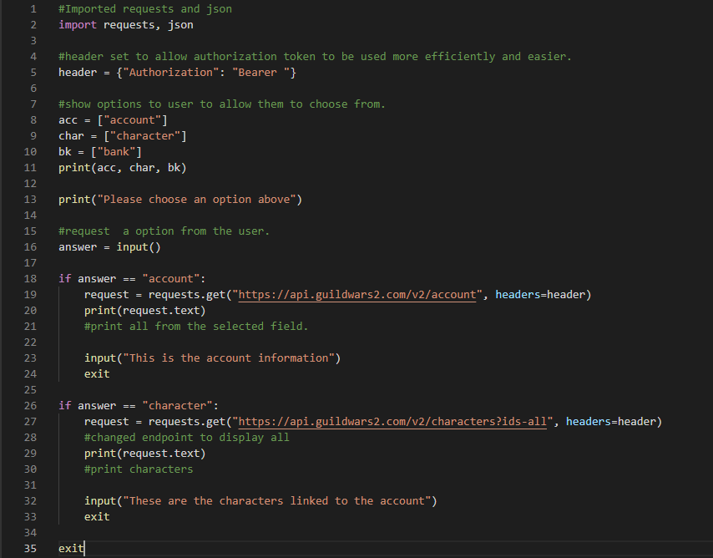
This is the first additions made to the code. After seeing that the previous code worked the plan was made to add another endpoint to see if it can also gather information. After testing that endpoint this result was given.
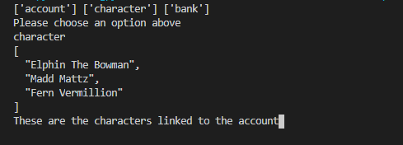
The endpoint gives those results using the API token. With this knowledge, it was easier to continue making and adding more endpoints and/or code to improve upon the application.

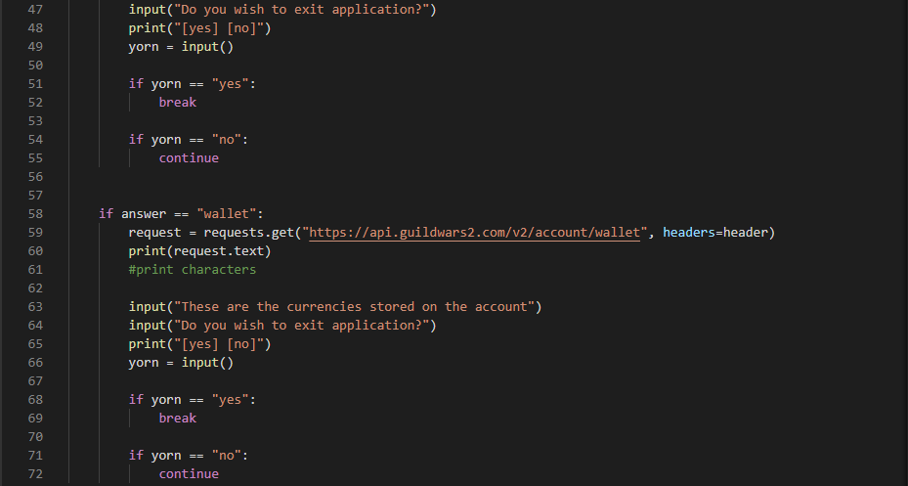
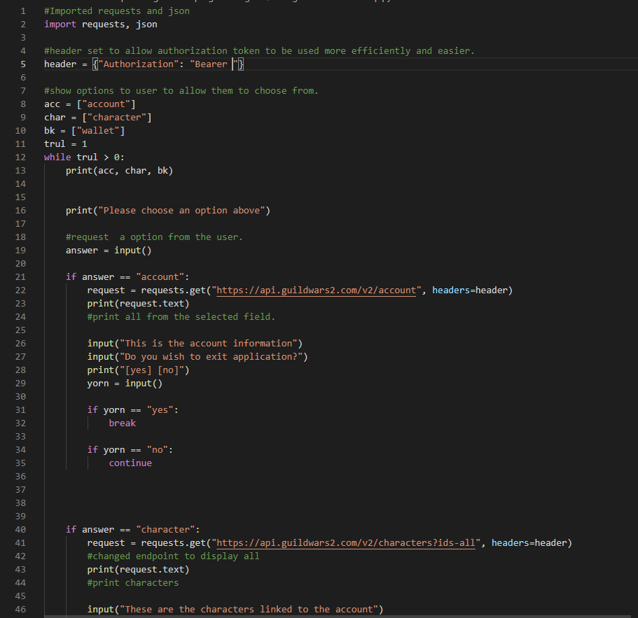
Third change in code

The third change in code. In this change of the code, there was a while loop added. Along the loop, an endpoint was added for the user to use. The loop works infinitely to and is only broken out when the user wants to leave the application. Because of that, another IF statement was added to give the user a choice of staying in or breaking out of the loop.
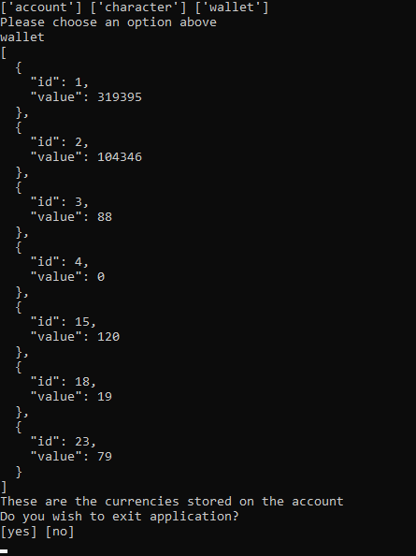
When the code is run the additional endpoint was chosen to show that it gathers information. The option then appears to exit the application. When the user inputs “yes” the application exits. Then when inputting “no” the application loops.

Final code
For the final parts of the code, each screenshot will be explained separately due to there being more to talk about than the previous snippets.
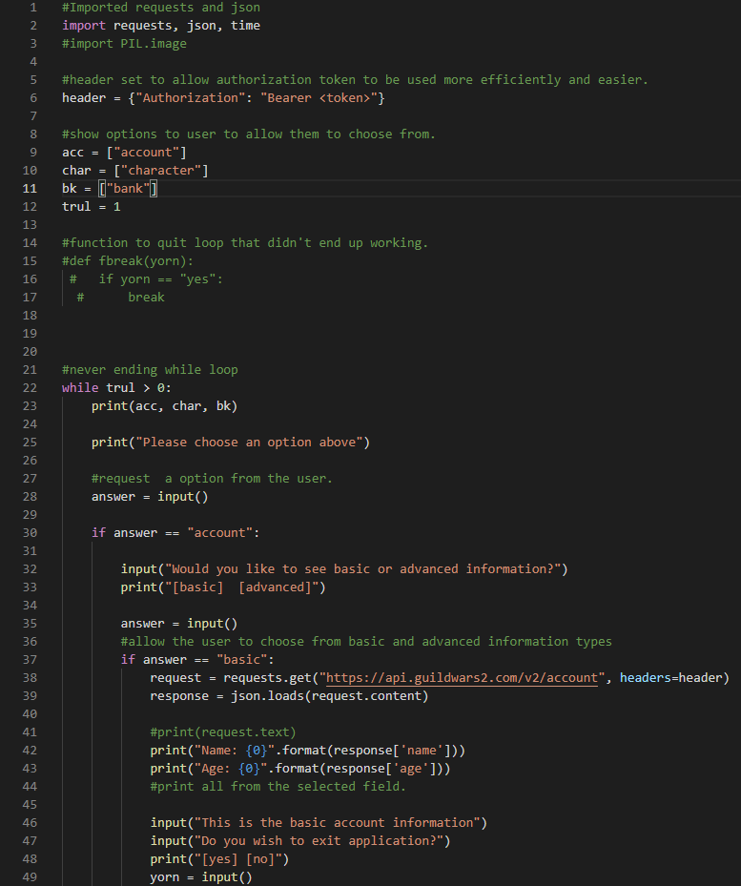
From the screenshot above you can see that there was an attempt at adding a function. Later it was found that the loop cannot be broken through a function therefore the idea was scrapped but kept in comments until the code clean up section. A new import has been added called “time” that is used later in the code.
The first endpoint also changed drastically. The user is now able to pick between basic and advanced information. Both use the command “json.loads” to then filter and pick out specific content. For example, the basic option picks just the age and name of the account.
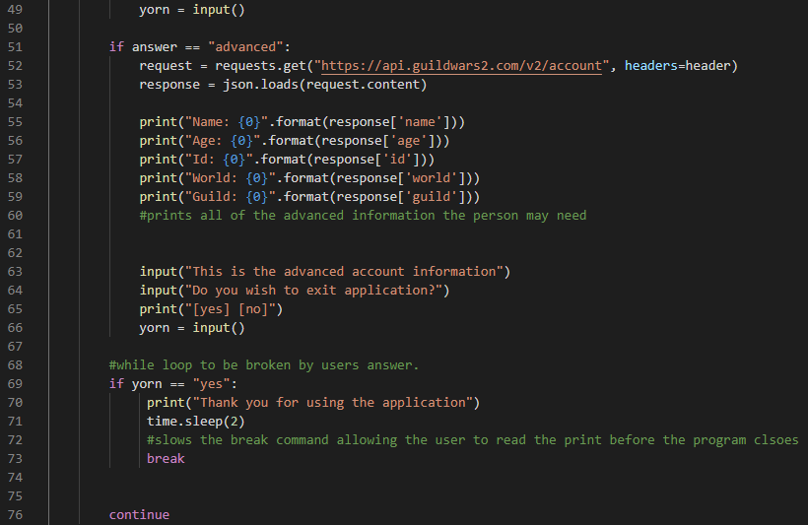
The advanced option prints out the Id, the world the account is on as well as the Guild that they could be in. This is along with the information that is also given in the basic option.
The exit option now displays a thank you message for the user that uses it. It prints the message then sleeps for 2 seconds allowing the message to be read before it closes. This is used for exiting at every part of the application.
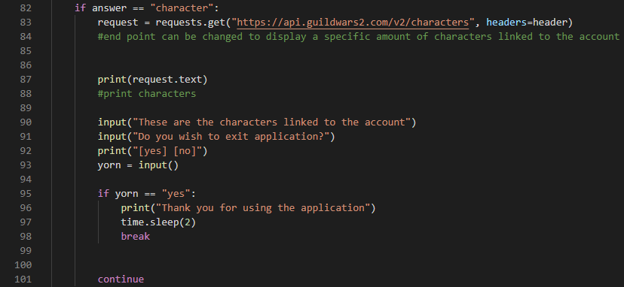
Compared to the other version nothing much changed. This was due to the fact the information received turned out to be in a list. After several attempts of trying to filter by character, there was an issue with the fact every one may have different amounts of characters. The best option was to keep it the same.
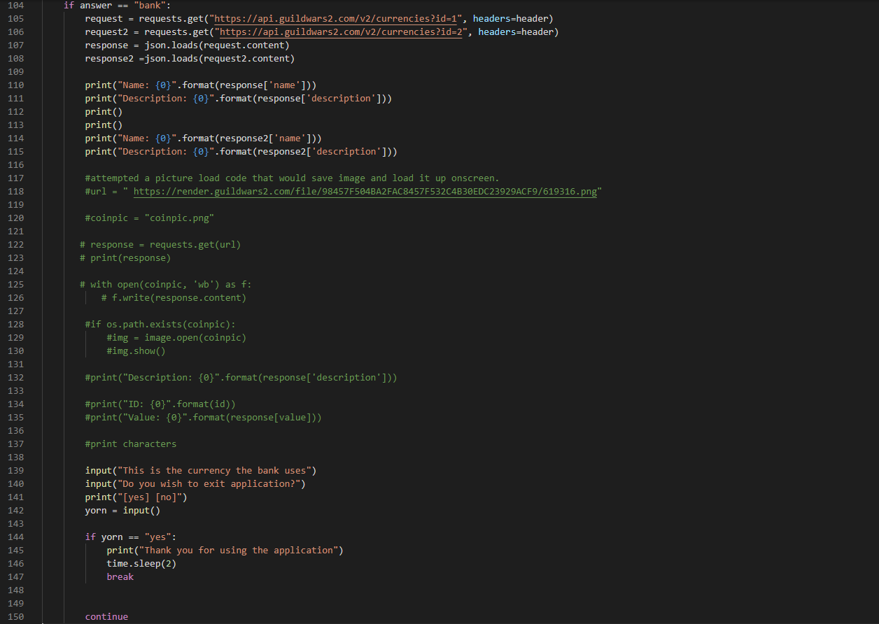
The end and final bit of code. The “wallet” has changed to a bank. This is due to not being able to display just the amount of gold the user has on the account after countless attempts. Instead, the bank shows the 2 currencies that can be used that are taken using 2 separate endpoints and filtered to show just the name and description.
There was also the attempt of making the system download and display the image of the currency. The first attempt was the coin. In the end, the file directory that stores everything turned out to be broken and could not download and import the “image” module. (This was tested separately, and code supposedly works).

Finished application (Code cleaned up)
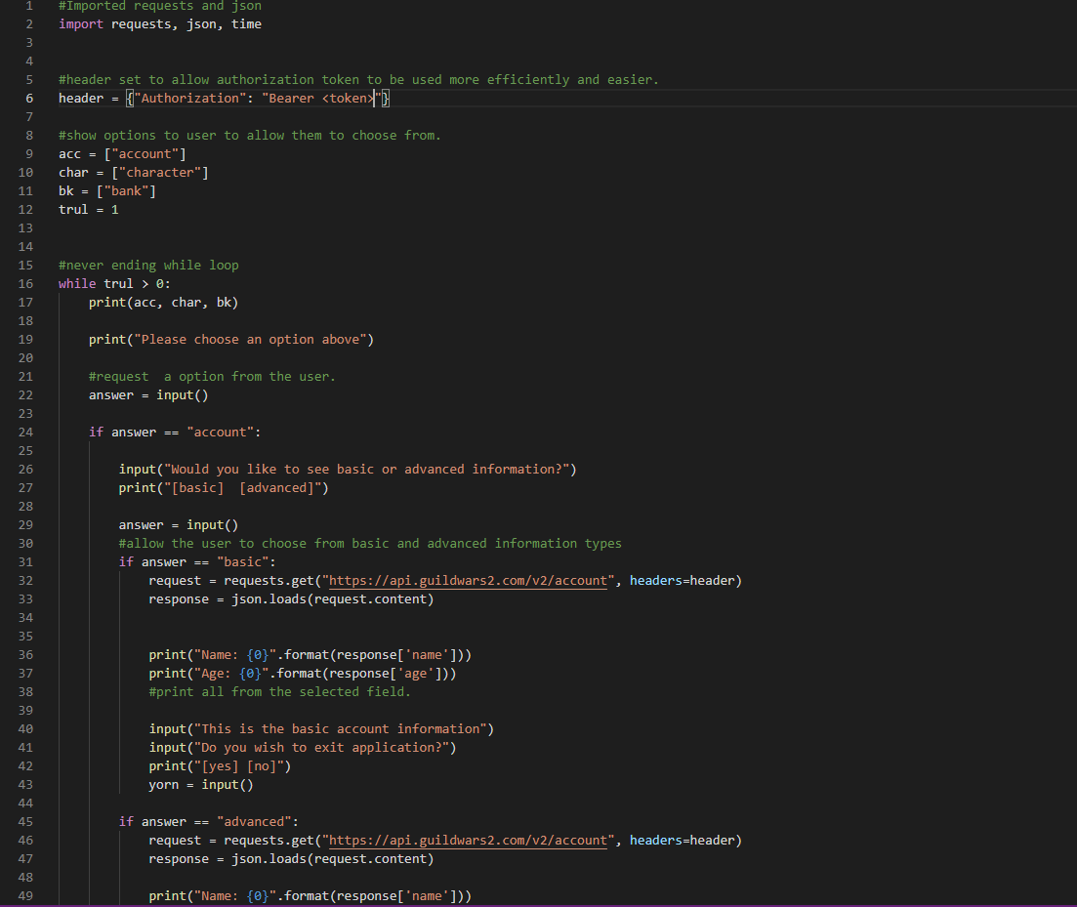
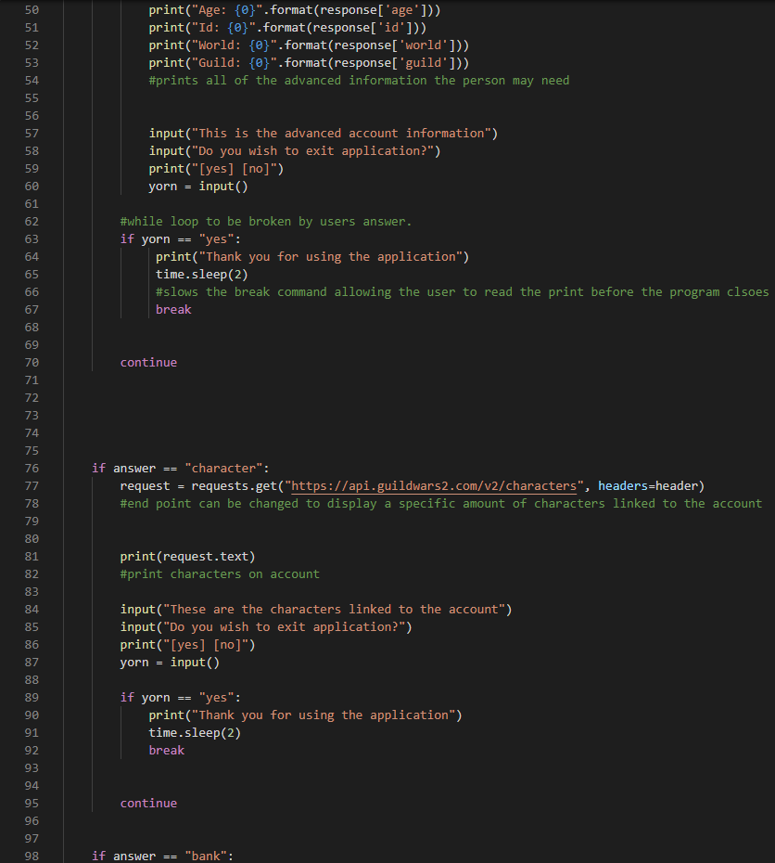
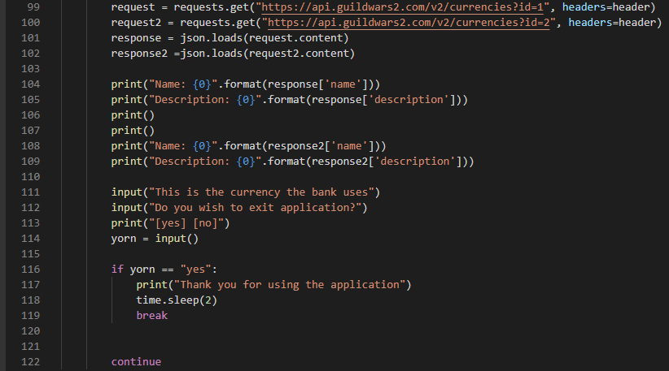
This is the final code with the comments of the old code removed to make it more readable and easier to understand.

Conclusion
The author of the assignment is happy with the result as they had no previous knowledge of python before this began. However, the author would have liked the commented-out code to work as it would have been a much better application overall. In the end. The author is still happy with the progress he made while working with python.

