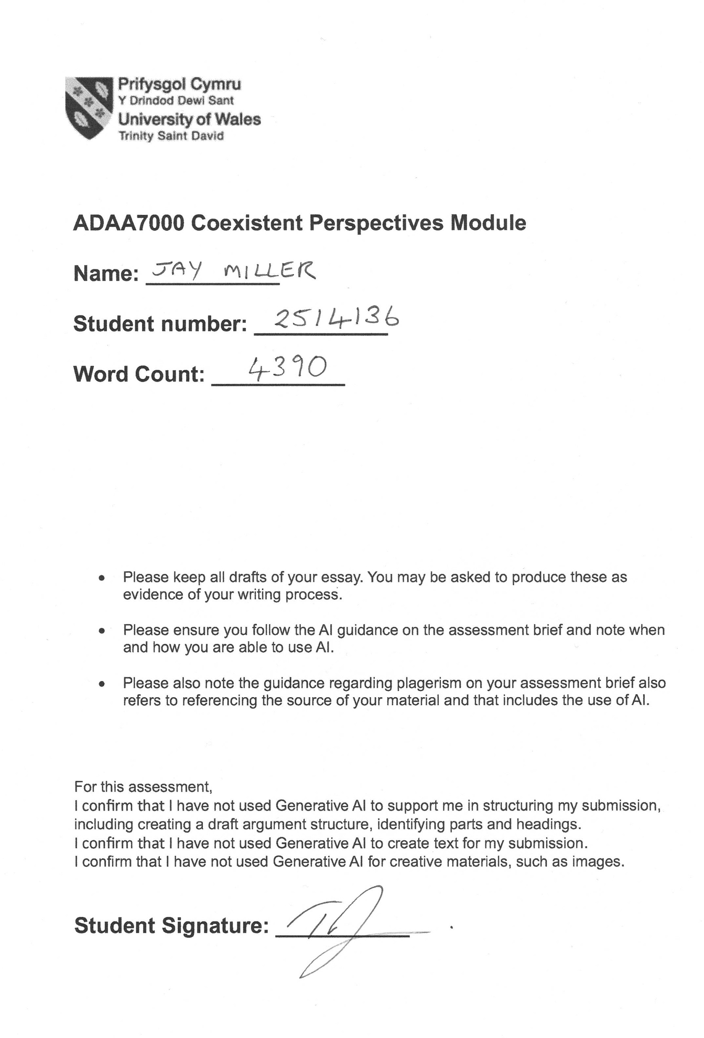

Question 3. Space and Place

Essay Title
Architectures of Absence: The uncanny and the eerie in the constructed environments of Gregor Schneider and Mike Nelson.

Abstract
‘Architectures of Absence’ explores the relationship between presence and absence within constructed space. The essay examines two of Gregor Schneider’s domestic environments, ‘Haus ur’ (1985-ongoing) and ‘Die Familie Schneider’ (2004), alongside Mike Nelson’s immersive installation, ‘The Coral Reef’ (2000 and 2010). Schneider enacts Freud’s uncanny through doubling, repetition, and concealment, while Nelson produces Mark Fisher’s eerie through a maze of unpopulated spaces that retain traces of past occupation. In both cases, absence is not an idea to be interpreted but a sensation to be undergone. The essay draws on several theoretical perspectives. Freud’s concept of the unheimlich shows how the familiar becomes a source of dread; this is central to analysing Schneider’s domestic installations. Anthony Vidler builds on Freud, extending the uncanny to architectural spaces. Fisher investigates the concept of the eerie, defined as a ‘failure of presence’, which forms the main framework for analysing Nelson’s work. Derrida’s hauntology provides a structure for understanding presence and absence, and Deleuze offers a distinction between representation and sensation. This essay argues that both artists build installations where absence operates as an active force rather than a void. Despite employing contrasting strategies, the artists reveal that presence and absence are not opposites but are produced simultaneously and are inseparable conditions of built space.

Introduction
“The house shelters daydreaming, the house protects the dreamer, the house allows one to dream in peace," writes Gaston Bachelard (1958, p.28) in ‘The Poetics of Space’. He proposes that architecture’s purpose is to provide a safe and stable environment, acting as a source of security. But what happens when, instead of being a source of protection and refuge, constructed space actively creates an environment that generates feelings of disorientation and dread?
The immersive installations of Gregor Schneider and Mike Nelson subvert the idea of architecture as a source of safety and protection. Both produce environments where absence, rather than presence, becomes the overriding force. In these installations, absence is not just emptiness but can be felt, turning built space into a site of unease and instability.
While Schneider and Nelson both create architectural installations that make absence felt, they use contrasting strategies. Schneider’s long-term work, ‘Haus ur’, is an immersive sequence of rooms duplicated within themselves (Mosar, 2025, p.65), hiding the original rooms beneath layers of construction (Mosar, 2025, p.72). This creates a space that is claustrophobic and destabilising, transforming what should be familiar and homely into a site of unease. He produces absence by adding, every new wall hides the one behind it. In contrast, Mike Nelson creates labyrinthine environments, empty of inhabitants but with traces of past occupation (Bishop, 2005), evoking an eerie sense of absence and psychological unease. In his work, absence emerges through omission, by what he leaves out, so his spaces feel recently abandoned and haunted by a lingering presence.
This essay will explore the relationship between presence and absence in these installations, focusing on Nelson’s ‘The Coral Reef’ and Schneider’s, ‘Haus ur’ and ‘Die Familie Schneider’. This leads to the central question: How do the constructed environments of Mike Nelson and Gregor Schneider make absence architecturally and psychologically present, and what do their contrasting uses of the uncanny and the eerie reveal about the relationship between presence and absence within built space?
To address this question, the essay draws on several theoretical perspectives. Sigmund Freud’s concept of the unheimlich shows how the familiar becomes a source of dread, which is central to analysing Schneider’s domestic installations. Anthony Vidler extends Freud’s idea to the built environment in ‘The Architectural Uncanny.’ Mark Fisher examines the weird and the eerie. One form of the eerie, defined as ‘a failure of presence’, forms the main framework for analysing Nelson’s work. Derrida provides a theory for understanding the relationship between presence and absence. Finally, Gilles Deleuze’s theories on art and sensation suggest that these installations should be approached as experiences rather than as meanings to be interpreted.
Despite opposing strategies, both artists’ work reveals the same insight about the nature of built space, an insight this essay argues reaches beyond the gallery into a wider architectural and psychological context.

Theoretical Background
Sigmund Freud's 1919 work, ‘Das Unheimlich’, examines the uncanny as a psychological phenomenon. This exploration developed from earlier writings by Burke and Kant, who saw the uncanny as relating to the sublime. Freud extends the earlier work of Ernst Jentsch (1997), who defined the uncanny as a feeling of doubt about the unknown, deriving from intellectual insecurity (Royle, 2003, p.52). Freud argued that the uncanny must be more than mere uncertainty about what is known, and set out to define it (Freud, 1919, p.125).
Freud (1919, p.132) noted that the German word for uncanny, ‘unheimlich’, means ‘unhomely’. ‘Heimlich’ translates as ‘homely’ but also can mean something concealed or kept hidden. This insight into the “slow unfolding of the homely into the unhomely” (Vidler, 1992, p.25) led Freud to view the uncanny as the resurfacing of something hidden and therefore familiar. This adds another level to the definition beyond the unknown as proposed by Jentsch. According to Freud, an experience of the uncanny might occur if something that should remain hidden in the unconscious re-emerges in the present. This produces a combination of the familiar and the unfamiliar, which creates a disturbing contradiction between the known and the unknown. “For this uncanny element is actually nothing new or strange, but something that was long familiar to the psyche and was estranged from it only through being repressed” (Freud, 1919, p.148).
Freud further differentiates between two species of the uncanny. One arises from the return of repressed fears and anxieties. The other comes from the reinforcement of primitive convictions. He writes, “the uncanny element we know from experience arises either when repressed childhood complexes are revived by some impression, or when primitive beliefs that have been surmounted appear to be once again confirmed” (Freud, 1919, p.155). “According to the latter theory, we all inherit, both on a phylogenetic and ontogenetic level, ‘primitive’ beliefs in magical and animistic phenomena” (Windsor, 2019). Freud argues that the familiar is essential to both types of the uncanny, and it is the combination of the unfamiliar and the familiar that leads to feelings of unease and dread.
Building on Freud’s ideas, Nicholas Royle connects the notion of the familiar to domesticity and the home. He writes, “The uncanny can take the form of something familiar unexpectedly arising in a strange and unfamiliar context”, or it can reveal something unhomely in the heart of the home. (Royle, 2003, p.1). Freud identified factors that create the uncanny: ‘repetition’ (Freud, 1919, p.144), doubling (p.141), déjà-vu, something hidden resurfacing, and when “the boundary between fantasy and reality is blurred” (p.150). In a domestic setting, these methods can transform the familiar, such as a home, into something disturbingly altered. These ideas support the analysis of Gregor Schneider’s domestic interiors and his creation of the unhomely.
Later thinkers expanded on Freud’s theory. For example, Lacan’s theory of extimacy helps us understand the effect produced by Schneider’s constructions. Unlike Freud’s uncanny, where the familiar becomes strange, Lacan argues that the alien is situated at the core of the familiar. This describes what Schneider produces: strangeness is not introduced into the home but is created from within the familiar, domestic structure (Dolar,1991).
Slavoj Žižek builds on Lacan, applying the concept of the ‘Real’ to everyday experience. He argues that the familiar conceals a disturbing core beneath its surface (Lechte, 2008, p.252). The uncanny emerges when this illusion fails, and the traumatic nature of existence becomes visible. He maintains that “The kernel of reality is horror, horror of the Real, and what constitutes reality is the minimum of idealization the subject needs in order to be able to sustain the Real” (Žižek, 1997, p.22). Applied to Schneider’s domestic spaces, this suggests that the disturbance is not external but was always underneath. The visible rooms of ‘Haus ur’ can be viewed as ‘the minimum of idealisation’, the domestic, familiar surface concealing the inaccessible spaces behind.
Freud’s examination of the uncanny is mostly psychoanalytical, though he notes a linguistic link through heimlich and homely. Anthony Vidler builds on Freud by exploring the uncanny in built space. Vidler (1992, p.12) recognises that buildings can exhibit uncanny qualities and provoke unease. He argues that modern architecture, through new materials, surveillance, automation, and deconstruction, can provoke anxiety or alienation (Vidler, 1992, p.13). The uncanny, for Vidler, is both psychological and a condition of the modern built environment (Vidler, 1992, p.8).
While Schneider’s domestic constructions exemplify Freud’s uncanny, Nelson’s installations evoke unease for a different reason. Nelson’s environments are not homely or domestic; their discomfort comes from something other than making the familiar strange. To understand the source of discomfort in Nelson’s work, we turn to Mark Fisher. In his 2016 work, “The Weird and the Eerie”, he explores the strange, defining the eerie and the weird as two distinct modes with specific properties (Fisher, 2016, p.9). Unlike Freud's uncanny, which situates the strange within the familiar, Fisher (2016, p.10) proposed that the weird and the eerie work from the other direction, “allowing us to see the inside from the perspective of the outside”. He argues that the weird and the eerie are a disturbance of reality or agency. He views them as modes of strangeness that break normal expectations, a “fascination for the outside, for that which lies beyond usual perception, cognition and experience” (Fisher, 2016, p.8).
For Fisher (2016, pp.10,15), the weird is an intrusion by an outside presence that causes a feeling of wrongness. While the weird involves a presence, he suggests that the eerie is constituted by an absence and concerns existence and non-existence (Fisher, 2016, p.12). Fisher explains the eerie arises when “there is something present where there should be nothing, or nothing present where there should be something” (Fisher, 2016, p.61). He defines it as “a failure of absence or a failure of presence,” creating uncertainty about agency and causation (Fisher, 2016, pp.11, 61-64). It is this speculation and suspense, which contrasts with the sensation produced by the weird, that Fisher identifies as key to the eerie.
This linking of the eerie with a sense of mystery and the opposition of presence and absence clarifies Nelson’s environments in contrast to Schneider’s. Nelson’s installations are composed of maze-like corridors and rooms, “each of which appears to belong to a recently departed individual or group of individuals” (Bishop, 2005, p.44). While the rooms are filled with objects, the inhabitants are missing. This failure of presence produces a sensation of the eerie, where there is “nothing present where there should be something” (Fisher, 2016, p.61). Importantly, the eerie absence in Nelson’s work contrasts with Schneider’s uncanny, which arises instead from a strangeness introduced inside the familiar.
Further, Derrida provides the philosophical framework for understanding the relationship between presence and absence. In the ‘Specters of Marx’, he argues that presence is never pure but always inhabited by traces of what has passed (Derrida,1994). Applied to architectural space, this means that a built structure carries traces of previous use and what is concealed beneath the surface.
In these installations, the uncanny and the eerie act on the viewer as experiences, and not as something to interpret. This distinction is clarified by Deleuze’s theory of art as producing sensation rather than meanings to be understood (Deleuze, 2017). For Deleuze, art’s power lies not in producing meanings, but in creating sensations, affects and intensities that act directly on the body (Grosz, 2008). This helps explain how these environments work; the experience is felt before it is understood.

Gregor Schneider
Gregor Schneider’s installation, ‘Haus ur’, in Rheydt, Germany, is also the location of his childhood home. He began using the vacant house as an art studio in 1985 and started restructuring the interior. He duplicated rooms, creating identical ones within existing ones, where “the new rooms were smaller, more menacing. The whole house was directed in upon itself - a kind of morbid regression” (Coxhead, 2008).
Schneider’s construction of a room within a room creates absence by concealing the original version. He explains, “What is exciting for me is that from the moment I rebuild a room, the original room that lies behind it becomes hidden, and the newly built room is accepted as a room that has always existed. For me, this emptiness is part of the work” (Williams, 2010, p.2). The newly constructed room becomes a duplication of itself whilst simultaneously concealing the original one, a situation in “which presence and absence, construction and elimination are indistinguishable from one another” (Mosar, 2025, p.76).
Developing these interventions, Schneider not only built rooms within rooms but also installed moving ceilings and rotating rooms, creating a disorienting environment in which doors led to unexpected places. “When movement is then introduced into the process, whole rooms begin to turn, or ceilings move up or down – one finds oneself imperceptibly within a completely alienated time frame” (Williams, 2010). This leads to internal windows not corresponding to the exterior, and to artificially lit windows looking out onto other windows or onto blank walls (Auslander, 2003, p.86).
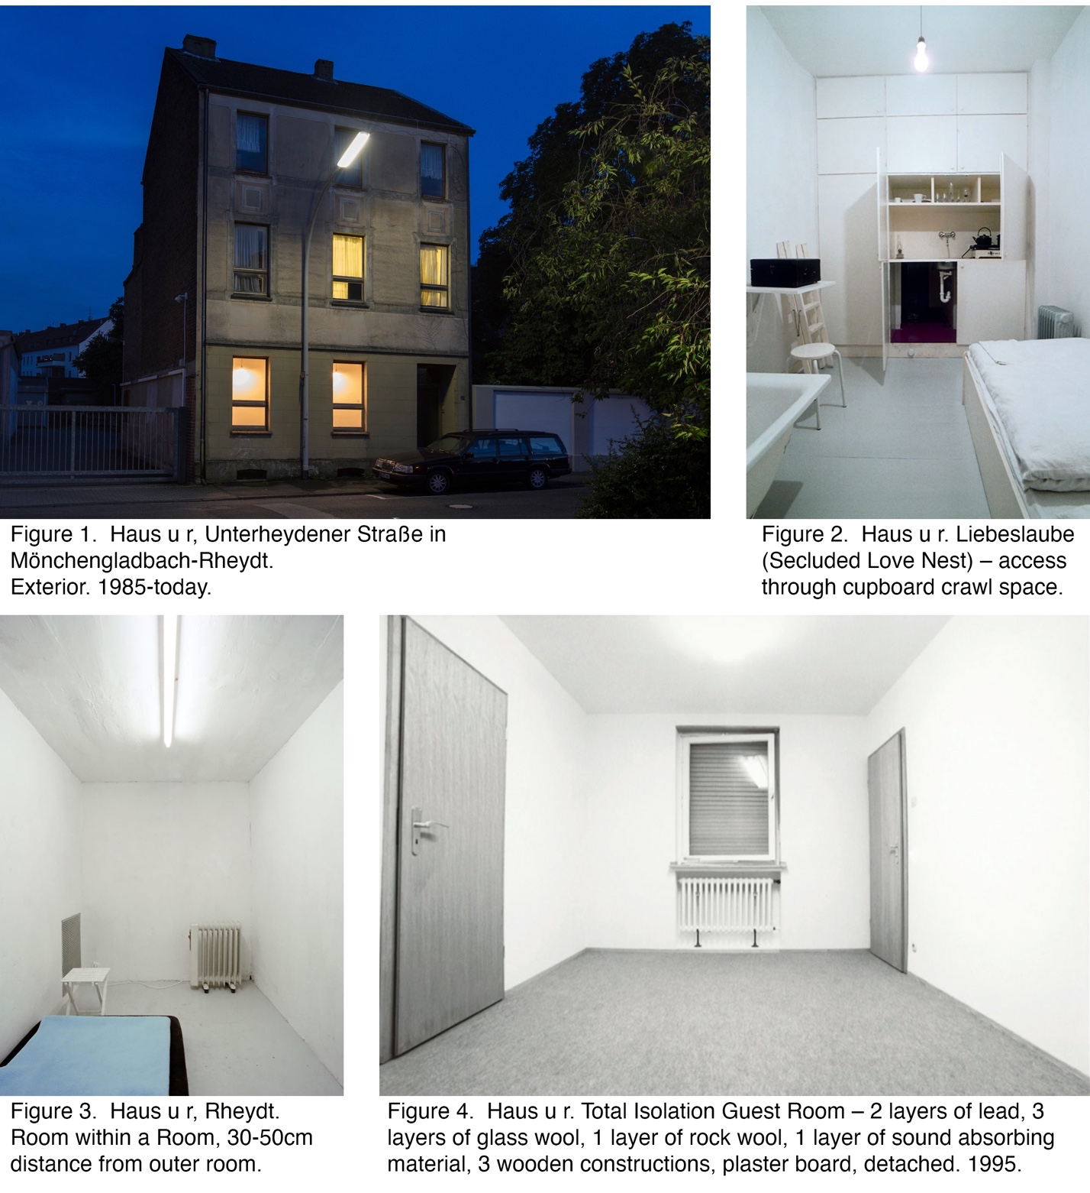

Schneider reconfigured walls and doors and placed false walls in front of existing ones, creating voids and inaccessible spaces (Davidts, 2013). “Even if you enter and leave by the same door,” Schneider says, “you end up in a different place. And if you open the wrong door at the wrong time, then you fall into the space between” (Coxhead, 2008). He often fills these hidden voids with coloured bricks or photographs, even though they will never be seen (Auslander, 2003, p.87). Schneider considers these invisible works as important as the visible. He believes they affect both conscious and unconscious perceptions of space (Birnbaum, 2000), and that traces of the original architecture and past events linger. Agreeing with Husserl that, even if things are hidden, “the remain present, spatially and temporally” (Trigg, 2013, p.28). He asserts that the underlying materials of walls can “alter the effect of a room without you quite being able to say why.” The spectator’s experience changes due to factors beyond perception (Auslander, 2003, p.87).
The combined effect of these strategies shifts the perception of the house. Superficially, the house appears habitable. Yet the effect is anything but "homely”, provoking terror in its visitors (Williams, 2010, p.4). Freud identifies this sense of the unhomely (unheimlich) as the uncanny. He defines it as a disturbing experience rooted in something once familiar and long known. Freud describes the uncanny as “something that was long familiar to the psyche and was estranged from it only through being repressed” (Freud, 1919, p.148). In this context, Anthony Vidler (1992, p.17) observes that “the house provided an especially favored site for uncanny disturbances: its apparent domesticity, its residue family history and nostalgia, its role as the last and most intimate shelter of private comfort…”.
In 2001, Schneider reconstructed ‘Haus ur’ at the Venice Biennale. He dismantled and rebuilt rooms from the first house, renaming it ‘Totes Haus ur’ (Dead House ur), highlighting his belief that moving the work from a private to a public context results in its ‘death’. Schneider agrees with Richard Serra that relocating site-specific art effectively destroys it (Kaye, 2000, p.2).
Carrying this investigation of domestic duplication forward, Schneider created ‘Die Familie Schneider’ in 2004: two identical adjacent houses in Walden Street, London. After collecting keys, paired visitors entered each house alone, then exchanged keys and entered the second. It became clear that it was an exact duplication of the first house, with every detail doubled (Mosar, 2025, p.97). Both houses were inhabited by a family: a woman washing dishes, a naked man in the shower masturbating, and a small figure covered in a black plastic bag in the windowless bedroom (www.artangel.org.uk, n.d.). Not only were the two houses identical, but, uncannily, they also seemed to be peopled with the same inhabitants performing the same actions (Education Notes, n.d.), thereby evoking a disturbing sense of déjà-vu (Rumsby, 2004). This sense of doubling was reinforced by the actors, who were pairs of identical twins. Ignoring the observers, they continued their tasks without speaking (Mosar, 2025, p.99). This prompted visitors to question their own role, often feeling discomfort being unseen intruders in a private space.
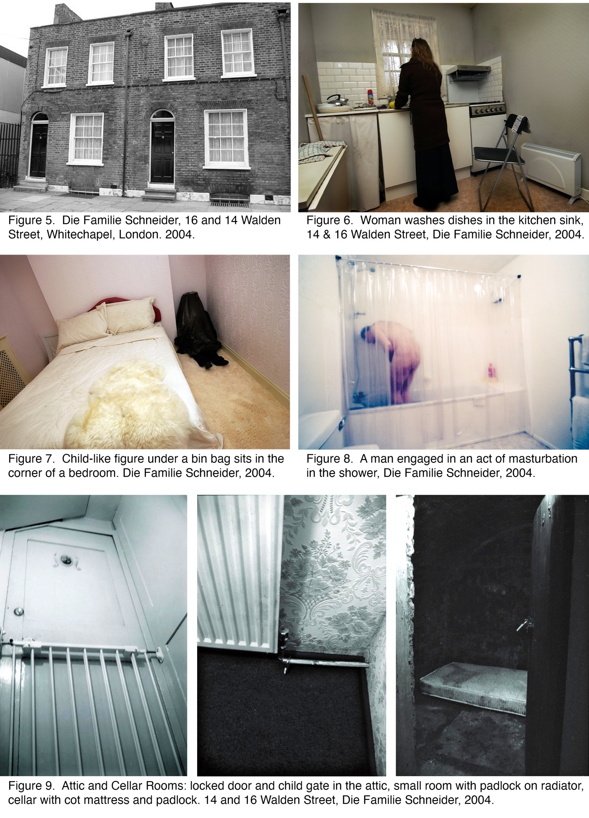
“The ‘familiarity' of the interiors, so perfectly duplicated, conveys a sense of displacement and claustrophobic apprehension” (Albano, 2008). This doubling and the familiarity of domestic interiors foregrounds Freud’s uncanny (Trigg, 2013, p.28). Freud sees repetition and the double as sources of terror, linked to primitive fears hidden in the psyche: “something that has been repressed and now returns” (Freud, 1919, p.147). Schneider noted, “Visiting these two identical houses, with rooms occupied by identical twins behaving identically, caused unpredictable and extreme responses” (Williams, 2010, p.4). He suggests, “Visitors found it especially awful to encounter what seemed the very same room, with the very same people, a second time in the second house, and to re-experience the very same uneasy feelings again” (p.4). “Normally,” Schneider explains, “daily lives are something that we experience uniquely. But there you experienced a daily life that wasn’t unique anymore. This was for many people a very intense experience” (Lloyd, 2020). “The impression that a unique event could actually repeat itself was perceived as horrifying,” Schneider says. It “exposes deficiencies in our perceptual apparatus; our inability to see any differences” (Borcherdt, 2022). You start to question your own perceptions, suggests Schneider.
Further secrets are alluded to in the attic and the cellar: disturbing graffiti visible through the keyhole of a locked door, a bare box room, a crying baby, and a cot mattress in the basement (Coxhead, 2008). This heightens dread and fear, where the familiar and homely become strange. The epitome of the unheimlich, according to Schelling, is where something that ought to have remained secret and hidden comes into the open (Freud, p.148).
The actual construction of the space further added to the visitors’ discomfort. The fake walls made the spaces smaller than expected. This forces unwanted intimacy with the ‘family’ and perhaps recreates a sense of returning to a childhood home, intensifying the feeling of being a forbidden observer. Collectively, these elements in ‘Die Familie Schneider’ vividly express Freud’s concepts of the uncanny by showing how the familiar home is subverted. This creates a disturbing environment in which, according to Royle (2003, p.2), there is “something unhomely at the heart of home”. Freud suggests this sense of unease is produced by phenomena such as doubling, déjà vu, and the resurfacing of repressed fears and primitive beliefs. Schneider’s work creates an experience in which “the boundary between fantasy and reality is blurred” (Freud, 1919, p.150). The viewer enters a vulnerable state in which the distinction between dreams and reality dissolves, evoking feelings of the uncanny. “Schneider’s works can be read as powerful and disturbing simulacra (in Jean Baudrillard’s definition as the convergence of reality and fiction) that, by challenging … the ordinariness of appearances, render palpable the psychological, social and political dimension of space as a place of fear” (Albano, 2008).

Mike Nelson
In ‘Being and Nothingness’, Jean-Paul Sartre (1966, p.42) describes planning to meet his friend Pierre in a café. When Sartre arrives and discovers Pierre is missing, he feels his friend's absence as the most powerful thing in the full café. Sartre argues that absence is not simply 'nothing' but a felt and experienced lack. This 'nothingness' haunts the space.
Drawing on Sartre’s observations, this essay argues that Mike Nelson’s constructed environments generate a powerful sense of absence in a similar way. Accessed by a network of maze-like passages, the viewer moves through the fictional world filled with evidence of recent habitation. The sense of absence arises because the inhabitants seem to have recently departed (Bishop, 2005, p.44), leaving an atmosphere of eeriness. In these spaces, fullness contrasts with what Nelson calls “an emptiness and a lingering presence of absence” (Kholeif and Nelson, 2014, p.70). This effect differs, however, from Gregor Schneider’s uncanny interiors, in which absence arises through the repeated construction and doubling of domestic space.
His constructed environments led Mike Nelson to be chosen to represent Britain at the 2011 Venice Biennale and to be twice shortlisted for the Turner Prize. This essay examines ‘The Coral Reef’, which is an immersive installation created in 2000 for Matt’s Gallery in East London and reconstructed in 2010 for Tate Britain. In this work, fifteen rooms, each themed around a distinct ideology, invite visitors to consider their meanings. Nelson uses the reef metaphor to represent a prevalent ideology of capitalism, within which a complex formation of belief systems exists (Tate, 2010), illustrating capitalism’s economic structure.
Each room in ‘The Coral Reef’ contributes to this overall theme. The installation consists of waiting rooms, lobbies, offices, and empty spaces connected by a network of disorienting passages. Nelson sees these as individual reception rooms that lead to one another, “like a series of introductions to books that don’t exist” (Tate, 2010). For the writer Jeremy Millar, these anterooms are intermediary or transition spaces, "places in which we might wait, or pass through, but seldom dwell” (Nelson et al., 2004). After entering a fake art gallery entrance, the first room is an Islamic taxi office. Other rooms include a biker hang-out, a room with Americana, a surveillance room, a bar with a machine gun and mask, a tiny room with a sleeping bag, and an empty room. Notably, one of the last rooms before exiting is a replica of the Islamic taxi office, which led to confusion when visitors then encountered rooms different from those they recalled walking through only minutes previously (Bishop, 2005, p.45). Not knowing if you were back at the start was disconcerting. This repeated room intensified the maze-like confusion and is similar to Freud’s sense of repetition when lost in a maze (Trigg, 2013, p.215; Withers, 2000). Nelson notes, “disorientation was so much part of ‘The Coral Reef’ - you were supposed to be lost in a world of lost people” (Bishop, 2005, p.45).
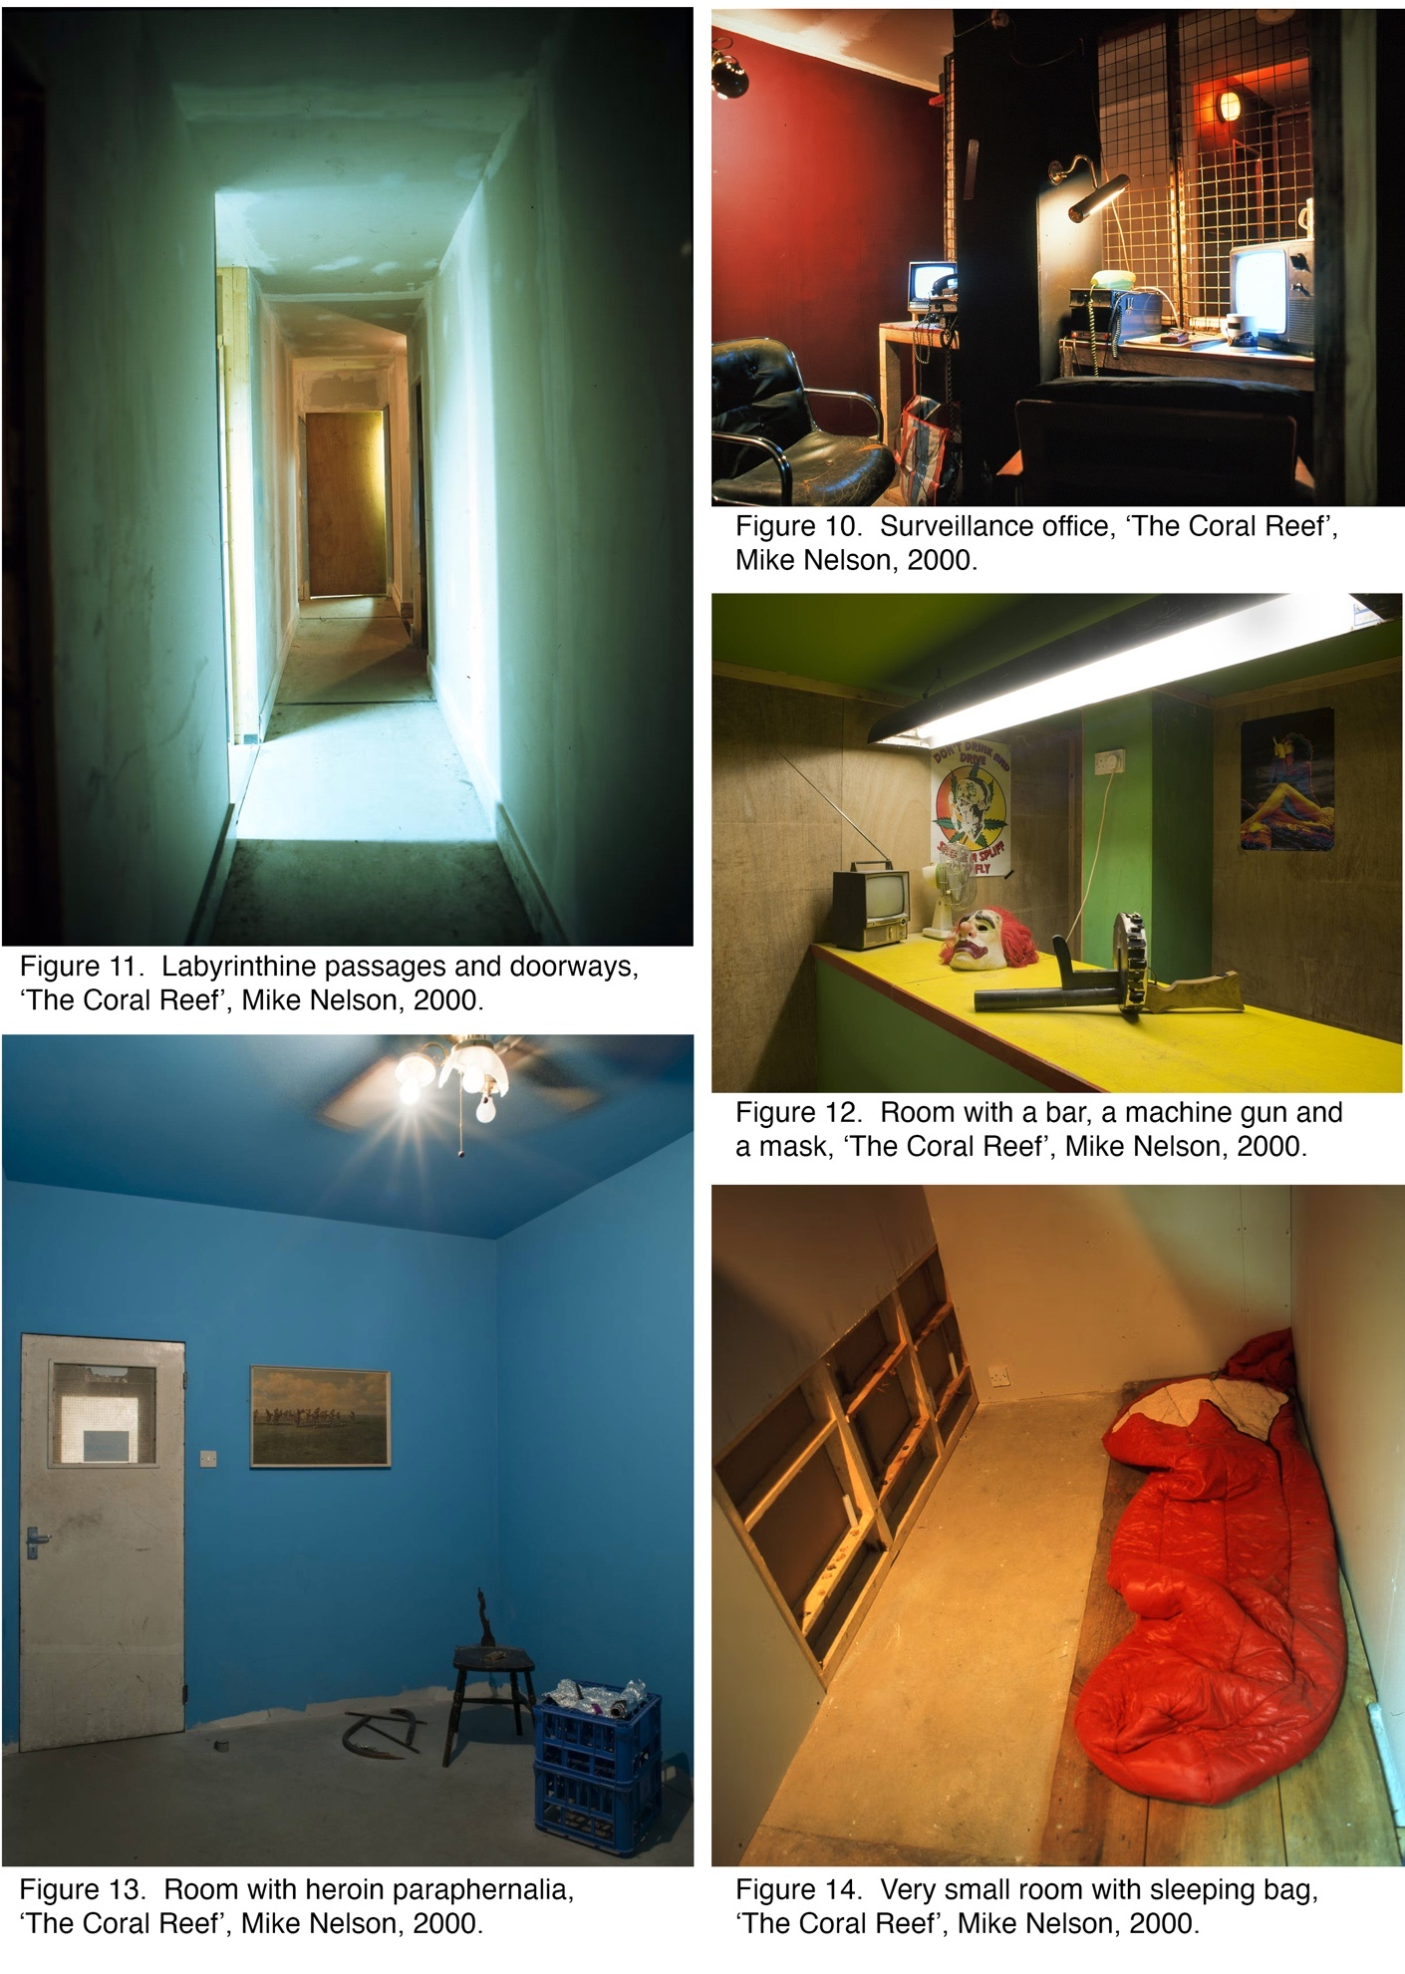
Nelson built the artwork using discarded materials and objects that showed evidence of previous use. The idea that the items were suffused with memories, retained from their former context, was important to him because they possess a “sense of the presence of life, and of time” (Nelson, 2023, p.25). He suggests that the lingering sense of history in the objects produces a resonance and contributes to the scene’s reality (Burrows and O’Sullivan, 2019, p.144). He views these found items as similar to Duchamp’s ‘readymades’. He maintains that “ultimately all the objects are the things they’re made out of. They’re like readymades, to some degree” (Rachelwithers.com, 2026). This resonates with Deleuze and Guattari, who position the readymade as “the base or ground of art” (Deleuze and Guattari 1987, p.315).
A narrative dimension adds to the all-encompassing experience. Nelson saw ‘The Coral Reef’ as his “first work that managed to equate a literary structure to a spatial structure” (Tate, 2010). In a similar way to reading, the viewer becomes an active participant in the fictional narrative. This immersion in the unfolding story increases the affective quality of the experience (Tate, 2010). However, unlike most books, the story unfolds non-linearly. Nelson notes, “an atmosphere is created from something not definable by categories such as geography, culture or time” (Mike Nelson, 2010). As H. P. Lovecraft maintains: “Atmosphere is the all-important thing, for the final criterion of authenticity is not the dovetailing of a plot but the creation of a given sensation” (Nelson, 2001). A counterpart to the ‘The Coral Reef’ was created for the Venice Biennale in 2001 (Nelson, 2023, p.9). Similar to ‘The Coral Reef’, ‘The Deliverance and the Patience’ consisted of unoccupied, interconnected rooms. Each space has a distinct theme, addressing the history of global capitalism, oppression, escape, and imperialism (Nelson, 2023, p.71).

Conclusion
This essay examines how the architectural installations of Mike Nelson and Gregor Schneider make absence present, and what their strategies reveal about the relationship between presence and absence within constructed space.
As discussed earlier, both artists produce immersive environments that provoke feelings of dread. Visitors to Schneider’s domestic constructions experience fear even though they are within a safe exhibition environment (Williams, 2010, p.4). Nelson’s installations, likewise, can instil unease or even terror in the viewer, reactions driven by the sense that something fundamental is missing (Tate, 2010). “As visitors, we are ‘affected’ by artworks that subtly subvert the familiar and confronted with their alienating otherness” (Albano, 2008).
Returning to the essay's starting point, consider Gaston Bachelard’s (1958, p.28) idea of architecture as providing shelter, safety, and peace. Schneider and Nelson create the opposite, an environment that is claustrophobic and disconcerting. Both construct architectural installations where absence is psychologically present and operates as a distinct force. This can be interpreted through Derrida’s concept of Hauntology, in which aspects of the past, or future possibilities, affect the present reality (1994, p.1). However, while both artists create psychologically charged absences, they do so through opposing strategies.
In ‘Haus ur’, Schneider creates absence through duplication and construction to excess. This domestic doubling and repetition enact Freud’s concept of the uncanny by what is concealed rather than what is present. It is as if the original architecture is repressed beneath the newly constructed interior. In Baudrillard’s terms, this is a simulacrum, in which the original has been so thoroughly buried that it can no longer serve as a reference (Sarup, 1993, p.164). Schneider’s domestic interiors are present and absent simultaneously.
In contrast to Schneider’s domestic uncanny, Mike Nelson’s environments create unease through what is missing. His constructed spaces are full of traces of absent inhabitants. The rooms are full of objects suggesting occupation and a narrative that can’t be found. This creates a lingering atmosphere of eeriness. Within his definition of the eerie, this constitutes Fisher’s ‘failure of presence’, where nothing persists where something should be. Sartre argues that absence is always related to presence, and as such, absence can only be experienced if there was once a presence, and our consciousness actively perceives this relationship (Herrington, 2008). As in Sartre’s café, it is the fullness of the space that makes the absence felt. In Nelson’s environments, the absence operates through what is withheld. Unlike Schneider’s accumulation and burial, absence is made concrete through the lack of presence. Like Sartre’s experience, the viewer is left searching for the thing that is missing.
Even with these opposing strategies, the same resolution is reached. Both artists challenge the boundary between what is present and what is missing. This shows that presence and absence are created together. This insight might not be reached through examining just one of the artists. Taken together, they reveal a more extensive perspective: the inseparability of presence and absence is not confined to domestic interiors, the uncanny, or the eerie. Within architecture, they show that presence and absence are produced simultaneously and are inseparable as a condition of built space (Herrington, 2008).
This essay concludes that every presence in architecture is accompanied by an absence, and that the very act of construction involves simultaneous concealment. Therefore, haunting within architecture is something that architecture actively performs by producing absence and presence together.
Moving from the gallery environment, this extends into the everyday experience of built space. We all live in constructed environments, viewing the home as stable and solid. Yet, every building conceals its previous states; houses and cities are built over what was there before, leaving traces of past lives (Petracchin, 2025, p.84). Both artists “expose the fissures of contemporary life and elaborate on the displacement inherent to the experience of the uncanny” (Albano, 2008).

Bibliography

Books and Articles
Albano, C. (2008). Uncanny: A Dimension in Contemporary Art. Esse, (62 - Fear II). Available at: https://esse.ca/en/uncanny-a-dimension-in-contemporary-art/ [Accessed 2 Apr. 2026].
All posts (2014). The Book of Gregor Schneider: Will It be his Most Lasting Artwork? [online] The Nomadic Journal. Available at: https://thenomadicjournal.com/2014/12/08/the-book-of-gregor-schneider-will-it-be-his-most-lasting-artwork/ [Accessed 13 Mar. 2026].
Auslander, P. (2003). Behind the Scenes: Gregor Schneider’s ‘Totes Haus ur’. PAJ: A Journal of Performance and Art, [online] 25(3), pp.86–90. Available at: https://www.jstor.org/stable/3246423.
Bachelard, G. (2014). The Poetics of Space. Translated by M. Jolas. New York: Penguin Books.
Bergstrom, J. (1999). Endless Night: Cinema and Psychoanalysis, Parallel Histories. Berkeley: University of California Press, Cop.
Birnbaum, D., Bronfen, E., Udo Kittelmann and Gregor Schneider (2001). Gregor Schneider: Totes Haus Ur; La Biennale di Venezia 2001.
Birnbaum, D. (2000). Interiority Complex: Gregor Schneider. [online] Artforum. Available at: https://www.artforum.com/features/interiority-complex-gregor-schneider-2-162420/
Bishop, C. (2005). Installation Art: A Critical History. London Tate Publ.
Borcherdt, G. (2022). The Family. Aperture, [online] (247), pp.70–73. doi:https://doi.org/10.2307/27316843.
Burrows, D. and O’Sullivan, S. (2019). Fictioning. Edinburgh University Press.
Carey-Thomas, L. (2021). The Scene is Set – Tate Etc. | Tate. [online] Tate. Available at: https://www.tate.org.uk/tate-etc/issue-22-summer-2011/scene-set [Accessed 20 Mar. 2026].
Colebrook, C. (2002). Gilles Deleuze. London: Routledge.
Coxhead, G. (2008). The Family Haunt - Our Correspondent is Spooked by an Eerie Home Conversion. [online] Available at: https://www.gregor-schneider.de/articles/20041006_times.pdf [Accessed 1 Apr. 2026].
Davidts, W. (2013) “Home Improvement and Studio Stupor. On Gregor Schneider’s (Dead) House ur,” in A.-S. Lehmann, R. Esner, and S. Kisters (eds.) Hiding Making - Showing Creation. 1st ed. Routledge, pp. 209–225. Available at: https://doi.org/10.4324/9781003697329-15.
DC (2020). Galerie Dennis Cooper presents … Gregor Schneider – DC’s. [online] Denniscooperblog.com. Available at: https://denniscooperblog.com/galerie-dennis-cooper-presents-gregor-schneider-2/
D Costello and J Vickery (2007). Art: Key Contemporary Thinkers. Oxford: Berg.
Deleuze, G. (2017) Francis Bacon: The Logic of Sensation. London: Bloomsbury Academic.
Deleuze, G. and Guattari, F. (1994). What is Philosophy? New York: Columbia University Press.
Derrida, J. (1994). Specters of Marx. New York: Routledge.
de Ruyter, T. (2008). Gregor Schneider l’Architecture du Desastre. Art press, 342, pp.31–37.
Dessau, O. (2015). Gregor Schneider. [online] Artreview.com. Available at: https://artreview.com/april-2015-feature-gregor-schneider/ [Accessed 13 Mar. 2026].
Dillon, B. (2011). Ruins. London: Whitechapel Gallery; Cambridge.
Dolar, M. (1991). ‘I Shall Be with You on Your Wedding-Night’: Lacan and the Uncanny. doi:https://doi.org/10.2307/778795
Education Notes. (n.d.). Available at: https://kaldorartprojects.org.au/wp-content/uploads/2021/03/1620kaldornotes_schneider1.pdf.
Fisher, M. (2016). The Weird and the Eerie. London: Repeater Books.
Fisher, M. (2014). Ghosts of My Life. Ropley: John Hunt Publishing.
Frers, L. (2013) “The Matter of Absence,” Cultural Geographies, 20(4), pp. 431–445. Available at: https://doi.org/10.1177/1474474013477775.
Freud, S. (1919). The Uncanny. New York: Penguin Books.
Freud, S., Strachey, J., Cixous, H. and Dennome, R. (1976). Fiction and Its Phantoms: A Reading of Freud’s Das Unheimliche (The ‘Uncanny’). New Literary History, 7(3), p.525. doi:https://doi.org/10.2307/468561.
Grosz, E.A. (2008). Chaos, territory, Art: Deleuze and the framing of the earth. New York, Ny: Columbia University Press, Cop.
Hale, J. (2017). Atmospheric Architectures: The Aesthetics of Felt Spaces. Gernot Böhme. Edited/translated by A-C. Engels-Schwarzpaul. Interstices: Journal of Architecture and Related Arts. doi:https://doi.org/10.24135/ijara.v0i0.18.
Herrington, S. (2008) “You Are Not Here: Sartre’s Phenomenological Ontology and the Architecture of Absence,” Footprint: Delft School of Design Journal [Preprint]. Available at: https://doi.org/10.59490/FOOTPRINT.2.2.686.
Hudek, A. (2014). The Object. London: Whitechapel Gallery; Cambridge, Massachesetts.
Jean-Paul Sartre (1966). Being and Nothingness: An Essay in Phenomenological Ontology. New York: Pocket Books.
Jentsch, E. (1997). On the Psychology of the Uncanny (1906). Angelaki, 2(1), pp.7–16. doi:https://doi.org/10.1080/09697259708571910.
Johnston, A. (2013). Jacques Lacan (Stanford Encyclopedia of Philosophy). [online] Stanford.edu. Available at: https://plato.stanford.edu/entries/lacan/.
Jones, J. (2010). And Now for a Modern Masterpiece: Mike Nelson’s ‘The Coral Reef’. [online]. Available at: https://www.theguardian.com/artanddesign/jonathanjonesblog/2010/jun/14/mike-nelson-coral-reef-masterpiece [Accessed 19 Mar. 2026].
Kaye, N. (2000). Site-Specific Art: Performance, Place and Documentation.
Kholeif, O., Nelson, M. and Whitechapel Art Gallery (2014). Mike Nelson: Again, More Things (A Table Ruin); London: Whitechapel Gallery.
Lechte, J., (2008) Fifty Key Contemporary Thinkers: from Structuralism to Post-humanism.
Lloyd, J. (2020). The Eerie Resonance of Gregor Schneider’s Disquieting Interiors. [online] Elephant. Available at: https://elephant.art/the-eerie-resonance-of-gregor-schneiders-disquieting-interiors-22052020/
Loock, Ulrich (2011). Gregor Schneider. Ten Years After. Cura. Magazine. 6 Jun.
Nelson, M. (2023) Extinction Beckons: Mike Nelson. London: Hayward Gallery Publishing.
Mosar, C. (2025). Gregor Schneider. Haus U R.
Nelson, M. (2001). A Forgotten Kingdom. Institute of Contemporary Art.
Nelson, M., Aldiss, B.W., Millar, J. and Oxford, M.A. (2004). Mike Nelson.
Nelson, Mike and J. Rogers (2003), ‘Mike Nelson Interviewed by John Rogers’, Fused, 2 July,p. 21.
Noys, B. (2010) ‘The Horror of the Real: Žižek’s Modern Gothic’, International Journal of Žižek Studies, 4(4), pp. 1–13. Available at: https://research-ebsco-com.uwtsd.idm.oclc.org/linkprocessor/plink?id=415d8140-52f1-31a4-8ca6-2c5044fe9a67 (Accessed: 14 April 2026).
Massumi, B. (1995). The Autonomy of Affect. Cultural Critique, (The Politics of Systems and Environments), pp. 83-109.
Mike Nelson. (2010). ‘Ideal Syllabus’. Frieze, (130), Apr., p.26.
O’Sullivan, S. (2006) Art Encounters Deleuze and Guattari: Thought Beyond Representation. 1st ed. 2006. London: Palgrave Macmillan UK. Available at: https://doi.org/10.1057/9780230512436.
O’Sullivan, S. and Zepke, S. (2008). Deleuze, Guattari and the Production of the New. Bloomsbury Publishing.
O’Sullivan, S. and Zepke, S. (2010) Deleuze and Contemporary Art. 1st ed. Edinburgh: Edinburgh University Press. Available at: https://doi.org/10.1515/9780748642403.
Petracchin, A. (2025) “Spectres: Architectural Theory as Hauntology,” Footprint: Delft School of Design journal. Delft: Architecture Theory Chair (TU Delft) and Stitching, pp. 77–90. Available at: https://doi.org/10.59490/footprint.19.2.7806.
Powell, J. (2007). Derrida For Beginners. Red Wheel/Weiser.
Rachelwithers.com. (2026). Coming Soon: Sculpture Now, 2014: Mike Nelson in Conversation | Rachel Withers. [online] Available at: http://www.rachelwithers.com/mike-nelson-in-conversation-with-rachel-withers/ [Accessed 19 Mar. 2026].
Rachelwithers.com. (2011). Host Pavilion/Guest House/Han | Rachel Withers. [online] Available at: http://www.rachelwithers.com/host-pavilionguest-househan/ [Accessed 19 Mar. 2026].
Royle, N. (2003). The Uncanny. Manchester: Manchester University Press.
Roug, L. (2003). This Old Obsession. [online] Los Angeles Times. Available at: http://articles.latimes.com/2003/nov/30/entertainment/ca-roug30 [Accessed 16 Mar. 2026].
Rumsby, B. (2004). Escenic. [online] The Telegraph. Available at: https://www.telegraph.co.uk/culture/art/3625006/A-very-special-kind-of-fear.html [Accessed 2 Apr. 2026].
Sam, S. (2013). Mike Nelson. [online] Artforum. Available at: https://www.artforum.com/columns/mike-nelson-talks-about-his-latest-works-215631/ [Accessed 20 Mar. 2026].
Sarup, M., (1993) An Introductory Guide to Post-structuralism and Postmodernism.
Slavoj Zizek and Von, J. (1997). The Abyss of Freedom/ Ages of the World. Ann Arbor, Mich.: University of Michigan Press.
Southbank Centre (2023). Mike Nelson in Conversation about Extinction Beckons. [online] Southbankcentre.co.uk. Available at: https://www.southbankcentre.co.uk/magazine/mike-nelson-in-conversation-about-extinction-beckons/
Stephen Zepke (2017) “‘A Work of Art Does not Contain the Least Bit of Information’: Deleuze and Guattari and Contemporary Art,” Performance Philosophy, 3(3), pp. 751–765. Available at: https://doi.org/10.21476/PP.2017.33145.
St-Jean, P., Clark, O.G. and Jemtrud, M. (2022) “A Review of the Effects of Architectural Stimuli on Human Psychology and Physiology,” Building and Environment, 219. Available at: https://doi.org/10.1016/j.buildenv.2022.109182.
Taylor, P.A. and Gunkel, D.J. (2007) International Journal of Žižek Studies. Leeds, England: [Institute of Communications Studies, University of Leeds].
Tate (2021). ‘Die Familie Schneider’, Gregor Schneider, 2004 | Tate. [online] Tate. Available at: https://www.tate.org.uk/art/artworks/schneider-die-familie-schneider-264248 [Accessed 1 Apr. 2026].
Teo, T. and Pavón-Cuéllar, D. (2014) Extimacy, Encyclopedia of Critical Psychology. Springer, pp. 661–664. Available at: https://doi.org/10.1007/978-1-4614-5583-7_106.
Trigg, D. (2009) “The Place of Trauma: Memory, Hauntings, and the Temporality of Ruins,” Memory Studies, 2(1), pp. 87–101. Available at: https://doi.org/10.1177/1750698008097397.
Trigg, D. (2013). The Memory of Place: A Phenomenology of the Uncanny. Athens, Ohio: Ohio University Press.
Vidler, A. (1992). The Architectural Uncanny: Essays in the Modern Unhomely. Cambridge, Mass. [Etc.] Mit Press.
Vidler, A. (2002). Warped Space: Art, Architecture, and Anxiety in Modern Culture. Cambridge, Mass.; London: Mit.
Wallis, C. (n.d.). Mike Nelson in Conversation – Tate Etc. [online] Tate. Available at: https://www.tate.org.uk/tate-etc/issue-22-summer-2011/mike-nelson-conversation
Williams, G. (2007). The Gothic.
Williams, G. (2010). Doubling. Art Monthly, 340, 10 Oct.
Withers, R. (2000). Mike Nelson. [online] Artforum. Available at: https://www.artforum.com/events/mike-nelson-175944/ [Accessed 19 Mar. 2026].
Windsor, M. (2019) “What is the Uncanny?” The British Journal of Aesthetics, 59(1), pp. 51–65. Available at: https://doi.org/10.1093/aesthj/ayy028.
www.artangel.org.uk. (n.d.). Die Familie Schneider. [online] Available at: https://www.artangel.org.uk/project/die-familie-schneider/

Videos and Websites
AA School of Architecture (2015). Gregor Schneider - Invisible Dead Room. [video] YouTube. Available at: https://www.youtube.com/watch?v=8yKC9EaguDo [Accessed 6 Apr. 2025].
Art Basel (2020). Meet the Artists | Mike Nelson. [video] YouTube. Available at: https://www.youtube.com/watch?v=0jO8JUeASfo
Ben Lewis. (2025). Art Safari 1 · Ben Lewis. [video] Available at: https://benlewisprojects.com/films/art-safari-1 [Accessed 13 Mar. 2026].
Gregor-schneider.de. (2023). Gregor Schneider. [online] Available at: https://gregor-schneider.de [Accessed 19 Mar. 2026].
Gregor Schneider END. (2009). [video] YouTube. Available at: https://www.youtube.com/watch?v=xPVhQ9ZdiZc [Accessed 13 Mar. 2026].
Kaldor Public Art Projects (2022). Project 16: Gregor Schneider, 2007 – John Kaldor Recollections. [video] YouTube. Available at: https://www.youtube.com/watch?v=_ma-rYYzh9I [Accessed 16 Mar. 2026].
Projects, A. (2025). Kaldor Public Art Projects. [video] Kaldorartprojects.org.au. Available at: https://kaldorartprojects.org.au [Accessed 16 Mar. 2026].
SMK – Statens Museum for Kunst (2013). Mike Nelson - ‘Kristus och Judas’. [video] YouTube. Available at: https://www.youtube.com/watch?v=dGFdPxqSxl0
Southbankcentre.co.uk. (2023). Jeremy Deller on the Genius of Artist Mike Nelson. [video] Available at: https://www.southbankcentre.co.uk/magazine/jeremy-deller-on-mike-nelson-extinction-beckons/
Southbankcentre.co.uk. (2023). Mike Nelson on his Exhibition, Extinction Beckons. [video] Available at: https://www.southbankcentre.co.uk/magazine/mike-nelson-on-extinction-beckons-at-hayward-gallery/
Tate (2011). Mike Nelson at the Venice Biennale 2011 | TateShots. [video] YouTube. Available at: https://www.youtube.com/watch?v=rYyVFCAYzGY
Tate (2010). Mike Nelson – The Coral Reef | TateShots. [video] YouTube. Available at: https://www.youtube.com/watch?v=gUsaSnyvZnA
Tate (n.d.). ‘The Coral Reef’, Mike Nelson, 2000. [video] Tate. Available at: https://www.tate.org.uk/art/artworks/nelson-the-coral-reef-t12859
www.youtube.com. (n.d.). Mike Nelson | Turner Prize Nominee 2007 | TateShots. [video] Available at: https://www.youtube.com/watch?v=3sS4pS06Nek

List of Images
Figure 1.
Haus u r, Unterheydener Straße in Mönchengladbach-Rheydt. 1985-today. Available at: https://tique.art/features/gregor-schneider/) [Accessed 1 Apr. 2026].
Figure 2.
Haus u r, Rheydt, UR19b – Room within a Room, Liebeslaube (Secluded Love Nest) – access through cupboard crawl space. Blockboards on a wooden construction, 1 window, 1 lamp, 1 tub, 1 radiator, 1 cupboard, grey wooden floor, white plastered walls and ceiling. 1995. Photograph: Gregor Schneider. (Mosar, C. (2025). Gregor Schneider. Haus U R.).
Figure 3.
Haus u r, Rheydt, UR1 - Room within a Room – chipboard on a construction of steel and wood, detached, 30-50cm distance from outer room. 1985-today. Photograph: Gregor Schneider. Available at: https://gregor-schneider.de/rooms.htm [Accessed 1 Apr. 2026].
Figure 4.
Haus u r, Rheydt, UR12 – Total Isolation Guest Room – 2 layers of lead, 3 layers of glass wool, 1 layer of rock wool, 1 layer of sound absorbing material, 3 wooden constructions, plaster board, detached. 1995. Photograph: Gregor Schneider. Available at: https://gregor-schneider.de/rooms.htm [Accessed 1 Apr. 2026].
Figure 5.
Die Familie Schneider, 16 and 14 Walden Street, Whitechapel, London. 2004.
Available at: https://www.gregor-schneider.de/places/2004london/pages/20041002_01_waldenstreet.htm [Accessed 1 Apr. 2026].
Figure 6.
Woman washes dishes in the kitchen sink, Walden Street, Die Familie Schneider, 2004. Photograph: Gregor Schneider. Available at: https://www.artangel.org.uk/project/die-familie-schneider/ [Accessed 1 Apr. 2026].
Figure 7.
Child-like figure concealed in a bin bag sits in the corner of a bedroom in Walden Street, Die Familie Schneider, 2004. Photograph: Gregor Schneider. Available at: https://www.artangel.org.uk/project/die-familie-schneider/ [Accessed 1 Apr. 2026].
Figure 8.
A man engaged in an act of masturbation in a shower, Walden Street, Die Familie Schneider, 2004. Photograph: Gregor Schneider and Artangel, London. Available at: https://esse.ca/en/uncanny-a-dimension-in-contemporary-art/ [Accessed 1 Apr. 2026].
Figure 9.
Attic and Cellar Rooms: locked door and child gate in the attic, small room with padlock on radiator, cellar with cot mattress and padlock. 14 and 16 Walden Street, Die Familie Schneider, 2004. Available at: https://www.tate.org.uk/art/artworks/schneider-die-familie-schneider-264248 [Accessed 1 Apr. 2026].
Figure 10.
Surveillance office, ‘The Coral Reef’, Mike Nelson, 2000. Photograph courtesy of the Artist and Matt’s Gallery, London, Collection of the Tate. Available at: https://seanosullivan.ie/coral/?utm_source=Pinterest&utm_medium=organic [Accessed 16 Apr. 2026].
Figure 11.
Labyrinthine passages and doorways, ‘The Coral Reef’, Mike Nelson, 2000. Photograph courtesy of the Artist and Matt’s Gallery, London. Available at: https://www.mattsgallery.org/exhibitions/the-coral-reef [Accessed 16 Apr. 2026].
Figure 12.
Room with a bar, a machine gun and a mask, ‘The Coral Reef’, Mike Nelson, 2000. Photograph courtesy of the Artist and Tate Gallery, London. Available at: https://www.tate.org.uk/art/artworks/nelson-the-coral-reef-t12859 [Accessed 16 Apr. 2026].
Figure 13.
Room with heroin paraphernalia, ‘The Coral Reef’, Mike Nelson, 2000. Photograph courtesy of the Artist and Tate Gallery, London. Available at: https://www.tate.org.uk/art/artworks/nelson-the-coral-reef-t12859 [Accessed 16 Apr. 2026].
Figure 14.
Very small room with sleeping bag, ‘The Coral Reef’, Mike Nelson, 2000. Photograph courtesy of the Artist and Matt’s Gallery, London. Available at: https://www.mattsgallery.org/exhibitions/the-coral-reef [Accessed 16 Apr. 2026].

