Tutorial 1 - Written by Nicholas Gelstharp – 30th January 2023
Within this document I will be looking at the different types of databases, including examples of when it would be appropriate for each to be used as well as what some of the advantages and disadvantages of each. The type of database should primarily be determined by the purpose of the database and also its target user group, and where the information may need to be stored. For example if the users need to have quick access to information from all over the world and security is not a huge concern, then a cloud or web based solution may be a great choice, however if this would mean the exportation of sensitive data to countries outside of the UK or EU then this could have legal ramifications which would mean that this solution is not appropriate. The structure of a database is key to its usability and how it will be queried and the inherent costs that could be associated with this.
One type of database is a relational database. A relational database is a database that is made up of a collection of “relations” [1] that are typically sorted in columns and rows in a single, or collection of tables. The relationship between records within these tables are what makes a database relational. An example of a use for a relational database would be a library, where within the database there may be fields relating to books, authors and publishers. There may be many relationships between this data, and in the example shown below the field “written by” has been included to illustrate the relationship between the table containing information on books, and the table containing information on authors [2]
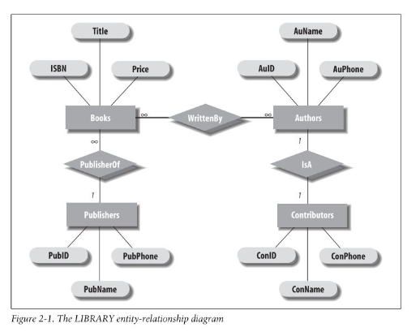
In order to report on or access these relationships, there is usually an element of programming needed in order to be able to write complex searches that can then be easily input at the view or external level. The main advantage of a relational database is that traditionally they are simple to use and it is easy to partner multiple tables together to create relationships. This type of database is one of the more “traditional” types of database and the benefit of this is that there has been thousands or people that have developed user guides, instructions and tutorials mainly in the form of SQL. This means that getting the information that is needed to use and set this up can be done quite easily. A relational database is also compatible with other widely available technologies such as the cloud, which means that the backup and restore of a database can be relatively simple depending on the storage methodology and technology used [3]
Another type of database is a cloud database. In comparison to many other types of database, this type is the one of the more recent developments with the widescale adoption and availability of the cloud. A cloud-based database is a database that resides on a cloud platform and industry leaders including Google, Amazon and eBay have proven that Cloud infrastructure is incredibly reliable, available and scalable [4]. These advantages are very attractive for organisations, and the association with these large organisations that have a proven track record for delivering all these features is seen as a huge benefit. Cloud SQL is an example of a use for a cloud database and the figure below demonstrates how the traditional SQL setup has been adapted to enable Cloud servers to be utilised [4].
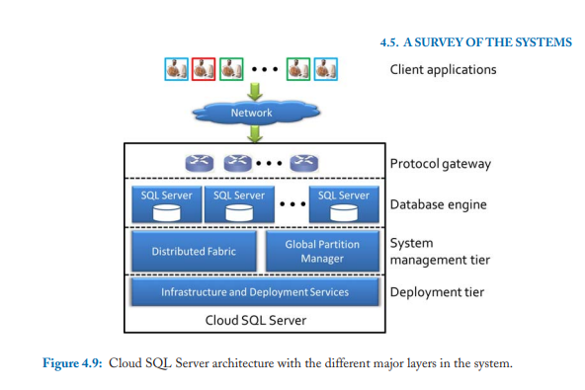
One of the advantages of a cloud database is that the costs of setting up and maintaining an SQL database like the one shown in the figure, can be significantly cheaper as the cloud SQL server will be set up and maintained by the service provider. This can mean expensive data centres which require constant temperature and climate controls will not need to be something that is locally considered saving time, space and significant costs savings from building to staff.
Another example of a database would be an object-oriented database. An object-oriented database. The main difference between a relational database and an object oriented database all records are stored as objects, and there is no requirements for tables, columns or rows. This is shown in the diagram below [5]
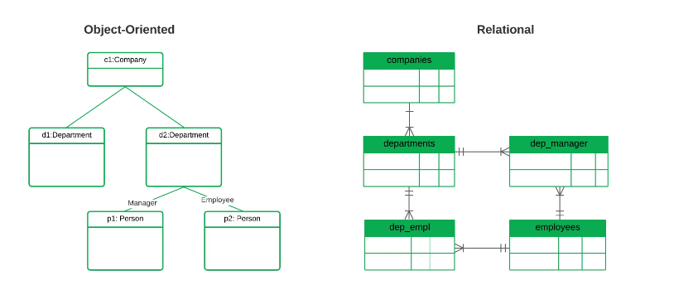
Object oriented databases are often associated with the MongoDB and AWSDynamoDB . However, unlike relational databases which have largely adopted SQL or variations of it, object-oriented databases do not have one ubiquitous programming language and this can mean that interacting with it and using it to its full potential can require a higher level of skill than the other types of database. This can also mean that finding staff with the required skills set to maximise the efficiency and effectiveness of this type of database can also be significantly more difficult as the talent pool is a lot smaller than those that can be found when looking for those to maintain a relational database.
Graph databases use nodes to store all of the information relating to a record and they get their name from the often-graphical presentation of the data, which examines the relationship between two nodes. These are less restrictive databases in comparison to a relational database where the tabular format will dictate which relationships can be reported on, and a graph database is best used when trying to find the shortest path between two nodes. The figure below shows this using the popular game “six degrees of Kevin Bacon”. In this case it shows the relationship between Kevin Bacon and Miss Piggy [6]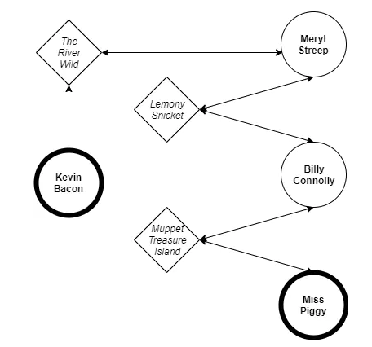
The ability to show these relationships both visually and efficiently are definitely two of the biggest advantages that are associated with this type of database. A practical example of when this is used is for social networks where graphical information can be used to show friendships or to link key fields of information for something like a dating website that will allow compatibility [7]. Graphical databases are also well suited where applications are likely to be iterated due to their less restrictive nature, they are much easier to manipulate into ever changing these ever changing structures.

References

[1] | J. L. Harrington, Relational database design and implementation: Clearly explained, Morgan Kaufmann, 2009.
[2] | S. Roman, in Access database design and programming, 3rd ed ed., O'Reilly, 2002, p. 17.
[3] | IBM, "Benefits of relational databases," IBM, [Online]. Available: https://www.ibm.com/topics/relational-databases#:~:text=The%20primary%20benefit%20of%20the,group%2C%20and%20also%20combine%20queries.. [Accessed 30 January 2023].
[4] | S. Das, A. E. Abbadi and D. Agrawal, in Data management in the cloud challange and opportunities, Morgan & Claypool, 2013, pp. 21, 79.
[5] | mongodb, "What is an object-oriented database," mongoDB, [Online]. Available: https://www.mongodb.com/databases/what-is-an-object-oriented-database. [Accessed 30 January 2023].
[6] | OCI, "Graph Database Defined," [Online]. Available: https://www.oracle.com/uk/autonomous-database/what-is-graph-database/. [Accessed 30 January 2023].
[7] | R. Angles and C. Gutierrez, Survey of graph database models, vol. 40, no. 1, p. 1:8, 2008.

