University of Wales Trinity Saint David
Wales Institute of Science and Art


Engineering Materials

Materials and Manufacturing
ACHA4025

Marcus Tenniswood
2501145
27/4/26

Contents
1 Introduction 2
2 Literature Review 2
3 Methodology 3
4 Test Results 5
5 Analysis 6
6 Conclusion 7
7 References 7

Introduction
As an engineer for a high-performance team taking part in the Dakar Rally, material selection is essential for every attribute of the vehicle. Specifically in this report regard is taken to the suspension components. In the given scenario, there were 2 critical failures in the suspension of the vehicle, both in the driveshafts of the suspension, taking place in the 4th and 5th stage of the rally. This led to a total immobilisation of the vehicle and retirement from the stages. Therefore, the task outlined in the brief, as an engineer a complete investigation of the reasons behind why this failure occurred must take place, and following this an investigation on why it took placed when the component was previously reliable. The Dakar environment is full of serious challenges that could affect the damaged components, these include geographic challenges of sand dunes, rock beds and gravel tracks. These are all abrasive and can increase wear on components. There are also environment stressing factors like the high heat and temperature change which can cause thermal expansion. Furthermore, there are the more obvious factors that could affect a car during the Dakar such as harsh mechanical loading when landing from jumps or going over washboard ripples in sand. These may be possible causes for the failure, but the purpose of this technical report is to investigate why this may have happened, exploring variables such as the shift in supplier of aluminium alloy, as both the manufacture and assembly of the shaft were identical to previous iterations. This leads the purpose of this technical report to be completion of materials testing on a sample provided to be the same as the failed component, followed by root cause analysis, to determine if the failure was really material based or whether an explanation could be found elsewhere and finally future mitigation proposal, to propose possible technical remedies to ensure that a failure such as the one that has just occurred, never takes place again.

Literature Review
In this section, the outlined specification of what should be expected of the alloy will be shown. These include the Yield strength mentioned in the brief, that should be able to comfortably handle 90MPa. The material should also have basic other functions expected of an alloy being used in rally, such as fatigue strength and ductility, whilst remaining with a high strength to weight ratio. Test methods usually used within industry to measure how hard a material is the Rockwell hardness test, it is a non-destructive test, where a load is placed on the material and then it is observed under a microscope. This eliminates human error from testing as there is a direct number that correlates to what is expected of a certain material. The expected yield strength of a driveshaft material used in rally would be in the range of 275-500MPa, this range is high due to the different alloys with weight restrictions also a factor, as stated in the brief it must comfortably survive a constant force of at least 90MPa, so anywhere within this range is suitable. The expected Youngs modulus would be around 70MPa, this would provide a bit of ‘give’ within the shaft, as to not snap, allowing elastic deformation under load. However not too low as to deform plastically under the expected forces. The ultimate stress is the most important factor, with expected values in the range of 300-600MPa, UTS is essential as it does not provide information for bending or deformation, it shows when the material would snap, this is on line with the failures that had affected the car in the 4th and 5th stages previously.

Methodology
To complete the investigation into the material used in the drive shaft of the Dakar Rally car, a sample was used in a testing rig, this would allow for data values to be recorded and used for calculations to understand the Youngs modulus, stress and strain of the material. But to gather all this data the experiment must first take place. To begin with the sample is acquired, it must be the exact size of the parameters for the testing machine, as shown in Figure 1, it must have 2 squares with mounting holes and the connecting testing area of the sample. The length of the testing area must be 31mm, according to the specification, which was accurate to the sample measured in the experiment.
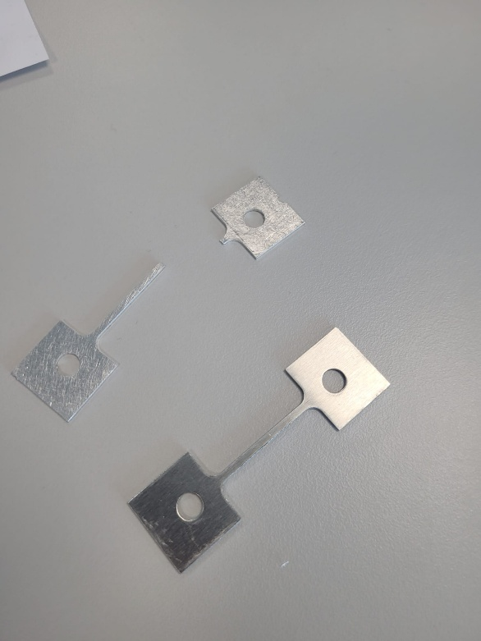
Figure 1
This sample is then mounted into the testing rig, secured in by an Allen key mounting screw through the holes in the top and bottom portion of the sample. The scales are then zeroed with the sample in mount, ensuring that the dial, shown in figure 2, is at aligned at a point for exact measurement movements.
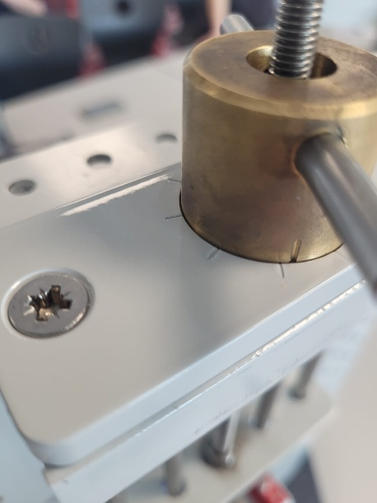
Figure 2
Once ensuring this is set, with the 2 lines aligned, the scale is then zeroed, shown in figure 3 is the measurement gauge, this is where the results are recorded from after each turn of the dial.
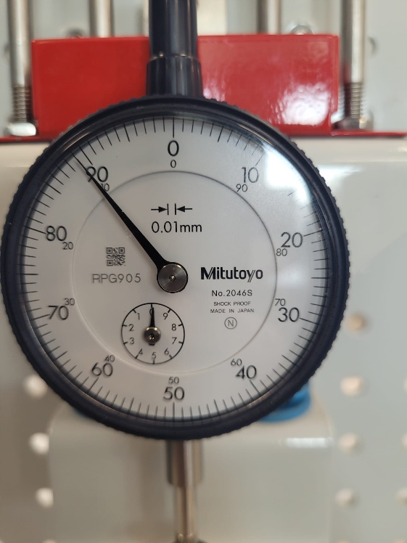
Figure 3
Whilst the image of the dial in figure 3 shows the number that the sample snapped rather than showing a zeroed number, it gives an idea of the readings and resolution that were in the experiment, this gauge has a resolution of +-0.01mm. The experiment is ready to begin once everything is all set up, the crank is turned in 0.2 increments, in a smooth but slow constant movement. Then the dial is recorded and the cycle continues, this happens until the test sample snaps.
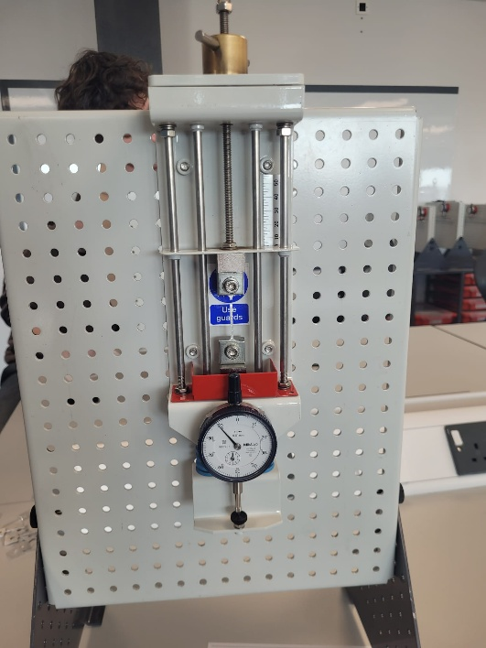
Figure 4
Figure 4 shows the experiment rig once it had been completed, with the test sample snapped in place in the mounts. Once the sample snaps, it can then be removed and analysed for the cause of failure. Ideally the exact test would be repeated multiple times, allowing for averages to be taken and anomalous results to be removed and accounted for.

Test Results
load nut movement (mm) | dial indicator (mm) | Force (N) | Strain | Stress (Pa) | Extension(mm)
0 | 0 | 0 | 0 | 0 | 0
0.2 | 16.5 | 16.5 | 0.005323 | 8250000 | 0.165
0.4 | 34.5 | 34.5 | 0.011129 | 17250000 | 0.345
0.6 | 54 | 54 | 0.017419 | 27000000 | 0.54
0.8 | 71.5 | 71.5 | 0.023065 | 35750000 | 0.715
1 | 90 | 90 | 0.029032 | 45000000 | 0.9
1.2 | 107.5 | 107.5 | 0.034677 | 53750000 | 1.075
1.4 | 126 | 126 | 0.040645 | 63000000 | 1.26
1.6 | 144.5 | 144.5 | 0.046613 | 72250000 | 1.445
1.8 | 161.5 | 161.5 | 0.052097 | 80750000 | 1.615
2 | 179 | 179 | 0.057742 | 89500000 | 1.79
2.2 | 196.5 | 196.5 | 0.063387 | 98250000 | 1.965
2.4 | 215 | 215 | 0.069355 | 107500000 | 2.15
2.6 | 227.5 | 227.5 | 0.073387 | 113750000 | 2.275
2.8 | 238 | 238 | 0.076774 | 119000000 | 2.38
3 | 250 | 250 | 0.080645 | 125000000 | 2.5
3.2 | 257 | 257 | 0.082903 | 128500000 | 2.57
3.4 | 266.5 | 266.5 | 0.085968 | 133250000 | 2.665
3.6 | 273.5 | 273.5 | 0.088226 | 136750000 | 2.735
3.8 | 278 | 278 | 0.089677 | 139000000 | 2.78
4 | 287 | 287 | 0.092581 | 143500000 | 2.87
4.2 | SNAP | 0 | 0 | 0 | 0
Figure 5
Shown in the first 2 columns are the recorded results, the load nut was turned in incredments of 0.2, and after each turn the reading on the dial indicator was recorded. These 2 columns along with the measured length and area, were used to calculate the force, stress and strain that was applied to the test material during the experiment.

Figure 6
Shown in figure 6 is a graph that shows stress against strain, from this graph we attain ideas about the material, understanding of the relationships and possible explanation of why the material failed in such a way in the rally.

Analysis
Using the data collected and shown above in the table and graph, a series of data was calculated and recorded. The first of which was the Youngs modulus, this is calculated as the gradient of the line of the stress and strain graph. The Youngs modulus of the aluminium in this experiment was worked out to be 2 GPa, this is extremely low for what is expected of aluminium. According to Matweb the Youngs modulus of aluminium is supposed to be within the range of 68-70 GPa, therefore the result produced from the experiment is incredibly low and below expected levels. The possible reasons for why this could possibly be so low is due to potential manufacturing issues, that cause cracks, or micro-abrasions in the grain structure of the alloy, this would cause the sample to not deform elastically as expected within the test, and snapping rather than deforming for longer. This could be the explanation as to why the driveshaft failed, this is because the young modulus shows extreme compromise to what should be expected of aluminium.
Another calculated value gained from the experiment is the ultimate tensile strength, this was the highest amount of load on the sample before it snapped. In the experiment this value was 143.5 MPa, this value is higher than the typical range of pure aluminium, but much lower than the annealed aluminium alloys expected to be used in the driveshaft of the vehicle, the value being much lower than expected fits in line with the aforementioned results and also with the failures observed in the rally itself. This could have been the reason of explanation of failure as the forces in a rally such as landing from jumps and going over harsh bumps could exceed the strength of the driveshaft, and as the alloy isn’t as strong as needed this could be a reason for the failure.
Another value obtained by the results recorded is the yield strength, the yield strength obtained from the results from the experiment was around 4MPa, this is slightly lower than the yield strength of pure aluminium, expected to be in the range of 7-11MPa. Once again, the sample tested in the experiment performs at levels lower than expected, yield strength would be an essential quality of a metal used in a drive shaft because it would be directly responsible for how much torque the shaft can transmit without deforming plastically. This being lower than even pure aluminium almost directly explains that the failure is due to a manufacturers error with the production of the alloy.

Conclusion
To conclude, through the experiment and calculated results directly from the experiment, it is certain that there was a manufacturers error with the production of the alloy, this is certain because the results shown are even lower than expected values for pure aluminium which is known to be even weaker than traditional alloys and especially not annealed or heat treated alloys. Overall, the tested sample failed to meet the minimum required specifications for the application. The change in the stiffness of the alloy suggests a massive failure in the company’s heat-treating processes and the significantly lower Youngs modulus suggests a change in the internal grain structure, possibly due to impurities. The root cause for this could be down to negligence from the supplier, as these results are consistent with borderline scrap metal. This metal alloy, if continued to be used would have serious consequences to the health and safety of everyone involved, the pilots, spectators, mechanics and other drivers on the stage. The final recommendations for the engineering team responsible for the driveshaft would be immediate supplier termination, and new ones to be found, with material testing to take place before use in the vehicle.

References
Data sheet for aluminium (available at: https://www.matweb.com/search/datasheet.aspx?bassnum=AMEAL00 )( Accessed on 26/4/26)
Tensile strength of aluminium (available at: https://civilsguide.com/what-is-the-tensile-strength-of-aluminium/ ) (Accessed on 26/4/26)
Yield strength of aluminium (available at: https://www.metals4u.co.uk/blog/yield-strength-of-aluminium )(accessed 26/4/26)
Definitions used for applications (available at: https://www.protolabs.com/en-gb/resources/blog/understanding-yield-strength/#:~:text=Why%20Yield%20Strength%20Matters%20in,deform%20permanently%20under%20expected%20loads. )(Accessed 26/4/26)
Material testing (https://industrialphysics.com/knowledgebase/articles/rockwell-hardness-test/ )(accessed 26/4/26)

