Module title: Foreign Languages & Cultural Awareness
Module code: BMIH5003
Lecturer: Lisa Bassler
Student name: Renáta Kapus
Student ID: 2226188

Intercultural Competence Report

Executive Summary

This report summarises the differences between England and Germany, analyses them applying the GLOBE Project’s culture and leadership study including for example, power distance, performance orientation,charismatic, etc. It examines the difficulties of intercultural leadership in the hospitality sector.

Content Table

Executive summary………………………………………………………………………….............2

Introduction……………………………………………………………………………………...........4

Findings………………………………………………………………………………………….........4

Conclusion………………………………………………………………………………………........9

Recommendations……………………………………………………………………………….......9

References………………………………………………………………………………………......11

Introduction

This report involves investigating the key differences between England and Germany by using the GLOBE Project’s culture and leadership study. It also focuses on the challenges of intercultural leadership in the hospitality industry.
The Globe Project is a singular, extensive investigation, conducted in cooperation with close to 500 researchers, into cultural customs, leadership principles, and interpersonal and generalized trust in 150 countries. Growing in size and scope, GLOBE is now among the social sciences' most extensive studies of its sort (Globe,2020).

Findings

Cultural differences

Although speaking English is not a big deal for most Germans because it has been taught in primary schools since 2005, there are still evident cultural distinctions between the British and the Germans (Ibanez,2022). In terms of traffic laws, there is one stark contrast between Germany and Britain: in Germany, like in most of Europe, people drive on the right side of the road, while in Britain, people drive on the left. Germans are renowned for their diligence, directness, and timeliness. Conversely, while communicating with others, the British have a tendency to be more courteous and indirect (Ibanez,2022).
The UK is famous for its fish and chips, whereas Germany is recognized for its mouthwatering sausages and beer. Music-wise, the UK produced bands like The Beatles and One Direction, while Germany produced classical music legends like Bach and Beethoven (Expatrio, 2024).

Due to Germany's historical Christian heritage, religion has influenced many cultural emblems. Indirect symbols like the shape of a pretzel and blatant symbols like the cross are included (Expatrio, 2024).

Strong family values have always been ingrained in German culture, and even in larger or more ephemeral cities like Berlin, it is not unusual to see multiple generations of a family living in or near the same town or city and getting together frequently for holidays or celebrations (Expatrio, 2024).

English culture has been enhanced by the many contributions of Afro-Caribbeans, Asians, Muslims, and other immigrant groups as the British Empire grew and the nation absorbed peoples from all over the world ( Harford and Kellner, 2024).

Leadership Visualization

Comparing England to Germany using the Globe Project’s leadership visualization, it can be said that England (6,01) is more charismatic than East (5,87) and West Germany (5,84) as shown in Figure 1., 2. and 3. Therefore, England possesses strong core beliefs enables one to inspire, motivate, and demand excellent performance from others. East (5,51) and West Germany (5,49) is less team oriented than England (5,71), however, the difference is not so big. The capacity to form cohesive teams and carry out a shared objective for team members stays under average in both countries. The extent of decision-making and implementation collaboration among managers exceeds the average regarding England (5,57) and Germany as well, yet East (5,7) and West Germany (5,88) have higher score.

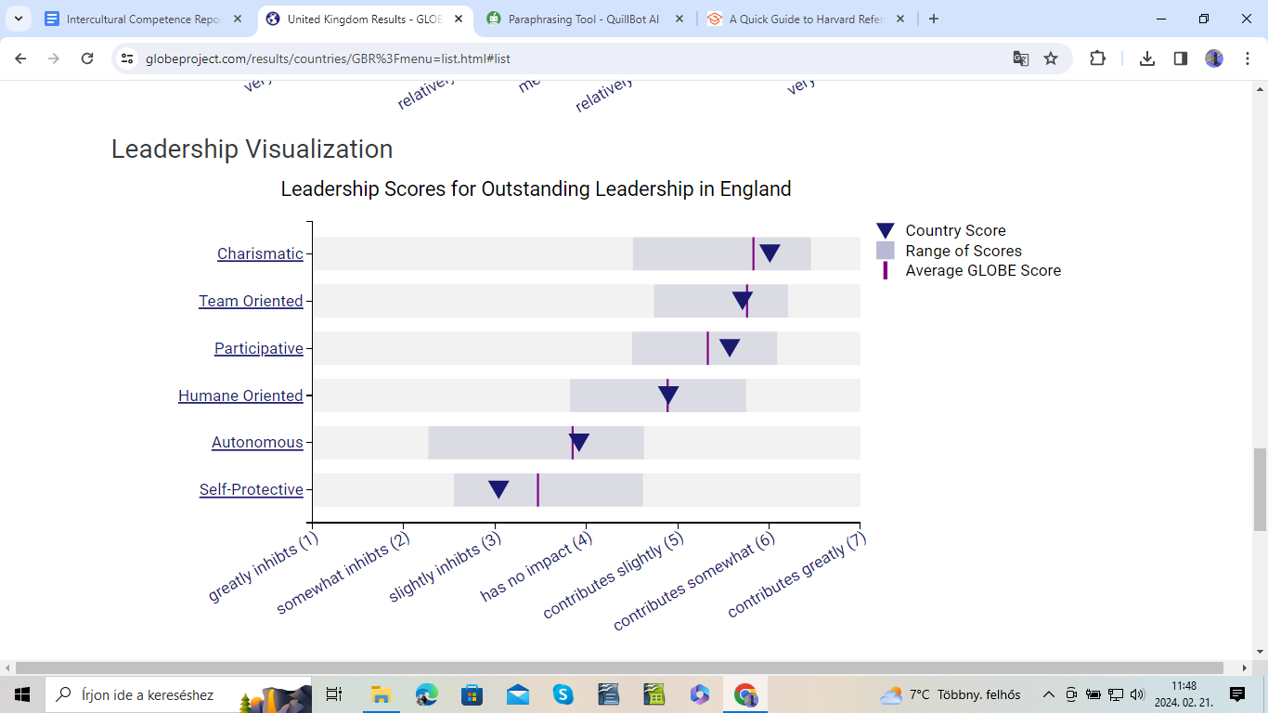
Figure 1. Leadership Visualization England (Globe,2020)
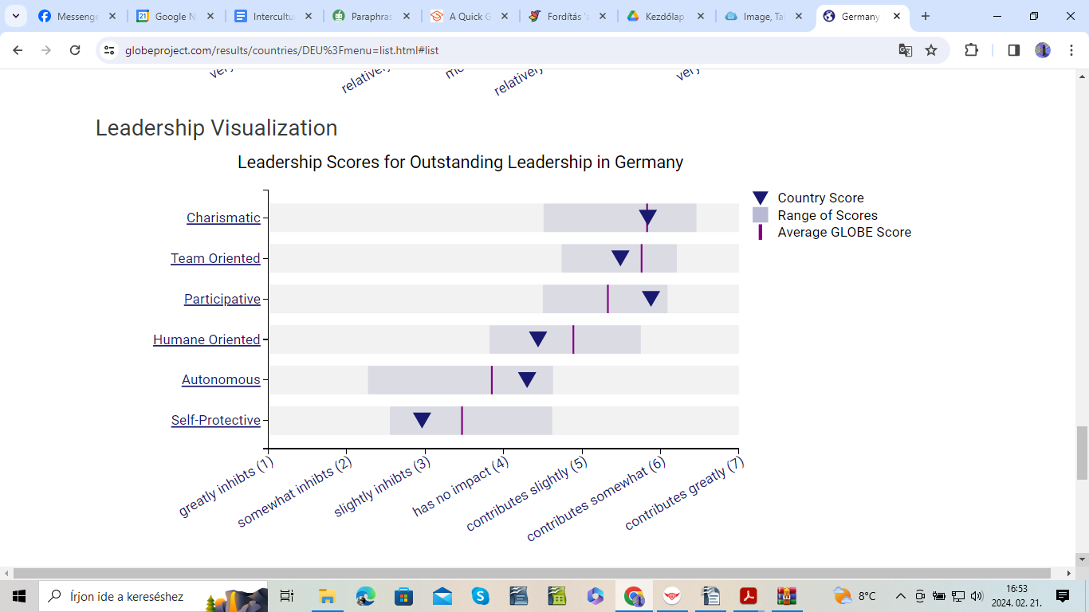
Figure 2. Leadership Visualization West Germany (Globe,2020)

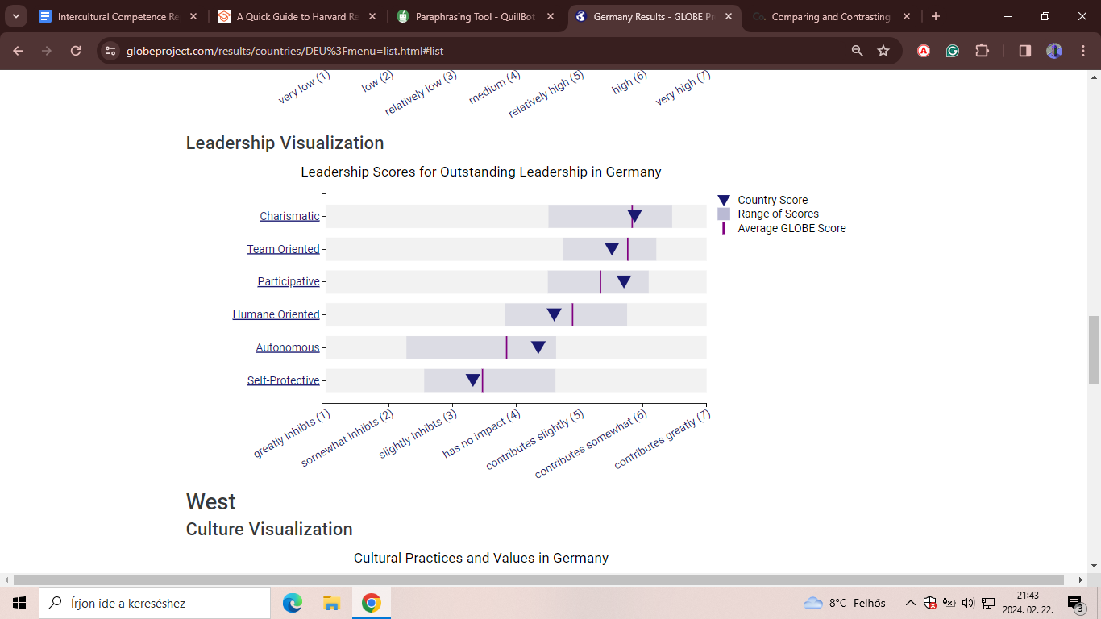
Figure 3. Leadership Visualization East Germany (Globe,2020)

Culture Visualization

According to the Globe Project, culture visualization includes cultural practices and values. Comparing England to Germany, England’s Performance Orientation Practice Score is medium level (4,08), East Germany’s Practice Score (4,09) is almost the same as England’s while West Germany’s is higher (4,25) transcending the average level. The Performance Orientation means how much a group supports and recognizes individuals for their exceptional work and progress. Unlike the Value Score of the two countries is much higher than the Practice one. England’s (5,9) is less than West (6,01) and East Germany’s (6,09), therefore, all in all, it can be said that both of the countries’ Value Scores are in high level.
Considering Power Distance, the degree to which privileges associated with status, power imbalances, and authority are accepted and supported by the community, the Practice Scores are higher than the Value Scores in both countries. England’s Practice Score (5,15) is less than East (5,54) and West Germany’s (5,25), however, East Germany has the highest of them. Regarding the Value Scores, West Germany has the lowest score (2,54), East has 2,69 score under the average, England’s score (2,8) exceeds the average, nevertheless it is in relatively low level.

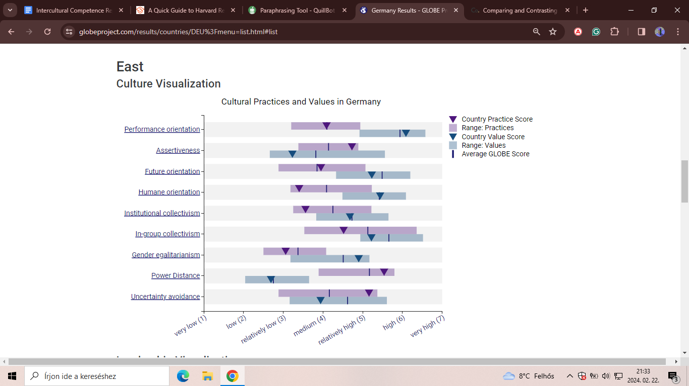
Figure 4. Culture Visualization East Germany (Globe,2020)
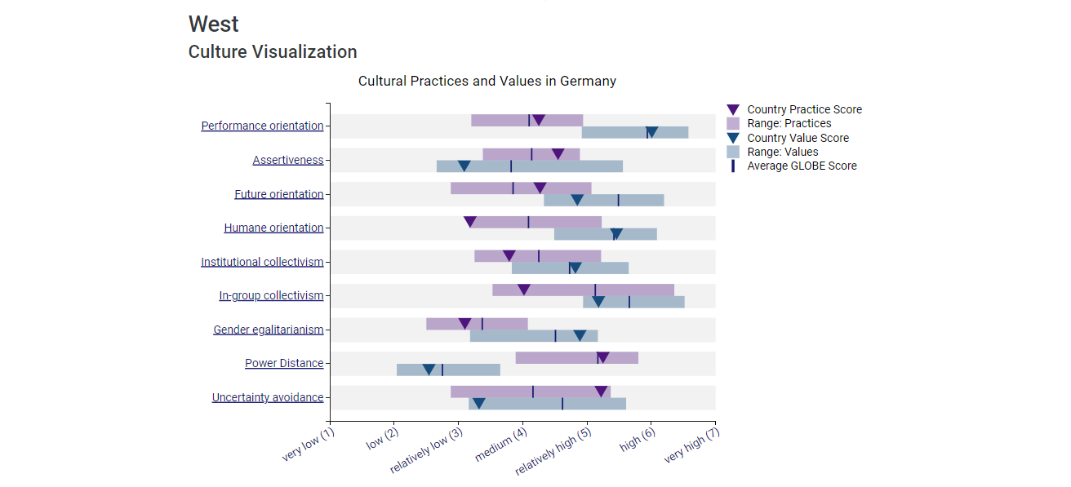
Figure 5. Culture Visualization West Germany (Globe,2020)

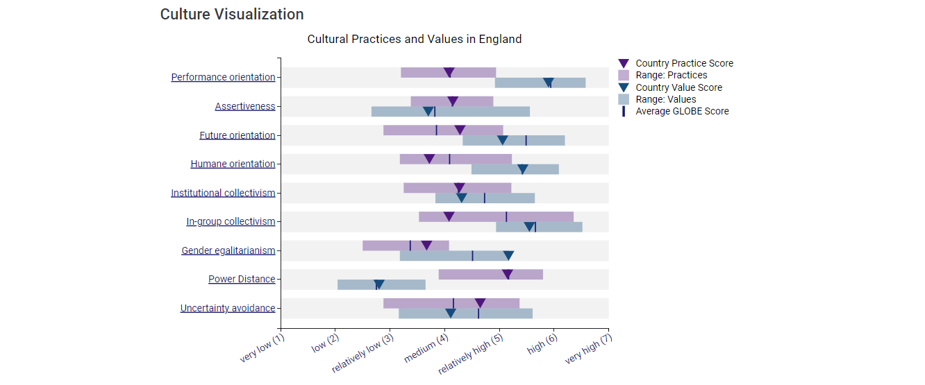
Figure 6. Culture Visualization England (Globe,2020)

Challenges of intercultural leadership in the hospitality

The growing global operations of hospitality companies pose significant challenges for management and staff in terms of efficiently collaborating and interacting with individuals from many cultural backgrounds (Grobelna,2015,p.1).
First of all, a wide range of hotel visitors from various social and cultural backgrounds may be a factor in the rise in miscommunications and other misunderstandings, particularly given that visitors from other cultures may have different expectations and preferences from hotel staff (Grobelna,2015,p.4-5). For example, in a study conducted among hotel guests from various nationalities visiting the Central Florida area, Edwin N. Torres et al. (2014, p. 260) demonstrated that while certain service elements are universal, guests from diverse cultures can also find delight in distinct services and amenities.
When leading a team of people from different cultural backgrounds, a leader must be able to understand the requirements and expectations of these workers, support their growth and drive, and prepare their successors to be accepting of diversity (Burkiewicz and Knap-Stefaniuk, 2022).
The need of open and adaptable leadership cannot be overstated in multicultural firms, which are defined by the diversity of cultures among its clientele and workforce (Knap-Stefaniuk and Burkiewicz, 2018). To address the varied needs and expectations of staff members and patrons from various cultural backgrounds, for instance, hotels and other tourism-related establishments should foster an environment that encourages the free exchange of ideas, opinions, and experiences, as well as the pursuit of novel solutions and daring new tasks (Burkiewicz and Knap-Stefaniuk, 2022).

Conclusion

This report has shown what basic differences can be found between England and Germany in terms of culture. It has examined these two countries based on the GLOBE Project’s culture and leadership study focused on most relevant practises and values. The most important challenges of intercultural leadership in the hospitality have been mentioned to face.

Recommendations

Based on the findings and conclusions in this report, the following recommendations are made:
- Building a culturally rich workplace culture and raising employees' knowledge of cultural diversity will be facilitated by multicultural training (Gong, 2008).
- Developing initiatives to raise awareness of cultural diversity, strengthening attitudes toward differences between various groups, recognizing shared perspectives and relationships among various ethnic groups, communicating in a flexible manner, and expressing personal worries and confusions when confronted with cultural barriers (Gong, 2008).
- Speaking out against discrimination, being patient and tolerant with the beliefs and customs of other cultures, and keeping up with the rapidly changing cultural landscape (Bechervaise, 2018).

References

Bechervaise, C. (2018) ‘5 Ways to Overcome Cultural Barriers in the Workplace’, Take It Personel-ly, 2 January. Available at: https://takeitpersonelly.com/2018/01/02/5-ways-to-overcome-cultural-barriers-in-the-workplace/ (Accessed: 25 February 2024).
Burkiewicz, Ł. and Knap-Stefaniuk, A. (2022) ‘Multiculturalism as a Challenge for Contemporary Leadership – an Analysis within the Context of Hotel Management in the 21st Century’, Perspectives on culture, 2022 (38), pp.411-424. DOI: 10.35765/pk.2022.3803.25.
Expatrio (2024) Germany or UK to Study: Which is Best for Students?. Available at: https://www.expatrio.com/about-germany/germany-vs-uk#so,_should_you_study_in_the_uk_or_germany? (Accessed: 20 February 2024).
Expatrio (2024) German Culture. Available at: https://www.expatrio.com/about-germany/german-culture (Accessed: 20 February 2024).
Globe (2020) About The Globe Project. Available at: https://globeproject.com/about%3Fpage_id=intro.html#globe2020_intro (Accessed: 19 February 2024).
Globe (2020) Results. Available at: https://globeproject.com/results/countries/GBR%3Fmenu=list.html#list (Accessed: 21 February 2024).
Globe (2020) Results. Available at: https://globeproject.com/results/countries/DEU%3Fmenu=list.html#list (Accessed: 22 February 2024).
Gong, Y. (2008) ‘Managing cultural diversity in hospitality industry’, UNLV Theses, Dissertations, Professional Papers, and Capstones, 480, DOI: http://dx.doi.org/10.34917/1688179.
Grobelna, A. ( 2015) ‘Intercultural Challenges Facing the Hospitality Industry. Implications for Education and Hospitality Management’, Journal of Intercultural Management, 7(3), pp. 101–117. DOI 10.1515/joim-2015-0023.
Harford, W. and Kellner, P. (2024) ‘England’, Britannica, 18 February. Available at: https://www.britannica.com/place/England (Accessed: 19 February 2024).
Ibanez, F. (2022) ‘Cultural differences between Germany and Great Britain’, Alphatrad, 21 January. Available at: https://www.alphatrad.co.uk/news/cultural-differences-germany-great-britain (Accessed: 19 February 2024).
Knap-Stefaniuk, A. & Burkiewicz, Ł. (2018) ‘Contemporary Leadership in the Context of Multiculturalism – Challenges for Human Resource Management’, Scientia et Societas, 14(2), 113–122. DOI: 10.35765/pk.2022.3803.25.
Torres E.N., Fub X., Lehto X. (2014) ‘International Journal of Hospitality Management’, Examining key drivers of customer delight in a hotel experience: A cross-cultural perspective, 36, pp. 255–262. Available at: https://stars.library.ucf.edu/cgi/viewcontent.cgi?referer=&httpsredir=1&article=1197&context=rosenscholar (Accessed: 25 February 2024).

