What are the motivations that drive collectors of battlefield relic material – critically assess the activities of one example.

Collectors of military relics can be motivated to pursue their interests for a wide variety of reasons. These reasons can range from a personal interest in a specific domain of militaria, or accumulating historical items linked to an ideology which one may also align one’s self with. Alternatively, a collector may acquire militaria for financial incentive. In the case of Craig Gottlieb, it could be argued that more than one of the previous reasons given could help to explain his involvement with the collection of military relics.
Craig Gottlieb was born in Florida USA in 1971. Collecting military relics has been a passion for him for most of his life, after he acquired his first items when he was younger than ten years old. Gottlieb served in the US Marine Corps for a number of years and retired at the rank of Major. He now runs Craig Gottlieb Militaria, an auction house which specialises in military artefacts and firearms. The majority of Gottlieb’s stock, however, is of Nazi origin.
A strong case can be made to support the argument that Gottlieb is financially motivated to collect war relics, specifically of Nazi origin. In 2011, Gottlieb was interviewed by Fox News over an item that he had acquired from a Second World War veteran. The item Fox News was captivated by, was argued to be the desk piece that Adolf Hitler signed the 1938 Munich Pact on. If the desk piece is genuine, it could be worth at least one million US dollars according to Gottlieb. At the end of the interview Gottlieb agreed that he would want the desk to eventually end up in a museum, however, he also suggested that market forces could suggest an alternative destination for the desk. The reason that Gottlieb sounds financially motivated is that if he cared more about the history associated with the desk, then would it not be more fitting for such a prestigious piece of 1930s diplomacy to end up in a museum where it can be maintained safely and studied by academics, in opposition to selling it to the highest bidder who may add it to a private collection?
A more forgiving spectator may be willing to dismiss the issues surrounding who Gottlieb sells the desk to, as a one-off trade, which may not reflect the rest of Gottlieb’s business dealings. To support this more forgiving position, there would need to be a pattern of Gottlieb donating or selling (at achievable amounts), military artefacts to museums. As it happens, Gottlieb possessed in 2014, one of Hitler’s hats, uniform’s and some personal belongings. In an interview with Real News, Gottlieb spoke extensively about profit and the financial value of these items. He stated that he paid more than one million US dollars for the items, but that they could be worth three million dollars. Just as in the previous interview with Fox News, Gottlieb said that he ideally wanted the artefacts to go to a museum. However, Gottlieb also said, ‘why do you make a profit off of an iPhone, why don’t you just give it away?’ This implies that Gottlieb is comparing trading a modern day product designed for the public to use everyday to a unique historical artefact associated with one of the most evil men in history. Furthermore, in the same interview, Gottlieb stated, ‘If someone pays a million dollars, for example, for Hitler’s hat, don’t you think there’s a really good chance that its going to get preserved?’In fairness to Gottlieb, it is unlikely that if someone paid that kind of money for a product, that they would not treat the hat with care. However, Gottlieb could still give the hat to a museum or sell the hat to a museum for a fraction of the cost, and would that museum not look after the hat? One of the main functions of museums is to preserve relics and antiquities. It is because Craig Gottlieb has acquired a substantial amount of highly rare artefacts and not automatically donated or sold them to museums, rather seeking a more profitable venture, that it is being argued that Gottlieb is financially motivated to collect military relics.
When the archaeologist may tease out an artefact from the ground, Gottlieb teases the value out of the artefact. The main reason this is being argued is because on top of the previous reasons given of Gottlieb’s existing collection of rare militaria and how he intends to pass it on to its next owner, is his appearance on the American TV-show Pawn Stars. Pawn Stars is a show which depicts a large pawn shop in America, where people take all sorts of generally rare items to the store to get them valued. Gottlieb’s role in the show is the ‘expert’ who places the value on rare military items, which commonly refer to American Civil War guns, and renaissance weapons. People who value antiques, whether they be paintings, furniture, china tea pots or guns, should not automatically be assumed to be looking solely for financial gain, with no interest in the product or its history. The Antiques Roadshow is a prime example of this, as the people who value the products that come on the show, are not valuing the product for a potential buyer right in front of them. That is the difference with Gottlieb and Pawn Stars. When Gottlieb is called in to value a product, it is to give the shop owner (the one who decides whether or not to purchase the product) an idea of the price for a sale which could be made on the day. As an example, in series six episode twenty-three, a collector brought in a Remington New Model Army .44 pistol from the American Civil War. Gottlieb valued the gun at two thousand dollars. The collector and store owner then settled on sixteen hundred dollars shortly after Gottlieb’s assessment of the gun. The value of the product that Gottlieb decides has financial relevance to Gottlieb, as he works with the pawn shop. Which is a stark contrast to the experts who value products on The Antiques Roadshow. Pawn Stars is yet another example of Gottlieb looking at historical artefacts through a financial lens.
The most forgiving defendant of Gottlieb may be willing to argue that the earlier examples of Nazi memorabilia owned by Gottlieb were all unique items with high price tags attached to them; suggesting that there is some reasonable grounds for Gottlieb to seek a financial profit. For anyone who agrees with the earlier statement, it would be invaluable for them to spectate the TV-show Nazi War Diggers, later renamed Battlefield Recovery. The show stars four characters, three of whom self-identify as metal detectorists and diggers with an interest in Second World War archaeology. Gottlieb is the ‘historian’ and ‘military tactics expert’ of the group, who is also the team leader. The series is set on the Eastern Front around the Baltic states and Poland. The goal of the show is for the characters to find Second World War sites (generally battlefield sites) and dig up the relics. What the show does, however, is it fetishizes militaria. In episode one series one, the team travel to Saldus in Latvia. They uncover a Second World War bunker with Wehrmacht equipment still inside. Amongst their findings they came across, two bayonets, a gas mask, ammo pouches, a grenade, an axe and a watch. It is understandable that when an authentic object is found buried within the ground, that the finder would become excited. However, the bayonet had not been unearthed for more than five minutes and yet Gottlieb was already discussing the value of the artefact. ’In the market something like this if it was in brand new condition would be worth three hundred dollars, obviously this is much more valuable than that.’ This contributes to fetishization because it demonstrates that if one knows where to dig, then they could find hundreds to thousands of dollars’ worth of relics. In some ways, Gottlieb creates an itinerary of what items are worth recovering. He had already stated the monetary value of the bayonet, but later on in the episode the team unearthed a watch. The watch was not in working condition but had managed to stay preserved beneath the soil. The team were excited when they found the watch, but again, within a short space of time, Gottlieb was setting a value on the watch. ‘The watch has no monetary value, you couldn’t get five dollars for it at a flea market’. This tells viewers that there are some items not worth recovering because they do not hold financial importance. The characters on Battlefield Recovery are not professional archaeologists, they do not use the material found in the ground to give context to a wider narrative surrounding Stalin’s advance into German occupied territory. A clear contrast to Battlefield Recovery, is the story of Barrington Anglo Saxon Cemetery. The Anglo-Saxon site of Barrington was discovered in the nineteenth century but then rediscovered in 1987 by a metal detectorist called Chris Montague. Montague informed Alison Taylor, the Cambridgeshire county archaeologist of his discovery. Taylor then organised a professional archaeological excavation to examine the site, which over the course of two years, revealed one hundred and fifty bodies, buried with rare and valuable artefacts. Barrington has given archaeologists the opportunity to learn about Anglo-Saxon burial sites which has further enhanced our understanding of Anglo-Saxon culture. Had Barrington been discovered by the likes of Gottlieb, there is a high chance that the artefacts at the site would have been looted and sold on to collectors and enthusiasts. The items would be around, but their story and context would be lost, serving little to no academic benefit. Throughout the duration of series one episode one of Battlefield Recovery, the team constantly refer to the archaeological relics as treasure. Treasure, as defined by the Oxford English dictionary, means an individual or collection of valuable objects. The significance of this is that the team are not looking at the artefacts as historical items with stories behind them. Rather, the team appear to only show interest in items when they contain monetary value. The fact that Gottlieb’s team found and excavated a site in under forty eight hours, without a professional archaeologist or without creating a site report, whilst referring to their finds as treasures and not reporting potential black diggers to the authorities; suggests that their whole project in the first episode was unprofessional, with only a financial goal in view.

As previously suggested, it is proposed that Gottlieb could have more than one motive for collecting military relics. When it is taken into consideration that Gottlieb first started to collect militaria as a child, the avenue of a personal interest in the industry opens up. A lot of the relics that Gottlieb collects are of Nazi origin, however, it may be far-fetched to suggest that Gottlieb is ideologically fascist. From the material available, there is not enough evidence to support such a claim. On the other hand, it is feasible to argue that Gottlieb has a strong personal interest in German military relics, particularly from the Second World War. The interview Gottlieb filmed with Fox News was shot in Gottlieb’s office. His office was decorated with Hitler Youth knives, swastika flags, SS and Wehrmacht uniforms, German rifles and propaganda posters. The fact that his office was decorated with so much Nazi iconography suggests that Gottlieb is not just interested in selling militaria, otherwise he would not have made the effort to put his collection on display.
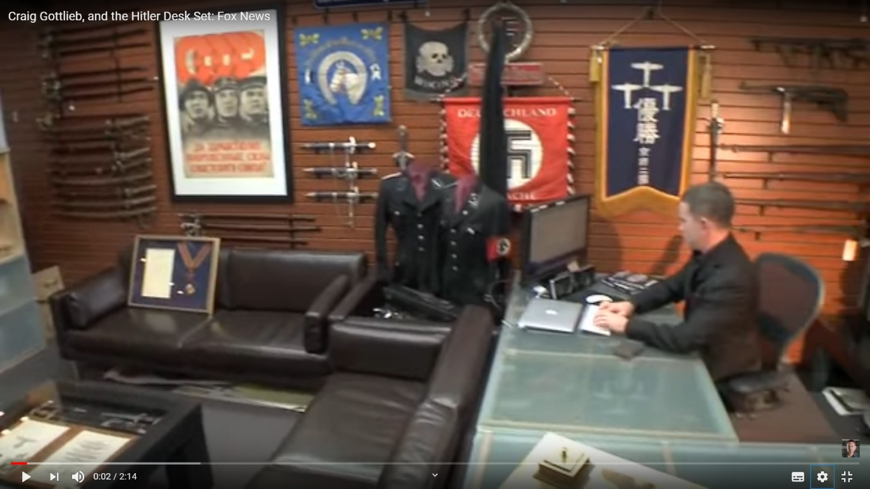
(Figure 1)
Another example supporting the claim that Gottlieb has a passion for Second World War German artefacts is his connection with the MP40. Gottlieb has a YouTube channel where he has posted videos of his hobbies, personal life, and work. Some of these videos include Gottlieb firing assault rifles and submachine guns, which on its own is nothing worth mentioning. However, one of the weapons Gottlieb fires is an MP40. It is unclear if it is an original or a replica as that is not explained. Nevertheless, a fully functional MP40, regardless whether it is original or not, is not an easy weapon to get hold of even in the United States, only specialist arms dealers trade them, meaning not every single gun store in the US stocks these specific guns. This is supported by how expensive these weapons are when they go to market. This means Gottlieb would have had to go out of his way to acquire one. Firing old weapons can serve as an interest to various people, as there are YouTube channels that specialise in this field such as hickok45 and Forgotten Weapons accumulating roughly six million subscribers between them. Once again there is a difference between Gottlieb firing vintage weaponry in comparison to other channels. As Gottlieb fires the MP40, the video is edited in such a way that the shot cuts between Gottlieb firing the weapon to an authentic German soldier firing the weapon in the same stance during the Second World War. It is not necessary to include this in the video, hence all it does is give the impression that Gottlieb wants to identify as a member of the Wehrmacht. The MP40 was a weapon used extensively by the Third Reich, finding its way into the hands of the Wehrmacht, the SS and German police forces. Over one million of these guns were made during the Second World War and has become one of the corner stones of German military iconography alongside the Tiger Tank, the Stuka and the U-boat. For this reason, it should come as no surprise that Gottlieb owns several of these guns, as it is on the check list of ‘things to own’ for collectors of Nazi militaria.
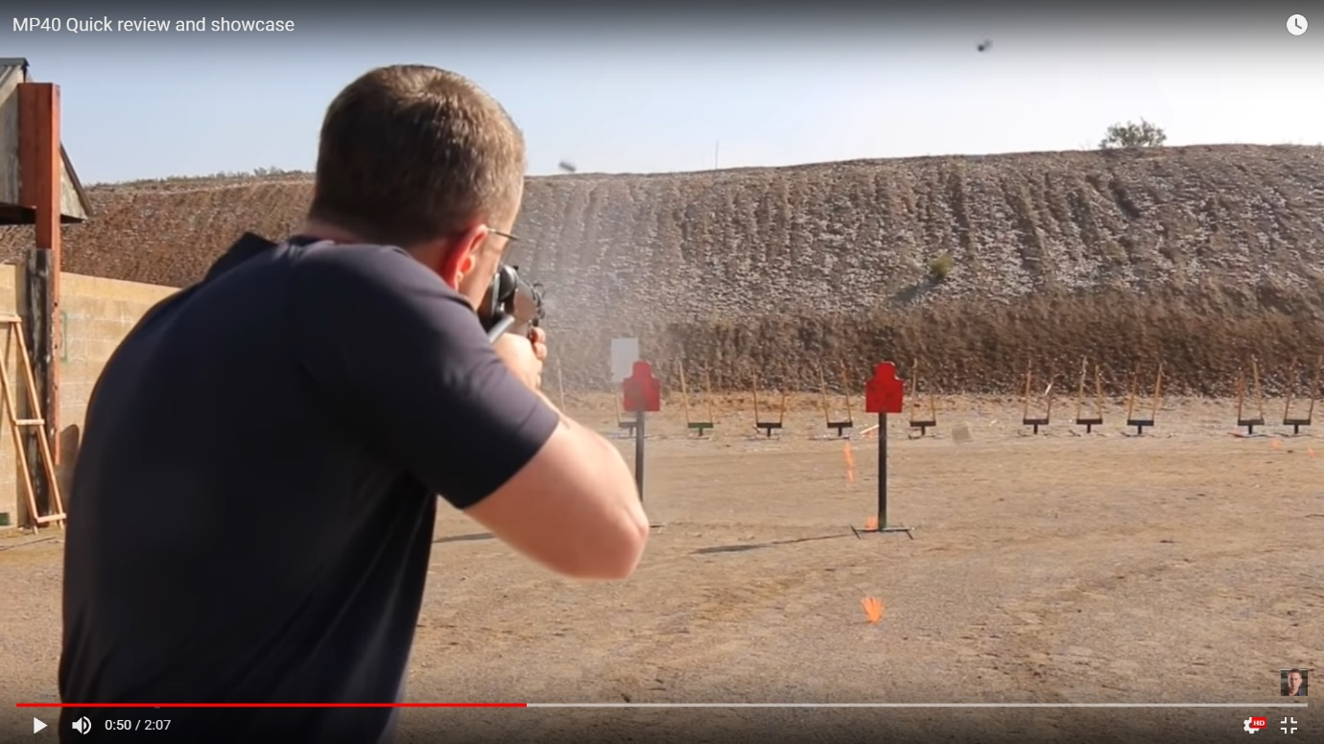
(Figure 2)

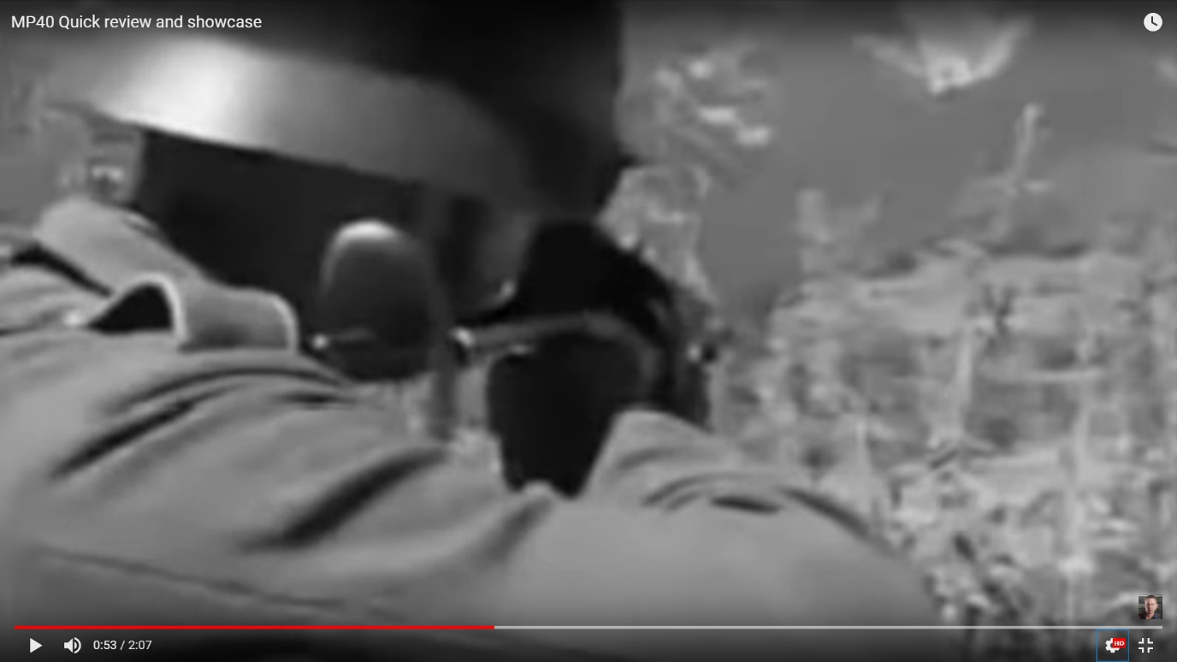
(Figure 3)

In closure, there is no overreaching reason why collectors spend their time gathering military relics. The factors that drive collectors to accumulate military relics from the Napoleonic wars may be very different to the factors that motivate collectors to gather Nazi militaria. In the case of Craig Gottlieb, there are at least two reasons that motivate him to collect military relics. The first, would be his own personal interest in German militaria from the Second World War. People collect all sorts of items which are worth a lot of money, such as Lilly Hartley who has one of the largest collections of first-edition books in the world. Gottlieb cannot be accused of collecting German militaria solely for profit, as there are endless other categories of relics, antiques and artefacts that provide immense financial gain for the collector. However, Gottlieb has clearly recognised that there is a lot of money to be made in the business of battlefield relics and has taken the opportunity to capitalise on that industry. A great deal of Gottlieb’s involvement in collecting battlefield militaria revolves around trade. Gottlieb has consistently demonstrated through his statements and business transactions, that money is a significant factor that has motivated him to continue to buy and sell battlefield relics.

Words: 2713

Bibliography

Addictedtobleeps, We dig a WW2 Bunker and find LOADS of relics! [Battlefield Recovery], https://www.youtube.com/watch?v=Tli1DSsGXPA&t=877s . published 15/11/2019.
Forgotten Weapons, https://www.youtube.com/user/ForgottenWeapons .
Gottlieb, Craig, Craig Gottlieb, and the Hitler Desk Set: Fox News, https://www.youtube.com/watch?v=S2NoV252iZo . published 02/09/2011.
Gottlieb, Craig, Hitler's Uniform, Craig Gottlieb, Glenn Beck's Blaze, https://www.youtube.com/watch?v=n2KrPa2uH-Q . published 03/04/2014.
Gottlieb, Craig, Pawn Stars: Rare Smith & Wesson, https://www.youtube.com/watch?v=UTCUAeWZOK4 . published 07/12/2014.
Gottlieb, Craig, MP40 Quick review and showcase, https://www.youtube.com/watch?v=OS2EFL17BSs . published 18/12/2014.
Hickok45, https://www.youtube.com/channel/UCvB3solmhqtgDeLpD-yTtfg .
HistoryHunter, Craig Gottlieb, https://www.historyhunter.com/ , Published N/A.
International Military Antiques, MP40, https://www.ima-usa.com/pages/search-results/mp40.
Malim T., Hines J., The Anglo-Saxon Cemetery At Edix Hill (Barrington A), Cambridgeshire. (Published by Council for British Archaeology. York. 1998).
Oxford’s learners dictionary, Treasure, https://www.oxfordlearnersdictionaries.com/definition/english/treasure_1 .
Pawn Stars, Pawn Stars: Remington New Model Army .44 | History, https://www.youtube.com/watch?v=5TAWRAlSTwE . published 12/03/2018.

HistoryHunter, Craig Gottlieb. https://www.historyhunter.com/ , Published N/A. [accessed 03/03/2020].
Craig Gottlieb, Craig Gottlieb, and the Hitler Desk Set: Fox News. https://www.youtube.com/watch?v=S2NoV252iZo , published 02/09/2011. [accessed 15/02/2020].
Gottlieb, The Hitler Desk Set, 2011.
Gottlieb, The Hitler Desk Set, 2011.
Craig Gottlieb, Hitler's Uniform, Craig Gottlieb, Glenn Beck's Blaze, https://www.youtube.com/watch?v=n2KrPa2uH-Q . published 03/04/2014. [accessed 15/02/2020].
Gottlieb, Hitler’s uniform, 2014.
Gottlieb, Hitler’s uniform, 2014.
Craig Gottlieb, Pawn Stars: Rare Smith & Wesson, https://www.youtube.com/watch?v=UTCUAeWZOK4 . published 07/12/2014. [accessed 15/02/2020].
Pawn Stars, Pawn Stars: Remington New Model Army .44 | History, https://www.youtube.com/watch?v=5TAWRAlSTwE , published 12/03/2018. [accessed 03/03/2020].
Addictedtobleeps, We dig a WW2 Bunker and find LOADS of relics! [Battlefield Recovery], https://www.youtube.com/watch?v=Tli1DSsGXPA&t=877s , (published 15/11/2019). [Accessed 27/02/2020].
Addictedtobleeps, Battlefield Recovery. (2019).
Tim Malim, John Hines, The Anglo-Saxon Cemetery At Edix Hill (Barrington A), Cambridgeshire, (Published by Council for British Archaeology, York. 1998).
Oxford’s learners dictionary, Treasure, https://www.oxfordlearnersdictionaries.com/definition/english/treasure_1 . [accessed 27/02/2020].
Gottlieb, The Hitler Desk Set, 2011.
Gottlieb, The Hitler Desk Set, 2011.
International Military Antiques, MP40, https://www.ima-usa.com/pages/search-results/mp40 . [accessed 20/02/2020].
Hickok45, https://www.youtube.com/channel/UCvB3solmhqtgDeLpD-yTtfg . [accessed 15/02/2020]. Forgotten Weapons, https://www.youtube.com/user/ForgottenWeapons . [accessed 15/02/2020].
Craig Gottlieb, MP40 Quick review and showcase, https://www.youtube.com/watch?v=OS2EFL17BSs . (published 18/12/2014). [accessed 15/02/2020].
Gottlieb, MP40, (2014).
Gottlieb, MP40, (2014).
Gottlieb, MP40, (2014).

