Name: Daniel Rhys Newman
Student Number: 1702330
Module Title: Introduction to Web Development
Module Code: ACCA4003
Module Lecturer: Kemi Ademoye
Assignment Title: HTML & CSS Web Development

Table of Contents:

Introduction: Page 3
Requirements: Pages 3-5
Implementation: Pages 5-11
Evaluation: Pages 11-12
References: Pages 13-14

Introduction:
This report outlines the features, uses and requirements of the Gamer Galaxy website produced by the author. It also includes a self-evaluation of the creation of the website and its features. This report will feature a map of the website, a diagram of the home page, screenshots of the website, validation of the HTML and CSS and a report of the accessibility of the website. Finally, this report will include references of information sources used and images from the websites used.

Requirements:

Introduction to Website
The site that has been created is titled “Gamer Galaxy”. Its purpose is to be a place to come to for Video Game related news, information about new and upcoming game releases. The target audience of the website would typically be 18 and over as the website mentions video games with age ratings of 18+. As a result, the website did not need to have simplified text or be child friendly. However, the website is still meant to feel professional, so it is child friendly in terms of its written text and avoids profanity or overly informal language. The community for video games is vast and news comes out every day regarding new releases or rumours and so it will constantly remain relevant so long as it is updated daily or weekly. The subject of gaming was chosen due to the huge scale of the gaming industry and the high levels of interest in gaming content.

Navigation Diagram
Website navigation is important for all websites. Making the website easy to navigate is very important as surveys show that 50% of website navigation is done via the use of headers, with bad navigational structures described as one of the top ten web development mistakes. [1]

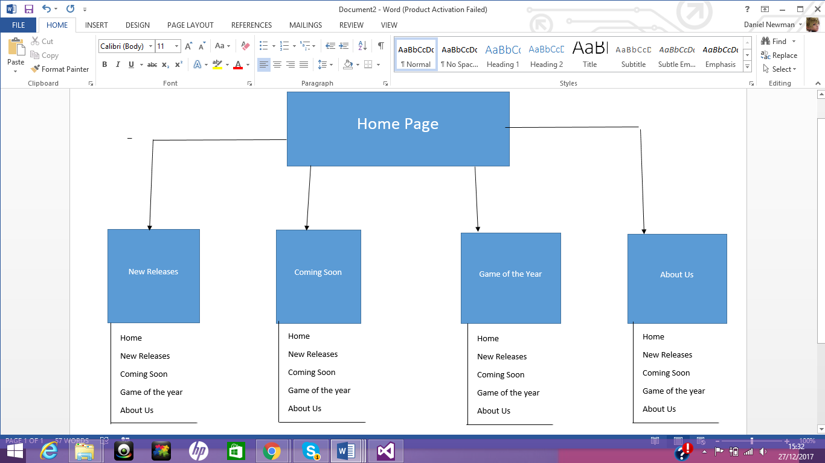

The diagram above shows that the home page leads to all the other pages and each page can lead to any other page. This method of going to any page from any page was important to include so that it didn’t matter which page you were on at the time so that you could still access any page.

Home Page Design
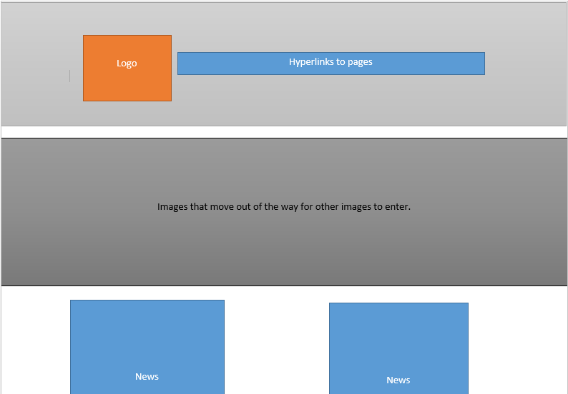

This diagram shows where the different aspects of the home page are. The plans show a layout where there is a header with the logo, hyperlinks and also then shows how the banner works and how much of the page it should take up. Finally, the diagram shows that the news segment should have segregated areas for the articles, spaced out between each other.

Implementation:

The Website
In this section, pages of the website will be shown. This will show how each page is accessed as well as the purpose of each of the pages. When planning the website, it was crucial that everything had a purpose. Any images used must have had an appropriate reason for being there and any text used must have a purpose for being there.

Home Page
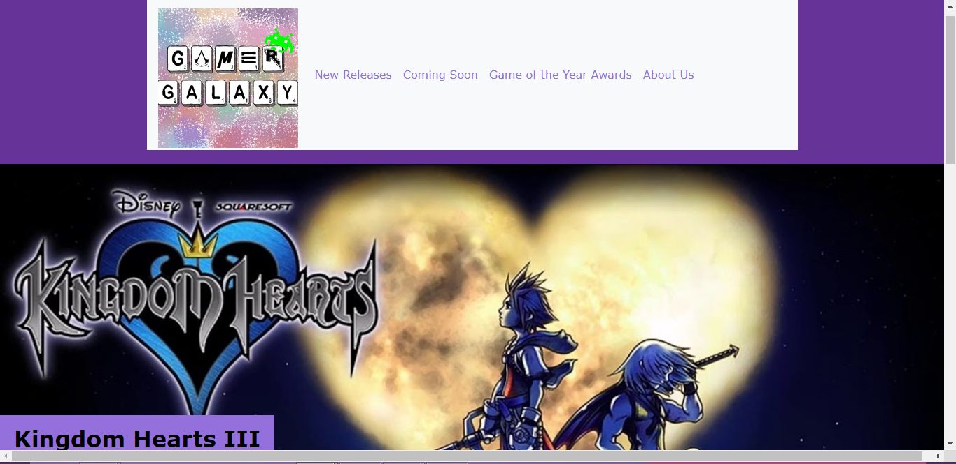
This is the top of the original page. The header is the only way to navigate the website and is the same design on every subsequent page. The logo is a link to the homepage and the next four links lead to the other pages. The house style is purple and gold. I have used two shades of purple (dark for the header and footer, light purple for the rest) and also gold for decoration. The large image used is the banner and is also an animated slideshow, I used four images which all relate to news stories written below the slideshow.
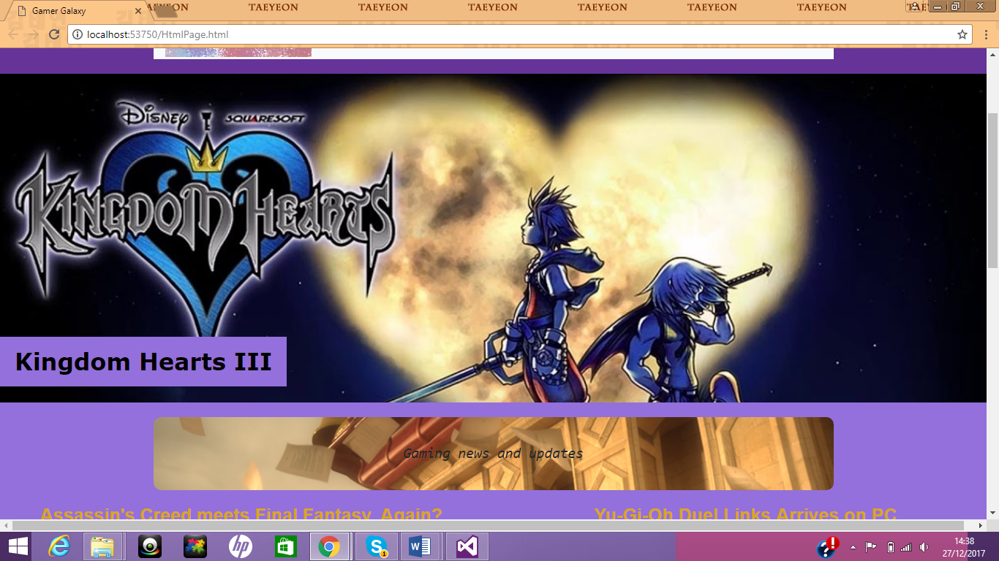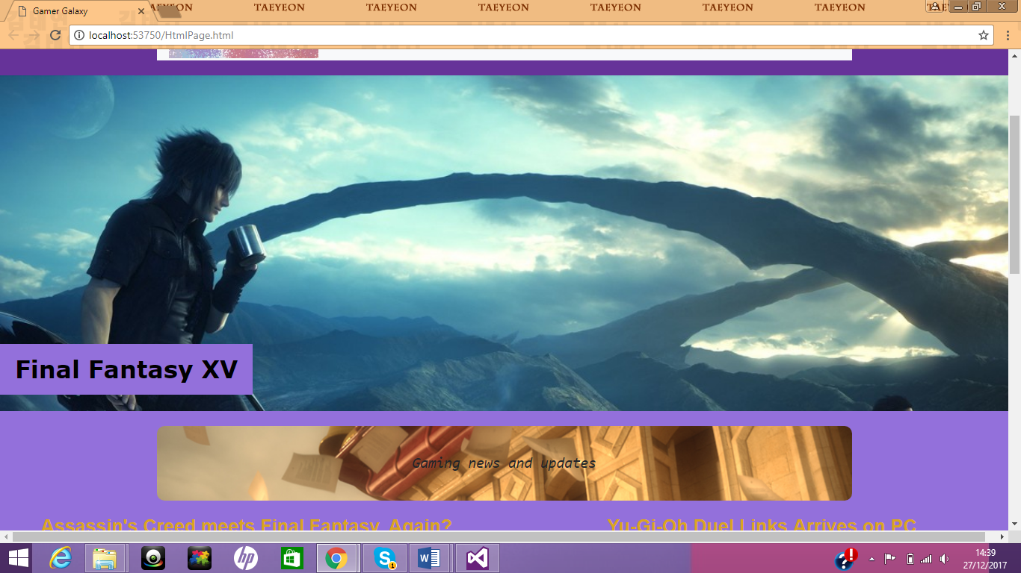
Above images show off the transition. The images move to the left as another image enters from the right, beside the original image. Below the animation is a banner for the next section, “Gaming News and Updates”. The image used for the banner is meant to represent news flying out of a window, this helps convey the idea that news is constant and would update in the future.
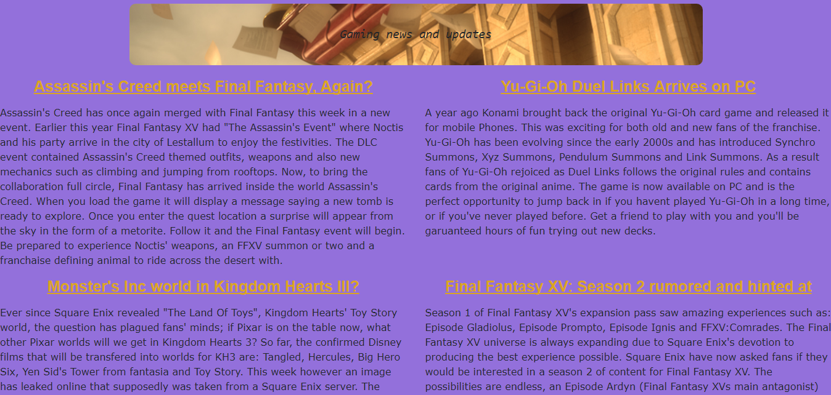
The news is written here. Gold is used for the titles to help make them stand out. The text is written in columns. So two stories can occupy the width of the screen with another two stories below them.
The images used in the animated banner relate to all four news stories on the page as a way of keeping the page consistent.
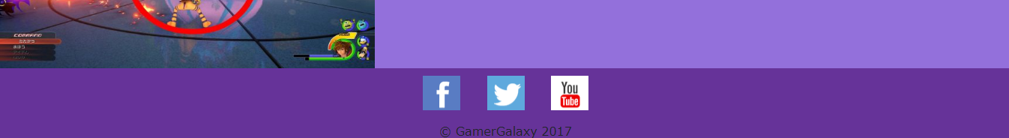
The footer at the bottom of the page is the same on every subsequent page. It contains social media links which change colour when the mouse hovers over them and then also some text saying what the website is.
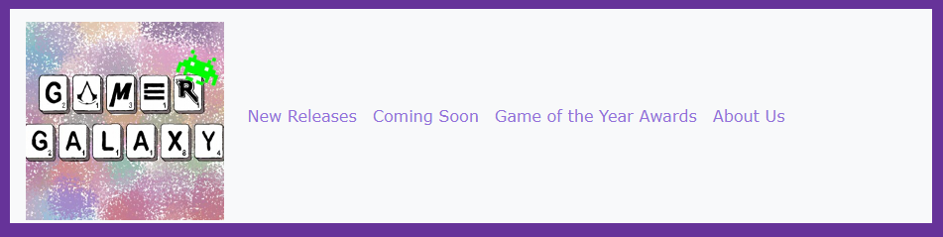
The header hyperlinks take you to each of the pages. Clicking the logo takes you to the homepage, and each of the other links takes you to the pages they relate to.

New Releases Page

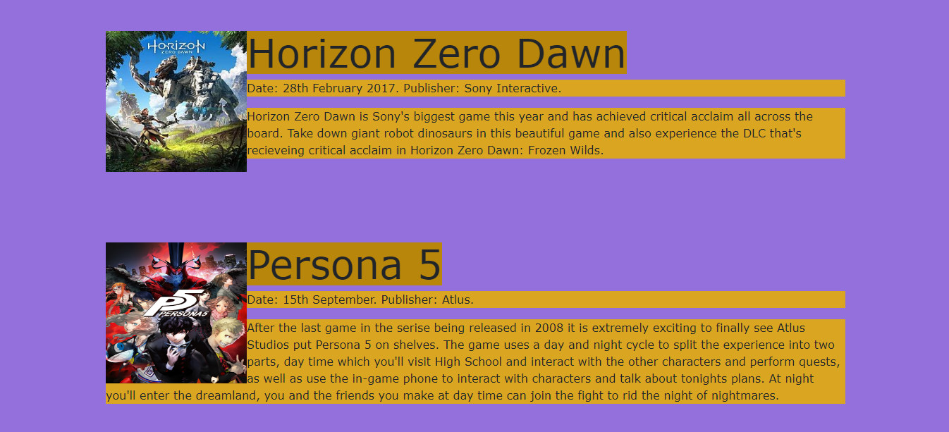
The contents of this page are lined up like this. The image is the cover of the game, with the title displayed in the dark gold background. The line beneath that contains the date of release and the publisher that made the game. It then includes a descriptive paragraph about the game itself. This concept continues throughout the remainder of the page.

Coming soon page
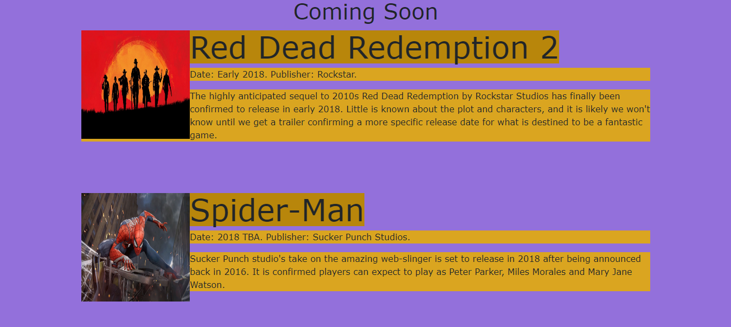
The coming soon page is laid out similarly to the New Releases page with the same concept and design being used. The major difference between the two are the dates being coming soon instead of dates that have already past.

Game of the Year Page
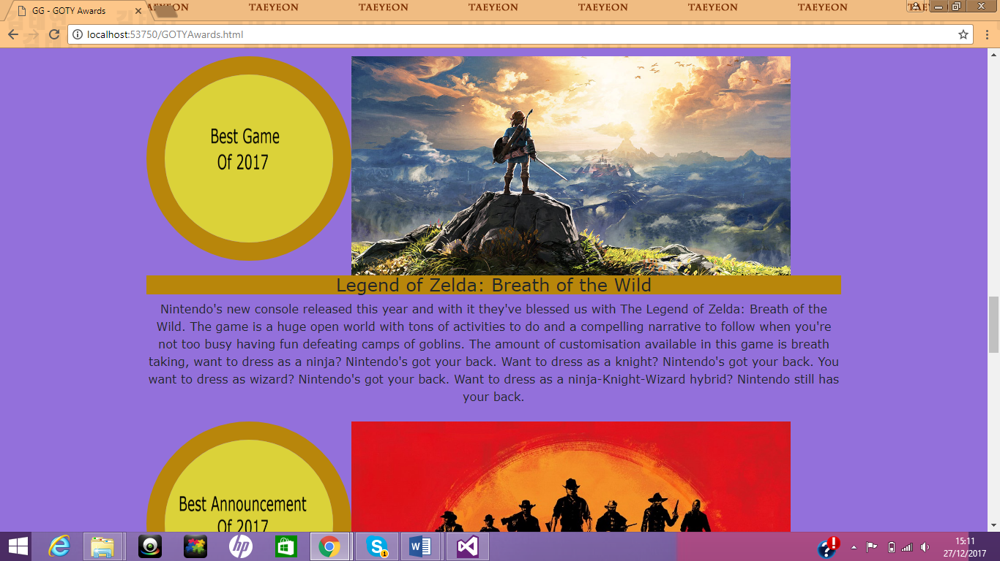
The Game of the Year page is designed to have the award on the left, along with a large landscape image of the winning game. Below them is a golden bar with the name of the game and then finally a description of why the game has been selected for that award. Each segment is a new award and a new game that has won each award. The layout is consistent throughout the page but the content is different.
About Us Page
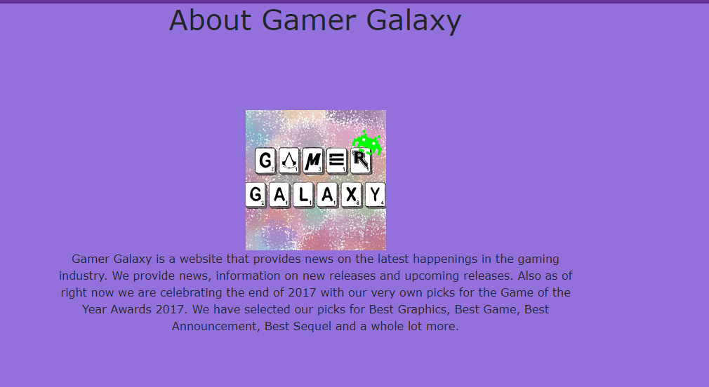
The About Us page is very simple and is a paragraph under the logo. Though it is simple, it is valuable to have on the website as it can make or break whether someone remains on the site long enough to understand what it’s about.
Validation:
Validating a website is the making certain that it follow the basic structures and normalities that are set out by organisations. The process of validating code is done via matching your code and then checking the structure in writing and format to let the user know how well it can be interpreted. [2]
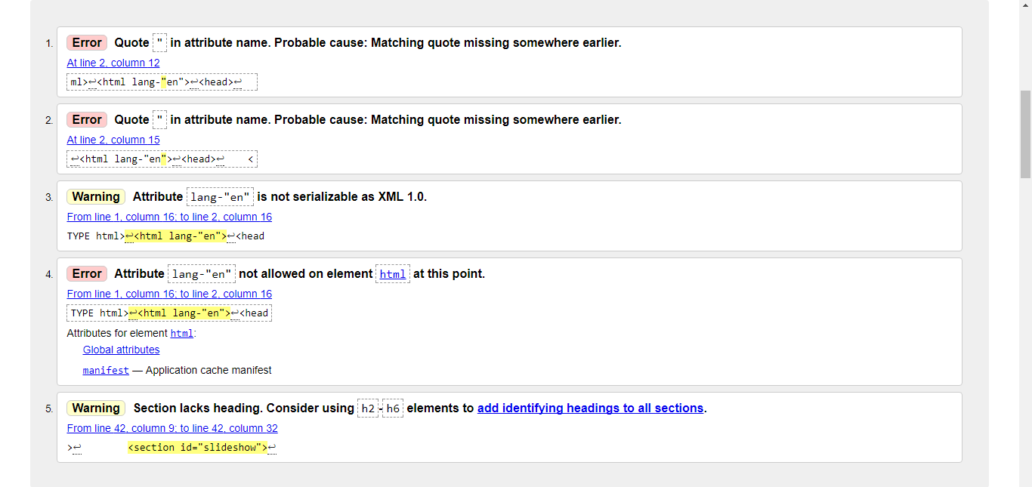
After putting the HTML into a validator [3] the main chunk of the issues exist in the line:
<html lang-"en">
The website works with this line regardless, however it was not understand what the intention of the line was. The only other issue is a warning that it wants to include h2 and h6 elements to help make the identifier “slideshow” become more specific.
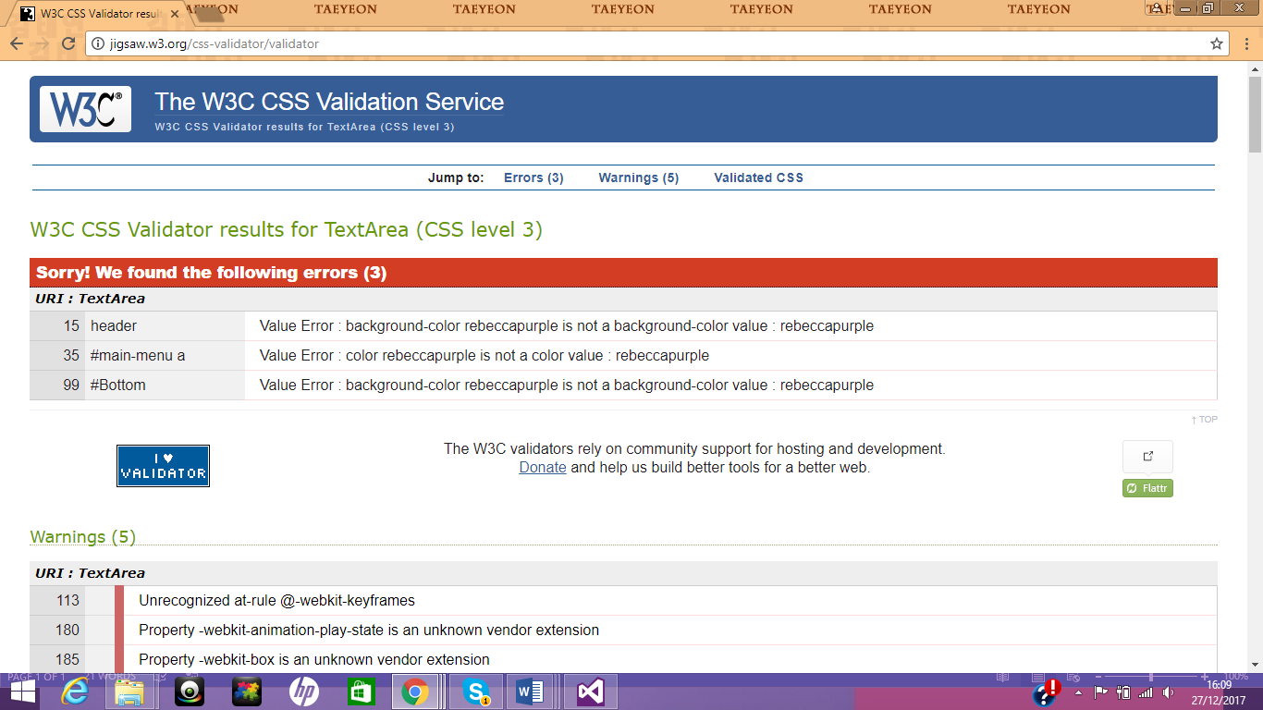
The three errors with the CSS [4] pages is that the validator doesn’t recognise the colour “rebeccapurple.” The colour works in Visual Studio and displays on the webpage. Visual Studio allows you to enter names of colours (as well as rgb and hex) and the validator doesn’t seem to understand rebeccapruple as an official colour.
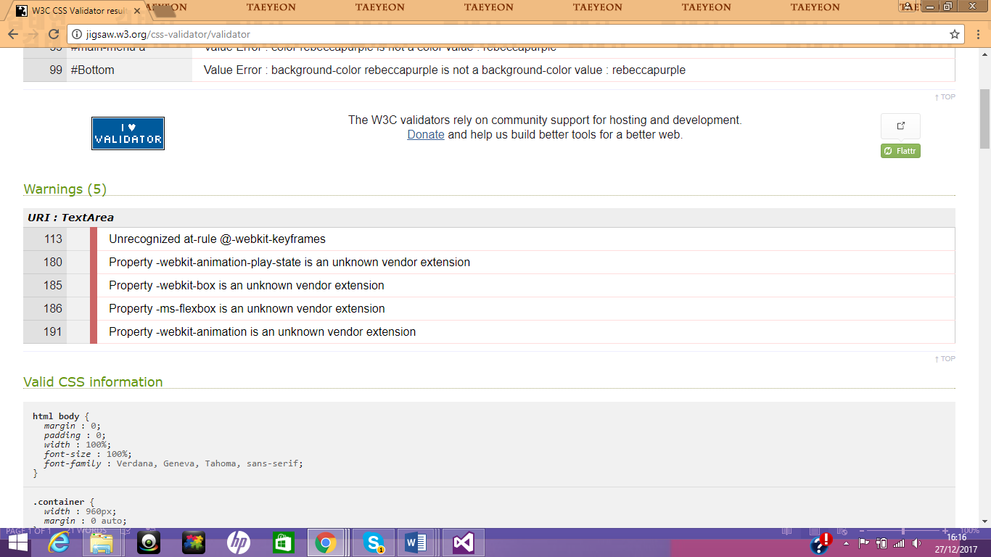
It picked up on 5 warnings; all of them exist because the validator doesn’t recognise –Webkit and –ms-flexbox extensions.

Evaluation:
Accessibility is very important to a website. There needs to be careful planning to ensure that the website isn’t difficult to use and also that it suits the needs of disabled individuals. The internet should have equal opportunities to use the resources and webpages available for everyone, even to those with disabilities. As a result, procedures need to be put in place so that everyone can use the web freely. [5]
The headings of the website are written in bold and are larger than the rest of the text. This was intentional so that the titles of anything could be easily read. In the HTML document, things are placed in <div> identifiers so as to keep related items together. This is helpful because it means that they are connected and as a result looks like its own group of connected pieces. The images are large on the home screen as they are meant to be the centre of attention. However on the “New Releases” page and the “Coming Soon” pages, images are not as big. This is because they are not meant to be the centre of attention.
The colours in the foreground are a dark shade of purple. This is bold and clearly shows off the header and footer. Meanwhile the background is light purple which allows dark text to be easily read by users. Navigation is very simple. The links are kept on the header of every page consistently. No matter which page the user is on, the links remain in the same location. This is extremely good for accessibility as a user can quickly switch pages whenever they want as they always know where the links are instead of worrying about how to navigate to another page of the website. With regards to disabled access to the website, a lot of those features are placed in the software of the users’ computer. For example, text should be read when selected using the narrator tool on the computer. If text is too small for the user they can use the zoom feature available on their browser, their computer or on their phone/tablet.
Though the website works well and looks good, there are still things about it that aren’t perfect. The header of the website on every page should be done differently. The header takes up too much height of the page. This is because the logo was designed to be a square, and as a result it had to be large enough to be readable, which in turn took up a lot of space on the page. I would also prefer the links of the header to be contained inside a drop down list that would appear if a button was pressed. This happens when the page is halved in size. However due to a lack of responsive web design, this effect is not pulled off as well as originally hoped. To fix the issues with the header, the easiest solution would be to make a wider logo with less height. This would also be useful for marketing as it would improve the recognisability of the website and its brand. On the game of the year page, the trophy icon that was produced is an image with a CSS border surrounding it. The icon could have been more recognisable or creative. For example, text over an image of a trophy would have been more recognisable and would have appeared more professional.

References:

[1] | C. L. e. a. Jengchung Victor Chen, "The interaction effects of familiarity, breadth and media usage on web browsing experience.," Computers in Human Behavior, pp. 2141-2151, 8 June 2011.
[2] | WordPress, "Validating a Website," WordPress, [Online]. Available: https://codex.wordpress.org/Validating_a_Website. [Accessed 29 December 2017].
[3] | W3C, "Markup Validation Service," W3C, [Online]. Available: https://validator.w3.org/. [Accessed 23 December 2017].
[4] | W3C, "CSS Validation Service," W3C, [Online]. Available: http://jigsaw.w3.org/css-validator/. [Accessed 23 December 2017].
[5] | O. W. G. (. Shawn Lawton, "Introduction to Web Accesibility," W3, September 2005. [Online]. Available: https://www.w3.org/WAI/intro/accessibility.php. [Accessed 30 December 2017].

Website Images Sourced:
220px-Horizon_Zero_Dawn – https://en.wikipedia.org/wiki/Horizon_Zero_Dawn
ACO – http://comicbook.com/category/ubisoft
ACOrigins – http://www.allkeyshop.com/blog/assassins-creed-features-include-naval-battles-eagle-scout-tombs-and-more/
Call-of-duty-wwii-image – https://www.trueachievements.com/n27660/call-of-duty-counts-down-to-wwii
Destiny – https://en.wikipedia.org/wiki/Destiny_2
FC5 – https://www.theverge.com/2017/5/26/15691642/e3-2017-destiny-2-far-cry-5-star-wars-battlefront
Ff7 – https://www.express.co.uk/entertainment/gaming/796884/Final-Fantasy-7-Remake-release-date-UPDATE-Square-Enix-news-Kingdom-Hearts-3
FinalFantasy – https://www.google.co.uk/url?sa=i&rct=j&q=&esrc=s&source=images&cd=&ved=0ahUKEwjnz8HSjarYAhVDK1AKHbErDB8QjB0IBg&url=https%3A%2F%2Fwww.polygon.com%2F2015%2F9%2F16%2F9337773%2Ftokyo-game-show-2015&psig=AOvVaw2TACDDhQcq7K0sqkVe8RrD&ust=1514461089787548
GoW – http://www.howtreasure.com/1157/god-of-war-4-although-dad-of-war-wouldve-sounded-better-release-date/
Gwent – https://www.playstation.com/en-us/games/gwent-the-witcher-card-game-ps4/
Ignis – http://cogconnected.com/2017/10/final-fantasy-xv-episode-ignis-trailer/
KH3 – https://www.polygon.com/2017/6/11/15777666/new-kingdom-hearts-3-trailer-square-enix-orchestra-world-tour-e3-2017
KHGOTYpage – https://kotaku.com/this-is-the-intro-to-kingdom-hearts-iii-1589443754
KHLeak – http://kh13.com/news/rumor-screenshots-of-a-possible-monsters-inc-world-for-kingdom-hearts-iii-reportedly-leaked-on-resetera
KingdomHearts – http://www.behindthevoiceactors.com/video-games/Kingdom-Hearts/
KingdomHeartsBanner – https://eu.square-enix.com/en/blog/new-kingdom-hearts-3d-screenshots
Persona_5_cover_art – https://en.wikipedia.org/wiki/Persona_5
PersonaMain – http://www.kotaku.co.uk/2017/03/29/2017-delivers-yet-another-classic-in-persona-5
RedDead – https://www.express.co.uk/entertainment/gaming/783879/Red-Dead-Redemption-2-release-date-update-news-UK-retailer-September-Rockstar
Shadowofwar – https://www.shadowofwar.com/
Social-media-sprite-sheet – https://moodle.uwtsd.ac.uk/course/view.php?id=2051
SpiderMan – https://news.marvel.com/games/66757/marvels-spider-man-swings-e3-2017/
Ubi – http://www.cgmagonline.com/2017/05/31/ubisoft-updates-their-iconic-swirl-logo/
Yakuza – https://www.playstation.com/en-us/games/yakuza-0-ps4/
YuGiOh – http://comicbook.com/2015/05/13/yu-gi-oh-creator-kazuki-takahashi-to-appear-at-san-diego-comic-c/
Zelda – https://www.nintendo.com/games/detail/the-legend-of-zelda-breath-of-the-wild-switch

marking criteria and Student FEEDBACK

This section details the assessment criteria. The extent to which these are demonstrated by you determines your mark. The marks available for each criterion are shown. Lecturers will use the space provided to comment on the achievement of the task(s), including those areas in which you have performed well and areas that would benefit from development/improvement.

Common Assessment Criteria Applied (Assignment 1) | Marks available | Marks  awarded
1. Research-informed Literature
Extent of research and/or own reading, selection of credible sources, application of appropriate referencing conventions.
Demonstrates a good level of research. (Grade mark: 60.00%) | 5 | 3
2. Knowledge and Understanding of Subject
Extent of knowledge and understanding of concepts and underlying principles associated with the discipline.
Demonstrates a good understanding of the standards used to design and implement a website. The main area for improvement is your use of the grid system to layout and structure your content and how to nest the HTML classes that make up the grid. (Grade mark: 60.00%) | 20 | 12
3. Analysis
Analysis, evaluation and synthesis; logic, argument and judgement; analytical reflection; organisation of ideas and evidence
A good evaluation of the website with some relevant suggested improvements has been provided, but the section on the accessibility evaluation could be improved. (Grade mark: 57.50%) | 20 | 11.5
4. Practical Application and Deployment
Deployment of methods, materials, tools and techniques; application of concepts; formulation of innovative and creative solutions to solve problems.
A very good attempt featuring a simple website with well-thought-out content. Well done. Some suggested improvements include: be careful with your choice of colours and ensure there is enough contrast between the text and background for all content. As mentioned above, the layout could also be improved and also note that it is good practice to name the home page of a website as either index.html or default.html. There was a slight problem with the slideshow on your home page. See your report for how to fix this and some additional comments. (Grade mark: 61.00%) | 50 | 30.5
5. Skills for Professional Practice
Attributes in professional practice: individual and collaborative working; deployment of appropriate media; presentation and organisation.
The report is of a good standard. Additional, suggested improvements have been provided in your report. (Grade mark: 60.00%) | 5 | 3

Assignment Mark (Assessment marks are subject to ratification at the Exam Board. These comments and marks are to give feedback on module work and are for guidance only until they are confirmed. ) | Late Submission Penalties (tick if appropriate) |  | 60%
 | Up to one week late |  | 60%
 | 1st/2nd/3rd attempt? |  | 60%

