Microprocessors
Assignment
By Sam Woolner

I have been tasked with coding a car park with a single entrance controlled by a traffic light system and a barrier, this system is regularly used in many city centre multistorey carparks. Unfortunately, since I do not own a car park to code, I will be substituting it with an Arduino Uno and a simple breadboard circuit designed to replicate it.
Before I began construction I was advised to use the online program Tinkercad to make the circuit. The reasons for this are as follows, it was advertised as being beginner friendly, it was free to access and it would allow me to use any number of conponents as I wanted.
Constructing the circuit was quite easy as the software displayed conponents exactly how they would look in the real world insead of using simbols, helping me have a much better idea of how to construct it.
Below is a screenshot of the constructed circuit which I designed as explained above.
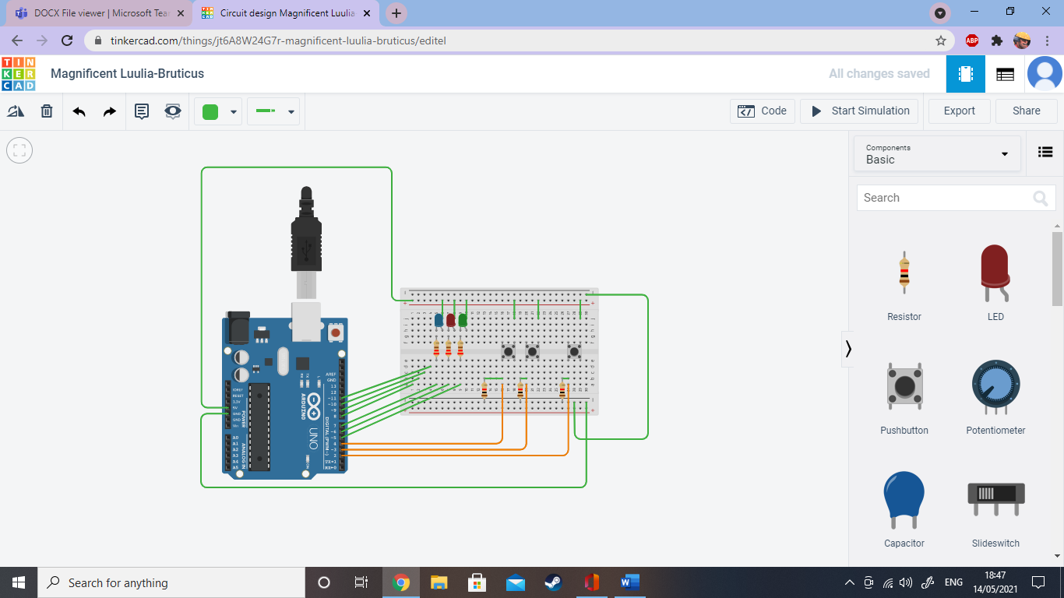
The reason for using an Arduino Uno is mainly because it was the only option on the program, but other to that it is also one of the simplest devices to use in coding a circuit and I have had experience using them before, so I was familiar with how to set it up. There are other more complex and sophisticated alternatives available but this is what works best for me.
Three LED’s have been used to replicate traffic light system; the resistors used before them will reduce the current as not to damage them. When the red LED glows the barrier is down, and when the green LED glows, the barrier will raise allowing the vehicle to proceed. The blue LED was meant to be for an intermittent stage where the barrier was about to change which would be very similar to amber in a road traffic system. Unfortunately in my programme this has failed to operate correctly. It’s new purpose is to display that the system is receiving power thus still functioning.
The three pushbuttons are designed to replicate the stages of the car parks capacity. The middle one (green) will represent the carpark having spaces and the barrier being open. The button to the right (red) will represent the carpark being full and the barrier being closed.
For the wiring, on the Arduino the wire connected to 5V provides power to the circuit, and the wire connected to GND acts as a point for the circuit to close. These are essential for any circuit.
The wires connected to ~5, ~6 and 7 are connected to the LED’s in order to control them from the commands sent by the pushbuttons. The three orange wires connected to 2, ~3 and 4 connect the pushbuttons the Arduino, where the signal from the button being pressed is interpreted by what the Arduino has been coded to interpret.
This is the code that was used in the circuit is displayed at the bottom of this document.
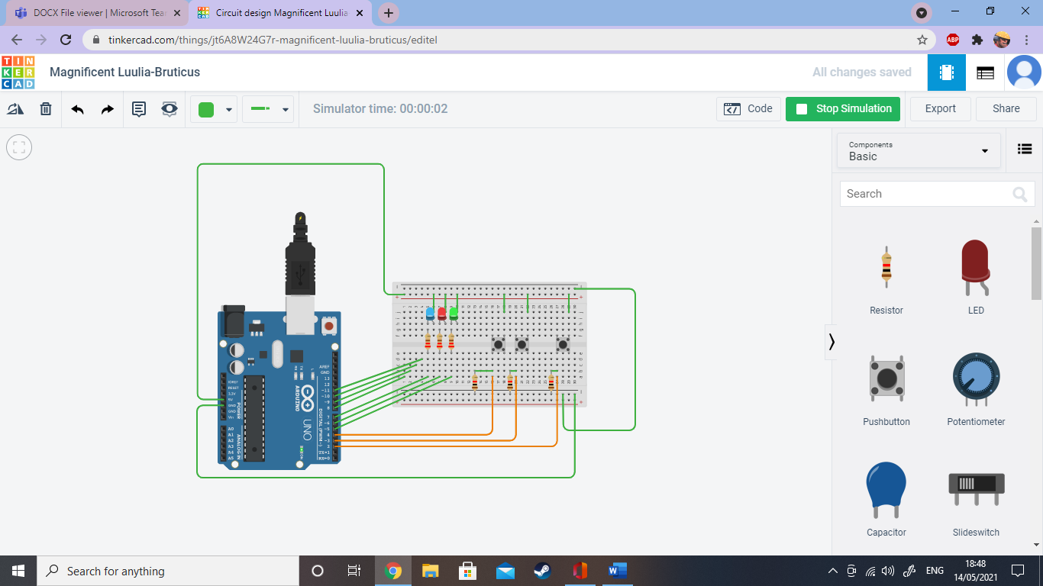
Above is the circuit operating without any inputs being made.
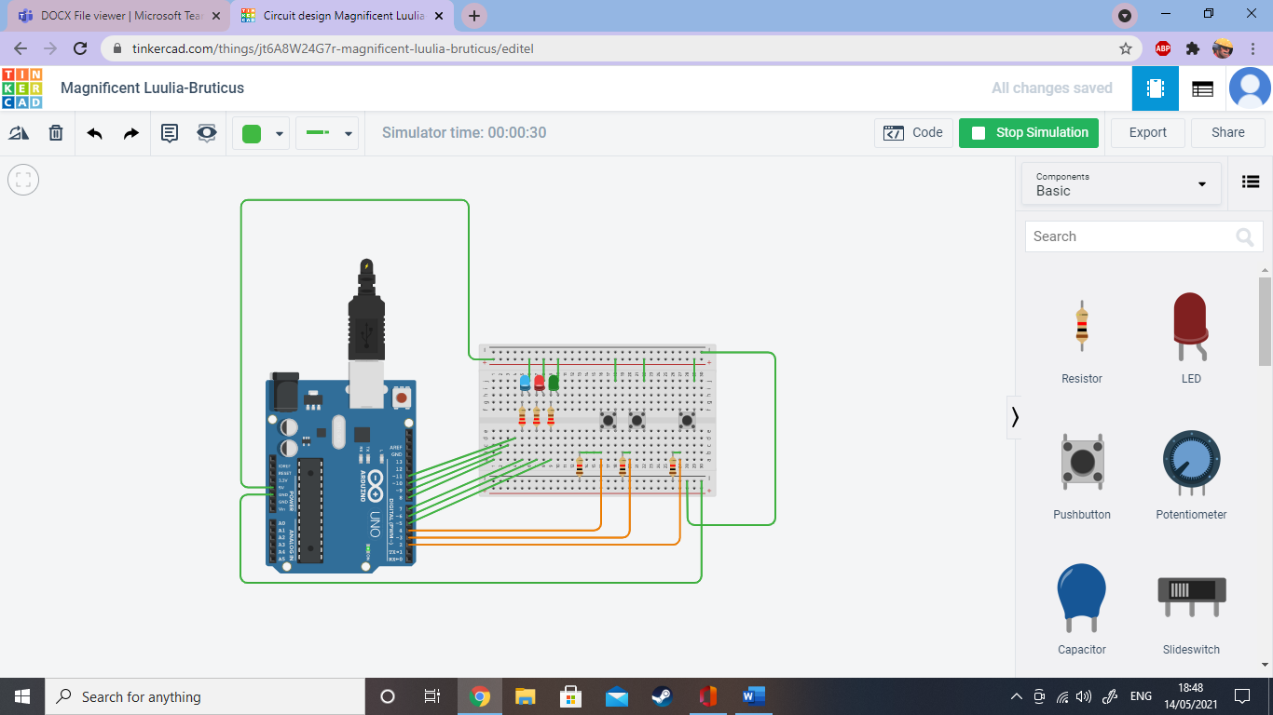
Above is a screenshot when the right button is pressed. Just as I had hoped Arduino reads this as the car park being full and displays illuminates the red LED indicating that the car park is full. However, if the right button is pressed first, it will first illuminate the green LED and then switch to the red LED. This is because it has been designed so that the carpark cannot be opened already closed so it will briefly open it for a second before needing to close it again. Unfortunately, I am unable to visually display this in my document.
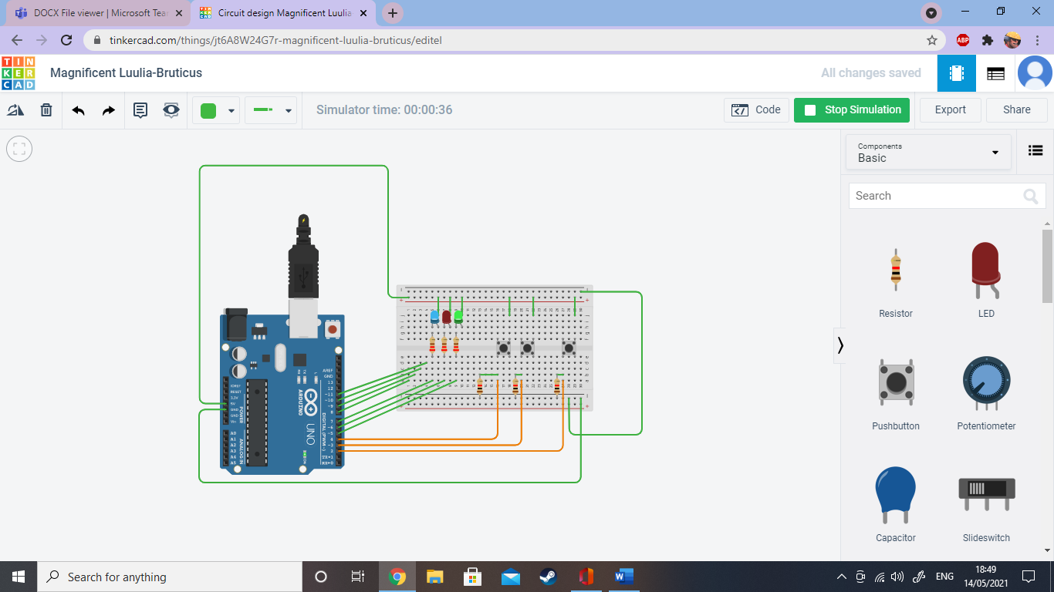
Above is when the middle button is pressed. The green LED will light up displaying that the carpark is open, just as I had wanted it to work.
Conclusion
In conclusion I am pleased that after a lot of trial and error I was able to eventually make the circuit work. It should now replicate the simple but effective system used in many carparks. Although I had difficulty in the use of the blue lit LED for my original intended purpose, I had given it an alternative use. The only other thing to be considered along with this system is that whilst the carpark scans the vehicles it would have to match up with a number plate recognition service. However, that was not included in the assignment.

Code used
#include <Stepper.h>

const int button = 2; // assign the push button to pin 2
const int sensor1 = 3; // assign sensor 1 to pin 3
const int sensor2 = 4; // assign sensor 2 to pin 4
const int green = 5; // assign the green LED to pin 5
const int red = 6; // assign the red LED to pin 6
const int FULL_SIGN = 7; // assign the full sign display to pin 7
const int stepsPerRevolution = 200; // change this to fit the number of steps per revolution for your motor
unsigned int fullpark = 10; // max amount of cars
int cars = 0; //holds number of cars currently in car park
int x = 0; // will be used to check the state of sensor 2

int outsense = 0; // starting state of the outsense
int storedSensor2 = 1; // starting state of sensor 2

Stepper myStepper(stepsPerRevolution, 8, 10, 9, 11); // initialize the stepper library on pins 8 through 11:

void setup() {
myStepper.setSpeed(60); // set the speed at 60 rpm:
Serial.begin(9600); // initialize the serial port:
Serial.println("Press q to enter service menu. \n"); // print the message to the serial monitor
Serial.println("Press n to enter max number of cars allowed in garage. \n"); // print the message to the serial monitor
pinMode(button, INPUT); // configure the push button to be a digital input
pinMode(sensor1, INPUT); // configure sensor 1 to be a digital input
pinMode(sensor2, INPUT); // configure sensor 2 to be a digital input
pinMode(green, OUTPUT); // configure the green LED to adopt the status of a digital output
pinMode(red, OUTPUT); // configure the red LED to adopt the status of a digital output
pinMode(FULL_SIGN, OUTPUT); // configure the full sign to adopt the status of a digital output
}
void loop() {

if (cars < fullpark){ // execute the following code if the car park is not full

if(digitalRead(button)==1){ // execute the following code if the push button is pressed
myStepper.step(stepsPerRevolution/4); // turn the motor 90 degrees clockwise
digitalWrite(red, HIGH); // turn the red LED on
Serial.print("Raising barrier\n"); // print the message 'raising barrier'
delay(1000);
digitalWrite(green, HIGH); // Turn the green LED on
digitalWrite(red, LOW); // Turn the red LED off

do
{
delay(50); // wait for sensors to stablize
x = digitalRead(sensor1); // check sensor1
} while (x < 1); // when the car passes sensor 1, do the following
Serial.print("Lowering barrier\n"); // print that the barrier is lowering
myStepper.step(-stepsPerRevolution/4); // turn the motor 90 degrees anti clockwise
digitalWrite(green, LOW); // turn green LED off
digitalWrite(red, HIGH); // turn red LED on
cars ++; //increase the number of cars in the car park
delay(500);
Serial.print("The count is now "); // print the new value for the cars in the car park
Serial.println(cars);

}
}
{
outsense = digitalRead(sensor2); // see if car is leaving

if(outsense == 1 && cars >= 1){ // if a car is leaving do the following
if (storedSensor2 == 0) {
cars--; // decrease the number of cars by 1
Serial.print("The count is now "); // print the new value of cars in the car park
Serial.println(cars);
digitalWrite(FULL_SIGN, LOW); // turn off full sign if on
}
}
storedSensor2 = outsense;
}

if (cars == fullpark){ // car park has reached maximum number of cars allowed
delay(300);
digitalWrite(FULL_SIGN, HIGH); // Turn on the full sign LED
digitalWrite(red, HIGH); // Turn on the red LED
Serial.println("Sorry, The car park is full\n"); // display the message that the car park is full
delay(300);
}
}

