Table of Contents
Abstract 2
1. Introduction 2
2. Task 1: Database Design and Implementation 3
2.1 Database Analysis 3
2.2 Entity Relationship Diagram (ERD) 3
2.3 SQL Code Implementation 4
2.4 Data Population and Validation 6
3. Task 2: Transaction Handling and Database Performance 9
3.1 Transaction Scenario 9
3.2 Indexing for Performance 10
3.3 Functions, Triggers, and Procedures 11
4. Evaluation of Design and Implementation 13
4.1 Logical Database Design 13
4.2 Data Integrity and Validation 13
4.3 Transaction Management and Concurrency Control 14
4.4 Query Performance and Indexing 14
4.5 Scalability and Multi-User Deployment 15
Conclusion 15
References 16

AutoPilot Fleet Database Design and Implementation Using PostgreSQL

Abstract
This report describes the structure and development of a PostgreSQL relational database management system for AutoPilot Fleet, an organization offering self-driving car rental services. The report covers the proposed solution to the development of an efficient database for the registration of customers and their vehicles, rental processing, as well as scheduling maintenance for company vehicles. Basic concepts are related to the normalization process, generating primary and foreign keys, use of constraint to maintain data integrity, and use of rollback/commit units. This report also discusses about the ways and means to optimize the database such as indexing, Use of stored procedures & triggers. In addition, the report assesses the design of the system with specific regard to multiple user simultaneous access, nested transaction control and isolation of levels coupled with control on problems such as lost updates and uncommitted dependencies.

1. Introduction
AutoPilot Fleet provides an innovative service of renting self-driving cars for different time, and if necessary, for any necessary period instead of car-sharing as a modern form of car rental. In an effort to automate the running of the business, maintain the reliability of the records and enhance performance the company needs an efficient database that will address such aspects as vehicle tracking, clients, rental services and maintenance services.
The database must handle several essential business processes: issuing new vehicles and customers, fulfilling rental requests, organizing services, and receiving opinions from customers. The design also has to factor in transaction management, data integrity in case of operations such as rollback and commit. In addition, common strategies for performance improvement including creating indexes on the most often searched columns will be used to make queries run smoothly and prepare the program for increased usage.
This report will cover the following topic of the database design process: First, creation of the Entity Relationship Diagram (ERD); second, SQL code of the database schema; third, description of the transaction with the use of rollback/commit operations; fourth, the topic of index and stored procedure for the performance tuning. Furthermore, the report compares the capabilities of the system in handling multidimensional applications, especially in consideration to isolation levels and concurrency control.

2. Task 1: Database Design and Implementation

2.1 Database Analysis
The core entities required for the AutoPilot Fleet system include:
- Vehicles: Every vehicle within a fleet of vehicles has properties including vehicle_id, make, model, carrying capacity, and other accompanying features. These attributes contain more description about the vehicle.
- Customers: Customers include the customer_id, customer name, the customer’s email, and the date they registered. Customers can create multiple rental orders meaning that one customer can have many rental orders.
- Rental Orders: A rental order is a single rental process and has fields as order_id, start_date, end_date, etc., they have reference keys to the vehicle_id and customer_id. These enable the system to determine which customer hired which vehicle and for how long.
- Maintenance: Vehicles need to be maintained and their maintenance is recorded using the variables: maintenance_id, vehicle_id, maintenance_date and details. This assist in making a confirmation that all the vehicles that are used are well serviced and in a condition that can help them to run.
- Feedback: Customers may add feedback after the completion of a rental order that may contain feedback_id, order_id, review, and rating.
These entities will have individual attributes that must be recorded in a database, as well as the interconnections between them. The following steps show how these requirements are implemented in relational database schema.

2.2 Entity Relationship Diagram (ERD)
The Entity Relationship Diagram (ERD) illustrates the structure of the database, showing entities, attributes, and relationships. The key relationships are as follows:
- A Customer can place multiple Rental Orders.
- A Vehicle can be rented in multiple Rental Orders.
- A Vehicle can have multiple Maintenance records.
- A Rental Order can generate a Feedback entry.
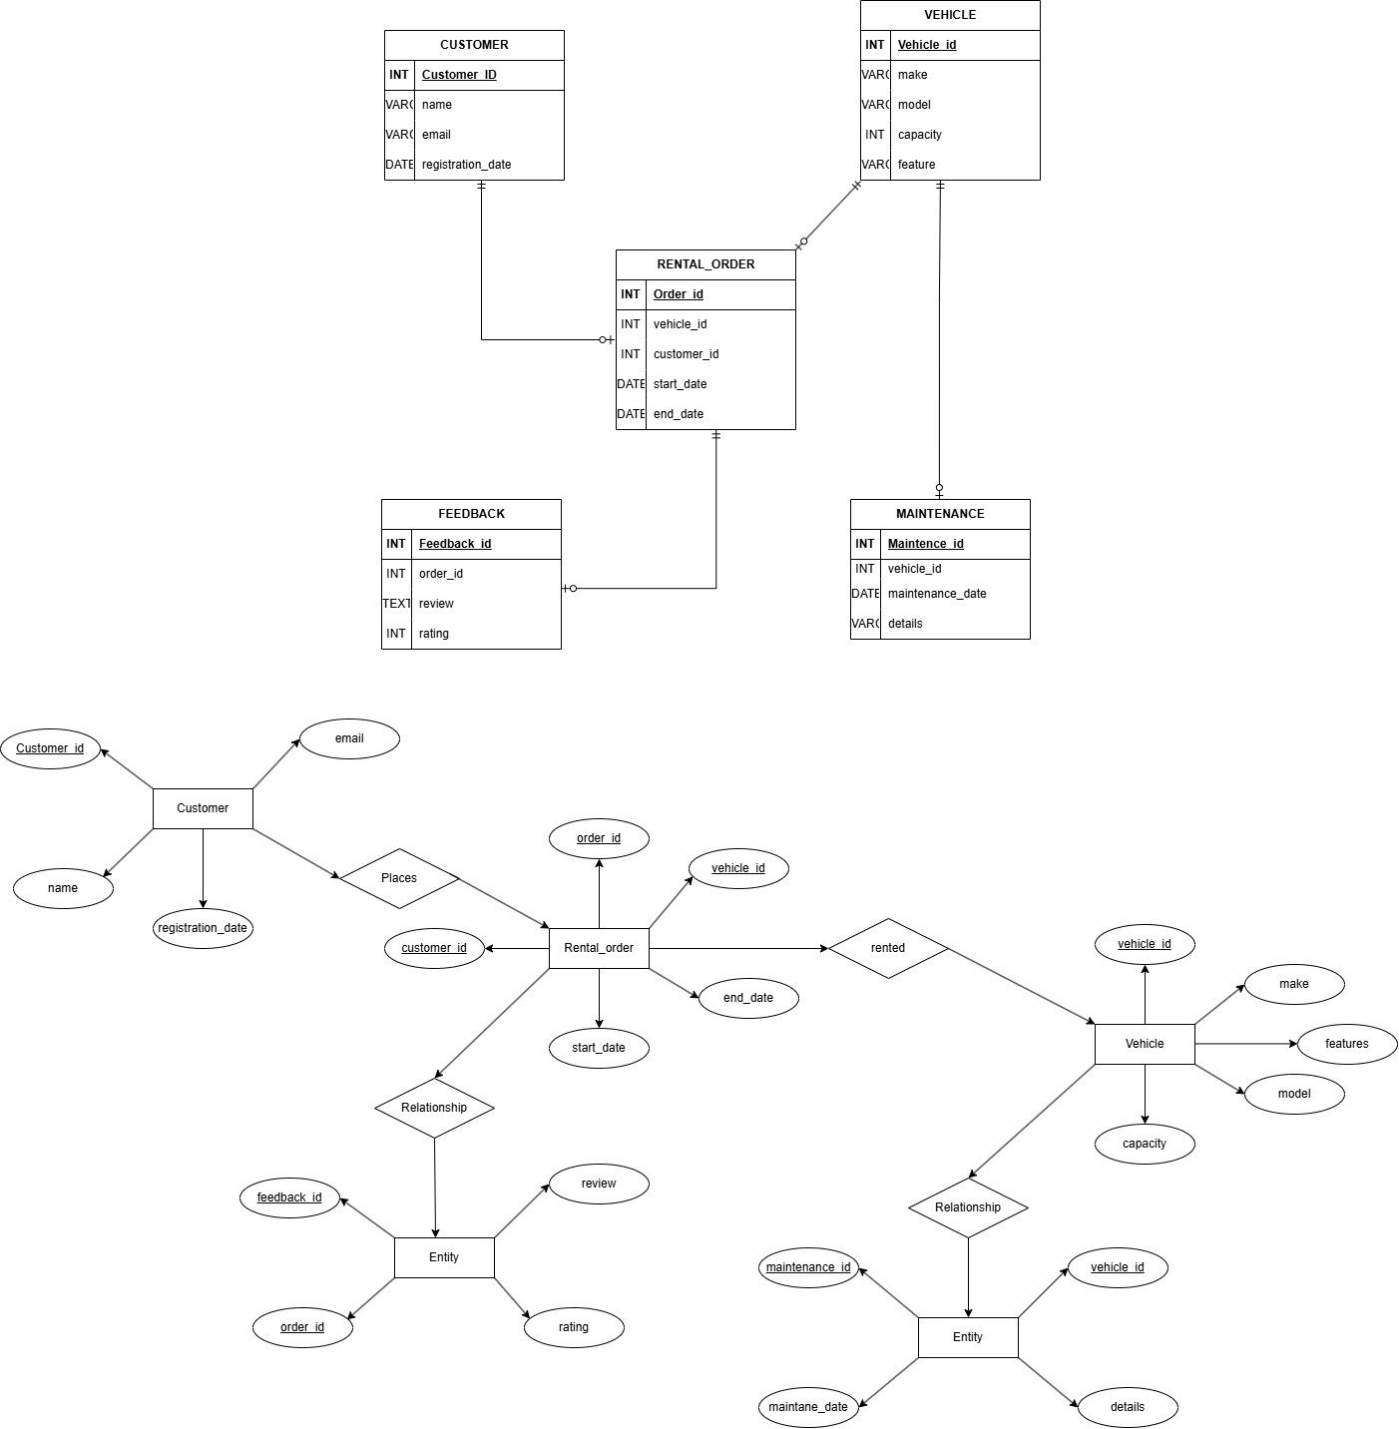
The ERD shows the relationships between vehicles, customers, rental orders, maintenance records, and customer feedback. The primary keys (PK) uniquely identify each record in the respective tables, while foreign keys (FK) maintain referential integrity between related entities.

2.3 SQL Code Implementation
The database tables are created using SQL statements to define the structure of each entity, including the necessary primary keys, foreign keys, and constraints.
SQL Code for Table Creation:
CREATE TABLE Vehicle (
vehicle_id SERIAL PRIMARY KEY,
make VARCHAR(255) NOT NULL,
model VARCHAR(255) NOT NULL,
capacity INT CHECK (capacity > 0),
features VARCHAR(255)
);

CREATE TABLE Customer (
customer_id SERIAL PRIMARY KEY,
name VARCHAR(255) NOT NULL,
email VARCHAR(255) UNIQUE NOT NULL,
registration_date DATE DEFAULT CURRENT_DATE
);

CREATE TABLE Rental_Order (
order_id SERIAL PRIMARY KEY,
vehicle_id INT REFERENCES Vehicle(vehicle_id) ON DELETE CASCADE,
customer_id INT REFERENCES Customer(customer_id) ON DELETE CASCADE,
start_date DATE NOT NULL,
end_date DATE NOT NULL
);

CREATE TABLE Maintenance (
maintenance_id SERIAL PRIMARY KEY,
vehicle_id INT REFERENCES Vehicle(vehicle_id) ON DELETE CASCADE,
maintenance_date DATE NOT NULL,
details VARCHAR(255)
);

CREATE TABLE Feedback (
feedback_id SERIAL PRIMARY KEY,
order_id INT REFERENCES Rental_Order(order_id) ON DELETE CASCADE,
review TEXT,
rating INT CHECK (rating >= 1 AND rating <= 5)
);

2.4 Data Population and Validation
To ensure the integrity of the design, realistic sample data is inserted into the tables. The sample data includes at least four records for each table, allowing for the validation of primary and foreign key constraints.
SQL Code for Data Insertion:
-- Inserting Data for Vehicle Table
INSERT INTO Vehicle (make, model, capacity, features)
VALUES
('Tesla', 'Model X', 5, 'Autonomous, Electric, 4 Doors'),
('Nissan', 'Leaf', 5, 'Electric, 4 Doors'),
('Ford', 'Fusion', 5, 'Hybrid, Autonomous, 4 Doors'),
('Chevrolet', 'Bolt', 4, 'Electric, Autonomous, 4 Doors');
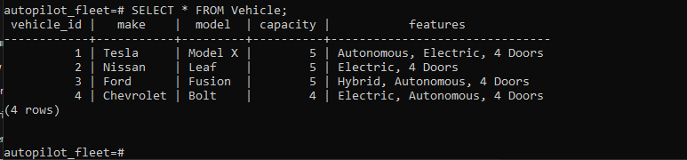
-- Inserting Data for Customer Table
INSERT INTO Customer (name, email, address, phone_number)
VALUES
('John Doe', 'john.doe@example.com', '123 Main St, London', '123-456-7890'),
('Jane Smith', 'jane.smith@example.com', '456 Elm St, London', '234-567-8901'),
('Emily Johnson', 'emily.johnson@example.com', '789 Oak St, London', '345-678-9012'),
('Michael Brown', 'michael.brown@example.com', '101 Pine St, London', '456-789-0123');
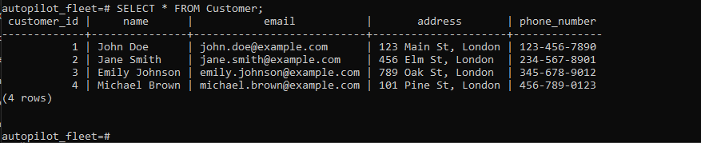
-- Inserting Data for Rental_Order Table
INSERT INTO Rental_Order (customer_id, vehicle_id, start_date, end_date, total_cost)
VALUES
(1, 1, '2024-11-01', '2024-11-03', 200.00),
(2, 2, '2024-11-02', '2024-11-05', 250.00),
(3, 3, '2024-11-04', '2024-11-07', 180.00),
(4, 4, '2024-11-06', '2024-11-08', 210.00);
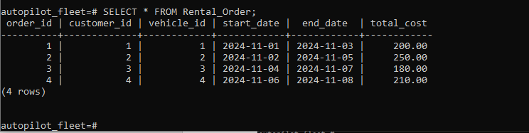
-- Inserting Data for Maintenance Table
INSERT INTO Maintenance (vehicle_id, maintenance_date, maintenance_type, maintenance_cost)
VALUES
(1, '2024-10-20', 'Battery Check', 50.00),
(2, '2024-09-15', 'Tire Change', 100.00),
(3, '2024-08-30', 'Oil Change', 75.00),
(4, '2024-07-10', 'Brake Inspection', 60.00);
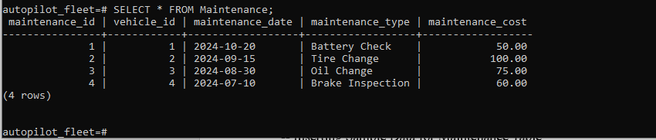
-- Inserting Data for Feedback Table
INSERT INTO Feedback (order_id, customer_id, rating, comments)
VALUES
(1, 1, 5, 'Excellent service and smooth ride!'),
(2, 2, 4, 'Good experience, but the vehicle could have been cleaner.'),
(3, 3, 5, 'Very happy with the vehicle and the booking process.'),
(4, 4, 4, 'Great ride, but it was a bit difficult to find a parking spot.');
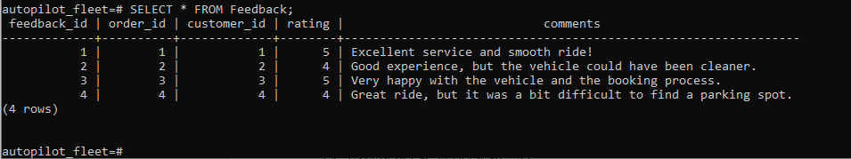

3. Task 2: Transaction Handling and Database Performance

3.1 Transaction Scenario
In the AutoPilot Fleet rental service, transactions ensure that key operations like booking a rental and updating vehicle availability are processed atomically. If any part of the transaction fails, it is rolled back to maintain consistency.
SQL Code for Transaction Scenario:
BEGIN;

-- Step 1: Insert rental order (customer 2 rents vehicle 1 from 2024-12-10 to 2024-12-12)
INSERT INTO Rental_Order (customer_id, vehicle_id, start_date, end_date, total_cost)
VALUES (2, 1, '2024-12-10', '2024-12-12', 300.00);

-- Step 2: Update vehicle availability to FALSE (vehicle 1 is rented)
UPDATE Vehicle
SET available = FALSE
WHERE vehicle_id = 1;

-- Uncomment below to simulate rollback or commit
-- ROLLBACK; -- Simulate an error and rollback
-- COMMIT; -- Commit the transaction if successful
Rationale:
- Begin Transaction: Starts the transaction ensuring atomicity (all-or-nothing).
- Insert Rental Order: A record is inserted into Rental_Order with the vehicle and customer details.
- Update Vehicle Availability: The vehicle’s availability status is set to FALSE to mark it as unavailable.
- Error Handling: If an error occurs (e.g., vehicle already rented), ROLLBACK is used to undo both operations. If successful, COMMIT applies the changes.
This ensures that either both operations (order and availability update) succeed or neither do, maintaining data consistency.

3.2 Indexing for Performance
In AutoPilot Fleet's database, certain queries, such as looking up available vehicles or retrieving customer rental histories, will need to be optimized. Secondary indexes can improve the performance of frequent queries.
SQL Code for Creating Secondary Indexes:
-- Index on vehicle make and model for faster lookups
CREATE INDEX idx_vehicle_make_model ON Vehicle(make, model);

-- Index on customer email for quick lookups
CREATE INDEX idx_customer_email ON Customer(email);

-- Index on rental order start date for efficient filtering
CREATE INDEX idx_rental_order_start_date ON Rental_Order(start_date);
Rationale:
- Indexing on columns frequently used in WHERE clauses or joins improves query performance.
- The indexes on the make and model of vehicles, email of customers, and start date of rental orders ensure efficient querying.

3.3 Functions, Triggers, and Procedures
To automate business processes and ensure data consistency, functions, triggers, and stored procedures are implemented. These include:
- Trigger for Auditing Insert, Update, and Delete: Logs changes to critical tables (e.g., Vehicle, Customer).
- Function for Calculating Rental Costs: Computes the total rental cost based on duration and vehicle type.
- Stored Procedure for Maintenance Updates: Automatically schedules maintenance after a certain number of rentals.
SQL Code for Trigger:
-- Function to log changes for auditing purposes
CREATE OR REPLACE FUNCTION audit_changes()
RETURNS TRIGGER AS $$
BEGIN
INSERT INTO Audit_Log (table_name, action, old_data, new_data)
VALUES (TG_TABLE_NAME, TG_OP, ROW(OLD.*), ROW(NEW.*));
RETURN NEW;
END;
$$ LANGUAGE plpgsql;

-- Trigger to audit changes on the Vehicle table
CREATE TRIGGER vehicle_audit
AFTER INSERT OR UPDATE OR DELETE ON Vehicle
FOR EACH ROW
EXECUTE FUNCTION audit_changes();
Testing Insertion Operation
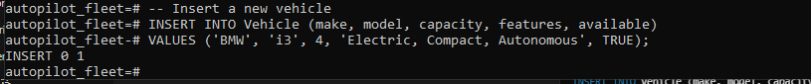

Testing Updating Operation
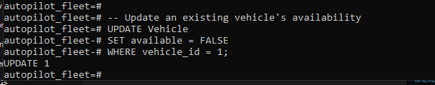
Testing Deleting Operation
Checking the Audit_Log Table for Logged Changes
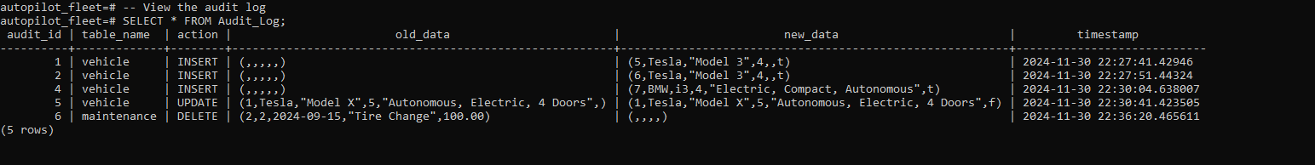

4. Evaluation of Design and Implementation
This section considers the logical database design and development of the AutoPilot Fleet database, particularly with regard to data and transaction control and query efficiency and expandability. It also evaluates the concurrency problems, such as lost update, uncommitted dependency, and inconsistent analysis in the multi-user context.

4.1 Logical Database Design
AutoPilot Fleet uses principles of relational normalization in the design of the AutoPilot Fleet database to reduce occurrence of redundancy and enhance integrity of data. The schema adheres to the Third Normal Form (3NF), where:
- Redundancy is minimized: Information like customer information and car property characteristics are entered once, but relationships are made known through mechanisms like customer_id and vehicle_id.
- Data integrity is maintained: The last one is checking constraints, which ensure business rules including positive identification for vehicles capability in the case of a car.
- Business logic is embedded in the schema, ensuring that the system performs operations like capacity validation and enforces valid relationships between entities.
The design is quite useful in the organization of data although the complexity of joins may escalating as the size of data is escalating. Queries often require joining multiple tables (e.g., Customer, Rental_Order, Vehicle), which could affect performance for large datasets.

4.2 Data Integrity and Validation
Data integrity is crucial for ensuring the system’s reliability. The AutoPilot Fleet database employs several strategies:
- Primary and foreign keys maintain referential integrity. For example, Rental_Order references customer_id to ensure that every rental order is linked to a valid customer.
- Check constraints enforce valid data, such as ensuring vehicle capacity is greater than zero and feedback ratings fall between 1 and 5.
- Unique constraints on attributes like email prevent duplicate customer records, ensuring data consistency.
These measures are tested by inserting invalid data (e.g., a negative vehicle capacity or duplicate email), which is automatically rejected, ensuring the database remains consistent.

4.3 Transaction Management and Concurrency Control
The system utilizes ACID principles (Atomicity, Consistency, Isolation, Durability) to manage transactions, ensuring reliable operations:
- BEGIN, COMMIT, and ROLLBACK operations ensure that each transaction is atomic, either fully succeeding or fully reverting in case of failure (e.g. when a vehicle is unavailable for rental).
- Transaction isolation is implemented using the Read Committed isolation level, which ensures transactions read only committed data, preventing issues like dirty reads.
- Higher isolation levels, like Repeatable Read or Serializable, may be considered if the system requires handling more complex or long-running transactions.
These transaction handling enable avoiding concurrency problems including lost updates and dependencies of uncommitted data, making it possible to have more than one user.

4.4 Query Performance and Indexing
To boost query efficiency, the system indexes frequently searched columns:
- Vehicle make and model: Helps speed up searches when customers browse vehicles.
- Customer email: Ensures fast retrieval of customer details, especially when checking for duplicates.
- Rental order start date: Enables easy identification of rental orders from a particular date up to another date.
SQL code for creating indexes:
CREATE INDEX idx_customer_id ON Rental_Order (customer_id);
CREATE INDEX idx_vehicle_id ON Rental_Order (vehicle_id);
Although indexing impacts query performance positively, an unfavorable position occurs in an insert, update and delete operation. However, the gain from fast queries is assured and more important when considering the read operations in the described system.

4.5 Scalability and Multi-User Deployment
Scalability is addressed by normalized structures to ensure that when designed the database has only one single point of access for all the rows of any table and indexes on attributes that are likely to be searched because this will ensure that even as the size of the data doubles the time taken by the query to run is , at most, doubled. In a multi-user environment, managing data consistency and preventing issues like deadlocks or resource contention is critical:
- Transaction management guarantees that information does not change while several users perform several processes at once, the final BEGIN, COMMIT, and ROLLBACK controls will not allow half of the record to be updated.
- Increase of the data set will pass through the system by handling the large data set through optimized query that is supported by the indexation and proper normalization.
The system's transaction handling mechanisms and indexing strategies ensure that AutoPilot Fleet’s database can scale effectively while maintaining performance and consistency across multiple users.

Conclusion
The AutoPilot Fleet database design successfully integrates normalization, data integrity, transaction management, and indexing to support the company’s operational needs. The system efficiently handles data consistency, ensures fast query performance, and scales well in a multi-user environment. By using appropriate transaction isolation levels, the system avoids common concurrency problems, ensuring reliable operations even under high user load. Future enhancements like introducing higher isolation levels or materialized views could further optimize the system as it grows.

References
C. J, D. (2004). An introduction to database systems: Date, C. J: Free Download, Borrow, and Streaming. Internet Archive. https://archive.org/details/introductiontoda0000date
Elmasri, R. (2017, March 17). Fundamentals Of Database System, 7Th Edn: Elmasri Ramez And Navathe Shamkant: Free Download, Borrow, and Streaming: Internet Archive. Internet Archive. https://archive.org/details/fundamentalsofda0000elma_w5c8
The PostgreSQL Global Development Group. (2019). PostgreSQL: The world’s most advanced open-source database. Postgresql.org. https://www.postgresql.org/

